Laporan Praktikum

Nama : Kinanti Nailah Ambarwati
Kelas : SIB - 2E
Link Git : https://github.com/kinantinailah/PBO_KinantiNailahA

Tugas Jobsheet 2
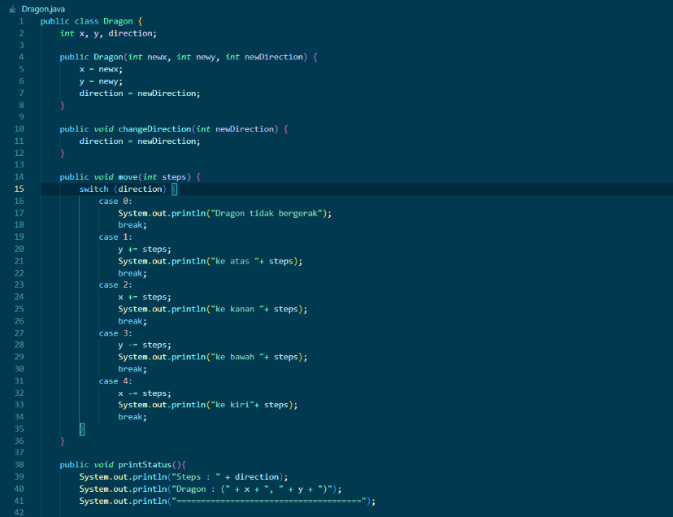
- Code
- dragon
- dragon main
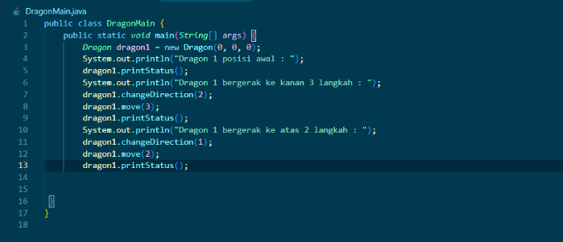
- Output
