HOW TO BUILD YOUR OWN GRANIER-TYPE SAP FLOW SENSORS
Ivo Offenthaler, Institute of Botany, Univ. Agric. Sci. Vienna
(last revised: June 23rd, 2001)

Since you are visiting this page you probably are familiar with the theoretical background of the method. (If not: brush up your French by reading the original paper by Granier or the good review on sap flow measurements by Smith & Allen.)
True, you can order the Granier sap-flow sensors from various suppliers, e.g. UP (Germany) or Dynamax (US), but making them yourself will:

save you some money
allow you to customize your sensors
increase your self-esteem (ha!! finally you got it working!)
Before you start
Note the pending patent for the design of these sap flow sensors. If you want to build them for commercial use (as though your time allowed...) you have to obtain the license from INRA.
If you don't have the opportunity to calibrate your sensors (which is likely), be aware to keep as close as possible to the design proposed by Granier (1985)! Remember that his sap-flow equation is an empirical one, and that sensor characteristics might vary considerably with heating power and the replacement or introduction of new materials (heat-conducting paste, teflon, copper tubelets, epoxy layers etc.)
To illustrate this: the mere application of some heat-conducting paste between sensor and aluminium tubelet can lower the sensor temperature at zero flow conditions by 2-3 K. However, many of the sensors on the market don't fully comply to Granier's specifications either.
Shopping list
Here's what you need - and where to get it:
Teflon coated constantan and copper wire: OMEGA ENGINEERING. Contact your local representative. You will need the .005 inch diameter wire (for cable extensions you should also purchase some larger diameter constantan wire: 0.01 inch or larger). Smallest package unit is 50 feet, one role each will last for appr. 30 sensors. Don't forget to ask for the free 'OMEGA Temperature Handbook': a fine compendium to learn some more about temperature measurement.
Hint: the term "CONSTANTAN" refers not to a single but to a number of different copper-nickel alloys. "Our" Copper-Constantan TCs require another type of alloy than e.g. Iron-Constantan TCs - so make sure to order the correct wire (ask for 'matched pairs').
Some lenghts of cable (insulated copper, flexible)

Aluminium tubes: Hard to find! Try a specialised dealer for ARCHITECTS' EQUIPMENT: obviously, 2 mm aluminum tubing is exactly what they need to construct models of future scyscrapers.
Hypodermic needles; local drugstore. Measure: diameter x length = 0.9 x 40 mm (standard LUER, the ones with yellow endpiece. Try different brands: they differ slightly in inner diameter, some might be too narrow. TERUMO© work fine.)
Adjustable constant-voltage source: this source is connected to your main power supply (which will be 12 VDC in many cases) and will deliver the voltage necessary to power each connected sensor with 0.2 W. You can obtain it from any major distributor of electronic components for less than 15 US$. If you are not sure which one to order, click here.
Soldering equipment: low melting point tin, soldering ion. (A high temperature soldering junction is more stable, but manipulation becomes way more complicated. Unless you got some professional equipment or you're really in for the challenge, better try the first.)
A nail cutter (perfect for cutting fine wires), calipers.
A magnifying glass. You WILL need one.
Superfast (cyanacrylate) glue
Heat-shrinkable insulation tube
A multi-meter to measure resistance

Back from shopping?
Then you're ready to proceed to STEP ONE
(see picture on the last page of this manual if you are in doubt about the one ore other construction detail)

References:
A. Granier 1985: Une nouvelle méthode pour la mesure du flux de sève dans le tronc des arbres. ANN.SCI.FOR. 43, 139-200

D.M. Smith & S.J. Allen 1996: Measurement of sap flow in plant stems. J.EXP.BOT. 47, 1833-1844

(back)

SPECIFYING THE POWER SUPPLY

(return to instructions)

Granier-type sensors are powered with 0.2 W (at least, they were originally designed in this way). This is achieved by passing an electrical current through a resistive wire (the Constantan wire coiled around the hypodermic needle). How can one calculate the voltage needed to drive enough current through the coil?

Power (P) = Voltage (U) * Current (I) [eq.1]
and
Voltage (U) = Resistance (R) * Current(I) [eq. 2]
so that
P = R * I^2

solving for P = 0.2 W and R = 14 Ohm (which is the resistance of the heating coil), you need a current of

I = SQR (P/R)
= SQR(0.2/14) = 0.1195 A

running through the coil. Entering these values into eq. 2 gives the required voltage:

U = 14 * 0.1195 = 1.673 V

per probe.

--------------------------------------------------------------------------------
EXAMPLE:
I use to power two Granier sensors with one supply and connect the two heating coils in series. This means adding the single coil resistances which in turn requires the double voltage = 3.34 V. Adding some safety margin I therefore might choose a supply with a voltage range between 0 - 5 V. The main power supply is 12 VDC, both probes consume 2 * 0.2 = 0.4 W. According to these limitations a power supply with the following specifications would work fine:

max. input voltage (Vi max) 12 VDC or more
P max = 1 W
output voltage (Vo) = 0...5 VDC

Now we are going to make a thermocouple (short: TC). You can use them not only for the sap-flow sensors but for most applications that require temperature measurements. For more information what a TC is and what it does, click here.
Take two 10 cm pieces of Constantan and copper wire. Remove 5 mm of the insulation. Twist the bare ends together (5-6 tight turns will suffice), a caliper is helpful. If necessary, clean the junction using benzine or chloroform.
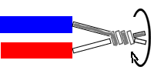

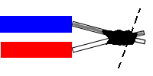
Cover the junction with a smooth layer of soldering tin. Use the nail-cutter to trim the junction

Plain cake :) take one of the hypodermic needles and remove the tip (=the blade). Do not simply cut it off: this would crimp the opening. Better put the needle on a hard surface. Place the blade of a sharp knife against the needle and roll the needle while exerting moderate pressure on the knife. This will produce a break section: use some pliers to break the tip off the needle.

Of course the probe has to be equipped with some heater. The heater consists of a length of Constantan (a true multi-purpose alloy!) wire wound around the needle.
Cut some 30 cm of the 0.005 " Constantan wire. The resistance of this length should be about 15 Ohm, so that you can re-cut it to precisely 14 Ohm lateron.
The following might be the most tedious effort of all:
thread one end of the wire through the needle. Start from the tip of the needle. If this just does not work: try to slim down the teflon insulation by repeatedly straightening it between your fingers. If this doesn't work either: remove the thermocouple and strip the copper wire from its insulation. However, the latter is not very desirable - it's only a last desperate attempt.
Sooner or later you have all three leads running through the needle. (Congrats! Have a coffee break!) Use some tape to mark the end of the heating wire: you need that to distinguish it from the thermocouple wires.
Now: retract the thermocouple by gently pulling from the base until the thermojunction is inside the needle, 10 mm from the tip. This is easier if you paint some mark on the thermocouple wires and observe the movement of this mark. It also helps you to ensure the thermojunction stays in place during the following manipulations.
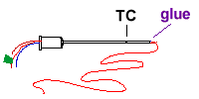
Add a droplet of fast hardening glue to the tip of the needle. Wait for it to dry (have another coffee-break!)
O.K. time for the spin! Cover 2 cm from the tip of the needle with a thin layer of cyanacrylate glue. Spin the wire around the needle. The turns should be tight and regular, with no space between them. Some glue squeezing out between the turns makes the coil more compact. Allowing for approx. 4 cm of wire to run through the needle base, you should obtain a 2 cm heating coil. Immediately after finishing the coil (as long as the glue is still elastic): try if the probe really fits snugly into the aluminium tube. It may be necessary to slim down the teflon insulation as described above.
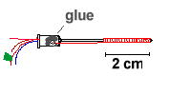
Use a hot pin to make a hole in the plastic needle adapter. Thread the free end of the heating wire through this hole inside the adapter. Finally, fill some glue (e.g. 2-component glue) into the needle base (check before if the TC junction is still correctly positioned).

Wiring the single parts together is best explained with a diagram:
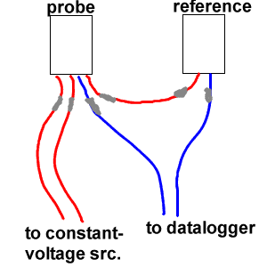
You will find that connecting the short wire ends to any extension is difficult. And: you cannot solder the Constantan wire. One solution is to use a crimping technique: cut short lengths (4 mm) from the hypodermic needles and introduce the wire ends from opposite sides. Then, take some robust pliers and compress the needle tubelets FIRMLY. This gives a satisfactory connection. In the diagram, these crimp connections are depicted by grey bars.
- Connect the Constantan ends of the thermocouples. Use enough wire (Constantan wire, n.b.) for the extension: the probes will be at least 10 cm apart when installed at the trunk. Preferably take some larger diameter wire for the extension, otherwise your sensor becomes too fragile.
- Connect the ends of the heating coil to your constant-voltage source (if you power more than one sensor in series, remember the right order: voltage source - coil 1 - coil 2 - voltage source). Before going to the field: take the multimeter and make sure that the heating current indeed is 120 mA. Trim the voltage source to obtain the desired current.
- Connect the copper ends of the thermocouples to the input terminals of your datalogger.
The probe might look something like this:
(return to STEP 1)
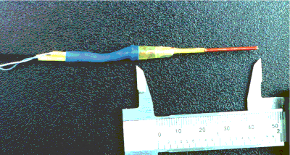
To install your sensors:
- Cut some 2 cm pieces of aluminium tube. Drill a 2mm hole into the bole. Remove a small core of bark and phloem (use a cork-borer). Insert the aluminium tubelet (a precision screwdriver with a blade slightly smaller than the inner diameter of the tubelet can be used to push it down the hole - be careful not to narrow the opening of the tube.)
- Apply some heat conducting paste (electronics distributer) onto the probes. Insert probe and reference probe, resp. in the appropriate tubes. If they don't move in smoothly, don't use force - this will only destroy the coil.
- Use silicone grease to cover the exposed xylem. Especially with resinous species, this will help a lot to prevent the probes from getting clogged beneath the bark.

DONE!
WAS THIS MANUAL OF ANY HELP TO YOU?
Please mail your questions, criticism etc. to: offentha@edv1.boku.ac.at

Stand age, productivity and hydraulic conductance of douglas-fir in the Wind River Basin
Barbara Bond
Oregon State University
Michael G. Ryan
U.S. Forest Service
Mathew Williams
Woods Hole Marine Biological Laboratory

- Executive Summary
- Objectives
- Approach
- Results
- Products
  - Papers & Presentations

Executive Summary:
We are testing the hypothesis that hydraulic resistance increases as trees grow and age, and that this increased resistance results in lower rates of photosynthesis and transpiration (per unit leaf area) in older trees and reduced productivity in older stands. To test this hypothesis, we are conducting a "suite" of measurements using Douglas-fir at sites of three age classes at Wind River, a 20-year-old stand, a 40-year-old stand, and the old growth trees in the canopy crane circle. Measurements include whole-tree sap flow, leaf-level gas exchange, and foliar nitrogen and carbon isotope content. Subsequently, we will use a process model to estimate stand-level performance. Analyses to date show some consistency with the hypothesis. For example, soil water was depleted more rapidly at the youngest site, and this site also had higher stomatal conductance and photosynthesis in August, 1999. Sap flow per unit sapwood area was also much higher in younger trees. On the other hand, when transpiration per unit leaf area is estimated from sap flow using estimates of whole-tree leaf area from allometric analyses, transpiration rates per unit leaf area appear similar for 20-year-old and old growth trees because the older trees have less leaf area per unit sapwood area. The results emphasize the importance of using a variety of measurement approaches to answer complex questions about plant functions in nature. In continuing analyses we will seek to explain some of the apparent discrepancies in the data that have been analyzed so far.

Objectives -- to answer the following questions:
- Is there evidence for a hydraulic limitation of gas exchange that increases with tree age in Douglas-fir at Wind River?
- To what extent do hydraulic limitations result in changes in productivity through stand development?

Approach:
We erected scaffolding towers to provide access to canopy tops in a 20-year-old and 40-year-old stand at Wind River to use in comparisons with measurements of old growth trees in the canopy crane circle. At each of the three sites we conducted the following measurements through the growing seasons of 1998 and 1999:
- determination of the leaf area:sapwood area ratio for the three age classes of trees
- soil moisture measurements using TDR and five locations per site, at least monthly
- measurements of pre-dawn leaf water potential of understory trees, at least monthly, as an alternate mechanism of assessing soil water potential
- determination of the moisture retention curve for soil samples to convert TDR measurements to soil water potential
- continuous measurements of sapflow of boles of four to six trees per site as well as of branches of selected trees,
- measurements of diurnal water potential of twigs from the tops of trees accessible from the towers or the canopy crane, at least monthly
- measurements of photosynthesis and stomatal conductance of twigs from the tops of trees accessible from the towers of the canopy crane (using a LiCor 6400 with both current and 1-year-old foliage)
- determination of the nitrogen content 1-year-old foliage at each site
- determination of the carbon isotope composition (δ¹³C) of 1-year-old foliage at each site
In the coming months we will be analyzing the data from these measurements intensively and we will begin to parameterize the model (MBL/SPA) described in the original proposal as a mechanism of "scaling up" our results.

Results to Date:
We are in a relatively early phase of data analysis. Here we share a sample of the analyses that have been completed so far.
- Leaf area:sapwood area ratios.
This is critical information for "scaling up" the sapflow and gas exchange measurements, and we suspect the information will be valuable to many other WESTGEC researchers (e.g., it will provide a way of estimating stand LAI if basal sapwood area is determined). In our original proposal, we underestimated both the importance of the information as well as the complexity of the measurements. To develop this relationship, Nate McDowell harvested over 40 branches from each of the two younger age classes, measured their diameter, length and total leaf area, and developed allometric equations to predict leaf area. Working with Roaki Ishii, he also developed allometric equations to predict leaf area of branches from old growth trees outside the crane circle. Then he measured the dimensions of every branch on five to seven in tact trees of each age class and summed the leaf areas per branch to predict whole tree leaf area.
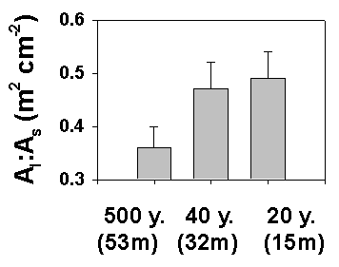
Figure 1. Leaf area:sapwood area (A_{l}:A_{s}) Pseudotsuga menziesii, Wind River, WA.
As Fig. 1 shows, older trees had much lower leaf area per unit sapwood area compared with younger trees. This might be interpreted as an "attempt" by the larger trees to compensate for the increased hydraulic resistance due to size by reducing the leaf area supplied by sapwood.
Site | Date (1998) | θ (m³ m⁻³) ± s.e.
500 yr | Aug. 2 | 0.42 ± 0.02
 | Sept. 14 | 0.27 ± 0.02
20 yr | Aug. 2 | 0.29 ± 0.03
 | Sept. 14 | 0.17± 0.02
Table 1. Volumetric soil moisture, θ (m³ m⁻³), on representative mid- and late-season days in 1998 (N=5).
- Soil moisture measurements.
Not all of our soil moisture measurements have been compiled and analyzed, but in general, we found that soil moisture became more depleted in the younger stands compared with the old-growth area through the season (e.g. Table 1; the dates shown were selected to correspond to sapflow data shown below). The entire data set will eventually be placed on our web site so that other WESTGEC researchers have access to this information.
Site | Date | Ψ _{pre-dawn} (MPa) ± s.e.
500 yr | June 28, 1999 | -4.1 ± 0.3
 | July 20, 1999 | -4.9 ± 0.1
40 yr | June 28, 1999 | -4.0 ± 0.4
 | July 20, 1999 | -4.1 ± 0.1
20 yr | June 28, 1999 | -4.3 ± 0.5
 | July 20, 1999 | -5.2 ± 0.5
- Table 2. Soil moisture availability as indicated by pre-dawn water potential measurements of understory species.
- Pre-dawn water potentials.
Ψ_{pre-dawn} measurements of understory species in 1999 also show a trend of more rapid depletion of soil moisture in the youngest stand compared to the oldest, although the difference is not as pronounced as in the measurements of volumetric water content. Ψ_{pre-dawn} measurements for the 40-year-old site indicated less moisture depletion compared with either of the other two stands, however. We will need to analyze more of our data to fully understand the seasonal trends across the sites. (Note: we periodically measured Ψ_{pre-dawn} of the study trees as well to verify that the difference between the ground measurements and the tops of canopies followed the expected hydrostatic gradient - it did).
- Soil moisture release curves.
We have placed curve-fit equations to predict soil water potential from soil water content have been placed on the web site for the canopy crane, at http://depts.washington.edu/wrccrf/presandreps/bond1.html.
- Sap flow.
As we explained in the progress report in our 2nd year renewal, we encountered difficulties with the EMS sapflow devices we used in the summer of 1998. We are continuing to work with Jura Kucera of the Czech Republic to retrieve as much information as possible from these measurements. Currently, we are analyzing measurements from our Granier sensors. These data were acquired only for the 20year-old and old-growth sites at the end of 1998 and through the entire season of 1999 for all three sites (except during power emergencies).
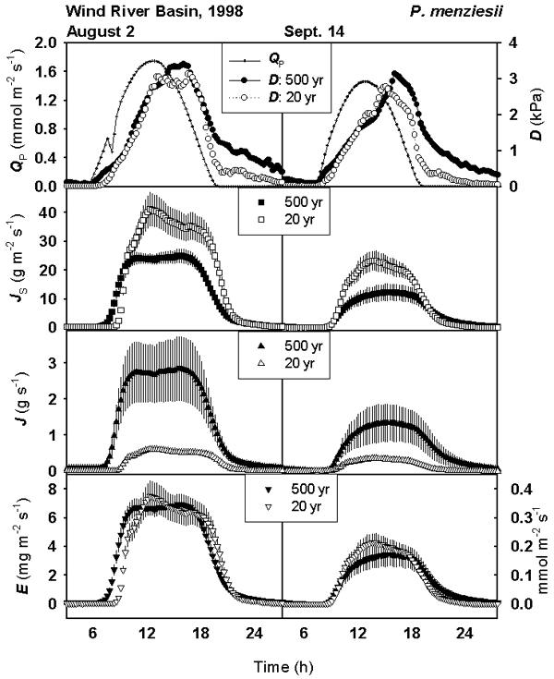
Figure 2. Mean sapflow at breast height for trees in the 20-year-old and old growth stands on clear days when soil moisture was high (Aug. 2) and low (Sept. 14).
Figure 2 Illustrates 1998 sap flow data for the oldest and youngest trees on a day when soil moisture was moderately high (August 2) and quite low (Sept. 14) (refer to Table 1 for soil moisture information). [note that the x-axis in Fig. 2 is "time of day"]. The sap flow per unit sapwood area (J_{s}) was much higher for the younger trees. Sap flux is generally lower in older sapwood compared with newer annual rings, so we placed sensors at different depths (0-20 mm and 15-35mm). Interestingly, we found that the radial variation in sap flow depended on tree size - the greatest variation between the outer and inner sapwood occurred in the youngest trees, and the radial patter was much less distinct in old trees. We accounted for this variation in "scaling" to the whole tree basis (J). Viewed on a whole tree basis, flux was much higher for the larger trees, which of course makes sense simply because they are larger. On the other hand, when the sap flow of whole trees is divided by total leaf area for the whole tree to produce an estimate of unit leaf transpiration (E), the flux rates for the two age classes appeared nearly identical when soil moisture was high and just slightly higher for younger trees when soil moisture was low. This is a consequence of the much lower leaf area per unit sapwood area in the older trees (Fig. 1). But it is also important to note that soil moisture availability was much lower in the younger stand on each of these days (Table 1), meaning that the young trees were able to "pull" water from soil more effectively than did the older trees.
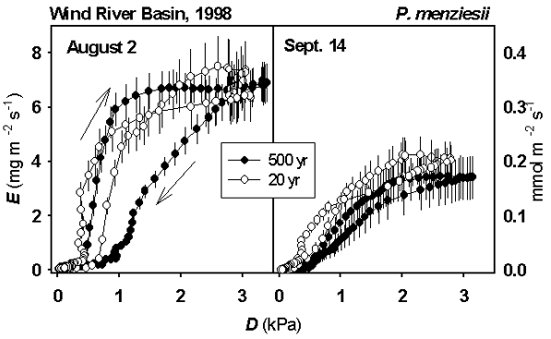
Figure 3. Transpiration data from Fig. 2 expressed as a function of evaporative demand.
When the same data are expressed as a function of vapor pressure deficit (D) rather than time, it is clear that low soil moisture had a strong influence on transpiration in the late season (Fig. 3). Also, the transpiration of older trees showed a stronger response to the soil water deficit - i.e., the stomatal response to D was more sensitive to soil moisture deficit for old trees than for young trees. This is expected if hydraulic resistance per unit leaf area is greater for the older trees. Fig. 3 also illustrates hysteresis in the relationship between E and D - the responses in the morning are different from the afternoon (arrows show the time course for Aug. 2). The hysteresis, and the fact that it is different between age classes as well as between measurement dates, offers opportunities for exploring the role of "capacitance", or stored water, which we will be considering in more detail in future analyses.
Much more analysis is yet to be completed for the sap flow measurements. One of our goals is to scale the data from the individual tree to the stand level. This should set a lower limit to the latent energy flux expected from eddy covariance measurements.
- Diurnal measurements of leaf water potential.
Previous measurements with Douglas-fir have shown that this species tends to achieve a "threshold" leaf water potential (Ψ_{leaf}) of around -2.5 MPa. Stomatal closure near this level of water tension controls transpiration rates and prevents Ψ_{leaf} from dropping much further (possibly preventing excessive cavitation). Our measurements of (Ψ_{leaf}) between July 15-22, 1999 (Fig. 4) indicate that the old growth trees had reached this threshold whereas the younger trees had not. In other words, for the same level of evaporative demand (although there may have been slight differences among sites - we will be checking with local meterological data) and equivalent or greater soil moisture availability (Tables 1 and 2), old trees had significantly lower Ψ_{leaf} values. This is what would be expected if the total hydraulic resistance (per unit leaf area) is greater for old trees than for young trees.
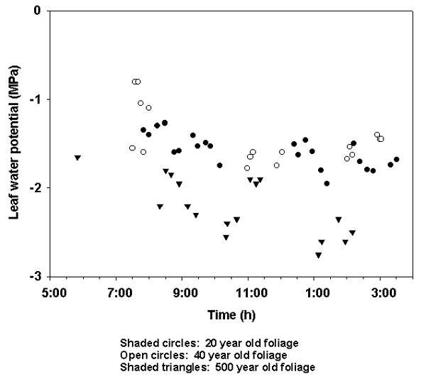
Figure 4. Leaf water potential: 20, 40 and 500 year old Pseudotsuga menziesii Wind River, WA. July 15-22, 1999.
- Photosynthesis and Stomatal Conductance.
Our hypothesis predicts that older trees should have lower average photosynthesis and stomatal conductance compared with young trees, and that the differences should become more pronounced with increasing vapor pressure deficit and decreased soil moisture availability. Through the summer of 1998 we conducted numerous measurements of leaf gas exchange to test the hypothesis. However, leaf morphology is quite different for the different age classes of trees (even for the same age class of foliage), and by the end of the season we suspected that we had made systematic errors in measuring the leaf area in the cuvettes of the gas analyzer, leading to potential errors in our estimation of gas exchange per unit leaf area. So we conducted a new series of measurements in 1999 using a different technique that minimizes the error in estimating leaf area. So far we have only been able to compile data for August, 1999 (Figs. 5 and 6). During this week, stomatal conductance and photosynthesis were higher for the youngest trees than for either of the other two age classes. This is surprising in several respects. First, the results from our sap flow analysis (above) indicated very little difference in the transpiration rates of trees at the 20-year-old site and the old-growth site. Second, the pre-dawn water potential data in Table 2 show higher moisture availability for the 40-year-old stand than either of the other two sites.
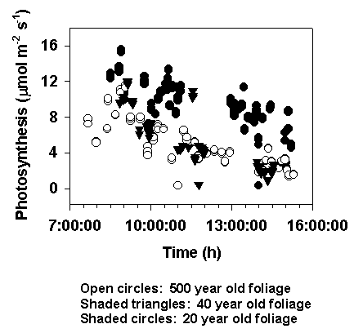
Figure 5. Photosynthesis: 20, 40 and 500 year old Pseudotsuga menziesii Wind River, WA. August 17-22, 1999.

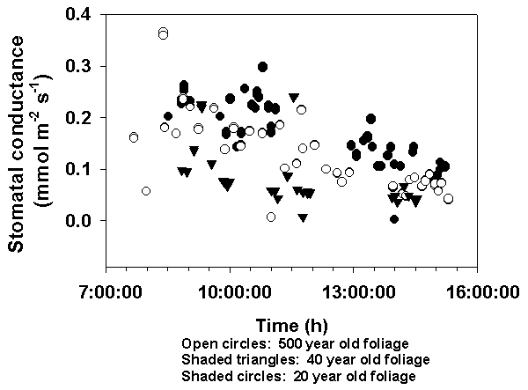
Figure 6. Stomatal conductance: 20, 40 and 500 year old Pseudotsuga menziesii Wind River, WA. August 17-22, 1999.

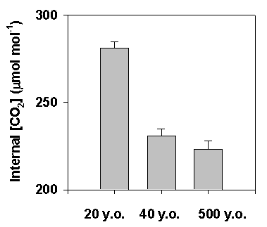
Figure 7. Leaf Internal [CO₂]. Pseudotsuga menziesii Wind River, WA. 1999.
The sites also differed in their instantaneous water use efficiency, as indicated by the average concentration of CO₂ in the leaf mesophyll (or "Ci") during the gas exchange measurements of Aug. 17-22 (Fig 7). Again, the results for the 20-year-old stand were distinct from the other two sites. The high internal [CO₂] for the youngest stand is indicative of comparatively low water use efficiency, which may help explain the lower water availability in mid-summer at this site.
- Foliar Nitrogen content.
Samples have not yet been analyzed.
- Foliar δ¹³C.
Our hypothesis predicts that the oldest trees should be enriched in ¹³C compared with the other sites (i.e., the δ¹³C value should increase with age and size of trees); the C_{i} data in Fig. 7 also suggest this. So far we have analyzed only a limited number of foliar samples for isotope content. These results showed a higher mean value for the old growth trees compared with both younger sites; however, the differences were not significant statistically. We will analyze more samples in the coming months.

Products:
- Extensive data sets that are currently in analysis (including gas exchange, sap flow, soil moisture and microclimate measurements at three sites at Wind River
- Construction of a 115' tower and a 50' tower at Wind River, WA; used for our research and also shared with other WESTGEC scientists
- Five presentations (see below)
- Initiation of Web site to share products from this research, http://www.fsl.orst.edu/oldtree/windriv.htm
- In addition to these direct outputs, a newspaper article ("Higher Learning: Cranes carry scientists to new views of life in the tops of old growth" The Eugene Register Guard, Sept. 1998) and a television program (Real Science! # 506, "Forest Through the Trees", 1999, Produced by the Public Broadcasting Service, San Jose, California) have been produced based on work for this project.
Papers/Presentations:
Phillips, Nathan G., B.J. Bond, N.G. McDowell, E.J. Watrud and M.G. Ryan. Does increased tree hydraulic resistance in tall trees affect elaf gas exchange? Paper presented at the 84th annual meeting of the Ecological Society of America, Spokane, WA, Aug., 1999.
Watrud, Eric J., N.G. Phillips, N.G. McDowell, B.J. Bond, and M.G. Ryan. Differences in soil water drawdown during the summer of 1998 in three different age classes of Douglas-fir in the Wind River Basin. Paper presented at the 84th annual meeting of the Ecological Society of America, Spokane, WA, Aug., 1999.
McDowell, Nate G., B.J. Bond, N.G. Phillips, M.G. Ryan, R.M. Hubbard, E.J. Watrud and D. Whitehead. Tree height influences the leaf area/sapwood area ratio in gymnosperms and angiosperms. Paper presented at the 84th annual meeting of the Ecological Society of America, Spokane, WA, Aug., 1999.
Phillips, Nathan G., B.J. Bond, N.G. McDowell, and M.G. Ryan. Results from our 1998 measurements at Wind River. Paper presented at the annual open house of the Wind River Canopy Crane, Wind River, WA, June, 1999. The powerpoint file for this presentation is available at http://www.fsl.orst.edu/oldtree/windriv.htm
Phillips, N., B.J. Bond, N.G. McDowell, M.G. Ryan, J. Chen, Paw U., K.T., King, T., and Xingli. Scaling water use of 20-, 40- and 500 year old Douglas-fir trees to the stand level: comparison with eddy covariance estimates of latent heat flux. Paper to be presented at the American Geophysical Union fall meeting, San Francisco, CA., 1999.

