


WEB BASED FIXED ASSET MANAGEMENT SYSTEM
FOR
SUNVISION COMPUTER SYSTEMS (PVT) LTD.

By.
M.M. Chaminda Keerthi Bandara
BIT Registration No: R012406
BIT Index No: 0124062

Supervisor: Mr. Ajith Gamage

July 2008

This dissertation is submitted in partial fulfillment of the requirement
of the Degree of Bachelor of Information Technology (External)
of the
University of Colombo School of Computing
DECLARATION

I certify that this dissertation does not incorporate, without acknowledgement, any material previously submitted for a Degree or Diploma in any University and to the best of my knowledge and belief, it does not contain any material previously published or written by another person or myself except where due reference is made in the text. I also hereby give consent for my dissertation, if accepted, to be made available for photocopying and for inter – library loans, and for the title and summary to be made available to outside organizations.

Signature of Candidate

………………………………. Date: …………………….
M.M.C.K Bandara

Signature of Supervisor

………………………………. Date: ……………………. Mr. Ajith Gamage

ABSTRACT

From small to large, any organization owns properties known as fixed assets. Fixed assets are long-term physical properties that an organization holds and uses in the production of its income.

The goal of this dissertation is to describe a computerization project accomplished for develop and implement a fully web based fixed asset management system. Upcoming sections mainly explain the advantages of the system, the process followed throughout the project development and implementation, difficulties found and the solutions provided to overcome them.

From the technical perspective, how to utilize open source technologies in enterprise application development and reduce the cost while successfully achieving business goals are explained.

In addition, it elaborates how the knowledge obtained throughout the BIT degree programme is applied in a real world application, while adopting new findings and methodologies in IT such as Web 2.0 technologies and Aspect Oriented Programming.

Finally, an evaluation is provided against the initial project goals and objectives while providing necessary guidelines for further improvements to this project.
ACKNOWLEDGEMENTS

I would like to express my greatest appreciation to my project supervisor Mr. Ajith Gamage for guiding me, to achieve the project goals within the deadline.

Proprietor of Sunvisions Computer Systems Mr. Suraj Rajapakshe and the staff deserves my thanks, for their continuous help throughout the project development.

Finally, I would like to offer my deep gratitude to my parents and elder brother for their constant insistence that I could accomplish anything that I setout to do.
TABLE OF CONTENTS

DECLARATION i
ABSTRACT ii
ACKNOWLEDGEMENTS iii
TABLE OF CONTENTS iv
LIST OF ACRONYMS viii
LIST OF FIGURES ix
LIST OF TABLES x
CHAPTER 1 - INTRODUCTION 1
1.1 PROJECT OVERVIEW 1
1.2 GENERAL INTRODUCTION 1
1.2.1 Introduction 1
1.2.2 Need For a Fixed Asset Management System 2
1.2.3 Subject Area Concerned 2
1.3 PROJECT SPECIFICATION 2
1.3.1 Fixed Asset Management System Goal 3
1.3.2 Objectives 3
1.4 USER AND SYSTEM REQUIREMENTS 4
1.4.1 System Requirements 4
1.4.2 User Requirements 4
1.5 SUMMARY OF FINDINGS 4
1.6 STRUCTURE OF THE DISSERTATION 5
CHAPTER 2 – BACKGROUND 6
2.1 TERMINOLOGY 6
2.1.1 Enterprise Resource Planning (ERP) 6
2.1.2 Fixed Assets and Asset Management 6
2.1.3 Depreciation 7
2.1.4 Rational Unified Process (RUP) 7
2.1.5 Aspect Oriented Programming (AOP). 8
2.1.6 MVC Design Pattern 9
2.2 TOOLS AND SIMULATORS 9
2.2.1 Spring Framework and Spring MVC 9
2.2.2 Hibernate 10
2.2.3 Ajax 11
2.2.4 Yahoo User Interface Library (YUI) 11
2.2.5 OpenQA : Selenium Test Tools 11
2.3 SUBJECT AREA OF THE SYSTEM 12
2.3.1 Depreciation Computational Techniques 12
2.3.2 Straight-line depreciation 12
2.3.3 Declining-balance/Reducing balance depreciation 13
2.3.4 Sum of years digits depreciation 13
2.4 SIMILAR SYSTEMS 14
2.4.1 Fixed Asset Pro 2006 14
2.4.2 AssetManage 2007 14
2.4.3 SAP AG’s mySAP 14
2.5 SUMMERY 14
CHAPTER 3 - ANALYSIS AND DESIGN 15
3.1 INTRODUCTION 15
3.1.1 Vision 15
3.1.2 Risk List 15
3.1.3 Use-Case Model (Actors, Use Cases) 15
3.2 CLIENT REQUIREMENT GATHERING AND ANALYZING 16
3.2.1 Regular Interviewing sessions. 16
3.2.2 Prototyping. 16
3.3 VISION DOCUMENT 16
3.3.1 Introduction 17
3.3.2 Positioning 17
3.3.3 Stakeholder And User Descriptions 18
3.3.4 User Environment 19
3.3.5 Summary of Key Stakeholder or User Needs (Non-Functional Requirements) 20
3.3.6 Product Overview 20
3.3.7 Assumptions and Dependencies 20
3.3.8 Functional requirements / Product Features 21
3.3.9 Prerequisites / Other Product Requirements 23
3.4 USE CASE DIAGRAM 24
3.5 DESIGN MODEL AND USE CASE REALIZATION. 27
3.5.1 Use Case Specification (UCS) 27
3.5.2 Sequence Diagram (SQD) 27
3.5.3 Collaboration Diagram (COD) 27
3.5.4 Activity Diagram (ACD) 27
3.6 DATA MODEL 31
3.6.1 Class Diagram 31
3.6.2 Database Design 34
CHAPTER 4 – USER INTERFACES 36
4.1 INTRODUCTION 36
4.2 USER INTERFACE DESIGN PATTERNS 36
4.3 SELECTED SCREENS 37
4.3.1 System Log In 37
4.3.2 A General Information Entry Screen 37
4.3.3 Using Information Browser 38
4.3.4 Using Calendar Control 38
4.3.5 Report Generating Screen - Assets Listing by Category 39
4.3.6 PDF Report Display through the Web Browser 39
4.3.7 Getting Report in Microsoft Excel Format 40
CHAPTER 5 - IMPLEMENTATION 41
5.1 CODE AND MODULE STRUCTURE 41
5.1.1 Structure of the Project 41
5.2 IMPLEMENTATION ENVIRONMENT 42
5.2.1 Hardware Configurations 43
5.2.2 Software Configurations 43
5.3 DEVELOPMENT TOOLS AND SELECTED CODE MODULES 43
5.3.1 NetBeans Integrated Development Environment (IDE) 43
5.3.2 Selected Code 43
5.4 Platform Independency 47
CHAPTER 6 - TESTING 48
6.1 INTRODUCTION 48
6.1.1 Content Testing 48
6.1.2 Interface Testing 48
6.1.3 Navigation Testing 48
6.1.4 Component Testing 48
6.1.5 Configuration Testing 49
6.1.6 Security Testing 49
6.1.7 Performance Testing 49
6.2 TESTING TOOLS AND SIMULATORS 49
6.2.1 Apache JMeter 49
6.2.2 OpenQA : Selenium Test Tool 49
6.3 TESTING EMPLOYEE REGISTRY 50
6.3.1 Unit Testing 50
6.3.2 Black Box Testing 53
6.3.3 Performance Testing 56
6.4 ACCEPTANCE TESTING 56
CHAPTER 7 - EVALUATION 57
7.1 APPRAISAL 57
7.2 FURTHER EXPANDABILITY OF THE SYSTEM 57
CHAPTER 8 - CONCLUSIONS 59
8.1 PROJECT ASSESSMENT 59
8.2 FURTHER IMPROVEMENTS 59
8.3 CONCLUSION 60
REFERENCES 61
APPENDIX A – DESIGN DOCUMENTATION 62
APPENDIX B – SYSTEM DOCUMENTATION 66
APPENDIX C – USER DOCUMENTATION 70
APPENDIX D – MANAGEMENT REPORTS 75
APPENDIX E – CODE LISTING 76
APPENDIX F – CLIENT CERTIFICATE 82
APPENDIX F – GLOSSARY AND INDEX 84

LIST OF ACRONYMS

AJAX - Asynchronous JavaScript and XML

AOP - Aspect Oriented Programming

EJB - Enterprise Java Beans

ERP - Enterprise Resource Planning

MVC - Model – View – Controller

ORM - Object – Relational Mapping

ROI - Return on Invest

LIST OF FIGURES

Figure 2.1 – Rational Unified Process Overview ……………………………… 8
Figure 2.2 – The Spring Framework Architecture …………………………….. 10
Figure 3.1 – Deployment Architecture ……………………………………….... 20
Figure 3.2 – Use Case Diagram ………………………………………………... 25
Figure 3.3 – Use Case Specification for Asset Registry ………………………. 28
Figure 3.4 (A) – Sequence Diagram for the Use Case Asset Registry ……….... 29
Figure 3.4 (B) – Collaboration Diagram for the Use Case Asset Registry ……. 29
Figure 3.5 – Activity Diagram for the Use Case Asset Registry ………………. 30
Figure 3.6 – Class Diagram ……………………………………………………. 32
Figure 4.1 – System Log In …………………………………………………….. 37
Figure 4.2 – A General Information Entry Screen ……………………………... 37
Figure 4.3 – Using Information Browser to fill a text field …………………..... 38
Figure 4.4 – Using Calendar Control ………………………………………….. 38
Figure 4.5 – Report Generating Screen – Assets Listing by Category ……….... 39
Figure 4.6 – PDF Report Display through the Web Browser ………………….. 39
Figure 4.7 – Downloading report in Microsoft Excel Format ………………….. 40
Figure 4.8 – Report after opened with OpenOffice.org Calc/Microsoft Excel … 40
Figure 5.1 – Code and Module Structure ………………………………………. 41
Figure 6.1 – Executing Unit Test with NetBeans IDE …………………………. 53
Figure 6.2 – Execution of Selenium Test Case ………………………………… 55
Figure 6.3 – JMeter Performance Test Result ………………………………….. 56
LIST OF TABLES

Table 3.1 – Summery of Stakeholders …………………………………………… 18
Table 3.2 – Summery of Users …………………………………………………… 19
Table 3.3 – Non Functional Requirements ………………………………………. 20
Table 3.4 – Object to Table Mapping ……………………………………………. 35
Table 4.1 – UI Design Patterns …………………………………………………... 36
Table 5.1 – Contents of the System Modules ……………………………………. 42
Table 6.1 – Applying Unit Testing ………………………………………………. 43
Table 6.2 – Selenium Test Case for White Box Testing ………………………… 55

CHAPTER 1 - INTRODUCTION
  - PROJECT OVERVIEW
The proposed system is a full featured fixed asset management system that has been specially designed to assist a small – medium size company to account for and manage their fixed assets.
The system is fully web based and therefore operable via the company intranet or internet. Development and implementation of the project is completely based on open source technologies.
The project scope covers maintaining organizational fixed asset related information, handling asset related transactions such as asset allocation, depreciation calculations and reporting for managerial purposes.
  - GENERAL INTRODUCTION
    - Introduction
First, it is necessary to understand the term Fixed Asset to grasp the purpose of the system. According to the investment dictionary [WWW3] a fixed asset is a long-term tangible piece of property that a firm owns and uses in the production of its income and is not expected to be consumed or converted into cash any sooner than at least one year's time.
Effectively managing the organizations’ non-inventory, fixed assets is the main goal of this project. Summery of the implementation objectives could be identified as
- Minimizing the wastage by tracking all the assets, their status, asset movements.
- Taking necessary controlling actions such as reallocating fixed assets location wise and custodian wise.
- Give asset custodians the ability of reporting, complaining about assets and making new requests.
- Reporting for managerial purposes.

    - Need For a Fixed Asset Management System
Need for such a system is aroused by the client organization, due to the several difficulties it have been facing.
The client organization operating in a rural area derives its income from students who make use of its IT educational services. Nature of the organization’s operational areas always forces them to keep the charges on students to a minimum level. As a result, client organization should keep their operational cost considerably low.
The proposed system assists them to consume their fixed assets systematically and it reduces the wastage to a great extend. For effective decision-making, the proposed system provides the necessary management information concerning the behavior of the fixed assets.
Because of the web-based nature of the system, users do not need computers with higher level of hardware configurations, instead, any machine, which could accommodate a web browser, can be used.
On the other hand, system is completely based on free and open source software. Therefore, it cuts down the cost on the system software for product implementation, such as operating system, RDBMS, etc.
Finally, by considering the above facts, it is clear that the system directly and indirectly helps to saturate the client’s main necessity (i.e. operational cost reduction).

    - Subject Area Concerned
Fixed Asset Management comes under the Financials sub sector of large well-known subject area called Enterprise Resource Planning (ERP) [WWW2]. Fixed asset management is essential for any organization to eliminate the difficulties they have been facing while performing tasks such as tracking and maintaining fixed assets. Moreover, it has a considerable influence on the organization’s accounting process.
  - PROJECT SPECIFICATION
Each organization has properties, which are used in long-term business operations. These properties are known as fixed assets and they hold a large amount of the investment. All business operations are depending on fixed assets and inefficient asset management may cause asset losses, difficulties in business operations and finally affect the organization’s ROI badly.
The project client, Sunvision Computer Systems is a medium size organization that provides IT related educational services. They are expanding their operations currently in Sabaragamuwa province and because of the limited resources and funds, they need effective mechanism to manage their investments on the fixed assets. Project goal could be summarized as follows.

    - Fixed Asset Management System Goal
The goal of this project is to develop a full-featured web based fixed asset management system, to assist small to medium size companies to account for and manage their fixed assets.

    - Objectives
The system is organized according to the popular management flow namely planning, execution, monitoring and controlling. Therefore, system objectives are grouped along with them as follows.
- Planning
  - Maintaining general organizational information repository with data such as employee details, organization structure etc.
  - Capture all the fixed asset related information and maintain them centralized in a well-organized manner.
- Execution
  - Tracking asset related transactions such as asset acquisitions, disposals, complaints from asset custodians etc.
  - Handling asset allocations person wise and location wise.
- Monitoring
  - Mainly provide managerial reports including asset status reports under several categories like category wise, owner wise etc. and assets depreciation reports.
- Controlling
  - Handle controlling actions like change asset custodian, location etc.
  - Manage asset maintenance and disposals transactions.

  - USER AND SYSTEM REQUIREMENTS
    - System Requirements

- To keep the project implementation and maintenance cost in minimal, it should be completely based on Free and Open Source Software (FOSS).
- All the reports are generated in PDF. The objective here is platform independency and easiness in printing.
- System should be expandable to reflect the expansions in business like adding new branches etc.
- Provides complete control over the fixed assets and eliminates the time normally associate with this task.
    - User Requirements

- The system should provide end-users with intuitive interface, ease of use and minimum learning curve.
- System should be completely web/browser based. Accessing system from any location without concerning the underlying hardware/software is the key objective here and the preferred browser is Mozilla Firefox.

  - SUMMARY OF FINDINGS
Main findings of the project could be categorized in technical, theoretical and business perspectives. Under technical point of view, applying new Web 2.0 technologies such as AJAX along with the open source technologies like Spring Framework is the key achievement.
Theoretical knowledge gathered throughout the BIT program has been applied in the project development. Tree traversal algorithms from the module Data Structures and Algorithms and Object to Relational Mapping (ORM) from DBMS/ADBMS modules are directly applied and they are described in Chapter 2.
From the business knowledge perspective Fixed Asset Management and knowledge related to ERP is unveiled within the project boundary.

  - STRUCTURE OF THE DISSERTATION
Contents of the upcoming chapters could be identified as follows.

- CHAPTER 2: BACKGROUND
  - Provides all the technical background and findings, which will be useful in understanding the system.
- CHAPTER 3: ANALYSIS AND DESIGN
  - Illustrate the system analyzing techniques followed and give detailed specification with Vision Document and Use Case Diagrams. Also includes Use Case Design, Data Modeling and design practices, which are related to system design.
- CHAPTER 4: USER INTERFACES
  - Present the User Interface design requirements and techniques followed with web interface development.
- CHAPTER 5: IMPLEMENTATION
  - Discuss about the implementation environment, describes reusable code modules and development tools used etc.
- CHAPTER 6: TESTING
  - Describes the testing strategy followed during the development process and provide necessary evidences such as test cases/results, performance test results with simulations etc.
- CHAPTER 7: EVALUATION
  - Discusses on how the system was evaluated.
- CHAPTER 8: CONCLUSION
  - Presents conclusions, future work and summary of what was achieved during the project.
- REFERENCES
- Appendices
  - Appendices cover Design Documentation, System Documentation, User Documentation, Management Reports, Code Listing and Client Certificate respectively.
CHAPTER 2 – BACKGROUND

Objective of this chapter is to provide the background information, which is necessary to understand the remaining dissertation text. At the end, it explains the systems that provide similar functionalities and distinct advantageous of the proposed system over them.
  - TERMINOLOGY
    - Enterprise Resource Planning (ERP)
Enterprise Resource Planning systems (ERPs) [WWW2] integrate (or attempt to integrate) all data and processes of an organization into a unified system. Usually an ERP system uses various computer software and hardware components to realize this integration.
Regardless of the organization's nature, ERP system covers most of the basic functions of an organization. Different organizations such as business organizations, non-profit organizations, and nongovernmental/governmental organizations utilize ERP systems in different extents.
Typically, a total ERP solution is a large system, which is built on individual application modules namely Financials, Manufacturing, Supply Chain, Customer Relationship Management (CRM), Human Resources, Warehouse Management and Decision Support systems. However, an ERP system may contain at least one or more modules from above, according to the organizational need.
Proposed solution, Fixed Asset Management System comes as a sub module, under the parent ERP module financials.

    - Fixed Assets and Asset Management
Fixed Assets
Fixed asset, [WWW2] (also known as Property, Plant and Equipment [PP&E]) is a term used in accountancy for assets and property, which cannot easily be converted into cash. In most cases, only tangible assets are referred to as fixed assets.
Some examples for fixed assets could be identified as office equipments, computers, furniture and motor vehicles.

Fixed Asset Management
Fixed assets management [WWW2] is an accounting process that seeks to track fixed assets for the purposes of financial accounting, preventive maintenance, and theft deterrence.
Regardless of the size of an organization, tracking assets is very important to every company. Company might lose the control of its fixed assets easily, if there is no proper method to keep track of them.
Tracking fixed assets in location, quantity, condition, maintenance and depreciation status wise, is a changeable task for all organizations. Need for a fixed asset management system is aroused with this challenge.
Asset management software allows the organization to track what assets it owns, where each is located, who has it, when it is scheduled for maintenance, and the cost and depreciation of each asset.
To be a successful fixed asset management solution, reporting is essential. Some common managerial reports include assets by category and location, depreciation reports etc.

    - Depreciation
Depreciation [WWW4] is a non-cash expense that reduces the value of an asset, as a result of wear and tear, age, or obsolescence.
In most cases, value of a fixed asset drops over time (or depreciate), and need to be replaced at the end of the useful life. Depreciation calculation could be done using several accounting formulae and they are explained later in this chapter. From organization’s accounting perspective, depreciation is a non-cash expense. Therefore, it lowers the company's reported earnings while increasing free cash flow.
Handling asset depreciation is a key functionality, which is expected from a fixed asset management system.

    - Rational Unified Process (RUP)
Rational Unified Process is a “use case driven, architecture centric, iterative and incremental” [Pressman, 2005] software process.
During the RUP, several phases (i.e. Inception, Elaboration, Transition and Construction) are passed to complete a development iteration.
The following diagram provides an overview of the RUP with its phases and related tasks performed during a phase.
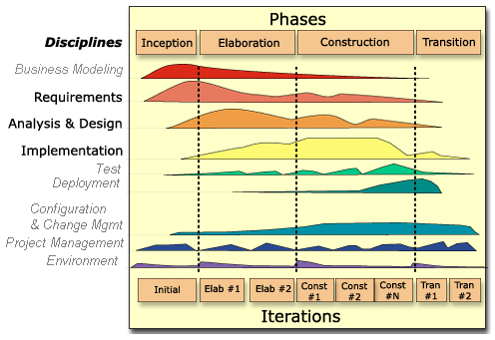

Figure 2.1 – Rational Unified Process Overview

    - Aspect Oriented Programming (AOP).
Aspect Oriented Programming (AOP) [Walls, 2008] is often defined as programming technique that promotes separation of concerns within a software system. Generally, software components are designed to perform some specific functionality by each, which are integrated together to buildup the main system. However, system services such as logging, transaction management and security often interfere these components. Therefore, software components have to carry out additional responsibilities beyond their core functionality. This has several disadvantages.
- System services are duplicated across multiple components.
- Software components have to focus on some tasks other than its main purpose.
AOP is designed to address these issues. Anyway, AOP is not a replacement for OOP or any other programming technique; instead, it is an enhancement for them.
The software framework Spring, which is used to build the proposed system, comes with rich support for AOP. That makes system modules highly cohesive by separating application business logic from system services.

    - MVC Design Pattern
Model-View-Controller (MVC) is a widely used software design pattern in system development. It separates whole software system into three main areas as explained below.
- Model – The Model represents the system’s persistence data and the business rules that manage access to and updates of this data.
- View – The View mainly represent the user interfaces. View does not have direct access to the Model; instead, it should always go through a controller when retrieving data. This clearly separates the business logic from user interface.
- Controller – The Controller defines the way the user interface reacts to the user’s input. The Controller is the object that manipulates the model. In web applications, which are based on MVC, all web requests are first passed to a controller. Then controller takes the necessary actions to manipulate the Model and display the View accordingly.
The major benefit of using the MVC design pattern is that it clearly modularizes the application into loosely coupled layers. This makes it possible to develop highly maintainable code. For example, change on a View component does not affect the Model and wise versa.
The proposed system is based on MVC and it utilizes the web-application development framework Spring MVC, which is explained in next section.
  - TOOLS AND SIMULATORS
    - Spring Framework and Spring MVC
The proposed system utilizes Spring and one of its components Spring MVC, as its main development framework.

Spring Framework
Spring is an open source, full-stack Java/Java EE application framework. Spring provides most of the features offered by other heavyweight application frameworks such as EJB, without much overhead. Some advantageous of using Spring in application development can be identified as follows [Walls, 2008].
- Spring is a lightweight framework. Even with simple application server like Apache Tomcat, it is possible to get use of enterprise level services with Spring. On the other hand, applications developed using Spring, have no dependencies on built in Spring classes in most cases.
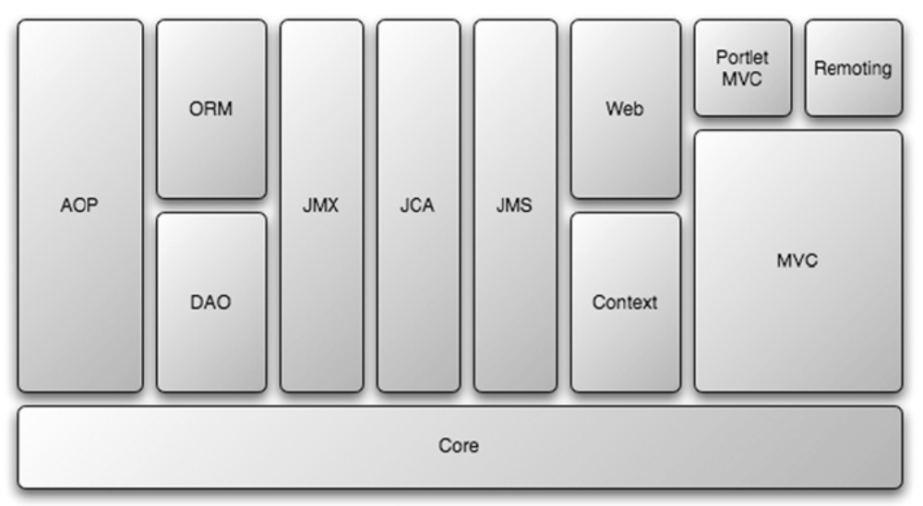
- Dependency Injection is one of the main features that Spring provides. Application objects are given their dependencies automatically by the framework; therefore, it is easy to develop highly cohesive and loosely coupled application objects. Because of that, software testing is much easier in Spring based applications than with others.
Figure 2.2 – The Spring Framework Architecture

As illustrated in above diagram, Spring framework contains large set of modules, which are useful in enterprise application development. However, not like some other Java EE frameworks, when using Spring, it is possible to use and deploy only the related modules to particular system.

Spring MVC
Spring MVC is a web-application development platform for Spring framework. It is based on MVC design pattern and it allows utilizing features provided by other Spring modules effortlessly.

    - Hibernate
Generally, in object-oriented system development, persistence data represent as object-oriented domain model. Usually this domain model is a set of classes/objects developed using particular development language of the system. In the proposed system, these are Plain Old Java Objects (POJOs). However, to store data it is essential to use traditional RDBMS when considering facts such as performance, security etc.
Hibernate [WWW6] is a powerful, high performance object/relational persistence and query service. It avoids the manual conversion between object-oriented domain to RDBMS while preserving most of the object-oriented concepts such as association, inheritance, polymorphism, composition, and collections.
The proposed system use Hibernate as its Object – Relational Mapping (ORM) service, along with the Spring framework.

    - Ajax
The acronym Ajax/AJAX is standing for Asynchronous JavaScript and XML. The advantage of using Ajax is, it gives web applications the ability of communicating between client and server, without reloading the whole page content like in classic web sites.
At client side or browser, JavaScript is used as programming language with built-in browser object XMLHttpRequest to communicate with the server. In most cases data transferred as XML contents. The server side technology does not influence the basic functionality of the Ajax.
There are some Ajax libraries are available freely, which can be used to perform common Ajax tasks. Prototype is such a library, which was selected to use with this project.

    - Yahoo User Interface Library (YUI)
The Yahoo User Interface (YUI) Library is a collection of commonly used GUI widgets for web applications, which is freely distributed under BSD license. YUI is completely written in JavaScript; therefore, it is platform independent.
Calendar, Tree Menu GUI widgets are some examples for available components in YUI library.

    - OpenQA : Selenium Test Tools
OpenQA.org provides a set of web application testing tools called Selenium. Selenium has two main components, namely Selenium Core and Selenium IDE. With Selenium, it is possible to automate the application testing process completely. Selenium is specifically designed to fulfill acceptance-testing requirements. Using Selenium IDE it is possible to record the test cases, flow of events for a particular user interface. These recorded test cases can be used with Selenium Core to automate the black box testing process.
Special advantage of using this tool is, it is completely free and open source. More details about using this product in software testing are explained in Chapter 6 Testing.
  - SUBJECT AREA OF THE SYSTEM
    - Depreciation Computational Techniques
The term Depreciation is described above. There are several standard methods available for depreciation calculation. Selecting a suitable depreciation method for the particular asset category is based on the organizational needs.
Some popular Depreciation Computational Techniques can be identified as follows. How these techniques were incorporated into the system is explained in Chapter 3 – Analysis and Design.

    - Straight-line depreciation
Straight-line depreciation is the most frequently used and straightforward technique that use to calculate asset depreciation. The salvage value is the estimated value of an asset at the end of its useful lifetime. This value even may be zero.
Depreciation charge could be explained as the cost of the asset divided by number of years of its useful life.
An equation could be derived as follows.
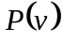 – Purchase price of asset
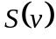 – Approximate salvage value
– Estimated useful life of asset
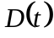 – Depreciation charge for year (t)

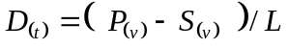

    - Declining-balance/Reducing balance depreciation
Declining-balance or reducing-balance method is an accelerated depreciation process. In this method, the value of the asset is depreciated rapidly at the early stages of its useful life.
Each period's depreciation is calculated based on the previous year's net book value, the estimated useful life and a factor. The commonly used value for the factor is 2 and in that case this method is known as double declining-balance method. Salvage value is not considered in declining-balance method.
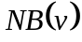 – Net Book Value
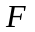– Factor - 2 for double declining balance
– Estimated useful life of asset (in years)
– Depreciation charge for year (t)

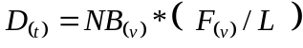
Since declining-balance depreciation does not always depreciate an asset fully by its end of life, some methods also compute a straight-line depreciation each year, and apply the greater of the two.

    - Sum of years digits depreciation
Sum of Years Digits depreciation method results in a more accelerated write-off than straight line, but less than declining balance. It is a historical depreciation method and salvage value is counted in the method.

– Estimated useful life of asset (in years)
 – Cost basis
– Approximate salvage value
– the year at
– Depreciation charge for year (t)
If 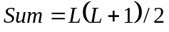then depreciation charge can be found as
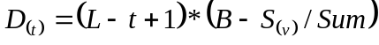
  - SIMILAR SYSTEMS
    - Fixed Asset Pro 2006
Fixed Asset Pro 2006 is a window-based asset management system, which is developed by Softdomain Systems, Malaysia. It is a straightforward application that provides most common asset management functionalities.

    - AssetManage 2007
Liberty Street Software, which is a Canadian company, provides an asset management solution called AssetManage. This is again standalone window-based application that targets mainly asset related accounting transactions.

    - SAP AG’s mySAP
SAP AG (Germany), the largest European software enterprise, provides an integrated enterprise resource planning solution called SAP ERP (mySAP) that targets business software requirements of midsize-large organizations in all industries and sectors.
mySAP’s core module Financial Accounting (FI), contains sub component namely Asset Accounting (FI-AA), which handles all the fixed asset related transactions including accounting information.

  - SUMMERY
By referring above sections, it is possible to identify some other available products that deliver similar functionalities. Even though, the proposed solution has some distinct advantages over the other systems.
Most of the available solutions for small-medium size organizations are window-based software packages and therefore, even system clients have to install software at the client side. The solutions that provide web-based interfaces such as mySAP are very expensive. Hence, their usage in small organizations is limited.
The goal of the proposed solution is addressing above issues while providing core functionalities of a fixed asset management system.

CHAPTER 3 - ANALYSIS AND DESIGN
  - INTRODUCTION
Requirement Gathering and Analysis is the first step in every standard Software Development Life Cycle (SLDC). However, this is handled in a specific way, according to the particular SLDC. The primary goal of this phase includes [Pressman, 2005; WWW2], clearly understand the user requirements and problem domain, achieve concurrence among all stakeholders, identifying business and requirements risks and defining the project scope.
The selected software engineering process for the proposed project is Rational Unified Process (RUP). RUP equivalence of this phase is known as the Inception phase. According RUP configuration guidelines some tasks related to other phases may overlap in this phase [Figure 2.1], but much effort lay on requirement gathering and analysis. For example, tasks related to design and implementation may perform infrequently.
Following artifacts should be produced at the completion of this process milestone.

    - Vision
Purpose of the Vision is to describe the stakeholders’ view of the product, specified in terms of the stakeholders’ key needs and features. It contains an outline of the envisioned core requirements and provides the contractual basis for the more detailed technical requirements. As the result, Vision Document is produced.

    - Risk List
Risk list describes the known and open risks to the project, sorted in decreasing order of importance and associated with specific mitigation or contingency actions.

    - Use-Case Model (Actors, Use Cases)
The use-case model describes system's intended functions and its environment. It serves as a contract between the customer and the developers.
  - CLIENT REQUIREMENT GATHERING AND ANALYZING
Requirement gathering was performed by using several techniques. The main approaches that applied were
    - Regular interviewing sessions
    - Prototyping

    - Regular Interviewing sessions.
Interviewing sessions conducted with the financial and administration division staff of the Sunvisions Computer Systems to identify the major requirements and business process.

    - Prototyping.
Prototyping approach applied while gathering the user requirements to clarify the client’s requirements and to fine-tune the final product to the user expectation.

  - VISION DOCUMENT
After capturing the client’s requirements, they were documented in Vision Document. The next attached document extracted from the official guideline for Rational Unified Process.
Vision Document

    - Introduction
The purpose of this document is to collect, analyze, and define high-level needs and features of the Web Based Fixed Asset Management System (hereafter refer as the System). It focuses on the capabilities needed by the stakeholders and target users, and why these needs exist. The particulars of how the proposed system fulfills these needs are explained in detail using use-case and supplementary specifications.

    - Positioning
Problem Statement
The problems with existing Fixed Asset Management Systems could be identified as follows.
- Most of the available systems are window based.
  - These systems should be installed on client computers, so applying software modifications and updates is relatively difficult.
  - Special hardware/software configurations might require on each client machine to meet the system’s minimum installation requirements.
- Most popular solutions currently available are commercial and proprietary products.
  - Most popular systems like SAP/R3, IFS systems are commercial products and designed to meet large enterprise requirements. Therefore, their usability in small – medium organizations is limited.
  - There are products that could be used in small scale; but most of them are window based. As a result, they are difficult to customize according to the client requirements.
- Scalability.
  - Low cost applications available for small-scale organization are not scalable in most cases. Enterprise class applications needs complex, high cost network configurations like VPNs etc.

To overcome above difficulties, the proposed system development is based on following key factors.
  - System is completely web based.
  - Whole product is developed and implemented on free and open source software.
  - Tailored to meet with the client’s exact requirements.

Product Position Statement
The proposed system allows the client to consume fixed assets systematically while reducing the wastage. For effective decision-making, the proposed system provides necessary management information regarding behavior of the fixed assets.

    - Stakeholder And User Descriptions
Stakeholder Summary
This table presents a summary list of non-user stakeholders. (The users are summarized in section 3.2.)
Name | Description | Responsibilities
Network administration division of Sunvision Computer Systems | Is the system implementer | - Maintaining system and infrastructure  - Handling system security and user privileges  - Backup and recovery
Table 3.1 – Summery of Stakeholders

User Summary
Note:
The field “Stakeholder” in the following table presents which stakeholder is responsible for representing the user’s interest if the user is not directly represented
Name | Description | Responsibilities |  | Stakeholder
Managerial User | Top management of the organization is represented here. | - Making decisions based on the managerial reports | Finance and Administration division of Sunvision Computer Systems
Administrative User | Represent the Finance and Administration division members. | - Maintaining organizational master data within the system  [E.g. employee, asset details].  - Performing controlling transactions [E.g. asset allocation] based on the management decisions. | - above
Asset Owner | Person who owns or holds the responsibility of the particular asset. Any organizational member may be listed under this category. | - Update the status of the owned assets.  - Request for or complaint about assets. | - above
Table 3.2 – Summery of Users

    - User Environment
Mozilla Firefox web browser is the only user environment requirement, since the application is optimized to particular browser. No other special software or hardware configuration is required.

    - Summary of Key Stakeholder or User Needs (Non-Functional Requirements)

Need | Concerns | Current Solution | Proposed Solutions
Accessing the system from any branch. | Simplicity and low cost. | None. |  | System is web based so could be accessed from anywhere.
At any moment it should be possible to locate/monitor status of an asset. | Minimize wastage and making managerial decisions effectively. | None.
Table 3.3 – Non-Functional Requirements

    - Product Overview
Product Perspective
Deployment architecture of the system is illustrated in the following diagram.

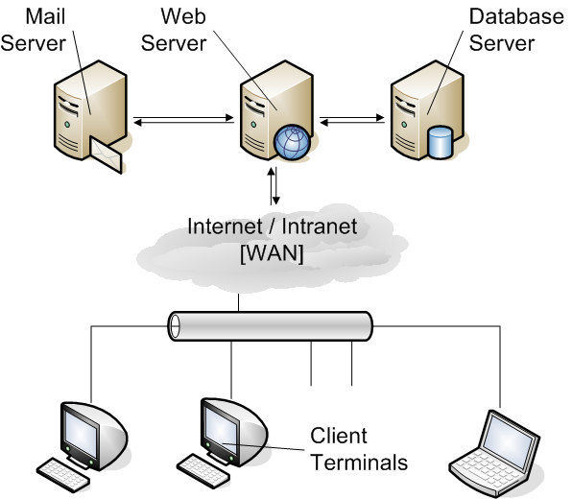

Figure 3.1 – Deployment Architecture

    - Assumptions and Dependencies
- A SMTP mail server is required to send the auto generated mails by the system.
- Finding a third party Web hosting service that support both Java and PostgreSQL 8.1 database all together may be difficult. It is recommended to implement a client’s own dedicated system for hosting.
    - Functional requirements / Product Features
The system features modularized according to the well-known management life cycle namely
      - Planning
      - Execution
      - Monitoring
      - Controlling
Master data capturing is mainly handled under Planning. The section Execution, covers mainly asset related transactions. Managerial reports are produced under Monitoring. Based on managerial reports corrective actions are carried out under Controlling.

Planning
- Employee Registry
All the necessary employee details are maintained within the system. In most cases, asset transaction directly or indirectly depends on the employee details. Because of the system could not import or utilize data from other systems like Human Resource Management, it is necessary to keep a local employee information repository.
This information mainly important while selecting asset custodians.
- Organizational Setup
Following details are captured under this section.
Company Branches
Information related to company branches is gathered under this. This feature helps to reflect the organizational growth within the system without affecting the internal structure of the system.
Company Divisions
All company divisions should be reflected within the system. They are important while maintaining employee details.
Locations
Assets are located based on the physical organizational locations. Keeping this information is essential to track asset movements.
- Asset Categories
To keep all company assets in organized manner, it is necessary to categorize them. System allows the users to define a set of asset categories and this information will be useful while searching asset items.
- Asset Suppliers
List of asset suppliers is maintained within the system. Asset acquisitions depend on this information.
Execution
- Asset Registry
All organizational fixed assets should be able to register within the system. Anyway, asset-purchasing process is not handled by the system, but purchasing information such as Purchase Order number, Date, etc. should be stored.
Asset Registry has an effect on the overall system, so all the asset related information should be captured here.
- Asset Allocation
Assets are mainly allocated in two ways.
    - Location wise
    - Custodian wise
Some assets like mobile phones can be directly assigned to a custodian. Assets like computers, white boards might be allocated to a location; in that case, it is necessary to assign a responsible person for the particular asset.
Generally, before start asset depreciation, it is necessary to allocate the particular asset either to a custodian or a location.

- Asset Complaints
Asset custodians may make complaints against the items they have been using or assigned to them.
- Asset Requests
Request for new assets can be made through the system, and then the responsible personnel will be notified via auto-generated emails.
Monitoring
- Asset Monitor
Monitoring the status of the assets is possible under three filtering conditions.
    - By Category
    - By Department
    - By Owner
- Transaction Reports
Main transaction report currently required is Depreciation Report for Year.

Controlling
- Change Custodian
Based on the management decisions, assets custodian or person who owns a particular asset may change.
- Change Location
Assets may move from one location to another and these movements should be recorded.

    - Prerequisites / Other Product Requirements
All system clients or users should have installed Mozilla Firefox 1.5 (or higher) web browser on their machines.

  - USE CASE DIAGRAM
The diagram on next page describes the identified use cases, actors and there relationships.

  - DESIGN MODEL AND USE CASE REALIZATION.
A use-case realization describes how a particular use case is realized within the design model, in terms of collaborating objects. Each Use Case in Use Case Diagram (UCD) is described using several documents.
    - Use Case Specification (UCS)
A use case specification defines a set of use-case instances, where each instance is a sequence of actions a system performs. It produces an observable result of value to a particular actor.
    - Sequence Diagram (SQD)
A sequence diagram describes a pattern of interaction among objects, arranged in a sequential order. It shows the objects participating in the interaction by their "lifelines" and the messages that they send to each other.
    - Collaboration Diagram (COD)
A collaboration diagram describes a pattern of interaction among objects. It shows the objects participating in the interaction by their links to each other and the messages that they send to each other.
    - Activity Diagram (ACD)
Activity Diagram represents the dynamics of the system. It contains activities, transitions between the activities, decision points and synchronization bars.

The use case “Asset Registration” is taken as a sample and next attached documents depicts the realization of that use case. Realization documents related to other use cases are included in Appendix A.

  - DATA MODEL
    - Class Diagram
Class Diagram (CLD) shows the static structure of the model, in particular, the things that exist such as classes, their internal structure, and their relationships to other classes.
As explained in Chapter 2, the proposed system follows the design pattern MVC. Class diagram reflect this by categorizing the identified classes into three main stereotypes.

Entity Classes
Represents the data structure that persists/stored in the system and reuse in use cases. In MVC, this group of classes is referred as the Model.

Boundary Classes
Mainly correspond to the user interfaces. Handling user performed events, displaying processed data and accepting user input is done by Boundary classes. The MVC equivalent of UML Boundary class is known as View.

Control Classes
Encapsulate application/business logic that is not related to user interface or to persistence data issues. The tasks such as updating data model, processing user inputs and providing necessary data to boundary classes are handled by Controllers. Same term Controller is used in both UML and MVC.

All the classes related to the System and their relations are illustrated in the UML Class Diagram attached next.

    - Database Design
In Data Modeling, Entity Classes are mainly considered since they represent the persistence storage. According to Rumbaugh [Rumbaugh, 2004], there are two main techniques that could be applied when mapping object Classes to Tables.
- Approach 1
  - Mapping model is to store <entity – name, key, attribute – name, value> tuples. Then, one table can store all classes, associations and generalizations for an entire object model.
- Approach 2
  - Each class is mapped into one or more tables. The objects in a class may be partitioned horizontally and/or vertically according to the design needs.

The first approach is not suitable for the proposed kind of systems since it may leads to ambiguities as well as performance issues. Therefore, second methodology was selected as the appropriate methodology for Data Modeling for the proposed system.

Object to Relational Mapping (ORM)
The manual process of object to relational mapping is explained next, by mapping entity class “Asset” into its particular data table. The system get the advantage of ORM system Hibernate (refer Chapter 2) to handles this process. Therefore, the manual tasks such as creating SQL queries are not required. In Chapter 5, tasks carried out will be explained concerning the Hibernate, with necessary code samples.

Asset Class Mapping To Table

Object Model | 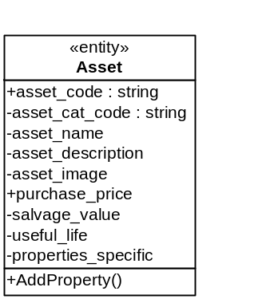
Table Model
  Attribute Name | Nulls ? | Domain
  asset_code | N | ID
  asset_cat_code | N | Category
  asset_name | Y | Name
  asset_description | N | Description
  asset_image | N | Image Path
  purchase_price | Y | Price
  salvage_value | Y | Salvage Value
  useful_life | N | Life time
Candidate Key : [asset_code]
Primary Key : [asset_code]
Frequently Accessed : [asset_code], [ asset_cat_code], [asset_name]
SQL Code | CREATE TABLE Assets  (  asset_code char(5) not null,  asset_cat_code char(20) not null,  asset_name varchar(30) not null,  asset_description char(20) not null,  asset_image char(20),  purchase_price char(20),  salvage_value varchar(25) not null,  useful_life varchar(25) not null,  CONSTRAINT assets_pkey PRIMARY KEY (asset_code)  );

Table 3.4 – Object to Table mapping.
CHAPTER 4 – USER INTERFACES
  - INTRODUCTION
In any software system, product User Interface (UI) plays a great role. Importance of the user interface becomes very high when it comes to a web application. The marketing effort of the product mainly depends on that. User friendliness and consistency should be maintained always.
  - USER INTERFACE DESIGN PATTERNS
Pressman [Pressman, 2005] extracts 10 design patterns in web user interface design. These patterns help to increase the user friendliness and to reduce the complexity of system user interfaces.

Pattern | Description
- Top – level navigation | Provides a top – level menu, often coupled with a logo or identifying graphic that enables direct navigation to any of the systems major functions.
- Card Stack | Provide the appearance of a stack of tabbed cards.
- Fill – in – the – blanks | Allow alphanumeric data to be entered in a “text box”
- Sortable Table | Displays a long list of records that can be sorted by selecting a toggle mechanism for any column label.
- Bread Crumbs | Provides a full navigation path when the user is working with a complex hierarchy of pages or display screens.
- Edit – in – place | Provides simple text editing capability for certain types of contents in the location that it is displayed.
- Simple Search | Provide the ability to search a Web site or persistent data source for a simple data item described by an alphanumeric string.
- Wizard | Takes the user through a complex task one step at a time.
- Shopping Cart | Provides a list of items selected for purchase.
- Progress Indicator | Provides an indication of progress when an operation is underway.

Table 4.1 – UI Design patterns.
Some of these patterns were applied to the system to provide rich user experience. Following selected screens depict different UI perspectives of the system.

  - SELECTED SCREENS
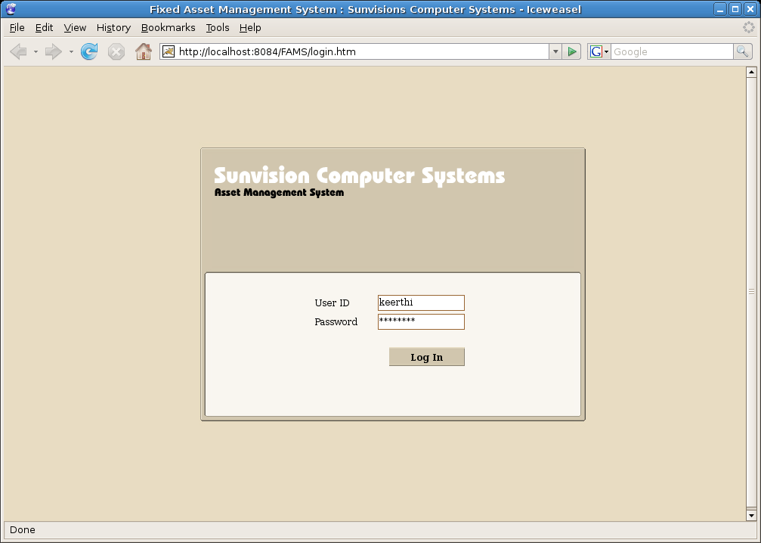
    - System Log In
Figure 4.1 – System Log In
    - A General Information Entry Screen
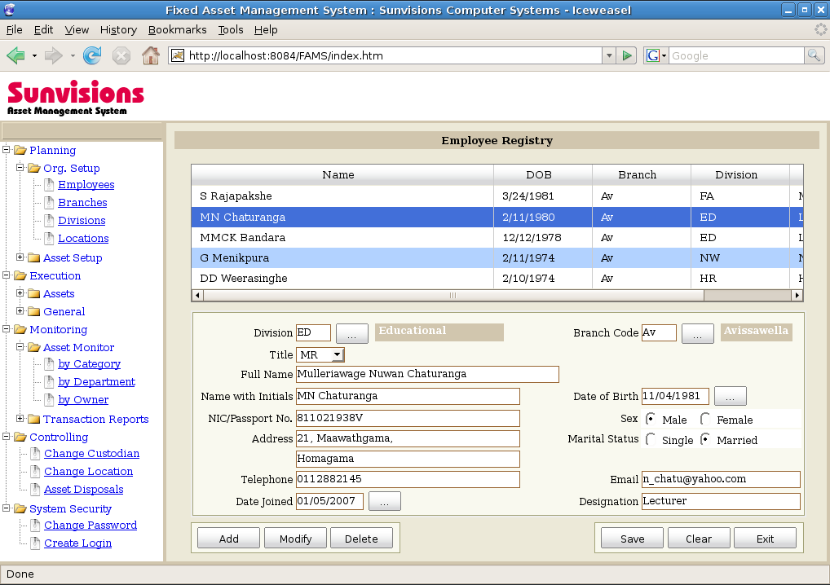

Figure 4.2 – A General Information Entry Screen
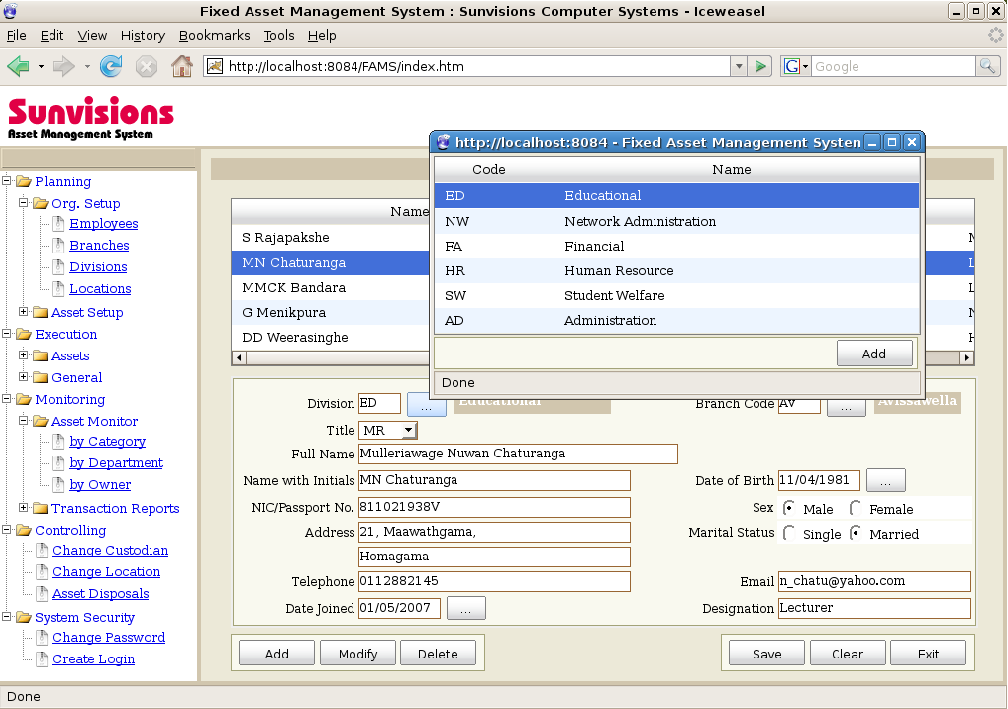
    - Using Information Browser
Figure 4.3 – Using Information Browser to fill a text field
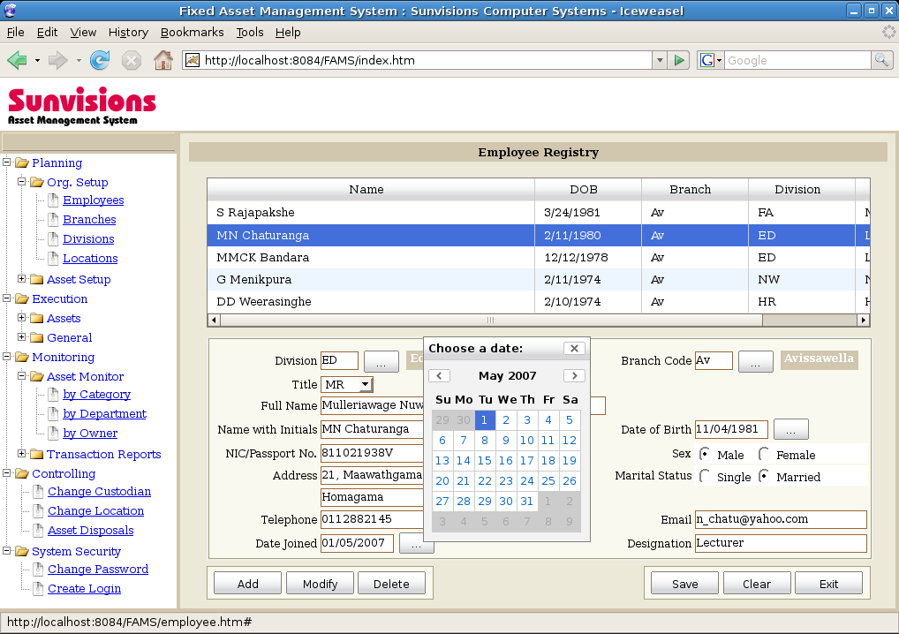
    - Using Calendar Control

Figure 4.4 – Using Calendar Control
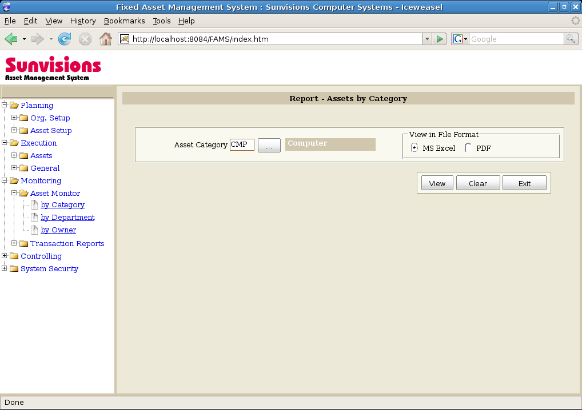
    - Report Generating Screen - Assets Listing by Category
Figure 4.5 – Report Generating Screen – Assets Listing by Category
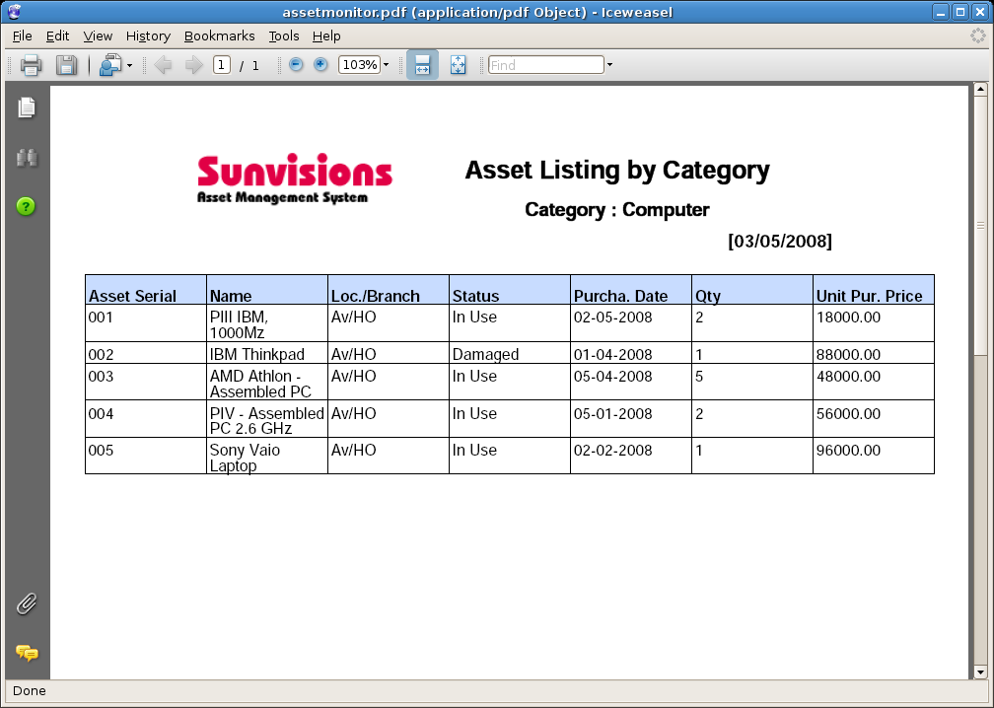
    - PDF Report Display through the Web Browser

Figure 4.6 – PDF Report Display through the Web Browser
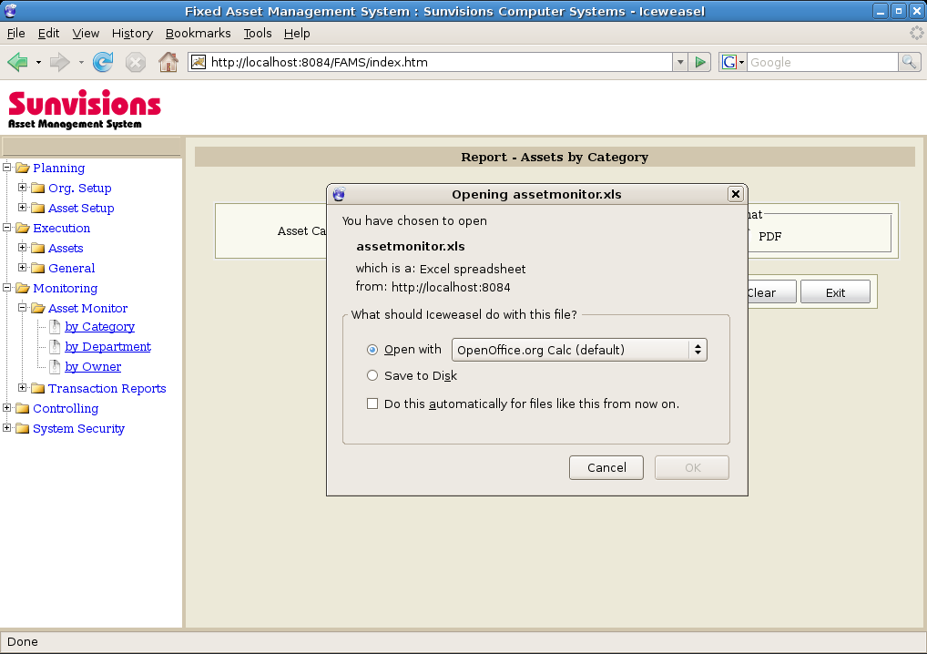
    - Getting Report in Microsoft Excel Format
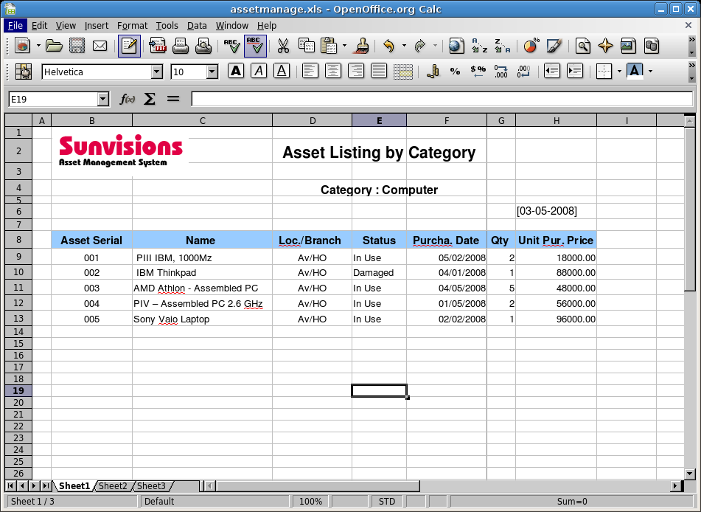
Figure 4.7 – Downloading report in Microsoft Excel Format
Figure 4.8 – Report after opened with OpenOffice.org Calc/Microsoft Excel
CHAPTER 5 - IMPLEMENTATION
  - CODE AND MODULE STRUCTURE
Normally, any web application is built using large set of ingredients. Java web application has no difference here. Even though ingredients might vary from application to application, there are several common contents for each of them such as HTML/JSP, Javascripts, images, configuration files and Java class files etc.
To assure the maintainability of the application, it is very important to modularize the application in a well-organized manner from the beginning of the project development.

    - Structure of the Project
Server side structure of the application can be depicted as follows.
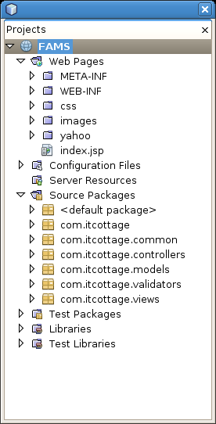
Figure 5.1 – Code and Module Structure

With regards to the Figure 5.1, following table explains the contents of the most important modules of the system.
Module | Sub Module | Description
Web Pages | WEB-INF | Contains all the HTML/JSP files and configuration files related to the project.
Web Pages | CSS | Cascade Style Sheets files which used to maintain the visual aesthetic stored here.
Web Pages | Images | All the project related images/pictures stored in this directory
Web Pages | Yahoo | Yahoo UI tool kit related files such as Javascripts, images stored here.
Source Packages | com.itcottage.* | Contains all the java classes related to the project. These source files further packaged according to their intended purpose.
Test Packages | - | Test Cases for unit testing come under this.
Libraries | - | Third party libraries used in development, such as database drivers, Hibernate etc. stored here.
Table 5.1 – Contents of the System Modules.

  - IMPLEMENTATION ENVIRONMENT
The product was implemented at the head office branch of the client organization. It is currently available only within the Local Area Network of the particular branch. At client site, a dedicated server machine is maintained for Linux based applications. Therefore, the particular project shares the same resource.

    - Hardware Configurations

- Pentium IV – Duo Core 3 GHz Processor
- 1 GB RAM
- 80 GB Hard drive (Only 20 MB is used for initial product implementation and more disk space will be required when transactions are happening)

    - Software Configurations

Server Side
- Linux (Debian Etch 4.0)
- Apache 2.0 Tomcat 6.0 web server
- JDK / Java 6.0
- Spring Framework 2.5
- Hibernate 3.2
- PostgreSQL 8.1
Client Side
- Mozilla Fire Fox 2.0 or above version

  - DEVELOPMENT TOOLS AND SELECTED CODE MODULES
    - NetBeans Integrated Development Environment (IDE)
The proposed system is built on several frameworks while utilizing several backend server applications. Without a suitable IDE, developing such an application is unrealistic. The free and open source development environment NetBeans, provides necessary resource integration while providing general IDE features for development such as syntax highlighting, code completion etc.

    - Selected Code
Following segment of code depicts the internal of the main tree-view component. It is possible to detect the implementation of the tree traversal algorithm within this code portion, and followed code standards such as naming conventions, comments etc.

/**
* @author : Keerthi Bandara
* @description : Controller to handle Main Tree component.
* @date : 12/02/2008
*/
package com.itcottage.common;
import org.springframework.validation.BindException;
import org.springframework.web.servlet.mvc.*;
import org.springframework.web.servlet.ModelAndView;
import javax.servlet.ServletException;
import javax.servlet.http.HttpServletRequest;
import javax.servlet.http.HttpServletResponse;
import org.apache.commons.logging.Log;
import org.apache.commons.logging.LogFactory;
import java.io.IOException;
import java.util.Date;
import java.util.Map;
import java.util.HashMap;
import org.springframework.orm.hibernate3.HibernateTemplate;

import java.io.*;
import javax.xml.parsers.*;
import org.w3c.dom.*;

import org.springframework.web.servlet.
mvc.ParameterizableViewController;
import javax.servlet.*;

/*
* Since there is no Model access or request data processing,
* MainTreeController extends from ParameterizableViewController
*/

public class MainTreeController extends ParameterizableViewController {

protected final Log logger = LogFactory.getLog(getClass());
private String strJScript = "";

/*
* Constructor overridden and set the view for controller.
*/
public MainTreeController(){
setViewName("main-tree");
}

/**
* Traverse through a given XML node and build the javascript
* string to render to the view.
* Then it will be used to build up the Main Tree at the client Side.
*
*/
public String traverse(Node tree) {

/*
* If the given Node has more child elements
*/

if (tree.hasChildNodes()) {

int nodeCount = tree.getChildNodes().getLength();

for (int i = 0; i < nodeCount; i++) {
if (tree.getChildNodes().item(i).getNodeType() == Node.ELEMENT_NODE) {

Element element = (Element)tree.getChildNodes().item(i);

if(element.getAttribute("hasChildren")
.equalsIgnoreCase("true")) {

String objId = element.getAttribute("id");
String objPId = element.getAttribute("pid");
String objLbl =element.getAttribute("label");

strJScript += "o = new Object();\n";
strJScript += "o.label = '" + objLbl + "';\n";
strJScript += "o.id = '" + objId + "';\n";

if (objPId.equalsIgnoreCase("0")) {
strJScript += "tmpMainNode1 = new " +
"YAHOO.widget.TextNode(o,
tree.getRoot(), false);\n";
} else {
strJScript += "n =
tree.getNodeByProperty('id', '"
+ objPId + "');\n";

strJScript += "tmpNode1 = new " +
" YAHOO.widget.TextNode(o, n,
false);\n";
}
}
}

/*
* Call the function recursively.
*/
traverse(tree.getChildNodes().item(i));
}
/*
* If the Element is a last level tree node
*/
} else {
if (tree.getNodeType() == Node.ELEMENT_NODE) {
Element element = (Element) tree;

String objId = element.getAttribute("id");
String objPId = element.getAttribute("pid");
String objLbl = element.getAttribute("label");
String objFrm = element.getAttribute("frm");

strJScript += "o = new Object();\n";
strJScript += "o.label = '" + objLbl + "';\n";
strJScript += "o.id = '" + objId + "';\n";

if (objPId.equalsIgnoreCase("0")) {
strJScript += "tmpMainNode1 = new
YAHOO.widget.TextNode(o,
tree.getRoot(), false);\n";
} else {
strJScript += "n = tree.getNodeByProperty('id',
'" + objPId + "');\n";
strJScript += "tmpNode1 = new
YAHOO.widget.TextNode(o, n, false);\n";
strJScript += "tmpNode1.labelStyle =
'icon-zip';\n";
strJScript += "tmpNode1.onLabelClick =
function(e){\n" + "o =
window.parent.document.
getElementById('frm');\n" +
"o.src = '"
+ objFrm + "';\n" + "}\n";
}
}
}

return strJScript;
}

@Override
public ModelAndView handleRequest(HttpServletRequest request,
HttpServletResponse response)
throws ServletException, IOException {

ServletContext ctx = this.getServletContext();

try {
DocumentBuilderFactory docFactory =
DocumentBuilderFactory.newInstance();

DocumentBuilder builder =
docFactory.newDocumentBuilder();

/*
* Load the XML file which contains structure of the Main Tree
* component.
*/
Document doc = builder.parse(
new File(ctx.getRealPath(
"/WEB-INF/config/main_tree.xml")));

strJScript += "var tree;\n";
strJScript += "var nodes = new Array();\n";
strJScript += "var nodeIndex;\n";

strJScript += "tree = new
YAHOO.widget.TreeView(\'treeDiv1\');\n";

traverse(doc.getDocumentElement());

} catch (Exception e) {
strJScript = e.getMessage();
e.printStackTrace();
}

Map<String, String> myModel = new HashMap<String, String>();

/*
* Set the created javascript string to refer in the view.
*/
myModel.put("jscript", strJScript);

/*
* Render the related JSP view file with the binded data.
*/
return new ModelAndView("common/main-tree", "model",
myModel);

}

}

  - Platform Independency
The proposed system occupies mainly in two ends. In the server-end or backend, which carries out all the processing work, and in the client-end or front-end which handles the user interactions with the system.
The application implementation is independent from its platform at the both ends of execution. Java based server side naturally becomes platform independent. On the other hand, Spring Framework, which is the development framework, is deployable on any Java application server. For example, it is deployable on a lightweight container like Apache Tomcat or enterprise grade server like JBoss.
The client side of the system is completely browser based. Even though, it is optimized for Mozilla Firefox web browser for better performance. Particular web browser is free and open source software and available for all major operating systems. Therefore, a user may access the system from anywhere without concerning his underlying platform.
CHAPTER 6 - TESTING
  - INTRODUCTION
The basic concept of testing is identifying defects in a software product. Rather than finding program bugs, it plays a great role in assuring software product quality.
Fundamental software testing philosophy does not change for Web Applications. Because of its specific characteristics, there may be some deviations from the standard methodologies. Pressman [Pressman, 2005] lists out several elements of testing with regards to a web application.

    - Content Testing
The main objectives of the content testing could be identified as
- To uncover syntactic errors (E.g. typos, grammar), graphical representations and other media.
- To uncover semantic errors (i.e., errors in accuracy or completeness of information) in any content object presented as navigation occurs.
- To find errors in the organization or structure of content that is presented to the end user.

    - Interface Testing
The process of interface testing is to
- Uncover errors related to specific interface mechanisms (Eg. errors in the proper execution of a menu link or the way data are entered in a form)
- Uncover errors in the way the interface implements the semantics of navigation, web application functionality or content display.

    - Navigation Testing
The navigation test ensures that the mechanisms that allow the web application user to travel through the web application are all functional and it validates that each navigation semantic unit can be achieved by the appropriate user.

    - Component Testing
Component – level or function testing attempts to uncover the errors in web application functions.
Each function or software module can be tested using well known testing strategies black – box testing and white – box testing.

    - Configuration Testing
Configuration testing is performed to identify the errors that may cause due to hardware and software configuration misbehavior on either client or server side.

    - Security Testing
The purpose of the security test is to identify vulnerabilities of the client – side environment, the network communications and server – side environment.

    - Performance Testing
Performance testing is used to uncover performance problems that can result from lack of server – side resources, inappropriate network bandwidth, inadequate database capabilities, poorly designed web application functionality and other hardware or software issues that can lead to degrade the client – server performance.
  - TESTING TOOLS AND SIMULATORS
    - Apache JMeter
Apache JMeter enables, gathering performance information and make capacity decisions on a particular Web Application. Tests can be created in a manner that simulates several users simultaneously requesting pages from the Web application. These simulations help determine the stability, speed, and responsiveness of the Web Application.

    - OpenQA : Selenium Test Tool
OpenQA Selenium helps to simulate the Black Box testing process of a web application. How Selenium is applying in product testing is explained later in this Chapter.

  - TESTING EMPLOYEE REGISTRY
Under upcoming subsections, the testing process carried out is explained with the sample program module Employee Registry. Similar process was followed during the testing phase for all other modules.
    - Unit Testing
A unit test examines the behavior of an individual unit of work. Normally in a Java application, the unit of work is a method or a function. Unit test ensures that the particular method returns certain values and throws correct exceptions if the usage of the method is out of its functional boundary.
JUnit is the selected unit-testing framework for proposed system. The development IDE NetBeans has built in support for JUnit and the unit-testing task is explained next. First, it describes the unit for testing and then the associated test case of the particular unit. Finally, it shows the result achieved at the end of the test run.

Testing Employee Registry Validation Units
Date Format Validation :
Unit
/**
* Validates format of a string that contains date value.
* Expected format - dd/MM/yyyy
*/
public boolean isValidDate(String strDate) {

boolean isValid;

SimpleDateFormat df = new SimpleDateFormat("dd/MM/yyyy");
df.setLenient(false);
ParsePosition pos = new ParsePosition(0);

Date date = df.parse(strDate, pos);

// Check all possible things that signal a parsing error
if ((date == null) || (pos.getErrorIndex() != -1)) {
isValid = false;
} else {
isValid = true;
}

return isValid;
}

Test Case
@Test
public void isValidDate() {
System.out.println("isValidDate");

// Mock Object
EmployeeController instance = new EmployeeController();

/*
* Test Cases
*/
boolean expResultFalse_01 = instance.isValidDate("");
assertFalse(expResultFalse_01);

boolean expResultFalse_02 = instance.isValidDate("11041981");
assertFalse(expResultFalse_02);

boolean expResultFalse_03 = instance
.isValidDate("11-04-1981");
assertFalse(expResultFalse_03);

boolean expResultFalse_04 = instance
.isValidDate("asdfasdfas");
assertFalse(expResultFalse_04);

boolean expResultTrue_01 = instance
.isValidDate("11/04/1981");
assertTrue(expResultTrue_01);

}

Email Format Validation :
Unit
/**
* Validates a string value for correct email format.
* Expected format - somevalue@somevalue.somevalue
*/
public boolean isValidEmail(String strEmail) {

boolean isValid = false;

Pattern p = Pattern.compile("^[a-zA-Z][\\w\\.-]*[a-zA-Z0-9]"
+ "@[a-zA-Z0-9][\\w\\.-]*[a-zA-Z0-9]\\"
+ ".[a-zA-Z][a-zA-Z\\.]*[a-zA-Z]$");
Matcher m = p.matcher(strEmail);

// Check whether match is found
boolean matchFound = m.matches();
if (matchFound) {
isValid = true;
}

return isValid;
}

Test Case
@Test
public void isValidEmail() {
System.out.println("isValidEmail");

// Mock Object
EmployeeController instance = new EmployeeController();

/*
* Test Cases
*/
boolean expResultFalse_01 = instance.isValidEmail("");
assertFalse(expResultFalse_01);

boolean expResultFalse_02 = instance
.isValidEmail("asdfasdf");
assertFalse(expResultFalse_02);

// Contains spaces in the value
boolean expResultFalse_03 = instance
.isValidEmail("keerthi bandara@gmail.com");
assertFalse(expResultFalse_03);

// Contians invalid character
boolean expResultFalse_04 = instance
.isValidEmail("keerthi*bandara@gmail.com");
assertFalse(expResultFalse_04);

boolean expResultTrue_01 = instance
.isValidEmail("keerthi@gmail.com");
assertTrue(expResultTrue_01);

boolean expResultTrue_02 = instance
.isValidEmail("keerthi.bandara@gmail.com");
assertTrue(expResultTrue_02);

}

Text Field Length Validation :
Unit
/**
* Validates a string value against a given length
*/
public boolean isValidLength(String strText, short length) {
// Validate length of the string
boolean isValid = (strText.length() <= length)? true: false;

return isValid;
}

Test Case
@Test
public void isValidLength() {
System.out.println("isValidLength");

// Mock Object
EmployeeController instance = new EmployeeController();

/*
* Test Cases
*/
boolean expResultFalse_01 = instance
.isValidLength("abcdef", (short) 5);
assertFalse(expResultFalse_01);

boolean expResultTrue_02 = instance
.isValidLength("abcde", (short) 5);
assertTrue(expResultTrue_02);

boolean expResultTrue_03 = instance
.isValidLength("abcd", (short) 5);
assertTrue(expResultTrue_03);

boolean expResultTrue_04 = instance
.isValidLength("", (short) 5);
assertTrue(expResultTrue_04);

}

Table 6.1 – Applying Unit Testing

Unit Test Execution

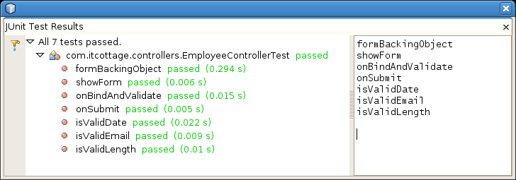
Figure 6.1 – Executing Unit Test with NetBeans IDE

    - Black Box Testing
The Black Box Testing process was automated with OpenQA Selenium tools. By using the browser integrated Selenium GUI; it is possible to record a set of Black Box Test Cases for an application user interface. These test cases can be altered and used to perform further test runs to meet with different test criteria.

Selenium Test Case for White Box Testing
A Selenium generated test case for Employee Registry is given below. In the next figure, performing test case execution using Selenium GUI is depicted.

<?xml version="1.0" encoding="UTF-8"?>
<!DOCTYPE html PUBLIC "-//W3C//DTD XHTML 1.0 Strict//EN"
"http://www.w3.org/TR/xhtml1/DTD/xhtml1-strict.dtd">
<html xmlns="http://www.w3.org/1999/xhtml" xml:lang="en" lang="en">
<head profile="http://selenium-ide.openqa.org/profiles/test-case">
<meta http-equiv="Content-Type" content="text/html; charset=UTF-8" />
<link rel="selenium.base" href="http://localhost:8084/" />
<title>test1</title>
</head>
<body>
<table cellpadding="1" cellspacing="1" border="1">
<thead>
<tr>
<td rowspan="1" colspan="3">test1</td>
</tr>
</thead>
<tbody>
<tr>
<td>open</td><td>/FAMS/index.htm</td><td></td>
</tr>
<tr>
<td>type</td><td>txtDiv</td><td>ED</td>
</tr>
<tr>
<td>select</td><td>sltTitle</td><td>label=MRS</td>
</tr>
<tr>
<td>type</td><td>txtBrn</td><td>AV</td>
</tr>
<tr>
<td>type</td><td>txtFullName</td><td>Nisansala Rajapakshe</td>
</tr>
<tr>
<td>type</td><td>txtInitName</td>
<td>N Rajapakshe</td>
</tr>
<tr>
<td>type</td><td>txtNIC</td><td>811021938V</td>
</tr>

<tr>
<td>type</td><td>txtAdd1</td><td>113/4, Kithulawila Uyana</td>
</tr>
<tr>
<td>type</td><td>txtAdd2</td><td>Kiriwattuduwa</td>
</tr>
<tr>
<td>type</td><td>txtPhone</td><td>0716833516</td>
</tr>
<tr>
<td>type</td><td>txtDOB</td><td>11/04/1981</td>
</tr>
<tr>
<td>click</td>
<td>//div[@id='frm_fields']/table/tbody/tr/td/
table/tbody/tr[6]/td[4]/label[2]/input</td>
<td></td>
</tr>
<tr>
<td>click</td>
<td>//div[@id='frm_fields']/table/tbody/tr/td/
table/tbody/tr[7]/td[4]/label[2]/input</td>
<td></td>
</tr>
<tr>
<td>type</td><td>txtEmail</td>
<td>nisansala_r@yahoo.com</td>
</tr>
<tr>
<td>type</td><td>txtDesig</td><td>IN</td>
</tr>
<tr>
<td>type</td><td>txtDateJoined</td>
<td>21/02/2006</td>
</tr>
<tr>
<td>click</td><td>//span[@id='btn_save']
/span/button</td>
<td></td>
</tr>
</tbody>
</table>
</body>
</html>
Table 6.2 – Selenium Test Case for White Box Testing

Test Case Execution

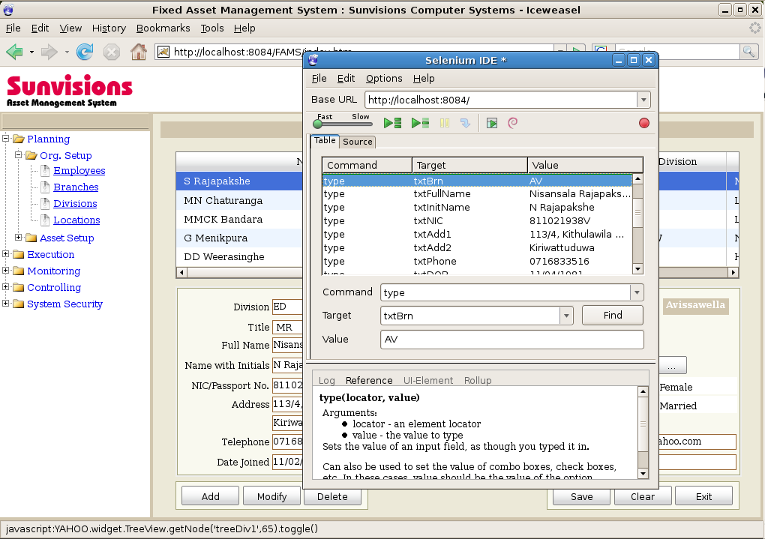
Figure 6.2 – Execution of Selenium Test Case

    - Performance Testing
Performance and stress testing was done using the tool Apache JMeter. JMeter automates the performance test process by submitting multiple concurrent requests to particular web interface.
The JMeter performance test result obtained for Employee Registry is displayed below. This simulates the behavior of general application user interface for 20 concurrent users.
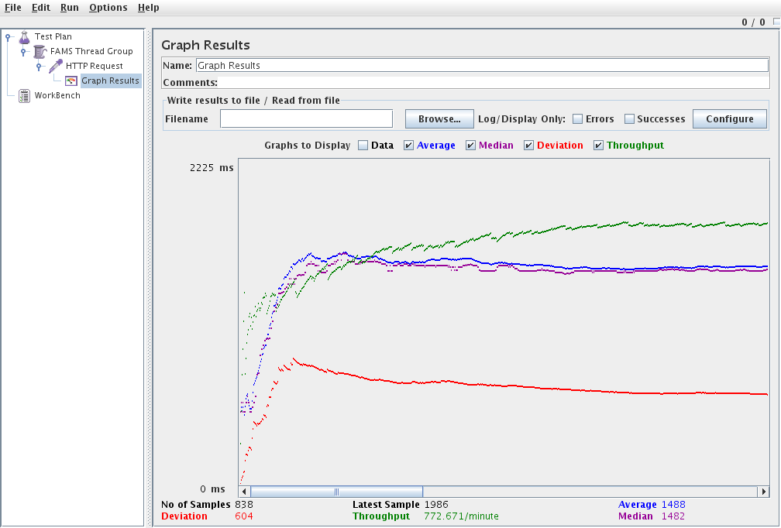
Figure 6.3 – JMeter Performance Test Result

  - ACCEPTANCE TESTING
Acceptance test is carried out by the client after system meets all the fundamental user requirements. A certificate of acceptance is issued as evidence of user satisfaction by the client. The issued client certificate is available at Appendix F.
CHAPTER 7 - EVALUATION
  - APPRAISAL
The proposed system is a partial implementation of an ERP system. Developing such a product needs a lot of business domain expertise, technical proficiency etc. The current effort was to develop a system that meets the particular client’s necessities, rather than developing an industry standard product.
At the beginning, it was expected to implement the system across two branches of the organization. However, to perform this, it was necessary to implement the system at a third party web hosting service provider. Since the client could not invest for such a facility presently, the initial implementation was done internally at the head office. Consequently, the system is accessible only within the Local Area Network of the head office at this moment.
Being compatible with all common web browsers is a very important factor to a web application. However, developing such a product requires lot more time and effort, and achieving such a target is very difficult within the given time boundary. As a solution, the product is optimized for Mozilla Firefox, which is an open source and free product that available on all main operating systems. This helps to preserve the platform independency of the system.
  - FURTHER EXPANDABILITY OF THE SYSTEM
There is a global trend of moving towards Free and Open Source Software (FOSS). By observing the present FOSS world, it is possible to detect standard software packages such as operating systems, database management systems and web browsers are commonly available. On the other hand, business applications are rare to observe. Besides, the quality of such available applications stays at a low level.
At the research stage of this project, several FOSS ERP applications were found but those projects are not continued any longer.
ERP applications are essential to any organization in this world. Therefore, there is a worldwide opportunity for such applications.
Asset Management System is one building block of an ERP solution. By including other ERP modules such as HR, GL, Inventory etc., which follow a common set of standards, the current project could be extended to a complete ERP solution. Current system is designed in such a manner that allows future expansions. However, developing an ERP solution is not just a simple task and it requires lot of business/industry knowledge and experience. In addition, the effort required is very high.
However, my belief is, throughout a proper community driven process, this goal can be realized. As an initiative, after applying several customizations, this particular project will be opened to the community as FOSS system.

CHAPTER 8 - CONCLUSIONS
  - PROJECT ASSESSMENT
The proposed project, “Web based Fixed Asset Management System” was developed to provide the ability of consuming organization’s fixed assets systematically, while reducing the wastage. Because of the system was designed primarily based on client’s requirements, this initial goal was achieved successfully.
It was possible to experience the various new technologies throughout the development of the project. Nevertheless, acquiring knowledge became very difficult while continuing the project development. Even for an industry popular technology like Spring, it was hard to find out reference materials, such as recommended readings, in the local market.
Further, acquiring knowledge from business world was essential. This awareness will strengthen me when facing the IT industry in future.

  - FURTHER IMPROVEMENTS
The proposed system covers the fixed asset management area of an ERP solution. Currently it is available as a stand alone, self-contained module. In addition, it is not linked with external ERP related systems such as HR, GL etc. By giving the ability to interact with other systems, this project can be extended from small-medium scale to enterprise level.
Another feature that can be incorporated is multi-language/localization support. Although, some experiments were carried out in this area, they could not be implemented due to time constraints. As a suggestion, GUI contents like text labels can be separated from the user interface and kept in separate resource files. Then these contents can be accessed programmatically and by altering the particular resource file, system can be transferred to another language/locale without affecting the internal system.

  - CONCLUSION
Even with some difficulties, ultimately the project was successfully completed while achieving the client’s total satisfaction. It was challengeable to complete the project within the limited time available while being a fulltime employee. Studying while working did take its heavy toll on me especially during the latter stages of the project.
Although it was a difficult task altogether, the satisfaction, I got from finishing this project and getting it accepted by the client, was remarkable to say the least. I grew in experience, personal interactions as well as in technical knowledge with this project, which would no doubt be a plus for my future career.
Finally, I would like to mention that this project will be continued further, and expect to publish as a free and open source solution, so any organization will be able to get the advantage of this project.
REFERENCES

[Walls, 2008] Walls, Craig. 2008. Spring in Action. Manning Publications Co., USA. Ryan Breidenbach.

[Pressman, 2005] Pressman, Roger S. 2005. Software Engineering, Practitioner's Approach. McGraw - Hill Companies, Inc..

[Rumbaugh, 2004] Rumbaugh, James. 2004. Object - Oriented Modeling and Design. Pearson Education, Inc. Michael Blaha, William Premelani, Frederick Eddy, William Lorensen.

[Thompson, 2005] Ed Lecky, Thompson. 2005. Professional PHP5. Wiley Publishing, Inc. Heow Eide-Goodman, Steven D. Nowicki, Alec Cove.

[WWW1] OMG Unified Modeling Language Specification site. http://www.omg.org

[WWW2] ERP definition from Wikipedia, the free encyclopedia. http://en.wikipedia.org/wiki/Enterprise_resource_planning

[WWW3] Financial and Accounting term definitions from answers.com. http://www.answers.com

[WWW4] Financial and Accounting term definitions from investorwords.com. http://www.investorwords.com/

[WWW5] Official web site for Spring application framework.
http://springframework.org/

[WWW6] Official web site for Hibernate object/relational persistence system. http://www.hibernate.org/
APPENDIX A – DESIGN DOCUMENTATION
Main system design documents are described under Chapter 3 - Analysis and Design. A set of additional design documents for several other programme modules attached next.

APPENDIX B – SYSTEM DOCUMENTATION
FIXED ASSET MANAGEMENT SYSTEM (FAMS) SETUP GUIDELINE
Throughout this guideline, only the product installation and setting up procedures are explained. Installation instructions for related software products not provided here and please refer the particular product documentation for setup instructions.
PREREQUISITES
Before continue the product installation, following system software should be installed and setup. For server products, it is necessary to have the related product access information such as administrative user account information, URLs etc.

- Apache Tomcat Version 6.0 with Java Runtime Environment (JRE) and Development Kit (JDK) Version 5.0 or above.
- PostgreSQL database server Version 8.1 or above.
- Mozilla Firefox web browser version 2.0 or higher.
INSTALLATION PACKAGE
The Fixed Asset Management System (FAMS) is available as a self-contained web archive (.war file). This is the standard installation package system for Java web applications. Therefore, it is possible to use this package to install the FAMS on any Java application server. Preferred application server at the moment is Apache Tomcat and installation setup is explained using that.
The FAMS package contains all the related libraries i.e. Spring an Hibernate, so it is not necessary to install them separately.
SETTING UP DATABASE
The first step of FAMS installation is setting up the database.
Creating Database
Create a new blank database either using PostgreSQL – PgAdmin tool or command line utilities. Then create new database user account and grant permission on the particular database, if you wish to use a separate user account for particular application.

Setting up new database using PostgreSQL command line utility (psql) is explained below.

Login to the Database Server
root# psql -U root -W -h localhost -d postgres
Create the Database
postgres=# CREATE DATABASE FAMS;
Create New Database User
postgres=# CREATE USER fams_user PASSWORD 'password';
Grant Permission to Newly Created User
postgres=# GRANT ALL ON DATABASE fams TO fams_user;

Creating Tables and Applying Initial Data
A SQL script is provided with all the table structures and data that necessary to startup the system. How this SQL script executes on newly created database is explained next.

Login to the Recently Created Database
compi:~# psql -U fams_user -W -h localhost -d fams
Executing SQL Script
fams=> \i ./fams.sql

DEPLOYING FAMS
After successfully setting up database, next step is to setup the application.
Package installation using Apache Tomcat Web Application Manger
By using the Tomcat Web Application Manager interface, the web application archive (FAMS.war) can be directly deployed on the server.
- Login to the Tomcat Web Application Manager
- Locate the subsection “WAR file to deploy” under “Deploy” (refer the following Figure)

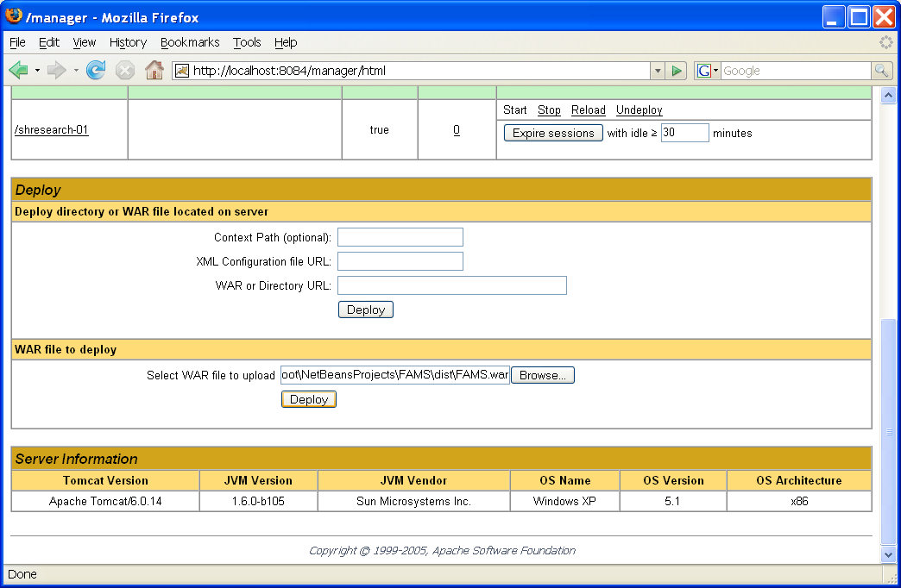
- Click browse button and locate the FAMS.war file in your local file system.
- Click Deploy

Setting up Database Configuration
Currently it is necessary to provide database configuration information manually to the application. Database access information is kept in the file called “jdbc.properties” which is located in
<tomcat_server_installation_path>/webapps/FAMS/WEB-INF/
Open the “jdbc.properties” file with a text editor.
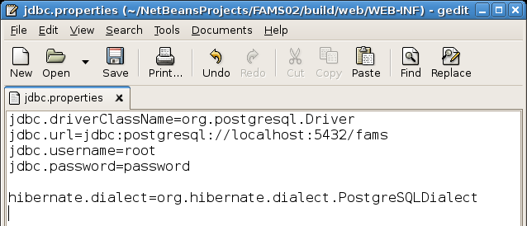
Edit the particular information according to your database setup.
ACCESSING SYSTEM
Once the FAMS is successfully deployed, the system may access using a web browser.

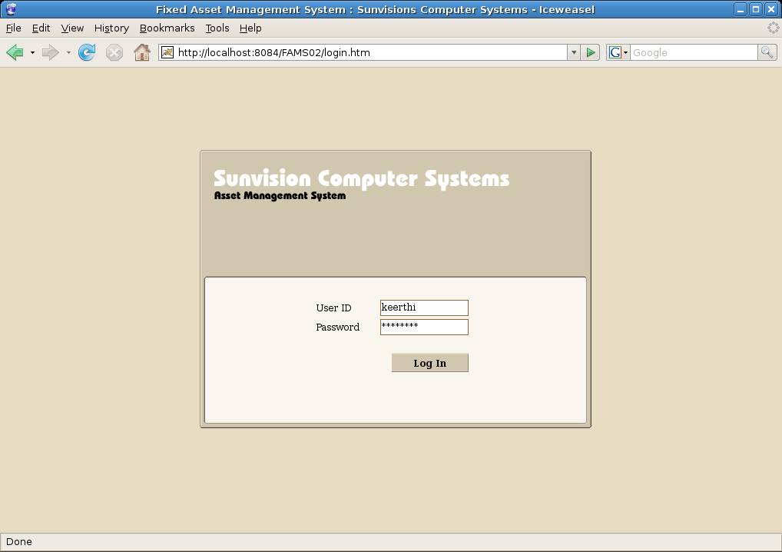

Use the administrative login information to start with the system. Once you logged in as the system administrator, you may create system user accounts for other users. Please refer the user manual for system administration.
APPENDIX C – USER DOCUMENTATION

Throughout this documentation, all the main user interactions with the system will be explained.
MAIN INTERFACE
After successful system installation, a user may login to the system via main system login screen. Please note that system administrator is responsible for creating user accounts and grant permissions for a given user account.
A user may navigate via the Main Tree menu at left (explained in next section) and can access any module required. However, some user may not have permission to access certain modules according to the organizational structure.
Following figure shows a user that access Employee Registry.

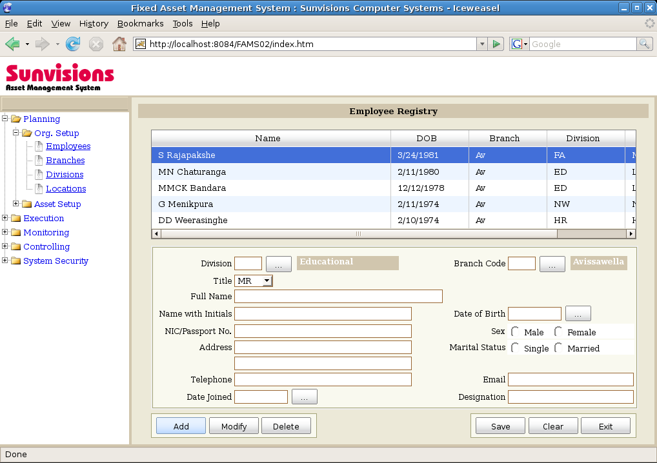
Accessing Employee Registry
NAVIGATING THROUGH MAIN TREE
The whole system is categorized in a user-friendly manner that a user may easily locate the required module by looking at the category.

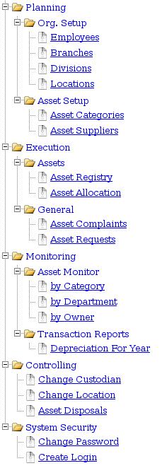 | Planning
 | Under this section, all the master data capturing activities are performed. The data captured here involves in transactions in next section.
 | Execution
 | All the system transactions perform here. In day today operations, this section engage in most cases.
 | Monitoring
 | This is the decision support area of the system. In this section, reports will be produced based on the data captured through the previous 2 sections.
 | Controlling
 | All the controlling transactions are performed in this section.
 | System Security
 | All the system security related functions are listed under this area.

Main Tree Menu Structure

MAIN COMPONENTS USED IN USER INTERFACE
Calendar Control
Instead of directly entering the value calendar control may use.

Common Information Browser

PRIMARY USER ACTIVITIES WITH THE SYSTEM
Common Transaction Buttons
On any information entry screen, following set of buttons are available and their behavior is common to all the screens. All the button related transactions are explained next. Anyway, the logged in user must have required credentials to perform the particular transaction.

Adding New Record
Adding record is quit straight forward. User may simply click on the Add button and that will enable all the text fields and other related controls for information entry. After entering all the required information, user may hit Save button to store the new record.

Editing Record
To edit an existing record, first select the particular record from the data grid. Then entry form will display all the related information for the selected record. To enable the data entry form for edit, click on the Modify button. After the modification, hit the save button to store the update. Some fields may not editable after once they have entered since they may affect the other parts of the system that use the particular information.

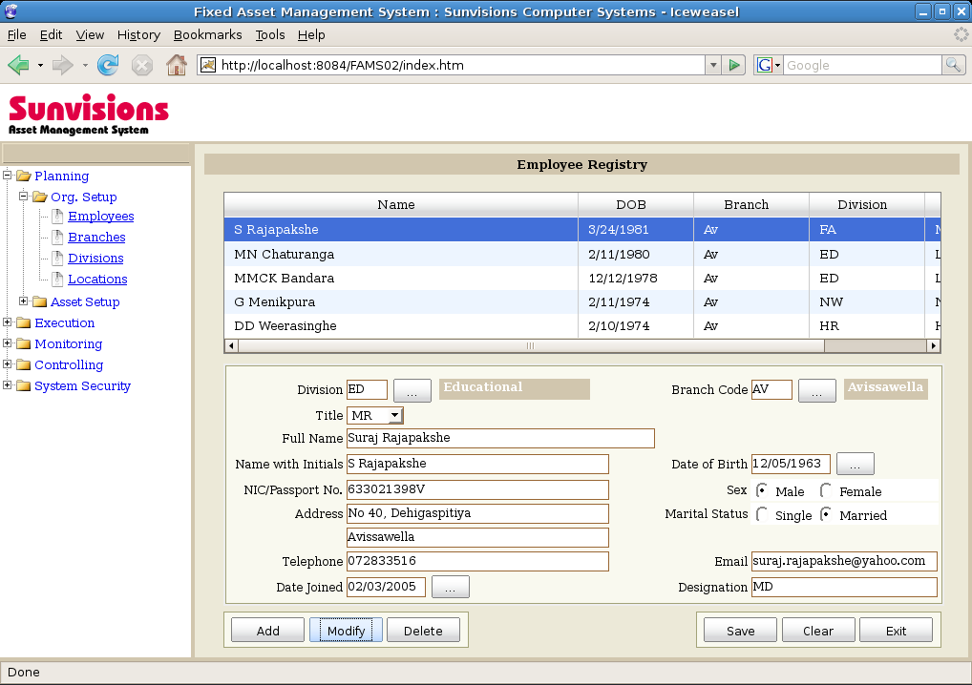

Deleting Record
Deleting record is similar to the record editing. First user selects the particular record from the data grid and click on the Delete button. In most cases, particular entry will be disabled instead removing from the system. Then the using particular data entry in future transactions will be prevented. This is to maintain the referential integrity of the system.
APPENDIX D – MANAGEMENT REPORTS

Some selected managerial reports in different file formats are listed next.
Asset Listing by Category – in PDF format
Asset Listing by Category – in PDF format
APPENDIX E – CODE LISTING
Some selected code modules are given next. They were selected in a manner that covers various aspects of the system.
A. CODE LISTING FOR LOGIN VIEW
<%@ include file="/WEB-INF/jsp/common/header.jsp" %>
<form method="post">
<table class="frmLabel" border="0" align="center">
<tr>
<td>&nbsp;</td>
<td>
<spring:bind path="command.*">
<c:if test="${not empty status.errorMessages}">
<c:forEach var="error" items="${status.errorMessages}">
<font color="red">
<c:out value="${error}" escapeXml="false" />
</font>
<br />
</c:forEach>
</c:if>
</spring:bind>
<!-- status messages -->
<c:if test="${not empty message}">
<font color="green">
<c:out value="${message}" />
</font>
<c:set var="message" value="" scope="session" />
</c:if>
</td>
<td>&nbsp;</td>
</tr>
<tr>
<td width="80">User ID </td>
<td>
<spring:bind path="command.userId">
<input name='<c:out value="${status.expression}"/>'
value='<c:out value="${status.value}"/>'
type="text" size="12"
maxlength="15">
</spring:bind>
</td>
<td>&nbsp;</td>
</tr>
<tr>
<td>Password</td>
<td>
<spring:bind path="command.password">
<input name='<c:out value="${status.expression}"/>'
value='<c:out value="${status.value}"/>'
type="password" size="12"
maxlength="15">
</spring:bind>
</td>
<td>&nbsp;</td>
</tr>
<tr>
<td>&nbsp;</td>
<td>&nbsp;</td>
<td>&nbsp;</td>
</tr>
<tr>
<td>&nbsp;</td>
<td align="right">
<input name="submit" value="Log In"
class="button" type="submit" />
</td>
<td>&nbsp;</td>
</tr>
</table>
</form>
</div>
<%@ include file="/WEB-INF/jsp/common/footer.jsp" %>

B. CODE LISTING FOR LOGIN CONTROLLER
/**
* @author : Keerthi Bandara
* @description : Controller to handle Main Tree component.
* @date : 12/02/2008
*/

package com.itcottage.controllers;

import com.itcottage.models.Employee;
import com.itcottage.common.ApplicationSecurityManager;
import org.springframework.web.servlet.mvc.SimpleFormController;
import org.springframework.web.servlet.ModelAndView;
import javax.servlet.ServletException;
import javax.servlet.http.HttpServletRequest;
import javax.servlet.http.HttpServletResponse;
import org.apache.commons.logging.Log;
import org.apache.commons.logging.LogFactory;
import java.io.IOException;
import java.util.Map;
import org.springframework.validation.BindException;
import org.springframework.orm.hibernate3.HibernateTemplate;
import org.hibernate.SessionFactory;
import org.hibernate.Transaction;
import org.hibernate.Query;

public class LoginController extends SimpleFormController {

private ApplicationSecurityManager applicationSecurityManager;
private HibernateTemplate hibernateTemplate;
private SessionFactory sessionFactory;

/**
* Always returns a new Employee object
* @see Employee
*/
protected Object formBackingObject(HttpServletRequest request)
throws Exception {
return new Employee();
}

/** Forwards to success view, if already logged in */
public ModelAndView showForm(HttpServletRequest request,
HttpServletResponse response, BindException errors,
Map controlModel) throws Exception {

if (applicationSecurityManager.getEmployee(request) != null) {
return new ModelAndView(getSuccessView());
}

return super.showForm(request, response, errors,
controlModel);

}

/** Validates user/password against database */
public void onBindAndValidate(HttpServletRequest request,
Object command, BindException errors) throws Exception {

if (errors.hasErrors()) {
return;
}

Employee formEmployee = (Employee) command;

org.hibernate.Session session = sessionFactory.openSession();

session.beginTransaction();

Query qry = session.createQuery("from Employee where " +
"userId = :userId and password
= :password");
qry.setString("userId", formEmployee.getUserId());
qry.setString("password", formEmployee.getPassword());

Employee dbEmployee = (Employee) qry.uniqueResult();
session.getTransaction().commit();

if (dbEmployee == null) {
errors.reject("error.login.invalid");
} else {
applicationSecurityManager.setEmployee(request,
dbEmployee);
}

}

/** returns ModelAndView(getSuccessView()) */
public ModelAndView onSubmit( HttpServletRequest request,
HttpServletResponse response, Object command,
BindException errors) throws Exception {
return new ModelAndView(getSuccessView());
}

public ApplicationSecurityManager getApplicationSecurityManager() {
return applicationSecurityManager;
}

public void setApplicationSecurityManager(
ApplicationSecurityManager applicationSecurityManager) {
this.applicationSecurityManager = applicationSecurityManager;
}

public void setHibernateTemplate(HibernateTemplate template) {
this.hibernateTemplate = template;
}

public void setSessionFactory(SessionFactory sessionFactory) {
this.sessionFactory = sessionFactory;
}
}

C. CODE LISTING FOR EMPLOYEE MODEL
/**
* @author : Keerthi Bandara
* @description : Model Class to represent Employee entity.
* @date : 12/02/2008
*/

package com.itcottage.models;

public class Employee {

/**
* Property declarations
*/

private int id;
private String firstName;
private String lastName;
private String userId;
private String password;

public int getId() {
return id;
}

public void setId(int id) {
this.id = id;
}

public String getFirstName() {
return firstName;
}

public void setFirstName(String firstName) {
this.firstName = firstName;
}

public String getLastName() {
return lastName;
}

public void setLastName(String lastName) {
this.lastName = lastName;
}

public String getUserId() {
return userId;
}

public void setUserId(String userId) {
this.userId = userId;
}

public String getPassword() {
return password;
}

public void setPassword(String password) {
this.password = password;
}

}

D. CODE LISTING FOR XML MAPPING EMPLOYEE ENTITY
<?xml version="1.0"?>
<!DOCTYPE hibernate-mapping PUBLIC
"-//Hibernate/Hibernate Mapping DTD 3.0//EN"
"http://hibernate.sourceforge.net/hibernate-mapping-3.0.dtd">

<!--
* @name : Keerthi Bandara
* @description : Hibernate configuration file for Employee Model/Entity class.
* @date : 12/02/2008
-->

<hibernate-mapping default-lazy="false">
<class name="com.itcottage.models.Employee" table="employee">
<id name="id" column="id">
<generator class="sequence"/>
</id>
<property name="firstName" column="first_name"/>
<property name="lastName" column="last_name"/>
<property name="userId" column="user_id"/>
<property name="password" column="password"/>
</class>
</hibernate-mapping>

APPENDIX F – CLIENT CERTIFICATE

As evidence of acceptance testing, Client certificate is attached next.

APPENDIX F – GLOSSARY AND INDEX

A
AJAX viii, 4, 11
AOP See
Aspect Oriented Programming ii, 8
C
Controller 9
D
Declining-balance 13
Dependency Injection 10
Depreciation 7, 12, 13, 23
E
Enterprise Resource Planning viii, 2, 6
ERP viii, 2, 4, 6, 14, 57, 59, 61
F
Financials 2, 6
fixed asset ii, 1, 3, 7, 14, 59
Fixed Asset Management 2, 3, 4, 6, 7, 17, 59, 66
M
Model viii, 9, 15, 31, 35, 44, 79, 81
R
Reducing balance 13
ROI viii, 2
S
SAP AG 14
SMS See Short Message Service
Spring Framework 9
V
View viii, 9, 31

