projectcode5/12

Kinda Nahas

12/5/2020

## R Markdown

This is an R Markdown document. Markdown is a simple formatting syntax for authoring HTML, PDF, and MS Word documents. For more details on using R Markdown see <http://rmarkdown.rstudio.com>.

When you click the **Knit** button a document will be generated that includes both content as well as the output of any embedded R code chunks within the document. You can embed an R code chunk like this:

AAPLs <- tq_get("AAPL", get = "stock.prices", from = "2020-01-02", to = "2020-08-07")   
AMZNs <- tq_get("AMZN", get = "stock.prices", from = "2020-01-02", to = "2020-08-07")  
TSLAs <- tq_get("TSLA", get = "stock.prices", from = "2020-01-02", to = "2020-08-07")  
ZMs <- tq_get("ZM", get = "stock.prices", from = "2020-01-02", to = "2020-08-07")  
MSFTs <- tq_get("MSFT", get = "stock.prices", from = "2020-01-02", to = "2020-08-07")  
  
AATZM <- tq_get(c("AAPL", "AMZN","TSLA", "ZM", "MSFT" ),  
 get = "stock.prices",  
 from = "2020-01-02",  
 to = "2020-08-07")

## Including Plots

You can also embed plots, for example:

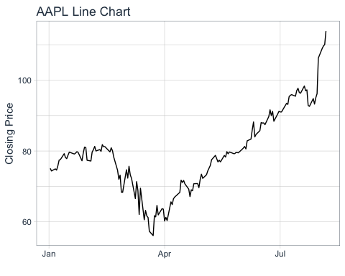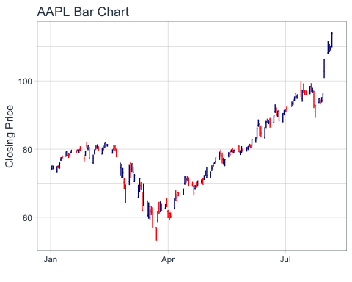

Note that the echo = FALSE parameter was added to the code chunk to prevent printing of the R code that generated the plot.

justapple <- read_excel("justapple.xlsx")  
  
p <- ggplot(justapple, aes(x = Date))  
p <- p + geom_line(aes(y = Volumer, colour = "robin"))  
  
# adding the relative humidity data, transformed to match roughly the range of the temperature  
p <- p + geom_line(aes(y = Volume/600, colour = "volume"))  
  
# now adding the secondary axis, following the example in the help file ?scale_y_continuous  
# and, very important, reverting the above transformation  
p <- p + scale_y_continuous(sec.axis = sec_axis(~.*50, name = "Total Volume"))  
  
# modifying colours and theme options  
p <- p + scale_colour_manual(values = c("blue", "red"))  
p <- p + labs(y = "Robinhood User holding",  
 x = "Date ",  
 colour = "Parameter")  
p <- p + theme(legend.position = c(0.8, 0.9))  
p

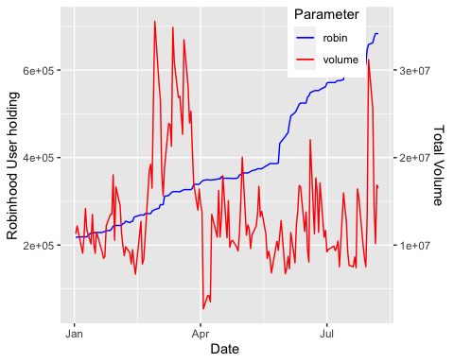

p <- ggplot(justapple, aes(x = Date))  
p <- p + geom_line(aes(y = Close, colour = "close"))  
  
# adding the relative humidity data, transformed to match roughly the range of the temperature  
p <- p + geom_line(aes(y = Volumer/5500, colour = "volume"))  
  
# now adding the secondary axis, following the example in the help file ?scale_y_continuous  
# and, very important, reverting the above transformation  
p <- p + scale_y_continuous(sec.axis = sec_axis(~.*5000, name = "Robinhood user holdings"))  
  
# modifying colours and theme options  
p <- p + scale_colour_manual(values = c("blue", "red"))  
p <- p + labs(y = "Closing stock price",  
 x = "Date ",  
 colour = "Parameter")  
p <- p + theme(legend.position = c(0.8, 0.9))  
p

