THE UNIVERSITY OF DODOMA
COLLEGE OF INFORMATICS AND VIRTUAL EDUCATION

DEPARTMENT OF ELECTRONIC AND TELECOMMUNICATION ENGINEERING (ETE)
FINAL YEAR PROJECT PROGRESS II REPORT
2025/2026 ACADEMIC YEAR

MESH NETWORK BASED EMERGENCY COMMUNICATION SYSTEM FOR RURAL AREAS

CLASS: Bsc. DCBE 4
Submitted by:
NAME OF STUDENT | REG. NUMBERS | SIGNATURE
ELISHA .K. MMARI | T22-03-04587
ELIUS JOHN | T22-03-00339
SHANNY .J. MWAMBASHI | T22-03-08376

SUPERVISOR NAME
JOHEVAJILE MAZIMA (PhD) __________________

TABLE OF CONTENT
Right-click and choose “Update Field” to generate the table of contents.

LIST OF FIGURES
Figure 1. System Architecture Diagram
Figure 2. Hardware Block Diagram
Figure 3. System Schematic Diagram
Figure 4. Software / Protocol Layering Diagram
Figure 5. Message Delivery Sequence Diagram
Figure 6. Reactive Route Discovery Sequence Diagram (RREQ / RREP)
Figure 7. Emergency (SOS) Broadcast Sequence Diagram
Figure 8. Location Sharing Sequence Diagram
Figure 9. Mobile Application Architecture Diagram
Figure 10. Ranger Node - Physical Interface
Figure 11. Mesh Topology with Multi-Hop Relaying

LIST OF TABLES
Table 1. Summary of Findings
Table 2. Connection to Project Objectives
Table 3. Radio Configuration Parameters
Table 4. Mesh Packet Header Fields
Table 5. Mesh Packet Types
Table 6. Firmware Pin Assignment
Table 7. Functional Requirements
Table 8. Non-Functional Requirements

LIST OF ABBREVIATIONS

Abbreviation | Full Meaning
ACK | Acknowledgement
AODV | Ad hoc On-Demand Distance Vector (routing)
API | Application Programming Interface
COTS | Commercial Off-The-Shelf
DRR | Disaster Risk Reduction
DTN | Delay Tolerant Network
GPS | Global Positioning System
GSMA | Global System for Mobile Communications Association
ITU | International Telecommunication Union
JSON | JavaScript Object Notation
LAN | Local Area Network
LoRa | Long Range Radio
LoRaWAN | Long Range Wide Area Network
LPWAN | Low Power Wide Area Network
MCU | Microcontroller Unit
NACK | Negative Acknowledgement
RREP | Route Reply
RREQ | Route Request
RSSI | Received Signal Strength Indicator
SF | Spreading Factor
SMS | Short Message Service
SNR | Signal-to-Noise Ratio
SOS | Emergency distress signal (from the international Morse code call sign)
TCRA | Tanzania Communications Regulatory Authority
TTL | Time To Live
UAV-BS | Unmanned Aerial Vehicle Base Station
UI | User Interface
UNDP | United Nations Development Programme
UNDRR | United Nations Office for Disaster Risk Reduction
URL | Uniform Resource Locator
WAN | Wide Area Network
Wi-Fi | Wireless Fidelity
WS | WebSocket

CHAPTER ONE

Introduction
Reliable communication is essential for effective emergency response, coordination, and public safety. During emergencies, the availability of timely and accurate information directly affects response efficiency and outcomes. However, conventional mobile networks and internet services often become unavailable or unreliable in emergency situations due to congestion, infrastructure damage, or power failures, leading to delayed responses and increased risks to life and property (Bagula, Zennaro & Pietrosemoli, 2014).
In Tanzania, communication infrastructure coverage and reliability remain uneven, particularly in rural areas. Regulatory and policy reports from the Tanzania Communications Regulatory Authority (TCRA) and related national digital development frameworks indicate persistent challenges related to network resilience, power dependency, and service continuity, especially during abnormal or high-demand conditions. Similar trends are observed across Sub-Saharan Africa, where telecom coverage expansion has improved access but has not fully addressed reliability during emergency scenarios (Bowmans, 2022).
Emergency situations may include medical incidents, security threats, environmental hazards, or infrastructure failures, all of which require rapid and reliable information exchange. Studies on rural emergency preparedness emphasize the need for communication systems that prioritize resilience, coverage, and low power consumption rather than high data throughput (Ahmed et al., 2020).
Despite improvements in connectivity, rural areas remain highly dependent on centralized commercial cellular infrastructure. When this infrastructure fails due to power outages, physical damage, or network congestion, communities experience complete communication blackouts. This dependency creates a critical vulnerability during emergencies when communication is most essential.

1.1 Project overview
This project focuses on the development of a resilient emergency communication system intended for rural environments where conventional mobile networks and internet services are unavailable or unreliable. The proposed system is designed as a decentralized, infrastructure independent solution that enables peer-to-peer emergency communication supporting both one-to-one messaging and one-to-many broadcast communication among users within the coverage area and basic location sharing during emergency situations.
By leveraging long-range, low-power wireless technologies and a resilient multi-hop relaying mechanism that buffers a message while a route to its destination is being discovered and retries delivery automatically when the destination becomes reachable, the project aims to enhance communication reliability, coordination, and community resilience during emergencies in rural contexts, particularly in Tanzania and similar regions.

1.2 Problem statement
In an ideal disaster management framework, rural communities should possess resilient, always on communication channels. According to the International Telecommunication Union (ITU), a robust emergency system must support reliable communication and coordination between affected citizens and responders, even when conventional communication infrastructure becomes unavailable.
Despite the expansion of mobile networks in Tanzania, TCRA reports reveal that rural infrastructure remains fragile, centralized, and lacks redundancy. During emergencies when communication is most critical, these networks frequently suffer from cascading failures caused by congestion, power outages, or physical damage. Currently, rural populations are almost entirely dependent on these vulnerable commercial networks, leaving them in a total information blackout when the primary towers fail (TCRA, 2022).
The UN Office for Disaster Risk Reduction highlights that these communication breakdowns paralyze the dissemination of life-saving alerts and location updates. In rural Tanzania, this leads to a coordination vacuum where community leaders cannot mobilize local help, and emergency responders cannot receive real-time data. This delay directly correlates with increased mortality rates and the failure of disaster mitigation efforts in underserved regions. (ITU, 2020; UNDRR, 2019).
While alternative wireless solutions exist, they are often black-box systems developed externally that rely on low-rate data transmission (e.g., simple text) or require pre-existing infrastructure that is often the first thing to fail. There is a critical lack of locally grounded research into systems that support real-time, many-to-many communication specifically optimized for the unique operational constraints such as limited power and rugged terrain of the Tanzanian rural context. (Bagula et al., 2016; World Bank, 2021).
Therefore, this project addresses the lack of a resilient, infrastructure-independent communication system capable of maintaining reliable peer-to-peer communication between users during conventional network outages.

1.3 Objectives

1.3.1 Main objective
To develop a decentralized emergency communication system for rural environments when conventional mobile networks and internet services are unavailable or unreliable.

1.3.2 Specific objectives
- To identify the requirements for designing system requirements for a decentralized emergency communication system in rural Tanzania.
- To design the architecture and communication framework for a decentralized emergency communication system in rural Tanzania.
- To develop a locally-sustainable hardware/software prototype for a decentralized emergency communication system in rural Tanzania.
- To validate the performance of the developed prototype under rural Tanzanian operating conditions.

1.4 Significance of the study
This study contributes to improving emergency preparedness and communication resilience in rural environments. By grounding the system design in locally observed communication challenges, the project provides empirical insight into the feasibility of decentralized emergency communication architectures within rural Tanzanian contexts.
Practically, the project demonstrates how low-power, long-range wireless technologies can be adapted to support many-to-many emergency messaging without reliance on centralized commercial infrastructure. This approach offers a cost-conscious and energy-efficient alternative suitable for resource-constrained environments.
Academically, the study contributes to existing research by evaluating decentralized communication performance under real rural constraints. The findings may inform future research, policy considerations, and scalable emergency communication strategies for underserved communities.

1.5 Project scope
This project focuses specifically on emergency communication systems for rural environments.

Included in scope
- Emergency text-based messaging
- One-to-one emergency messaging
- One-to-many broadcast messaging
- Location sharing
- Long-range wireless communication evaluation
- Resilient multi-hop message relaying
- Performance evaluation under constrained conditions

Excluded from scope
- Voice or video communication
- High-bandwidth applications
- Continuous real-time connectivity
- Replacement of cellular networks
- Commercial deployment considerations

CHAPTER TWO: LITERATURE REVIEW

2.1 Introduction
This chapter reviews existing literature related to emergency communication in rural environments, decentralized communication architectures, and alternative wireless technologies suitable for use during infrastructure failure. The review examines strengths and limitations of current systems and identifies research gaps that motivate the proposed study. Sources include academic research, regulatory reports, and documented emergency communication implementations relevant to rural contexts.

2.2 Emergency communication in rural environments
Emergency communication is essential for coordination, information dissemination, and lifesaving response during disasters. Rural environments present unique challenges due to geographical isolation, sparse population density, limited infrastructure, and unreliable power supply (ITU, 2020).
In Tanzania, rural communities often depend on a small number of cellular base stations, which are vulnerable to power outages and physical damage during emergencies (TCRA, 2022). When such failures occur, communication breakdowns delay coordination and reduce the effectiveness of emergency response efforts (UNDRR, 2019).
Studies on rural emergency preparedness emphasize that communication systems for such environments must prioritize resilience, low power operation, and long-range coverage rather than high data throughput or multimedia capability (Ahmed et al., 2020). These characteristics are critical for maintaining basic coordination when centralized infrastructure becomes unavailable.

2.3 Centralized communication infrastructure and its limitations
Traditional communication systems such as cellular networks and internet-based platforms rely heavily on centralized infrastructure including base stations, core network servers, and grid power. While efficient under normal operating conditions, these systems are vulnerable to cascading failures during emergencies caused by congestion, energy disruption, or physical damage (World Bank, 2021).
In rural Tanzania, centralized dependency creates a single point of failure. When primary cellular towers become non-operational, entire communities may experience complete communication blackouts. This vulnerability highlights the importance of exploring decentralized and infrastructure-independent alternatives.

2.4 Alternative emergency communication technologies
Various technologies have been explored to improve connectivity during network disruptions. Each presents specific advantages and limitations when evaluated against rural emergency requirements.

2.4.1 Low Power Wide Area Networks; LPWANs and LoRa
Low Power Wide Area Networks (LPWANs), including LoRa-based systems, are designed to support long-range, low-power communication using small data packets. LoRa technology enables long-range communication, often achieving several kilometres of coverage in rural environments, depending on factors such as antenna configuration, spreading factor, transmission power, and terrain conditions (Augustin et al., 2016; Bor et al., 2016).
LoRa provides several advantages that make it suitable for low-power communication systems. The technology consumes very little energy, allowing devices to operate for extended periods using batteries. It also supports long communication ranges, enabling connectivity over several kilometres in suitable conditions. In addition, LoRa is well suited for battery-powered devices and can operate without centralized infrastructure when configured in peer-to-peer modes, allowing nodes to communicate directly with each other.
Despite these benefits, LoRa also presents certain limitations. The technology supports relatively low data rates and is subject to duty cycle restrictions imposed by regional regulations, which limit how frequently devices can transmit. When many nodes attempt to transmit simultaneously, message throughput may decrease due to network congestion. Consequently, LoRa is not suitable for continuous real-time streaming or other high-bandwidth communication applications.

2.4.2 Unmanned Aerial Vehicle Base Stations (UAV-BS)
UAV-based communication systems use drones equipped with networking equipment to temporarily restore connectivity in disaster-affected areas (Mozaffari et al., 2019). These systems provide rapid deployment and flexibility in inaccessible terrain.
However, UAV-based communication systems have several limitations that affect their practical deployment. These include limited battery life, which restricts the duration of operation, as well as sensitivity to weather conditions that can interfere with flight stability and communication reliability. In addition, regulatory constraints governing drone operations may limit where and how such systems can be deployed. The operation of UAV-based networks can also be technically complex and may require specialized personnel and equipment. Furthermore, the overall deployment cost can be relatively high.
These constraints are presented by Unmanned Aerial Vehicle Base Stations (UAV-BS) reducing their practicality for sustained rural community-level deployment.

2.4.3 Satellite communication systems
Satellite phones and satellite messengers provide global connectivity independent of terrestrial infrastructure. They are effective during large-scale infrastructure collapse. (International Telecommunication Union [ITU], 2020; GSMA, 2022).
However, satellite communication systems present several limitations. The devices themselves are generally expensive, and their use often requires high subscription costs. In addition, satellite communication typically involves significant energy consumption, which may reduce device operating time in battery-powered scenarios. Scalability can also be challenging, particularly for widespread deployment in rural communities where affordability and accessibility are critical factors.
While reliable, satellite systems may not be economically feasible for broad rural community adoption.

2.4.4 Amateur (Ham) radio and shortwave systems
Ham and shortwave radio systems have historically been used during disasters due to their independence from cellular infrastructure (ITU, 2020). They are energy-efficient and capable of long-distance communication.
However, these systems have several limitations that restrict their broader use in community level communication. They typically require trained operators to function effectively, making them less accessible to untrained community members. Additionally, they are generally not designed to support structured many-to-many digital messaging, which is often required in modern decentralized communication systems. Thus, while valuable, they do not fully address human-centred decentralized digital communication needs.

2.4.5 Ad-hoc Wi-Fi Mesh networks
Ad-hoc Wi-Fi mesh networks allow devices to form temporary peer-to-peer communication networks without internet access. These systems support higher data rates and multimedia exchange but require significantly higher power consumption and denser node deployment compared to LPWAN technologies. (Bagula et al., 2016).
However, these systems also present several limitations. Their communication range is generally limited compared to long-range technologies, which can restrict coverage in wide geographic areas. They also consume significant amounts of power, making them less suitable for battery-operated devices intended for long-term use. In addition, Wi-Fi mesh networks typically require a high density of devices to maintain reliable connectivity across the network. These constraints reduce their effectiveness in sparsely populated rural environments.

2.5 Comparative analysis and synthesis
The reviewed technologies demonstrate that no single existing solution perfectly satisfies the combined requirements. When evaluated against critical criteria such as communication range, power consumption, infrastructure dependency, scalability, and usability for non-technical users, each technology exhibits specific trade-offs.
Centralized cellular systems offer convenience but fail under infrastructure disruption. Satellite systems offer independence but lack affordability and scalability. UAV-based systems provide rapid restoration but are operationally complex. Ham radio offers independence but requires skilled operators. Wi-Fi mesh networks offer flexibility but lack range and energy efficiency.
Unlike LoRaWAN deployments that rely on centralized gateways and network servers, LoRa radios can also operate in direct peer-to-peer communication modes, where devices communicate without relying on external infrastructure. This capability makes LoRa particularly suitable for decentralized emergency communication systems where cellular or internet connectivity may be unavailable.

2.6 Research gap
The literature reveals limited locally grounded research evaluating decentralized LoRa-based emergency communication systems specifically tailored to rural Tanzanian environments. Existing studies focus primarily on technological capabilities rather than context-specific implementation under rural constraints.
Such constraints include limited availability of grid power, dispersed settlement patterns, terrain interference, economic affordability challenges, and the need for systems that are accessible and simple for community members to use. These contextual factors significantly influence the feasibility and effectiveness of communication technologies in rural settings.
This study therefore proposes and evaluates a decentralized LPWAN-based emergency communication system tailored to rural Tanzanian constraints. Furthermore, limited studies evaluate how LoRa devices can support peer-to-peer messaging combined with reliable multi-hop relaying to maintain communication reliability in environments with intermittent connectivity.

CHAPTER THREE: METHODOLOGY

3.1 Introduction
This chapter presents the methodology used to achieve the project objectives. The study adopts a mixed research approach, combining secondary research, primary data collection, system design, prototype development, and experimental evaluation. Each specific objective has a tailored methodology, ensuring the project delivers a decentralized, infrastructure-independent emergency communication system suitable for rural Tanzanian environments.
The methodology ensures evidence-based identification of communication challenges and supports design decisions that are justified through real-world observations. It also allows for the definition of quantifiable functional and non-functional requirements, while enabling the prototype to be validated under realistic rural conditions.

3.2 Research design
The study adopts three complementary research approaches:
- Secondary search
- Academic publications, regulatory reports, and industry documentation were reviewed to understand existing emergency communication technologies and their limitations in rural environments (Bagula, Zennaro & Pietrosemoli, 2014; ITU, 2020; Bowmans, 2022).
- Primary search
- Observations in selected rural communities were conducted to understand communication infrastructure availability, power reliability, and user communication practices as reported from TCRA reports (TCRA, 2022).
- Experimental Research
- Design, prototyping, and testing of a hardware/software emergency communication system under simulated rural conditions. Evaluation focuses on message reliability, latency, power consumption, and communication range.

3.3 Objective based methodology

Objective 1: To identify the requirements for designing system requirements for a decentralized emergency communication system in rural Tanzania.
The methodology for this objective combines literature review, field observation, and qualitative analysis. A review of reports from the TCRA, ITU, and UNDRR is conducted to understand the context of rural network failures and existing communication challenges (TCRA, 2022; UNDRR, 2019). Field observations are carried out to inspect rural tower locations, assess the reliability of power supplies, and identify coverage gaps. These insights are then analysed qualitatively to identify recurring patterns of network failure and operational constraints.
The outcome of this process provides a comprehensive dataset that will inform the derivation of both functional and non-functional system requirements, ensuring that the proposed communication system aligns with real-world rural conditions.

Objective 2: To design a decentralized emergency communication system in rural Tanzania.
The methodology for this objective involves use case modelling, system architecture modelling, and the application of software design tools. Typical emergency scenarios and user interactions are defined through use case modelling to capture the context and requirements of rural communication. System architecture modelling is then employed to specify node roles, peer-to-peer communication topology, message propagation mechanisms, and reliable multi-hop routing behaviour tailored for decentralized LoRa communication.
UML-based modelling and diagramming tools are used to formalize these designs. Key design considerations include supporting many-to-many message exchange, ensuring offline-first and decentralized operation, and prioritizing urgent messages. The outcome of this process is a detailed architecture specification that can be directly implemented in the prototype.

Objective 3: To develop a locally-sustainable hardware/software prototype for a decentralized emergency communication system in rural Tanzania.
The methodology for this objective involves embedded firmware and hardware development, mobile application development, and iterative prototyping. Microcontroller-based LoRa nodes are implemented to support multi-hop peer-to-peer communication, reactive route discovery, and a local wireless access point through which a mobile device connects. A companion mobile application is developed to enable users to compose messages, receive alerts, and share location information through the connected LoRa node.
The prototype is developed iteratively, with individual modules integrated progressively to ensure system stability and functionality. A reliability layer combining acknowledgement, bounded retry, and route re-discovery is incorporated to allow the mesh to recover automatically when a destination node is temporarily unreachable. The outcome is a fully functioning prototype demonstrating both feasibility and operational sustainability in rural environments.

Objective 4: To validate the performance of the developed prototype for rural Tanzanian environment
The methodology for this objective involves both field testing and controlled experiments. Prototype nodes are deployed in rural-like environments to assess communication performance under real-world conditions, including terrain obstructions and varying distances. Controlled experiments are conducted to systematically evaluate range, latency, and reliability by placing LoRa nodes at different distances and measuring message delivery success rates.
Key performance metrics include communication range, representing the maximum reliable distance between nodes under rural conditions, and power consumption, reflecting the battery life of nodes during typical communication activity. The outcome of this validation is the verified alignment of the prototype with the agreed functional and non-functional requirements, confirming its suitability for deployment in rural Tanzanian settings.

CHAPTER FOUR: RESEARCH FINDINGS

4.1 Introduction
This chapter presents the findings from the primary research conducted to investigate the failure modes of existing communication infrastructure in rural Tanzania. The study focuses on understanding user needs, network reliability, power availability, and environmental constraints that impact emergency communication.
The findings are based on observational analysis of rural communication conditions supported by secondary data from regulatory and international reports (TCRA, 2022; ITU, 2020). The results provide an evidence-based foundation for deriving system requirements.

4.2 Network availability and reliability
Field observations and surveys indicate significant limitations in rural communication infrastructure. Many rural villages experience intermittent or unreliable mobile network access, as confirmed by observations and publicly available coverage reports. Coverage maps provided by TCRA show that rural populations often rely on a single mobile tower, creating vulnerability in the event of tower failure (TCRA, 2022).
Power reliability is another major concern. Observations and user reports indicate that power outages may last for extended periods, often ranging from 8 to 24 hours. These outages affect both communication towers and user devices, causing communication failures during emergencies due to a combination of network congestion and power dependency.
Network congestion further exacerbates these challenges. Reports and user experiences suggest that during high-demand periods, such as emergencies or community events, mobile networks may become congested, leading to delays in message delivery. These findings highlight that rural emergency communication is highly dependent on vulnerable infrastructure, underscoring the need for a resilient, decentralized system.

4.3 User communication priorities during emergencies
These findings align with global emergency communication guidelines for low-infrastructure environments (ITU, 2020; UNDRR, 2019). Participants identified short text messages as the most reliable communication method during emergencies due to their low bandwidth requirements and compatibility with basic devices. Emergency communication frameworks similarly recommend text messaging as a resilient fallback in congested or degraded networks (ITU, 2020; Ahmed et al., 2020).
Respondents also emphasized the importance of sharing location and status information to enable faster and more effective assistance. Disaster response studies confirm that including location data significantly improves situational awareness and coordination efficiency during emergency operations (UNDRR, 2019; World Bank, 2021).
Finally, participants highlighted the need for simple and accessible tools. They preferred interfaces that require minimal technical knowledge, reflecting findings from research on rural ICT adoption, which show that usability and simplicity are critical factors for successful deployment in underserved communities (ITU, 2020; Bowmans, 2022).

4.3.1 Implication
These findings indicate that emergency communication systems designed for rural environments must prioritize several key characteristics. Text-based messaging should be central, given its low bandwidth requirements and reliability in constrained networks. The ability to share location information is critical for improving situational awareness and facilitating effective emergency coordination. Systems should feature simple and accessible user interfaces to accommodate individuals with limited technical training. Additionally, the adoption of low-power communication technologies is essential to ensure continuous operation during extended power outages.

4.4 Environmental constraints
Field observations identified several environmental factors that affect communication in rural areas. Terrain obstacles, such as hills, forests, and rivers, can attenuate wireless signals and reduce the effective communication range. Sparse population distribution further complicates connectivity, as households are dispersed over large areas, making high-density network solutions like Wi-Fi mesh networks less practical. In addition, limited local technical support means that community members generally have minimal experience with advanced communication systems, highlighting the need for simple and user-friendly designs.

4.5 Summary of key findings
Aspect | Findings | Implications
Network coverage | Intermittent, often single tower dependency | System must operate independently of cellular networks
Power reliability | Outages 8-24 hours | Low-power operation required
Communication mode | Text messaging preferred in low infrastructure or emergency contexts | Text-based messaging is prioritized
Connectivity interruptions | Communication links may be temporarily unavailable due to terrain or distance | Reliable multi-hop message relaying required
Device access | Basic phones common | Simple, human-centred interface required
Table 1. Summary of Findings

4.6 Connection to project objectives
Objective | Findings Link | Notes
Identification of communication infrastructure limitations | Network gaps, power outages, congestion | Validates the need for resilient communication
Identification of user communication needs | Text messaging preferred in low-infrastructure or emergency contexts | Guides design priorities for messaging and interfaces
Identification of environmental communication constraints | Terrain and dispersed population | Justifies decentralized and resilient multi-hop architecture
Table 2. Connection to Project Objectives

CHAPTER FIVE: SYSTEM REQUIREMENTS, DESIGN AND WORK PERFORMED

5.1 Introduction
This chapter presents the final architecture and implementation of the decentralized emergency communication system, referred to throughout this chapter by its working name, ATCS (Alternative Text-based Communication System). The system was implemented, deployed on physical hardware, and field-tested in Dodoma, Tanzania. It consists of two cooperating tiers: a mesh network of battery-powered ESP32 “Ranger” nodes, each fitted with a LoRa radio, and a companion mobile application that a user's phone runs after connecting to the nearest node's own Wi-Fi hotspot. Every design decision described in this chapter reflects the version of the system that was actually built and tested, and departs in several respects from the design intentions recorded earlier in this project — most notably the transport used between the phone and a node, which was implemented using Wi-Fi and WebSocket rather than Bluetooth, for reasons explained in Section 5.2.

5.2 Overall system architecture
The implemented system follows a decentralized architecture in which the LoRa nodes relay packets for one another over radio without any centralized gateway, base station, or internet dependency. A phone never communicates over LoRa directly. Instead, each Ranger node operates its own Wi-Fi access point with a fixed network name and password, and a phone joins that hotspot and connects to a lightweight WebSocket server that the node exposes on port 8765. The node then acts as the phone's sole gateway into the LoRa mesh, translating simple JSON commands from the phone into LoRa packets, and translating incoming LoRa packets back into JSON events for the phone.
This differs from the Bluetooth-based transport originally envisioned for the phone-to-node link. Bluetooth was evaluated during early design but was not used in the final implementation: a local Wi-Fi access point paired with a persistent WebSocket connection was found to give more reliable throughput for JSON messaging, to integrate more predictably with the Android platform's background and permission behaviour, and to allow the existing web-standard mobile application stack (Section 5.5) to communicate with the node using ordinary browser networking APIs without a native Bluetooth bridge. The rest of this chapter describes the system as it was actually built around this Wi-Fi/WebSocket transport.
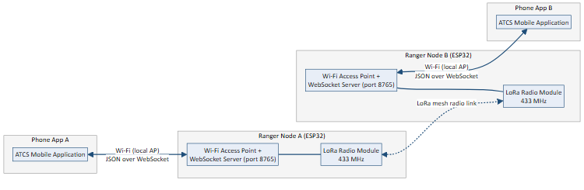
Figure 1. System Architecture Diagram
Figure 1 shows the two-tier shape of the system for a two-node deployment. Each Ranger node is simultaneously a LoRa mesh participant, relaying packets for other nodes, and a local access point serving exactly one nearby phone. A phone issues a command such as “send this text to Node 3” to its own node and never needs to know the mesh topology; the mesh determines how the message actually reaches its destination, including relaying it through intermediate nodes when the sender and the recipient are not within direct radio range of one another (Section 5.2.2).

5.2.1 Mesh packet format
Every packet exchanged over LoRa begins with a fixed-size header of 31 bytes, which is followed by up to 180 bytes of payload. The header is written field by field rather than transmitted as a raw in-memory structure, which avoids the extra padding bytes a compiler would otherwise insert and keeps every packet as compact as possible on a radio link where airtime is limited. Table 4 lists every header field.
Field | Size | Purpose
Type | 1 byte | Identifies the packet type (Table 5)
Message ID | 2 bytes | Originator-assigned identifier, used to detect duplicates and match acknowledgements
Source | 8 bytes | Node ID of the packet's original sender
Destination | 8 bytes | Node ID of the intended recipient, or “*” for a broadcast to every node
Previous hop | 8 bytes | The node that physically transmitted this copy of the packet — not necessarily the original sender
Time to live | 1 byte | Number of hops the packet may still travel before it is discarded
Hop count | 1 byte | Number of hops the packet has already travelled
Priority | 1 byte | Normal, control, or emergency — emergency traffic is always transmitted first
Payload length | 1 byte | Length of the data that follows the header
Table 4. Mesh Packet Header Fields

Packet Type | Purpose
DATA | Carries an actual application message — chat text, a location update, or a pairing request — addressed to one node or broadcast to all
ACK | Confirms that a DATA packet was received by its destination
HELLO | A short-range beacon a node sends periodically to announce itself to its direct neighbours
ROUTE REQUEST (RREQ) | Asks the mesh “does anyone know how to reach this node?” when no route is already known
ROUTE REPLY (RREP) | Answers a route request, retracing the path back to the node that asked
DISCOVER | An app-triggered scan asking “what nodes are out there?”, used when a user is adding a new device
DISCOVER REPLY | A node's answer to a discovery scan
SOS ACK | A lightweight, best-effort confirmation that a node received an emergency broadcast
NACK | Sent by a relay back toward a sender when it has no route to forward a message any further
Table 5. Mesh Packet Types

Every node is identified by a short, human-assigned ID of up to eight characters (for example “Node1”), configured individually on each physical device before it is flashed with the firmware. The reserved address “*” means broadcast: a packet addressed to “*” is delivered to every node that receives it and re-transmitted onward while its time-to-live allows, which is the mechanism the Emergency broadcast feature (Section 5.6.3) is built on.

5.2.2 Multi-hop relaying and route discovery
A key requirement identified in Chapter Four is that communication must continue to work even when the sender and the intended recipient are not within direct radio range of each other. This is satisfied by giving every node the ability to relay packets on behalf of other nodes, combined with a reactive route-discovery mechanism modelled on Ad hoc On-Demand Distance Vector (AODV) routing: a node only searches for a path to a destination when it actually needs to send something there, rather than continuously broadcasting full routing tables. When a node needs to reach a destination it has no known route to, it floods a route request outward; the destination (or any node already holding a route to it) replies, and every node the reply passes back through records a usable route in the process. Figure 6 (Section 5.6.1) illustrates this exchange for a three-node chain.
Every node that overhears a packet also learns, opportunistically, that the node which physically handed it that packet is a direct neighbour — so a route to any node currently within radio range is known immediately, without waiting for an explicit discovery round. Nodes further away are only discovered reactively, the first time something actually needs to be sent to them.

5.3 Hardware architecture
Each Ranger node is built around the same hardware subsystems identified during the design phase, with the corrections noted below reflecting the components actually used in the final build.
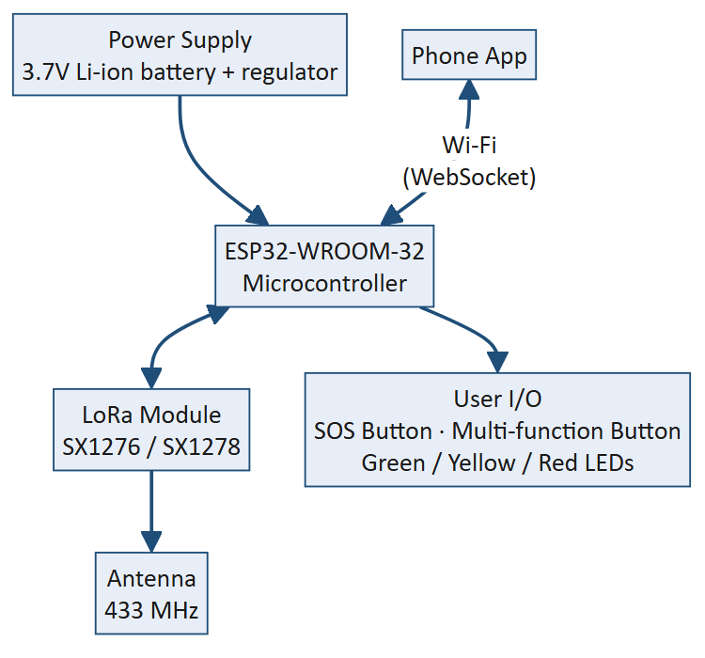
Figure 2. Hardware Block Diagram
The phone connects to the node over Wi-Fi rather than Bluetooth, as explained in Section 5.2; the hardware block diagram above reflects this. All other subsystems — the microcontroller, the LoRa radio and antenna, the battery and power regulation, and the button/LED user interface — match the original hardware design.

5.3.1 Primary hardware components

1. Microcontroller — ESP32-WROOM-32
Manages the system, encodes and decodes mesh packets, drives the LoRa radio over SPI, and runs the Wi-Fi access point and WebSocket server the phone connects to. The ESP32-WROOM-32 provides built-in Wi-Fi, sufficient processing power for the mesh-routing and message-handling logic, and is low-cost and widely supported for embedded development, making it well suited to a portable emergency communication node.

2. LoRa module — Semtech SX1276 / SX1278
Enables long-range communication between nodes. These modules provide reliable LoRa modulation, are well documented, and interface with the ESP32 over SPI.

3. Antenna — 433 MHz whip or PCB antenna
Transmits and receives LoRa signals. The final firmware configures the radio for the 433 MHz band — a license-friendly ISM band with good obstacle and foliage penetration for the target deployment regions — rather than the 868/915 MHz bands considered during early design; Table 3 lists the complete radio configuration.

4. Power supply — 3.7 V Li-ion battery and 3.3 V voltage regulator
Supplies stable voltage to the microcontroller and peripherals, ensuring stable operation and portability without reliance on external power.

5. Battery — 18650 Li-ion or LiPo 3.7 V rechargeable
Acts as the node's portable energy source. Note that live battery-level sensing (e.g. displaying a charge percentage on the status LED) was evaluated during design but was not implemented in the final firmware, since the prototype boards were not fitted with a fuel-gauge or ADC-based voltage sensing circuit; this is recorded as a limitation in Section 6 rather than presented as delivered functionality.

6. Buttons — tactile push buttons
Provide user input for the SOS and multi-function controls described in Section 5.5.2. Simple and robust, and easy to operate under emergency conditions with minimal technical knowledge.

7. LEDs — Green, Yellow, Red
Act as status indicators for power, communication activity, and warning/error conditions respectively, giving the user feedback even when no phone is connected. (An earlier version of the communication-flow diagram used elsewhere in project documentation mislabelled the middle LED as blue; the firmware and the physical build both use yellow, and that has been corrected throughout this report.)

8-11. Supporting components
Current-limiting resistors, smoothing capacitors, a micro-USB debug/programming port, and a prototyping/PCB board complete the build, serving the same protective, stabilising, and mechanical-mounting roles identified during the original hardware design.
Parameter | Value | Rationale
Frequency | 433 MHz | License-friendly ISM band with good obstacle penetration for the deployment region
Spreading Factor | SF9 | Balances range against airtime for a mesh expecting a small number of hops
Bandwidth | 125 kHz | Standard LoRa bandwidth balancing throughput and sensitivity
Coding Rate | 4/5 | Lightest forward-error-correction overhead, favouring throughput
Transmit Power | 20 dBm | Maximum permitted output, maximising single-hop range
Sync Word | Private (non-default) | Isolates the network from other, unrelated LoRa traffic in the area
Table 3. Radio Configuration Parameters

5.4 Schematic diagram
The detailed electrical schematic developed during the hardware design phase (component-level wiring between the ESP32, the SX1278 module, the power-regulation circuitry, and the LED/button interface) remains the authoritative reference for PCB fabrication and is retained from the original hardware design documentation as Figure 3. To keep this schematic traceable to the firmware that was actually flashed onto the hardware, Table 6 below lists the microcontroller pin assignment exactly as configured in the final firmware source.
[Figure 3 — System Schematic Diagram — to be inserted from the project's hardware design files.]
Signal | ESP32 Pin | Signal | ESP32 Pin
LoRa SCK | GPIO 19 | SOS Button | GPIO 13
LoRa MISO | GPIO 18 | Multi-function Button | GPIO 0
LoRa MOSI | GPIO 5 | Green LED | GPIO 2
LoRa CS (NSS) | GPIO 17 | Yellow LED | GPIO 14
LoRa RST | GPIO 16 | Red LED | GPIO 12
LoRa DIO0 | GPIO 4
Table 6. Firmware Pin Assignment

5.5 Software architecture
The system software is organised into four layers rather than the two originally envisioned, reflecting the introduction of a dedicated mesh-routing layer and a distinct application-level JSON protocol between the phone and its node.
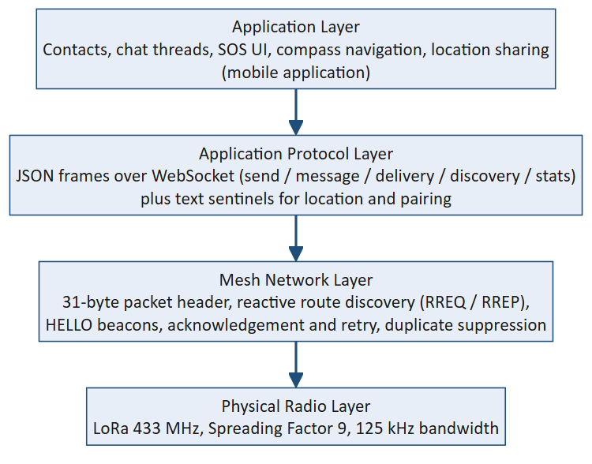
Figure 4. Software / Protocol Layering Diagram
The physical radio layer and the mesh network layer both run entirely on the ESP32 firmware, written in Arduino C++. The application protocol layer defines every JSON message exchanged over the WebSocket link (Section 5.6), plus a small number of plain-text conventions carried inside ordinary chat payloads for location sharing and device pairing. The application layer — contacts, chat threads, the Emergency broadcast channel, compass navigation, and location sharing — is implemented entirely within the mobile application, built with a modern web application framework (Next.js/React, in TypeScript) and packaged as a native Android application using Capacitor, which provides access to device GPS, orientation sensors, and platform-level networking APIs while keeping a single shared codebase.

5.6 Communication workflow
The communication workflow defines how a message actually propagates through the implemented system, from the moment a user presses send to the moment delivery is confirmed on their screen.
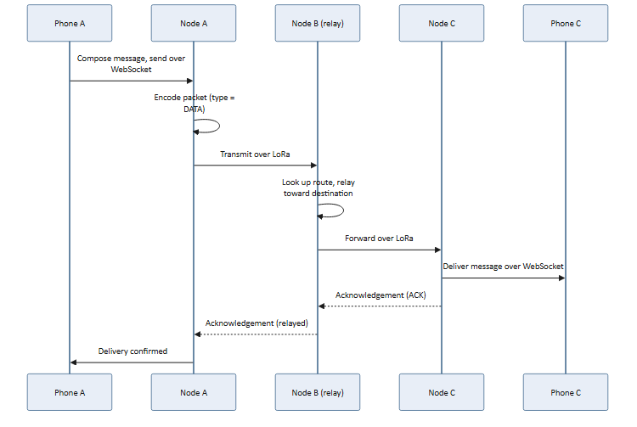
Figure 5. Message Delivery Sequence Diagram

Step 1 — Compose
The user composes a message in the mobile application.

Step 2 — Send over Wi-Fi
The application sends a small JSON command over its WebSocket connection to the locally connected Ranger node, naming the intended recipient and the message content.

Step 3 — Encode and transmit
The node encodes the message into a DATA packet carrying the 31-byte mesh header described in Section 5.2.1, and transmits it over LoRa.

Step 4 — Relay if necessary
If the destination is not a direct neighbour, intermediate nodes relay the packet one hop at a time toward it, decrementing the time-to-live and forwarding it according to a route either already known or discovered on demand (Section 5.6.1).

Step 5 — Deliver and acknowledge
The destination node delivers the message to its own connected phone over WebSocket, and sends an acknowledgement back along the same path the message arrived by.

Step 6 — Confirm
The acknowledgement is relayed back to the originating node, which reports delivery to the sending phone; the message status in the application updates from “sent” to “delivered”.
If no acknowledgement arrives within the expected time, the sending node automatically retransmits the message a bounded number of times, and — if the destination still cannot be reached — attempts one additional round of route re-discovery before finally reporting the delivery as failed to the sending phone. This is the mechanism referred to in Chapter One as resilient multi-hop relaying: the network buffers and retries a message on the sender's behalf while a usable path to the destination is unavailable or being re-established, rather than requiring the destination to already be reachable at the moment of sending.
A duplicate-detection cache prevents the same logical message from being processed twice when a packet is legitimately re-transmitted or received by more than one path, and a priority scheme ensures that emergency traffic is always transmitted ahead of ordinary chat traffic when a node has more than one packet queued.

5.6.1 Reactive route discovery
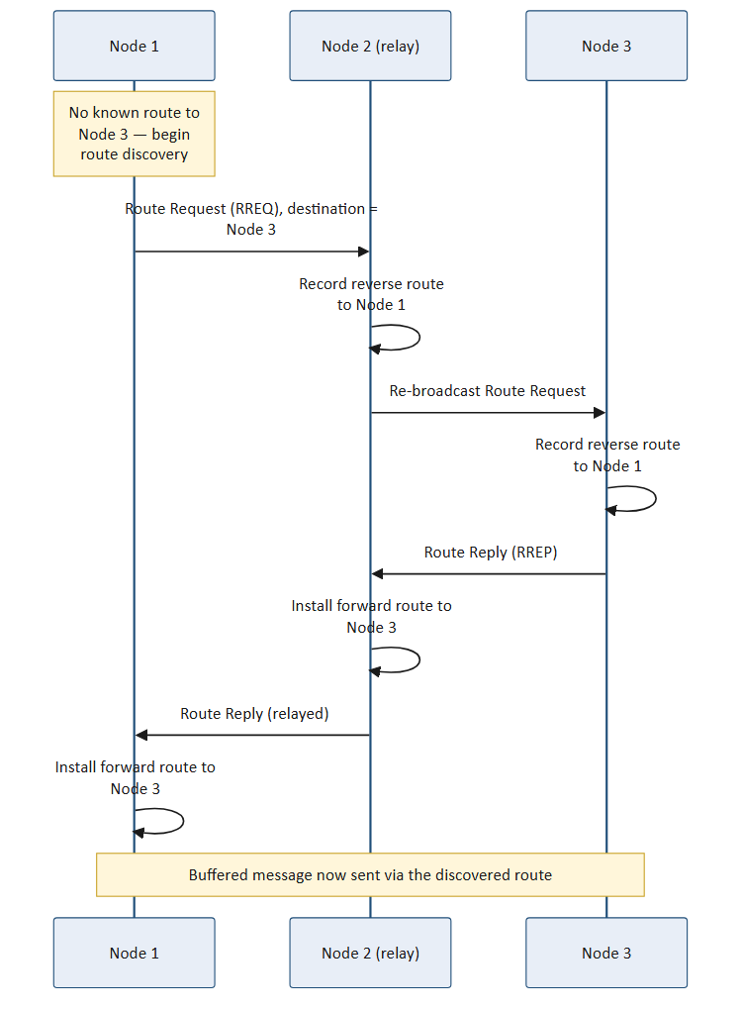
Figure 6. Reactive Route Discovery Sequence Diagram (RREQ / RREP)
Figure 6 shows a route request/route reply exchange for a message from Node 1 to Node 3, where the two nodes are not within direct range of one another and Node 2 sits between them. Node 1 floods a route request; Node 2 relays it onward while recording a reverse route back to Node 1; Node 3 replies, and the reply retraces the same path back, installing a usable forward route at every node it passes through. A single discovery round therefore benefits every node along the path, not only the two endpoints.

5.6.2 Device discovery and pairing
Before two nodes can exchange messages, their owners must first discover and pair with one another. A user opens the “add device” screen in the mobile application, which repeatedly sends a discovery scan through the local node; every node that hears the scan replies, and the results (including how many hops away each node is) are shown in the application. Tapping “add” on a discovered node sends a pairing request to it over the mesh; the receiving node's application automatically accepts and replies, so that only one side needs to take action for both users to end up with each other as a saved contact.

5.6.3 Emergency (SOS) broadcast
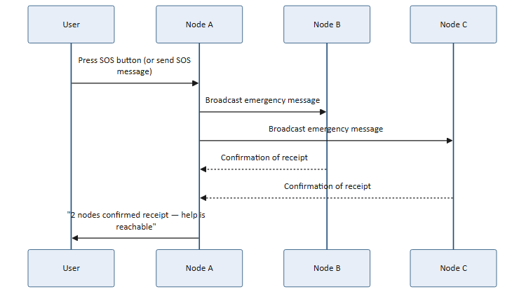
Figure 7. Emergency (SOS) Broadcast Sequence Diagram
Pressing the physical SOS button, or sending a message containing the word “SOS” from within the application's Emergency channel, triggers a broadcast addressed to every node (“*”) rather than a single recipient. The message is given the highest transmission priority and sent as a short burst of repeated copies for resilience against a single lost packet, rather than relying on the same acknowledgement-and-retry mechanism used for ordinary one-to-one messages — individually acknowledging a broadcast to every node in range would itself flood the network. Each node that receives the broadcast instead sends a lightweight, best-effort confirmation back to the sender, and the sender's application accumulates these into a running count (“2 nodes confirmed receipt”), giving the sender confidence that help is reachable without requiring guaranteed delivery to every single node.

5.6.4 Location sharing
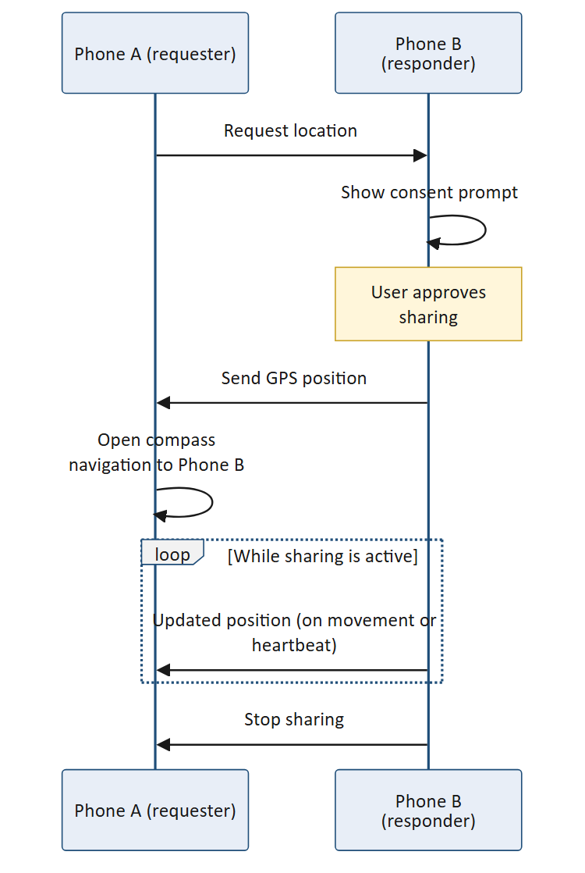
Figure 8. Location Sharing Sequence Diagram
A user can request another node's location, which always requires the other person's explicit consent before anything is shared. Once accepted, the responder can share either a single, one-time position or a continuously updated “live” position; live sharing sends an updated position whenever the sharer has moved a meaningful distance, or periodically even while stationary, so the requester has continuing proof the share is still active. The requester's application opens a compass view automatically as soon as the first position arrives, showing a live bearing and distance toward the other person rather than a map (Section 5.6.5).

5.6.5 Compass-based navigation
An earlier design direction explored offline map-based navigation, in which map imagery for the deployment area would be downloaded once and cached for fully offline use afterward. This approach was evaluated during development but was ultimately not carried into the final system: sourcing and packaging usable offline map tiles is itself a connectivity-dependent problem for a system whose core premise is guaranteed operation with no connectivity at all, and it added considerable engineering complexity for a feature whose core purpose — guiding one person toward another person's last known position — does not strictly require a map. The final implementation instead provides compass-based navigation: using the device's GPS position and its own compass heading, the application continuously computes and displays the bearing and distance to a contact's last known location, updating in real time as the user moves or turns. This was found during field testing to be a simpler, more robust guidance mechanism given the project's hardware and time constraints, at the acknowledged cost of not showing surrounding terrain or paths; this trade-off is revisited as future work in Chapter Six.

5.7 Message structure
At the mesh layer, every message is carried inside the fixed packet format described in Section 5.2.1 and Table 4: a message ID for duplicate detection and acknowledgement matching, source and destination node IDs, a hop count and time-to-live for routing, a priority level, and the message payload itself. At the application layer, the phone and its node exchange small JSON frames over WebSocket — for example a frame of type “send” to transmit a chat message, or a frame of type “message” delivering an incoming one, along with signal-quality and hop-count information so the application can show whether a contact is reached directly or via a relay. Location-sharing and device-pairing requests are carried as short, recognisable text prefixes inside an ordinary message payload (for example a location request or a pairing request), which keeps the firmware itself completely unaware of these higher-level features — it only ever handles opaque addressed bytes — so that new application-layer capabilities can be added without changing the firmware.

5.8 User interaction design
The system provides both a mobile application interface and a physical node interface.

Mobile application interface
The mobile application allows a user to view their contacts, hold private conversations and a shared Emergency broadcast conversation, see delivery status for each message, trigger an SOS broadcast and see mesh-wide confirmation as it arrives, request or share location (one-time or live), navigate toward a contact using the compass view, and discover and pair with nearby nodes — all without requiring any technical knowledge of the underlying mesh.
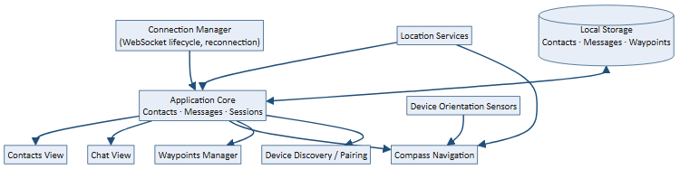
Figure 9. Mobile Application Architecture Diagram
Internally, the application is organised around a single connection manager responsible for the WebSocket link to the node, and a single application core that owns the contact list, message threads, and active sessions (an in-progress SOS, an active location share, an open navigation session). Every screen — contacts, chat, compass navigation, waypoints, and device pairing — reads from and updates this shared state rather than keeping its own independent copy, which keeps the application's behaviour predictable as features were added during development.

Node physical interface
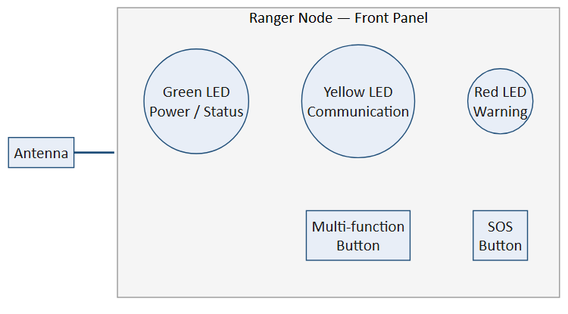
Figure 10. Ranger Node - Physical Interface
The multi-function button provides several operations through a single control: a single press toggles or triggers a device discovery scan, a double press forces the node to reconnect, and other gestures are reserved for maintenance actions. The dedicated SOS button immediately triggers an emergency broadcast regardless of what else the node is doing. The green, yellow, and red LEDs give at-a-glance status — power/normal operation, active communication or scanning, and warning or error conditions respectively — so a user can tell the node is working even without a phone connected.

5.9 System requirements

5.9.1 Functional requirements
- The system shall enable offline text-based communication without internet or mobile network coverage.
- The system shall support long-range communication between ESP32 LoRa nodes.
- The system shall relay messages across intermediate nodes using reactive route discovery so that nodes outside each other's direct radio range can still communicate.
- The system shall provide emergency SOS and emergency broadcast communication features.
- The system shall support automatic device discovery, pairing, and synchronization between nodes.
- The system shall support real-time messaging, message delivery, and communication status updates.
- The system shall support one-time and continuous (live) location sharing, subject to the recipient's explicit consent.
- The system shall provide compass-based bearing-and-distance navigation assistance toward a contact's last known location during emergencies.
The system shall provide a reliable, scalable, and user-friendly communication platform for emergency and remote-area communication.

5.9.2 Non-functional requirements
- The system shall operate with low power consumption.
- The system shall maintain reliable communication over long distances.
- The firmware shall use non-blocking operations.
- The system shall provide quick response to emergency broadcasts.
- The communication protocol shall minimize packet collisions.
- The system shall support scalability for multiple nodes.

5.9.3 Architectural requirements
The architecture follows a decentralized, multi-hop LoRa communication model. Each node acts independently and communicates using the mesh protocol described in Section 5.2. The firmware includes:
- Mesh packet encoding and parsing
- Neighbour discovery via periodic beacons
- Reactive route discovery and route table maintenance
- Duplicate packet suppression
- Acknowledgement, bounded retry, and route re-discovery for reliable delivery
- Priority-based transmit queueing (emergency traffic first)
- Device discovery and pairing handling
- Emergency broadcasting
- LED and button state management
- Wi-Fi access point and WebSocket communication with the mobile application

5.9.4 Testing plan and methods

Functional Testing
- Verified successful LoRa transmission and reception.
- Tested device discovery and pairing.
- Tested acknowledgement-based delivery confirmation.
- Tested multi-hop relaying and route discovery across more than two nodes.
- Tested SOS broadcast and mesh-wide confirmation.
- Verified LED state transitions and button gestures.

Performance Testing
- Measured RSSI and SNR values between paired nodes.
- Evaluated single-hop and multi-hop communication range.
- Tested route re-discovery behaviour when a node temporarily goes out of range.

Usability and Field Testing
- Tested the mobile application on Android hardware in field conditions in Dodoma, Tanzania.
- Verified WebSocket communication and reconnection behaviour under real Wi-Fi conditions.
- Tested compass navigation accuracy and GPS/orientation sensor behaviour outdoors.

5.9.5 Work done so far
At the current stage of the project, the system is fully implemented and functional at both the firmware and application level, and has moved substantially beyond the point reported in earlier progress documentation. The following has been completed:
- ESP32 and SX1278 hardware integration, with the radio configured as described in Table 3.
- A complete mesh-routing firmware implementing the packet format in Table 4, all nine packet types in Table 5, neighbour discovery via periodic beacons, reactive route discovery (RREQ / RREP), duplicate suppression, and an acknowledgement/retry/route-recovery reliability layer.
- A priority-based transmit queue that guarantees emergency traffic is sent ahead of ordinary traffic.
- Emergency SOS broadcasting with mesh-wide, per-node delivery confirmation.
- Automatic device discovery and pairing between nodes, requiring action from only one side.
- A Wi-Fi access point and WebSocket server on each node, replacing the Bluetooth link originally envisioned, and forming the sole interface between a node and its connected phone.
- A fully built and field-tested mobile application (Next.js/React, packaged as a native Android application) providing contacts, private and Emergency-broadcast chat with delivery status, SOS triggering with live confirmation count, one-time and continuous location sharing with consent, and compass-based navigation.
- LED state-machine and multi-function/SOS button logic on the node.
- RSSI/SNR signal diagnostics, together with a live reachability indicator in the application that distinguishes a directly-reached contact from one being reached through a relay, and names the relaying node.
Iterative field testing in Dodoma identified and led to the correction of several real-world integration issues beyond pure protocol logic — for example, the on-screen keyboard obstructing the message-composition interface on some Android devices, and status notifications overlapping one another when an emergency broadcast and an active navigation session occurred at the same time — both of which were identified through hands-on use and corrected through targeted interface and platform-configuration fixes. This kind of field-driven refinement is treated as part of the deliverable, not a separate activity, since a system intended for real emergency use must be validated under the same conditions it is meant to work in.
The current progress therefore represents a working, end-to-end system — firmware and application — that has been exercised on real hardware rather than only designed on paper. The activities that remain, including structured quantitative performance validation and hardware finalisation, are described in Chapter Six.

CHAPTER SIX: NEXT STEPS AND FUTURE WORK

6.1 Introduction
This chapter outlines the work that remains to take the decentralized emergency communication system from its current, functionally complete and field-tested state to a fully validated and deployment-ready solution. Unlike the position reported earlier in this project, the mesh firmware and the companion mobile application described in Chapter Five are both implemented and working end-to-end; what remains is primarily structured quantitative validation, hardware finalisation, and evaluation at a larger network scale.

6.2 Hardware finalisation
The prototype has been developed and tested on breadboard and hand-wired hardware. The next phase involves transitioning to a stable, field-ready build:
- Fabrication of a custom printed circuit board incorporating the ESP32-WROOM-32 microcontroller, the SX1278 LoRa module, power-management circuitry, LED indicators, and the button interfaces, following the pin assignment in Table 6.
- Integration of the 18650 Li-ion battery pack with the 3.3 V voltage regulator for stable, portable power delivery in the field.
- A mechanical enclosure providing weather resistance and physical durability suitable for rural environmental conditions, including exposure to dust, humidity, and elevated temperatures.
- Verification of antenna performance at 433 MHz to confirm the signal propagation needed for the target communication range.
- Addition of a battery fuel-gauge or ADC-based voltage-sensing circuit, so that battery-level reporting — evaluated but not implemented in the current prototype (Section 5.3.1) — can be added to both the node's status LED and the mobile application.

6.3 Structured field testing and performance validation
Functional testing to date (Section 5.9.4) has confirmed that transmission, reception, discovery, pairing, multi-hop relaying, acknowledgement-based delivery, and SOS broadcasting all work correctly. The next phase is a more rigorous, quantitative validation of the system's performance envelope under controlled and rural-like conditions, directly addressing Objective 4.

6.3.1 Communication range testing
Pairs of LoRa nodes will be deployed at progressively increasing distances, starting from 100 metres and extending to the maximum reliable range achievable under open-field and obstructed conditions. RSSI and SNR values will be recorded at each distance interval to characterize signal degradation patterns. The target range for reliable single-hop communication under rural conditions is a minimum of 2 kilometres, to be confirmed through these structured trials.

6.3.2 Message delivery reliability testing
A defined number of test messages will be transmitted between nodes at fixed distances, and delivery success rates will be calculated for both direct and multi-hop (relayed) transmissions. The acknowledgement, retry, and route-recovery mechanism described in Section 5.6 will be exercised under simulated intermittent connectivity — for example, temporarily powering down an intermediate relay node — to confirm that messages are successfully retried and re-routed once a usable path becomes available again.

6.3.3 Latency measurement
End-to-end message latency will be measured from the time of transmission initiation at the sender node to confirmed receipt at the destination node, for both direct and relayed deliveries. Latency measurements will be recorded across varying distances, hop counts, and network load conditions to characterize system responsiveness.

6.3.4 Power consumption assessment
Power consumption will be measured during active transmission, standby listening, and idle states using a precision current meter. Battery runtime will be estimated under simulated typical usage patterns, including periodic message transmission and continuous standby operation. The objective is to confirm that nodes can operate for a minimum of 24 hours on a single battery charge without access to grid power.

6.4 Multi-node network evaluation
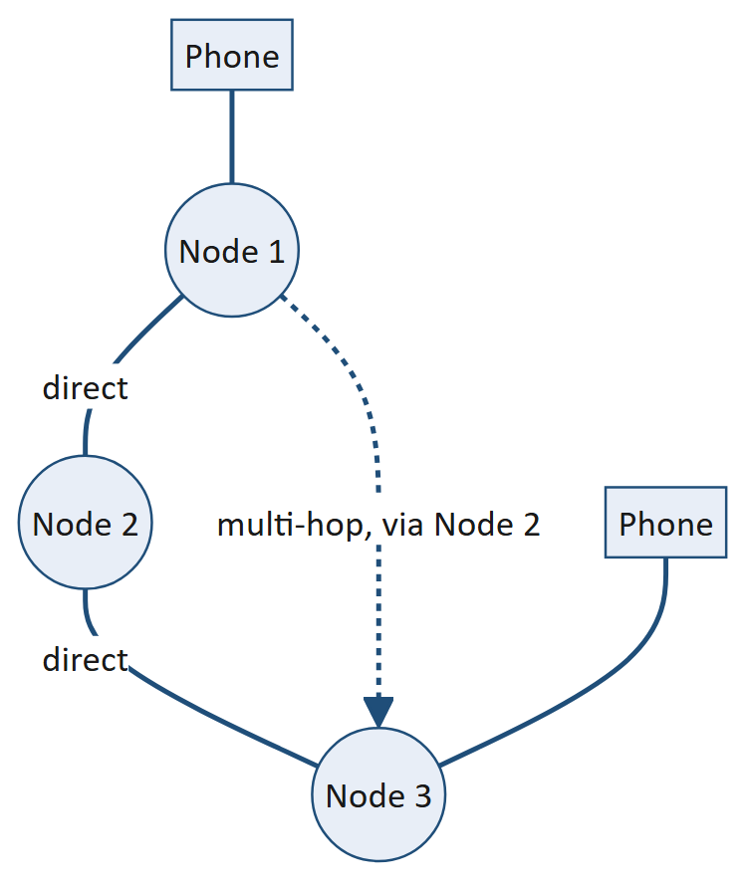
Figure 11. Mesh Topology with Multi-Hop Relaying
Testing to date has exercised both direct, two-node communication and small multi-hop chains. The next phase extends evaluation to a larger multi-node network configuration, illustrated in Figure 11, to assess scalability and network-wide behaviour under more realistic conditions. This evaluation will examine:
- Message delivery consistency when multiple nodes are transmitting within the same frequency channel simultaneously.
- The effectiveness of the priority-based queueing and duplicate-suppression mechanisms (Section 5.6) under increased network traffic.
- Route-discovery and relaying performance across intermediate nodes when the direct path between a sender and a receiver is obstructed or out of range, as in Figure 11.
A minimum network size of three to five nodes will be used for this evaluation phase to simulate a realistic small-scale rural community deployment.

6.5 Platform and feature extensions
- iOS packaging — the mobile application's underlying framework (Next.js/React with Capacitor) already supports iOS as a target platform in principle; the application has, to date, been built, field-tested, and validated on Android only, and packaging and testing an iOS build remains future work.
- Revisiting offline map-based navigation as a complement to the compass-based guidance delivered in the current system (Section 5.6.5), if development time allows, with particular attention to avoiding the connectivity-dependent map-distribution problems identified during the original evaluation of that approach.
- Support for more than one phone connecting to a single node's access point, to serve small teams sharing one node.

6.6 Documentation and reporting
Comprehensive documentation will continue to be produced to support reproducibility, future development, and potential community deployment. This includes hardware schematics and PCB design files, the firmware source code with inline documentation, the mobile application source code, and a deployment guide suitable for non-technical community facilitators. All findings from the structured validation phase described in Section 6.3 will be compiled into the final project report and submitted as the formal project deliverable.

CONCLUSION
This project has addressed a critical and persistent challenge facing rural communities in Tanzania and similar contexts across Sub-Saharan Africa: the absence of reliable, infrastructure-independent communication systems during emergencies. By investigating the failure modes of conventional cellular infrastructure, identifying user communication priorities, and designing a decentralized LoRa-based system, the project has produced a contextually grounded and technically feasible solution tailored to rural operational constraints.
The study began by establishing, through secondary research and field observation, that rural communities in Tanzania remain heavily dependent on single-point cellular infrastructure that is vulnerable to power outages, physical damage, and network congestion during emergencies. These findings confirmed the need for a resilient, decentralized system capable of operating entirely independently of conventional network infrastructure.
That system has since been designed, implemented, and field-tested. The final ATCS prototype consists of ESP32-based LoRa mesh nodes running firmware that performs reactive multi-hop route discovery, acknowledgement-based reliable delivery, and priority-based emergency broadcasting, paired with a fully built Android mobile application that gives users messaging, SOS, location sharing, and compass-based navigation without any reliance on cellular networks or the internet. The system has been exercised on real hardware in the field in Dodoma, Tanzania, and several design decisions in this report — including the move from a Bluetooth to a Wi-Fi/WebSocket phone-to-node link, and the move from offline map-based navigation to compass-only guidance — were made specifically in response to what that field testing revealed, rather than decided in advance on paper. What remains, as set out in Chapter Six, is primarily structured quantitative performance validation and the transition from prototype hardware to a finalised, field-ready build.

REFERENCES
Bagula, A., Zennaro, M., Inggs, G., Scott, S., & Gascon, D. (2016). Ubiquitous sensor networking for development (USN4D): An application to rural emergency communication. IEEE Communications Magazine, 54(4), 153-159. https://doi.org/10.1109/MCOM.2016.7470934
International Telecommunication Union. (2020). Disaster relief systems, network resilience and recovery (ITU-T Rec. L.392). Geneva, Switzerland: ITU.
United Nations Office for Disaster Risk Reduction. (2019). Global assessment report on disaster risk reduction. Geneva, Switzerland: United Nations.
World Bank Group. (2020). Information and communications for development: Maximizing mobile. Washington, DC, USA: World Bank.
Tanzania Communications Regulatory Authority. (2022). Quarterly communications statistics report. Dar es Salaam, Tanzania: TCRA.
GSMA. (2021). The mobile economy of Sub-Saharan Africa. London, UK: GSMA Intelligence.
LoRa Alliance. (2020). LoRaWAN™ specification v1.0.4. Fremont, CA, USA: LoRa Alliance.
Adelantado, F., Vilajosana, X., Tuset-Peiró, P., Martinez, B., Melià-Seguí, J., & Watteyne, T. (2017). Understanding the limits of LoRaWAN. IEEE Communications Magazine, 55(9), 34-40. https://doi.org/10.1109/MCOM.2017.1600613
Bor, M., Vidler, J., & Roedig, U. (2016). LoRa for the Internet of Things. Proceedings of the 2016 International Conference on Embedded Wireless Systems and Networks (EWSN), Graz, Austria.
Petäjäjärvi, J., Mikhaylov, K., Hämäläinen, M., & Iinatti, J. (2017). Evaluation of LoRa LPWAN technology for remote health and emergency monitoring. In IEEE International Conference on Wireless Communications and Networking.
Meshtastic Project. (2023). Meshtastic: Open source, off-grid, decentralized messaging. Retrieved from https://meshtastic.org
teKsafari. (2023). Fling: Infrastructure-free communication using LoRa. Retrieved from https://www.teksafari.org/notes/fling
Augustin, A., Yi, J., Clausen, T., & Townsley, W. (2016). A study of LoRa: Long range & low power networks for the Internet of Things. Sensors, 16(9), 1-18. https://doi.org/10.3390/s16091417
Kumar, S., Kumar, A., & Singh, R. (2020). Store-and-forward communication techniques for delay-tolerant emergency networks. International Journal of Communication Systems, 33(5). https://doi.org/10.1002/dac.4184
Perkins, C., Belding-Royer, E., & Das, S. (2003). Ad hoc On-Demand Distance Vector (AODV) Routing (RFC 3561). Internet Engineering Task Force.

