

Big Data Analytics Lab

PMDS507P

Name: **Tufan Kundu** Registration number: **24MDT0184**

Slot: L29+L30

Digital Assignment 4

# 

## 

## Explain the procedure to run the Hadoop WordCount program using the in-built mapreduce-examples.jar.

**Step 1:** Preparing the text file

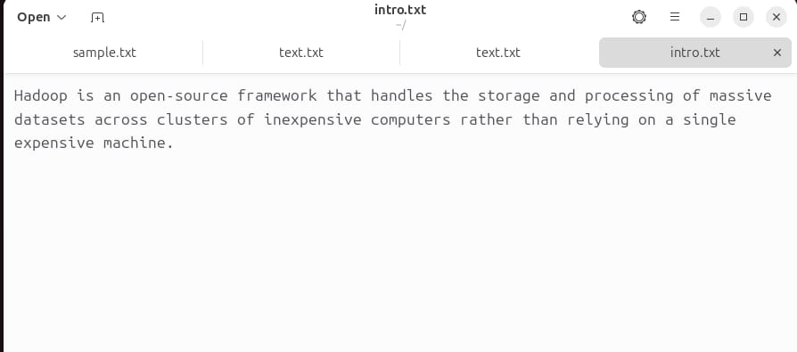

**Step 2**: Start HDFS and YARN and verify with jps

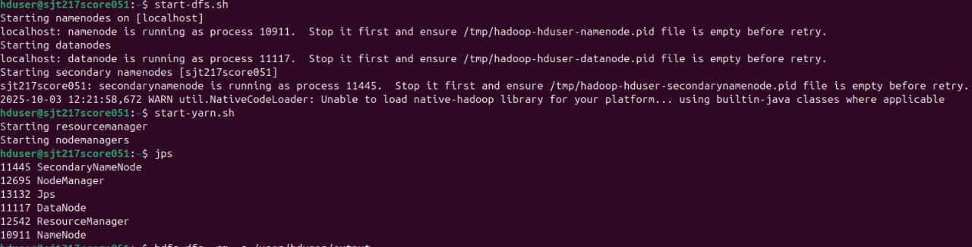

**Step 3:** Creating the directory

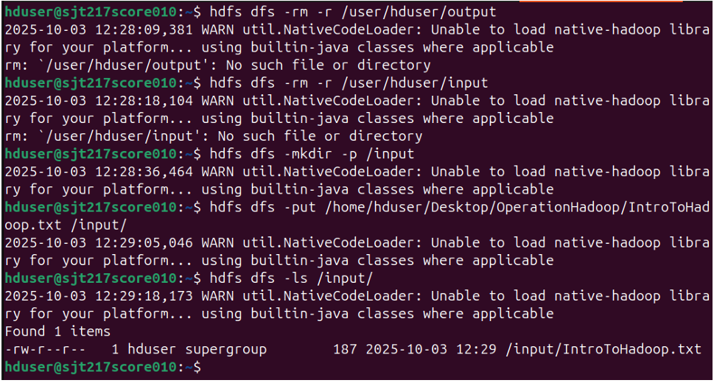

**Step 4:** Displaying the text file

***hdfs dfs -cat /input/intro.txt***



**Step 5:** Running wordcount by inbuilt mapreduce functions

***hadoop jar /home/hduser/hadoop/share/hadoop/mapreduce/hadoop-mapreduce-examples-3.3.1.jar wordcount /input /output***

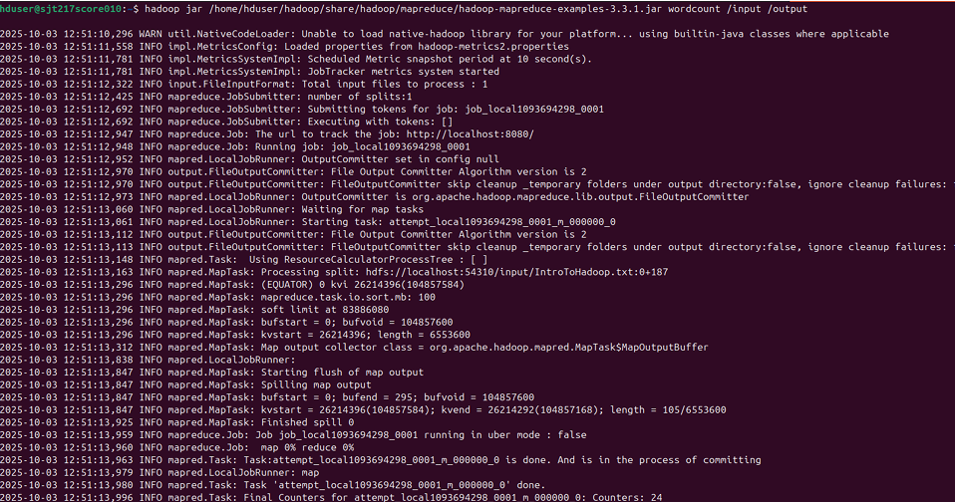

**Step 6:** Display the results

***hdfs dfs -cat /output/part-r-00000***

