Introduction to STARS

*Xinyue Ye (Email:* [xye5@kent.edu](mailto:xye5@kent.edu)*, wechat: 2241165161 qq: 2241165161)*

STARS (Space Time Analysis of Regional Systems) was developed by Prof. Sergio Rey and others.

区域系统时空分析（STARS）是一个开源软件包，专为空间面板分析而设计。 STARS将时空分析方法汇集成一个用户友好的图形环境，提供一系列动态链接的图形视图。它旨在用作探索性数据分析工具。 STARS也可以从命令行使用，以支持高级用户更灵活和专门的分析类型。STARS完全以Python编写，STARS是跨平台的，易于安装和扩展。

The interface of STARS will be launched as the following:

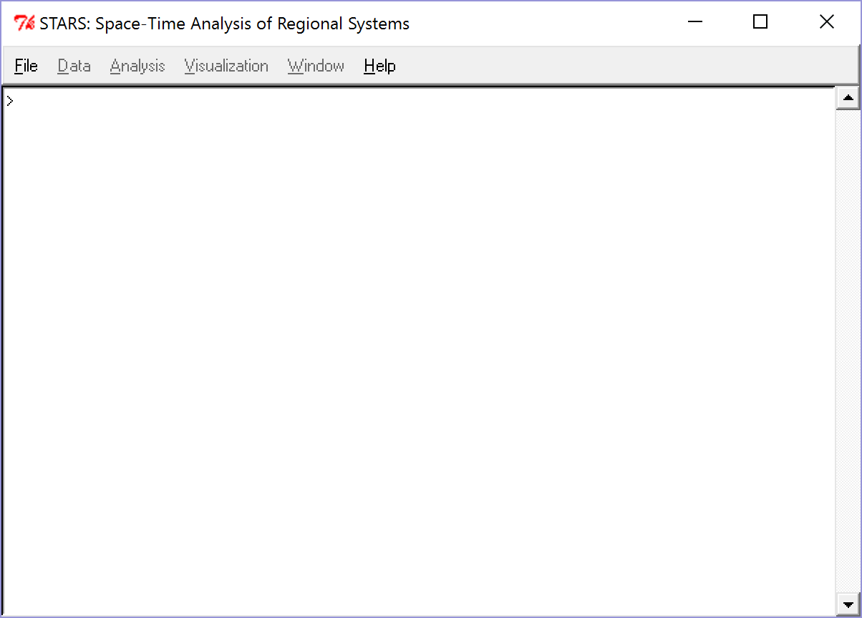

STARS中包含计算方法

Descriptive statistics contains distribution and summary measures for variables by cross-section, time period, or pooled. Exploratory spatial data analysis includes various methods specifically designed to analyze spatial dependence such as Global and local versions of Moran’s I, Geary’ c and the G statistic. Inequality measurements quantity and decompose inequality over time and space, such as classic and spatial Gini Coefficients as well as Theil decomposition. Mobility presents internal mobility dynamics. Markov analysis examines transitional dynamics of distributional attributes through the use of classic Markov and spatial Markov techniques.

Check your C folder:

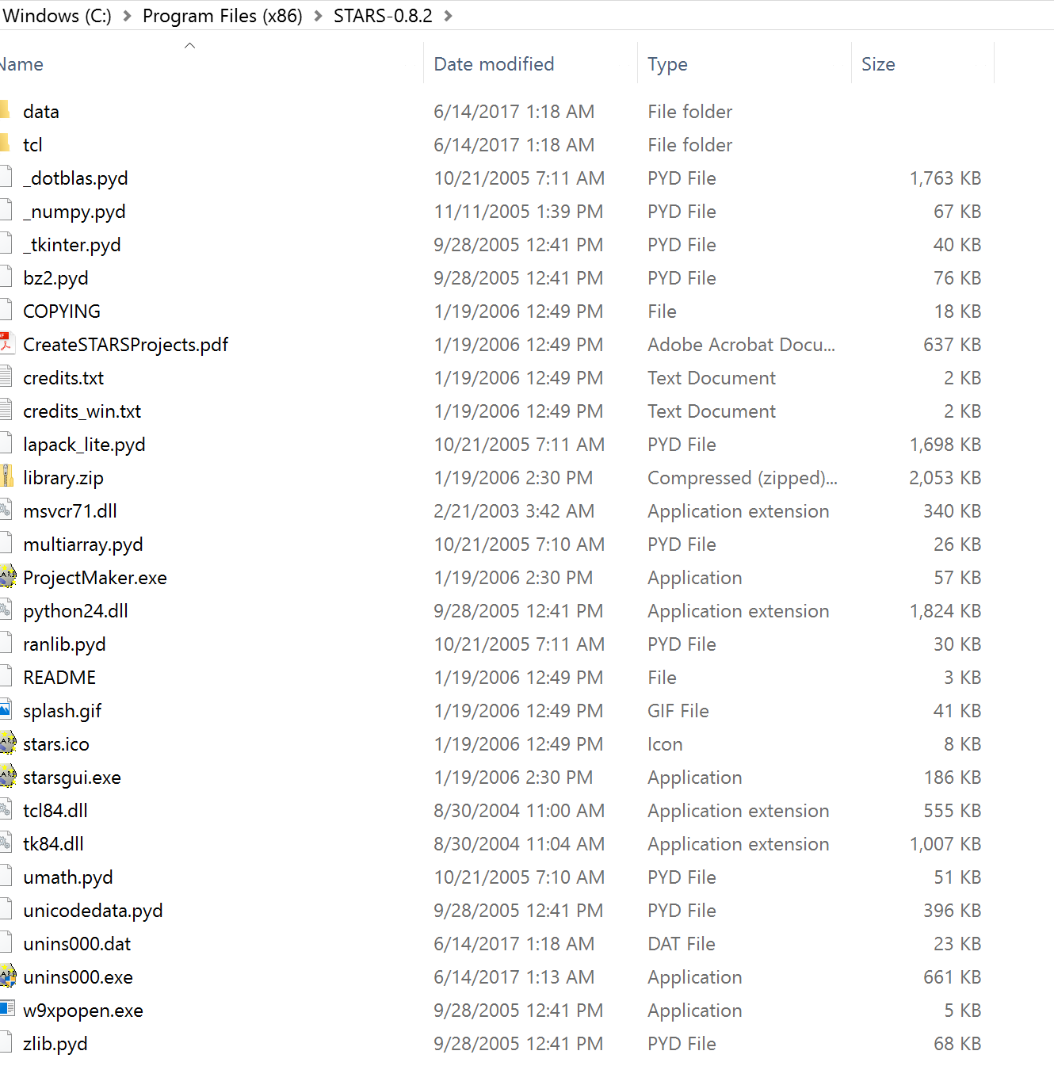

There are two components to STARS: A project maker and the software itself.

CreateSTARSProjects.pdf shows How to Create STARS Projects with ProjectMaker.

Double click ProjectMaker.exe:

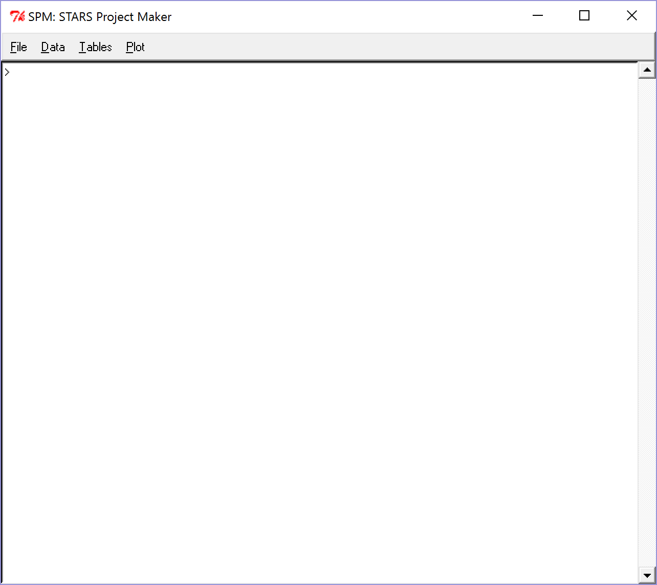

Follow CreateSTARSProjects.pdf to get your own STARS project files. The following demo will show you how to use the sample data.

STARS附带了一个内置的示例项目(sample data)，我们将使用它来说明一些核心功能。在Windows下启动STARS可以通过双击其图标完成。从那里可以通过从菜单中选择Help-Example Peoject来加载示例项目。屏幕应如下所示：

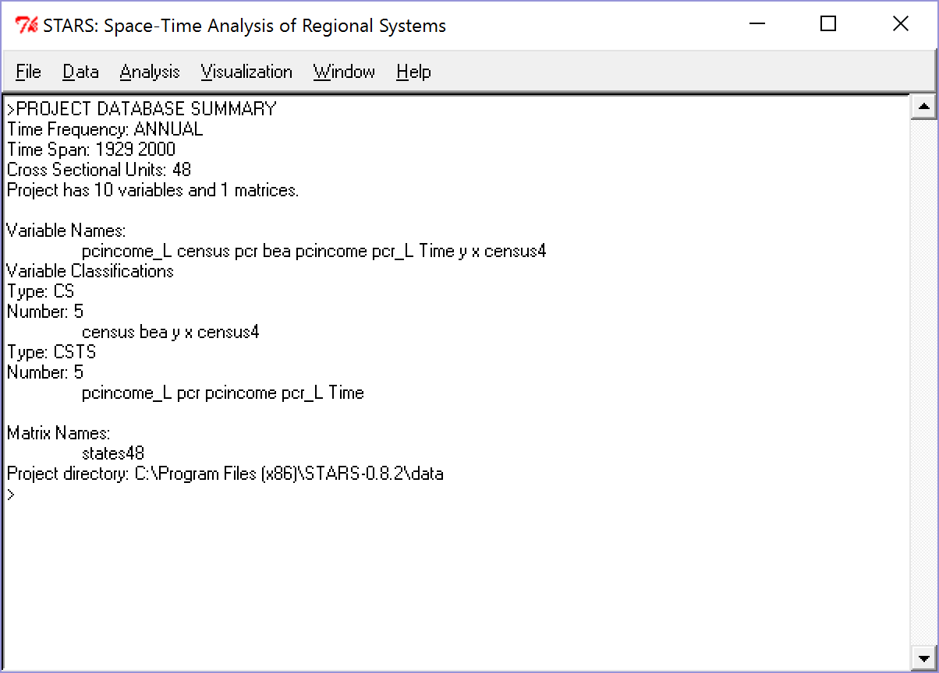

该示例项目在美国48个州中有72年的数据。我们要分析的关键变量是pcr(人均收入标准化到一年的平均水平)。为了开始我们的探索，我们首先对样本中每年的空间自相关进行分析。这是通过选择Analysis-ESDA-Global Moran来完成的，这将引发以下对话。

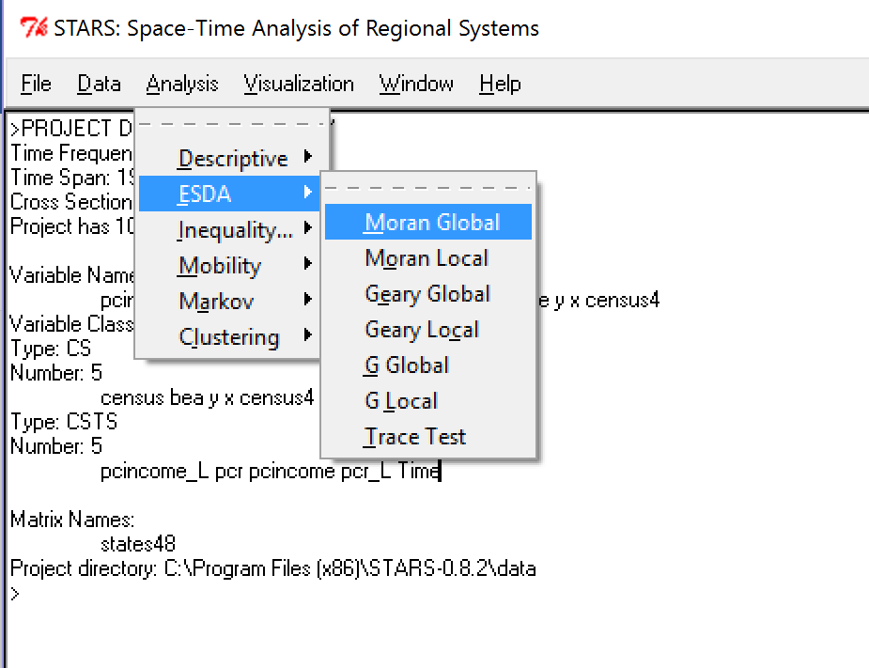

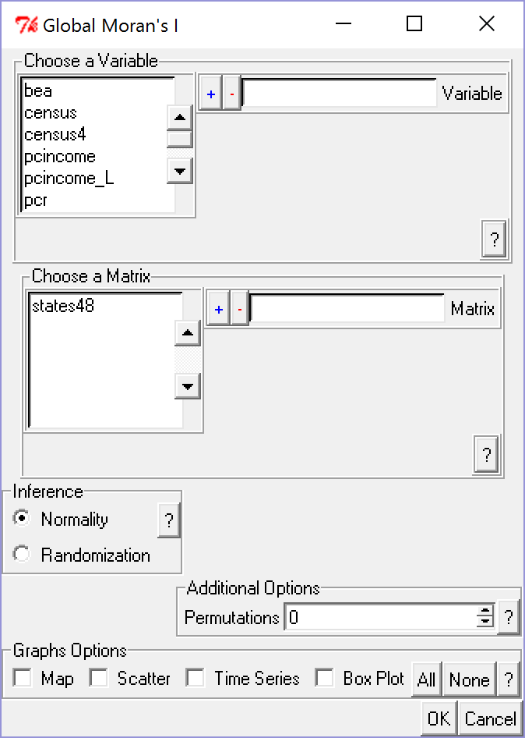

To do Global Moran’s I, you need to select a variable, a spatial matrix, inference/permutation, and graphs (optional).

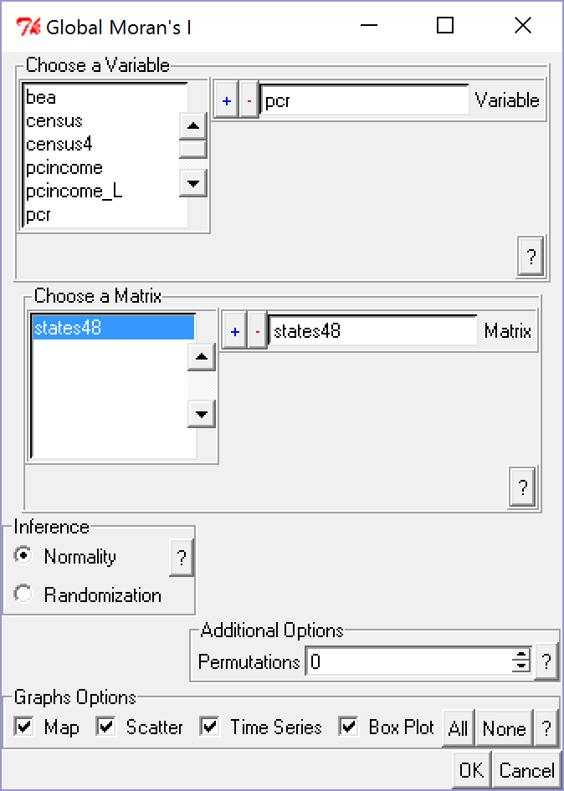

您将同时获得四个视图。左上方1929年的人均收入使用了奎特里图。旁边是同年的莫兰散点图。右下方的视图是该年收入的Box Plot，左下角的视图是Global Moran统计的时间序列图。这四个视图提供了有关数据的空间，时间和分布维度。为了进一步探索这些维度之间的关系，STARS实现了许多类型的交互式可视化。

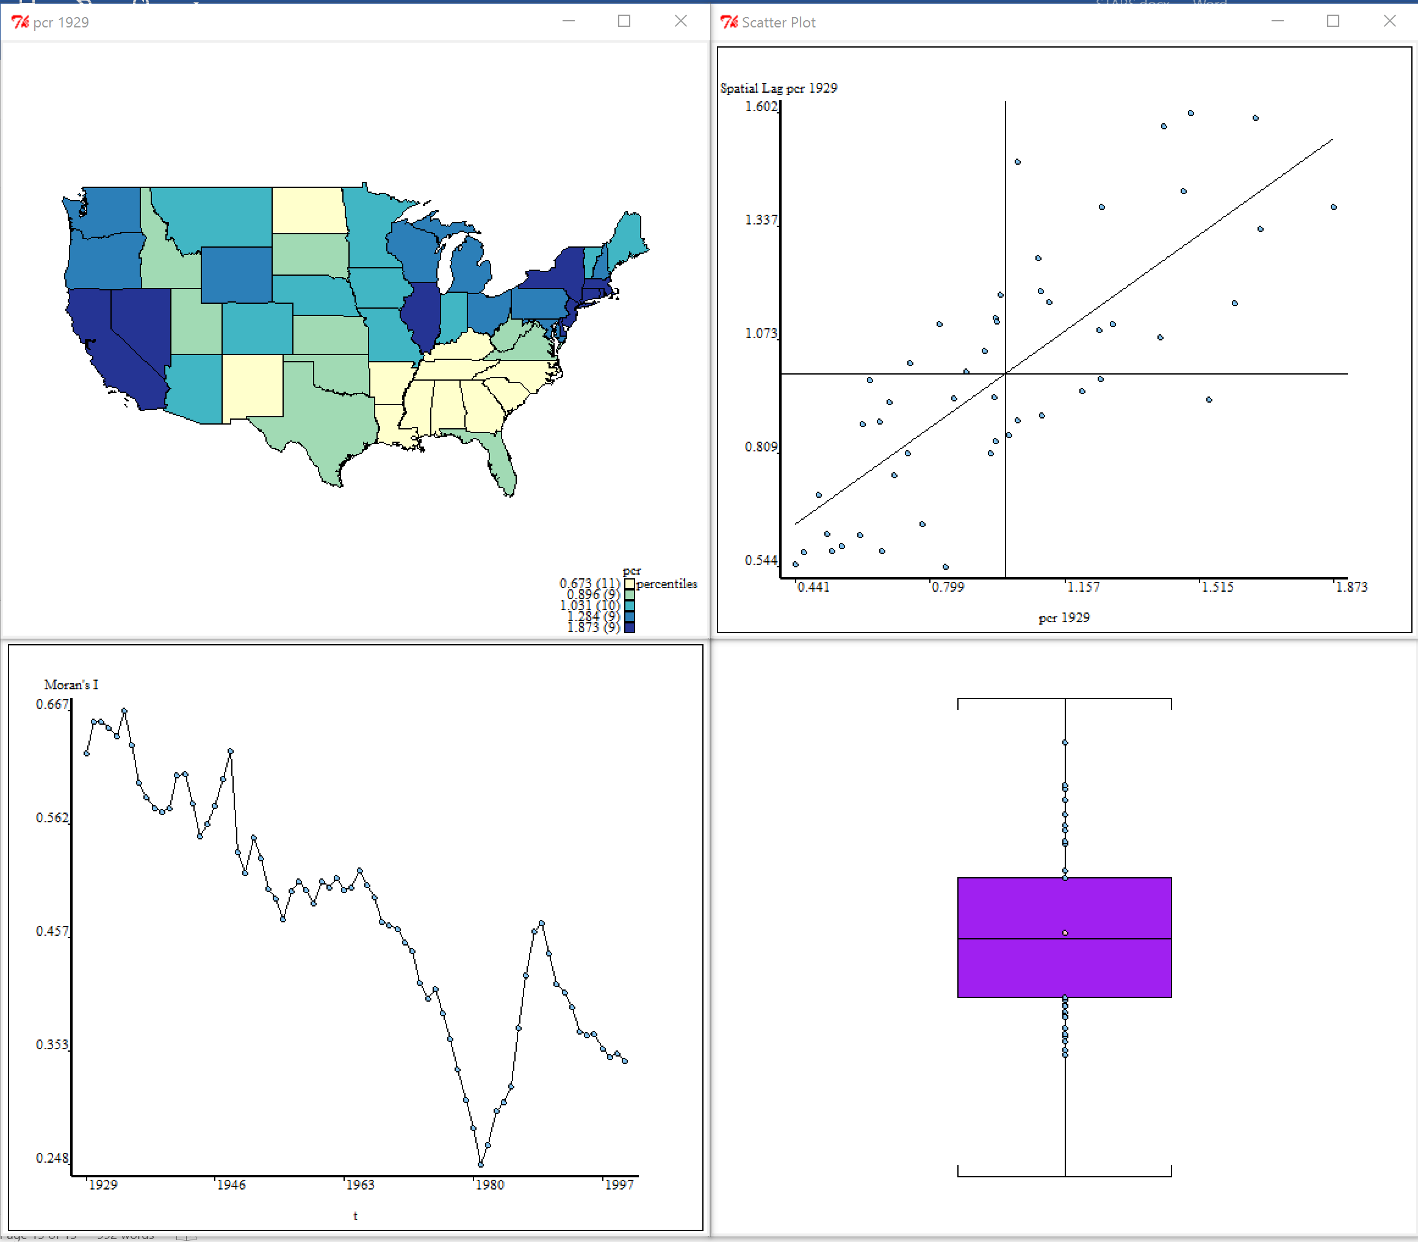

Click Time Series Plot (bottom left) and right click/interaction/travelling

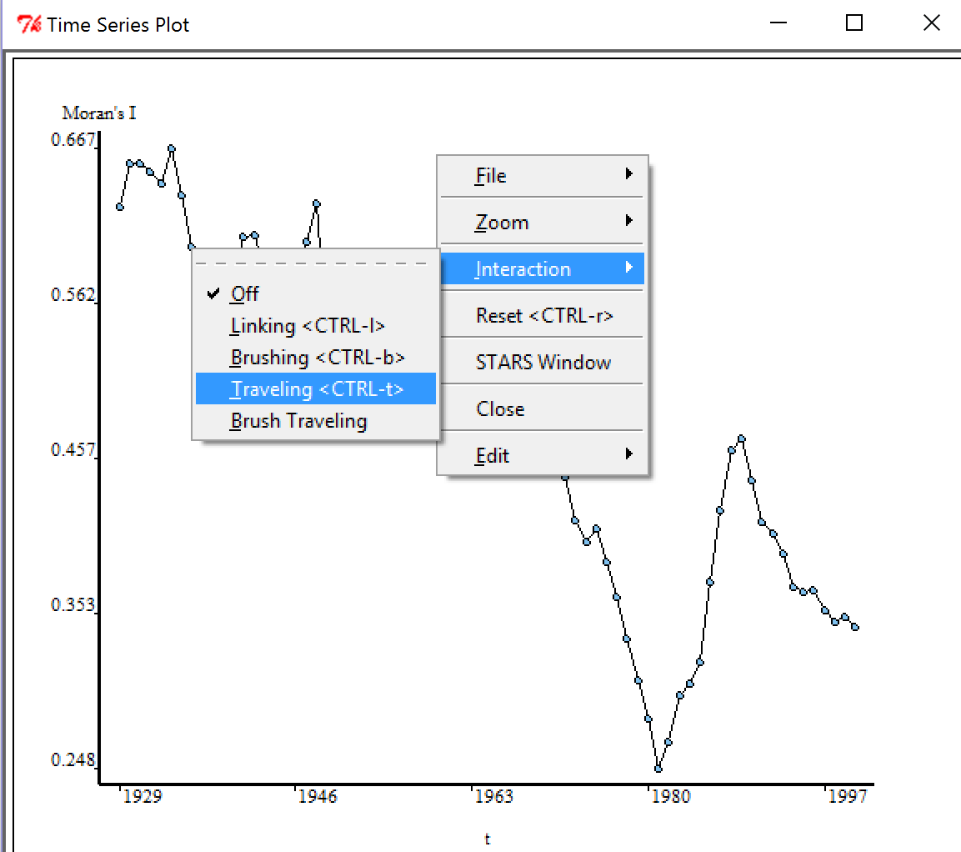

You will find out how these four figures are linked and move over time.

The main interface reports the calculation results:

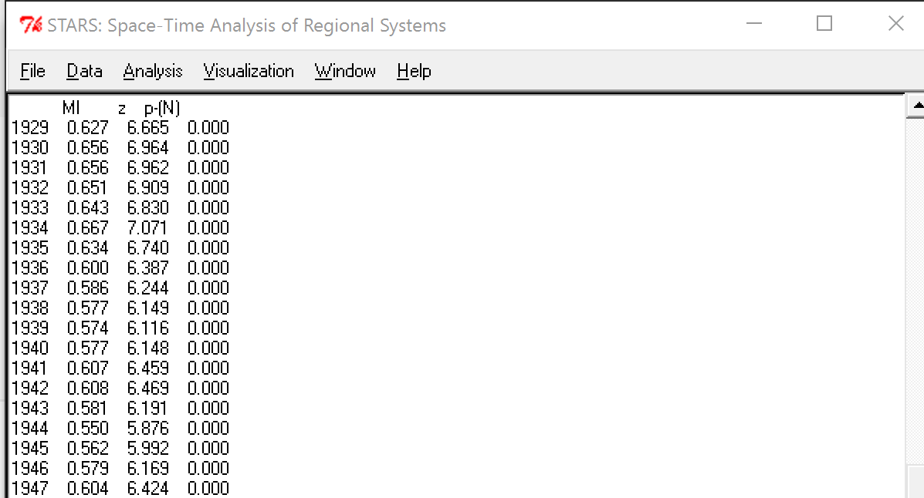

You can add more graphs, such as:

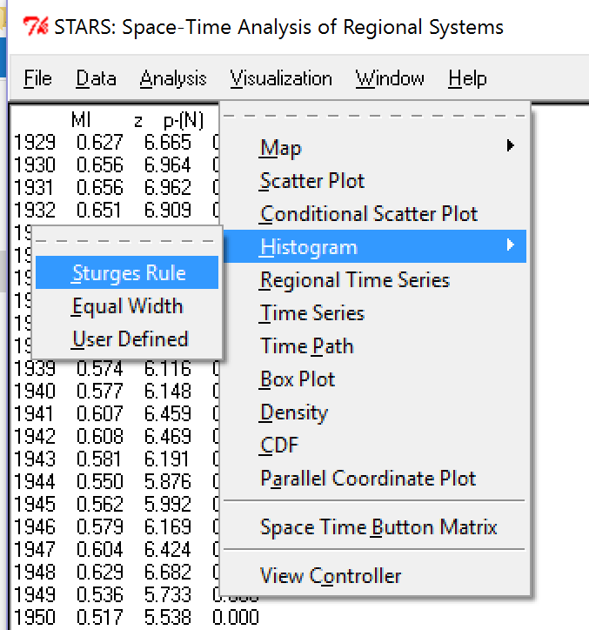

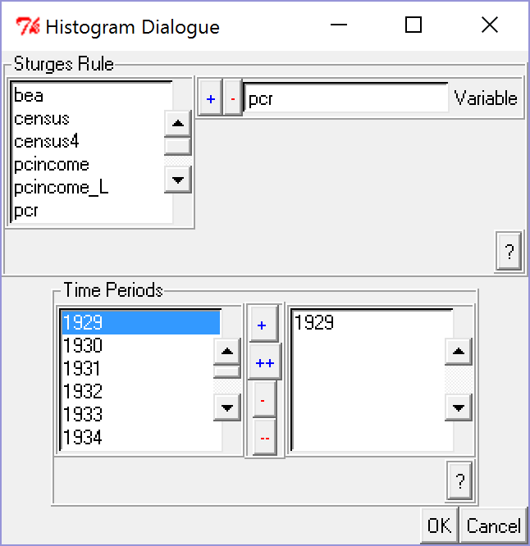

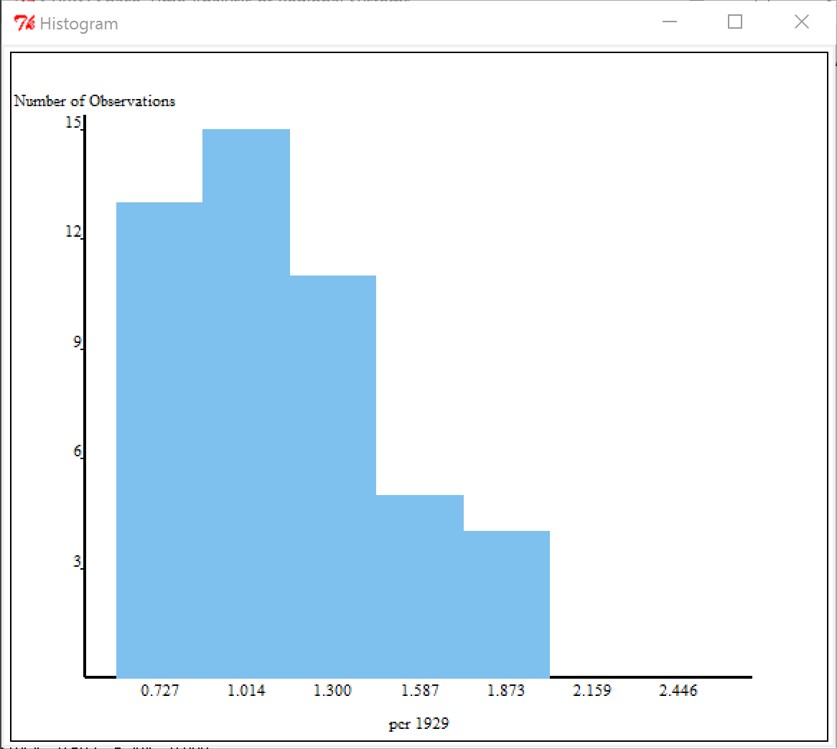

Try travel again, and you will find out all these graphs are linked. The final output of the histogram will be:

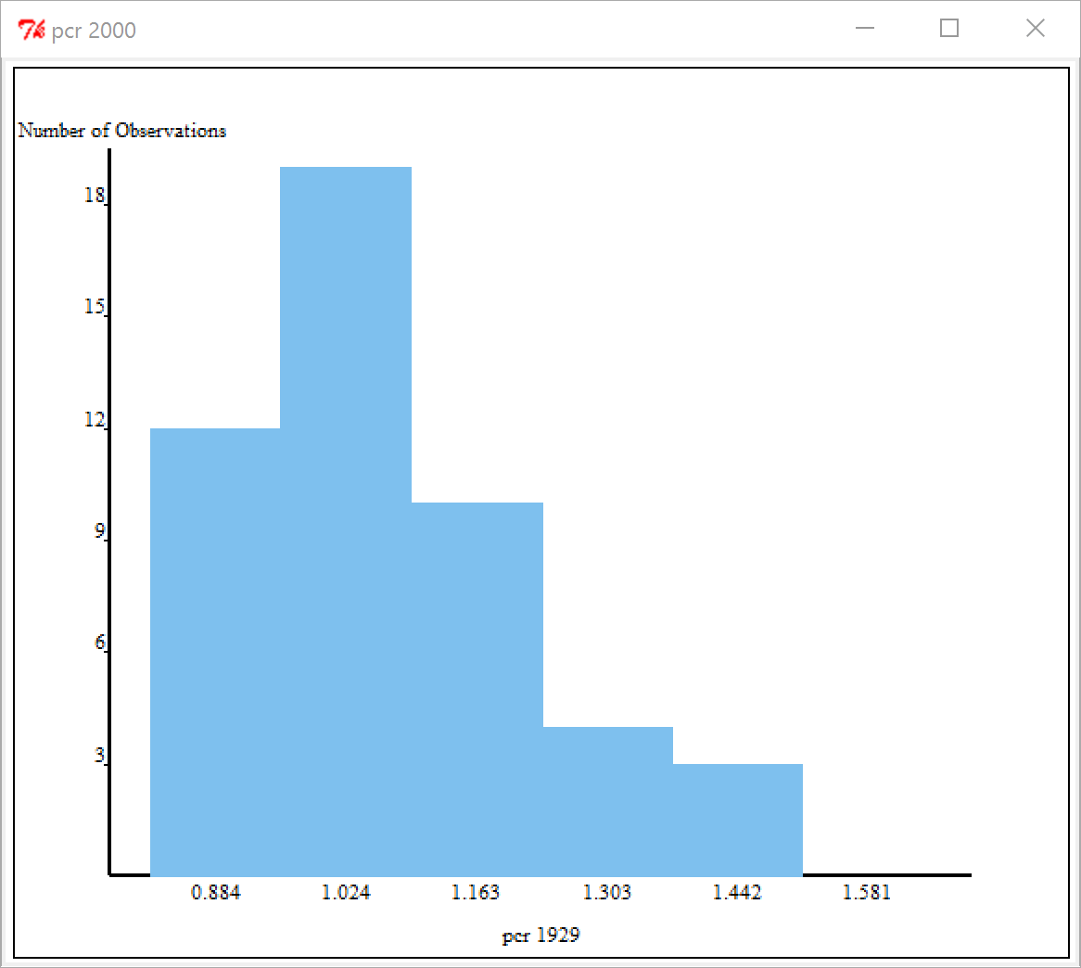

You can check how these functions work by reading the codes:

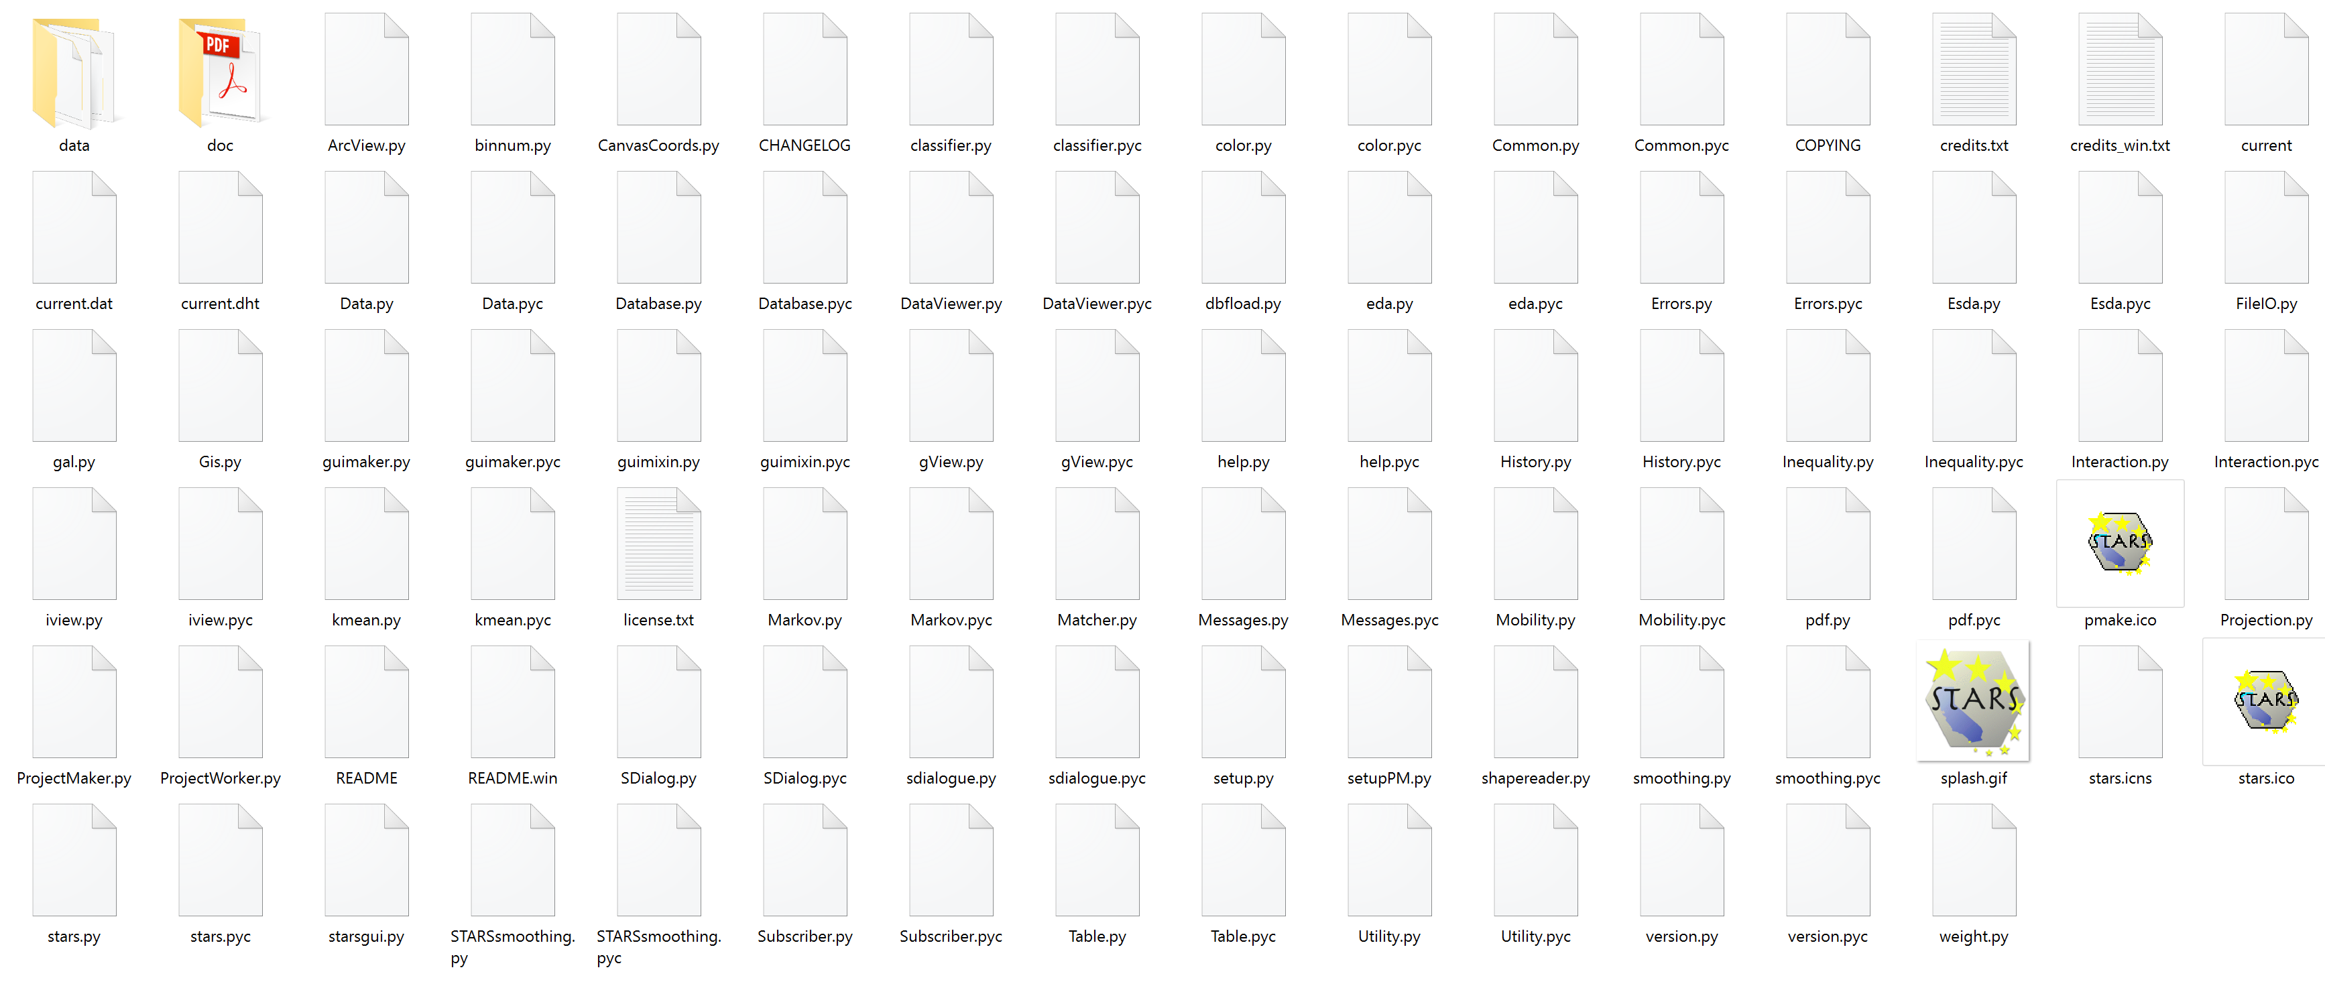

Open esda.py in the word:

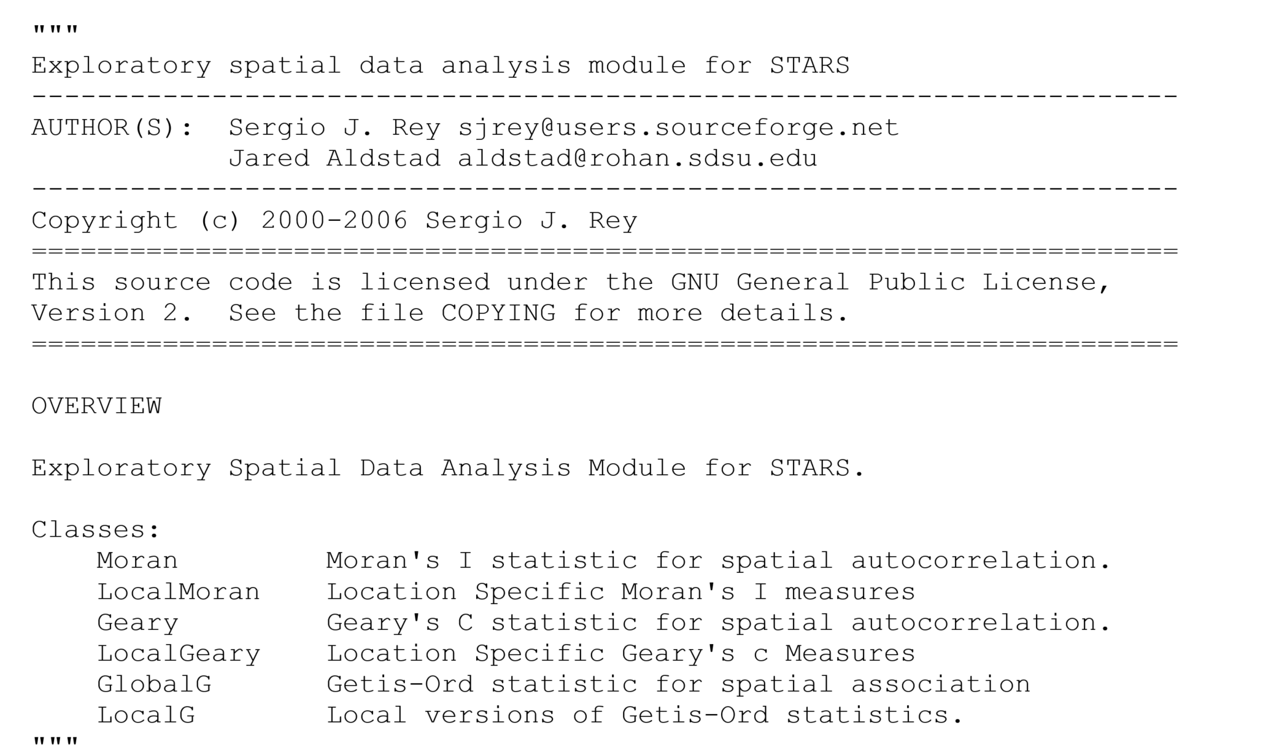

这里考虑了两个社区的并置，第一个包括学术空间分析领域，而第二个是更广泛的开源软件世界。空间分析和开源运动平行兴起。这些问题超越了空间分析软件工具的开发，对学科未来的发展具有重要的意义。开放源代码被称为“二十世纪唯一真正创新的商业概念，代表了新经济中真正新的”（Sandred，2001）。这主要是因为开源协作为企业在创新和产品开发方面提供了非常不同的模式。更广泛地说，开放源代码被视为创新，分享和应用新软件和知识的工具和流程的革命性集合。

STARS provides three Markov calculation: classic, spatial, and Local Moran.

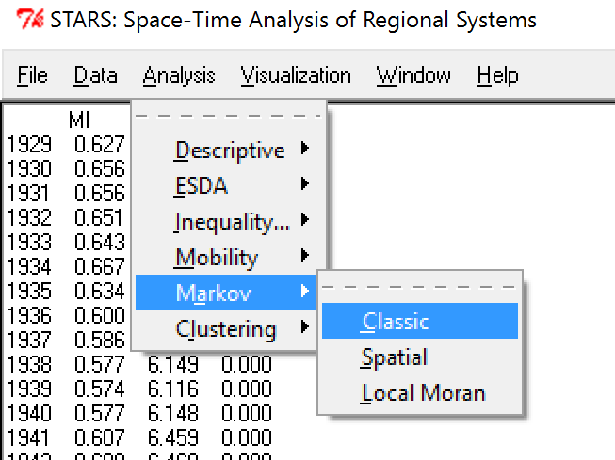

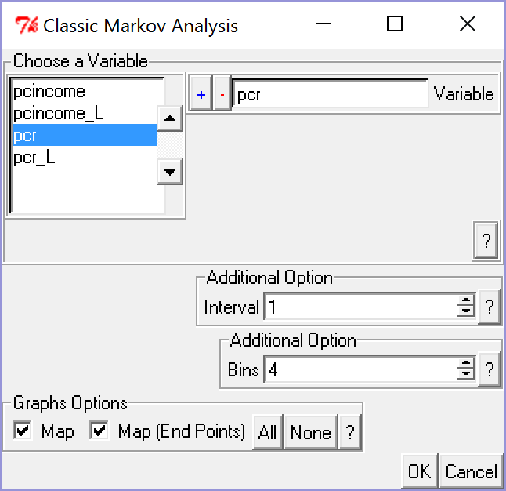

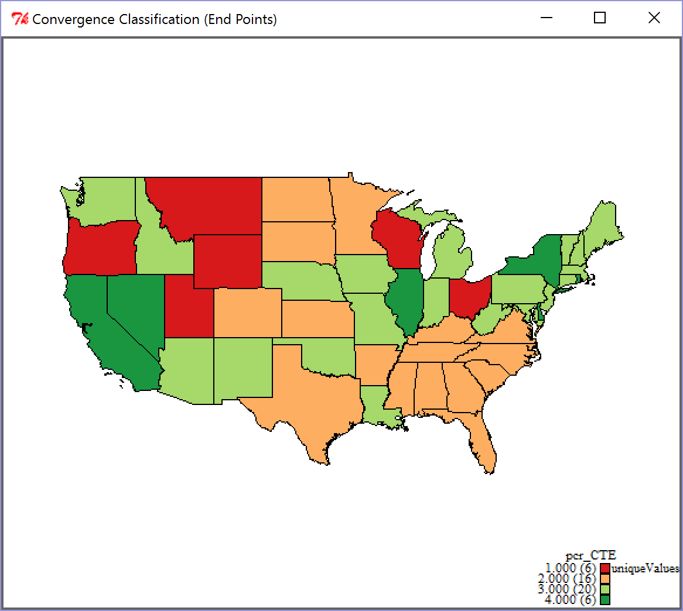

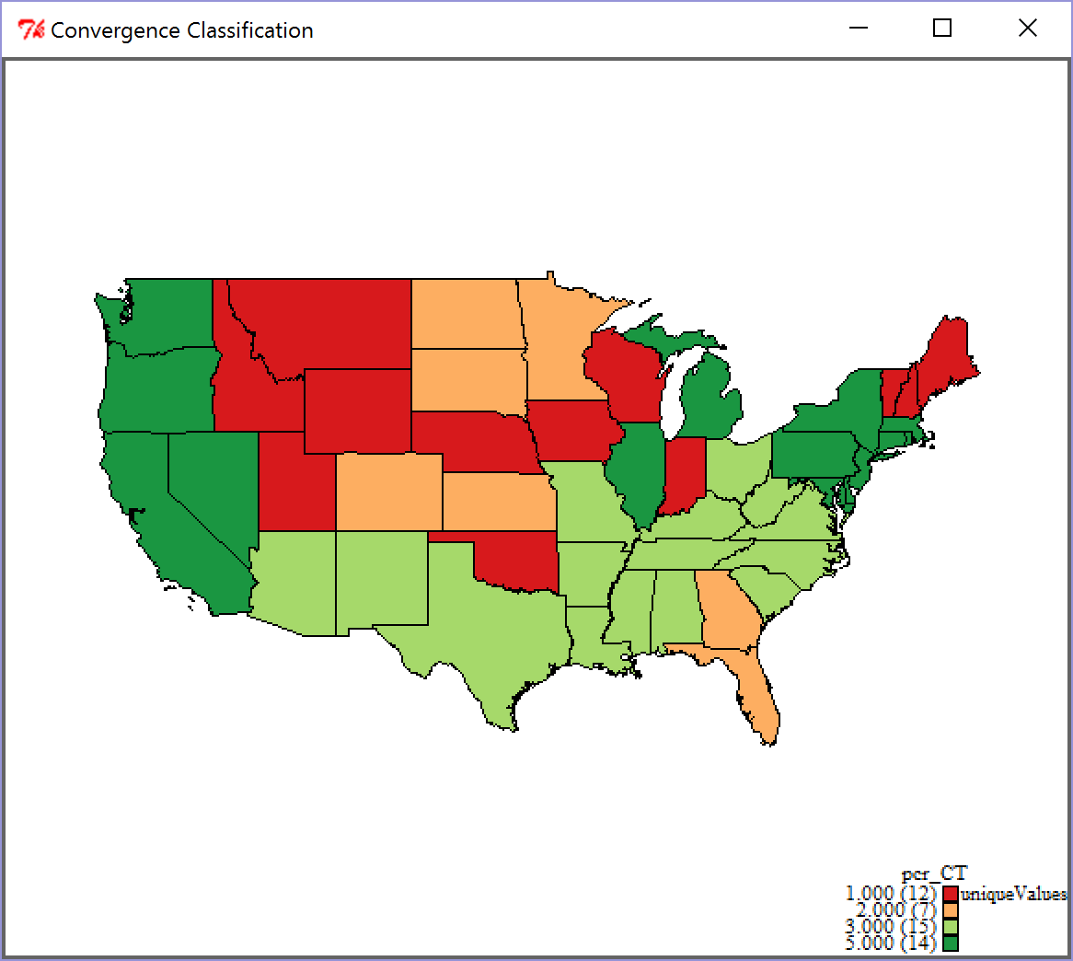

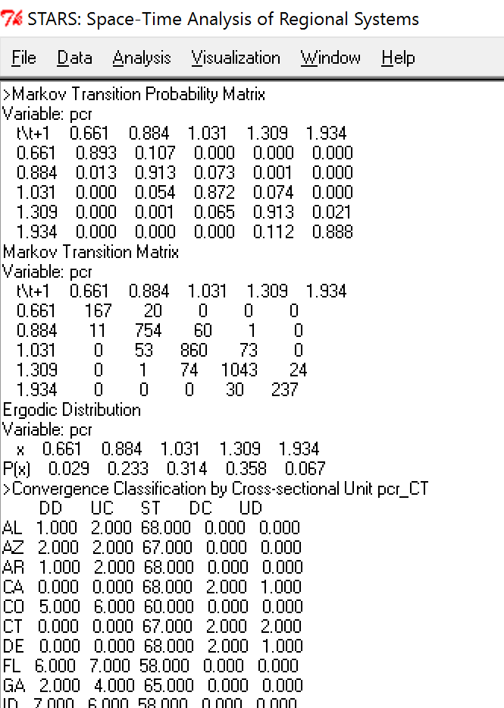

Search Markov.py

What are these terms?

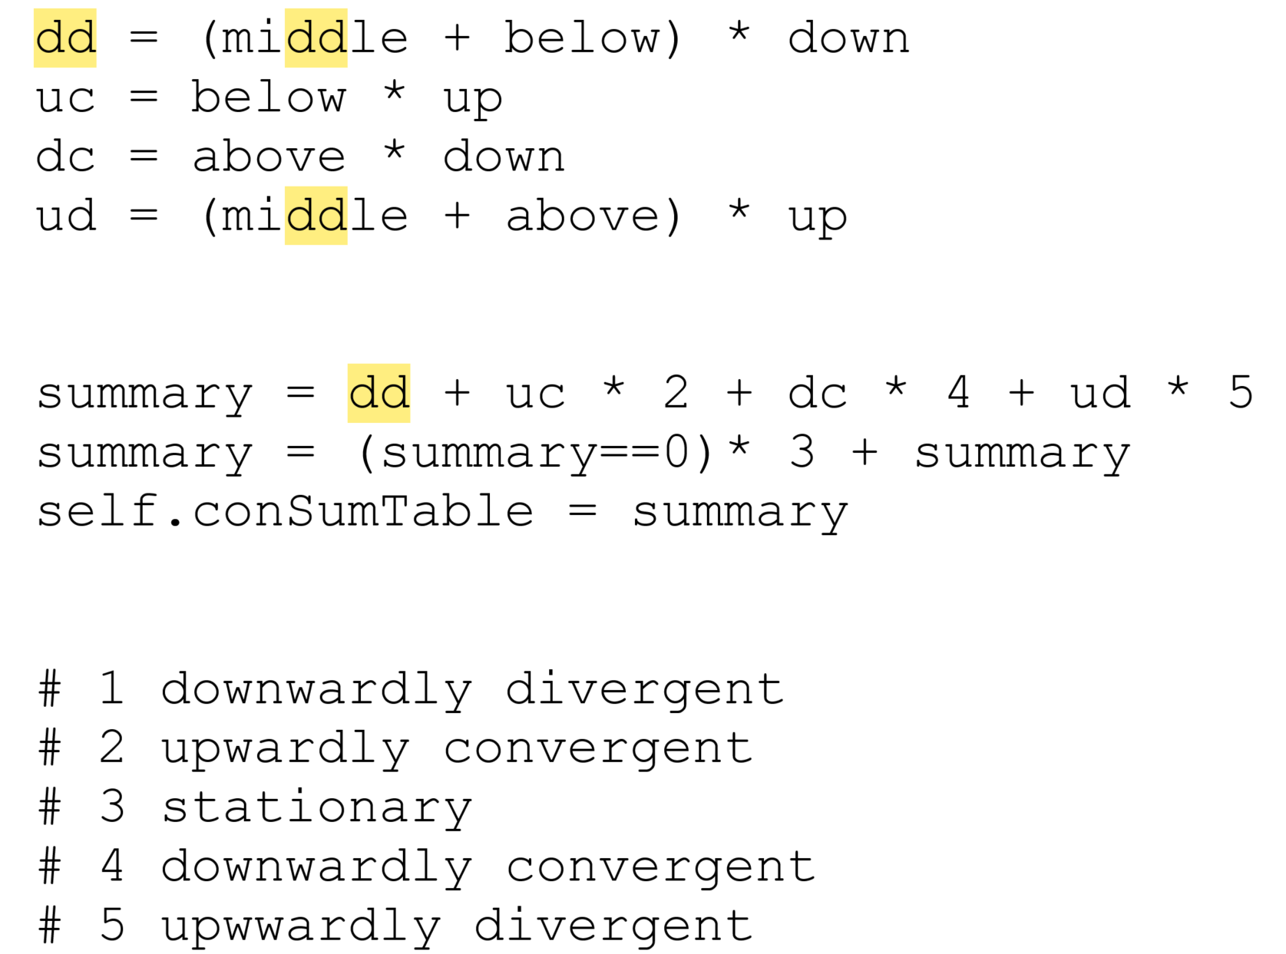

加入开发人员和用户组:

Wechat: 2241165161

QQ: 2241165161

加入群组之前介绍你的名字和专业知识

STARS 相关出版物 (特别是中国数据):

Note: * denotes that I serve as the corresponding author. Students, post-docs and advisee are underlined.

Rey, S. J., & Janikas, M. V. (2006). STARS: space–time analysis of regional systems. Geographical analysis, 38(1), 67-86. **(SSCI)**

**Ye, X**. (2017) Spatial econometrics, The International Encyclopedia of Geography. Edited by Douglas Richardson, Noel Castree, Michael F. Goodchild, Audrey Kobayashi, Weidong Liu, and Richard A. Marston. DOI: 10.1002/9781118786352.wbieg0982

Lee, J. & **Ye, X\***. (2017) Obesity Prevalence Simulator: An Open Source Spatiotemporal Model for Simulating Obesity Prevalence. In Thill, J. and Dragicevic, S. (eds.) Springer’s Series on Advances in Geographic Information Science.

Gu, J., Zhou, S., & **Ye, X**. (2016). Uneven regional development under balanced development strategies: space-time paths of regional development in Guangdong, China. *Tijdschriftvoor Economische en SocialeGeografie, TESG: Journal of Economic and Social Geography* doi:10.1111/tesg.12200 **(SSCI)**

She, B., Duque, J., & **Ye, X**. (2016) The Network-Max-P-Regions Model. *International Journal of Geographical Information Science* doi: 10.1080/13658816.2016.1252987 **(SCI/SSCI)**

She, B., Zhu, X., **Ye, X\***, Guo, W., Su, K., & Lee, J. (2015). Weighted network Voronoi Diagrams for local spatial analysis. *Computers, Environment and Urban Systems*, *52*, 70-80. **(SSCI)**

Wang, Z., Cheng, Y., **Ye, X**., & Wei, Y. (2015) Analyzing the Space-Time Dynamics of Innovation in China: ESDA and Spatial Panel Approaches. *Growth and Change* DOI: 10.1111/grow.12115 **(SSCI)**

**Ye, X**., She, B., Wu, L., Zhu, X., & Cheng, Y. (2014) An Open Source Toolkit for Identifying Comparative Space-Time Research Questions. *Chinese Geographical Science*, 24(3): 348-361 **(SCI)**

Yue, W., Zhang, Y., **Ye, X**\*., Cheng, Y., & Leipnik, M. R. (2014). Dynamics of multi-scale intra-provincial regional inequality in Zhejiang, China. *Sustainability*, *6*(9), 5763-5784. **(SCI/SSCI)**

**Ye, X**., and Yue, W. (2014) Comparative Analysis of Regional Development: Exploratory

Space-Time Data Analysis and Open Source Implementation. Economics, No 2014-20, Kiel Institute for the World Economy. (downloaded 1544 times, 6/14/2017)

Curtis, A., **Ye, X**., Heob, E., Targhetta, J., Salvato,V., Martin, R., Rudy, B., Louisa H. (2014) A Comparison of Three Approaches to Identify West Nile Virus Mosquito Space-Time Hotspots in the Houston Vicinity for the Period 2002-2011. *Applied Geography*, 51:58-64 **(SSCI)**

**Ye, X**. & Rey, S. J. (2013) A Framework for Exploratory Space-Time Analysis of Economic Data. *Annals of Regional Science*, 50(1): 315-339 **(SSCI)**

**Ye, X**. & Wu, L. (2011) Analyzing the Dynamics of Homicide Patterns in Chicago: ESDA and Spatial Panel Approaches. *Applied Geography*, 31: 800-807 **(SSCI)**

**Ye, X**. & Carroll, M. (2011) Exploratory Space-Time Analysis of Local Economic Development. *Applied Geography*, 31: 1049-1058 **(SSCI)**

Rey, S. & **Ye, X**. (2010) Comparative Spatial Dynamics of Regional Systems. In A. P´aez, J. Le Gallo, R. Buliung, and Dall’Erba, S. (eds.) Progress in Spatial Analysis: Theory, Computation, and Thematic Applications. 441-464. Springer.

Wei, Y. D. and **Ye, X**. (2009) Beyond Convergence: Space, Scale, and Regional Inequality in China. *Tijdschriftvoor Economische en SocialeGeografie, TESG: Journal of Economic and Social Geography*, 100: 59-80 **(SSCI)**

Rey, S. J., and **Ye, X**\*. (2007) Spatial Dynamics in City Size Distribution. Proceedings of The 2nd ICA Workshop on Geospatial Analysis and Modeling (Spatial Structure and Dynamics of Urban Environments).

**Ye, X**., (2006) Spatializing Zipf’s Law in the Dynamic Context: US Cities 1960-2000. UCGIS Summer Assembly Proceedings.