FaceTrack: Recent Changes
Oct 9, 2026 · @Vignesh

At a glance
FaceTrack on iPhone 17 went from 10 FPS to 30 FPS with one face, and each frame now takes 23 ms instead of 76 ms. Three changes did it. None changed which models are used (YuNet finds faces, EdgeTAM follows them), and tracking accuracy stayed the same in every test.
# | Change | Why it was needed | Effect on iPhone 17 (one face)
1 | EdgeTAM looks at a 512×512 image instead of 1024×1024 | 1024 was far more detail than a face needs, and the tracker was 75% of the work | 76 ms → 43 ms per frame, 10 → 15 FPS
2 | Model results are read in one go instead of piece by piece | Two steps had become slower: reading results bit by bit added about 10 ms | 43 ms → 37.5 ms per frame, FPS unchanged
3 | Camera runs at 60 FPS instead of 30 | The app was waiting for the next camera frame, so the saved time never showed | 37.5 ms → 23 ms per frame, 15 → 30 FPS
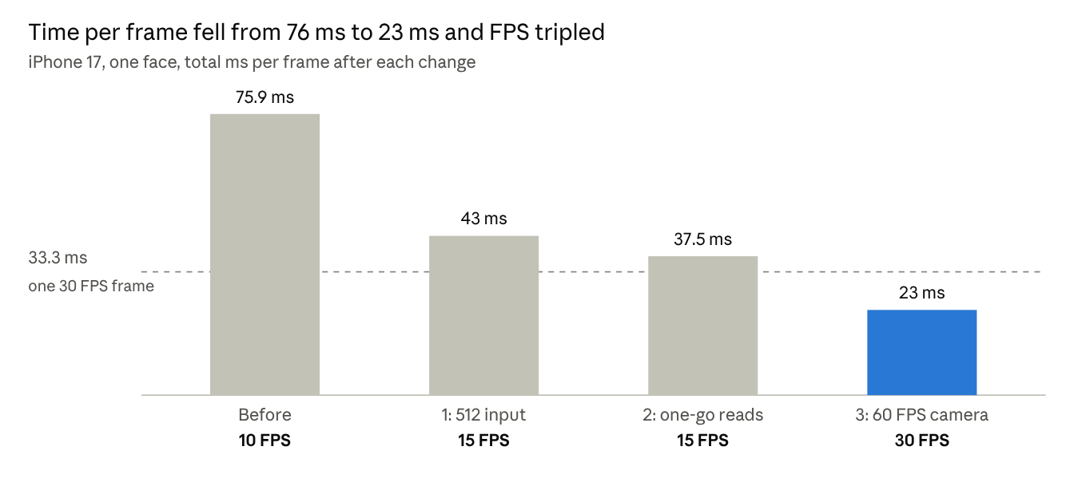
Measured in Xcode's console on iPhone 17, Oct 9 2026
Change 2 saved time but stayed above the 33 ms line, so FPS only moved once Change 3 let frames arrive every 16.7 ms.
A fourth idea, a smaller memory per face, was tested and not applied, because it would no longer raise the frame rate (see Considered but not done).

Starting point
Before these changes FaceTrack ran at about 10 FPS on iPhone 17, taking 76 ms per frame with one face. Every frame goes through these steps:
- Find faces: YuNet scans the frame (every third frame) on the phone's graphics chip.
- Understand the frame: EdgeTAM's image encoder turns the frame into features, once per frame, on the Neural Engine (the phone's AI chip).
- Memory attention: for each face, EdgeTAM compares the frame with its memory of that face from earlier frames.
- Draw the mask: EdgeTAM outlines the face.
- Save to memory: the new outline is stored for the next frames.
Memory attention alone took 35 ms per face, and steps 2 to 5 together were about 75% of the frame time. So the tracker, not the face detector, was what to make faster.

Change 1: EdgeTAM looks at a smaller image (1024 → 512)
Result: 76 ms → 43 ms per frame, 10 → 15 FPS, with the same tracking accuracy.

What changed
EdgeTAM used to shrink every camera frame to 1024×1024 pixels before working on it. It now uses 512×512. It is the same trained model; no retraining was needed. An open-source fork of EdgeTAM (faster-edgetam) had already shown that the model works at 512 and 768 by changing only its settings.

Why
- Faces don't need that much detail. A face is a large, smooth region. 1024 pixels is meant for tracking small, thin objects such as wires or hands.
- The work grows with image size. Halving the width and height means a quarter of the pixels. Every EdgeTAM step shrinks with it, so total work for one face fell from 148 to 31 billion operations (4.8× less).
- The tracker was the bottleneck, so this was the biggest lever available.

How it was checked
Test | Result
Does my conversion still match Meta's own tracker at 512? (40-frame clip with the face hidden for 5 frames) | Yes: 100% mask overlap on average, 99.8% at worst
Does it still find the right face? 5 faces, 34 to 92 pixels wide, with known true positions | 1024 and 512 both kept every face in 100% of visible frames, and both dropped faces while they were hidden
How different do the outlines look? | About 95% overlap with the 1024 outline; the difference is at the edge (how much hair or neck is included), not where the face is

Effect on the phone
Each EdgeTAM step got 46% to 66% faster. That is less than the 4.8× cut in work, because every model call has a fixed cost that doesn't shrink. The old 1024 models are kept as a backup in conversion/models_1024/.

Change 2: Reading model results in one go
Result: 43 ms → 37.5 ms per frame. Two slowdowns that appeared after Change 1 are gone.

The problem
After Change 1, two steps that don't run on the AI chip got slower instead of faster:
Step | Before Change 1 | After Change 1
Assembling a face's memory (copying 8 stored memories into one input) | 1.1 ms | 5.5 ms
Finding faces with YuNet | 7.8 ms | 14.5 ms

The cause
Both steps read the models' results one small piece at a time, and every read paid a small fixed cost to access the result:
- The memory was copied row by row: 512 separate reads for each of the 8 memories, about 4,000 per frame.
- YuNet's result was read value by value: 5,040 possible faces with up to 15 numbers each.
Each read costs only about a microsecond, but thousands of them add up to milliseconds. The cost likely became visible at 512 because Core ML started handing back results in a form that is slower to access piece by piece. That part is an inference; the fix works either way.

The fix
Each result is now read once, as a whole block, and then used from that copy. This changed two small files, MLArray+Utils.swift and FaceDetector.swift. The numbers the app works with are exactly the same.

Effect on the phone
Step | Before the fix | After the fix
Assembling memory | 5.5 ms | 0.1 ms
YuNet | 14.5 ms | 10 ms
Total per frame | 43 ms | 37.5 ms
FPS shown | 15 | 15
The frame rate didn't change. Change 3 explains why and fixes it.

Change 3: Camera at 60 FPS
Result: 37.5 ms → 23 ms per frame, 15 → 30 FPS.

Why the frame rate was stuck at 15
The app always works on the newest camera frame and skips any it has no time for, so it never falls behind. At 30 FPS the camera delivers a frame every 33.3 ms.
- Frame processing took 37.5 ms, just longer than 33.3 ms.
- So when the app finished, the next frame had just arrived and been skipped, and it waited for the one after.
- The result: it processed every second frame, which is 15 FPS, whether a frame took 34 ms or 66 ms.
That is why Change 2 saved 5.5 ms but the FPS didn't move.

What changed
The camera now asks for 60 FPS (a frame every 16.7 ms), choosing the smallest camera mode of at least 1280×720 that supports it. If a camera can't do 60 FPS (for example on a Mac), it uses the fastest rate available. This is in CameraController.swift.

Effect on the phone
The frame rate doubled, and something unexpected happened: every AI step also got about 35% faster, although the models didn't change.
Step | Camera at 30 FPS | Camera at 60 FPS
Find faces (YuNet) | 10 ms | 6.5 ms
Understand the frame | 10 ms | 6 ms
Memory attention, per face | 17.5 ms | 12.4 ms
Save to memory + draw mask, per face | 6 ms | 3 ms
Total per frame | 37.5 ms | 23 ms
FPS shown | 15 | 30
The likely reason: at 30 FPS the chip sat idle for about 29 ms between frames and slowed itself down to save power. At 60 FPS a new frame is always waiting, so it stays at full speed. This is inferred from the timings and can't be measured directly. During about a minute of running, FPS dipped once to 24.
Trade-off: the camera and chip work harder, so the app uses somewhat more battery and runs the phone warmer.

Considered but not done: a smaller memory per face
Decision: skipped, because after Change 3 it would no longer raise the frame rate.
Each face's memory holds 2 "anchor" frames (the first detection and the latest correction) plus the 6 most recent frames. Cutting the recent frames from 6 to 3 makes memory attention 22% less work.
- Accuracy: no loss in my tests. Even after a 20-frame blackout, the face was found again on the first visible frame.
- Speed now: it would save only about 2 to 3 ms per face. With one face, 23 ms becomes about 20 ms, but the app would still show 30 FPS. Reaching 60 FPS needs under 16.7 ms per frame.
- With two faces (estimate): about 39 ms becomes about 36 ms, which is 20 FPS either way.
So it adds a small accuracy risk on real-world use without a visible gain. It stays available as an option: python export_edgetam.py --num-recent 3.

Where the changes live
Everything is in Face Recognition › FaceTrack on your Mac. Every file was checked against my copy with a checksum after copying.
File | Change | What changed
ios/FaceTrack/Models/ (4 EdgeTAM models + edgetam_config.json) | 1 | Re-exported at 512
ios/FaceTrack/EdgeTAM.swift, TrackManager.swift, Pipeline.swift | 1 | Mask size read from the config instead of fixed at 256
conversion/edgetam_coreml_modules.py, export_edgetam.py + check scripts | 1 | New --image-size option (512 default, 768, 1024)
ios/FaceTrack/MLArray+Utils.swift, FaceDetector.swift | 2 | Results read in one go
ios/FaceTrack/CameraController.swift | 3 | Camera asks for 60 FPS
DESIGN.md (§4.7, §6.3), README.md | all | Measurements and the new options
conversion/models_1024/ | backup | The previous 1024 models, to switch back
To switch back to 1024: copy the contents of conversion/models_1024/ into ios/FaceTrack/Models/ and run the app again.

Next steps
- OC-SORT hybrid (biggest remaining gain, especially with several faces): keep IDs using YuNet's boxes and simple motion prediction, and run EdgeTAM only when YuNet loses a face (side view or blocked).
- SFace re-identification: give each face a fingerprint so a person who leaves the view for more than 1 second comes back with the same ID.

Terms used
Term | Meaning
FPS | Frames per second the app processes and shows
ms | Millisecond, one thousandth of a second
Neural Engine | The part of the iPhone chip built for running AI models
YuNet | The small model that finds faces
EdgeTAM | Meta's phone-sized version of SAM 2; follows each face and outlines it
Memory attention | The EdgeTAM step that compares the current frame with what it remembers about a face
Mask | The pixel-by-pixel outline of a face
Core ML | Apple's system for running AI models on iPhone and Mac

