CHINHOYI UNIVERSITY OF TECHNOLOGY · ABF-FST RESEARCH STUDY
Role Guide 6: Documentary Evidence Research Assistant
Step-by-step instructions for the Documentary RA role in the ABF-FST Digital Respondent Portal.
STUDY | Developing and Validating the Agribusiness Bankability Framework for Food Systems Transformation through Novel Financing Models in Zimbabwe (ABF-FST)
PRINCIPAL RESEARCHER | Happyson Saina, Doctor of Strategic Management candidate, Chinhoyi University of Technology
SUPERVISORS | Dr L. Chikazhe and Dr J. Kanyepe
FOR | Research assistants who collect, assess and code documentary evidence
SYSTEM ADDRESS | https://research.agribizframework.com
CONTACT | 0773943709 · abffst.research@gmail.com
VERSION | Version 1.28 · 6 October 2026

Screenshots in this document use fictional demonstration data. Organisation and person names, phone numbers and figures shown in them are not real study records.

Contents
1. Your role at a glance 3
2. Signing in and your screens 4
Signing in 4
Finding your way around 4
Your screens 5
Changing your password 5
3. Your routine 6
4. Step-by-step tasks 7
4.1 Reading the dashboard 7
4.2 The fastest way: upload the document (Quick add) 7
4.3 Coding another chapter of the same document (Copy for another chapter) 9
4.4 Adding a document by hand 9
4.5 Correcting a record's details 9
4.6 Attaching the source file, and removing a wrong one 10
4.7 Assessing and including a document 10
4.8 Coding a document: two ways 12
4.9 Auto-fill: the AI drafts, you review 12
4.10 Downloading or emailing completed forms (Form PDFs) 17
4.11 Judging authenticity 18
5. Rules you must follow 19
6. Troubleshooting 20
7. Quick reference 22
8. Every screen and button for your role 23
8.1 Sign in 23
8.2 The header and menu bar (every screen) 23
8.3 Change Password 24
8.4 KII / Document Dashboard 24
8.5 Documents (the corpus) 25
8.6 New Documentary Evidence Record 25
8.7 Document record 26
8.8 Auto-fill review screen 27
8.9 Completed forms (Form PDFs) 28

1. Your role at a glance
You build the documentary corpus of 50–75 coded sources: record each document, judge its authenticity before it can be included, explain your reasoning in a memo, and code it with the Document, Digital Platform & Media Analysis Tool in KoboToolbox.

You can
- See the KII/Doc Dashboard, the Documents register and document records.
- Create document records: upload the document and let the AI fill in the details and draft the form (Quick add), or type them in.
- Copy a record for another chapter of the same document, with its own file.
- Correct a record's details, assess authenticity, include or exclude, write memos.
- Attach, replace or remove a document's source file.
- Use Auto-fill (once switched on) to have AI draft the coding form, then review, edit and submit it.
- Download PDFs of completed document coding forms.

You cannot
- See or edit KII records, questionnaire QA, the Main-400 register, costs or exports.
- Include a document before its authenticity has been assessed.
- Send an AI draft to KoboToolbox without reviewing it: nothing is submitted until you select Submit.

Where this fits
The System Manual explains how the whole system works. This guide covers only what you do, and its last section lists every screen and button you can use, with what each does and why. Ask the Field Coordinator or PI when something is outside your role.

2. Signing in and your screens

Signing in
- Open https://research.agribizframework.com/admin/login in any modern browser (Chrome, Edge, Firefox or Safari), on a computer, tablet or phone.
- Type your Username and Password, then select Sign in.
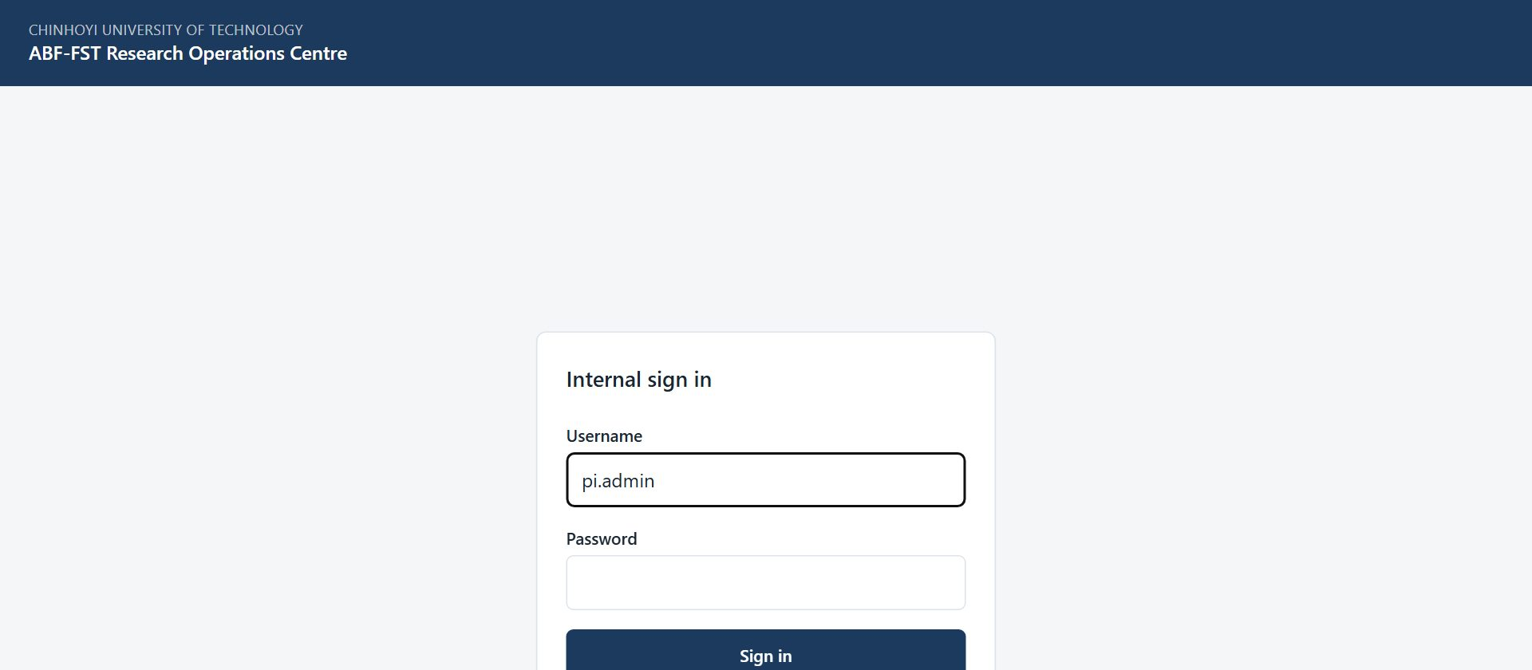
Figure 1. The sign-in screen for all internal staff.
- You arrive on your start screen: KII/Doc Dashboard. The bar across the top lists only the screens your role (Documentary RA) can open.

Accounts
There is no self-registration. The PI / System Admin creates every account and sets its role. Ask the PI if you need an account, a different role, or a password reset.

Finding your way around
- The top bar shows your username and role, and the screens you can use. It is not a full menu with some items greyed out: anything absent is simply not part of your role.
- Most screens have a ← Back to … link at the top that returns you to the screen you came from.
- Registers show 20 rows per page to begin with. At the foot of the list, Show lets you choose 10, 20, 50, 100 or 200 rows per page (the portal remembers your choice), and the page numbers, Previous, Next and the double arrows take you to any page. The Search box above the list narrows it.
- Change password (top right) lets you set a new password at any time. Choose a long password you do not use anywhere else.
- Sign out (top right) ends your session. Always sign out on a shared or public computer.
- If you are inactive for a while you may be asked to sign in again. This protects research data on unattended devices.

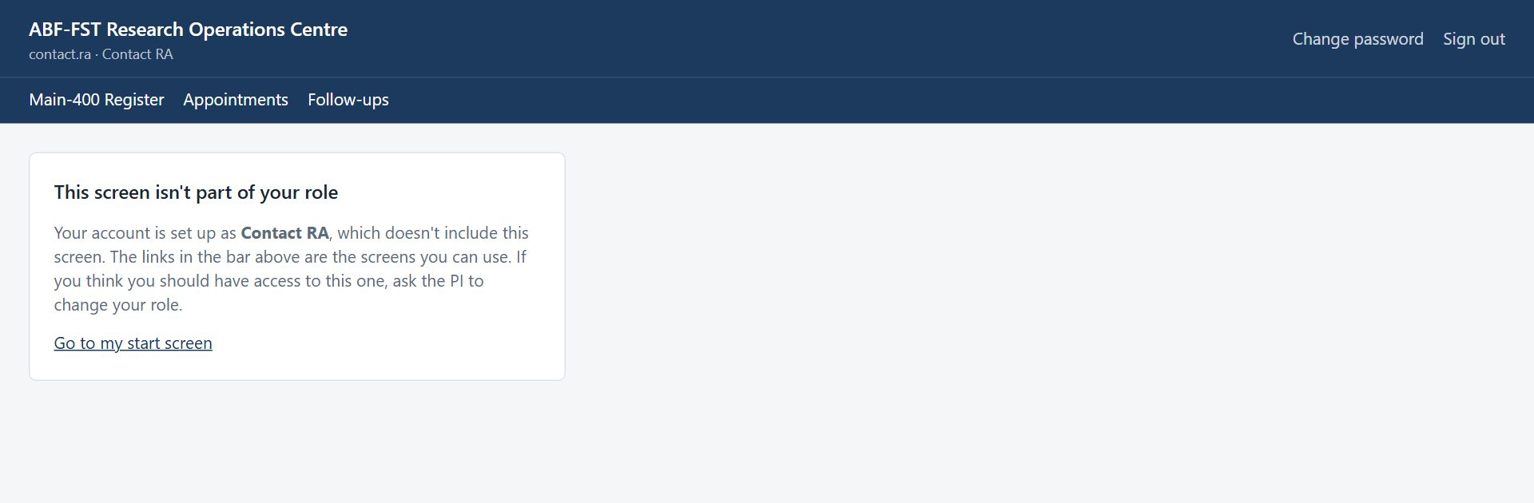
Figure 2. Opening a screen outside your role (for example from an old bookmark) shows this card instead of the screen.

Your screens
Screen | What you use it for
KII/Doc Dashboard | Documents by type and QA status against the 50–75 target.
Form PDFs | Completed document coding forms, and whether the portal matches KoboToolbox (Sync now).
Documents | The corpus; create records by uploading the document, and manage them.

Changing your password
- Select Change password in the top right corner.
- Enter your Current password, then the New password twice, and select Change password.
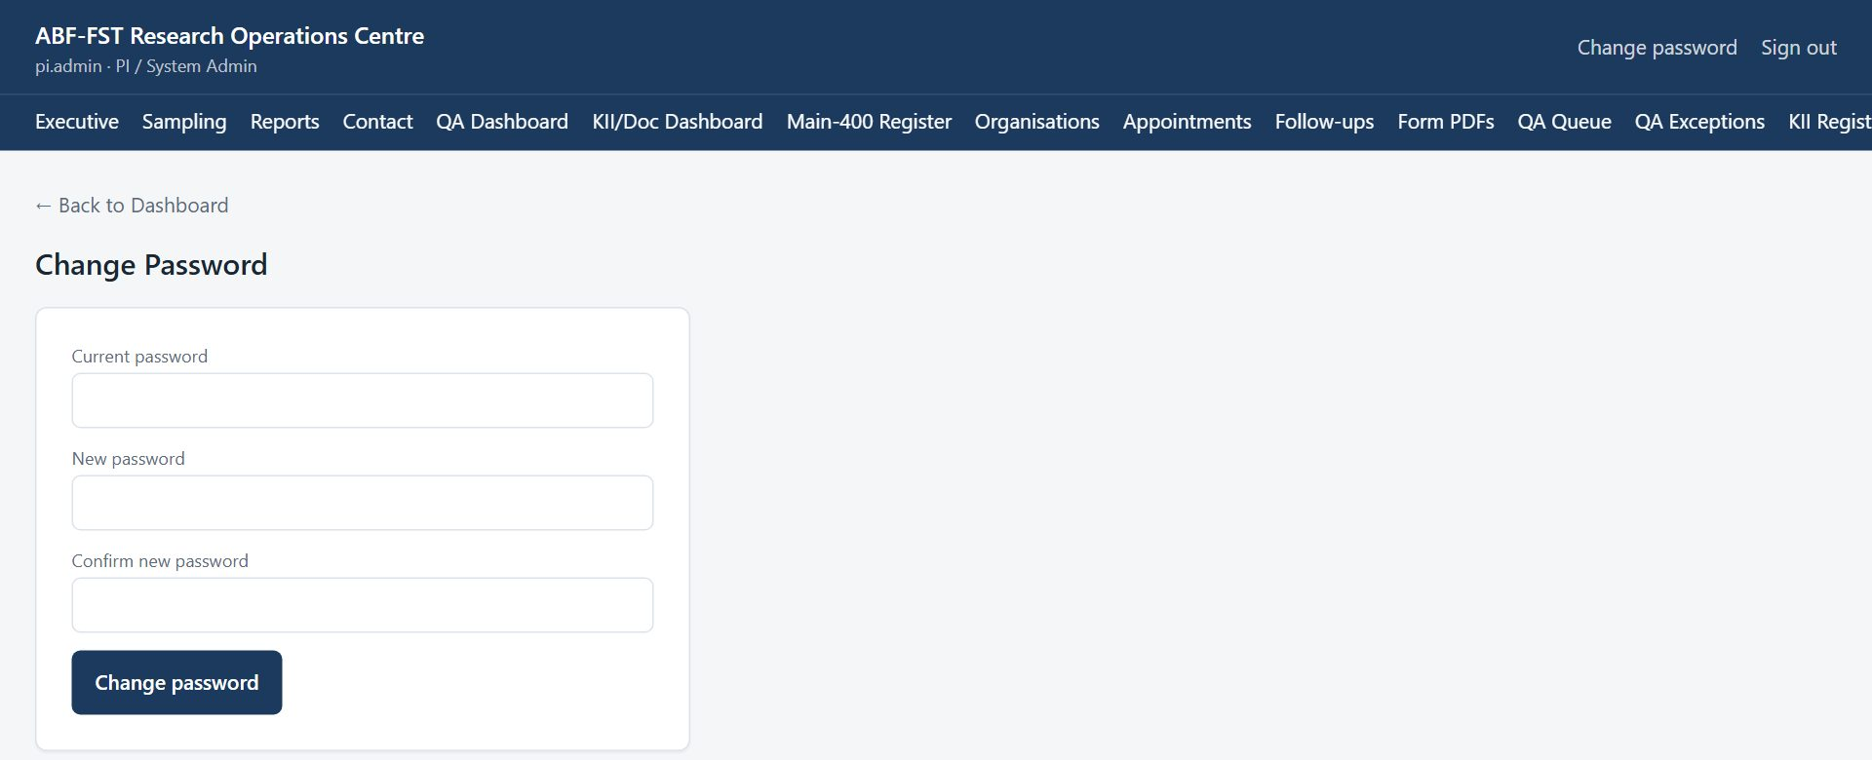
Figure 3. Change Password screen.
- Use the new password next time you sign in. If you have forgotten your password, ask the PI to reset it.

3. Your routine
A suggested rhythm. Adjust it to the Field Coordinator's plan.
When | What to do
When you find a source | Documents → New document → upload the file (Quick add): the AI fills in the record and drafts the form. No file? Type the details, with a precise reference and an evidence extract.
Check the details | Read the Record details on the record page and correct anything the AI got wrong.
Assessment | Verify authenticity against the source; mark Verified or Disputed; write the memo.
Inclusion | Include or Exclude with reasons in the memo.
Source file | Upload the source. Wrong one? Select Remove file and upload the right one.
Coding | Review the AI's draft field by field (Auto-fill), Save, then Submit; or use Code this document to answer the form yourself.
Another chapter | On the record, Copy for another chapter: enter the pages, and a new record with its own file is drafted. Authenticity is assessed separately for each.
Afterwards | Form PDFs shows the completed form; Sync now confirms the portal and KoboToolbox match.

4. Step-by-step tasks

4.1 Reading the dashboard
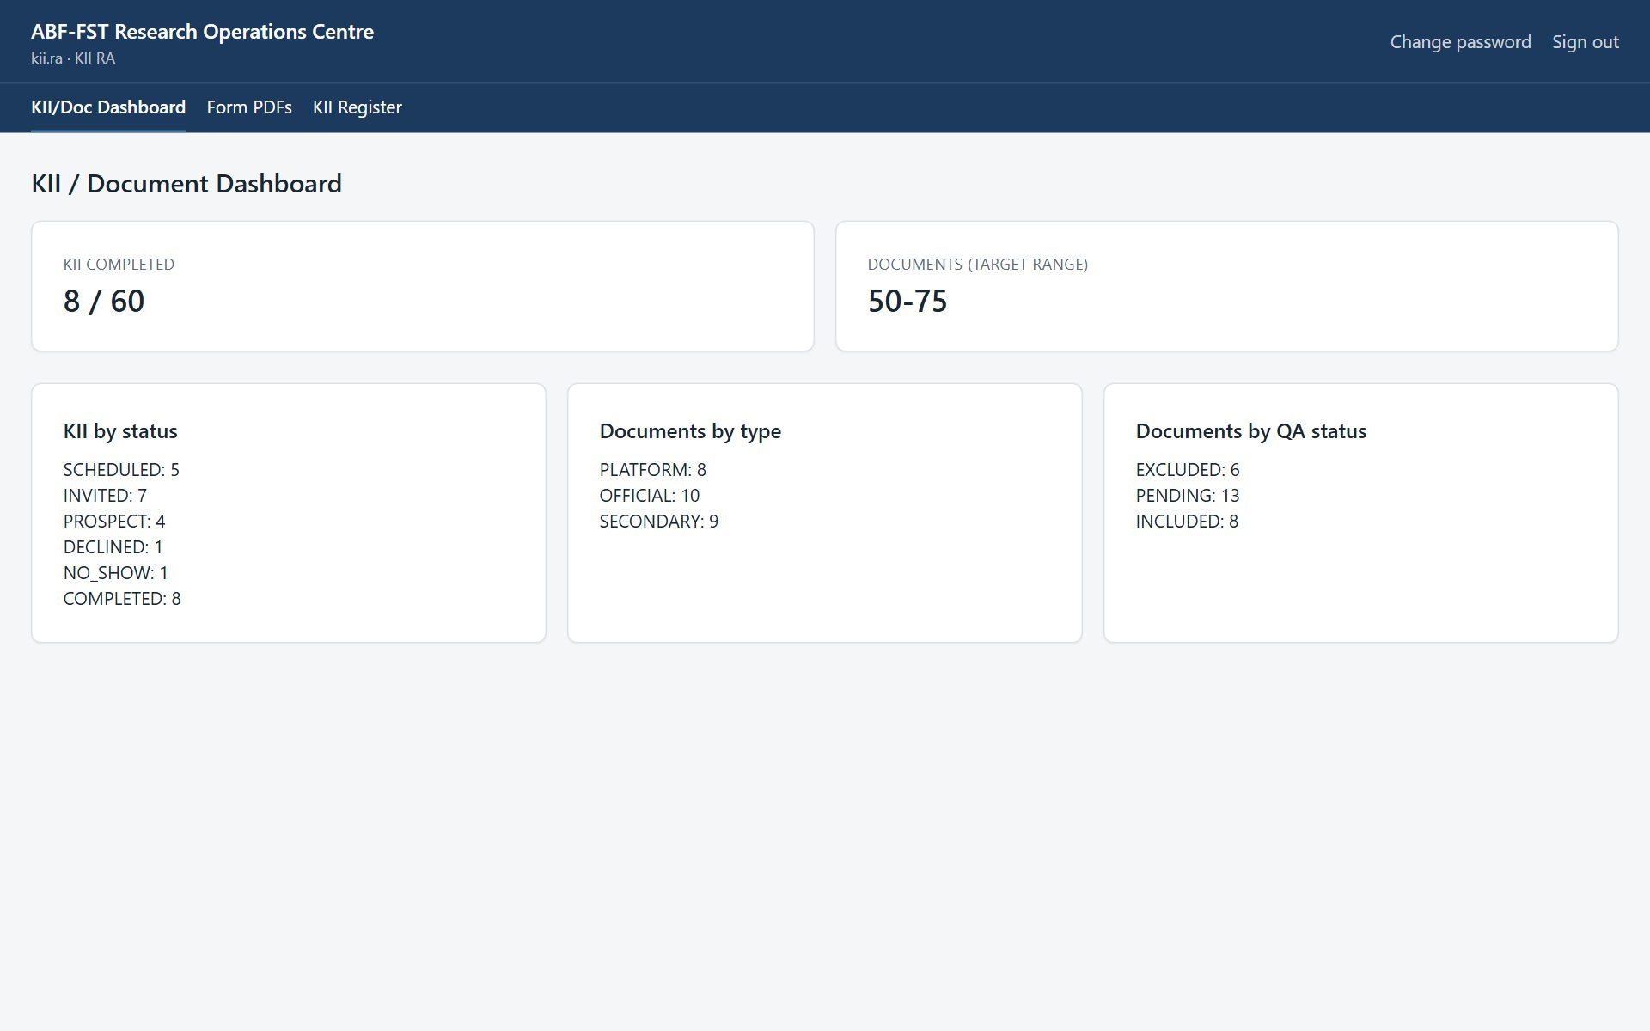
Figure 4. Documents by type and by QA status.

4.2 The fastest way: upload the document (Quick add)
You do not need to type the details of a document. Upload it and the AI reads it, fills in the record, drafts the whole KoboToolbox coding form, and waits for you to review. (This needs AI drafting to be switched on; otherwise use “Adding a document by hand” below.)
- Select Documents → New document. At the top is the box Fastest: upload the document.
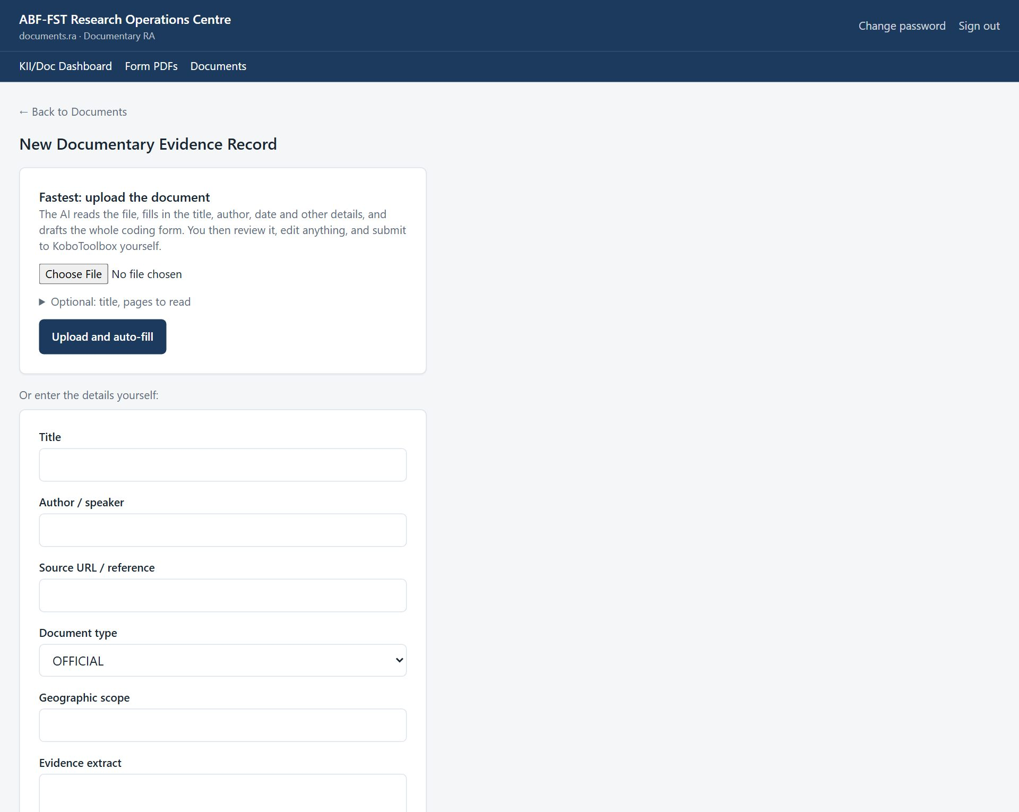
Figure 5. New document: upload the file and let the AI do the rest.
- Choose the file: a PDF, a Word (.docx) or Excel (.xlsx) file, a text or CSV file, or a JPG or PNG scan or photo (up to 20 MB). Nothing else is required.
- Optional (open Optional: title, pages to read): a Title if you want your own; Pages to read if you are coding one chapter of a long PDF, for example 290-340; or tick Read the whole document in parts for a PDF over 100 pages (see “Coding a very long document” below).
- Select Upload and auto-fill. The record is created straight away and the review screen opens, showing “Step 1 of 2: reading the document’s details”, then “Step 2 of 2: drafting the coding form”. You can leave the page; the draft will be there when you return.
- The AI has filled in the title, author, date, document type, geographic scope, value chain and source it found in the document, and left blank anything the document does not state. Check them on the record page under Record details and correct anything wrong; a correction shows in the draft at once and is used when you submit.
- You still make the human decisions: assess authenticity (Verified or Disputed) and Include or Exclude the document, as described below.
- Review every section of the draft, Save changes, then Submit to KoboToolbox (see “Auto-fill: the AI drafts, you review”). The portal keeps its own copy of the completed form; Sync now on Form PDFs confirms the portal and KoboToolbox match.

4.3 Coding another chapter of the same document (Copy for another chapter)
A long report holds several evidence units. Give each chapter you want coded its own record, so each gets its own ratings, its own DOC ID and its own row in the export. You do not upload the file again or retype the details:
- Open the record of the document and, under Copy for another chapter, enter the chapter's Pages to read (for example 290-340) and, if you like, a Chapter title. Leave the title empty and the AI names the part from its pages, for example “Title – Chapter 6: Agriculture (pp. 290-340)”.
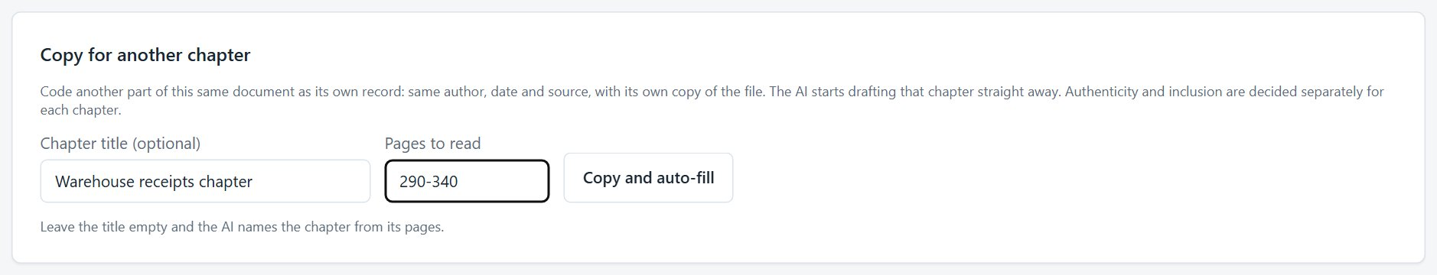
Figure 6. Copy for another chapter: pages, and an optional title.
- Select Copy and auto-fill (or Copy record if AI drafting is not switched on). A new record is created with the same author, date, source, type and scope, and its own copy of the file, so removing or replacing one file never affects the other.
- With AI drafting on, the new record's review screen opens and the AI starts drafting that chapter. Review, save and submit it as usual.
- Authenticity and Include or Exclude are not copied: assess each chapter on its own. Repeat for every chapter you want coded.

Copy needs a file
The Copy for another chapter panel appears once a record has its source file. A title or pages is required, and a long PDF needs a page range (or the whole-document option). If the pages are not valid nothing is created.

4.4 Adding a document by hand
- Select Documents → New document and, below Or enter the details yourself, fill in Title, Author / speaker, Source URL / reference, Document type (OFFICIAL, SECONDARY or PLATFORM), Geographic scope and an Evidence extract, then select Create document record. The document ID (e.g. DOC-0025) is generated.
- Then attach the source file (below). If AI drafting is on, ticking Start Auto-fill as soon as the file is uploaded sends you straight to the draft.

4.5 Correcting a record's details
- Open the record. Under Record details you can edit the title, author, publication or event date, source URL or reference, geographic scope, value chain and document type.
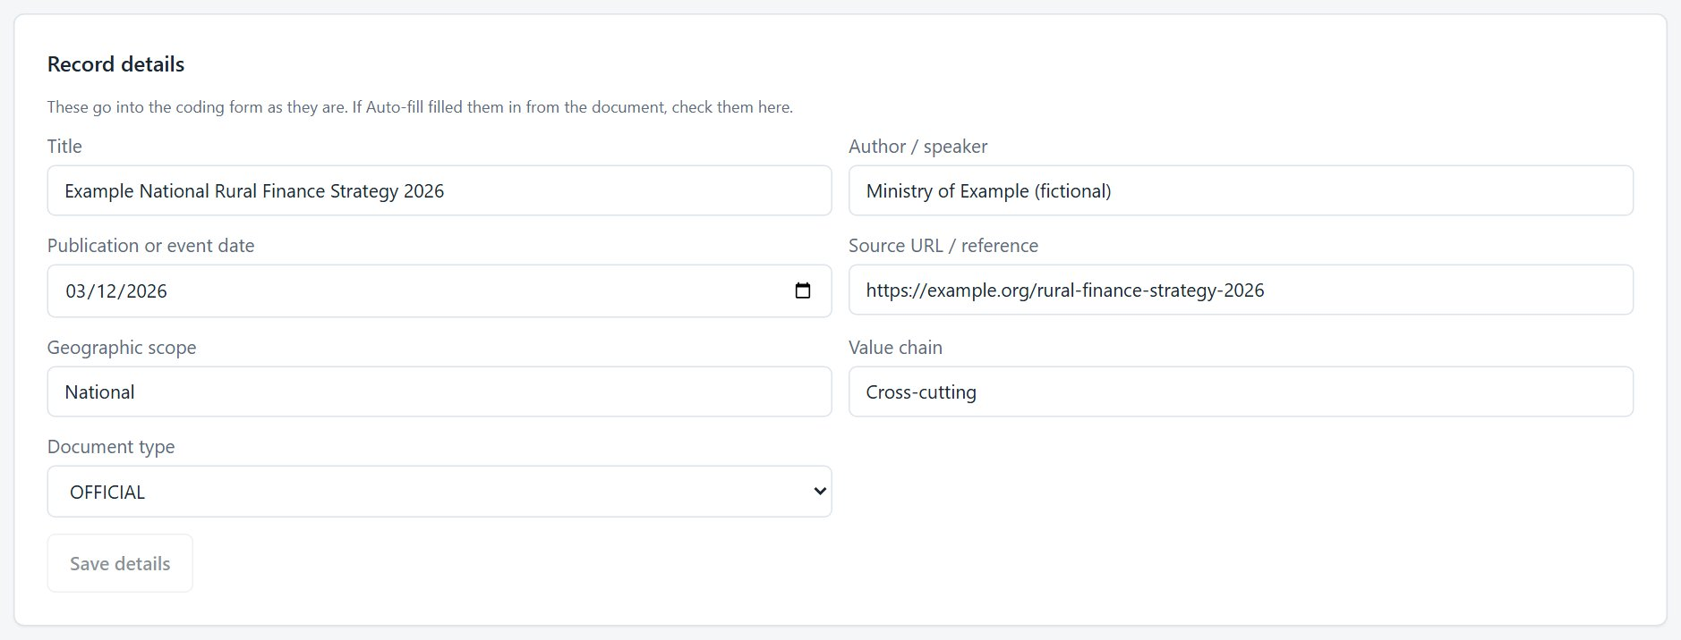
Figure 7. Record details: the details the AI filled in, ready to check.
- Select Save details. The details appear in the coding form's Section A: on the review screen they show in grey, and the corrected values are the ones submitted to KoboToolbox.

4.6 Attaching the source file, and removing a wrong one
- On the document's page, under Source file, select Choose File and pick the source: a PDF, a scan or photo (JPG or PNG), a Word (.docx) or Excel (.xlsx) file, or a text or CSV file. Audio and video can be attached as a reference. The limit is 20 MB. The file is stored privately on the server.
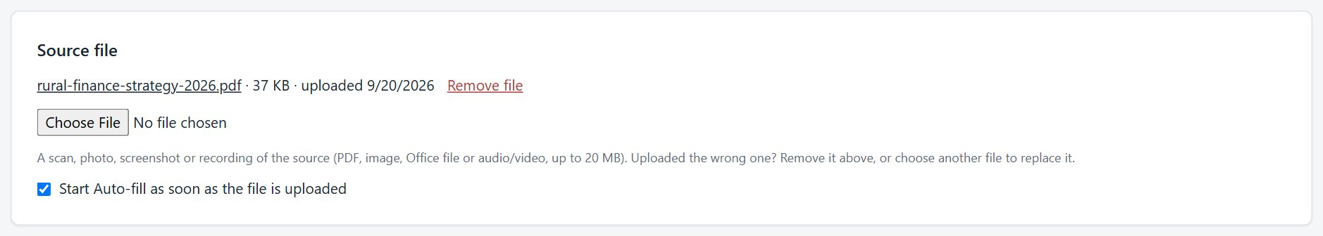
Figure 8. Source file: the file name, size and date, with Remove file beside it.
- A bar shows how much of the file has been sent. A large file on a slow connection can take a minute or two: wait until it says Saving… and the file name appears. If Start Auto-fill as soon as the file is uploaded is ticked (it is by default), the review screen then opens and the AI starts reading.
- Attached the wrong one? Select the red Remove file link beside the file name and confirm. The file is deleted from the server and the record says “No file uploaded yet”. Then choose the right file.
- Choosing another file straight away also replaces the old one.

What goes with a removed file
An AI draft (see below) made from the removed or replaced file is discarded too, so a draft of the wrong document can never be reviewed and submitted for the right one. A draft that has already been submitted to KoboToolbox is kept as the record of what was filed. Removals are recorded in the audit log with the file name.

4.7 Assessing and including a document
- In Documents, select Manage on the record.
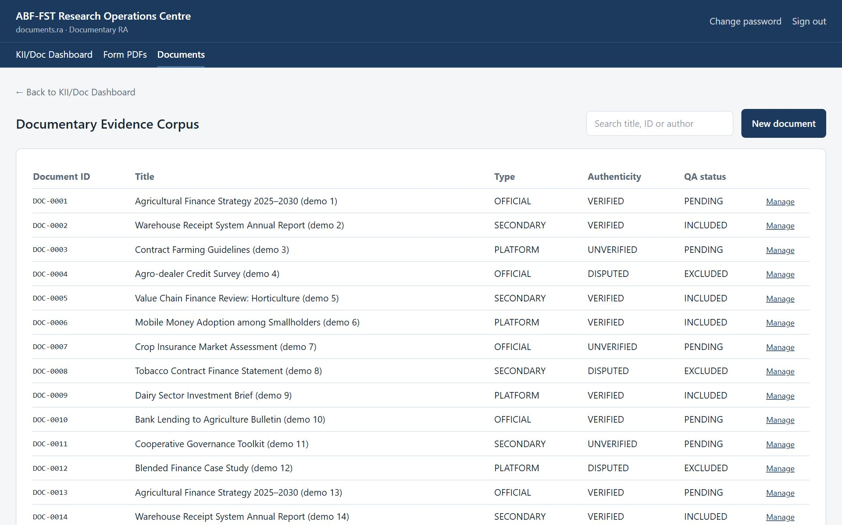
Figure 9. Documentary Evidence Corpus.
- Assess authenticity: select Mark verified or Mark disputed.
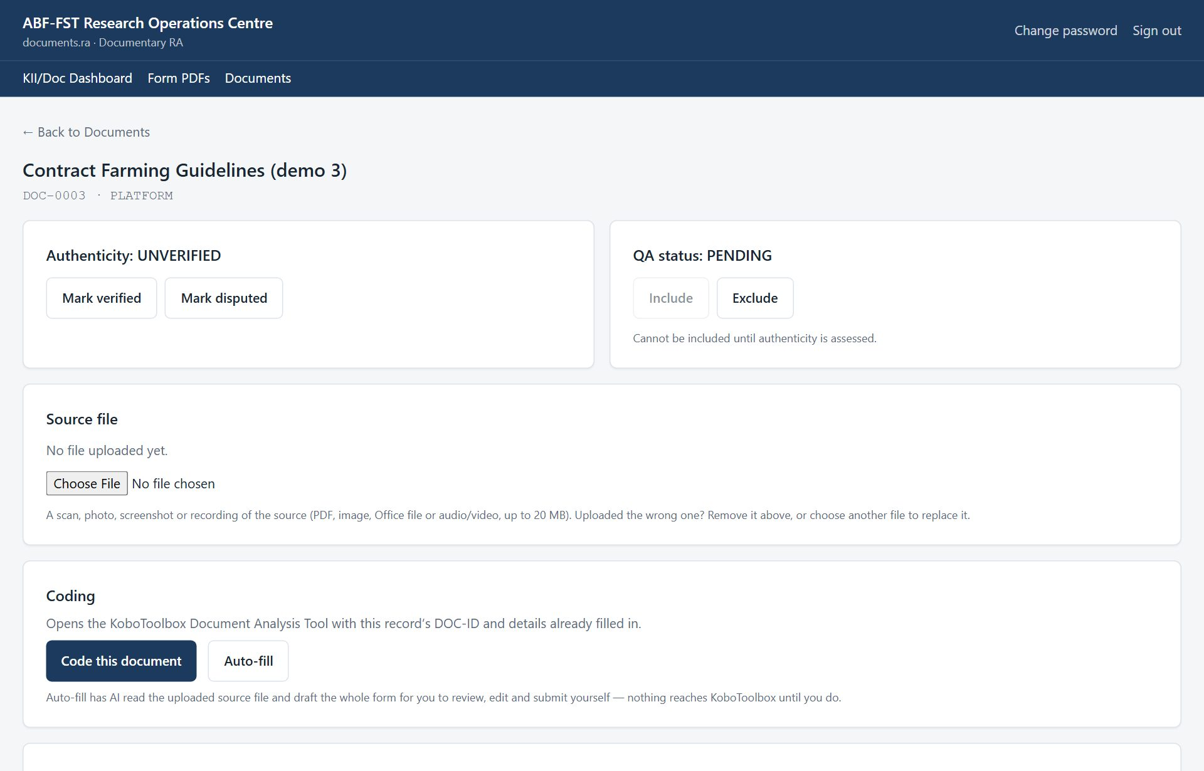
Figure 10. Document record: authenticity, QA status, memo and coding form.
- Set the QA status: Include or Exclude. A document cannot be included until authenticity has been assessed.
- Write the Interpretive memo (dispute reasons, interpretation notes) and select Save memo.
- Code the document (next two sections). The completed form's PDF then appears on the record, under Completed coding form (KoboToolbox).

4.8 Coding a document: two ways
The Coding panel offers two buttons for the Document, Digital Platform & Media Analysis Tool:
Button | What it does | Use it when
Code this document | Opens the KoboToolbox Document Analysis Tool with the DOC ID, title, author, date and source already filled in. You answer every other question yourself. | You code by hand, or the source cannot be read by the AI.
Auto-fill | Has the AI read the uploaded source file and draft answers to the whole form. You review, edit and submit. | A source file is uploaded and you want a fast first draft. The button only appears once the administrator has switched AI drafting on.

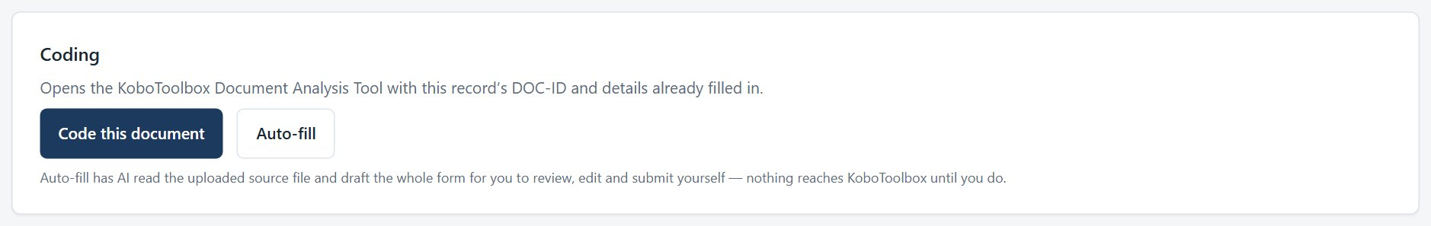
Figure 11. The Coding panel: Code this document, and Auto-fill.

4.9 Auto-fill: the AI drafts, you review
- Attach the source file (above). Select Auto-fill in the Coding panel; the review screen opens.
- If the file is a PDF of more than 100 pages, enter the Pages to read, for example 10-90. The AI reads up to 100 pages at a time, so either choose the pages that make up this evidence unit, such as one chapter, or tick Read the whole document in parts (see “Coding a very long document” below). Its locators use the original page numbers. For shorter files, leave the box empty to read everything.
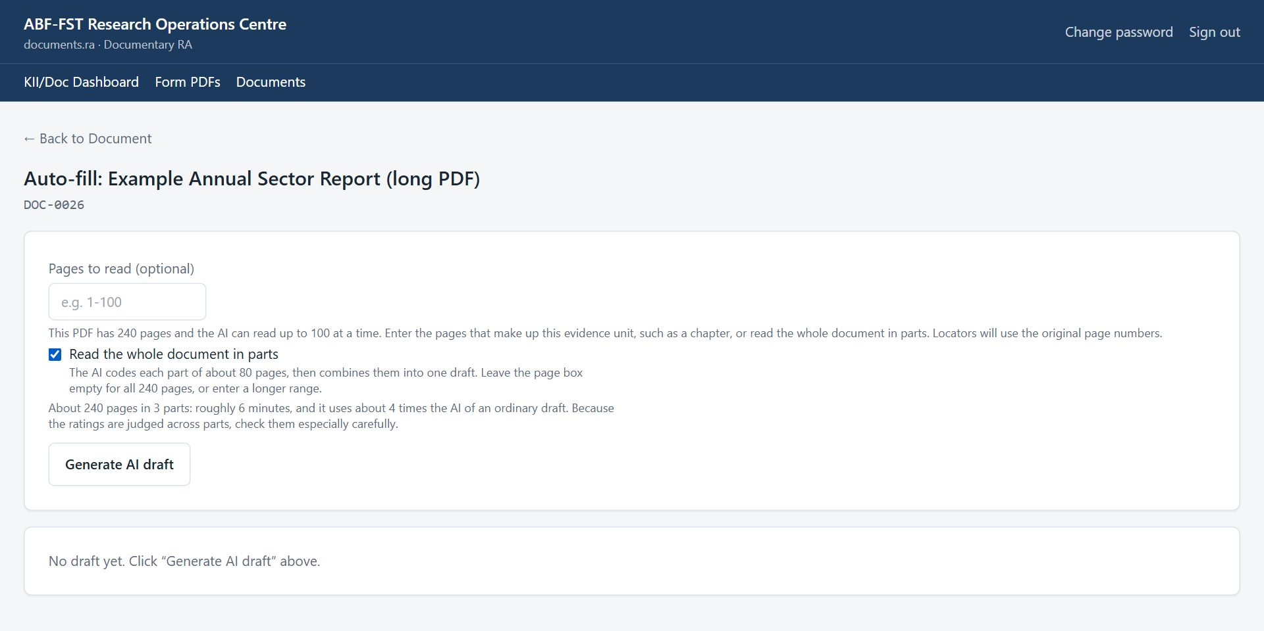
Figure 12. A 240-page PDF: enter a page range, or read the whole document in parts.
- Select Generate AI draft. The AI reads in the background, usually one to five minutes. You can leave the page and come back; the draft will be there.
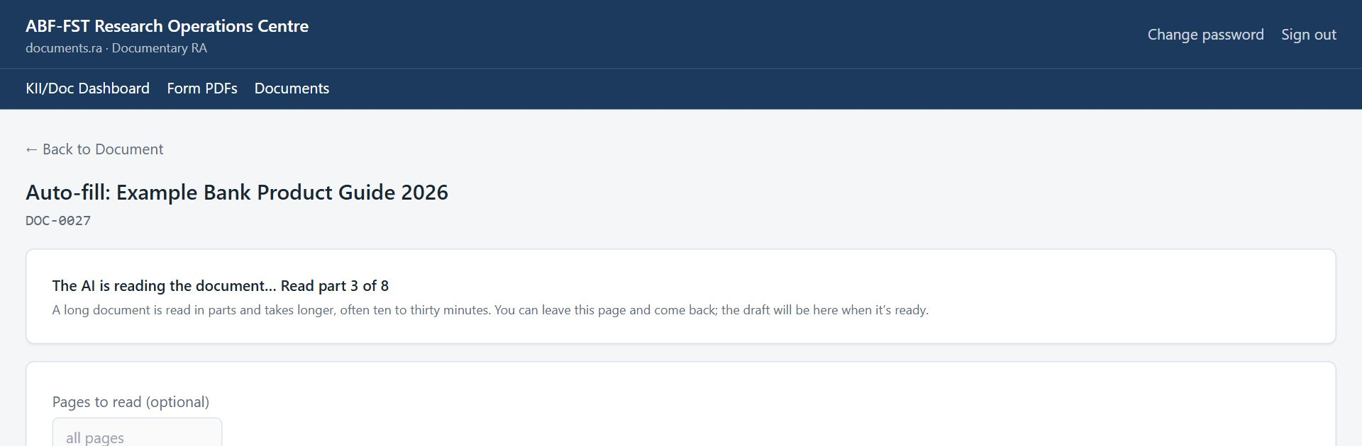
Figure 13. The AI is reading the document.
- Read the draft. It has every section of the KoboToolbox form, A to L. The DOC ID, author, title, date and source come from the record and cannot be changed here; everything else you can edit.
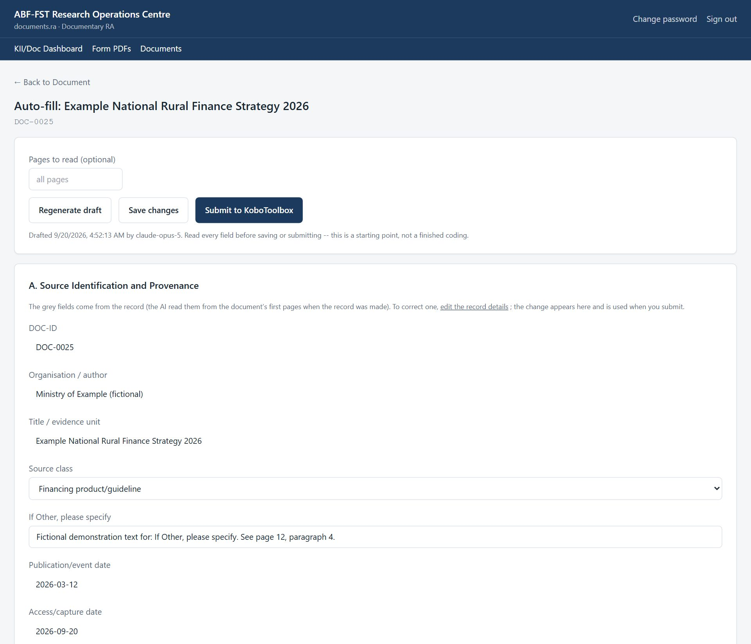
Figure 14. The review screen: the draft, ready to check and edit.
- Check the judgements, not just the facts: the strength ratings (Sections D and H), the hypothesis codes (Section K) and the locators. Open the source and confirm a few page or paragraph references.
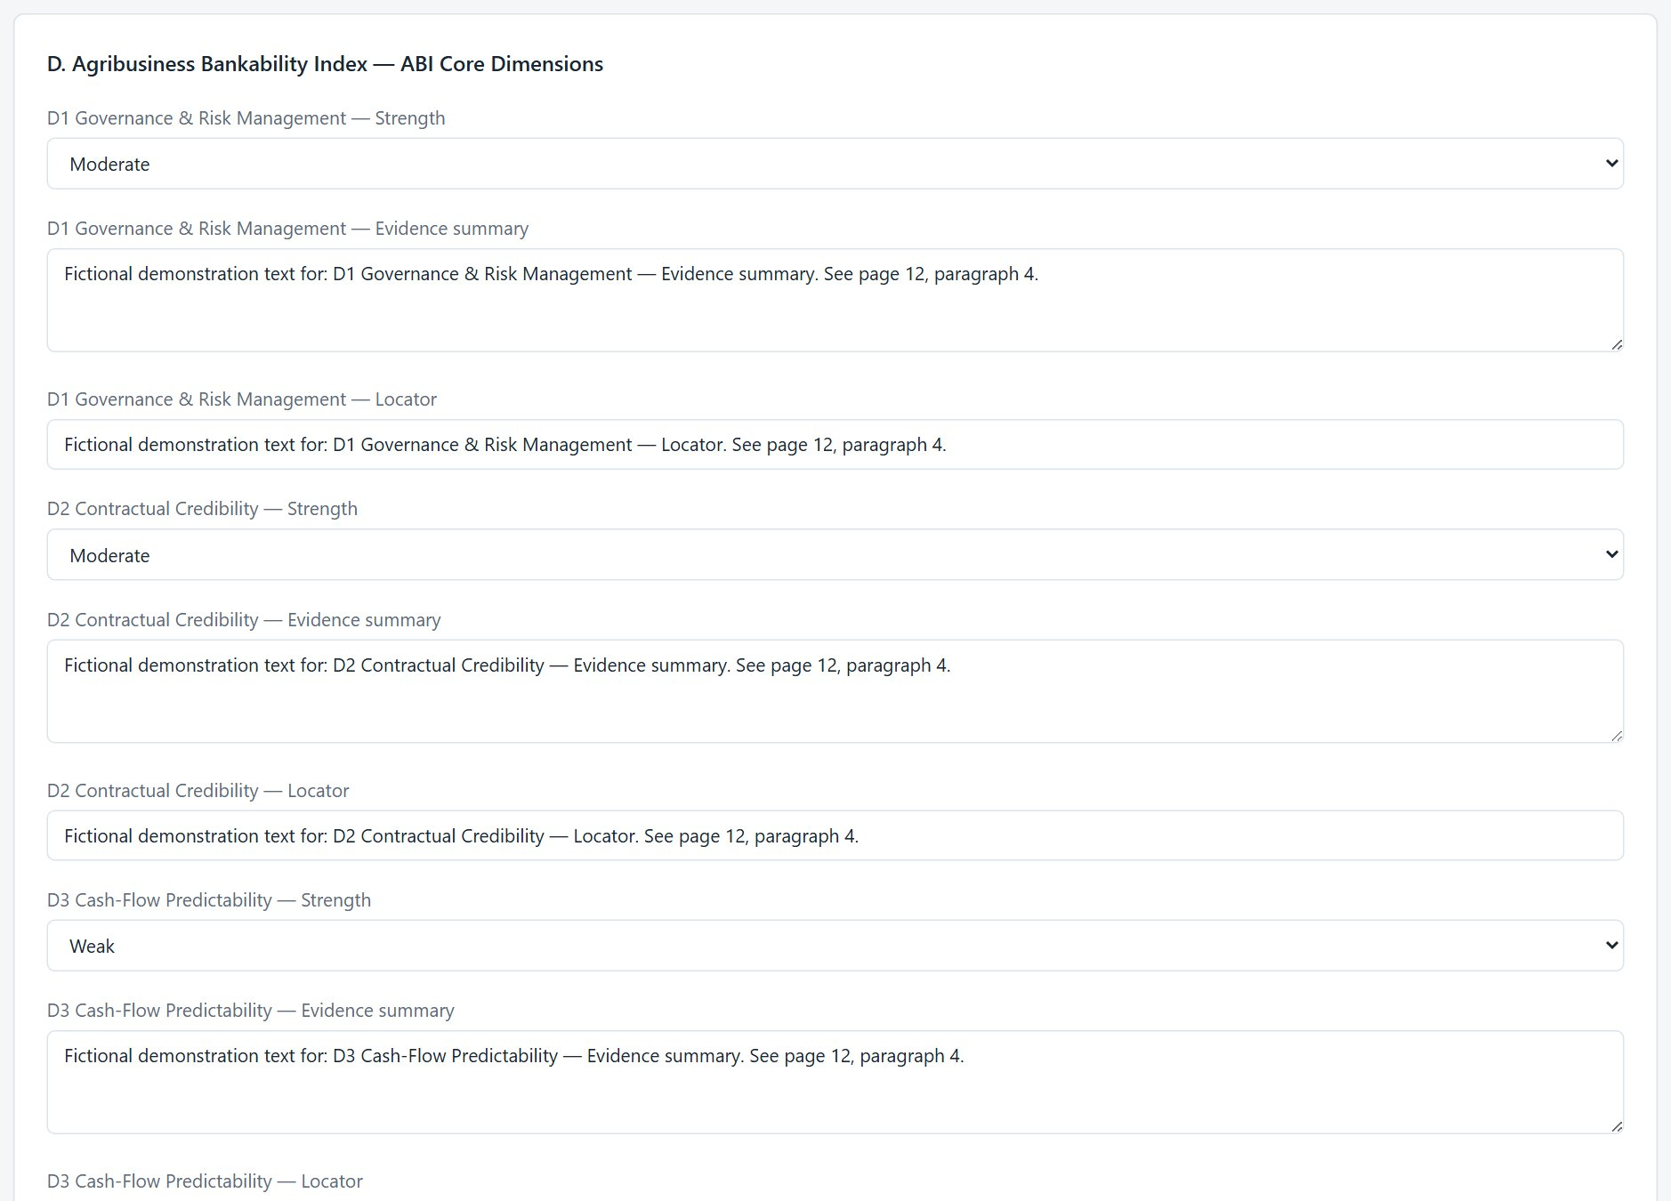
Figure 15. Section D: ratings and locators, all editable.
- Check the numbers in Section J against the source. Add or remove metrics as needed.
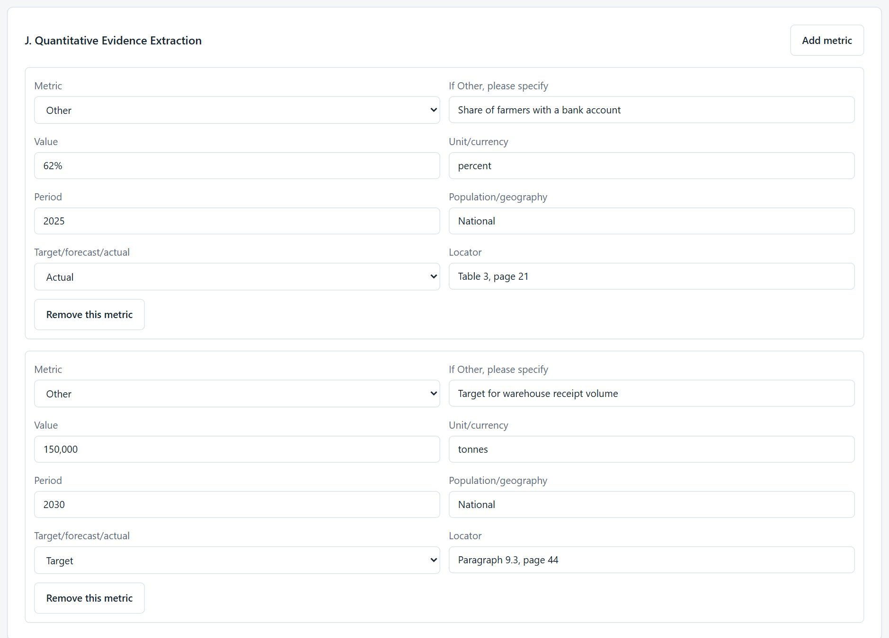
Figure 16. Section J: quantitative metrics.
- Select Save changes to keep your edits and finish later. When you are satisfied, select Submit to KoboToolbox and confirm. Your reviewed answers are sent as a completed record.
- The record appears at once under Completed coding form (KoboToolbox) on the document page and in Form PDFs, found by its DOC ID. The portal's copy of the Document Analysis Tool is refreshed the moment you submit. If a coding you submitted is later deleted in KoboToolbox, the next sync (automatic, or Sync now on Form PDFs) unlocks the document so it can be coded again.

The draft is a starting point, not a finding
Sections D to K are this study's documentary analysis. The AI drafts them; you are responsible for them. Change any rating you disagree with. A draft where everything is rated as strongly supportive deserves a second look.
Nothing reaches KoboToolbox until you select Submit. Each draft and submission is recorded in the audit log, so the study can say exactly which records were AI-assisted.
Submit once. A second submission would create a duplicate record for the document, and the screen shows “Already submitted” to stop it.
File type |  | Can the AI read it? | Locators
PDF |  | Yes, up to 100 pages at a time; longer files by page range, or read whole in parts (up to 1,500 pages). | Original page and paragraph numbers.
JPG, PNG (scan or photo) |  | Yes. Very large photos are shrunk automatically. | Whatever the image shows.
Word (.docx), Excel (.xlsx), text, CSV |  | Yes, as text. | No page numbers: headings, paragraph or section numbers, sheet names.
Audio or video |  | No. Upload a transcript (PDF, Word or text) and keep the recording as the source reference. | -
Old .doc or .xls |  | No. Save as a PDF or as .docx / .xlsx and upload that. | -

Coding a very long document
The AI can take in 100 pages at a time. A report of several hundred or a thousand pages therefore needs one of two approaches:
- One record per chapter (recommended). Make a record for each part you want coded, for example “NDS2 – Agriculture chapter”: upload the PDF once, then use Copy for another chapter on that record for every further part, entering each part's page range (see “Coding another chapter of the same document” above). Review and submit each one. Each part gets its own DOC ID, its own coding and its own row in the Excel export.
- Read the whole document in parts. Tick Read the whole document in parts. Leave Pages to read empty for every page, or enter a longer range such as 1-600 (up to 1,500 pages). The AI codes each part of about 80 pages, then combines them into one draft for the record. The screen tells you how many parts it will take and asks you to confirm, then shows progress (“Read part 3 of 8”, then “Combining the parts into one draft”). Expect roughly ten to thirty minutes, and you can leave the page.

A combined draft needs extra care
Because the ratings are judged across the parts rather than from every page at once, check the strength ratings (Sections D and H), the hypothesis codes (Section K) and the locators more carefully than for a single chapter. The draft states which pages it covers; confirm that this is the evidence unit you meant.
A whole-document read costs about the number of parts plus one times an ordinary draft. If any part fails, the whole draft fails and nothing is saved, so you never receive a coding that silently skipped pages.
Whether a whole-document coding is appropriate for a given source is a methodology decision for the PI; for a report that covers many topics, one record per chapter usually gives a sharper analysis.

If Auto-fill shows a message
You see | What it means | What to do
“Pages to read (required)”, or “This PDF has N pages…” | The PDF is longer than 100 pages. | Enter a page range of up to 100 pages, or tick Read the whole document in parts.
“…over the 1500-page ceiling…” | The PDF is longer than the most that can be read in one draft. | Enter a page range, or make one record per chapter.
“Step 1 of 2…” or “Step 2 of 2…” | A record made by Quick add is being filled in and drafted. Nothing is wrong. | Wait, or leave the page and come back.
A detail in Section A is wrong or blank | The AI reads only what the document states, and can mistake a title or date. | Correct it under Record details on the record page; the draft and the submission use the corrected value.
Quick add says the file can't be used | Unsupported type (for example audio), a damaged file, or a long PDF with no pages chosen. | Read the message: convert the file, enter a page range, or tick Read the whole document in parts. No record is created when this happens.
“Reconcile the pre-interview profile first…” when accepting a questionnaire, or a KII's coding will not complete | The case has a locked pre-interview profile with facts not yet verified with the respondent or not reconciled. | Open the case (or KII record) → Interview sheet; verify every fact, and ask the coordinator to reconcile the corrected ones.
“Read part 4 of 12” or “Combining the parts…” | A long document is being read in parts. Nothing is wrong. | Wait, or leave the page and come back.
“The AI's answer was cut off…” | The range was too big to answer in one go. | Try a narrower range.
“A draft is already being generated” | You or a colleague already started one. | Wait for it to finish (about five minutes; up to half an hour for a document read in parts).
“The last attempt failed: …” | The AI request did not complete. | Select Generate AI draft again. If it keeps failing, tell the administrator the message.
“The AI account has run out of credit…” | The study's AI account has no funds left. | Tell the administrator, who adds credit on the AI provider's billing page (Meta, for the Muse model); nothing else to do on this screen.
No Auto-fill button | AI drafting has not been switched on, or there is no source file yet. | Attach the file; otherwise ask the administrator.
Submit is refused by KoboToolbox | KoboToolbox did not accept the record. | Tell the administrator; your draft is kept.

Cost
Each draft is a paid request on the study's AI account. A short chapter costs little; a full 100 pages costs several times more; a whole document read in parts costs about the number of parts plus one times an ordinary draft. Choose the pages you need.

4.10 Downloading or emailing completed forms (Form PDFs)
- Select Form PDFs. You see the completed Document Analysis Tool forms from KoboToolbox, newest first.
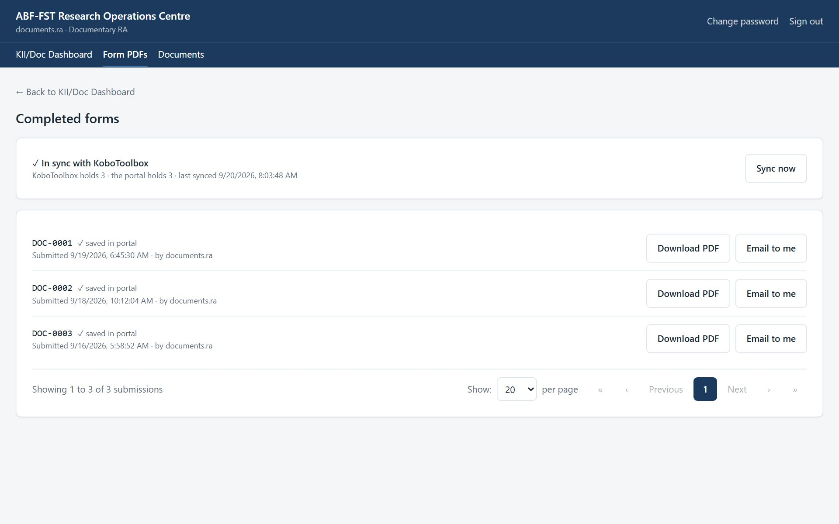
Figure 17. Completed document coding forms, with the sync status.
- Select Download PDF to save a readable copy: sections, questions, the chosen answers as words (not codes) and repeated groups.
- Select Email to me to send the PDF to the email address on your account.

At the top of the page, a sync panel shows whether the portal holds the same forms as KoboToolbox, for example “✓ In sync with KoboToolbox — KoboToolbox holds 12 · the portal holds 12”. Each row also says “✓ saved in portal” once the portal has an identical copy. If the panel says “Not in sync”, select Sync now (read-only roles see the panel but not the button); it takes a few seconds.
The same PDF is available from the record itself: the case page (questionnaire), the KII page (KII Guide) or the document page (coding form).
How the sync works
The portal keeps its own copy of the questionnaire, KII Guide and Document Analysis Tool, and refreshes it every 15 minutes and whenever someone selects Sync now. A submission edited in KoboToolbox is updated here; one deleted in KoboToolbox is flagged as removed. You never need to sync before downloading a PDF: the PDF is always read from KoboToolbox at that moment.

4.11 Judging authenticity
- Official: from a government body, regulator or the organisation itself — check it on the issuer's own site or registry.
- Secondary: reports, studies, articles — check the publisher, author and date.
- Platform: websites, social media, digital platforms — capture the URL and date accessed; corroborate claims elsewhere.
- Mark Disputed when authorship, date or content cannot be confirmed, and say why in the memo.

5. Rules you must follow
- Record the exact source reference so another researcher can find the same document.
- Do not store copyrighted documents outside the study's approved storage.
- Treat everything in the portal as confidential research data. Do not screenshot, copy, print or forward names, phone numbers, email addresses or answers except as your role requires.
- Never share your username or password, and never sign in for someone else.
- Use the respondent's contact details only to manage their participation in this study (invitations, reminders, appointments).
- Never tell a respondent, lender or anyone else that answers affect financing. The study generates no score, rating or financing decision.
- If a respondent asks to withdraw, stop contacting them and tell the Field Coordinator or PI the same day so the withdrawal is recorded.
- Report a lost device, a suspected account compromise, or data sent to the wrong person to the PI immediately.

6. Troubleshooting
Situation | Likely cause | What to do
Include is greyed out | Authenticity not assessed. | Mark verified or disputed first.
No coding form PDF on the record | The form was not submitted with this DOC ID. | Use Code this document or Auto-fill so the DOC ID is filled in for you.
A record says “Already submitted” and is locked | Its coding was already sent to KoboToolbox. | To redo it, delete that record in KoboToolbox, then select Sync now on Form PDFs.
No Auto-fill button | No source file yet, or AI drafting is not switched on. | Attach the file; otherwise ask the administrator.
Auto-fill asks for Pages to read | The PDF has more than 100 pages. | Enter a range of up to 100 pages, such as one chapter, or tick Read the whole document in parts.
Uploaded the wrong file | It happens. | Select Remove file beside the file name, then upload the right one.
"This screen isn't part of your role" | The screen belongs to another role (often an old bookmark or shared link). | Select Go to my start screen. If you need that screen, ask the PI about your role.
"Too many sign-in attempts from this network" | Sign-in is rate-limited per network; an office shares one address. | Wait a minute and try again. A wrong password says so explicitly.
A register shows fewer rows than expected | Registers show 20 rows per page to begin with; a Contact RA sees only assigned cases. | Choose more rows under Show at the foot of the list, use the page numbers or Next, or search. Ask the Field Coordinator to assign the case.
A button is greyed out | A required step is missing (a note, an authenticity decision, a selection). | Read the message beside the button; complete the missing step first.
"KoboToolbox couldn't be reached" | KoboToolbox is slow or the connection token has changed. | Try again in a few minutes. If it persists, tell the PI.
Form PDFs says "Not in sync with KoboToolbox yet" | The counts differ: a form was submitted or changed in KoboToolbox since the last sync (it runs every 15 minutes). | Select Sync now. If it still differs, or says it couldn't reach KoboToolbox, try again in a few minutes and tell the PI if it persists.
A document says "Already submitted" and its answers are locked | Its coding was already sent to KoboToolbox; changing it here would not change that record. | To redo the coding, delete that record in KoboToolbox, then select Sync now on Form PDFs. The document unlocks.
A page keeps loading | A slow or dropped connection. | Refresh the page. Your saved work is not lost; unsaved typing may be.
Email invitations says email isn't set up | Outgoing email has not been configured on the server. | Ask the administrator to run configure-email.sh. Until then, send invitations by WhatsApp.
A WhatsApp invitation was prepared but never sent | Prepare counts it as sent and moves the case to S05. | Open the case and Revoke that invitation; send a new one from the case's Invitations panel when you can reach the person.
A case is missing from the WhatsApp or email queue | It is not verified (S03 or S04), has no number or email on file, already has an open invitation, or is assigned to another Contact RA. | Verify the case, add the contact detail, or check its invitation history.
The contact finder says it would overwrite a detail | The organisation contact already has a different phone or email. | Check which is right and correct it under Respondents and contact details.
A file upload seems stuck | A large file on a slow connection takes time; the bar shows how much has been sent. | Wait for Saving… and the file name. If it fails, try again or upload a smaller version.

7. Quick reference
Sign in | https://research.agribizframework.com/admin/login
You start on | KII/Doc Dashboard
Target | 50–75 coded documents
Types | OFFICIAL, SECONDARY, PLATFORM
Fast path | New document → upload file → AI fills the record and drafts the form → check details → assess authenticity → review draft → Submit → Sync now
Long report | One record per chapter: Copy for another chapter, then the chapter's pages
Auto-fill | AI drafts; you review every field; only Submit sends it
Help | Field Coordinator; PI: Happyson Saina, 0773943709, abffst.research@gmail.com

8. Every screen and button for your role
This section lists every screen you can open as Documentary RA, and for each control: what it does and when to use it, why it exists (the rule behind it), and what you will see next. It is the same material as the Screen and Button Reference, cut down to your role.
Reading the tables
Control is the label you see on screen. Why it exists explains the rule or risk behind it; if a button is greyed out, this column usually says why. A control that needs a note or a confirmation says so.

8.1 Sign in
Who can open it: every role. Where: /admin/login
Where every staff member starts. Staff accounts are created by the PI; there is no self-registration.
Control | What it does and when to use it | Why it exists | What happens next
Username | Type the username the PI gave you. | Every action in the portal is recorded against a named person, so accounts are never shared. | Nothing yet; you also need the password.
Password | Type your password. The characters are hidden. | Passwords are never shown or emailed; the PI can reset yours but cannot read it. | Nothing yet; select Sign in.
Sign in | Checks your username and password and opens your start screen (the first screen your role uses). | Repeated wrong attempts from one network are refused for a minute, to stop password guessing. | Your start screen opens. A wrong password says so. “Too many sign-in attempts” means wait a minute.

8.2 The header and menu bar (every screen)
Who can open it: every role. Where: (top of every screen)
Shown at the top of every signed-in screen. The menu bar lists only the screens your role may open.
Control | What it does and when to use it | Why it exists | What happens next
Menu bar (Executive, Sampling, … Audit) | Opens a screen. The current screen is underlined. | The list is built by the server from your role, so you never see a screen that would refuse you. | The screen opens. A screen not in your list shows “This screen isn't part of your role”.
Change password | Opens the Change Password screen. | You should change the first password you were given, and any password you think someone saw. | The Change Password screen opens.
Sign out | Ends your session on this device. | Protects the data if the device is shared or lost. Always sign out on a shared device. | Your session on this device ends and you return to the Sign in screen.
← Back to … (top left) | Returns to the parent screen (for example from a case to the register). | A consistent way back that does not lose your place in the menu. | The parent screen opens.
Go to my start screen | Appears on the “This screen isn't part of your role” page and takes you to your own start screen. | An old bookmark or shared link may point at a screen that belongs to another role; this gets you out safely. | Your start screen opens.

8.3 Change Password
Who can open it: every role. Where: /admin/account
Change your own password.
Control | What it does and when to use it | Why it exists | What happens next
Current password | Type the password you use now. | Proves it is really you before a change, in case a signed-in device was left open. | Nothing yet.
New password | Type the new password. | It must be long enough, not a common password, not all digits and not similar to your username or name; the screen says which rule failed. | Nothing yet.
Confirm new password | Type the new password again. | Catches a typing slip that would lock you out. | Nothing yet.
Change password | Saves the new password. | Your old password stops working straight away, and other people (including the PI) never see your new one. | A confirmation appears. Use the new password next time.

8.4 KII / Document Dashboard
Who can open it: PI / System Admin, Field / Digital Coordinator, Data Analyst, Supervisor, KII RA, Documentary RA. Where: /admin/dashboard/kii-documents
Progress of the two qualitative strands against their targets (about 60 KIIs, 50–75 documents).
Control | What it does and when to use it | Why it exists | What happens next
KII by status | Counts KII records at each stage (prospect, invited, scheduled, completed, declined, no-show). | Shows how far the interview target has come. | Read only.
Documents by type / by QA status | Counts documents by type (official, secondary, platform) and by decision (pending, included, excluded). | Only included documents count towards the corpus target. | Read only.

8.5 Documents (the corpus)
Who can open it: PI / System Admin, Field / Digital Coordinator, Documentary RA, Supervisor. Where: /admin/documents
The register of documentary evidence (target 50–75 coded, included documents).
Control | What it does and when to use it | Why it exists | What happens next
New document | Opens the New Documentary Evidence Record screen. | Every source needs a record with a document ID before it can be coded. | The New document screen opens.
Search title, ID or author | Filters the list as you type. | Finding one document in 100 or more. | Only matching documents are listed.
Manage | Opens the document record. | All work on a document happens on its own record. | The document record opens.
Show / page numbers | Choose rows per page and move between pages. | As on every register. | The list redraws.

8.6 New Documentary Evidence Record
Who can open it: PI / System Admin, Field / Digital Coordinator, Documentary RA. Where: /admin/documents/new
Creates a document record. The fastest way is to upload the file and let the AI fill in the record and draft the coding form.
Control | What it does and when to use it | Why it exists | What happens next
Choose file (Fastest: upload the document) | Choose the document: PDF, Word, Excel, text or CSV, or a JPG/PNG scan or photo (up to 20 MB). | The AI can read all of these, so you do not retype details that are already on the first page. | Nothing is sent until you select Upload and auto-fill.
Optional: Title | Type a title of your own. | You may want a specific name, for example for one chapter of a report. | A typed title is kept; the AI does not replace it.
Optional: Pages to read | Enter the pages of a long PDF that make up this evidence unit, for example 290-340. | The AI reads at most 100 pages at a time, and a long report holds several evidence units. | Only those pages are read. With no title, the AI names the part.
Optional: Read the whole document in parts | Ticks the option to read a PDF longer than 100 pages in parts of about 80 pages, then combine them. | For a document you want coded as one unit; slower and dearer, and the ratings need extra checking. | The screen shows how many parts and asks you to confirm before it starts.
Upload and auto-fill | Creates the record, uploads the file, and starts the AI: first it fills in the record's details, then it drafts the whole coding form. | Saves typing every detail and every answer; a person still reviews and submits. | The review screen opens and shows “Step 1 of 2… Step 2 of 2”. If the file cannot be used, nothing is created.
Title, Author / speaker, Source URL / reference, Document type, Geographic scope, Evidence extract → Create document record | The manual way: type the details yourself and save. | For a source with no file yet, or when AI drafting is switched off. | The record is created with a document ID (for example DOC-0025) and opens.

8.7 Document record
Who can open it: PI / System Admin, Field / Digital Coordinator, Documentary RA, Supervisor. Where: /admin/documents/{id}
Everything about one document: authenticity, the decision to include it, its file, its details, its coding and its memo.
Control | What it does and when to use it | Why it exists | What happens next
Mark verified / Mark disputed | Records your judgement of whether the document is what it claims to be: the right author, date and content. | Documents are evidence; a forged or doubtful one must not enter the corpus unnoticed. Disputed documents are kept and explained, not deleted. | The authenticity changes and is audited. Include becomes available once assessed.
Include / Exclude | Decides whether the document counts in the corpus. | A document cannot be Included until authenticity has been assessed, so unassessed evidence never counts. | The QA status changes; Include stays greyed out while authenticity is Unverified.
Source file → Choose File | Uploads or replaces the source (up to 20 MB). Replacing removes the old file and any unsubmitted draft made from it. | The record keeps one current source. A draft of the wrong document must never be submitted for the right one. | A bar shows progress, then the file name appears. With Start Auto-fill ticked, the review screen opens.
Start Auto-fill as soon as the file is uploaded (tick box) | When ticked, uploading immediately starts the AI draft. | Saves a step for the common case. | After the upload, the review screen opens and the AI starts reading.
Remove file | Deletes the source file from the server. | For a wrong upload. It also discards the unsubmitted AI draft made from it; a draft already submitted is kept as the record of what was filed. | A confirmation names what goes. The record says “No file uploaded yet”.
Copy for another chapter (Chapter title, Pages to read, Copy and auto-fill) | Makes another record for a different part of the same source: same author, date, source and type, and its own copy of the file. | A long report holds several evidence units, each of which should be coded, judged and exported on its own. | A new record is created (and, with AI on, drafted) and opens. Authenticity and inclusion are not copied.
Record details → Save details | Edits the title, author, date, source, scope, value chain and type. | These feed Section A of the coding form; if the AI filled them in from the document, this is where you check and correct them. | “Details saved.” The draft and the submission use the corrected values.
Code this document | Opens the KoboToolbox Document Analysis Tool with the document ID and details filled in. | For coding by hand, or when the AI cannot read the source. | The KoboToolbox form opens in a new tab.
Auto-fill | Opens the review screen for the AI draft of the whole coding form. | A fast first draft that a person then checks. | The Auto-fill review screen opens.
Interpretive memo → Save memo | Writes down your reasoning: why authenticity was disputed, how you read the document. | The memo is the audit trail of your judgement, needed for the dissertation. | A “saved” message; the memo stays on the record.
Completed coding form → Download PDF | Downloads the completed coding form for this document. | A readable copy of what was submitted. | A PDF downloads (only if a form was submitted with this document ID).

8.8 Auto-fill review screen
Who can open it: PI / System Admin, Field / Digital Coordinator, Documentary RA, Supervisor. Where: /admin/documents/{id}/ai-draft
Where you review the AI's draft of the KoboToolbox coding form, edit it and submit it. Nothing reaches KoboToolbox until you select Submit.
Control | What it does and when to use it | Why it exists | What happens next
Pages to read | For a PDF over 100 pages, enter the pages that make up this evidence unit. | The AI reads at most 100 pages at a time. | Only those pages are drafted; locators keep the original page numbers.
Read the whole document in parts | Reads the whole PDF (or a long range) in parts of about 80 pages and combines them. | For one coding of a long document; costs about the number of parts plus one times an ordinary draft. | You are asked to confirm. Progress shows “Read part 3 of 8”, then “Combining the parts”.
Generate AI draft / Regenerate draft | Starts the AI reading the source. Regenerate replaces the current draft and any unsaved edits. | Each draft is a paid request, so it starts only when you ask; regenerating asks first because it discards your edits. | The AI works in the background (usually one to five minutes) and you can leave the page. The draft appears here when ready.
The draft fields (sections A to L) | Every question of the form, with the AI's answer. Edit any grey-free field: text, choices, tick boxes, dates. | The AI drafts; you are responsible for the judgements (strength ratings, hypothesis codes) that are the study's documentary analysis. | Edits are kept in the browser until you select Save changes.
Section A grey fields (DOC ID, author, title, date, source) | Come from the record and cannot be edited here; use “edit the record details”. | The draft must agree with the record it is attached to. | Corrections on the record show here at once and are the values submitted.
Add metric / Remove this metric (Section J) | Adds or deletes a row of the quantitative metrics table. | Numbers in the source (percentages, amounts, targets) are recorded one per row with a locator. | The row is added or removed in the draft.
Save changes | Saves your edits to the draft on the server. | Lets you stop and finish later without submitting. | “Changes saved.” The button is unavailable after submission.
Submit to KoboToolbox | Sends the reviewed draft to KoboToolbox as a completed record, after you confirm. It saves your edits first. | The one place the portal writes to KoboToolbox, and only on this deliberate click: a person, not the AI, submits the study's documentary analysis. Once only, so no duplicate. | “Submitted to KoboToolbox, and a copy is now held in the portal.” The answers lock and the screen says “Already submitted”. A second click is refused.

8.9 Completed forms (Form PDFs)
Who can open it: PI / System Admin, Field / Digital Coordinator, QUAN/Kobo QA RA, KII RA, Documentary RA, Supervisor. Where: /admin/submissions
The completed KoboToolbox forms for your role (the questionnaire, the KII Guide or the Document Analysis Tool; the PI, coordinator and supervisor can switch between all three).
Control | What it does and when to use it | Why it exists | What happens next
Sync panel: “In sync with KoboToolbox” | Shows how many submissions KoboToolbox holds and how many the portal holds, and when they were last matched. | The portal keeps its own copy of the completed forms. If the two numbers differ, the portal is behind. | Read only. “Not in sync” means press Sync now.
Sync now | Pulls that form from KoboToolbox now and updates the portal's copy. | The automatic sync runs every 15 minutes; this brings it up to date immediately. It also notices edits and deletions made in KoboToolbox. | The counts refresh. A KII record's coding can move to COMPLETE; a document whose submission was deleted in KoboToolbox unlocks.
✓ saved in portal (on each row) | Says the portal holds an identical copy of that submission. | Proof, row by row, that nothing was lost or changed between KoboToolbox and the portal. | Read only. It is missing until the next sync for a new or edited row.
Download PDF | Downloads that completed form as a readable PDF (sections, questions, answers as words). | A readable copy for records, meetings and checking. | A PDF downloads; the download is audited.
Email to me | Emails that PDF to the address on your own account. | A PDF is a full research record, so it goes only to you, never to a typed-in address. | “Sent to …” (address masked). Recorded in the audit log.
Show / page numbers | Choose rows per page and move between pages. | As on every register. | The list redraws.

