CHINHOYI UNIVERSITY OF TECHNOLOGY · ABF-FST RESEARCH STUDY
Role Guide 7: Data Analyst
Step-by-step instructions for the Data Analyst role in the ABF-FST Digital Respondent Portal.
STUDY | Developing and Validating the Agribusiness Bankability Framework for Food Systems Transformation through Novel Financing Models in Zimbabwe (ABF-FST)
PRINCIPAL RESEARCHER | Happyson Saina, Doctor of Strategic Management candidate, Chinhoyi University of Technology
SUPERVISORS | Dr L. Chikazhe and Dr J. Kanyepe
FOR | Analysts monitoring progress and working with de-identified data
SYSTEM ADDRESS | https://research.agribizframework.com
CONTACT | 0773943709 · abffst.research@gmail.com
VERSION | Version 1.20 · 4 October 2026

Screenshots in this document use fictional demonstration data. Organisation and person names, phone numbers and figures shown in them are not real study records.

Contents
1. Your role at a glance 3
2. Signing in and your screens 4
Signing in 4
Finding your way around 4
Your screens 5
Changing your password 5
3. Your routine 6
4. Step-by-step tasks 7
4.1 Your start screen 7
4.2 Reading the dashboards 7
4.3 Using Reports (analytics and charts) 8
4.4 Downloading data 12
4.5 Working with the analysis export 12
5. Rules you must follow 14
6. Troubleshooting 15
7. Quick reference 16
8. Every screen and button for your role 17
8.1 Sign in 17
8.2 The header and menu bar (every screen) 17
8.3 Change Password 18
8.4 Executive Dashboard 18
8.5 Sampling Dashboard 19
8.6 Contact Dashboard 19
8.7 KII / Document Dashboard 20
8.8 Reports 20
8.9 Cost Dashboard 20
8.10 Export 21

1. Your role at a glance
You monitor fieldwork through the dashboards and Reports and prepare analysis from the de-identified export. Your role is read-only: you cannot change any record, and you never see names or contact details.

You can
- Open the Executive, Sampling, Contact and KII/Doc dashboards, Reports and Cost (view).
- Download the de-identified analysis export (CSV).

You cannot
- Change any record anywhere.
- See case pages, respondent names, contact details or completed forms.
- Download the operational export or the KoboToolbox data (ask the PI for the de-identified extracts you need).

Where this fits
The System Manual explains how the whole system works. This guide covers only what you do, and its last section lists every screen and button you can use, with what each does and why. Ask the Field Coordinator or PI when something is outside your role.

2. Signing in and your screens

Signing in
- Open https://research.agribizframework.com/admin/login in any modern browser (Chrome, Edge, Firefox or Safari), on a computer, tablet or phone.
- Type your Username and Password, then select Sign in.
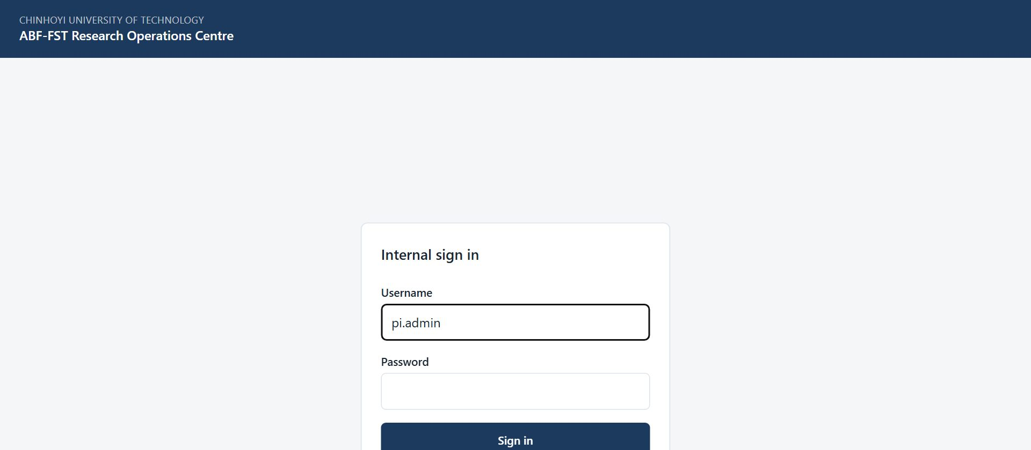
Figure 1. The sign-in screen for all internal staff.
- You arrive on your start screen: Executive Dashboard. The bar across the top lists only the screens your role (Data Analyst) can open.

Accounts
There is no self-registration. The PI / System Admin creates every account and sets its role. Ask the PI if you need an account, a different role, or a password reset.

Finding your way around
- The top bar shows your username and role, and the screens you can use. It is not a full menu with some items greyed out: anything absent is simply not part of your role.
- Most screens have a ← Back to … link at the top that returns you to the screen you came from.
- Registers show 20 rows per page to begin with. At the foot of the list, Show lets you choose 10, 20, 50, 100 or 200 rows per page (the portal remembers your choice), and the page numbers, Previous, Next and the double arrows take you to any page. The Search box above the list narrows it.
- Change password (top right) lets you set a new password at any time. Choose a long password you do not use anywhere else.
- Sign out (top right) ends your session. Always sign out on a shared or public computer.
- If you are inactive for a while you may be asked to sign in again. This protects research data on unattended devices.

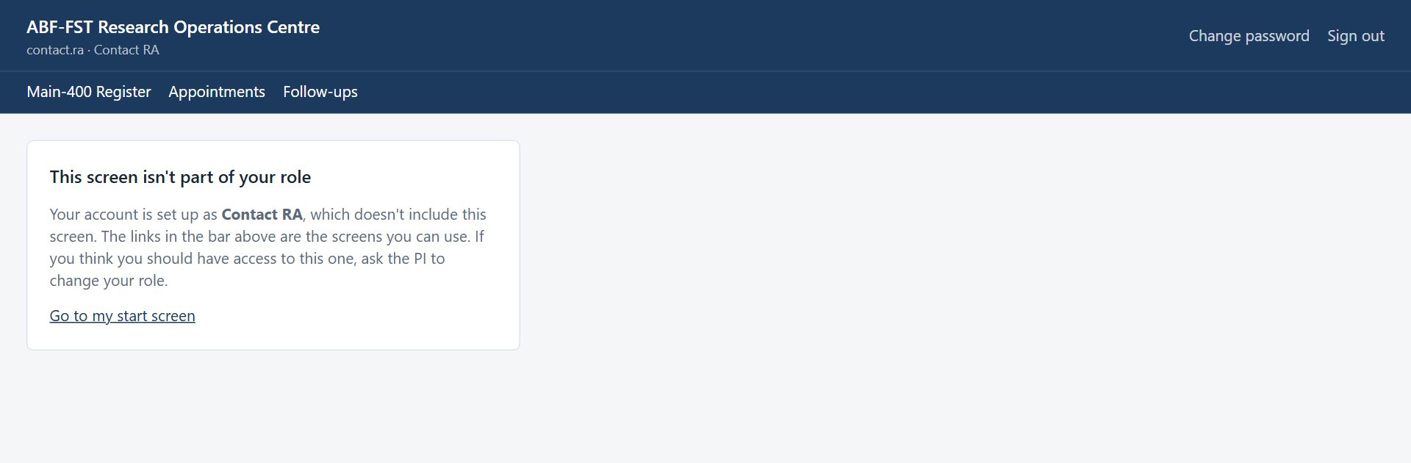
Figure 2. Opening a screen outside your role (for example from an old bookmark) shows this card instead of the screen.

Your screens
Screen | What you use it for
Executive, Sampling, Contact, KII/Doc | Progress and coverage.
Reports | Analytics with charts and tables.
Cost | Spend and cost per completed case (view only).
Export | De-identified analysis export.

Changing your password
- Select Change password in the top right corner.
- Enter your Current password, then the New password twice, and select Change password.
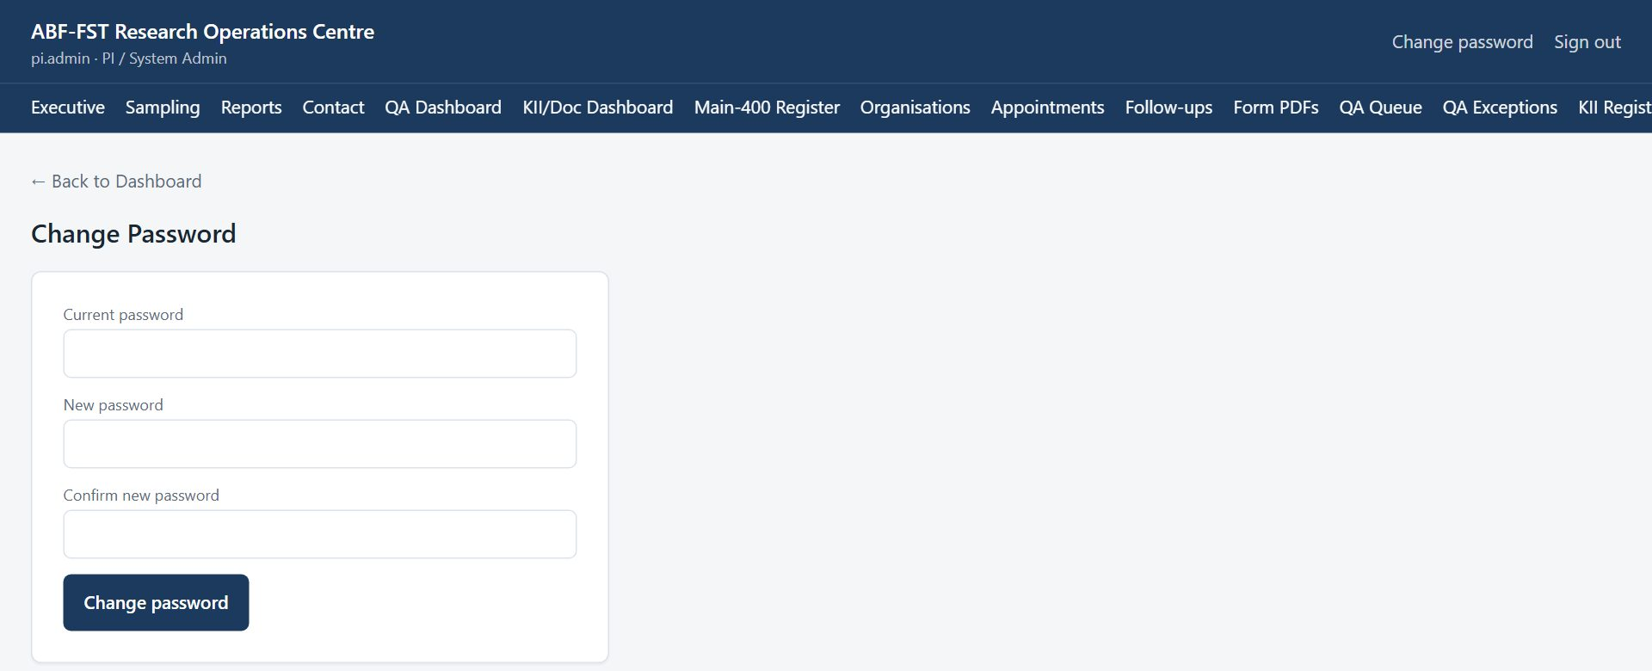
Figure 3. Change Password screen.
- Use the new password next time you sign in. If you have forgotten your password, ask the PI to reset it.

3. Your routine
A suggested rhythm. Adjust it to the Field Coordinator's plan.
When | What to do
Weekly | Reports for the last 7 and 30 days; coverage by province, organisation type and size; mode balance; completion times.
Monthly | Download the analysis export; update progress tables for the PI and supervisors.
Before data lock | Agree the final export and cleaning plan with the PI.

4. Step-by-step tasks

4.1 Your start screen
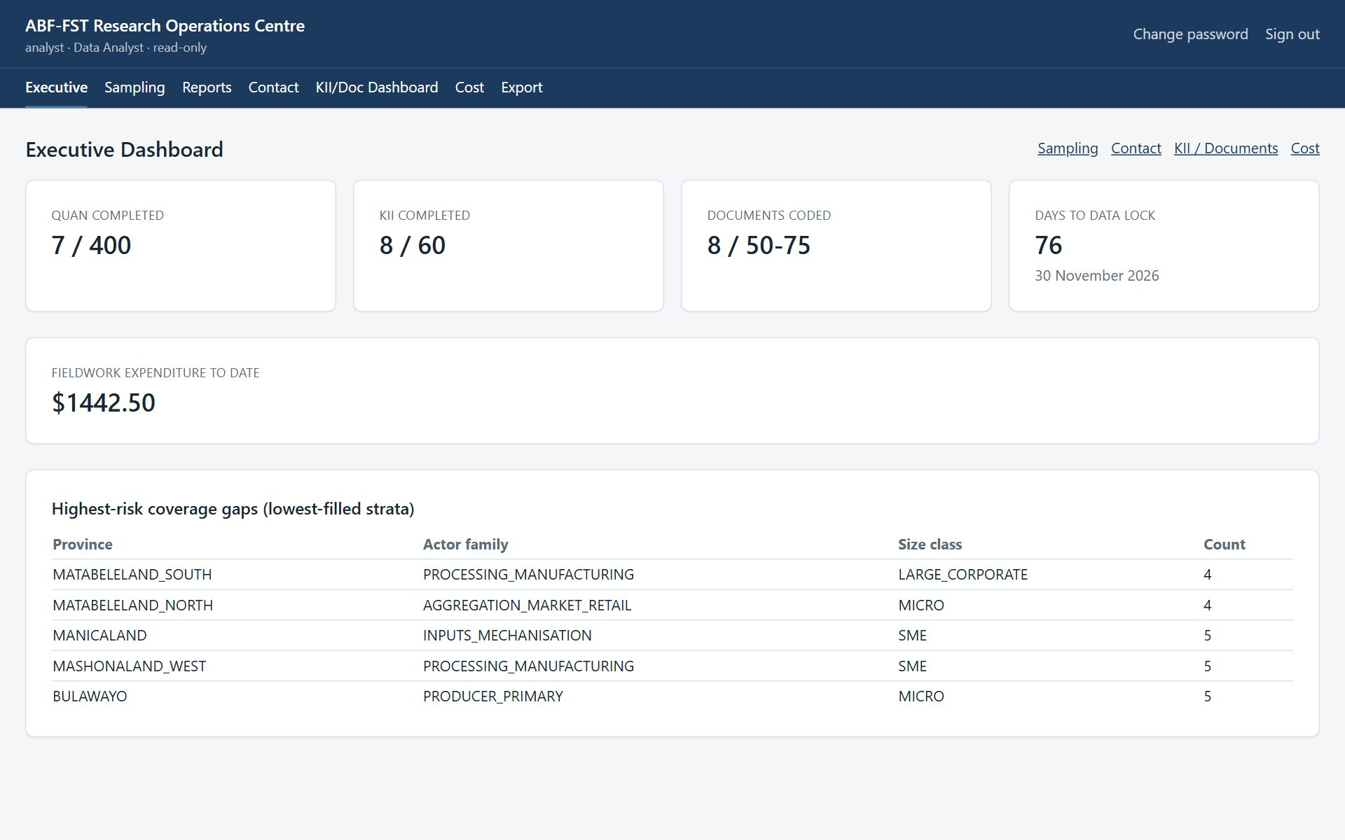
Figure 4. Executive Dashboard as seen by the Analyst.

4.2 Reading the dashboards
Dashboards are for monitoring; nothing on them changes data. Figures refresh whenever the screen is opened.
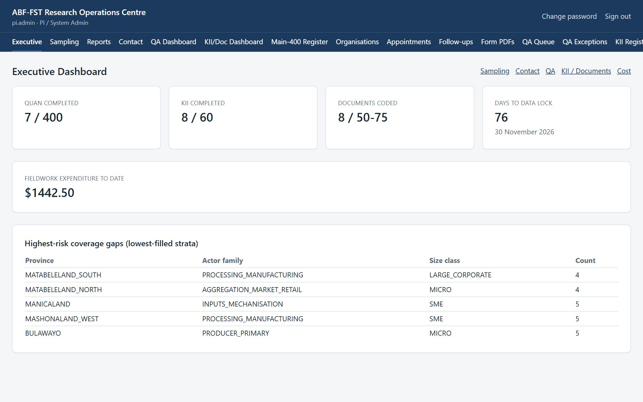
Figure 5. Executive Dashboard: completions against the 400 / 60 / 50–75 targets, days to data lock, spend, and the lowest-filled strata.
Dashboard | What it tells you | Use it to
Executive | QUAN completed out of 400, KII completed out of 60, documents coded against 50–75, days to the 30 November 2026 data lock, spend to date, lowest-filled strata. | See overall progress and where fieldwork attention is most needed.
Sampling | Main cases by province, verified/total by stratum, Reserve activations by reason. | Check the design stays balanced across strata.
Contact | Organisations verified, eligible respondents identified, invitations sent and opened, upcoming appointments, refusals, unreachable cases. | Track outreach and spot stalled contact.
QA Dashboard | Submissions today and in total, the open QA queue, decisions recorded, completions by administration mode. | Keep the QA backlog under control.
KII/Doc Dashboard | KII completed against 60; KIIs by status; documents by type and QA status. | Track the qualitative and documentary strands.

Targets versus records
The registers hold more records than the targets (for example 90 KII records for 60 completed interviews). The surplus is reserve depth for non-response, not extra work.

4.3 Using Reports (analytics and charts)
- Select Reports in the top bar.
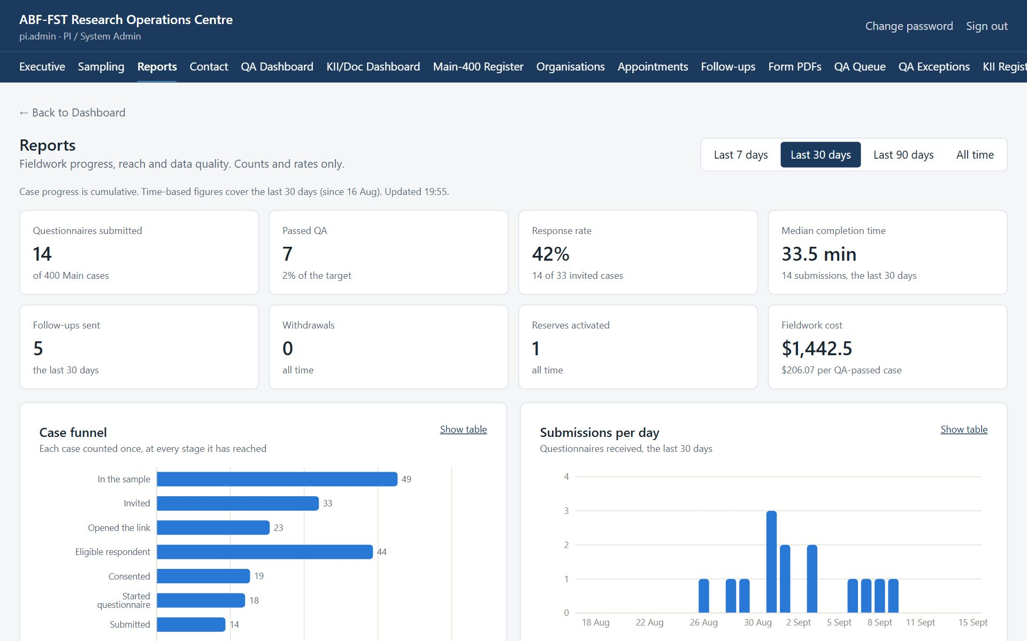
Figure 6. Reports: headline figures for the chosen period.
- Choose the period with Last 7 days, Last 30 days, Last 90 days or All time. Case progress (the funnel and workflow) is always cumulative; time-based figures such as submissions per day follow the period.
- Read the headline cards: questionnaires submitted, passed QA, response rate (submitted ÷ invited), median completion time, follow-ups sent, withdrawals, Reserves activated, and fieldwork cost per QA-passed case.
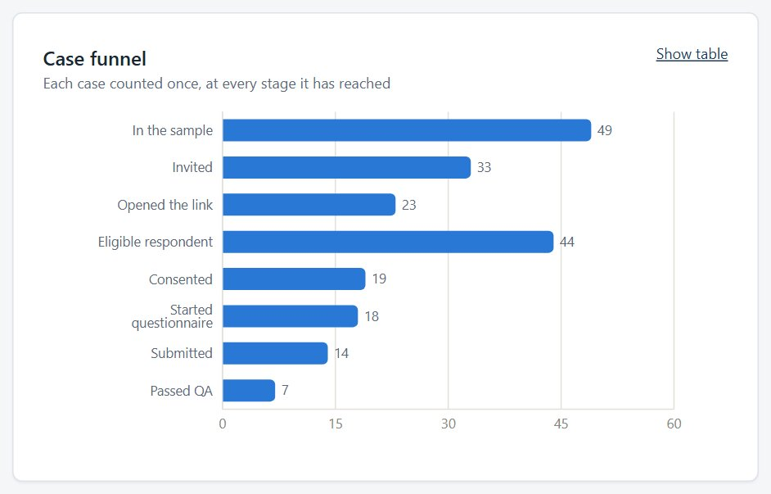
Figure 7. Case funnel: each case counted once at every stage it has reached.
- Select Show table on any chart to see the exact numbers, for example to copy them into a progress report.
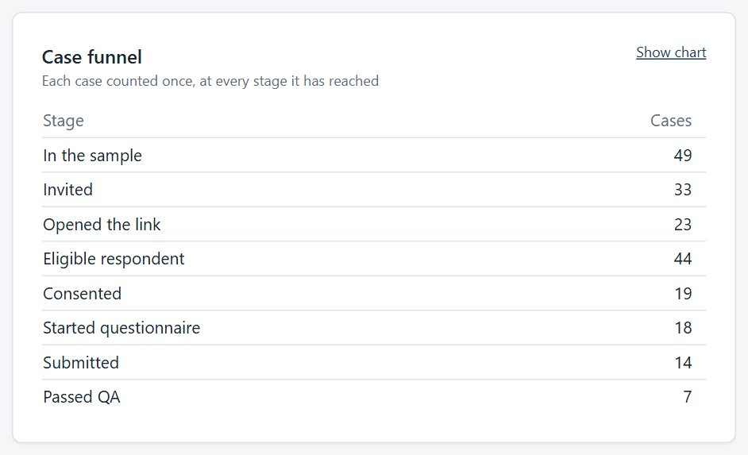
Figure 8. The same chart as a table.
- Use Coverage to see, by province, organisation type and size, what share of cases have been invited and have submitted. Short bars show where contact effort should go next.
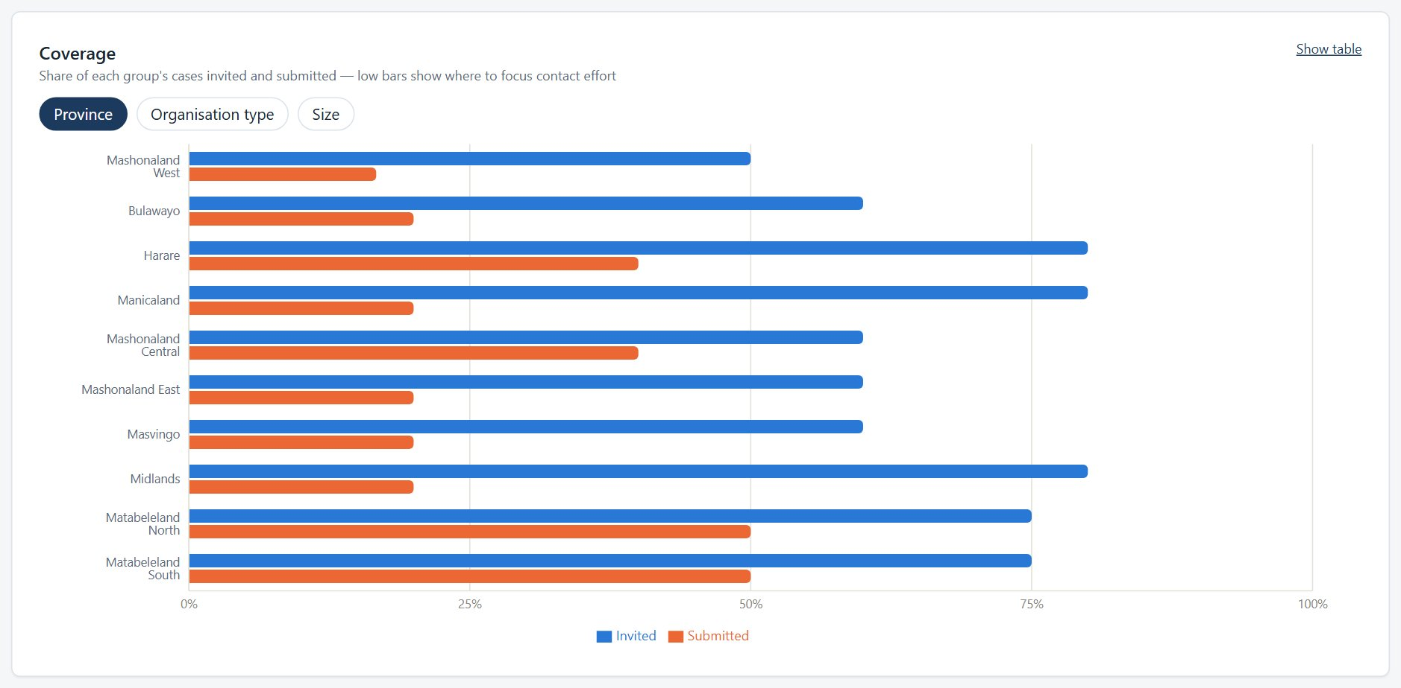
Figure 9. Coverage by group.
- Check How questionnaires were completed. If one administration mode dominates (more than 70% once at least 10 questionnaires are in), the chart shows an imbalance alert so the team can review the mix.
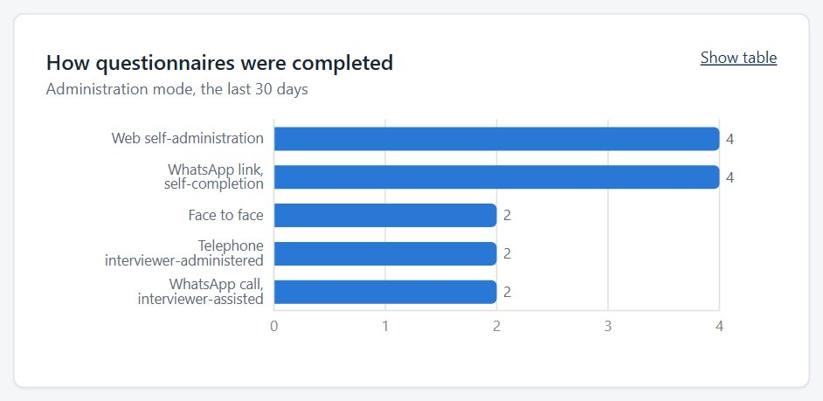
Figure 10. Administration modes.
- Review Time to complete the questionnaire and QA outcomes. Very short or very long completions are what the QA duration rules flag.
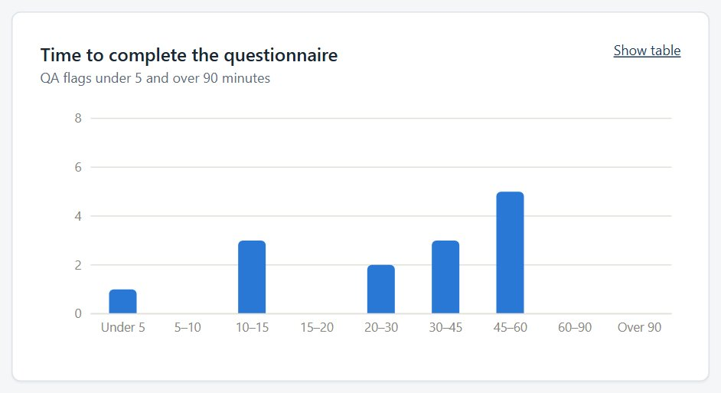
Figure 11. Completion-time distribution.

Reports show counts and rates only — never names or answers — so they are safe to discuss with supervisors.

4.4 Downloading data
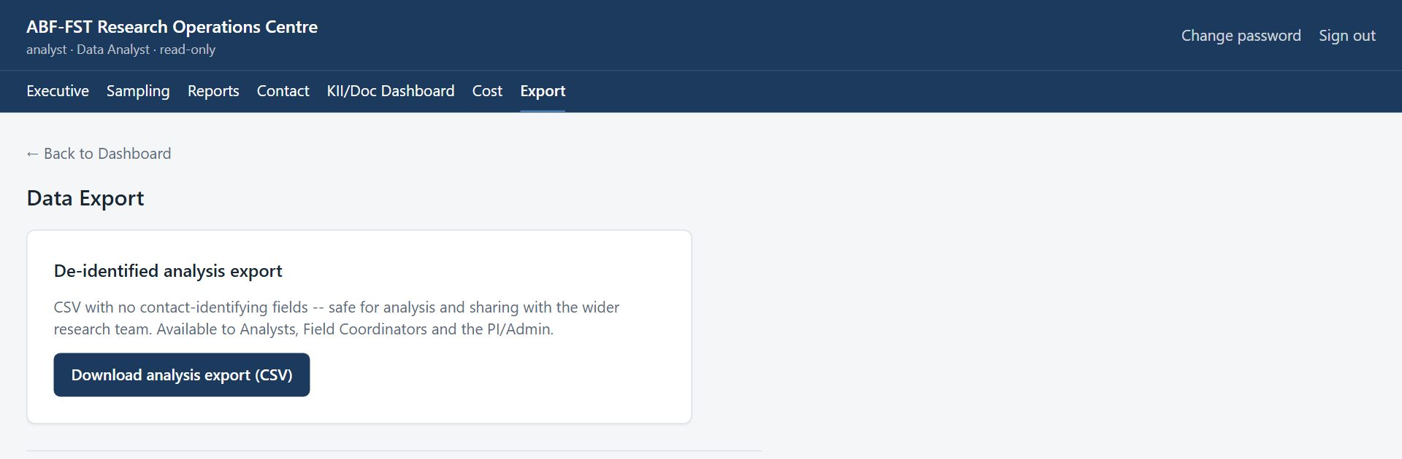
Figure 12. Data Export.
Download | Contains | Who
De-identified analysis export (CSV) | One row per questionnaire: sample_id, master_id, province, actor_family, value_chain, size_class, administration_mode, qa_status, submitted_at, completion_seconds. No names or contact details. Participants who withdrew are left out. | PI, Field Coordinator, Analyst
Full operational export (CSV) | Every questionnaire, including withdrawn ones (consent_withdrawn), plus organisation name, respondent name, phone, email and gatekeeper details. Internal operations only. | PI only
KoboToolbox data: Excel workbook | Every submission's answers for one form: data_codes (codes for SPSS/Stata/R), data_labels, a sheet per repeat group, the questions dictionary, the choices lists, and for the questionnaire the matched case, QA status, withdrawal flag and workflow status. | PI only
KoboToolbox data: All completed forms (PDF ZIP) | Every completed form as a PDF, with manifest.csv listing file, record, KoboToolbox id and submission time. | PI only
Analysis packs: SmartPLS 4 and ATLAS.ti | Three ZIP downloads that open directly in your analysis software. SmartPLS pack: the questionnaire as one numeric row per respondent who passed QA, with a data dictionary and a missing-value code of -99. ATLAS.ti interviews pack: one Word document per key informant interview plus an attribute sheet. ATLAS.ti documents pack: the uploaded source files named by document ID plus an attribute sheet. Each has a README that says how to import it. No names, organisation, job title or contact details; anyone who withdrew consent is left out. | PI only

4.5 Working with the analysis export
- One row per questionnaire submission. sample_id links to the case; master_id to the organisation.
- qa_status: use only QA_PASSED rows for the main analysis unless the PI says otherwise.
- Participants who withdrew after submitting are already left out of this export (PI decision, 15 September 2026).
- completion_seconds is the time taken; administration_mode is 01–06 (see the table in the Quick reference).
- Store exports only on encrypted, access-controlled storage and delete working copies when no longer needed.

5. Rules you must follow
- Never try to re-identify organisations or people from exported data.
- Treat everything in the portal as confidential research data. Do not screenshot, copy, print or forward names, phone numbers, email addresses or answers except as your role requires.
- Never share your username or password, and never sign in for someone else.
- Use the respondent's contact details only to manage their participation in this study (invitations, reminders, appointments).
- Never tell a respondent, lender or anyone else that answers affect financing. The study generates no score, rating or financing decision.
- If a respondent asks to withdraw, stop contacting them and tell the Field Coordinator or PI the same day so the withdrawal is recorded.
- Report a lost device, a suspected account compromise, or data sent to the wrong person to the PI immediately.

6. Troubleshooting
Situation | Likely cause | What to do
Export button missing | Only the de-identified export is available to Analysts. | Ask the PI for any further extract.
"This screen isn't part of your role" | The screen belongs to another role (often an old bookmark or shared link). | Select Go to my start screen. If you need that screen, ask the PI about your role.
"Too many sign-in attempts from this network" | Sign-in is rate-limited per network; an office shares one address. | Wait a minute and try again. A wrong password says so explicitly.
A register shows fewer rows than expected | Registers show 20 rows per page to begin with; a Contact RA sees only assigned cases. | Choose more rows under Show at the foot of the list, use the page numbers or Next, or search. Ask the Field Coordinator to assign the case.
A button is greyed out | A required step is missing (a note, an authenticity decision, a selection). | Read the message beside the button; complete the missing step first.
"KoboToolbox couldn't be reached" | KoboToolbox is slow or the connection token has changed. | Try again in a few minutes. If it persists, tell the PI.
Form PDFs says "Not in sync with KoboToolbox yet" | The counts differ: a form was submitted or changed in KoboToolbox since the last sync (it runs every 15 minutes). | Select Sync now. If it still differs, or says it couldn't reach KoboToolbox, try again in a few minutes and tell the PI if it persists.
A document says "Already submitted" and its answers are locked | Its coding was already sent to KoboToolbox; changing it here would not change that record. | To redo the coding, delete that record in KoboToolbox, then select Sync now on Form PDFs. The document unlocks.
A page keeps loading | A slow or dropped connection. | Refresh the page. Your saved work is not lost; unsaved typing may be.
Email invitations says email isn't set up | Outgoing email has not been configured on the server. | Ask the administrator to run configure-email.sh. Until then, send invitations by WhatsApp.
A WhatsApp invitation was prepared but never sent | Prepare counts it as sent and moves the case to S05. | Open the case and Revoke that invitation; send a new one from the case's Invitations panel when you can reach the person.
A case is missing from the WhatsApp or email queue | It is not verified (S03 or S04), has no number or email on file, already has an open invitation, or is assigned to another Contact RA. | Verify the case, add the contact detail, or check its invitation history.
The contact finder says it would overwrite a detail | The organisation contact already has a different phone or email. | Check which is right and correct it under Respondents and contact details.
A file upload seems stuck | A large file on a slow connection takes time; the bar shows how much has been sent. | Wait for Saving… and the file name. If it fails, try again or upload a smaller version.

7. Quick reference
Sign in | https://research.agribizframework.com/admin/login
You start on | Executive Dashboard
Administration modes | 01 Web self-administration; 02 WhatsApp link, self-completion; 03 Telephone, interviewer-administered; 04 WhatsApp call, interviewer-assisted; 05 Video call, interviewer-assisted; 06 Face to face
Help | Field Coordinator; PI: Happyson Saina, 0773943709, abffst.research@gmail.com

8. Every screen and button for your role
This section lists every screen you can open as Data Analyst, and for each control: what it does and when to use it, why it exists (the rule behind it), and what you will see next. It is the same material as the Screen and Button Reference, cut down to your role.
Your role is read-only
Buttons that change anything are not shown to you: the screen shows “Your role has read-only access” instead. Only the controls you can see are listed here.
Reading the tables
Control is the label you see on screen. Why it exists explains the rule or risk behind it; if a button is greyed out, this column usually says why. A control that needs a note or a confirmation says so.

8.1 Sign in
Who can open it: every role. Where: /admin/login
Where every staff member starts. Staff accounts are created by the PI; there is no self-registration.
Control | What it does and when to use it | Why it exists | What happens next
Username | Type the username the PI gave you. | Every action in the portal is recorded against a named person, so accounts are never shared. | Nothing yet; you also need the password.
Password | Type your password. The characters are hidden. | Passwords are never shown or emailed; the PI can reset yours but cannot read it. | Nothing yet; select Sign in.
Sign in | Checks your username and password and opens your start screen (the first screen your role uses). | Repeated wrong attempts from one network are refused for a minute, to stop password guessing. | Your start screen opens. A wrong password says so. “Too many sign-in attempts” means wait a minute.

8.2 The header and menu bar (every screen)
Who can open it: every role. Where: (top of every screen)
Shown at the top of every signed-in screen. The menu bar lists only the screens your role may open.
Control | What it does and when to use it | Why it exists | What happens next
Menu bar (Executive, Sampling, … Audit) | Opens a screen. The current screen is underlined. | The list is built by the server from your role, so you never see a screen that would refuse you. | The screen opens. A screen not in your list shows “This screen isn't part of your role”.
Change password | Opens the Change Password screen. | You should change the first password you were given, and any password you think someone saw. | The Change Password screen opens.
Sign out | Ends your session on this device. | Protects the data if the device is shared or lost. Always sign out on a shared device. | Your session on this device ends and you return to the Sign in screen.
← Back to … (top left) | Returns to the parent screen (for example from a case to the register). | A consistent way back that does not lose your place in the menu. | The parent screen opens.
Go to my start screen | Appears on the “This screen isn't part of your role” page and takes you to your own start screen. | An old bookmark or shared link may point at a screen that belongs to another role; this gets you out safely. | Your start screen opens.

8.3 Change Password
Who can open it: every role. Where: /admin/account
Change your own password.
Control | What it does and when to use it | Why it exists | What happens next
Current password | Type the password you use now. | Proves it is really you before a change, in case a signed-in device was left open. | Nothing yet.
New password | Type the new password. | It must be long enough, not a common password, not all digits and not similar to your username or name; the screen says which rule failed. | Nothing yet.
Confirm new password | Type the new password again. | Catches a typing slip that would lock you out. | Nothing yet.
Change password | Saves the new password. | Your old password stops working straight away, and other people (including the PI) never see your new one. | A confirmation appears. Use the new password next time.

8.4 Executive Dashboard
Who can open it: PI / System Admin, Field / Digital Coordinator, Data Analyst, Supervisor. Where: /admin/dashboard
The one-page picture of the study: how many cases are where in the funnel, response and quality headlines, and the weakest parts of the sample. Counts and rates only; never a name.
Control | What it does and when to use it | Why it exists | What happens next
Tiles: QUAN completed, KII completed, Documents coded, Days to data lock, Fieldwork expenditure to date | Show the headline counts against their targets, the days left to the data lock (30 November 2026) and the spend so far. Read them; there is nothing to press. | Aggregates only, so the dashboards are safe to show to people who must not see respondent identities. | Numbers update whenever the screen is opened or refreshed.
Highest-risk coverage gaps | Lists the strata (province × organisation type × size) with the lowest fill so far. | Tells the coordinator where fieldwork effort is most needed to meet the sample design. | Use it to decide where to send Contact RAs next.
Links: Sampling, Contact, QA, KII / Documents, Cost | Open the related dashboards. | Saves hunting through the menu. | The linked screen opens.

8.5 Sampling Dashboard
Who can open it: PI / System Admin, Field / Digital Coordinator, Data Analyst, Supervisor. Where: /admin/dashboard/sampling
How the Main-400 and Reserve-400 samples stand.
Control | What it does and when to use it | Why it exists | What happens next
Main-400 by province | Shows how many Main cases each province holds and how many are verified. | The design fixes how many organisations each province must contribute. | Read only.
Verified / total by stratum | Shows verification progress in each stratum. | A stratum that cannot be verified may need a Reserve replacement. | Read only.
Reserve activations by reason | Counts Reserve cases activated, by the authorised reason. | Reserve replacement is controlled and audited; this shows how often and why it happens. | Read only. “No reserve activations yet” until one is made.

8.6 Contact Dashboard
Who can open it: PI / System Admin, Field / Digital Coordinator, Data Analyst, Supervisor. Where: /admin/dashboard/contact
Contact activity: how many are invited, reminded, reached, and how appointments stand.
Control | What it does and when to use it | Why it exists | What happens next
Contact figures | Show counts of contacts, reminders and appointments by status. | Lets the coordinator see whether contact is on schedule without opening cases. | Read only.

8.7 KII / Document Dashboard
Who can open it: PI / System Admin, Field / Digital Coordinator, Data Analyst, Supervisor, KII RA, Documentary RA. Where: /admin/dashboard/kii-documents
Progress of the two qualitative strands against their targets (about 60 KIIs, 50–75 documents).
Control | What it does and when to use it | Why it exists | What happens next
KII by status | Counts KII records at each stage (prospect, invited, scheduled, completed, declined, no-show). | Shows how far the interview target has come. | Read only.
Documents by type / by QA status | Counts documents by type (official, secondary, platform) and by decision (pending, included, excluded). | Only included documents count towards the corpus target. | Read only.

8.8 Reports
Who can open it: PI / System Admin, Field / Digital Coordinator, Data Analyst, Supervisor. Where: /admin/reports
Charts for supervision meetings and progress reports: funnel, submissions per day, coverage, time to complete, QA outcomes, modes and workflow. Counts and rates only.
Control | What it does and when to use it | Why it exists | What happens next
Last 7 days / Last 30 days / Last 90 days / All time | Sets the period the time-based charts cover. | Meetings usually ask “what happened this week or month”. Case progress is always cumulative. | Every time-based chart redraws for that period.
Province / Organisation type / Size | Changes what the coverage chart is broken down by. | Coverage matters along all three design dimensions. | The coverage chart redraws.
Show table / Show chart | Switches one chart between its picture and the numbers behind it. | Every chart is available as a table so numbers can be read out, copied or checked. | The chart is replaced by a table (and back).

8.9 Cost Dashboard
Who can open it: PI / System Admin, Field / Digital Coordinator, Data Analyst, Supervisor. Where: /admin/cost
What the fieldwork has cost, by category, so cost per completed case can be reported.
Control | What it does and when to use it | Why it exists | What happens next
Spend by category | Shows spend for RA allowance, airtime/data, transport, accommodation, hosting, messaging and other. | Funders and the dissertation need the real cost of each completed case. | Read only.

8.10 Export
Who can open it: PI / System Admin, Field / Digital Coordinator, Data Analyst. Where: /admin/export
Downloads of data for analysis and for the data lock. Every download is audited, and the disclaimer at the foot applies to everything exported.
Control | What it does and when to use it | Why it exists | What happens next
Download analysis export (CSV) | Downloads case-level data with no contact-identifying fields (no names, phone numbers or emails). Withdrawn participants' answers are left out. | The version that is safe for analysis and for sharing with the wider research team. | A CSV downloads.

