CHINHOYI UNIVERSITY OF TECHNOLOGY · ABF-FST RESEARCH STUDY
Taking Part in the ABF-FST Study — Respondent Guide
A simple, step-by-step guide for organisations invited to take part in the study, on a phone or computer.
STUDY | Developing and Validating the Agribusiness Bankability Framework for Food Systems Transformation through Novel Financing Models in Zimbabwe (ABF-FST)
PRINCIPAL RESEARCHER | Happyson Saina, Doctor of Strategic Management candidate, Chinhoyi University of Technology
SUPERVISORS | Dr L. Chikazhe and Dr J. Kanyepe
FOR | Invited respondents (owners, managing directors and senior managers of selected organisations)
SYSTEM ADDRESS | https://research.agribizframework.com
CONTACT | 0773943709 · abffst.research@gmail.com
VERSION | Version 1.30 · 7 October 2026

Screenshots in this document use fictional demonstration data. Organisation and person names, phone numbers and figures shown in them are not real study records.

Contents
1. Welcome 3
What you should know first 3
2. What you need 4
3. Taking part, step by step 5
Step 1 — Open your link 5
Step 2 — Confirm your organisation 5
Step 3 — Tell us a little about you 5
Step 4 — Read the participant information 6
Step 5 — Give your decision 7
Step 6 — Check what we already know (only if shown) 8
Step 7 — Choose how you would like to take part 8
Step 8a — Complete the questionnaire yourself 9
Step 8b — Ask a researcher to call you 11
Step 9 — Finished 12
4. Reminders 13
5. Your rights and your information 14
6. Questions and answers 15
7. If you were invited to a Key Informant Interview 16
Step 1 — Open your link 16
Step 2 — Read the participant information 16
Step 3 — Give your decision 16
Step 4 — Start the interview 16
8. Contact the research team 17

1. Welcome
Thank you for considering taking part. Your organisation has been selected for a doctoral research study at Chinhoyi University of Technology on how agribusinesses in Zimbabwe can become better prepared for financing and investment.
The study | Developing and Validating the Agribusiness Bankability Framework for Food Systems Transformation through Novel Financing Models in Zimbabwe (ABF-FST)
Researcher | Happyson Saina, doctoral researcher, Chinhoyi University of Technology
Supervisors | Dr L. Chikazhe and Dr J. Kanyepe
Ethics | Research Ethics Clearance Letter, Chinhoyi University of Technology (Annex 19, Form GRSD 17 SEBS/06/2025)
Time needed | About 15–25 minutes
Questions | Happyson Saina · 0773943709 · abffst.research@gmail.com

What you should know first
- Taking part is voluntary. You can say no, or stop at any time, with no consequence.
- Your answers are used for research only. No score, rating or financing decision is produced, and your individual answers are never shared with any lender or financial institution.
- Your name and contact details are kept separately from your answers and are only used to manage your participation (for example a reminder or arranging a call).
- Results are only ever reported in combined, anonymised form.

2. What you need
- Your personal invitation link, sent to you by WhatsApp, SMS or email. It starts with research.agribizframework.com/i/.
- A phone, tablet or computer with internet access. No app to install and no account to create.
- About 15–25 minutes somewhere you will not be interrupted. If you prefer, a researcher can go through it with you by phone or WhatsApp.

Your link is personal
The link belongs to your organisation and works for 14 days. Please do not forward it to other organisations. If it has expired or does not work, contact the research team for a new one.
Is this message genuine?
The research team will only send links beginning https://research.agribizframework.com/i/. We will never ask for passwords, bank details or payment. If in doubt, call Happyson Saina on 0773943709.

3. Taking part, step by step

Step 1 — Open your link
Tap the link in the message. The study portal opens in your browser.

Step 2 — Confirm your organisation
The screen asks you to confirm the name of your organisation. If it is correct, tap Yes, that's correct. If it is not your organisation, do not continue — contact the research team using the details in your invitation.
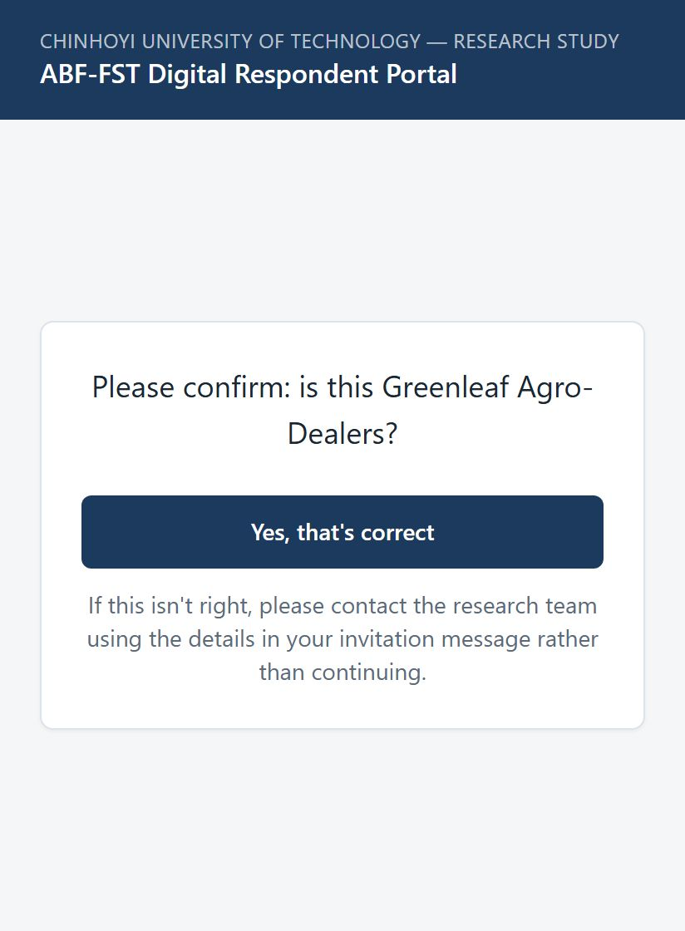
Figure 1. Confirming the organisation.

Step 3 — Tell us a little about you
- Type Your full name.
- Choose the option under Which best describes your role?: Owner / Founder, CEO / Managing Director, Finance / Credit / Risk, Operations, Strategy / Business Development, Supply Chain / Commercial, or Other senior manager.
- Tap Continue.

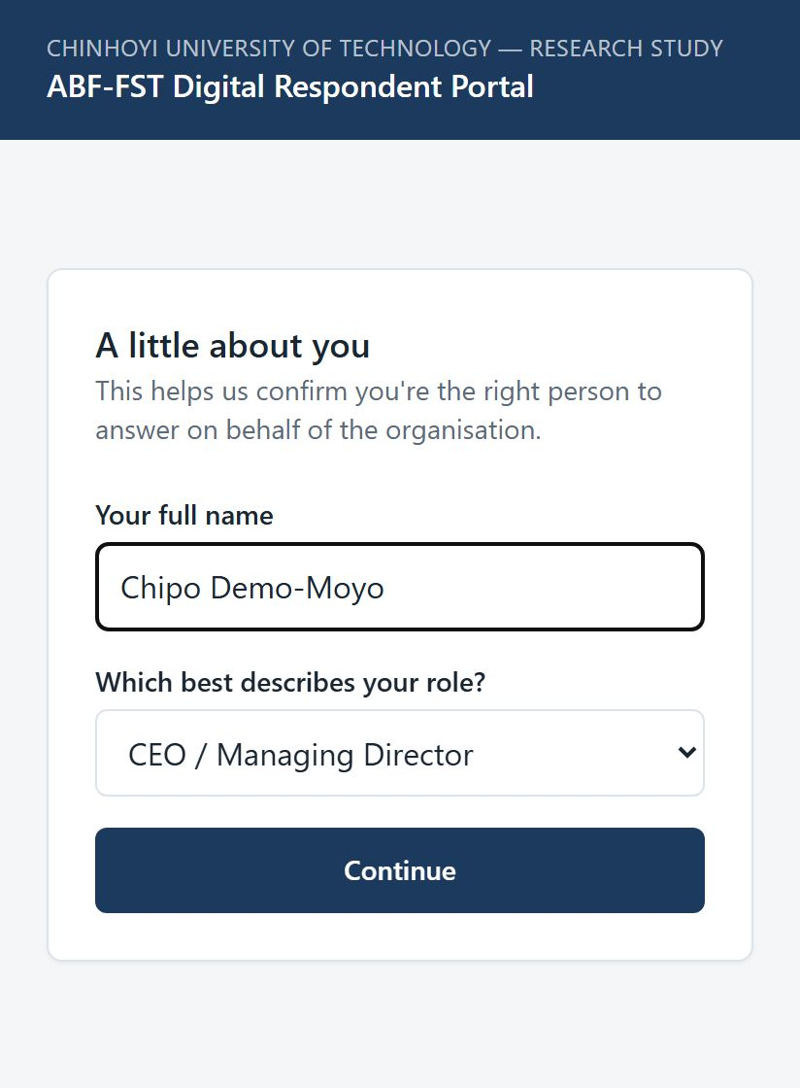
Figure 2. A little about you.
Not the right person?
If none of the roles describes you, choose None of these describe me. You will be thanked and no questions will be asked. It would help us greatly if you could tell the researcher who contacted you who the right senior person is.

Step 4 — Read the participant information
Read the information about the study: who is doing it, what taking part involves, how your information is protected, and your rights. If the research team has published them, a section called How to verify this is a genuine study lets you open their official approval letters. When you are ready, tap Continue to consent. Tap Go back if you need to.
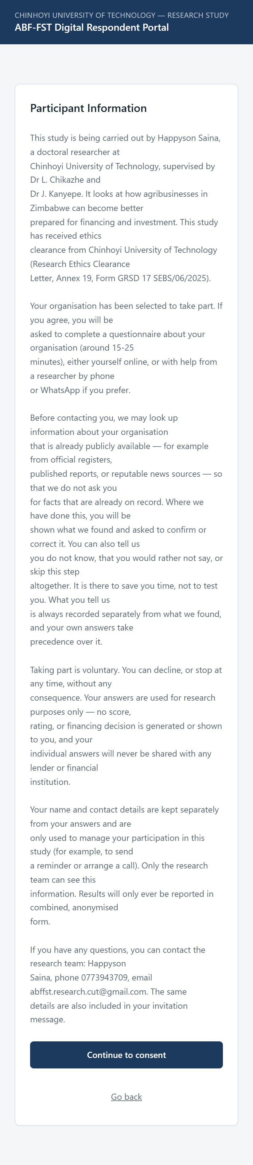
Figure 3. Participant Information.

Step 5 — Give your decision
- Tap I agree to take part if you are happy to continue.
- Tap I do not wish to take part if you would rather not. That is completely fine, and nobody will pressure you.
- Tap Re-read the participant information to look at it again first.

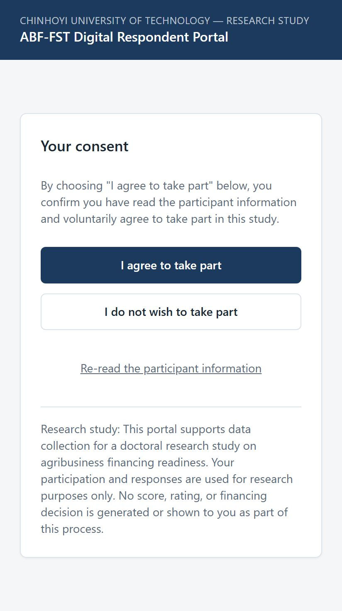
Figure 4. Your consent.

Step 6 — Check what we already know (only if shown)
To save you time, the research team may have looked up information about your organisation that is already public, such as registry records or published reports. An AI tool from a company outside Zimbabwe helps with that search: it is given your organisation's details and your name and job title, never your phone number, email address or anything you tell us in the questionnaire or an interview, and a member of the research team checks everything it finds. If so, a screen called Before we continue shows each item. For each one you can choose Yes, correct, Partly correct, No — correct it (and type the right answer), Don't know, Prefer not to say or Not applicable. You can also skip this step. Your own answers always take precedence.

Step 7 — Choose how you would like to take part
Option | What happens next
Complete it myself now | You fill in the questionnaire online at your own pace (about 15–25 minutes).
Have a researcher call me | You choose a convenient date and time, and a researcher calls to go through it with you.
Complete it via WhatsApp | A researcher guides you through it over a WhatsApp call.
Ask someone to contact me another way | The team gets in touch to find a way that works for you.

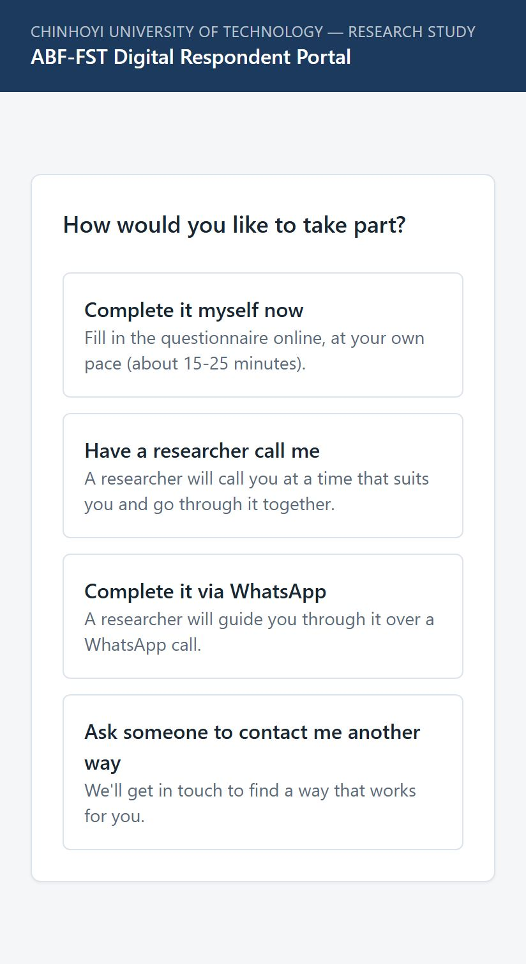
Figure 5. How would you like to take part?

Step 8a — Complete the questionnaire yourself
- Tap Start the questionnaire.
- The questionnaire opens on KoboToolbox, the secure data-collection service used by the study. Read each question and choose or type your answer, then tap Next.
- On the last page, tap Submit, not Save Draft. The thank-you text on that page appears before you submit: your answers are sent only when you tap Submit.
- The form jumps straight back to its first page, empty. A few seconds later a banner at the top says your answers were successfully submitted. That banner means you are done, and your answers reach the research team automatically. You can close the page.

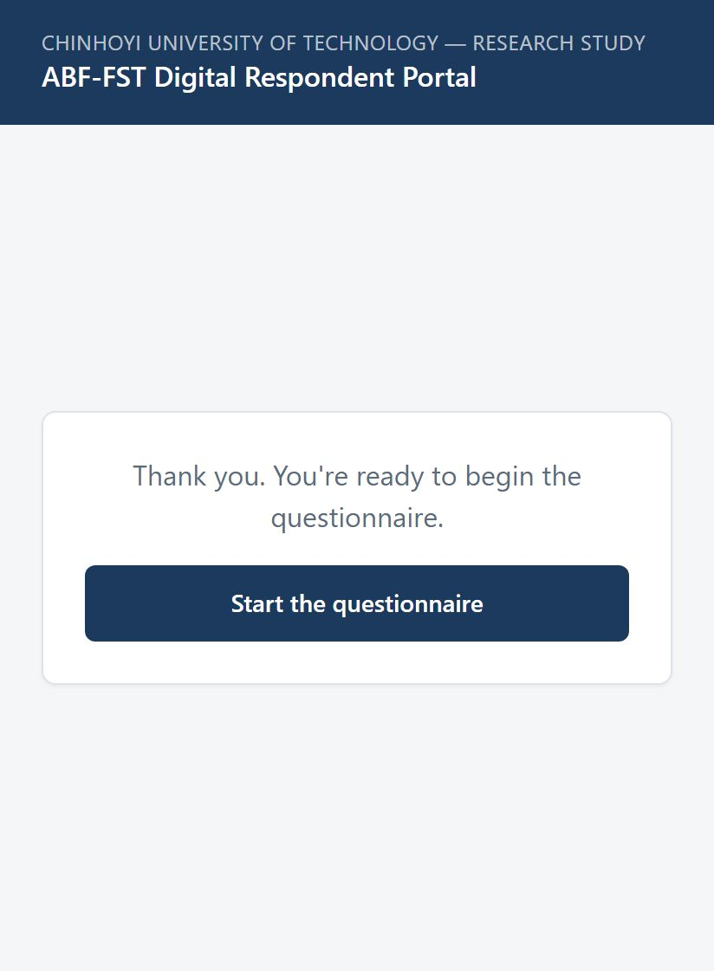
Figure 6. Ready to begin.
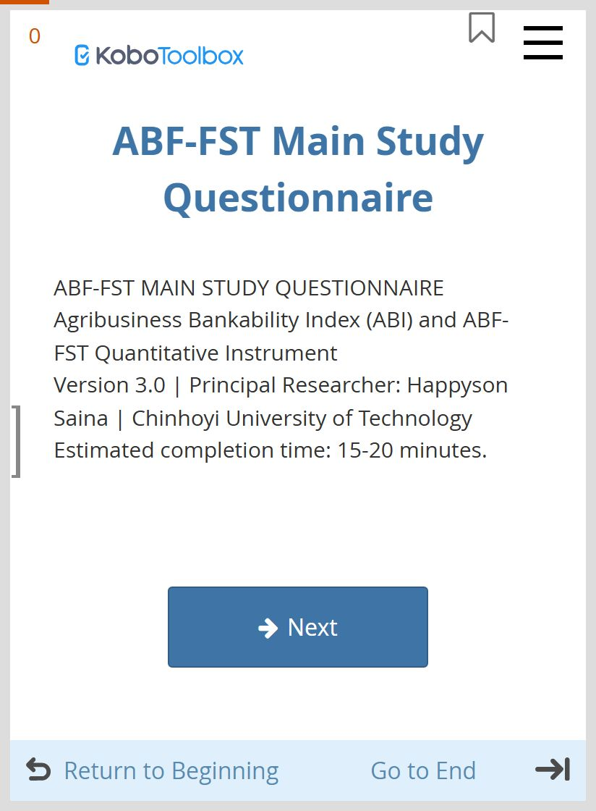
Figure 7. The questionnaire's first page.
Tips for the questionnaire
Answer for your organisation as a whole, from your own knowledge. There are no right or wrong answers.
If the questionnaire does not open, tap Try again, or choose Ask a researcher to help me instead.
Complete it in one sitting where possible, with a steady connection.
If Submit does not go through, look for a question marked in red: it still needs an answer.
Save Draft keeps your answers on your own device only; nothing reaches the study until you tap Submit.
Always start from your personal link, never from a saved or forwarded questionnaire page: only answers started from your link can be matched to your organisation.

Step 8b — Ask a researcher to call you
- Choose your Preferred date and time. It must be in the future.
- Tap Request this time.
- You see Your request has been sent. A researcher will contact you to confirm. There is nothing else you need to do for now.

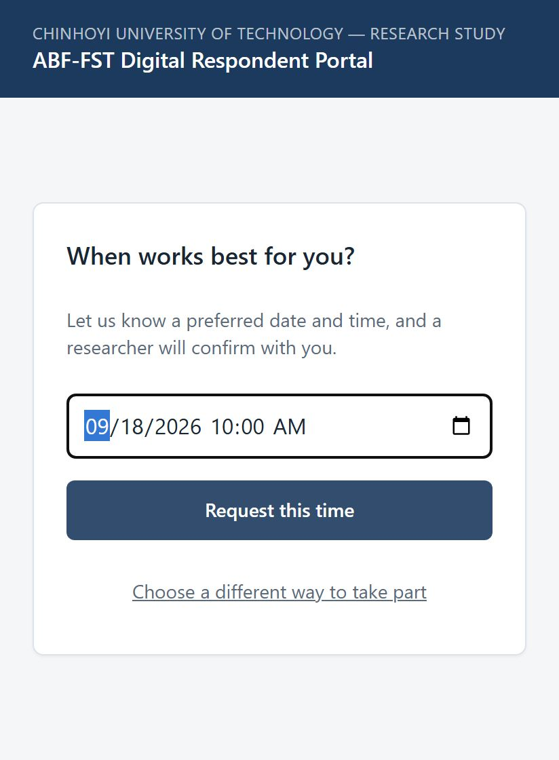
Figure 8. Choosing a time for a call.
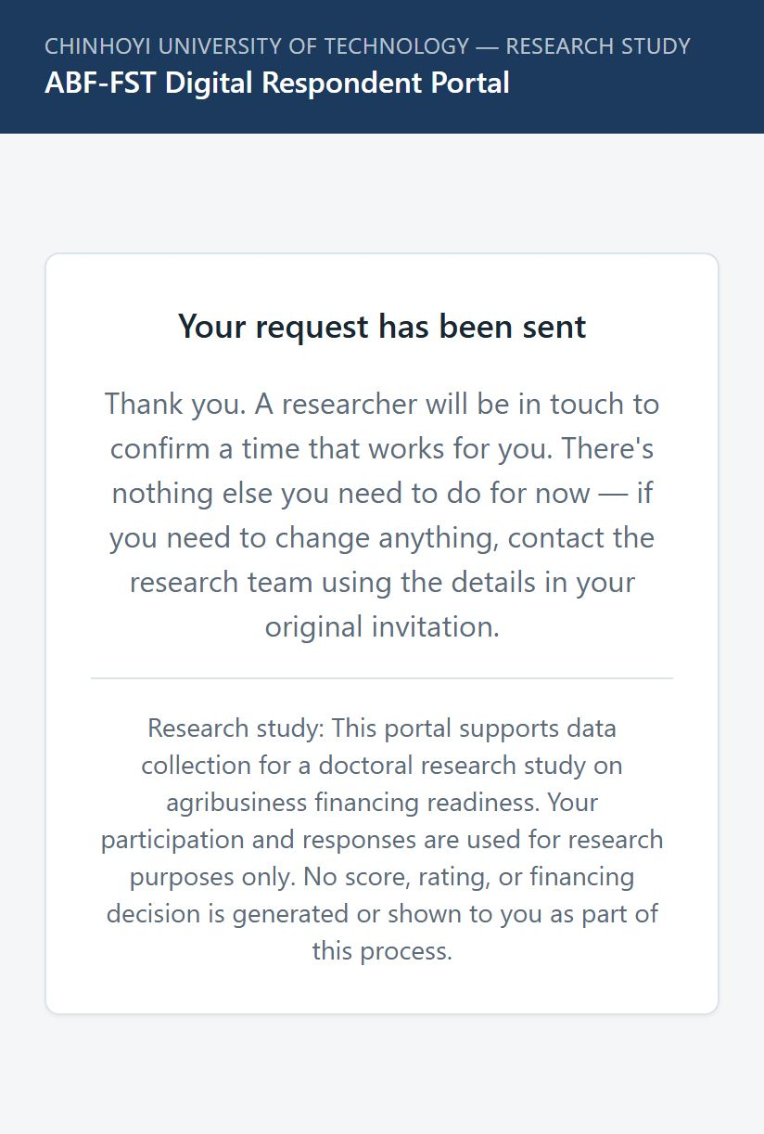
Figure 9. Your request has been sent.

Step 9 — Finished
- If you completed the questionnaire yourself, the banner saying your answers were successfully submitted is the end: you can close the page. The empty form that appears just before it is normal. Submit once, and do not fill the form in again.
- If you asked a researcher to call you, the portal shows Your request has been sent, and the researcher completes the questionnaire with you during the call.
- You will not see any score or result, because the study does not produce one.

4. Reminders
If you have not yet taken part, you may receive up to two short reminders by WhatsApp (around two days and seven days after your invitation). They simply ask you to use the link you were sent. If you do not wish to take part, just tell the research team and the reminders will stop.

5. Your rights and your information
- You may decline or stop at any time, without giving a reason and without any consequence.
- You may withdraw after taking part by contacting the research team. Your link and reminders will be stopped and your contact details erased from the study system.
- Your contact details are seen only by the research team and used only to manage your participation.
- Your answers are stored securely, used for research purposes only, and reported only in combined, anonymised form.
- No score, rating or financing decision is generated, and your individual answers are never given to lenders or financial institutions.
- You may ask for a copy of your completed questionnaire; the team can email it to the address they hold for you.

6. Questions and answers
Question | Answer
The link says it is not valid. | It may have expired (links last 14 days), been replaced by a newer link, or been copied incompletely. Contact the research team for a new link.
I started but was interrupted. | Open your link again. If it does not continue where you were, contact the team and a researcher can help.
I am not the right person to answer. | Choose None of these describe me, and please let the researcher know who the right senior person is.
Will my answers affect our access to finance? | No. The study produces no score, rating or decision, and individual answers are never shared with lenders.
Can someone help me complete it? | Yes. Choose Have a researcher call me or Complete it via WhatsApp, or call 0773943709.
I chose a time but need to change it. | Contact the research team using the details in your invitation.
Who can I speak to about the study? | Happyson Saina, 0773943709, abffst.research@gmail.com.

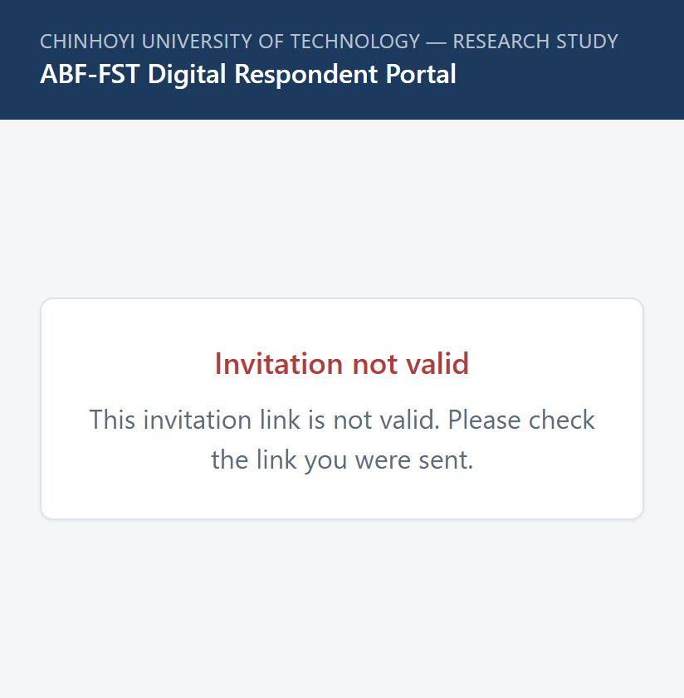
Figure 10. What an invalid or expired link looks like.

7. If you were invited to a Key Informant Interview
Some people are invited differently: instead of an organisation being asked to complete the Main Study Questionnaire, you may be invited by name to a Key Informant Interview (KII) because of your own knowledge and experience. If this is you, your link looks different and the steps are shorter -- the sections above do not apply.
Your link | Starts with research.agribizframework.com/ki/ -- note /ki/, not /i/.
Time needed | Usually 30–45 minutes. A shorter 12–15 minute version is used for some interviews.
Questions | Happyson Saina · 0773943709 · abffst.research@gmail.com

Step 1 — Open your link
Tap the link you were sent. The study portal opens in your browser -- no app to install and no account to create.

Step 2 — Read the participant information
Read about the study, why you have been invited, what taking part involves, and your rights. A section called How to verify this is a genuine study lets you open the official approval letters. When you are ready, tap Continue to consent.

Step 3 — Give your decision
- Tap I agree to take part if you are happy to continue.
- Tap I do not wish to take part if you would rather not. That is completely fine.
- Tap Re-read the participant information to look at it again first.

Step 4 — Start the interview
- Tap Start the interview.
- The interview opens on KoboToolbox, the same secure data-collection service used for the Main Study Questionnaire. Answer each question at your own pace, then tap Next.
- Continue to the end and tap Submit.

Would rather talk it through with someone?
This link is for completing the interview yourself, in your own time -- nobody else is on the call and nothing is recorded. If you would rather a researcher went through it with you instead, by phone, WhatsApp or video call, contact the research team using the details in your invitation and they will arrange it.
Most of chapter 6's questions and answers apply here too (an expired or invalid link, being interrupted partway through, who to contact). The one difference: there is no step asking you to confirm an organisation or your role -- you were identified and invited by name, so that step does not appear.

8. Contact the research team
Researcher | Happyson Saina
Phone / WhatsApp | 0773943709
Email | abffst.research@gmail.com
Institution | Chinhoyi University of Technology
Portal | https://research.agribizframework.com

Thank you for your time and for contributing to research on agribusiness financing in Zimbabwe.

