CHINHOYI UNIVERSITY OF TECHNOLOGY · ABF-FST RESEARCH STUDY
Role Guide 8: Supervisor (read-only)
Step-by-step instructions for the Supervisor (read-only) role in the ABF-FST Digital Respondent Portal.
STUDY | Developing and Validating the Agribusiness Bankability Framework for Food Systems Transformation through Novel Financing Models in Zimbabwe (ABF-FST)
PRINCIPAL RESEARCHER | Happyson Saina, Doctor of Strategic Management candidate, Chinhoyi University of Technology
SUPERVISORS | Dr L. Chikazhe and Dr J. Kanyepe
FOR | Academic supervisors and others overseeing the study
SYSTEM ADDRESS | https://research.agribizframework.com
CONTACT | 0773943709 · abffst.research@gmail.com
VERSION | Version 1.27 · 6 October 2026

Screenshots in this document use fictional demonstration data. Organisation and person names, phone numbers and figures shown in them are not real study records.

Contents
1. Your role at a glance 4
2. Signing in and your screens 5
Signing in 5
Finding your way around 5
Your screens 6
Changing your password 6
3. Your routine 7
4. Step-by-step tasks 8
4.1 Reading the dashboards 8
4.2 Using Reports (analytics and charts) 9
4.3 Reviewing a case read-only 11
4.4 Reviewing QA 12
4.5 Downloading or emailing completed forms (Form PDFs) 12
5. Rules you must follow 14
6. Troubleshooting 15
7. Quick reference 16
8. Every screen and button for your role 17
8.1 Sign in 17
8.2 The header and menu bar (every screen) 17
8.3 Change Password 18
8.4 Executive Dashboard 18
8.5 Sampling Dashboard 19
8.6 Contact Dashboard 19
8.7 QA Dashboard 20
8.8 KII / Document Dashboard 20
8.9 Reports 20
8.10 Main-400 Register (and Reserve) 21
8.11 Case page 21
8.12 Pre-Interview Profile (PROIT) and its review screen 22
8.13 Interview sheet (verifying a locked profile) 22
8.14 Register Organisation 23
8.15 Appointment Queue 23
8.16 Follow-ups due 23
8.17 Reserve Activation 24
8.18 QA Queue (with the KoboToolbox sync panel) 24
8.19 QA Exceptions 24
8.20 KII Register 25
8.21 KII record 25
8.22 Documents (the corpus) 25
8.23 Document record 26
8.24 Auto-fill review screen 26
8.25 Completed forms (Form PDFs) 26
8.26 Cost Dashboard 27

1. Your role at a glance
You oversee the study with read-only access to almost every screen: progress, the sample, contact activity, QA, the KII and documentary strands, and costs. You can open case pages and completed-form PDFs, but you cannot change anything.

You can
- Open 17 screens: all dashboards, Reports, Main-400 Register and case pages, Organisations, Appointments, Follow-ups, Form PDFs, QA Queue, QA Exceptions, KII Register, Documents, Reserve Activation and Cost.
- Download PDFs of completed forms for all three forms.

You cannot
- Change, send, assign, decide or log anything — forms and buttons are replaced by "Your role has read-only access" notes.
- Open the Audit Log, Export or Research Clearance.

Where this fits
The System Manual explains how the whole system works. This guide covers only what you do, and its last section lists every screen and button you can use, with what each does and why. Ask the Field Coordinator or PI when something is outside your role.

2. Signing in and your screens

Signing in
- Open https://research.agribizframework.com/admin/login in any modern browser (Chrome, Edge, Firefox or Safari), on a computer, tablet or phone.
- Type your Username and Password, then select Sign in.
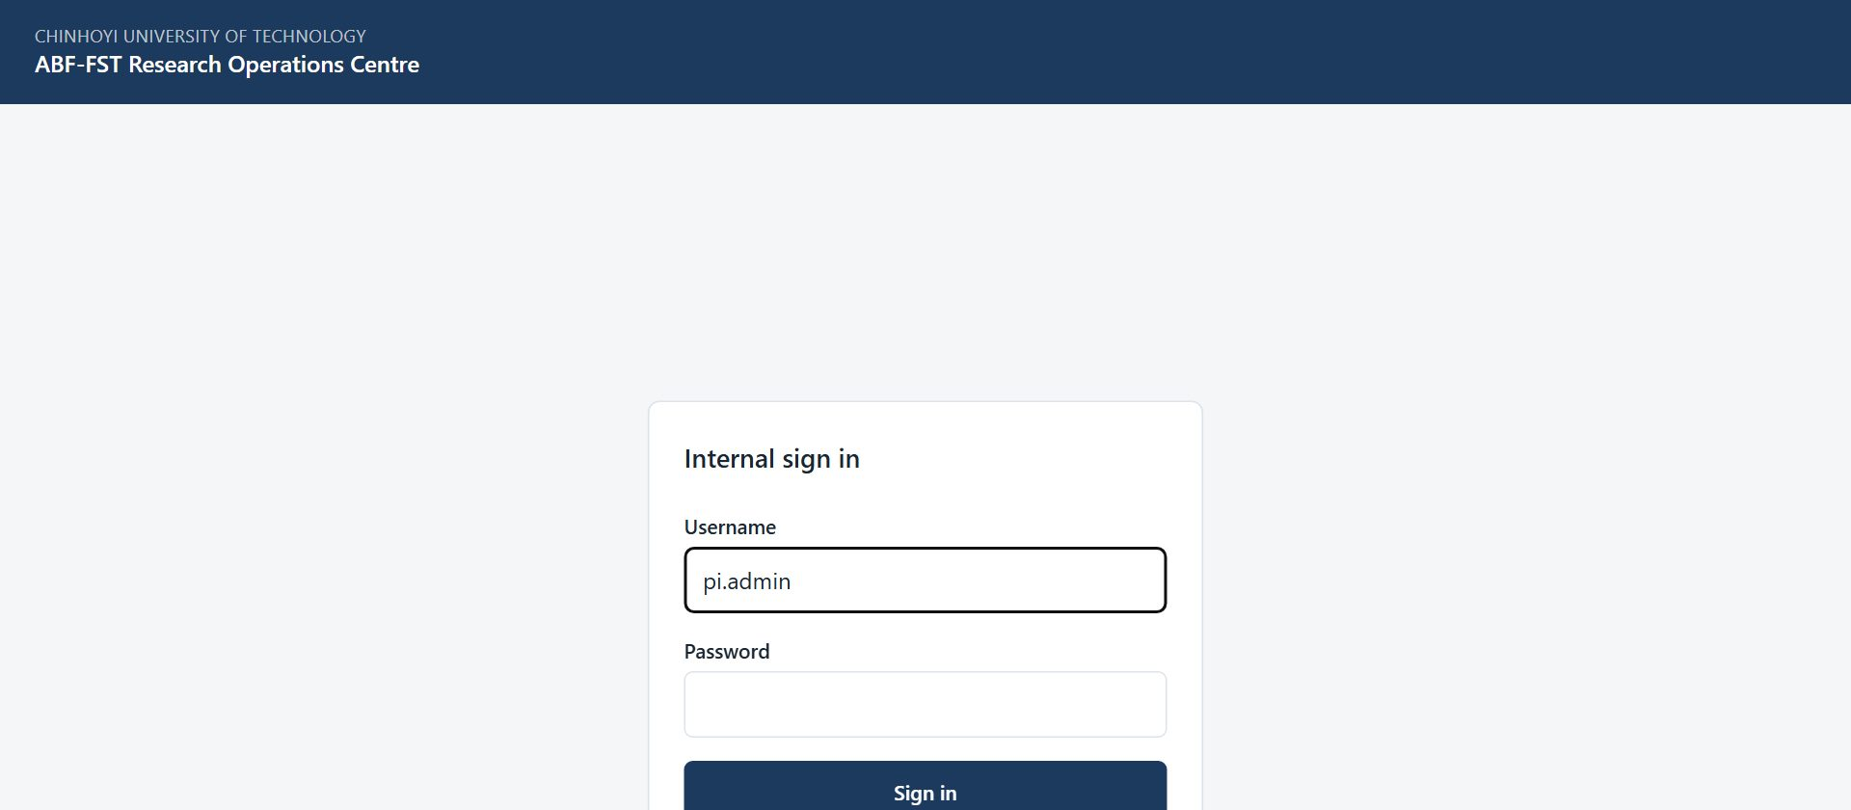
Figure 1. The sign-in screen for all internal staff.
- You arrive on your start screen: Executive Dashboard. The bar across the top lists only the screens your role (Supervisor (read-only)) can open.

Accounts
There is no self-registration. The PI / System Admin creates every account and sets its role. Ask the PI if you need an account, a different role, or a password reset.

Finding your way around
- The top bar shows your username and role, and the screens you can use. It is not a full menu with some items greyed out: anything absent is simply not part of your role.
- Most screens have a ← Back to … link at the top that returns you to the screen you came from.
- Registers show 20 rows per page to begin with. At the foot of the list, Show lets you choose 10, 20, 50, 100 or 200 rows per page (the portal remembers your choice), and the page numbers, Previous, Next and the double arrows take you to any page. The Search box above the list narrows it.
- Change password (top right) lets you set a new password at any time. Choose a long password you do not use anywhere else.
- Sign out (top right) ends your session. Always sign out on a shared or public computer.
- If you are inactive for a while you may be asked to sign in again. This protects research data on unattended devices.

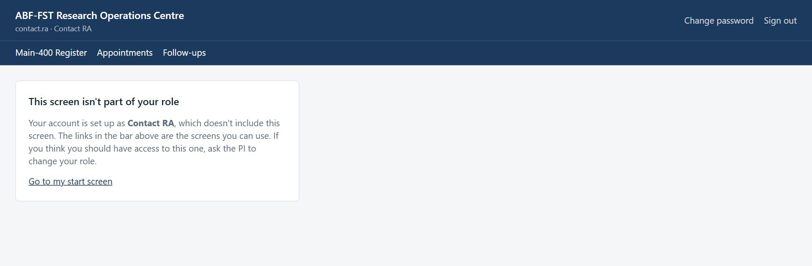
Figure 2. Opening a screen outside your role (for example from an old bookmark) shows this card instead of the screen.

Your screens
Screen | What you use it for
Dashboards and Reports | Progress, coverage, quality.
Main-400 Register and case pages | How individual cases are being handled.
Appointments, Follow-ups | Whether contact is on schedule.
Form PDFs | Completed questionnaires, KII Guides and document coding forms, and whether the portal matches KoboToolbox (read-only).
QA Queue, QA Exceptions | Quality decisions and flags.
KII Register, Documents | Qualitative and documentary strands.
Reserve Activation, Cost | Replacements and spend.

Changing your password
- Select Change password in the top right corner.
- Enter your Current password, then the New password twice, and select Change password.
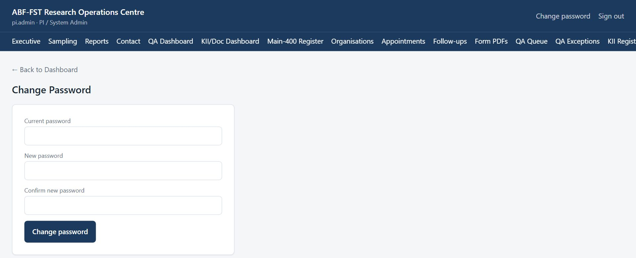
Figure 3. Change Password screen.
- Use the new password next time you sign in. If you have forgotten your password, ask the PI to reset it.

3. Your routine
A suggested rhythm. Adjust it to the Field Coordinator's plan.
When | What to do
Before supervision meetings | Reports (last 30 days): funnel, response rate, coverage, QA outcomes, mode balance.
Spot checks | Open a few case pages and completed-form PDFs; read QA notes and exceptions.
Monthly | Cost per QA-passed case; Reserve activations and their evidence notes.

4. Step-by-step tasks

4.1 Reading the dashboards
Dashboards are for monitoring; nothing on them changes data. Figures refresh whenever the screen is opened.
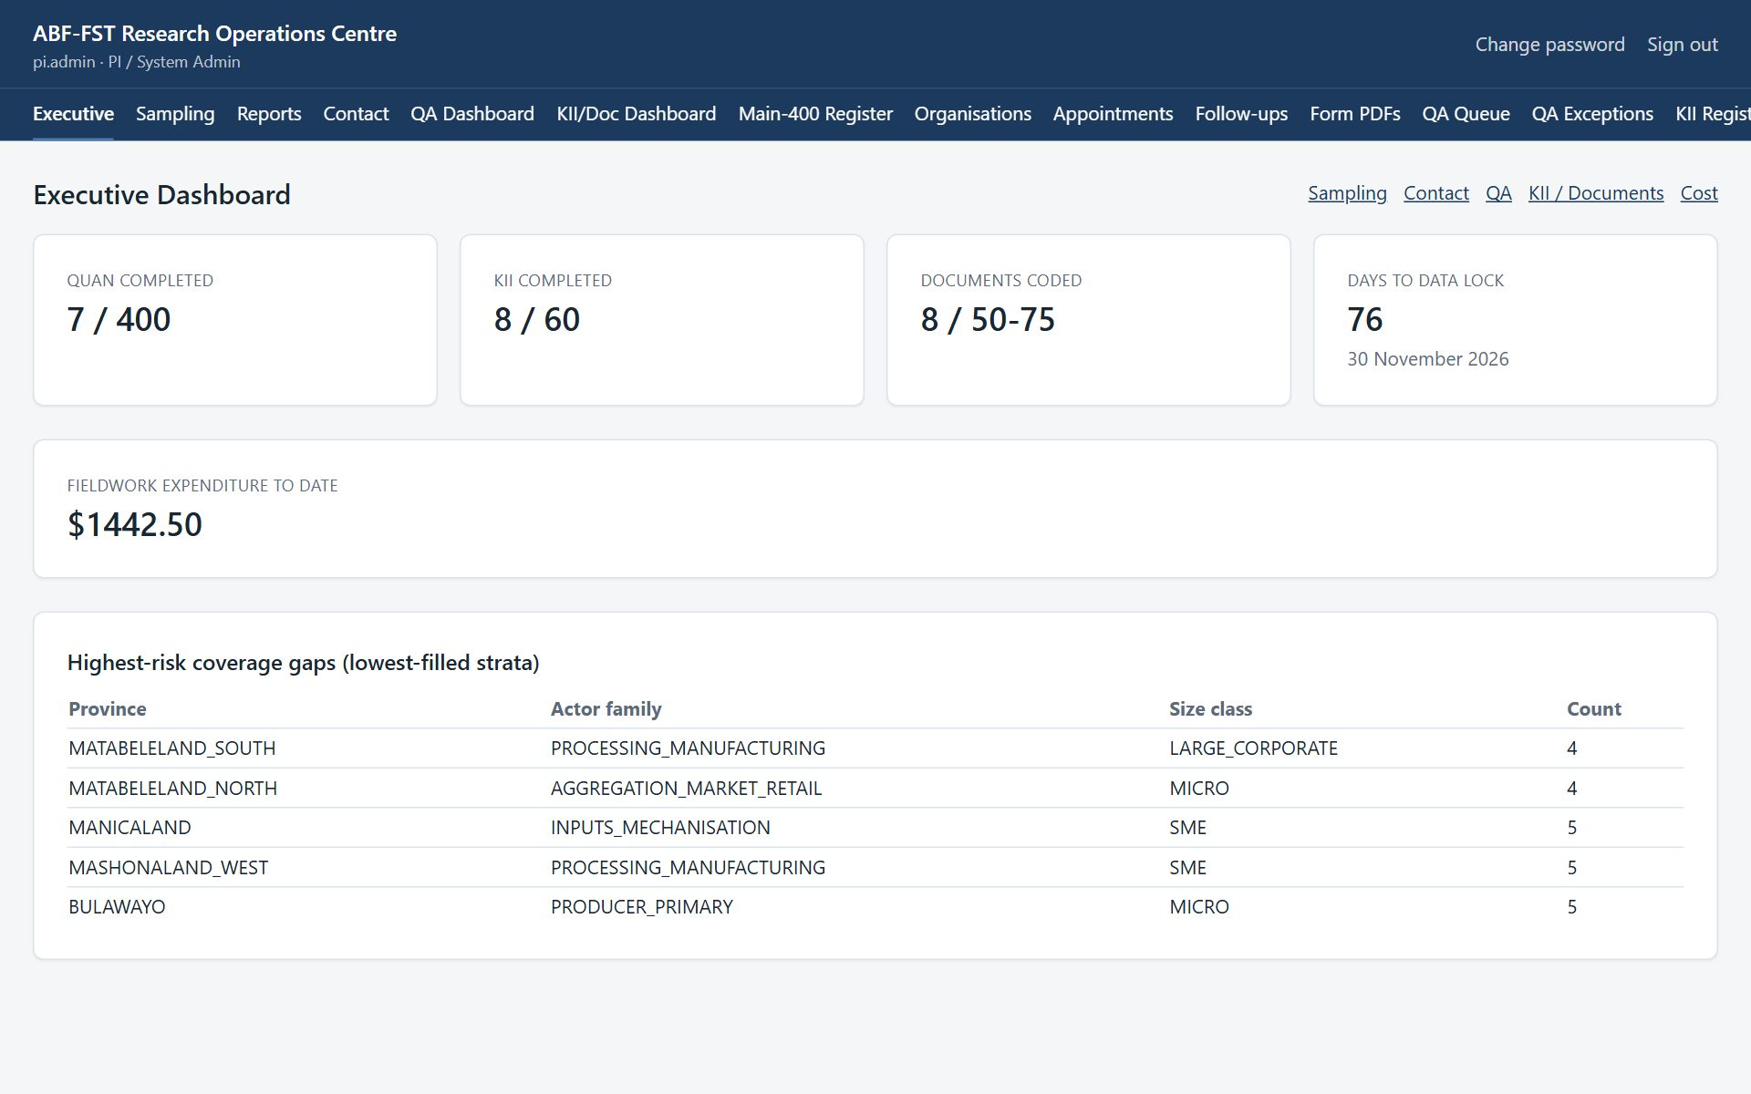
Figure 4. Executive Dashboard: completions against the 400 / 60 / 50–75 targets, days to data lock, spend, and the lowest-filled strata.
Dashboard | What it tells you | Use it to
Executive | QUAN completed out of 400, KII completed out of 60, documents coded against 50–75, days to the 30 November 2026 data lock, spend to date, lowest-filled strata. | See overall progress and where fieldwork attention is most needed.
Sampling | Main cases by province, verified/total by stratum, Reserve activations by reason. | Check the design stays balanced across strata.
Contact | Organisations verified, eligible respondents identified, invitations sent and opened, upcoming appointments, refusals, unreachable cases. | Track outreach and spot stalled contact.
QA Dashboard | Submissions today and in total, the open QA queue, decisions recorded, completions by administration mode. | Keep the QA backlog under control.
KII/Doc Dashboard | KII completed against 60; KIIs by status; documents by type and QA status. | Track the qualitative and documentary strands.

Targets versus records
The registers hold more records than the targets (for example 90 KII records for 60 completed interviews). The surplus is reserve depth for non-response, not extra work.

4.2 Using Reports (analytics and charts)
- Select Reports in the top bar.
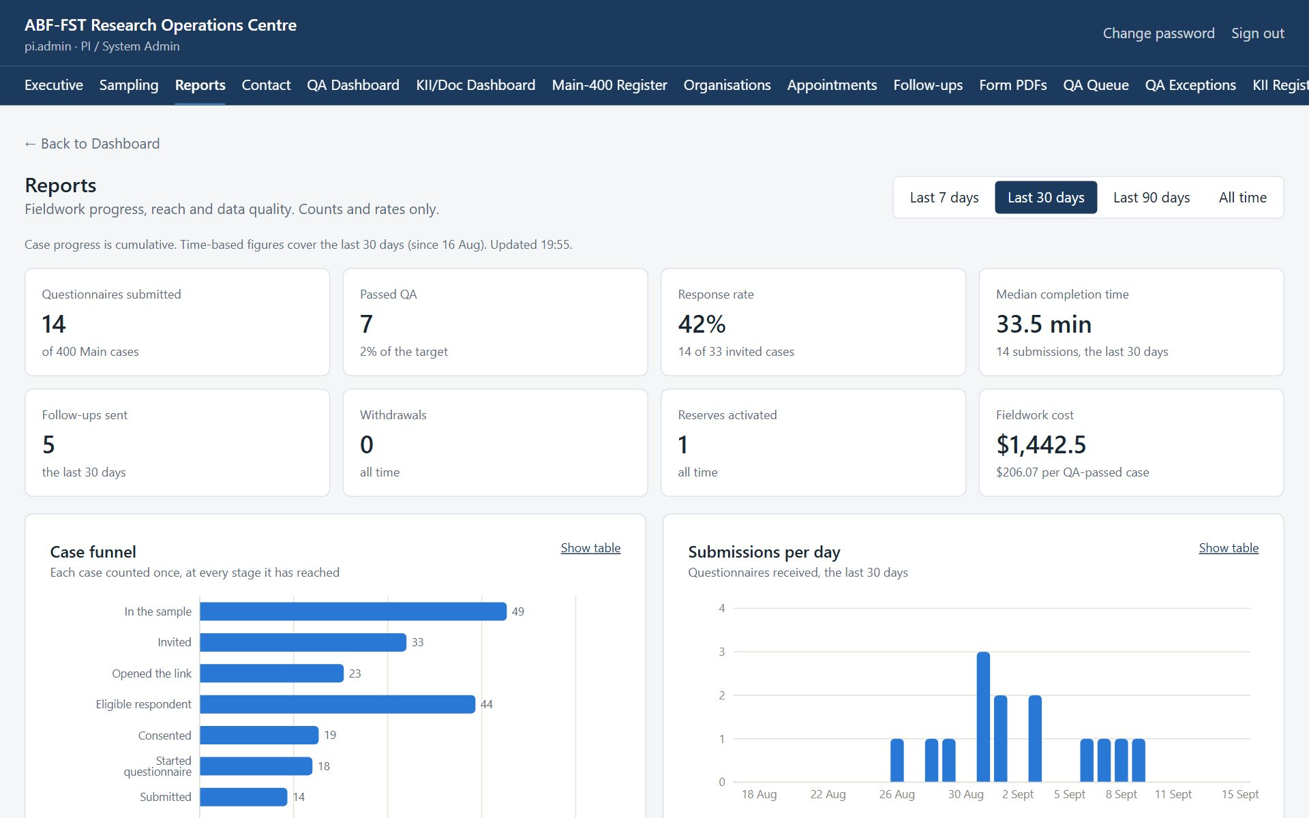
Figure 5. Reports: headline figures for the chosen period.
- Choose the period with Last 7 days, Last 30 days, Last 90 days or All time. Case progress (the funnel and workflow) is always cumulative; time-based figures such as submissions per day follow the period.
- Read the headline cards: questionnaires submitted, passed QA, response rate (submitted ÷ invited), median completion time, follow-ups sent, withdrawals, Reserves activated, and fieldwork cost per QA-passed case.
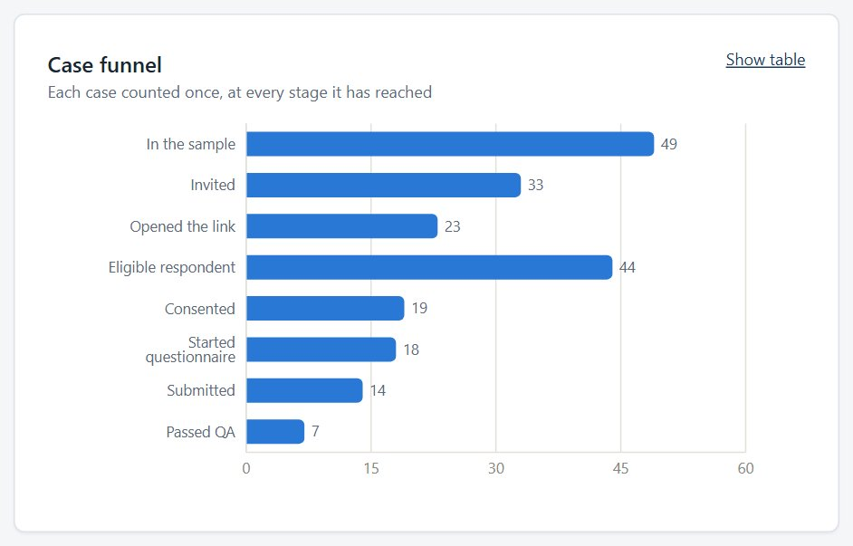
Figure 6. Case funnel: each case counted once at every stage it has reached.
- Select Show table on any chart to see the exact numbers, for example to copy them into a progress report.
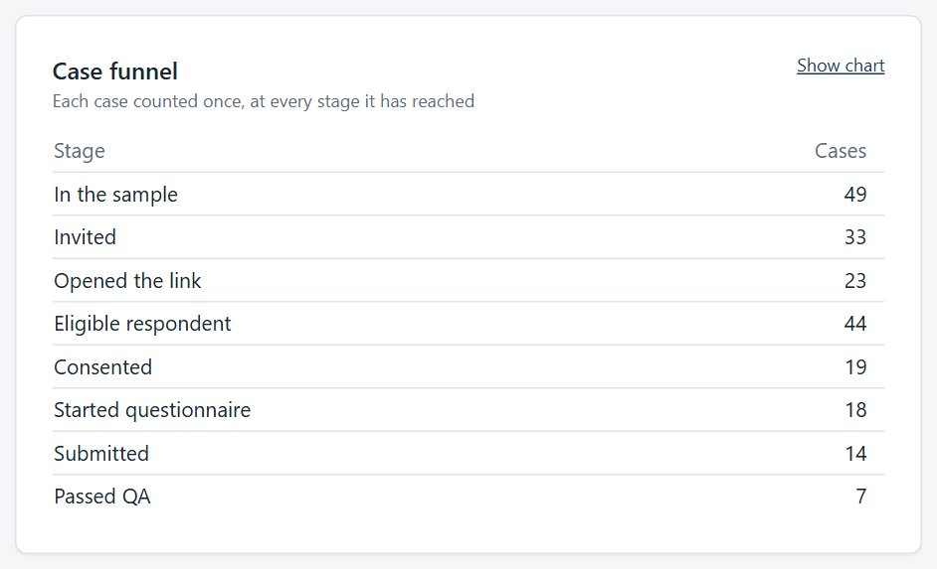
Figure 7. The same chart as a table.
- Use Coverage to see, by province, organisation type and size, what share of cases have been invited and have submitted. Short bars show where contact effort should go next.
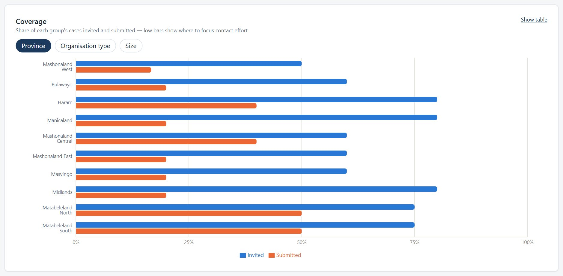
Figure 8. Coverage by group.
- Check How questionnaires were completed. If one administration mode dominates (more than 70% once at least 10 questionnaires are in), the chart shows an imbalance alert so the team can review the mix.
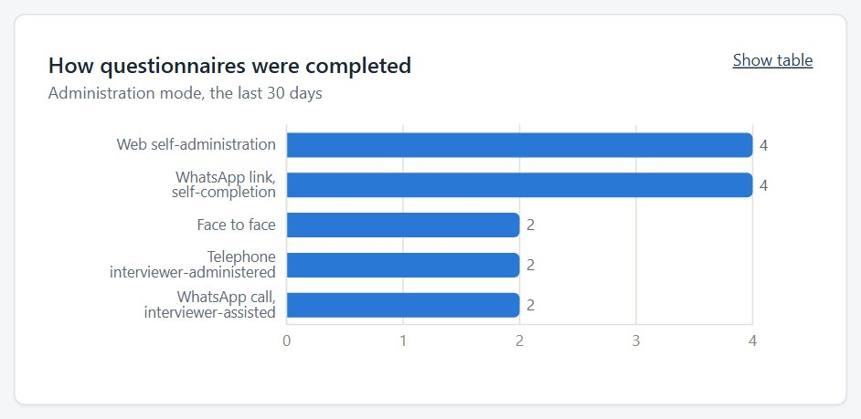
Figure 9. Administration modes.
- Review Time to complete the questionnaire and QA outcomes. Very short or very long completions are what the QA duration rules flag.
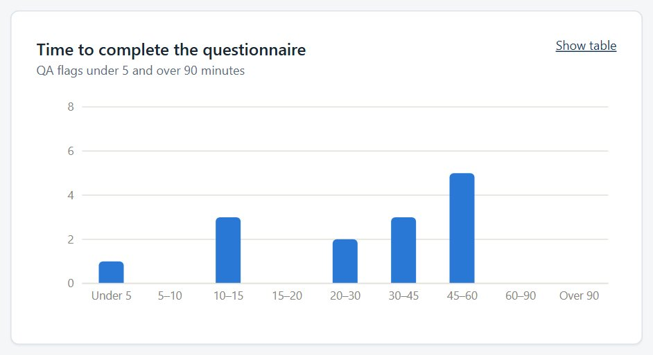
Figure 10. Completion-time distribution.

Reports show counts and rates only — never names or answers — so they are safe to discuss with supervisors.

4.3 Reviewing a case read-only
- Select Main-400 Register, search for a case, and select View.
- Review the respondent, invitation history, completed questionnaire, status and contact timeline. Controls are replaced by read-only notes.
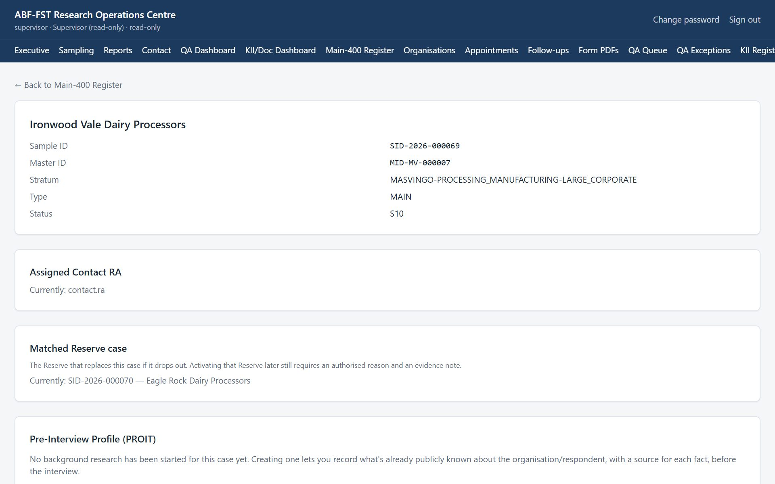
Figure 11. A case page in read-only view.
- Find contact details with AI on the case page shows what the AI found for the organisation, with the page and passage for each finding, and which findings the team accepted or rejected.
- On the register, WhatsApp invitations lists the verified cases waiting for a WhatsApp invitation. You see the list, not the Prepare button.

4.4 Reviewing QA
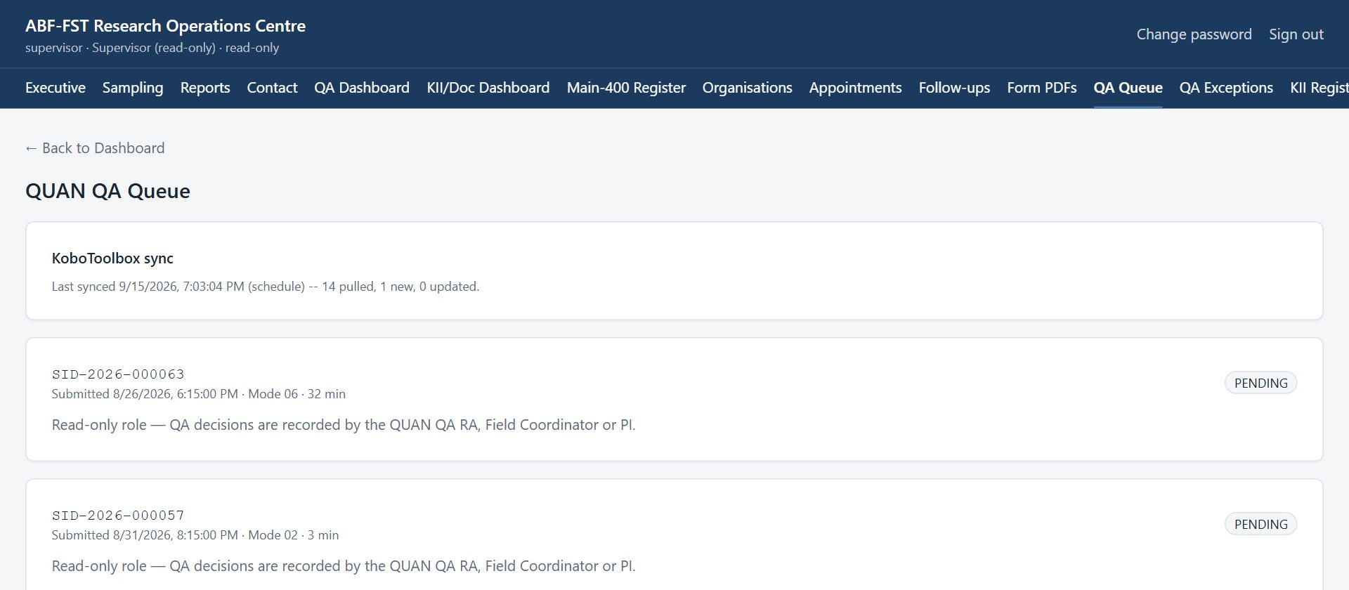
Figure 12. QA Queue in read-only view.
Check that notes explain decisions and that exceptions are closed with reasons.

4.5 Downloading or emailing completed forms (Form PDFs)
- Select Form PDFs. You see the completed questionnaire, KII Guide and document forms from KoboToolbox, newest first, 20 per page to begin with (choose more under Show at the foot of the list).
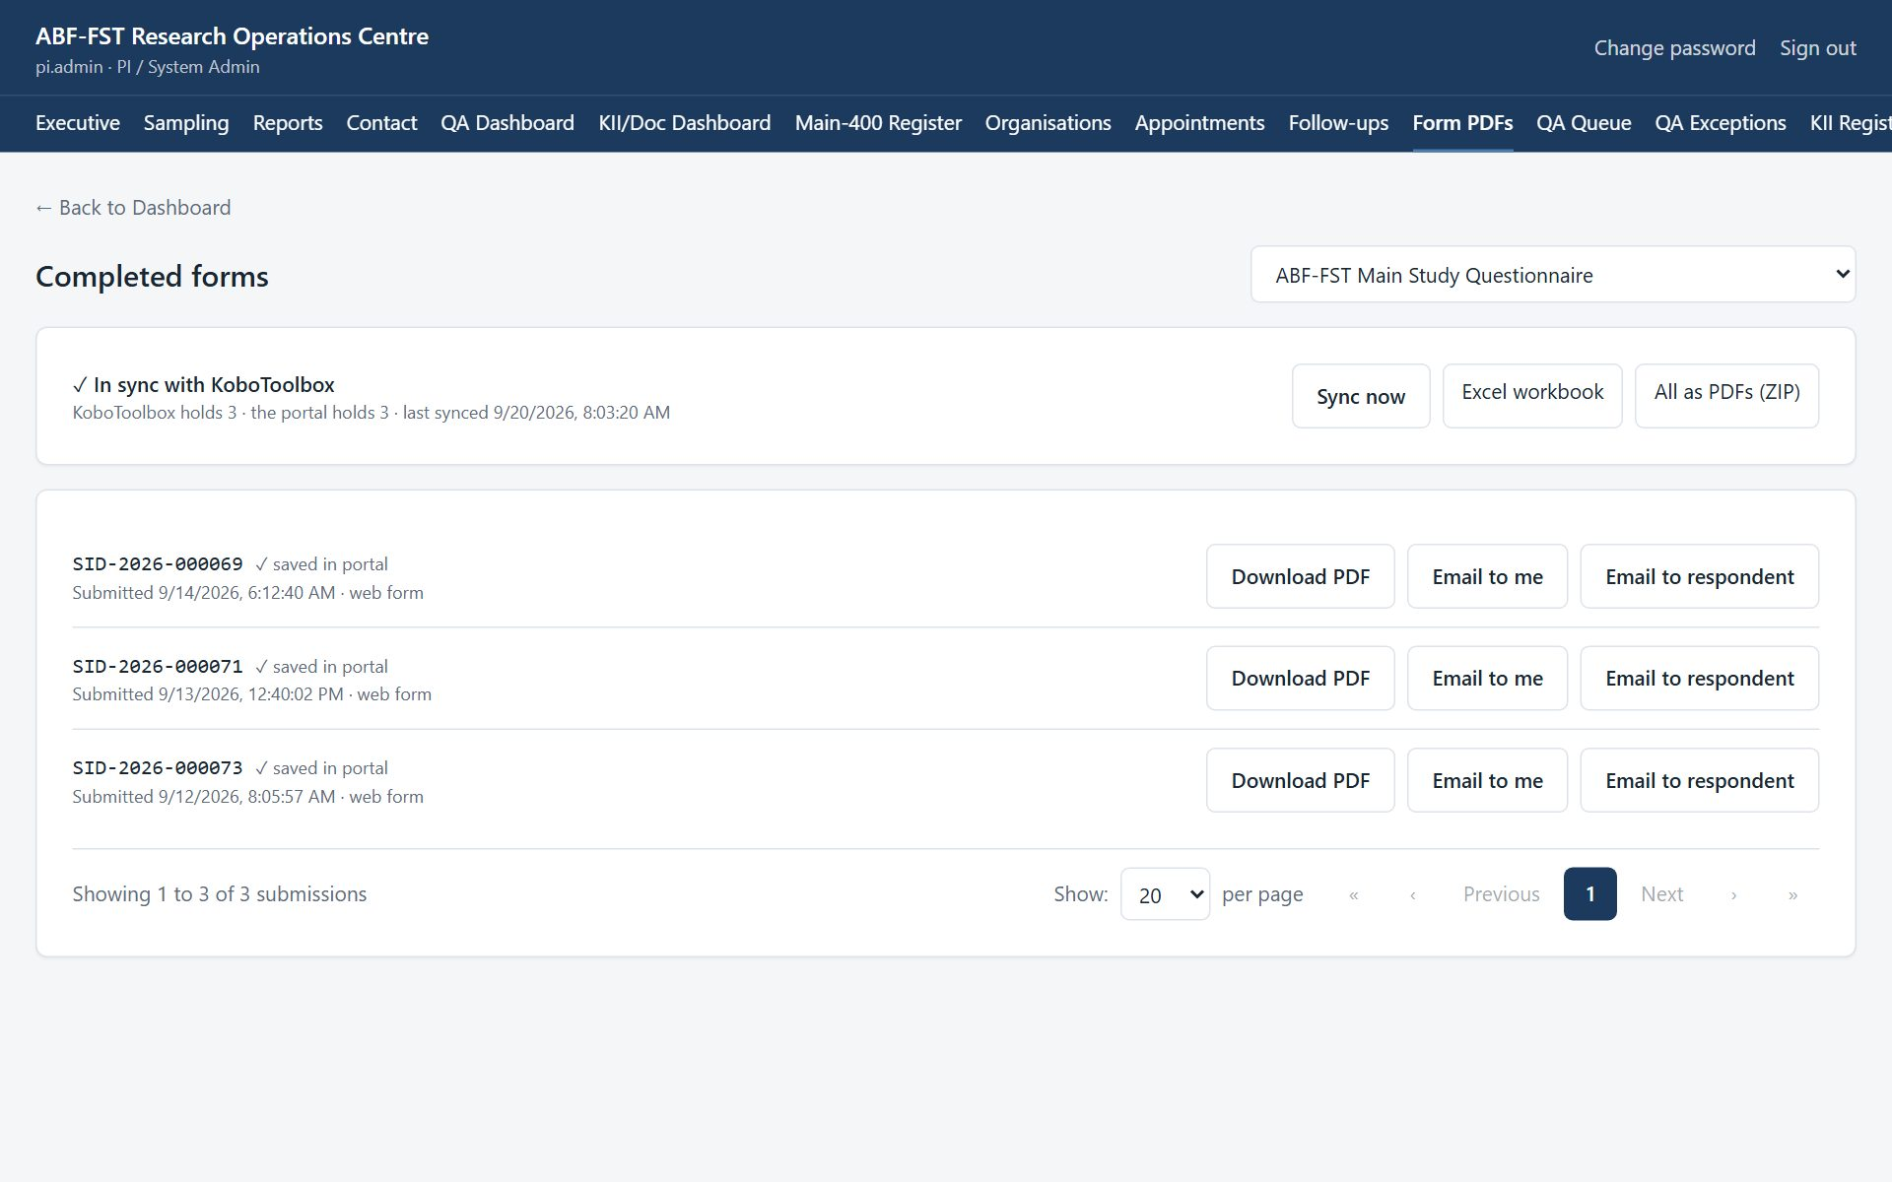
Figure 13. Completed form PDFs.
- Select Download PDF to save a readable copy: sections, questions, the chosen answers as words (not codes) and repeated groups.

At the top of the page, a sync panel shows whether the portal holds the same forms as KoboToolbox, for example “✓ In sync with KoboToolbox — KoboToolbox holds 12 · the portal holds 12”. Each row also says “✓ saved in portal” once the portal has an identical copy. If the panel says “Not in sync”, select Sync now (read-only roles see the panel but not the button); it takes a few seconds.
The same PDF is available from the record itself: the case page (questionnaire), the KII page (KII Guide) or the document page (coding form).
How the sync works
The portal keeps its own copy of the questionnaire, KII Guide and Document Analysis Tool, and refreshes it every 15 minutes and whenever someone selects Sync now. A submission edited in KoboToolbox is updated here; one deleted in KoboToolbox is flagged as removed. You never need to sync before downloading a PDF: the PDF is always read from KoboToolbox at that moment.

5. Rules you must follow
- Raise any concern about how a case, consent or data was handled with the PI directly.
- Treat everything in the portal as confidential research data. Do not screenshot, copy, print or forward names, phone numbers, email addresses or answers except as your role requires.
- Never share your username or password, and never sign in for someone else.
- Use the respondent's contact details only to manage their participation in this study (invitations, reminders, appointments).
- Never tell a respondent, lender or anyone else that answers affect financing. The study generates no score, rating or financing decision.
- If a respondent asks to withdraw, stop contacting them and tell the Field Coordinator or PI the same day so the withdrawal is recorded.
- Report a lost device, a suspected account compromise, or data sent to the wrong person to the PI immediately.

6. Troubleshooting
Situation | Likely cause | What to do
"Your role has read-only access to this screen" | Expected for the Supervisor role. | No action needed.
"This screen isn't part of your role" | The screen belongs to another role (often an old bookmark or shared link). | Select Go to my start screen. If you need that screen, ask the PI about your role.
"Too many sign-in attempts from this network" | Sign-in is rate-limited per network; an office shares one address. | Wait a minute and try again. A wrong password says so explicitly.
A register shows fewer rows than expected | Registers show 20 rows per page to begin with; a Contact RA sees only assigned cases. | Choose more rows under Show at the foot of the list, use the page numbers or Next, or search. Ask the Field Coordinator to assign the case.
A button is greyed out | A required step is missing (a note, an authenticity decision, a selection). | Read the message beside the button; complete the missing step first.
"KoboToolbox couldn't be reached" | KoboToolbox is slow or the connection token has changed. | Try again in a few minutes. If it persists, tell the PI.
Form PDFs says "Not in sync with KoboToolbox yet" | The counts differ: a form was submitted or changed in KoboToolbox since the last sync (it runs every 15 minutes). | Select Sync now. If it still differs, or says it couldn't reach KoboToolbox, try again in a few minutes and tell the PI if it persists.
A document says "Already submitted" and its answers are locked | Its coding was already sent to KoboToolbox; changing it here would not change that record. | To redo the coding, delete that record in KoboToolbox, then select Sync now on Form PDFs. The document unlocks.
A page keeps loading | A slow or dropped connection. | Refresh the page. Your saved work is not lost; unsaved typing may be.
Email invitations says email isn't set up | Outgoing email has not been configured on the server. | Ask the administrator to run configure-email.sh. Until then, send invitations by WhatsApp.
A WhatsApp invitation was prepared but never sent | Prepare counts it as sent and moves the case to S05. | Open the case and Revoke that invitation; send a new one from the case's Invitations panel when you can reach the person.
A case is missing from the WhatsApp or email queue | It is not verified (S03 or S04), has no number or email on file, already has an open invitation, or is assigned to another Contact RA. | Verify the case, add the contact detail, or check its invitation history.
The contact finder says it would overwrite a detail | The organisation contact already has a different phone or email. | Check which is right and correct it under Respondents and contact details.
A file upload seems stuck | A large file on a slow connection takes time; the bar shows how much has been sent. | Wait for Saving… and the file name. If it fails, try again or upload a smaller version.

7. Quick reference
Sign in | https://research.agribizframework.com/admin/login
You start on | Executive Dashboard
Most useful screen | Reports
Help | Field Coordinator; PI: Happyson Saina, 0773943709, abffst.research@gmail.com

8. Every screen and button for your role
This section lists every screen you can open as Supervisor, and for each control: what it does and when to use it, why it exists (the rule behind it), and what you will see next. It is the same material as the Screen and Button Reference, cut down to your role.
Your role is read-only
Buttons that change anything are not shown to you: the screen shows “Your role has read-only access” instead. Only the controls you can see are listed here.
Reading the tables
Control is the label you see on screen. Why it exists explains the rule or risk behind it; if a button is greyed out, this column usually says why. A control that needs a note or a confirmation says so.

8.1 Sign in
Who can open it: every role. Where: /admin/login
Where every staff member starts. Staff accounts are created by the PI; there is no self-registration.
Control | What it does and when to use it | Why it exists | What happens next
Username | Type the username the PI gave you. | Every action in the portal is recorded against a named person, so accounts are never shared. | Nothing yet; you also need the password.
Password | Type your password. The characters are hidden. | Passwords are never shown or emailed; the PI can reset yours but cannot read it. | Nothing yet; select Sign in.
Sign in | Checks your username and password and opens your start screen (the first screen your role uses). | Repeated wrong attempts from one network are refused for a minute, to stop password guessing. | Your start screen opens. A wrong password says so. “Too many sign-in attempts” means wait a minute.

8.2 The header and menu bar (every screen)
Who can open it: every role. Where: (top of every screen)
Shown at the top of every signed-in screen. The menu bar lists only the screens your role may open.
Control | What it does and when to use it | Why it exists | What happens next
Menu bar (Executive, Sampling, … Audit) | Opens a screen. The current screen is underlined. | The list is built by the server from your role, so you never see a screen that would refuse you. | The screen opens. A screen not in your list shows “This screen isn't part of your role”.
Change password | Opens the Change Password screen. | You should change the first password you were given, and any password you think someone saw. | The Change Password screen opens.
Sign out | Ends your session on this device. | Protects the data if the device is shared or lost. Always sign out on a shared device. | Your session on this device ends and you return to the Sign in screen.
← Back to … (top left) | Returns to the parent screen (for example from a case to the register). | A consistent way back that does not lose your place in the menu. | The parent screen opens.
Go to my start screen | Appears on the “This screen isn't part of your role” page and takes you to your own start screen. | An old bookmark or shared link may point at a screen that belongs to another role; this gets you out safely. | Your start screen opens.

8.3 Change Password
Who can open it: every role. Where: /admin/account
Change your own password.
Control | What it does and when to use it | Why it exists | What happens next
Current password | Type the password you use now. | Proves it is really you before a change, in case a signed-in device was left open. | Nothing yet.
New password | Type the new password. | It must be long enough, not a common password, not all digits and not similar to your username or name; the screen says which rule failed. | Nothing yet.
Confirm new password | Type the new password again. | Catches a typing slip that would lock you out. | Nothing yet.
Change password | Saves the new password. | Your old password stops working straight away, and other people (including the PI) never see your new one. | A confirmation appears. Use the new password next time.

8.4 Executive Dashboard
Who can open it: PI / System Admin, Field / Digital Coordinator, Data Analyst, Supervisor. Where: /admin/dashboard
The one-page picture of the study: how many cases are where in the funnel, response and quality headlines, and the weakest parts of the sample. Counts and rates only; never a name.
Control | What it does and when to use it | Why it exists | What happens next
Tiles: QUAN completed, KII completed, Documents coded, Days to data lock, Fieldwork expenditure to date | Show the headline counts against their targets, the days left to the data lock (30 November 2026) and the spend so far. Read them; there is nothing to press. | Aggregates only, so the dashboards are safe to show to people who must not see respondent identities. | Numbers update whenever the screen is opened or refreshed.
Highest-risk coverage gaps | Lists the strata (province × organisation type × size) with the lowest fill so far. | Tells the coordinator where fieldwork effort is most needed to meet the sample design. | Use it to decide where to send Contact RAs next.
Links: Sampling, Contact, QA, KII / Documents, Cost | Open the related dashboards. | Saves hunting through the menu. | The linked screen opens.

8.5 Sampling Dashboard
Who can open it: PI / System Admin, Field / Digital Coordinator, Data Analyst, Supervisor. Where: /admin/dashboard/sampling
How the Main-400 and Reserve-400 samples stand.
Control | What it does and when to use it | Why it exists | What happens next
Main-400 by province | Shows how many Main cases each province holds and how many are verified. | The design fixes how many organisations each province must contribute. | Read only.
Verified / total by stratum | Shows verification progress in each stratum. | A stratum that cannot be verified may need a Reserve replacement. | Read only.
Reserve activations by reason | Counts Reserve cases activated, by the authorised reason. | Reserve replacement is controlled and audited; this shows how often and why it happens. | Read only. “No reserve activations yet” until one is made.

8.6 Contact Dashboard
Who can open it: PI / System Admin, Field / Digital Coordinator, Data Analyst, Supervisor. Where: /admin/dashboard/contact
Contact activity: how many are invited, reminded, reached, and how appointments stand.
Control | What it does and when to use it | Why it exists | What happens next
Contact figures | Show counts of contacts, reminders and appointments by status. | Lets the coordinator see whether contact is on schedule without opening cases. | Read only.

8.7 QA Dashboard
Who can open it: PI / System Admin, Field / Digital Coordinator, QUAN/Kobo QA RA, Supervisor. Where: /admin/dashboard/qa
Quality checking at a glance: how many questionnaires wait for a decision and how the completed ones were done.
Control | What it does and when to use it | Why it exists | What happens next
Refresh | Re-reads the figures now. | The page does not update by itself while you watch it. | The numbers reload; the button says Refreshing… briefly.
Administration mode | Shows how many questionnaires were completed by each mode (web, telephone, WhatsApp-assisted, face to face). | Mode balance is a quality and method question for the study. | Read only.
Open QA queue | Goes to the QA Queue. | Takes you from the overview to the work. | The QA Queue opens.
Try again | Appears if the figures could not load; tries once more. | A dropped connection should not leave a blank page. | The figures load, or the message stays.

8.8 KII / Document Dashboard
Who can open it: PI / System Admin, Field / Digital Coordinator, Data Analyst, Supervisor, KII RA, Documentary RA. Where: /admin/dashboard/kii-documents
Progress of the two qualitative strands against their targets (about 60 KIIs, 50–75 documents).
Control | What it does and when to use it | Why it exists | What happens next
KII by status | Counts KII records at each stage (prospect, invited, scheduled, completed, declined, no-show). | Shows how far the interview target has come. | Read only.
Documents by type / by QA status | Counts documents by type (official, secondary, platform) and by decision (pending, included, excluded). | Only included documents count towards the corpus target. | Read only.

8.9 Reports
Who can open it: PI / System Admin, Field / Digital Coordinator, Data Analyst, Supervisor. Where: /admin/reports
Charts for supervision meetings and progress reports: funnel, submissions per day, coverage, time to complete, QA outcomes, modes and workflow. Counts and rates only.
Control | What it does and when to use it | Why it exists | What happens next
Last 7 days / Last 30 days / Last 90 days / All time | Sets the period the time-based charts cover. | Meetings usually ask “what happened this week or month”. Case progress is always cumulative. | Every time-based chart redraws for that period.
Province / Organisation type / Size | Changes what the coverage chart is broken down by. | Coverage matters along all three design dimensions. | The coverage chart redraws.
Show table / Show chart | Switches one chart between its picture and the numbers behind it. | Every chart is available as a table so numbers can be read out, copied or checked. | The chart is replaced by a table (and back).

8.10 Main-400 Register (and Reserve)
Who can open it: PI / System Admin, Field / Digital Coordinator, Contact RA, Supervisor. Where: /admin/sample
The list of sample cases. A Contact RA sees only the cases assigned to them. From here you open a case, and the coordinator moves or reassigns cases in bulk.
Control | What it does and when to use it | Why it exists | What happens next
Main / Reserve (sample type) | Switches the list between the 400 Main cases and the 400 locked Reserve cases. | Reserve cases are locked replacements and are handled differently from Main cases. | The list changes and returns to page 1.
Search ID or organisation | Filters the list as you type. | Finding one case among hundreds should not need paging. | Only matching cases are listed.
View | Opens the case page for that row. | All work on a case happens on its own page. | The case page opens.
WhatsApp invitations (the queue) | Lists the verified cases (S03 or S04) with a WhatsApp or phone number and no open invitation. A Contact RA sees only their own cases. | Without a WhatsApp Business account the portal cannot send WhatsApp messages; the queue makes each one a single tap. | Read only. The list shows masked numbers.
Show / page numbers / Previous / Next | Chooses how many rows to see (10, 20, 50, 100 or 200) and moves between pages. | Different jobs need different views; your choice is remembered. | The list redraws at the chosen size.

8.11 Case page
Who can open it: PI / System Admin, Field / Digital Coordinator, Contact RA, Supervisor. Where: /admin/sample/{Sample ID}
Everything about one organisation's place in the sample: who to contact, the invitation, the questionnaire, the timeline and the case's status.
Control | What it does and when to use it | Why it exists | What happens next
Send via WhatsApp / Send by SMS / Open in email app | Opens WhatsApp, your SMS app or your email program with the invitation message already written. | The portal does not send messages itself: you send from the study's own account so replies come to you. | Your messaging app opens with the text. Send it, then log it on the Contact timeline.
Completed questionnaire → Download PDF | Downloads the participant's completed questionnaire as a readable PDF. | A readable copy is needed for QA notes and for the participant if they ask. | A PDF downloads. The download is recorded in the audit log.
Find contact details with AI → To review / Already decided | Lists each finding with its confidence, the page it came from and the quoted passage, and the findings already accepted or rejected. | Anyone overseeing the case can see where every contact detail came from. | Read only. Select a page title to open it.
Pre-Interview Profile (PROIT) panel | Coordinator's tool for background research on the organisation before an interview. See the PROIT screen entry. | Public facts are found before contact so the respondent is asked to confirm them, not to repeat them. | See the PROIT entry.

8.12 Pre-Interview Profile (PROIT) and its review screen
Who can open it: PI / System Admin, Field / Digital Coordinator, Supervisor. Where: (panel on the case page) · /admin/proit/{id}
Records what is publicly known about an organisation and its respondent, each fact with a source, so the interview confirms facts instead of asking for them again. Never a private or inferred fact.
Control | What it does and when to use it | Why it exists | What happens next
Researcher review screen (link) | Opens a one-page summary: case, organisation, evidence, bankability context, gap summary and interview plan. | One readable page for the researcher to read before the interview. | Read only; sensitive items to avoid are listed at the bottom.

8.13 Interview sheet (verifying a locked profile)
Who can open it: PI / System Admin, Field / Digital Coordinator, Contact RA, KII RA, Supervisor. Where: (on the case page, and on the KII record)
The locked pre-interview profile as the interviewer uses it: confirm what is public, ask what is not, record what the respondent says, and after the interview reconcile it. The coordinator and PI see it inside the PROIT panel; a Contact RA sees it on a case assigned to them; a KII RA on a KII record.
Control | What it does and when to use it | Why it exists | What happens next
Status (Verified x of y · settled x of y / Reconciled) | Counts how many facts have been verified with the respondent and how many are settled. It reads Reconciled when all are. | A case is not complete until every fact is verified and, where corrected, reconciled. | Read only. It updates as answers are saved.
Confirm / Confirm, then probe / Ask (label on each row) | Tells you what to do with that row: confirm a public fact, confirm it and probe (sources disagree), or ask the question in full because nothing reliable is public. | Asking only what is not public reduces the burden on the respondent. | Read only.
Public source says (with source links) | Shows the public fact and where it came from. A weak source's value is hidden and the row says to ask in full. | A weak or uncorroborated fact must never be put to a respondent as if it were established. | Read only. Select a source to open it.

8.14 Register Organisation
Who can open it: PI / System Admin, Field / Digital Coordinator, Supervisor. Where: /admin/organisations
Adds an organisation that is not already in the sample and gives it a Master ID and, if wanted, a sample case.
Control | What it does and when to use it | Why it exists | What happens next
Search name, Master ID or district | Filters the list of registered organisations. | Avoids registering the same organisation twice. | Only matching organisations are listed.

8.15 Appointment Queue
Who can open it: PI / System Admin, Field / Digital Coordinator, Contact RA, Supervisor. Where: /admin/appointments
Calls that respondents have asked for, and their progress.
Control | What it does and when to use it | Why it exists | What happens next
Filter by status | Shows all appointments, or only Requested, Confirmed, Completed, Missed or Cancelled. | Coordinators mostly need the ones still to be acted on. | The list changes and returns to page 1.
Show / page numbers | Choose rows per page and move between pages. | As on every register. | The list redraws.

8.16 Follow-ups due
Who can open it: PI / System Admin, Field / Digital Coordinator, Contact RA, Supervisor. Where: /admin/follow-ups
Approved reminders (on day 2 and day 7 after an invitation) for invited cases that have not responded, and below them the invitations that have run out and need a new one.
Control | What it does and when to use it | Why it exists | What happens next
Case link (Sample ID) | Opens the case the reminder is for. | Lets you check the case before you send. | The case page opens.
Open in WhatsApp | Opens WhatsApp with the reminder text already written for that respondent. | Reminders are sent by a person from the study's WhatsApp account: nothing is sent automatically, so a person always decides. | WhatsApp opens with the message. If the button says “Open WhatsApp (choose contact)”, there is no mobile number on file (WhatsApp can't reach a landline): phone them, or pick the contact in WhatsApp and add the mobile on the case afterwards.
Invitations that have run out | Cases still waiting whose link has expired, or whose last invitation was revoked or replaced. | A reminder would point at a link that no longer works. | Select the Sample ID and send a new invitation from the case page; the case leaves the list and the reminders start again.

8.17 Reserve Activation
Who can open it: PI / System Admin, Field / Digital Coordinator, Supervisor. Where: /admin/reserve
Where a locked Reserve case is activated to replace a Main case that has dropped out.
Control | What it does and when to use it | Why it exists | What happens next
Search ID or organisation | Finds a locked Reserve case. | There are 400 locked cases. | Only matching cases are listed.

8.18 QA Queue (with the KoboToolbox sync panel)
Who can open it: PI / System Admin, Field / Digital Coordinator, QUAN/Kobo QA RA, Supervisor. Where: /admin/qa
Every completed questionnaire waits here for a human quality decision. Nothing is ever passed automatically.
Control | What it does and when to use it | Why it exists | What happens next
Note (required) | Write what you checked and found (for example “duration 28 min plausible, no duplicate”). | A decision nobody explained looks the same as one nobody made; the note is what a later reviewer relies on. | The decision buttons stay off until there is a note.

8.19 QA Exceptions
Who can open it: PI / System Admin, Field / Digital Coordinator, QUAN/Kobo QA RA, Supervisor. Where: /admin/qa/exceptions
Flags the automatic quality rules raised (for example a very short completion time). Each waits for someone to deal with it and explain what was done.
Control | What it does and when to use it | Why it exists | What happens next
Only mine | Shows just the exceptions assigned to you. | Lets each QA person work their own list. | The list narrows and returns to page 1.
Include resolved | Also shows exceptions that were already closed. | Useful for checking what was done before, or how similar flags were handled. | Closed exceptions appear with who closed them, when and why.

8.20 KII Register
Who can open it: PI / System Admin, Field / Digital Coordinator, KII RA, Supervisor. Where: /admin/kii
All Key Informant Interview records. Each record identifies a real person, so nothing here leaves the study team.
Control | What it does and when to use it | Why it exists | What happens next
Search KII ID, name or role | Filters the list as you type. | Finding one participant among dozens. | Only matching records are listed.
Find contact details with AI → Findings to review → Review N findings | Lists every KII record whose findings are waiting for a decision, and opens the chosen record. | A batch finishes one record at a time; this is where to pick up what has come in. | The KII record opens at its findings.
Manage | Opens the KII record. | All work on an interview happens on its own record. | The KII record opens.
Show / page numbers | Choose rows per page and move between pages. | As on every register. | The list redraws.

8.21 KII record
Who can open it: PI / System Admin, Field / Digital Coordinator, KII RA, Supervisor. Where: /admin/kii/{id}
The whole life of one interview: status, consent, the interview itself, transcript and coding.
Control | What it does and when to use it | Why it exists | What happens next
Completed KII form → Download PDF | Downloads the completed KII Guide for this record as a readable PDF. | A readable copy without opening KoboToolbox. | A PDF downloads; the download is audited.

8.22 Documents (the corpus)
Who can open it: PI / System Admin, Field / Digital Coordinator, Documentary RA, Supervisor. Where: /admin/documents
The register of documentary evidence (target 50–75 coded, included documents).
Control | What it does and when to use it | Why it exists | What happens next
Search title, ID or author | Filters the list as you type. | Finding one document in 100 or more. | Only matching documents are listed.
Manage | Opens the document record. | All work on a document happens on its own record. | The document record opens.
Show / page numbers | Choose rows per page and move between pages. | As on every register. | The list redraws.

8.23 Document record
Who can open it: PI / System Admin, Field / Digital Coordinator, Documentary RA, Supervisor. Where: /admin/documents/{id}
Everything about one document: authenticity, the decision to include it, its file, its details, its coding and its memo.
Control | What it does and when to use it | Why it exists | What happens next
Completed coding form → Download PDF | Downloads the completed coding form for this document. | A readable copy of what was submitted. | A PDF downloads (only if a form was submitted with this document ID).

8.24 Auto-fill review screen
Who can open it: PI / System Admin, Field / Digital Coordinator, Documentary RA, Supervisor. Where: /admin/documents/{id}/ai-draft
Where you review the AI's draft of the KoboToolbox coding form, edit it and submit it. Nothing reaches KoboToolbox until you select Submit.
Control | What it does and when to use it | Why it exists | What happens next
Section A grey fields (DOC ID, author, title, date, source) | Come from the record and cannot be edited here; use “edit the record details”. | The draft must agree with the record it is attached to. | Corrections on the record show here at once and are the values submitted.

8.25 Completed forms (Form PDFs)
Who can open it: PI / System Admin, Field / Digital Coordinator, QUAN/Kobo QA RA, KII RA, Documentary RA, Supervisor. Where: /admin/submissions
The completed KoboToolbox forms for your role (the questionnaire, the KII Guide or the Document Analysis Tool; the PI, coordinator and supervisor can switch between all three).
Control | What it does and when to use it | Why it exists | What happens next
Form (drop-down) | Chooses which form to list. Shown only to roles that may see more than one. | Each role sees only its own form, because raw answers can identify organisations and people. | The list and the sync panel change to that form.
Sync panel: “In sync with KoboToolbox” | Shows how many submissions KoboToolbox holds and how many the portal holds, and when they were last matched. | The portal keeps its own copy of the completed forms. If the two numbers differ, the portal is behind. | Read only. “Not in sync” means press Sync now.
✓ saved in portal (on each row) | Says the portal holds an identical copy of that submission. | Proof, row by row, that nothing was lost or changed between KoboToolbox and the portal. | Read only. It is missing until the next sync for a new or edited row.
Download PDF | Downloads that completed form as a readable PDF (sections, questions, answers as words). | A readable copy for records, meetings and checking. | A PDF downloads; the download is audited.
Show / page numbers | Choose rows per page and move between pages. | As on every register. | The list redraws.

8.26 Cost Dashboard
Who can open it: PI / System Admin, Field / Digital Coordinator, Data Analyst, Supervisor. Where: /admin/cost
What the fieldwork has cost, by category, so cost per completed case can be reported.
Control | What it does and when to use it | Why it exists | What happens next
Spend by category | Shows spend for RA allowance, airtime/data, transport, accommodation, hosting, messaging and other. | Funders and the dissertation need the real cost of each completed case. | Read only.

