CHINHOYI UNIVERSITY OF TECHNOLOGY · ABF-FST RESEARCH STUDY
Role Guide 9: Research Assistant (calls)
Step-by-step instructions for the Research Assistant (calls) role in the ABF-FST Digital Respondent Portal.
STUDY | Developing and Validating the Agribusiness Bankability Framework for Food Systems Transformation through Novel Financing Models in Zimbabwe (ABF-FST)
PRINCIPAL RESEARCHER | Happyson Saina, Doctor of Strategic Management candidate, Chinhoyi University of Technology
SUPERVISORS | Dr L. Chikazhe and Dr J. Kanyepe
FOR | The research assistants who phone Main-400 respondents and key informants to help them complete
SYSTEM ADDRESS | https://research.agribizframework.com
CONTACT | 0773943709 · abffst.research@gmail.com
VERSION | Version 1.56 · 8 November 2026

Screenshots in this document use fictional demonstration data. Organisation and person names, phone numbers and figures shown in them are not real study records.

Contents

1. Your role at a glance
You phone the Main-400 respondents and key informants assigned to you, help them finish, and fill the form in with them when they would rather do it on the call. Every completed form is credited to you when you administered it, or when your logged call or message was the last before they finished it themselves — so log every contact.

You can
- See My work: your assigned cases and KII records, your calls this week and every completion credited to you.
- Use Calls, Communications, Appointments and Follow-ups for the people assigned to you, and read their Main-400 cases.
- Fill in the questionnaire, or conduct the KII, with them on the phone or a WhatsApp call, after recording their verbal consent.
- Log calls, and WhatsApp, SMS or email messages you send from your own phone.

You cannot
- See or call anyone not assigned to you, or see another RA's credits.
- Change anyone's answers, or describe the study as a loan, a credit rating or a guarantee.
- Assign work or change a credit: the PI and Field Coordinator do that.

Where this fits
The System Manual explains how the whole system works. This guide covers only what you do, and its last section lists every screen and button you can use, with what each does and why. Ask the Field Coordinator or PI when something is outside your role.

2. Signing in and your screens

Signing in
- Open https://research.agribizframework.com/admin/login in any modern browser (Chrome, Edge, Firefox or Safari), on a computer, tablet or phone.
- Type your Username and Password, then select Sign in.
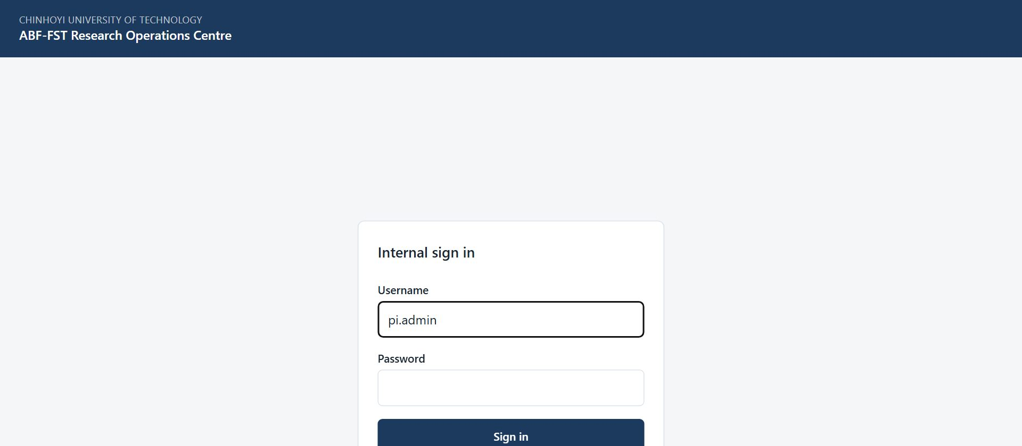
Figure 1. The sign-in screen for all internal staff.
- You arrive on your start screen: My work. The bar across the top lists only the screens your role (Research Assistant (calls)) can open.

Accounts
There is no self-registration. The PI / System Admin creates every account and sets its role. Ask the PI if you need an account, a different role, or a password reset.

Finding your way around
- The sidebar on the left shows your username and role, and the screens you can use, grouped as Dashboards, Reaching respondents, Main 400 sample, KII & documents, Quality & data and Administration. Select a group's heading to open it; on a phone, select Menu to open the sidebar. It is not a full menu with some items greyed out: anything absent is simply not part of your role.
- Most screens have a ← Back to … link at the top that returns you to the screen you came from.
- Registers show 20 rows per page to begin with. At the foot of the list, Show lets you choose 10, 20, 50, 100 or 200 rows per page (the portal remembers your choice), and the page numbers, Previous, Next and the double arrows take you to any page. The Search box above the list narrows it.
- Change password (top right) lets you set a new password at any time. Choose a long password you do not use anywhere else.
- Sign out (top right) ends your session. Always sign out on a shared or public computer.
- If you are inactive for a while you may be asked to sign in again. This protects research data on unattended devices.

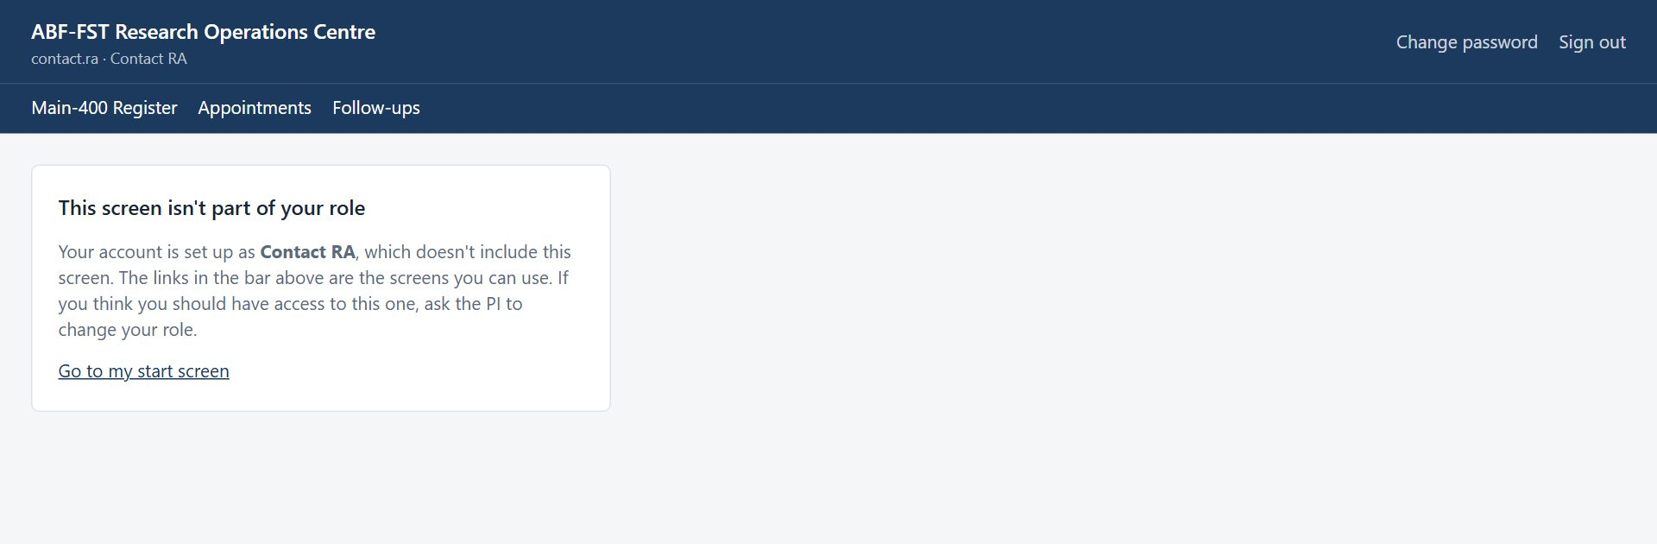
Figure 2. Opening a screen outside your role (for example from an old bookmark) shows this card instead of the screen.

Your screens
Screen | What you use it for
My work | Your assigned work and the completions credited to you, by period.
Calls | Everyone assigned to you who hasn't finished, closest to finishing first, and those with no link yet. Phone, fill in with them, log each call.
Communications | WhatsApp, SMS and email with your people, what they wrote back, and the call buttons.
Appointments | Times people asked you to call them back.
Follow-ups | Reminders due for your people.
Main-400 Register | Your assigned Main-400 cases, read-only.

Changing your password
- Select Change password in the top right corner.
- Enter your Current password, then the New password twice, and select Change password.
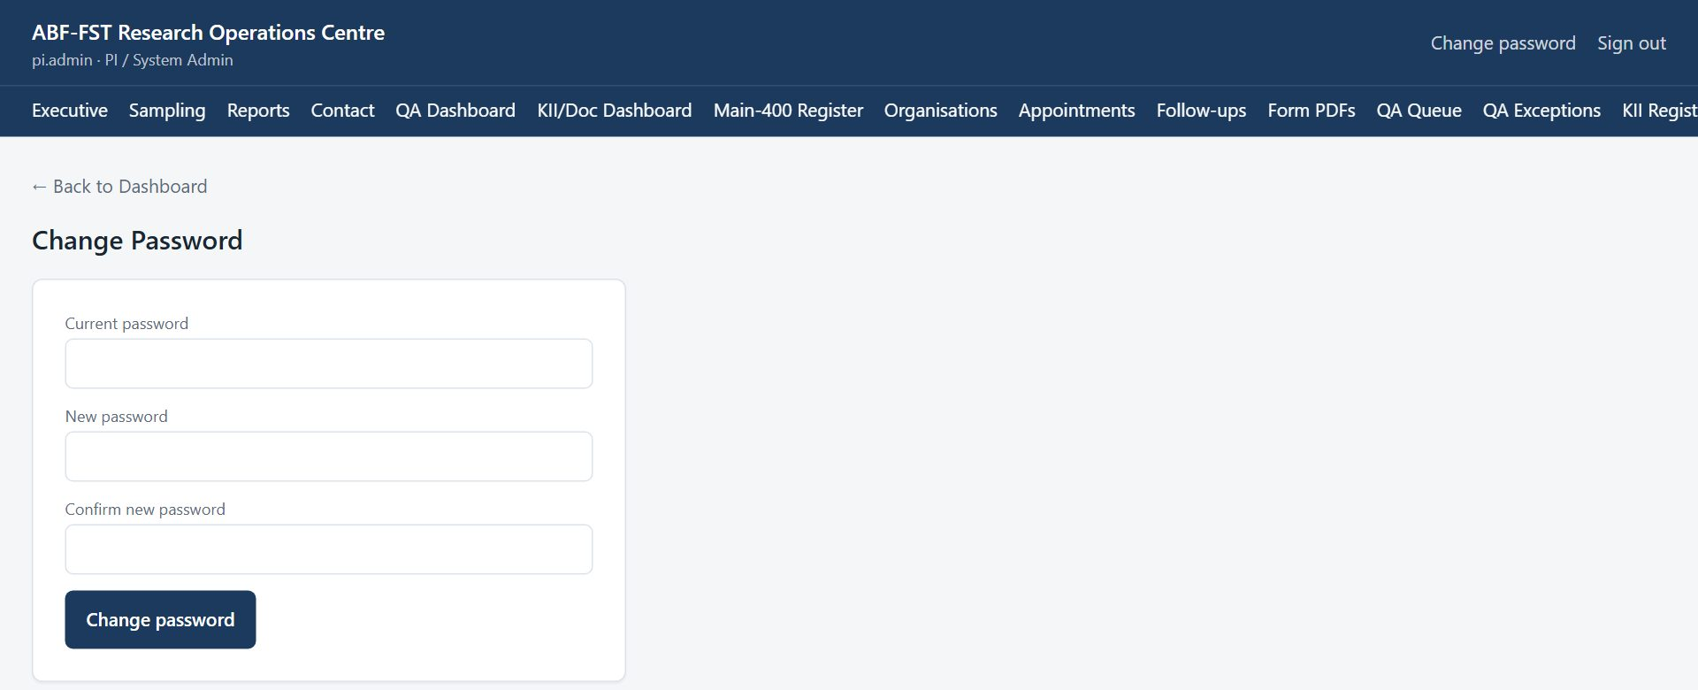
Figure 3. Change Password screen.
- Use the new password next time you sign in. If you have forgotten your password, ask the PI to reset it.

3. Your routine
A suggested rhythm. Adjust it to the Field Coordinator's plan.
When | What to do
Start of the day | My work: check your assigned numbers. Calls: start with Started, not finished, then Consented, then Opened.
Each call | Introduce yourself and the study. If they would like to do it now, use Fill in with them now; otherwise agree a time (Appointments) or send the link again.
After each call | Log it on Calls — even a call from your own phone or a WhatsApp message. An unlogged call earns no credit.
End of the week | My work: check the completions credited to you; tell the PI about any that are missing.

4. Step-by-step tasks

4.1 Filling in the form with them
- On Calls, find the person and select Fill in with them now (questionnaire) or Interview them now (KII).
- Choose Phone call or WhatsApp call. For the questionnaire, write who you are speaking to and choose their role.
- Read them the participant information. Only if they agree, tick the consent box (for a KII, tick recording consent only if they agreed to be recorded).
- Select Record consent and open the form. The form opens in a new tab with their ID filled in: go through it with them, reading questions as written, and submit.

4.2 Phoning people who haven't finished (Calls)
Calls lists everyone whose link was sent but who hasn't finished, closest to finishing first: Started, not finished, then Consented, not started, Opened, not started, and Link sent, not opened. It covers the Main 400 (with activated Reserves) and the key informants. A Contact RA sees only their own cases and a KII RA only the KII records.
- Select Calls. Choose Main 400, KII or both, and a stage; each button shows how many people it holds. Search by organisation, name, ID or phone number.
- Each card shows the organisation, who to ask for, every number on file (select Call to dial, or WhatsApp), the email and any gatekeeper, when the link was sent and opened, when it stops working, and the reminders and calls so far.
- Make the call. Remind them of the study by Happyson Saina at Chinhoyi University of Technology and offer to re-send the link if it was lost. Never read out or change their answers.
- Select Log a call, choose what happened, add a short factual note and, if they asked, a Call back on date. Select Save call. It goes into the case's (or KII record's) contact log under your name, and the card shows it as the last call.

A refusal on the phone
Choosing Refused records the call only. To close the case as Refused, use the case page, as before.
Link expired?
A card says when its link has expired. Issue a new one from the case or KII record page before asking them to continue.

4.3 How your completions are counted
- Administered: you opened the form with Fill in with them now and it was submitted.
- Assisted: they completed it themselves, and your logged call or message was the last before it, within 14 days.
- My work lists each one with the evidence. If one is missing (for example a call you forgot to log), tell the PI, who can correct it with a reason.

5. Rules you must follow
- Only call the people assigned to you.
- Never read out or change a respondent's answers, and never say they will get finance.
- Treat everything in the portal as confidential research data. Do not screenshot, copy, print or forward names, phone numbers, email addresses or answers except as your role requires.
- Never share your username or password, and never sign in for someone else.
- Use the respondent's contact details only to manage their participation in this study (invitations, reminders, appointments).
- Never tell a respondent, lender or anyone else that answers affect financing. The study generates no score, rating or financing decision.
- If a respondent asks to withdraw, stop contacting them and tell the Field Coordinator or PI the same day so the withdrawal is recorded.
- Report a lost device, a suspected account compromise, or data sent to the wrong person to the PI immediately.

6. Troubleshooting
Situation | Likely cause | What to do
“Not assigned to you” | The person is assigned to another RA, or to nobody. | Ask the PI or Field Coordinator to assign them to you.
“Record who you are speaking to and their role first” | The questionnaire needs to know the respondent's role (eligibility). | Fill in their name and role, then try again.
A completion isn't credited to you | No call or message of yours was logged before they finished, or another RA's came later. | Tell the PI; they can correct it with a reason.
"This screen isn't part of your role" | The screen belongs to another role (often an old bookmark or shared link). | Select Go to my start screen. If you need that screen, ask the PI about your role.
"Too many sign-in attempts from this network" | Sign-in is rate-limited per network; an office shares one address. | Wait a minute and try again. A wrong password says so explicitly.
A register shows fewer rows than expected | Registers show 20 rows per page to begin with; a Contact RA sees only assigned cases. | Choose more rows under Show at the foot of the list, use the page numbers or Next, or search. Ask the Field Coordinator to assign the case.
A button is greyed out | A required step is missing (a note, an authenticity decision, a selection). | Read the message beside the button; complete the missing step first.
"KoboToolbox couldn't be reached" | KoboToolbox is slow or the connection token has changed. | Try again in a few minutes. If it persists, tell the PI.
Form PDFs says "Not in sync with KoboToolbox yet" | The counts differ: a form was submitted or changed in KoboToolbox since the last sync (it runs every 15 minutes). | Select Sync now. If it still differs, or says it couldn't reach KoboToolbox, try again in a few minutes and tell the PI if it persists.
A document says "Already submitted" and its answers are locked | Its coding was already sent to KoboToolbox; changing it here would not change that record. | To redo the coding, delete that record in KoboToolbox, then select Sync now on Form PDFs. The document unlocks.
A page keeps loading | A slow or dropped connection. | Refresh the page. Your saved work is not lost; unsaved typing may be.
Send invitations says email isn't set up | Outgoing email has not been configured on the server. | Ask the administrator to run configure-email.sh. Until then, send invitations by WhatsApp.
Send invitations says SMS or WhatsApp isn't set up | Twilio has not been configured on the server, or (WhatsApp) Meta has not approved the sender and templates yet. | Ask the administrator to run configure-twilio.sh. Until then, send by email, or by hand from the study WhatsApp number.
A WhatsApp invitation was prepared but never sent | Prepare counts it as sent and moves the case to S05. | Open the case and Revoke that invitation; send a new one from the case's Invitations panel when you can reach the person.
A case is missing from the WhatsApp or email queue | It is not verified (S03 or S04), has no number or email on file, already has an open invitation, or is assigned to another Contact RA. | Verify the case, add the contact detail, or check its invitation history.
The contact finder says it would overwrite a detail | The organisation contact already has a different phone or email. | Check which is right and correct it under Respondents and contact details.
A file upload seems stuck | A large file on a slow connection takes time; the bar shows how much has been sent. | Wait for Saving… and the file name. If it fails, try again or upload a smaller version.

7. Quick reference
Sign in | https://research.agribizframework.com/admin/login
You start on | My work
Credit | Administered, or assisted within 14 days
Log | Every call and every message from your own phone
Never | Change answers, or promise finance
Help | Field Coordinator; PI: Happyson Saina, 0773943709, abffst.research@gmail.com

8. Every screen and button for your role
This section lists every screen you can open as Research Assistant (calls), and for each control: what it does and when to use it, why it exists (the rule behind it), and what you will see next. It is the same material as the Screen and Button Reference, cut down to your role.
Reading the tables
Control is the label you see on screen. Why it exists explains the rule or risk behind it; if a button is greyed out, this column usually says why. A control that needs a note or a confirmation says so.

8.1 Sign in
Who can open it: every role. Where: /admin/login
Where every staff member starts. Staff accounts are created by the PI; there is no self-registration.
Control | What it does and when to use it | Why it exists | What happens next
Username | Type the username the PI gave you. | Every action in the portal is recorded against a named person, so accounts are never shared. | Nothing yet; you also need the password.
Password | Type your password. The characters are hidden. | Passwords are never shown or emailed; the PI can reset yours but cannot read it. | Nothing yet; select Sign in.
Sign in | Checks your username and password and opens your start screen (the first screen your role uses). | Repeated wrong attempts from one network are refused for a minute, to stop password guessing. | Your start screen opens. A wrong password says so. “Too many sign-in attempts” means wait a minute.

8.2 The sidebar (every screen)
Who can open it: every role. Where: (left of every screen; Menu button on a phone)
Shown on the left of every signed-in screen. The sidebar lists only the screens your role may open, in groups.
Control | What it does and when to use it | Why it exists | What happens next
Group heading (Dashboards, Reaching respondents, …) | Opens or closes that group's list of screens. | With many screens, only the group of the page you are on starts open, so the list fits without scrolling. | The group's screens appear below its heading.
Screen name (Executive, Calls, … Audit Log) | Opens a screen. The current screen is highlighted. | The list is built by the server from your role, so you never see a screen that would refuse you. | The screen opens. A screen not in your list shows “This screen isn't part of your role”.
Change password | Opens the Change Password screen. | You should change the first password you were given, and any password you think someone saw. | The Change Password screen opens.
Sign out | Ends your session on this device. | Protects the data if the device is shared or lost. Always sign out on a shared device. | Your session on this device ends and you return to the Sign in screen.
← Back to … (top left) | Returns to the parent screen (for example from a case to the register). | A consistent way back that does not lose your place in the menu. | The parent screen opens.
Go to my start screen | Appears on the “This screen isn't part of your role” page and takes you to your own start screen. | An old bookmark or shared link may point at a screen that belongs to another role; this gets you out safely. | Your start screen opens.

8.3 Change Password
Who can open it: every role. Where: /admin/account
Change your own password.
Control | What it does and when to use it | Why it exists | What happens next
Current password | Type the password you use now. | Proves it is really you before a change, in case a signed-in device was left open. | Nothing yet.
New password | Type the new password. | It must be long enough, not a common password, not all digits and not similar to your username or name; the screen says which rule failed. | Nothing yet.
Confirm new password | Type the new password again. | Catches a typing slip that would lock you out. | Nothing yet.
Change password | Saves the new password. | Your old password stops working straight away, and other people (including the PI) never see your new one. | A confirmation appears. Use the new password next time.

8.4 Main-400 Register (and Reserve)
Who can open it: PI / System Admin, Field / Digital Coordinator, Contact RA, Supervisor, Research Assistant (calls). Where: /admin/sample
The list of sample cases. A Contact RA sees only the cases assigned to them. From here you open a case, and the coordinator moves or reassigns cases in bulk.
Control | What it does and when to use it | Why it exists | What happens next
Main / Reserve (sample type) | Switches the list between the 400 Main cases and the 400 locked Reserve cases. | Reserve cases are locked replacements and are handled differently from Main cases. | The list changes and returns to page 1.
Search ID, organisation or phone | Filters the list as you type: by Sample ID, organisation, Master ID, or a respondent's phone or WhatsApp number. A phone number can be typed any way (0772 123 456, +263772123456 or 772123456): it finds the record whose number on file has those digits. | Finding one case among hundreds should not need paging, and a caller who rings back can be found by their number. | Only matching cases are listed.
View | Opens the case page for that row. | All work on a case happens on its own page. | The case page opens.
WhatsApp invitations (the queue) | Lists the verified cases (S03 or S04) with a WhatsApp or phone number and no open invitation. A Contact RA sees only their own cases. | Without a WhatsApp Business account the portal cannot send WhatsApp messages; the queue makes each one a single tap. | Read only. The list shows masked numbers.
WhatsApp invitations → Prepare, Open WhatsApp, Copy message, Email the same link | Prepare creates the case's personal link and code and the approved message. Open WhatsApp opens that person's chat with the message ready; Copy message copies it. Email the same link (shown when the case has an email address) emails the same invitation from the study address. | The RA sends from the study phone so replies come back to the team. | Prepare moves the case to S05 at once, so send straight away. If you cannot, revoke the invitation on the case page.
Show / page numbers / Previous / Next | Chooses how many rows to see (10, 20, 50, 100 or 200) and moves between pages. | Different jobs need different views; your choice is remembered. | The list redraws at the chosen size.

8.5 Appointment Queue
Who can open it: PI / System Admin, Field / Digital Coordinator, Contact RA, Supervisor, Research Assistant (calls). Where: /admin/appointments
Calls that respondents have asked for, and their progress.
Control | What it does and when to use it | Why it exists | What happens next
Filter by status | Shows all appointments, or only Requested, Confirmed, Completed, Missed or Cancelled. | Coordinators mostly need the ones still to be acted on. | The list changes and returns to page 1.
CONFIRMED / CANCELLED (on a Requested appointment) | Confirm the time with the respondent and select CONFIRMED, or CANCELLED if it will not happen. | A respondent's request is only a request until a person confirms it. | The appointment's status changes.
COMPLETED / MISSED / CANCELLED (on a Confirmed appointment) | Record what happened at the appointment time. | Missed calls need to be rescheduled and counted; completed ones move the case forward. | The status changes; finished appointments show no more buttons.
Show / page numbers | Choose rows per page and move between pages. | As on every register. | The list redraws.

8.6 Follow-ups due
Who can open it: PI / System Admin, Field / Digital Coordinator, Contact RA, Supervisor, Research Assistant (calls). Where: /admin/follow-ups
Approved reminders (on day 2 and day 7 after an invitation) for invited cases that have not responded, and below them the invitations that have run out and need a new one.
Control | What it does and when to use it | Why it exists | What happens next
Case link (Sample ID) | Opens the case the reminder is for. | Lets you check the case before you send. | The case page opens.
Open in WhatsApp | Opens WhatsApp with the reminder text already written for that respondent. | Reminders are sent by a person from the study's WhatsApp account: nothing is sent automatically, so a person always decides. | WhatsApp opens with the message. If the button says “Open WhatsApp (choose contact)”, there is no mobile number on file (WhatsApp can't reach a landline): phone them, or pick the contact in WhatsApp and add the mobile on the case afterwards.
Invitations that have run out | Cases still waiting whose link has expired, or whose last invitation was revoked or replaced. | A reminder would point at a link that no longer works. | Select the Sample ID and send a new invitation from the case page; the case leaves the list and the reminders start again.
Mark as sent | Tells the portal you sent the reminder. | Otherwise the same reminder stays due and could be sent twice. | It is recorded as sent by you and leaves the list.
Asked, no reply yet: phone them | Organisations sent the introduction and its reminder with no answer, or whose introduction could not be delivered. | Automatic messages have done all they can; a call is next. | Select the Sample ID; if they agree on the phone, send the invitation from the case page.

8.7 Calls
Who can open it: PI / System Admin, Field / Digital Coordinator, Contact RA, KII RA, Supervisor, Research Assistant (calls). Where: /admin/calls
Everyone whose link was sent but who hasn't finished, Main 400 and KII, closest to finishing first, with every contact on file and a log of each call. A Contact RA sees their own cases, a KII RA the KII records.
Control | What it does and when to use it | Why it exists | What happens next
Main 400 / KII | Shows one study or both. | One person may call only the Main 400 or only the key informants. | The list redraws; the stage buttons show the new counts.
Stage buttons | Started, not finished · Consented, not started · Opened, not started · Link sent, not opened. | Call the people closest to finishing first. | The list shows that stage only, with how many people it holds.
Search | Finds an organisation, a person, an ID or a phone number. | To find someone who calls back. | Only matching cards stay.
Call / WhatsApp | Dials the number, or opens a WhatsApp chat with it. | Every number on file is shown, including second numbers in the same field. | Your phone or WhatsApp opens.
Log a call → Save call | Records how you contacted them (a call, or a WhatsApp, SMS or email from your own phone), the outcome, a note and an optional call-back date. | So the next caller knows what happened, Reports count it, and a research assistant's logged contact is what earns an assisted credit. | It goes into the contact log under your name and shows as the last call.
Fill in with them now / Interview them now | On the phone or a WhatsApp call: say who you are speaking to and their role (questionnaire), tick that you read them the participant information and they agreed, then Record consent and open the form. | Records their verbal consent (and eligibility) first, as the rules require, and stamps you in the form so the completion is credited to you as administered. | The form opens in a new tab with their case or KII ID filled in. Complete it with them and submit.
Assigned, no link yet (stage) | People assigned to a research assistant whom nobody has invited yet. | So they can be phoned and done by phone straight away, without waiting for a link. | Fill in with them now, or send the link from their page.

8.8 Communications
Who can open it: PI / System Admin, Field / Digital Coordinator, Contact RA, KII RA, Supervisor, Research Assistant (calls). Where: /admin/communications
Every message to and from participants in one place: WhatsApp, SMS and email the portal sent, with what happened to each one; WhatsApp messages and email replies received; and the events around them (invitations, the link opened, consent, the questionnaire submitted, follow-ups and calls). A Contact RA sees their own cases, a KII RA the KII records. It replaced Conversations.
Control | What it does and when to use it | Why it exists | What happens next
Channel cards (WhatsApp, SMS, Email) | Whether each channel is switched on, what is holding it back, and the last seven days' messages. | WhatsApp shows how many templates Meta has approved: until they are, WhatsApp messages the study sends first are refused. | Select “N of 6 templates approved” for each template's status; select Not delivered to list the conversations whose last message failed.
Waiting / Not delivered / All | Filters the conversation list. | Waiting lists people who wrote and need an answer; Not delivered lists conversations whose last message did not arrive. | The list changes. Search, register and channel narrow it further.
What happened (filter) | Narrows the list to: read our last message; delivered, not read; sent, no delivery report; have written back; never written back; called (phone or WhatsApp); not called yet. Each shows how many. | So you can chase the people who read but did not answer, or call everyone who has not been called. | The list shows only those people. Called conversations carry a “Called” tag.
Voice call / Video call / Phone | Voice call and Video call open the person's chat in WhatsApp on your computer or phone; press the phone or camera icon there. Phone dials the number. With several numbers, choose one first. | WhatsApp does not let a business number start a video call, so calls are made from your own WhatsApp. | A form opens: choose how you called and what happened, add notes or a call-back date, and select Save the call. It appears in the conversation, on the Calls screen and in the Called filter.
Log a call | Records a call made some other way. | Every call counts, wherever it was made from. | As above.
Delivery ticks | One grey tick: sent. Two grey ticks: delivered to the phone. Two blue ticks: read. Red “!”: not delivered, with the reason underneath. | So you know whether a message actually reached them before you chase. | Email only shows sent, or not delivered when it bounces.
Sent by hand from the study phone | Invitations and reminders sent with Open in WhatsApp. | The portal can't see those reach the phone, so they say “no delivery report”. | Nothing to do: it is a record.
WhatsApp / Email / SMS (writing) | Write to them on a channel and select Send. | Answer from the screen itself; the study's WhatsApp number is on no phone. | Sent and recorded under your name. WhatsApp only within 24 hours of their own last WhatsApp message (otherwise send the introduction or an invitation); SMS once a sender is registered; email to an address on the record. Words like “approved” or “guarantee” are refused. A WhatsApp or SMS message over 1,500 characters goes as numbered parts, (1/2), (2/2); the box says how many before you send.
Document / Photos & videos (WhatsApp) | Chooses files to send: PDF, Word, Excel, PowerPoint or TXT; JPG or PNG photos (up to 5 MB) and MP4 videos (up to 16 MB). On a phone, Photos & videos opens the gallery. Up to 10 at once; what you write becomes the caption. | Send the information sheet, a letter or a picture without leaving the portal. | Select Send N files: each goes as its own WhatsApp message. Only within 24 hours of their own last WhatsApp message, like a written one. iPhone HEIC photos and MOV videos are refused with what to do instead; refused words are refused in captions and file names too.
Voice note (WhatsApp) | Start recording, Stop, listen back, then Send voice note (up to 5 minutes). | A spoken message is quicker and more personal than a long text. | It arrives as a WhatsApp voice note. The browser asks once to use the microphone. Only within the same 24 hours.
Contact (WhatsApp) | Sends a name and number (with a short note) as a contact card. | WhatsApp lets them tap the number to chat, call or save it. | Sent and shown in the conversation. Only within the same 24 hours.
Contact details (right-hand panel) | Everything recorded: the organisation and where it is, every person with every number (Phone, WhatsApp and Copy links), gatekeepers, other emails, details found publicly, and where they stand: the link, consent, calls and the last message they read. | Everything needed to reach them, in one place. | Select Phone or WhatsApp next to a number to use it.
Mark handled | Records that what they wrote has been dealt with. | So colleagues don't answer it twice. Replying does this for you. | It leaves Waiting, with your name and the time.
Numbers not on any record | WhatsApp messages from numbers on no case or KII record (PI, Field Coordinator, Supervisor). | Someone may have a new phone; add the number to their case and later messages join their conversation. | Reply within 24 hours, or mark handled. The same rules as writing apply: refused words, and long replies sent in numbered parts.

8.9 My work
Who can open it: PI / System Admin, Research Assistant (calls). Where: /admin/my-work
A research assistant's own page: how many Main-400 cases and KII records are assigned to you, your calls this week, and every completed form credited to you — the number you are paid on. You only ever see your own.
Control | What it does and when to use it | Why it exists | What happens next
Completed (credited to you) | Forms credited to you in the period chosen below: questionnaires and KIIs, administered (you filled it in with them) and assisted (they finished it after your call or message). | This is the count you are paid on. | Read only.
Calls, Communications, Appointments, Follow-ups | Shortcuts to your working screens. | Everything you do happens there; this page adds it up. | The screen opens.
From / To / All time | Chooses the period, e.g. one pay month. | To check a month's count before payment. | The list and counts change.
Completions credited to you | Each completed form: when, which case or KII, administered or assisted, and the evidence (e.g. the call you logged). | So you can see exactly what you are credited with, and raise anything missing with the PI. | Read only.

