CHINHOYI UNIVERSITY OF TECHNOLOGY · ABF-FST RESEARCH STUDY
Role Guide 4: Questionnaire QA Research Assistant
Step-by-step instructions for the QUAN/Kobo QA RA role in the ABF-FST Digital Respondent Portal.
STUDY | Developing and Validating the Agribusiness Bankability Framework for Food Systems Transformation through Novel Financing Models in Zimbabwe (ABF-FST)
PRINCIPAL RESEARCHER | Happyson Saina, Doctor of Strategic Management candidate, Chinhoyi University of Technology
SUPERVISORS | Dr L. Chikazhe and Dr J. Kanyepe
FOR | Research assistants who check the quality of questionnaire submissions
SYSTEM ADDRESS | https://research.agribizframework.com
CONTACT | 0773943709 · abffst.research@gmail.com
VERSION | Version 1.21 · 4 October 2026

Screenshots in this document use fictional demonstration data. Organisation and person names, phone numbers and figures shown in them are not real study records.

Contents
1. Your role at a glance 3
2. Signing in and your screens 4
Signing in 4
Finding your way around 4
Your screens 5
Changing your password 5
3. Your routine 6
4. Step-by-step tasks 7
4.1 Reading the QA Dashboard 7
4.2 Reviewing questionnaires in the QA Queue 7
4.3 Working QA exceptions 8
4.4 Downloading or emailing completed forms (Form PDFs) 9
4.5 Writing good QA notes 10
5. Rules you must follow 12
6. Troubleshooting 13
7. Quick reference 15
8. Every screen and button for your role 16
8.1 Sign in 16
8.2 The header and menu bar (every screen) 16
8.3 Change Password 17
8.4 QA Dashboard 17
8.5 QA Queue (with the KoboToolbox sync panel) 18
8.6 QA Exceptions 19
8.7 Completed forms (Form PDFs) 19

1. Your role at a glance
You make sure every questionnaire counted towards the 400 target is complete, plausible and genuine. The system checks each submission automatically, but nothing passes QA until you (or the Field Coordinator or PI) decide, with a note.

You can
- See the QA Dashboard, QA Queue and QA Exceptions.
- Accept, re-query or reject submissions with a note.
- Assign, work and close QA exceptions.
- Run a KoboToolbox sync.
- Download and email PDFs of completed questionnaires.

You cannot
- See names, contact details or case pages; KII or document records; dashboards other than QA; exports.
- Change answers — corrections are made in KoboToolbox by whoever administered the questionnaire.
- Pass a submission without a note.

Where this fits
The System Manual explains how the whole system works. This guide covers only what you do, and its last section lists every screen and button you can use, with what each does and why. Ask the Field Coordinator or PI when something is outside your role.

2. Signing in and your screens

Signing in
- Open https://research.agribizframework.com/admin/login in any modern browser (Chrome, Edge, Firefox or Safari), on a computer, tablet or phone.
- Type your Username and Password, then select Sign in.
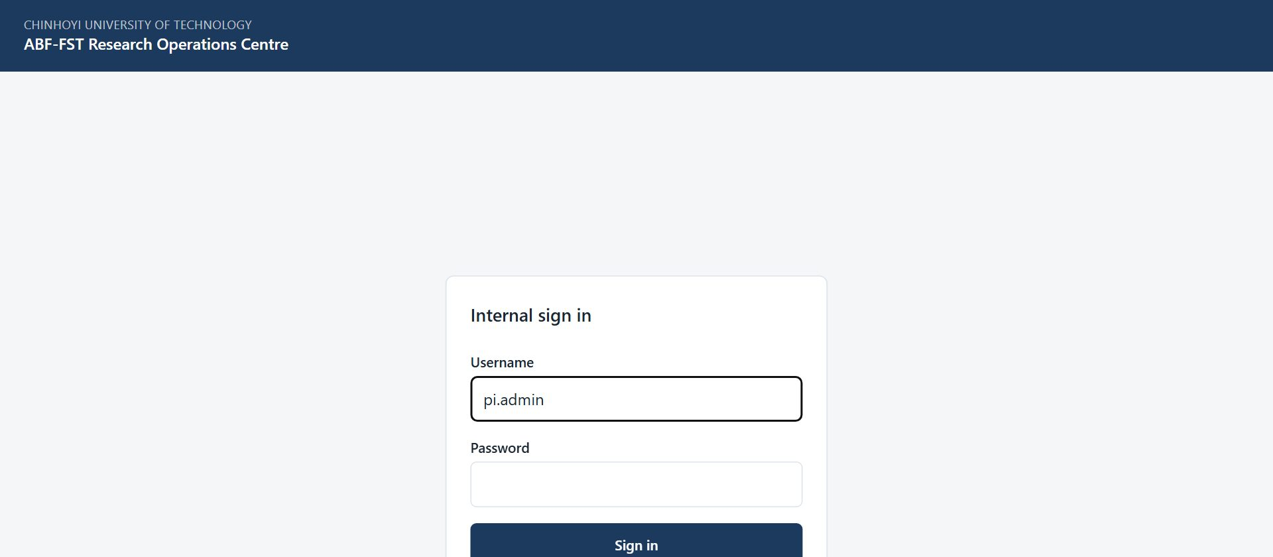
Figure 1. The sign-in screen for all internal staff.
- You arrive on your start screen: QA Dashboard. The bar across the top lists only the screens your role (QUAN/Kobo QA RA) can open.

Accounts
There is no self-registration. The PI / System Admin creates every account and sets its role. Ask the PI if you need an account, a different role, or a password reset.

Finding your way around
- The top bar shows your username and role, and the screens you can use. It is not a full menu with some items greyed out: anything absent is simply not part of your role.
- Most screens have a ← Back to … link at the top that returns you to the screen you came from.
- Registers show 20 rows per page to begin with. At the foot of the list, Show lets you choose 10, 20, 50, 100 or 200 rows per page (the portal remembers your choice), and the page numbers, Previous, Next and the double arrows take you to any page. The Search box above the list narrows it.
- Change password (top right) lets you set a new password at any time. Choose a long password you do not use anywhere else.
- Sign out (top right) ends your session. Always sign out on a shared or public computer.
- If you are inactive for a while you may be asked to sign in again. This protects research data on unattended devices.

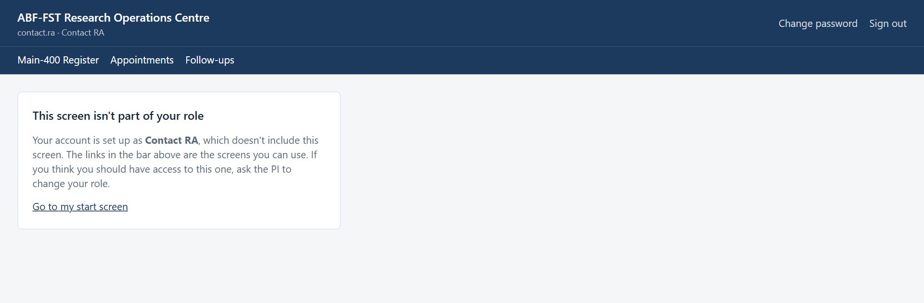
Figure 2. Opening a screen outside your role (for example from an old bookmark) shows this card instead of the screen.

Your screens
Screen | What you use it for
QA Dashboard | Submissions today and in total, queue size, decisions, modes.
Form PDFs | Readable copies of completed questionnaires.
QA Queue | Take decisions; run a KoboToolbox sync.
QA Exceptions | Automated flags to investigate and close.

Changing your password
- Select Change password in the top right corner.
- Enter your Current password, then the New password twice, and select Change password.
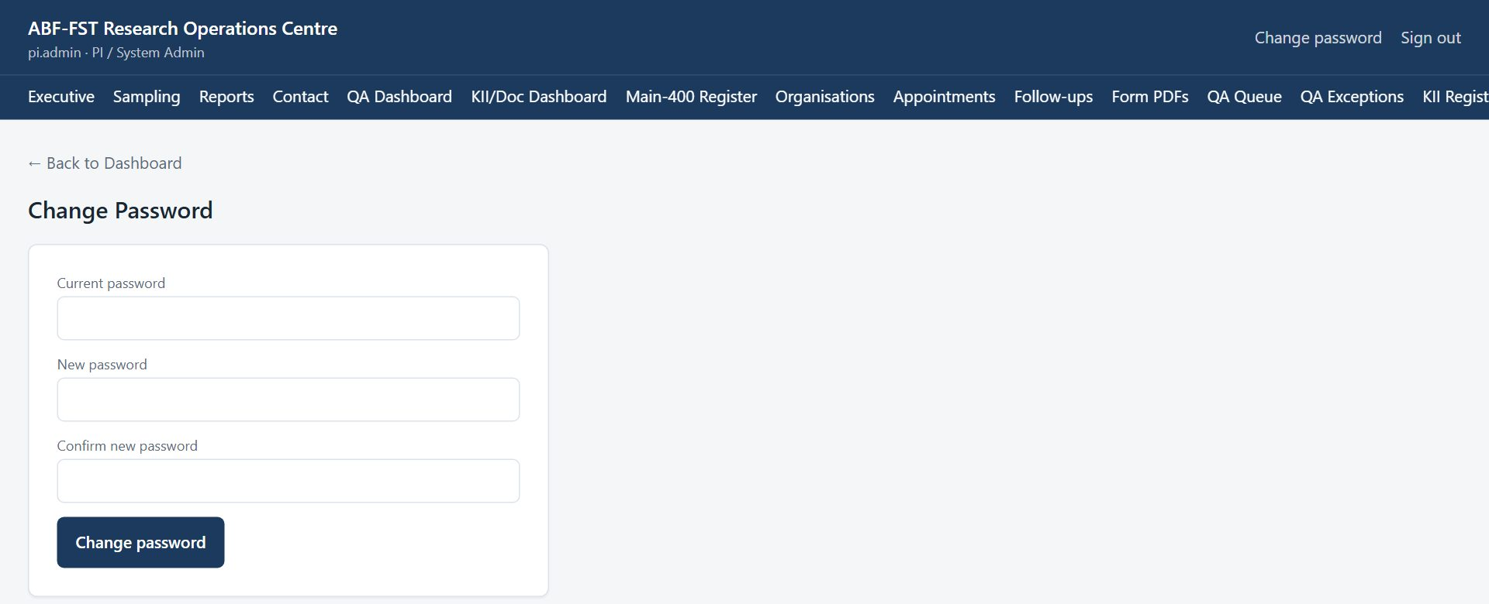
Figure 3. Change Password screen.
- Use the new password next time you sign in. If you have forgotten your password, ask the PI to reset it.

3. Your routine
A suggested rhythm. Adjust it to the Field Coordinator's plan.
When | What to do
Start of day | QA Dashboard: how many are waiting. Sync now on the QA Queue if you expect new submissions.
Main work | Oldest QA exceptions first, then the QA Queue oldest first.
For each submission | Open the PDF, check the rules, decide with a clear note.
End of day | Queue and exceptions no older than two days; report patterns (e.g. many short completions from one mode) to the Field Coordinator.

4. Step-by-step tasks

4.1 Reading the QA Dashboard
- Select QA Dashboard. It shows submissions today and cumulatively, the open queue, decisions recorded, and completions by administration mode (01–06).
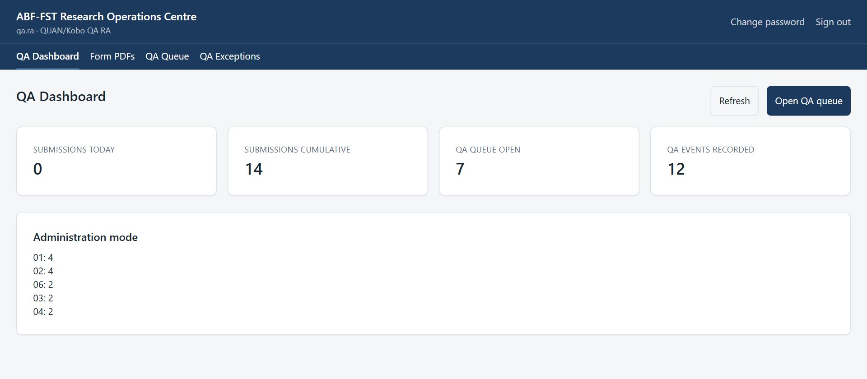
Figure 4. QA Dashboard.
- Select Refresh to update the figures, or Open QA queue to start work.

4.2 Reviewing questionnaires in the QA Queue
- Select QA Queue. Each submission shows the Sample ID, when it was submitted, the administration mode, the completion time in minutes and its QA status (PENDING or QUERY).
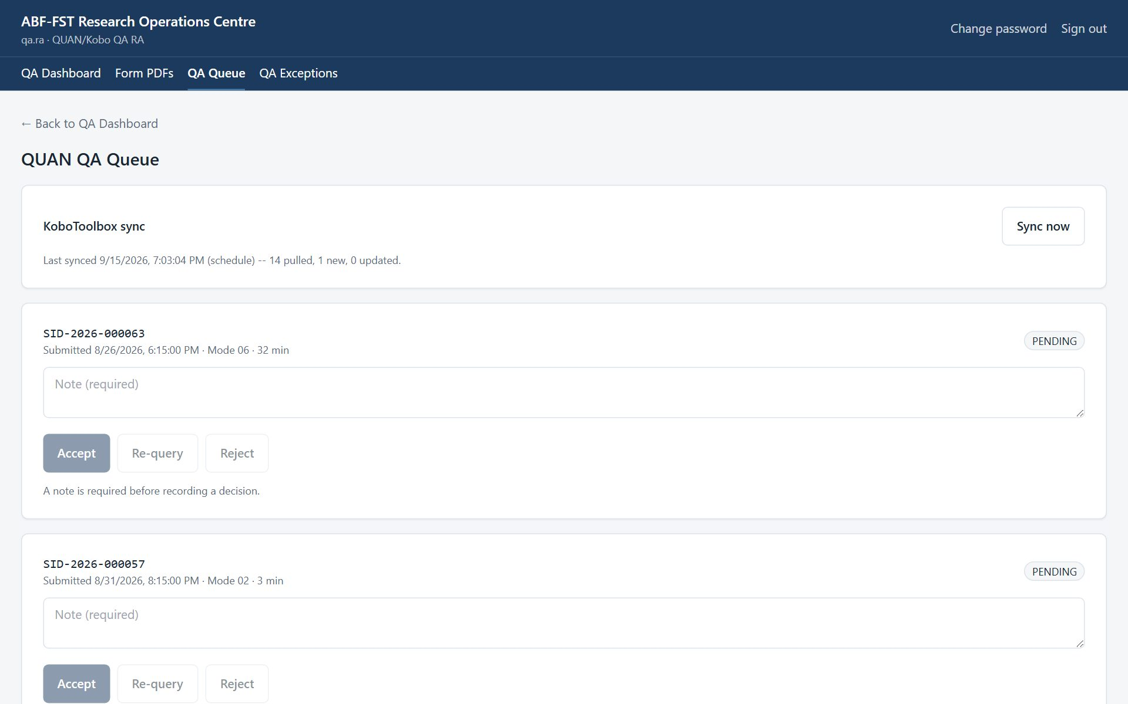
Figure 5. QUAN QA Queue with the KoboToolbox sync panel.
- Open the completed form to check the answers: Form PDFs → Download PDF, or the Completed questionnaire panel on the case page.
- Check it against the QA rules (table below) and any open QA exception for that case.
- Write a Note (required) explaining your decision.
- Select Accept (moves the case to S10 QA passed), Re-query (S09 QA query — follow up with the respondent or the RA who administered it) or Reject (not usable).

Rule | Setting | Effect
Required answers missing | 65 required fields from the live questionnaire | Hard stop: raises an exception; cannot pass without a human decision and note.
Too quick | Completed in under 5 minutes (300 s) | Soft flag for review.
Too slow | Completed in over 90 minutes (5400 s) | Soft flag for review.
Possible duplicate | Another submission for the same organisation within 24 hours | Soft flag for review.

Nothing passes automatically
Even a submission with no flags needs a person to select Accept. Every decision and its note is audited.

Pulling new submissions now
Submissions arrive within seconds (KoboToolbox notifies the portal) and a full check runs every 15 minutes between 06:00 and 22:00 and hourly overnight. To check immediately, select Sync now in KoboToolbox sync; the panel shows the last run, how many were pulled and how many were new or updated. An edited submission returns to the queue for review.

4.3 Working QA exceptions
- Select QA Exceptions. Each card shows the rule that fired (for example hard_stop_missing_required_fields or min_plausible_duration_seconds), the Sample ID, when it was raised and its status. Oldest first.
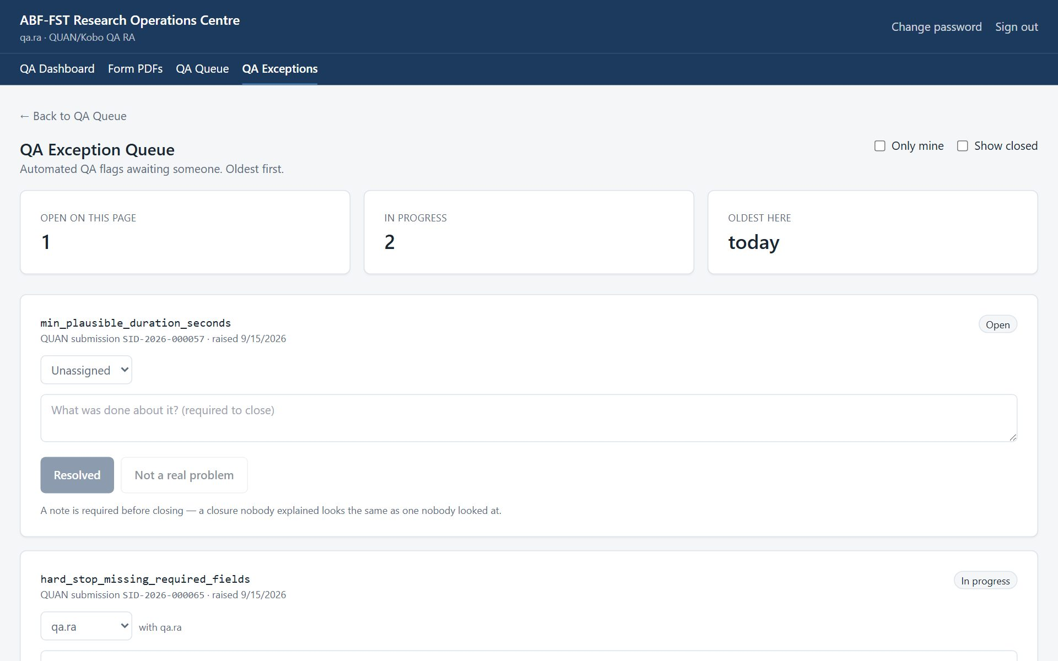
Figure 6. QA Exception Queue.
- Tick Only mine to see exceptions assigned to you; tick Show closed to include resolved ones.
- Use Assign to to take ownership (or give it to a colleague). The status becomes In progress.
- Investigate: open the form PDF, check the case timeline, contact the respondent if needed.
- Type What was done about it? and select Resolved, or Not a real problem if the flag was a false alarm. A note is always required.

4.4 Downloading or emailing completed forms (Form PDFs)
- Select Form PDFs. You see the completed questionnaire forms from KoboToolbox, newest first, 20 per page to begin with (choose more under Show at the foot of the list).
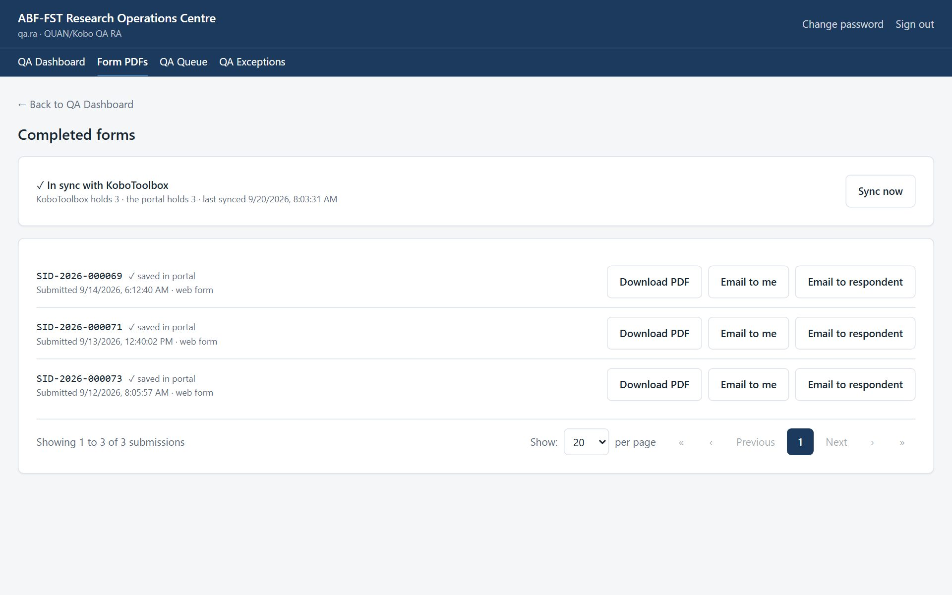
Figure 7. Completed form PDFs.
- Select Download PDF to save a readable copy: sections, questions, the chosen answers as words (not codes) and repeated groups.
- Select Email to me to send the PDF to the email address on your account.
- For the questionnaire only, select Email to respondent to send the respondent a copy of their own answers at the email address recorded on the case (only while their consent stands). You are asked to confirm first. Every email is audited with the address masked.

At the top of the page, a sync panel shows whether the portal holds the same forms as KoboToolbox, for example “✓ In sync with KoboToolbox — KoboToolbox holds 12 · the portal holds 12”. Each row also says “✓ saved in portal” once the portal has an identical copy. If the panel says “Not in sync”, select Sync now (read-only roles see the panel but not the button); it takes a few seconds.
The same PDF is available from the record itself: the case page (questionnaire), the KII page (KII Guide) or the document page (coding form).
How the sync works
The portal keeps its own copy of the questionnaire, KII Guide and Document Analysis Tool, and refreshes it every 15 minutes and whenever someone selects Sync now. A submission edited in KoboToolbox is updated here; one deleted in KoboToolbox is flagged as removed. You never need to sync before downloading a PDF: the PDF is always read from KoboToolbox at that moment.

4.5 Writing good QA notes
- State what you checked and what you found: "Duration 3 min; answers straight-lined in Sections 4–6; re-queried with RA".
- For Accept: "All required answers present; duration 28 min plausible; no duplicate".
- For Re-query: say exactly what needs confirming or completing.
- Never include personal opinions about the respondent.

5. Rules you must follow
- Decide on evidence, not on who the organisation is.
- Never download PDFs to personal devices or share them outside the team.
- Treat everything in the portal as confidential research data. Do not screenshot, copy, print or forward names, phone numbers, email addresses or answers except as your role requires.
- Never share your username or password, and never sign in for someone else.
- Use the respondent's contact details only to manage their participation in this study (invitations, reminders, appointments).
- Never tell a respondent, lender or anyone else that answers affect financing. The study generates no score, rating or financing decision.
- If a respondent asks to withdraw, stop contacting them and tell the Field Coordinator or PI the same day so the withdrawal is recorded.
- Report a lost device, a suspected account compromise, or data sent to the wrong person to the PI immediately.

6. Troubleshooting
Situation | Likely cause | What to do
Accept / Re-query / Reject are greyed out | No note written yet. | Type the note first.
Accept is refused: “Reconcile the pre-interview profile first…” | The case has a locked pre-interview profile with facts not yet verified with the respondent or not reconciled. | Ask the Field Coordinator to finish verification and reconciliation on the case's Interview sheet. Re-query and Reject are never blocked.
A submission I expected is not in the queue | It has not been pulled yet, or it was set aside (not launched from the portal). | Select Sync now; if still missing, tell the Field Coordinator.
"This screen isn't part of your role" | The screen belongs to another role (often an old bookmark or shared link). | Select Go to my start screen. If you need that screen, ask the PI about your role.
"Too many sign-in attempts from this network" | Sign-in is rate-limited per network; an office shares one address. | Wait a minute and try again. A wrong password says so explicitly.
A register shows fewer rows than expected | Registers show 20 rows per page to begin with; a Contact RA sees only assigned cases. | Choose more rows under Show at the foot of the list, use the page numbers or Next, or search. Ask the Field Coordinator to assign the case.
A button is greyed out | A required step is missing (a note, an authenticity decision, a selection). | Read the message beside the button; complete the missing step first.
"KoboToolbox couldn't be reached" | KoboToolbox is slow or the connection token has changed. | Try again in a few minutes. If it persists, tell the PI.
Form PDFs says "Not in sync with KoboToolbox yet" | The counts differ: a form was submitted or changed in KoboToolbox since the last sync (it runs every 15 minutes). | Select Sync now. If it still differs, or says it couldn't reach KoboToolbox, try again in a few minutes and tell the PI if it persists.
A document says "Already submitted" and its answers are locked | Its coding was already sent to KoboToolbox; changing it here would not change that record. | To redo the coding, delete that record in KoboToolbox, then select Sync now on Form PDFs. The document unlocks.
A page keeps loading | A slow or dropped connection. | Refresh the page. Your saved work is not lost; unsaved typing may be.
Email invitations says email isn't set up | Outgoing email has not been configured on the server. | Ask the administrator to run configure-email.sh. Until then, send invitations by WhatsApp.
A WhatsApp invitation was prepared but never sent | Prepare counts it as sent and moves the case to S05. | Open the case and Revoke that invitation; send a new one from the case's Invitations panel when you can reach the person.
A case is missing from the WhatsApp or email queue | It is not verified (S03 or S04), has no number or email on file, already has an open invitation, or is assigned to another Contact RA. | Verify the case, add the contact detail, or check its invitation history.
The contact finder says it would overwrite a detail | The organisation contact already has a different phone or email. | Check which is right and correct it under Respondents and contact details.
A file upload seems stuck | A large file on a slow connection takes time; the bar shows how much has been sent. | Wait for Saving… and the file name. If it fails, try again or upload a smaller version.

7. Quick reference
Sign in | https://research.agribizframework.com/admin/login
You start on | QA Dashboard
Duration limits | 5 to 90 minutes
Duplicate window | 24 hours
Required fields | 65 from the live questionnaire
Help | Field Coordinator; PI: Happyson Saina, 0773943709, abffst.research@gmail.com

8. Every screen and button for your role
This section lists every screen you can open as QUAN/Kobo QA RA, and for each control: what it does and when to use it, why it exists (the rule behind it), and what you will see next. It is the same material as the Screen and Button Reference, cut down to your role.
Reading the tables
Control is the label you see on screen. Why it exists explains the rule or risk behind it; if a button is greyed out, this column usually says why. A control that needs a note or a confirmation says so.

8.1 Sign in
Who can open it: every role. Where: /admin/login
Where every staff member starts. Staff accounts are created by the PI; there is no self-registration.
Control | What it does and when to use it | Why it exists | What happens next
Username | Type the username the PI gave you. | Every action in the portal is recorded against a named person, so accounts are never shared. | Nothing yet; you also need the password.
Password | Type your password. The characters are hidden. | Passwords are never shown or emailed; the PI can reset yours but cannot read it. | Nothing yet; select Sign in.
Sign in | Checks your username and password and opens your start screen (the first screen your role uses). | Repeated wrong attempts from one network are refused for a minute, to stop password guessing. | Your start screen opens. A wrong password says so. “Too many sign-in attempts” means wait a minute.

8.2 The header and menu bar (every screen)
Who can open it: every role. Where: (top of every screen)
Shown at the top of every signed-in screen. The menu bar lists only the screens your role may open.
Control | What it does and when to use it | Why it exists | What happens next
Menu bar (Executive, Sampling, … Audit) | Opens a screen. The current screen is underlined. | The list is built by the server from your role, so you never see a screen that would refuse you. | The screen opens. A screen not in your list shows “This screen isn't part of your role”.
Change password | Opens the Change Password screen. | You should change the first password you were given, and any password you think someone saw. | The Change Password screen opens.
Sign out | Ends your session on this device. | Protects the data if the device is shared or lost. Always sign out on a shared device. | Your session on this device ends and you return to the Sign in screen.
← Back to … (top left) | Returns to the parent screen (for example from a case to the register). | A consistent way back that does not lose your place in the menu. | The parent screen opens.
Go to my start screen | Appears on the “This screen isn't part of your role” page and takes you to your own start screen. | An old bookmark or shared link may point at a screen that belongs to another role; this gets you out safely. | Your start screen opens.

8.3 Change Password
Who can open it: every role. Where: /admin/account
Change your own password.
Control | What it does and when to use it | Why it exists | What happens next
Current password | Type the password you use now. | Proves it is really you before a change, in case a signed-in device was left open. | Nothing yet.
New password | Type the new password. | It must be long enough, not a common password, not all digits and not similar to your username or name; the screen says which rule failed. | Nothing yet.
Confirm new password | Type the new password again. | Catches a typing slip that would lock you out. | Nothing yet.
Change password | Saves the new password. | Your old password stops working straight away, and other people (including the PI) never see your new one. | A confirmation appears. Use the new password next time.

8.4 QA Dashboard
Who can open it: PI / System Admin, Field / Digital Coordinator, QUAN/Kobo QA RA, Supervisor. Where: /admin/dashboard/qa
Quality checking at a glance: how many questionnaires wait for a decision and how the completed ones were done.
Control | What it does and when to use it | Why it exists | What happens next
Refresh | Re-reads the figures now. | The page does not update by itself while you watch it. | The numbers reload; the button says Refreshing… briefly.
Administration mode | Shows how many questionnaires were completed by each mode (web, telephone, WhatsApp-assisted, face to face). | Mode balance is a quality and method question for the study. | Read only.
Open QA queue | Goes to the QA Queue. | Takes you from the overview to the work. | The QA Queue opens.
Try again | Appears if the figures could not load; tries once more. | A dropped connection should not leave a blank page. | The figures load, or the message stays.

8.5 QA Queue (with the KoboToolbox sync panel)
Who can open it: PI / System Admin, Field / Digital Coordinator, QUAN/Kobo QA RA, Supervisor. Where: /admin/qa
Every completed questionnaire waits here for a human quality decision. Nothing is ever passed automatically.
Control | What it does and when to use it | Why it exists | What happens next
KoboToolbox sync → Sync now | Pulls completed questionnaires from KoboToolbox right now, instead of waiting for the automatic check (every 15 minutes). | KoboToolbox is where the questionnaire is answered; the portal has to fetch what was submitted. A new or edited submission enters the queue when it is fetched. | A summary shows how many were new or changed. “Not connected” or “Last sync failed” explains a problem; the automatic check keeps trying.
Note (required) | Write what you checked and found (for example “duration 28 min plausible, no duplicate”). | A decision nobody explained looks the same as one nobody made; the note is what a later reviewer relies on. | The decision buttons stay off until there is a note.
Accept | Records that the submission passed quality checking. | Only a person can pass a questionnaire; even one that triggered no rule is not passed until someone accepts it. If the case has a locked pre-interview profile, every fact on it must first be verified with the respondent and reconciled (or a deviation recorded). | The submission is marked QA passed, the case moves on, and the decision is audited. If the profile is not reconciled you are told how many facts are outstanding, and nothing changes.
Re-query | Sends the submission back with a question about what needs confirming or fixing. | Some problems (an odd answer, a very short time) need the respondent or interviewer to clarify before a decision. | The submission is marked as queried and the case moves to “QA query”. If the answers are edited in KoboToolbox, the next sync puts it back in the queue.
Reject | Records that the submission fails and will not be used. | Fabricated, duplicate or unusable data must be kept out of the analysis, but never silently deleted. | The submission is marked rejected. It is kept and the decision and your note are audited.

8.6 QA Exceptions
Who can open it: PI / System Admin, Field / Digital Coordinator, QUAN/Kobo QA RA, Supervisor. Where: /admin/qa/exceptions
Flags the automatic quality rules raised (for example a very short completion time). Each waits for someone to deal with it and explain what was done.
Control | What it does and when to use it | Why it exists | What happens next
Only mine | Shows just the exceptions assigned to you. | Lets each QA person work their own list. | The list narrows and returns to page 1.
Include resolved | Also shows exceptions that were already closed. | Useful for checking what was done before, or how similar flags were handled. | Closed exceptions appear with who closed them, when and why.
Assign to | Chooses who deals with the exception, or Unassigned. | So each flag has an owner and none is left for “someone”. | The exception appears in that person's “Only mine” list.
What was done about it? (required to close) | Write what you did (what you checked, who you contacted). | A closure nobody explained looks the same as one nobody looked at. | The two closing buttons stay off until there is a note.
Resolved | Closes the exception because you dealt with a real problem. | Distinguishes “there was a problem and it was fixed” from a false alarm, so rules can be tuned. | The exception is closed with your name, the time and your note.
Not a real problem | Closes the exception because the flag was a false alarm. | False alarms are information too: many of them means a rule threshold may be wrong. | The exception is closed as dismissed, with your note.

8.7 Completed forms (Form PDFs)
Who can open it: PI / System Admin, Field / Digital Coordinator, QUAN/Kobo QA RA, KII RA, Documentary RA, Supervisor. Where: /admin/submissions
The completed KoboToolbox forms for your role (the questionnaire, the KII Guide or the Document Analysis Tool; the PI, coordinator and supervisor can switch between all three).
Control | What it does and when to use it | Why it exists | What happens next
Sync panel: “In sync with KoboToolbox” | Shows how many submissions KoboToolbox holds and how many the portal holds, and when they were last matched. | The portal keeps its own copy of the completed forms. If the two numbers differ, the portal is behind. | Read only. “Not in sync” means press Sync now.
Sync now | Pulls that form from KoboToolbox now and updates the portal's copy. | The automatic sync runs every 15 minutes; this brings it up to date immediately. It also notices edits and deletions made in KoboToolbox. | The counts refresh. A KII record's coding can move to COMPLETE; a document whose submission was deleted in KoboToolbox unlocks.
✓ saved in portal (on each row) | Says the portal holds an identical copy of that submission. | Proof, row by row, that nothing was lost or changed between KoboToolbox and the portal. | Read only. It is missing until the next sync for a new or edited row.
Download PDF | Downloads that completed form as a readable PDF (sections, questions, answers as words). | A readable copy for records, meetings and checking. | A PDF downloads; the download is audited.
Email to me | Emails that PDF to the address on your own account. | A PDF is a full research record, so it goes only to you, never to a typed-in address. | “Sent to …” (address masked). Recorded in the audit log.
Email to respondent (questionnaire only) | Emails the respondent a copy of their own answers, at the address on their case, after you confirm. | Respondents may ask for their answers; the copy goes only to the address on file and only while their consent stands. | A confirmation first; then “Sent to …”. Refused if consent was withdrawn or no email is on file.
Show / page numbers | Choose rows per page and move between pages. | As on every register. | The list redraws.

