CHINHOYI UNIVERSITY OF TECHNOLOGY · ABF-FST RESEARCH STUDY
Role Guide 5: Key Informant Interview Research Assistant
Step-by-step instructions for the KII RA role in the ABF-FST Digital Respondent Portal.
STUDY | Developing and Validating the Agribusiness Bankability Framework for Food Systems Transformation through Novel Financing Models in Zimbabwe (ABF-FST)
PRINCIPAL RESEARCHER | Happyson Saina, Doctor of Strategic Management candidate, Chinhoyi University of Technology
SUPERVISORS | Dr L. Chikazhe and Dr J. Kanyepe
FOR | Research assistants who arrange, conduct and process Key Informant Interviews
SYSTEM ADDRESS | https://research.agribizframework.com
CONTACT | 0773943709 · abffst.research@gmail.com
VERSION | Version 1.16 · 1 October 2026

Screenshots in this document use fictional demonstration data. Organisation and person names, phone numbers and figures shown in them are not real study records.

Contents
1. Your role at a glance 3
2. Signing in and your screens 4
Signing in 4
Finding your way around 4
Your screens 5
Changing your password 5
3. Your routine 6
4. Step-by-step tasks 7
4.1 Reading the KII/Doc Dashboard 7
4.2 Creating a KII record 7
4.3 Correcting a KII record's details 8
4.4 Taking a KII from invitation to coded transcript 8
4.5 Opening the KII Guide with the KII ID filled in 10
4.6 Sending the informant their own link (self-service) 10
4.7 Verifying a profile with the respondent, and reconciling it afterwards 11
4.8 Downloading or emailing completed forms (Form PDFs) 13
4.9 Consent in interviews 14
5. Rules you must follow 15
6. Troubleshooting 16
7. Quick reference 17
8. Every screen and button for your role 18
8.1 Sign in 18
8.2 The header and menu bar (every screen) 18
8.3 Change Password 19
8.4 KII / Document Dashboard 19
8.5 Interview sheet (verifying a locked profile) 20
8.6 KII Register 20
8.7 New KII Record 21
8.8 KII record 21
8.9 Completed forms (Form PDFs) 22

1. Your role at a glance
You take each Key Informant Interview from first contact to a coded transcript: keep the KII record's status current, record participation and recording consent separately, and complete the KII Guide in KoboToolbox so the interview can be analysed.

You can
- See the KII/Doc Dashboard, the KII Register and KII records.
- Create KII records; change status; record participation and recording consent; update transcript and coding progress.
- Send an informant their own self-service interview link (phone, WhatsApp or email on the record, then Invite), for someone who would rather complete it alone than do a live call.
- Download PDFs of completed KII Guide forms.

You cannot
- See or edit documents, questionnaire QA, the Main-400 register, costs or exports.
- Mark an interview completed with a recording unless recording consent was recorded.

Where this fits
The System Manual explains how the whole system works. This guide covers only what you do, and its last section lists every screen and button you can use, with what each does and why. Ask the Field Coordinator or PI when something is outside your role.

2. Signing in and your screens

Signing in
- Open https://research.agribizframework.com/admin/login in any modern browser (Chrome, Edge, Firefox or Safari), on a computer, tablet or phone.
- Type your Username and Password, then select Sign in.
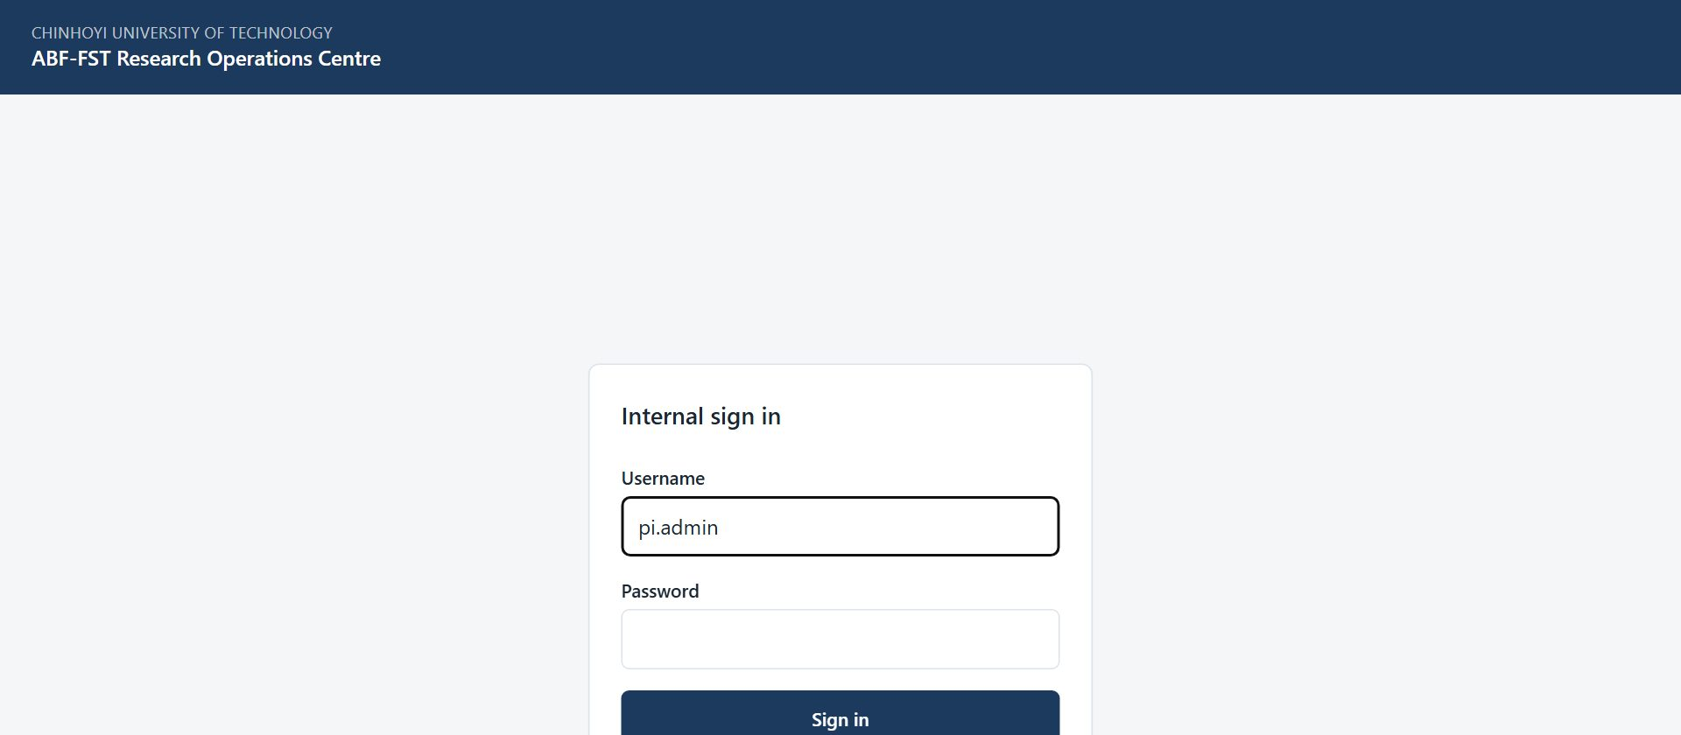
Figure 1. The sign-in screen for all internal staff.
- You arrive on your start screen: KII/Doc Dashboard. The bar across the top lists only the screens your role (KII RA) can open.

Accounts
There is no self-registration. The PI / System Admin creates every account and sets its role. Ask the PI if you need an account, a different role, or a password reset.

Finding your way around
- The top bar shows your username and role, and the screens you can use. It is not a full menu with some items greyed out: anything absent is simply not part of your role.
- Most screens have a ← Back to … link at the top that returns you to the screen you came from.
- Registers show 20 rows per page to begin with. At the foot of the list, Show lets you choose 10, 20, 50, 100 or 200 rows per page (the portal remembers your choice), and the page numbers, Previous, Next and the double arrows take you to any page. The Search box above the list narrows it.
- Change password (top right) lets you set a new password at any time. Choose a long password you do not use anywhere else.
- Sign out (top right) ends your session. Always sign out on a shared or public computer.
- If you are inactive for a while you may be asked to sign in again. This protects research data on unattended devices.

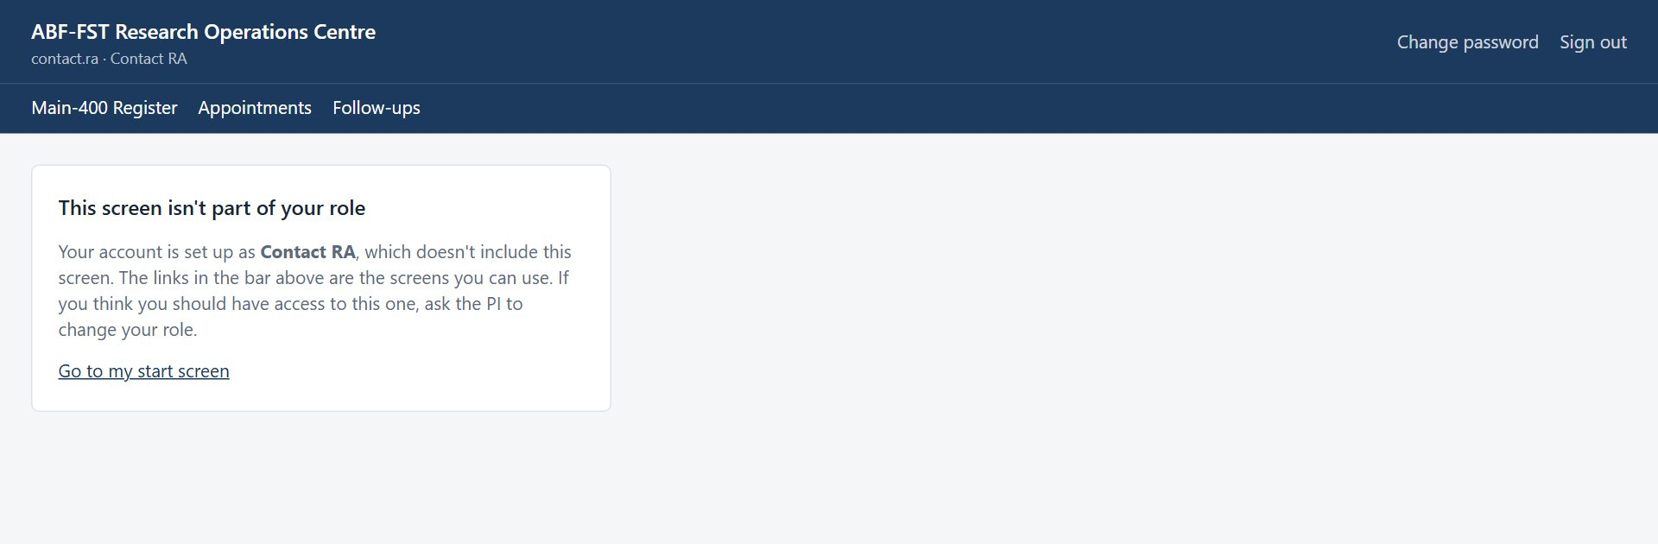
Figure 2. Opening a screen outside your role (for example from an old bookmark) shows this card instead of the screen.

Your screens
Screen | What you use it for
KII/Doc Dashboard | KIIs completed against the target of 60; KIIs by status.
Form PDFs | Completed KII Guide forms.
KII Register | All KII records; create and manage.

Changing your password
- Select Change password in the top right corner.
- Enter your Current password, then the New password twice, and select Change password.
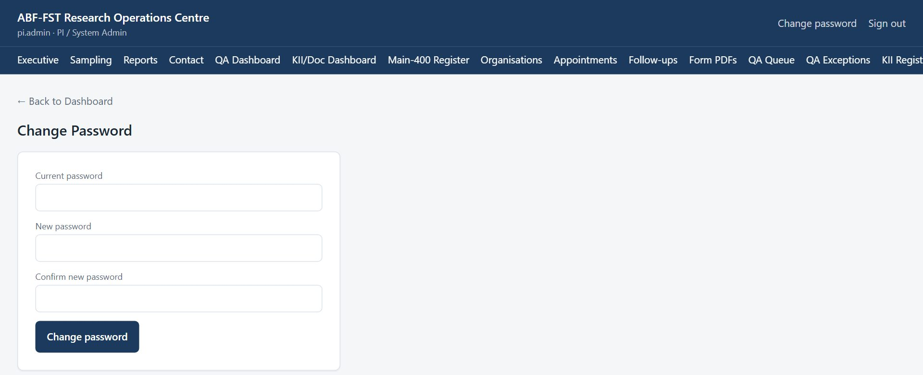
Figure 3. Change Password screen.
- Use the new password next time you sign in. If you have forgotten your password, ask the PI to reset it.

3. Your routine
A suggested rhythm. Adjust it to the Field Coordinator's plan.
When | What to do
Weekly planning | KII Register filtered mentally by status: PROSPECT and INVITED need contact; SCHEDULED need preparation.
Before each interview | Open the KII record's Interview sheet (once the coordinator has locked the profile): the public facts to confirm and the gaps to ask. Prepare the KII Guide.
At the interview | Record participation consent, and recording consent if recording.
After each interview | Mark COMPLETED (tick Recording made only if recorded); complete the KII Guide in KoboToolbox (Continue this interview opens it with the KII ID filled in, once consent is recorded); update transcript and coding as work progresses.

4. Step-by-step tasks

4.1 Reading the KII/Doc Dashboard
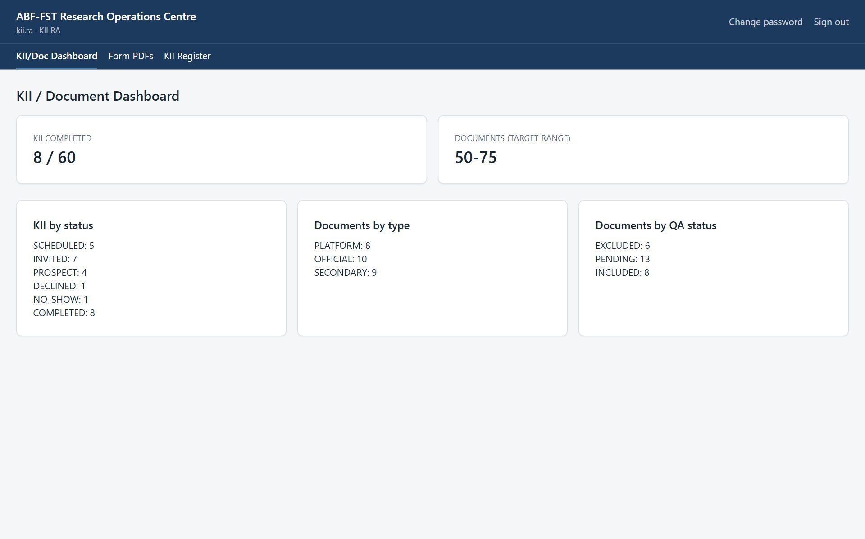
Figure 4. KII / Document Dashboard.

4.2 Creating a KII record
- Select KII Register → New KII record.
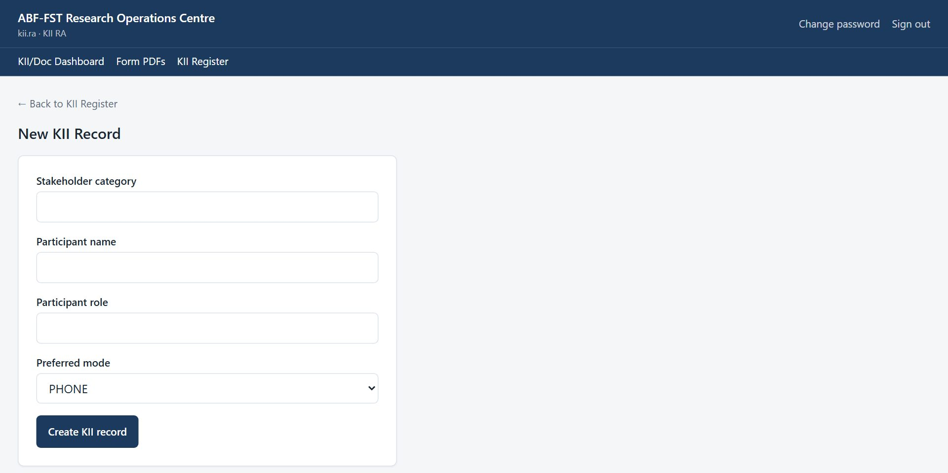
Figure 5. New KII Record.
- Enter Stakeholder category, Participant name, Participant role and Preferred mode, then select Create KII record. The KII ID (e.g. KII-0026) is generated.

4.3 Correcting a KII record's details
For a mistyped name, role or category, a contact detail, or anything else under Record details -- found after the record was created.
- On the KII record, under Record details, correct Participant name, Participant role, Stakeholder category, Phone, WhatsApp number, Email, Preferred mode, Interview date, Duration or Field notes.
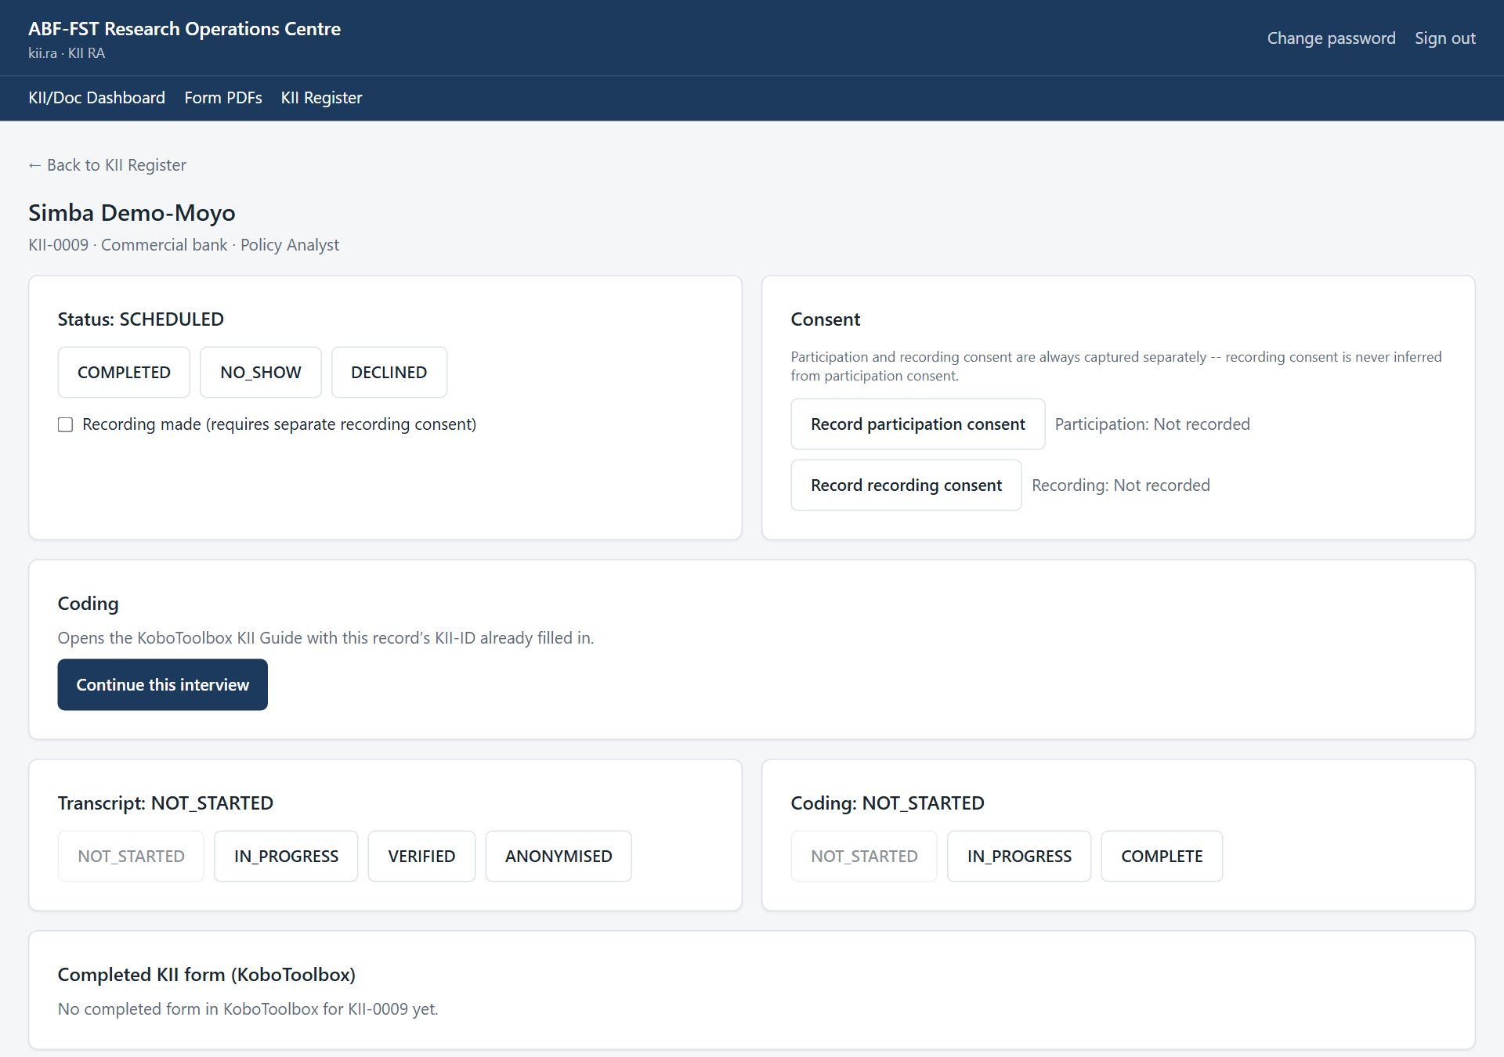
Figure 6. Record details: everything except status, transcript and coding progress.
- Select Save details.

Status, transcript and coding have their own controls
This form never changes Status, Transcript or Coding progress, even though they're part of the same record -- those only move through their own validated buttons below (status transitions, consent, transcript/coding progress), each of which is audited.

4.4 Taking a KII from invitation to coded transcript
- In KII Register, select Manage on the record.
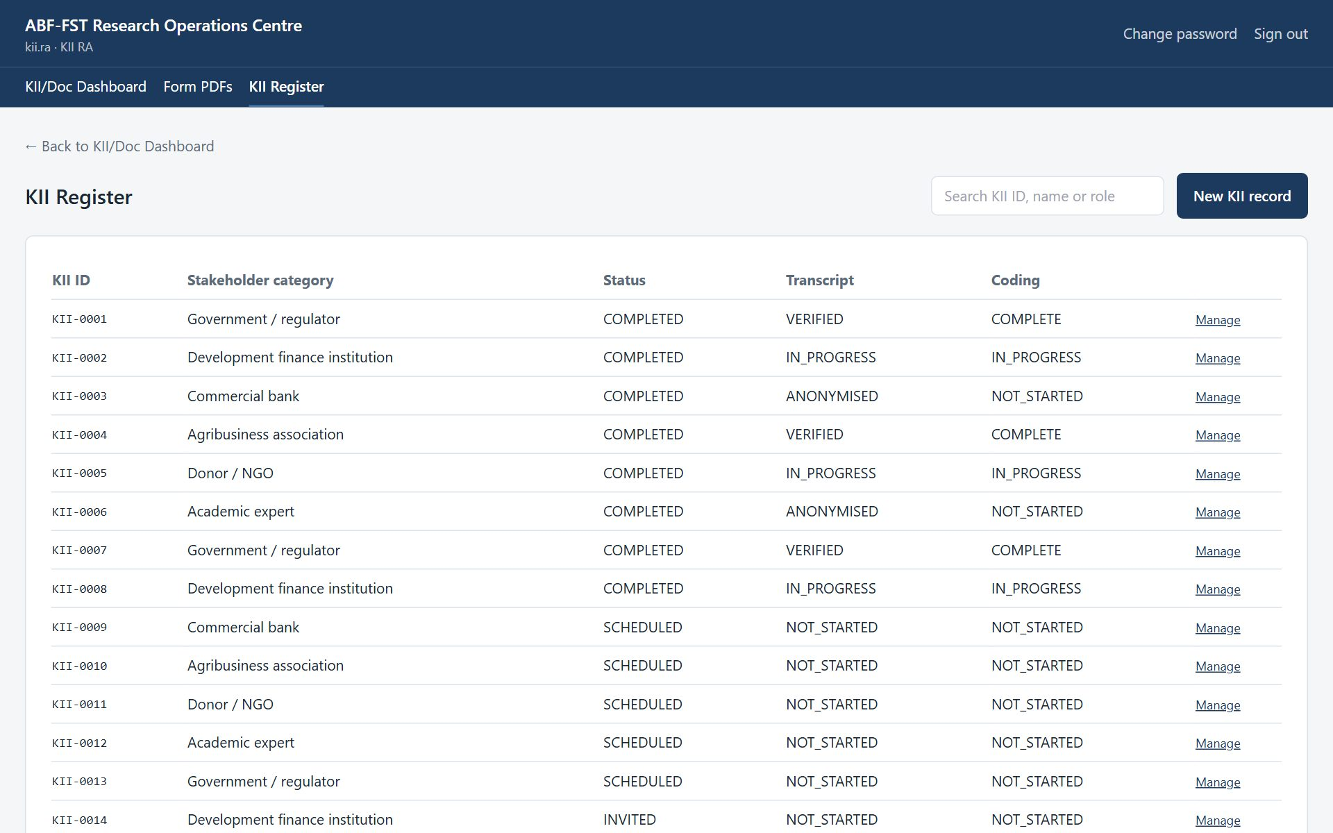
Figure 7. KII Register.
- Move the Status as things happen: PROSPECT → INVITED → SCHEDULED → COMPLETED, or DECLINED / NO_SHOW. Only valid next statuses are shown; NO_SHOW can be rescheduled.
Figure 8. KII record: status, consent, transcript and coding.
- Before the interview starts, select Record participation consent. If the interview will be recorded, also select Record recording consent — the two are always separate.
- When marking COMPLETED, tick Recording made only if a recording exists. The portal refuses a recorded completion without recording consent.
- Advance Transcript (NOT_STARTED → IN_PROGRESS → VERIFIED → ANONYMISED) and Coding (NOT_STARTED → IN_PROGRESS → COMPLETE) as the work progresses.
- Complete the KII Guide form in KoboToolbox using the KII ID (see the next section). The Completed KII form (KoboToolbox) panel then links to its PDF, and at the next sync (within 15 minutes, or at once with Sync now on Form PDFs) the portal sets Coding to COMPLETE for you.

4.5 Opening the KII Guide with the KII ID filled in
- Record participation consent first. Until you do, the Coding panel says “Record participation consent first” and the interview link is withheld.
Figure 9. Before consent: no interview link.
- Once consent is recorded, the panel offers Continue this interview. Select it: the KoboToolbox KII Guide opens in a new tab with the KII ID already entered, so it can never be mistyped and the completed form always matches this record.
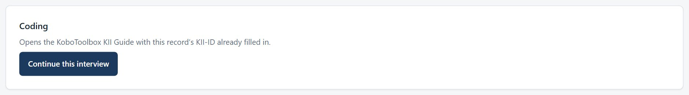
Figure 10. After consent: Continue this interview.
- Complete the interview in the form as usual.

What the link carries
Only the KII ID and your own username. It never carries the participant's name, role or organisation, so nothing identifying is left in a web address or your browser history.

4.6 Sending the informant their own link (self-service)
Some informants would rather complete the interview alone, in their own time, than do a live call. The Invite panel on the record sends them a personal link they can open unsupervised -- the same idea as a Main-400 invitation, but for a KII.
- Under Record details, enter the informant's Phone, WhatsApp number or Email and select Save details. At least one is needed to send a link.
Figure 11. Record details: phone, WhatsApp number and email.
- Under Invite (self-service link), choose a Channel and select Send link. The personal link, its manual code and ready-made WhatsApp/SMS/email messages appear -- the same panel used for Main-400 invitations.
- Send it on the channel you chose: Send via WhatsApp, Send by SMS, Email from study address (if email is set up) or Open in email app, or Copy message for anything else.

The informant opens the link, reads a short Key Informant Interview information sheet, agrees to take part, and is taken straight to the KII Guide with the KII ID already filled in -- no account, no app, nothing identifying in the link. Once they consent, Record participation consent on this page updates to GIVEN on its own, and Continue this interview above becomes available too, exactly as if an RA had recorded it.
Sending a new link replaces the old one
Issuing another link for the same informant (for example after 14 days, or if they ask for a resend) immediately retires the previous one -- only one link is ever live per KII record, the same rule as Main-400 invitations.
Still a self-administered interview, not a recorded one
Nobody is present on a self-service session, so there is nothing to record and no recording consent is asked for on this path. If the informant would rather be interviewed live and recorded, arrange that by phone, WhatsApp or video call instead, and record both consents the usual way (above).

4.7 Verifying a profile with the respondent, and reconciling it afterwards
Once a profile is locked, the interview has two duties: confirm what is public, and ask what is not. The Interview sheet is where you do both, and where the results are reconciled afterwards. It appears on the locked profile on the case page (coordinator and PI), on the case page of an assisted interview (Contact RA) and on the KII record (KII RA). Nothing here changes the public value.
- Open the case (or the KII record) and find Interview sheet: confirm what is public, ask what is not. Each row is one fact and is marked Confirm, Confirm, then probe or Ask.
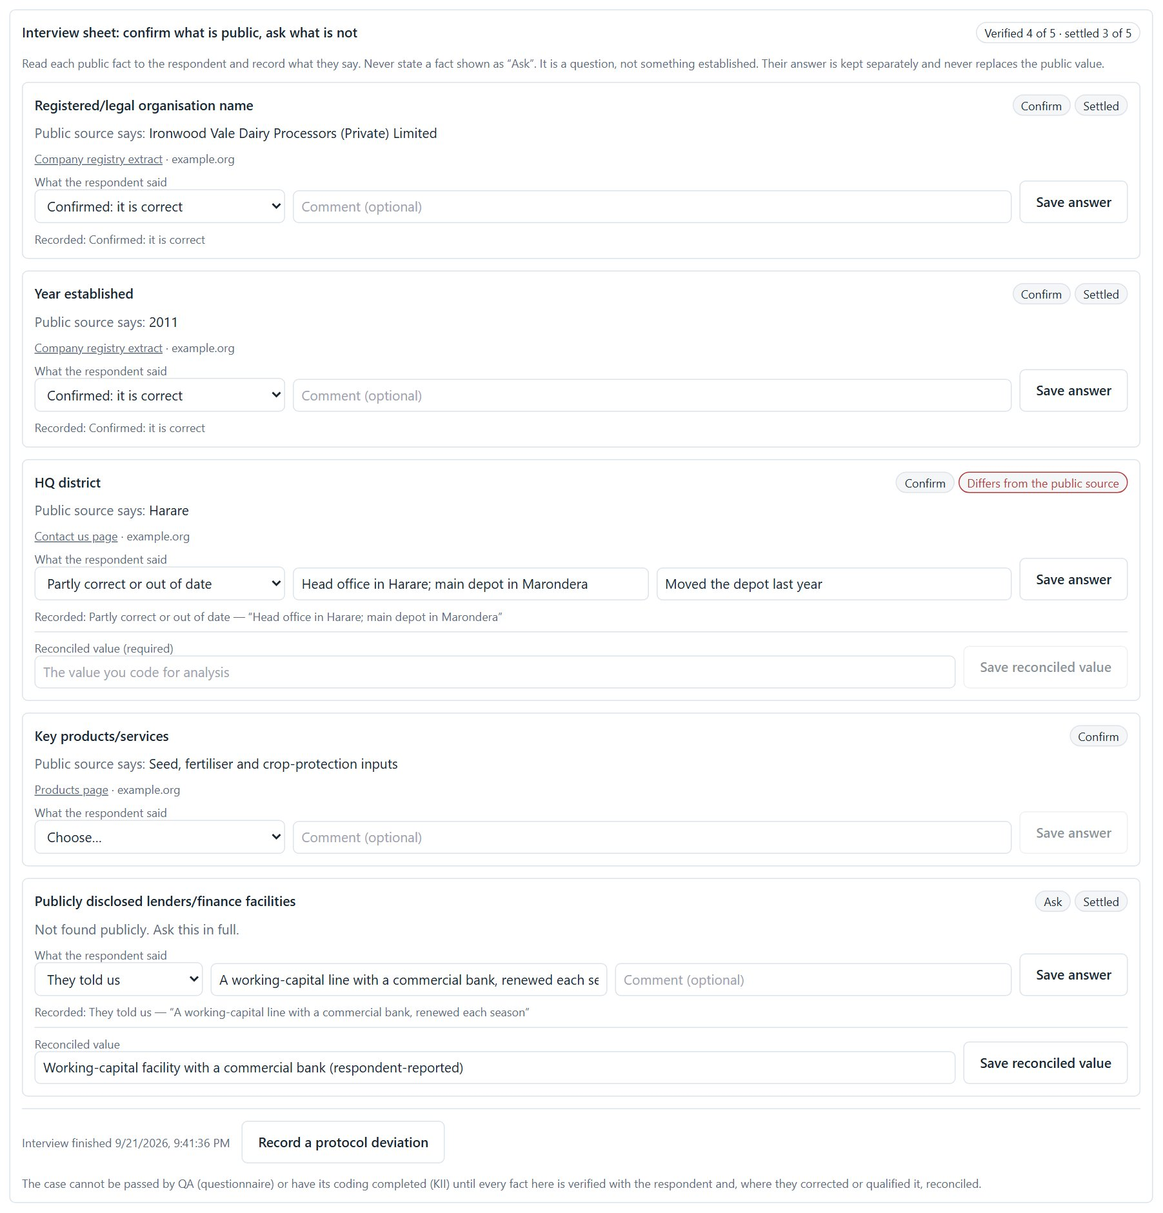
Figure 12. The interview sheet: confirm what is public, ask what is not.
- For a Confirm row, read the public fact to the respondent, with its source shown under it, and ask whether it is right. Never state a fact on an Ask row: it is a question, not something established. A weak source's value is deliberately hidden.
- In What the respondent said, choose the answer: confirmed, corrected, partly correct or out of date, does not know, prefers not to say, or does not apply. For a correction, type Their answer. Add a comment if useful, then select Save answer.
- For an Ask row, choose They told us and type what they said, or record that they do not know or would rather not say.
- When the interview is over, select Interview finished.

After the interview: reconcile (coordinator and PI)
- Rows where the respondent corrected or qualified a fact show Differs from the public source. Under Reconciled value (required), type the value you code for analysis, then select Save reconciled value. A plain confirmation or “does not apply” needs no reconciled value.
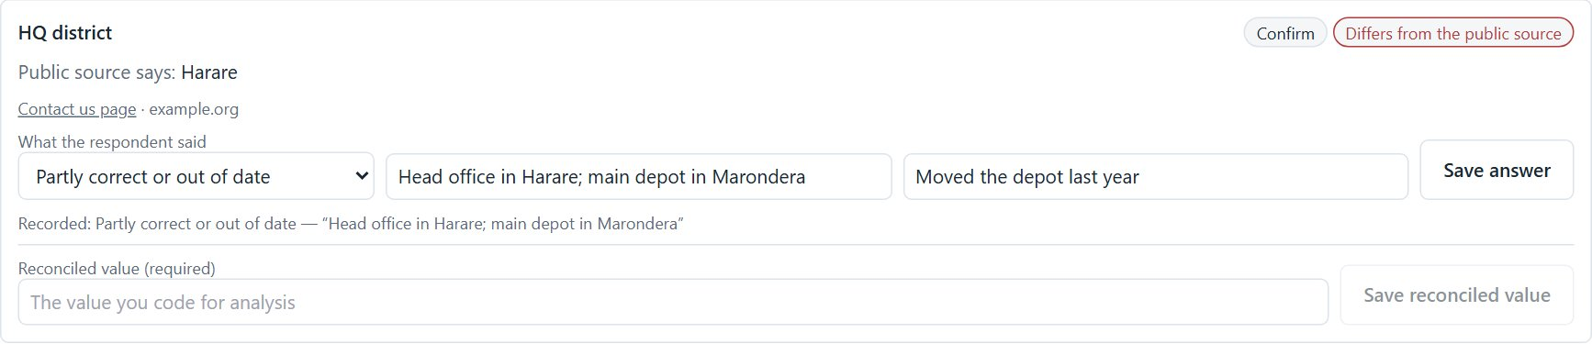
Figure 13. Reconciling a corrected fact: the three values stay separate.
- The status at the top of the sheet counts up: “Verified 6 of 8 · settled 5 of 8”, then Reconciled when every fact is settled. At that moment the portal also sends the whole profile (what was known, what the respondent said, the reconciled value, and the sources) to KoboToolbox, in the ABF-FST PROIT Interview Profile form, and the status shows Saved to KoboToolbox.
- If reconciliation truly cannot be finished (for example the respondent cannot be reached again), select Record a protocol deviation and give the reason. The case is released but stays flagged.

A case is not complete until its profile is reconciled
QA cannot Accept a questionnaire, and a KII's coding cannot become COMPLETE, while a locked profile still has facts not verified with the respondent or not reconciled. The message says how many are outstanding. Re-query and Reject are never blocked.
This applies only to a case that has a locked profile with facts on it. A case with no profile is not held up.

4.8 Downloading or emailing completed forms (Form PDFs)
- Select Form PDFs. You see the completed KII Guide forms from KoboToolbox, newest first.
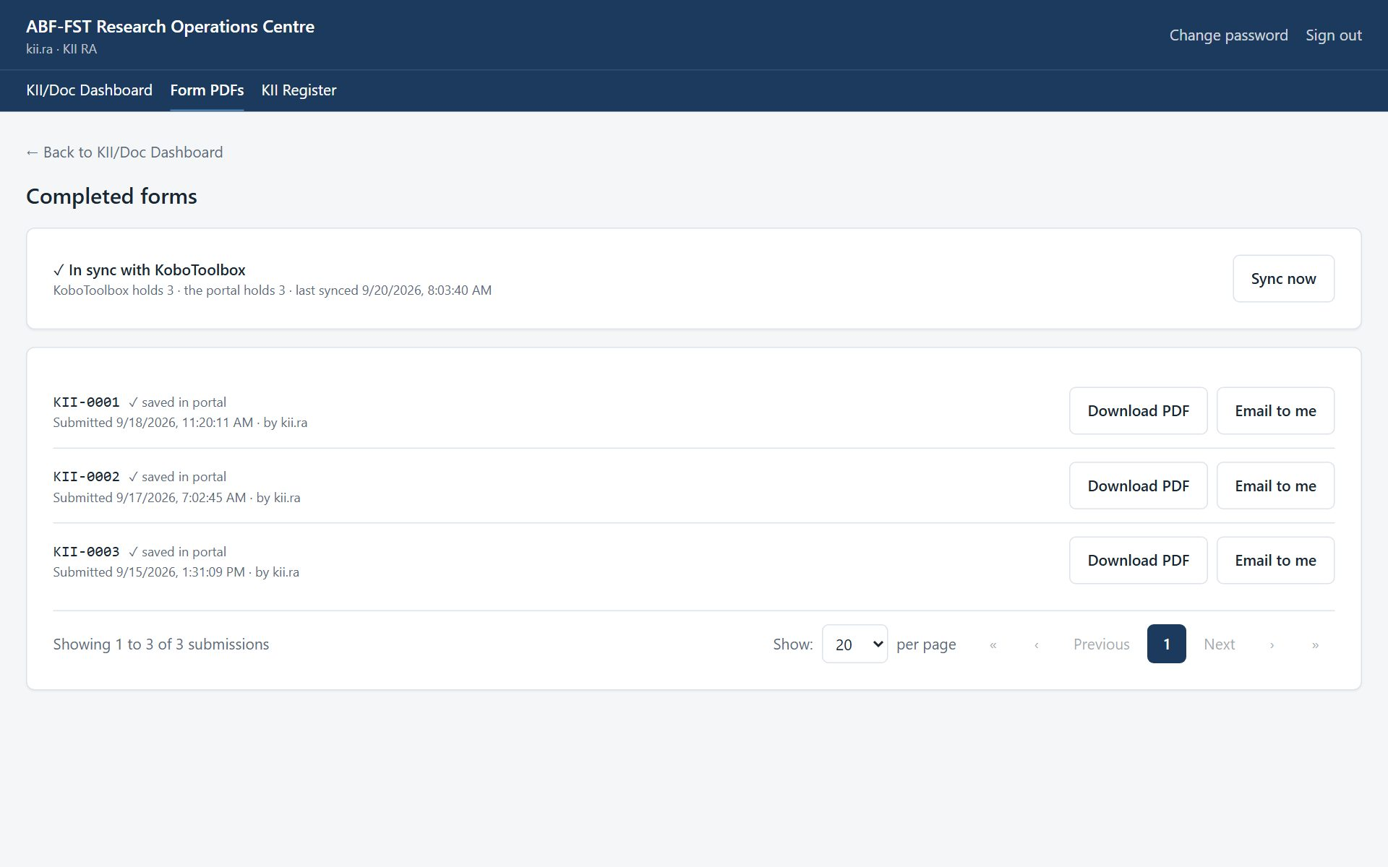
Figure 14. Completed KII Guide forms, with the sync status.
- Select Download PDF to save a readable copy: sections, questions, the chosen answers as words (not codes) and repeated groups.
- Select Email to me to send the PDF to the email address on your account.

At the top of the page, a sync panel shows whether the portal holds the same forms as KoboToolbox, for example “✓ In sync with KoboToolbox — KoboToolbox holds 12 · the portal holds 12”. Each row also says “✓ saved in portal” once the portal has an identical copy. If the panel says “Not in sync”, select Sync now (read-only roles see the panel but not the button); it takes a few seconds.
The same PDF is available from the record itself: the case page (questionnaire), the KII page (KII Guide) or the document page (coding form).
How the sync works
The portal keeps its own copy of the questionnaire, KII Guide and Document Analysis Tool, and refreshes it every 15 minutes and whenever someone selects Sync now. A submission edited in KoboToolbox is updated here; one deleted in KoboToolbox is flagged as removed. You never need to sync before downloading a PDF: the PDF is always read from KoboToolbox at that moment.

4.9 Consent in interviews
- Read or summarise the information sheet and ask for agreement before the first question.
- Ask separately whether the interview may be recorded. If they say no, take notes only.
- Record each decision on the KII record straight away with the matching button.
- If they later ask to stop or withdraw, stop, and tell the PI the same day.

5. Rules you must follow
- Keep recordings and transcripts only in the study's approved storage.
- Anonymise transcripts before they are shared for coding beyond the core team.
- Treat everything in the portal as confidential research data. Do not screenshot, copy, print or forward names, phone numbers, email addresses or answers except as your role requires.
- Never share your username or password, and never sign in for someone else.
- Use the respondent's contact details only to manage their participation in this study (invitations, reminders, appointments).
- Never tell a respondent, lender or anyone else that answers affect financing. The study generates no score, rating or financing decision.
- If a respondent asks to withdraw, stop contacting them and tell the Field Coordinator or PI the same day so the withdrawal is recorded.
- Report a lost device, a suspected account compromise, or data sent to the wrong person to the PI immediately.

6. Troubleshooting
Situation | Likely cause | What to do
COMPLETED with recording is refused | Recording consent not recorded. | Record recording consent first, or untick Recording made.
No PDF on the KII record | The KII Guide has not been submitted with this KII ID. | Check the KII ID in the KoboToolbox form.
"This screen isn't part of your role" | The screen belongs to another role (often an old bookmark or shared link). | Select Go to my start screen. If you need that screen, ask the PI about your role.
"Too many sign-in attempts from this network" | Sign-in is rate-limited per network; an office shares one address. | Wait a minute and try again. A wrong password says so explicitly.
A register shows fewer rows than expected | Registers show 20 rows per page to begin with; a Contact RA sees only assigned cases. | Choose more rows under Show at the foot of the list, use the page numbers or Next, or search. Ask the Field Coordinator to assign the case.
A button is greyed out | A required step is missing (a note, an authenticity decision, a selection). | Read the message beside the button; complete the missing step first.
"KoboToolbox couldn't be reached" | KoboToolbox is slow or the connection token has changed. | Try again in a few minutes. If it persists, tell the PI.
Form PDFs says "Not in sync with KoboToolbox yet" | The counts differ: a form was submitted or changed in KoboToolbox since the last sync (it runs every 15 minutes). | Select Sync now. If it still differs, or says it couldn't reach KoboToolbox, try again in a few minutes and tell the PI if it persists.
A document says "Already submitted" and its answers are locked | Its coding was already sent to KoboToolbox; changing it here would not change that record. | To redo the coding, delete that record in KoboToolbox, then select Sync now on Form PDFs. The document unlocks.
A page keeps loading | A slow or dropped connection. | Refresh the page. Your saved work is not lost; unsaved typing may be.
A file upload seems stuck | A large file on a slow connection takes time; the bar shows how much has been sent. | Wait for Saving… and the file name. If it fails, try again or upload a smaller version.

7. Quick reference
Sign in | https://research.agribizframework.com/admin/login
You start on | KII/Doc Dashboard
Target | 60 completed KIIs
Status order | PROSPECT → INVITED → SCHEDULED → COMPLETED
Transcript | NOT_STARTED → IN_PROGRESS → VERIFIED → ANONYMISED
Coding | NOT_STARTED → IN_PROGRESS → COMPLETE
Help | Field Coordinator; PI: Happyson Saina, 0773943709, abffst.research@gmail.com

8. Every screen and button for your role
This section lists every screen you can open as KII RA, and for each control: what it does and when to use it, why it exists (the rule behind it), and what you will see next. It is the same material as the Screen and Button Reference, cut down to your role.
Reading the tables
Control is the label you see on screen. Why it exists explains the rule or risk behind it; if a button is greyed out, this column usually says why. A control that needs a note or a confirmation says so.

8.1 Sign in
Who can open it: every role. Where: /admin/login
Where every staff member starts. Staff accounts are created by the PI; there is no self-registration.
Control | What it does and when to use it | Why it exists | What happens next
Username | Type the username the PI gave you. | Every action in the portal is recorded against a named person, so accounts are never shared. | Nothing yet; you also need the password.
Password | Type your password. The characters are hidden. | Passwords are never shown or emailed; the PI can reset yours but cannot read it. | Nothing yet; select Sign in.
Sign in | Checks your username and password and opens your start screen (the first screen your role uses). | Repeated wrong attempts from one network are refused for a minute, to stop password guessing. | Your start screen opens. A wrong password says so. “Too many sign-in attempts” means wait a minute.

8.2 The header and menu bar (every screen)
Who can open it: every role. Where: (top of every screen)
Shown at the top of every signed-in screen. The menu bar lists only the screens your role may open.
Control | What it does and when to use it | Why it exists | What happens next
Menu bar (Executive, Sampling, … Audit) | Opens a screen. The current screen is underlined. | The list is built by the server from your role, so you never see a screen that would refuse you. | The screen opens. A screen not in your list shows “This screen isn't part of your role”.
Change password | Opens the Change Password screen. | You should change the first password you were given, and any password you think someone saw. | The Change Password screen opens.
Sign out | Ends your session on this device. | Protects the data if the device is shared or lost. Always sign out on a shared device. | Your session on this device ends and you return to the Sign in screen.
← Back to … (top left) | Returns to the parent screen (for example from a case to the register). | A consistent way back that does not lose your place in the menu. | The parent screen opens.
Go to my start screen | Appears on the “This screen isn't part of your role” page and takes you to your own start screen. | An old bookmark or shared link may point at a screen that belongs to another role; this gets you out safely. | Your start screen opens.

8.3 Change Password
Who can open it: every role. Where: /admin/account
Change your own password.
Control | What it does and when to use it | Why it exists | What happens next
Current password | Type the password you use now. | Proves it is really you before a change, in case a signed-in device was left open. | Nothing yet.
New password | Type the new password. | It must be long enough, not a common password, not all digits and not similar to your username or name; the screen says which rule failed. | Nothing yet.
Confirm new password | Type the new password again. | Catches a typing slip that would lock you out. | Nothing yet.
Change password | Saves the new password. | Your old password stops working straight away, and other people (including the PI) never see your new one. | A confirmation appears. Use the new password next time.

8.4 KII / Document Dashboard
Who can open it: PI / System Admin, Field / Digital Coordinator, Data Analyst, Supervisor, KII RA, Documentary RA. Where: /admin/dashboard/kii-documents
Progress of the two qualitative strands against their targets (about 60 KIIs, 50–75 documents).
Control | What it does and when to use it | Why it exists | What happens next
KII by status | Counts KII records at each stage (prospect, invited, scheduled, completed, declined, no-show). | Shows how far the interview target has come. | Read only.
Documents by type / by QA status | Counts documents by type (official, secondary, platform) and by decision (pending, included, excluded). | Only included documents count towards the corpus target. | Read only.

8.5 Interview sheet (verifying a locked profile)
Who can open it: PI / System Admin, Field / Digital Coordinator, Contact RA, KII RA, Supervisor. Where: (on the case page, and on the KII record)
The locked pre-interview profile as the interviewer uses it: confirm what is public, ask what is not, record what the respondent says, and after the interview reconcile it. The coordinator and PI see it inside the PROIT panel; a Contact RA sees it on a case assigned to them; a KII RA on a KII record.
Control | What it does and when to use it | Why it exists | What happens next
Status (Verified x of y · settled x of y / Reconciled) | Counts how many facts have been verified with the respondent and how many are settled. It reads Reconciled when all are. | A case is not complete until every fact is verified and, where corrected, reconciled. | Read only. It updates as answers are saved.
Confirm / Confirm, then probe / Ask (label on each row) | Tells you what to do with that row: confirm a public fact, confirm it and probe (sources disagree), or ask the question in full because nothing reliable is public. | Asking only what is not public reduces the burden on the respondent. | Read only.
Public source says (with source links) | Shows the public fact and where it came from. A weak source's value is hidden and the row says to ask in full. | A weak or uncorroborated fact must never be put to a respondent as if it were established. | Read only. Select a source to open it.
What the respondent said | Record the answer: confirmed, corrected, partly correct or out of date, does not know, prefers not to say, or does not apply. For a gap, “They told us”. | The respondent's answer is kept separately from the public value and never replaces it; that separation is what lets the analysis compare the two. | Nothing is saved until Save answer.
Their answer / Comment | Type what the respondent said when they corrected or supplied a value, and any comment. | The exact answer is the research data; the comment explains it. | Kept with the row.
Save answer | Saves the answer for that fact. | Each answer is recorded as it is given, so nothing depends on memory after the interview. | The status updates; “Recorded: …” appears under the row. A correction shows “Differs from the public source”.
Differs from the public source (label) | Marks a fact the respondent corrected or qualified. | Contradictions between public sources and respondents are findings, not errors to hide. | Read only. The coordinator reconciles it.
Interview finished | Records that the interview and its verification are over, so reconciliation can begin. | Separates what was said in the interview from the researcher's later coding. | It shows the time it was recorded.

8.6 KII Register
Who can open it: PI / System Admin, Field / Digital Coordinator, KII RA, Supervisor. Where: /admin/kii
All Key Informant Interview records. Each record identifies a real person, so nothing here leaves the study team.
Control | What it does and when to use it | Why it exists | What happens next
New KII record | Opens the form to create a KII record. | Each interview gets its own record and KII ID from the start of contact. | The New KII Record screen opens.
Search KII ID, name or role | Filters the list as you type. | Finding one participant among dozens. | Only matching records are listed.
Manage | Opens the KII record. | All work on an interview happens on its own record. | The KII record opens.
Show / page numbers | Choose rows per page and move between pages. | As on every register. | The list redraws.

8.7 New KII Record
Who can open it: PI / System Admin, Field / Digital Coordinator, KII RA. Where: /admin/kii/new
Starts the record for one interview.
Control | What it does and when to use it | Why it exists | What happens next
Stakeholder category, Participant name, Participant role, Preferred mode | Say who the participant is and how they prefer to be interviewed. | The category places the interview in the KII design; the name and role are needed to arrange it. They stay in the portal and are never put into web addresses. | Nothing is saved until you select Create KII record.
Create KII record | Saves the record. | The KII ID (for example KII-0026) is generated by the system so it is never typed or reused. | The record opens at its starting status, with no consent recorded yet.

8.8 KII record
Who can open it: PI / System Admin, Field / Digital Coordinator, KII RA, Supervisor. Where: /admin/kii/{id}
The whole life of one interview: status, consent, the interview itself, transcript and coding.
Control | What it does and when to use it | Why it exists | What happens next
Status buttons (INVITED, SCHEDULED, COMPLETED, DECLINED, NO_SHOW) | Move the interview to the next status as things happen. Only valid next statuses are shown: a prospect can be invited or decline; an invited person scheduled or decline; a scheduled interview completed, no-show or decline; a no-show can be rescheduled. | A status should only follow what really happened, and COMPLETED, DECLINED are final. | The status changes and is audited. A final status shows no more buttons.
Recording made (tick box, when marking COMPLETED) | Tick it only if the interview was audio-recorded. | A recorded interview needs the participant's separate recording consent; the portal refuses to complete it as recorded without that. | If recording consent is missing you are told, and the status does not change.
Record participation consent | Records that the participant agreed to take part, after you read or summarised the information sheet. | Nobody is interviewed without consent. The interview link stays hidden until this is recorded. | The consent is recorded (with the information sheet version). Continue this interview appears.
Record recording consent | Records that the participant agreed to be audio-recorded. | Recording consent is always a separate decision; it is never assumed from taking part. | Recording consent is recorded and a recorded interview can be completed.
Continue this interview | Opens the KoboToolbox KII Guide in a new tab with this record's KII ID already filled in. | So the completed form always matches this record and the ID can never be mistyped. Only the ID and your username are sent, never the participant's name. | The KoboToolbox form opens. When submitted, the completed form appears under Completed KII form.
Transcript status (NOT_STARTED, IN_PROGRESS, VERIFIED, ANONYMISED) | Record how far the transcript has got. | A transcript must be verified and anonymised before it can be analysed or quoted. | The status changes and cannot go backwards.
Coding status (NOT_STARTED, IN_PROGRESS, COMPLETE) | Record how far the coding has got. It moves to COMPLETE by itself when the completed KII Guide is synced for this KII ID. | Shows what has and has not been analysed. If the interview had a locked pre-interview profile, COMPLETE is refused until it is reconciled; a synced KII Guide then completes it at the next sync. | The status changes and cannot go backwards. If the profile is not reconciled you are told what is outstanding.
Completed KII form → Download PDF | Downloads the completed KII Guide for this record as a readable PDF. | A readable copy without opening KoboToolbox. | A PDF downloads; the download is audited.

8.9 Completed forms (Form PDFs)
Who can open it: PI / System Admin, Field / Digital Coordinator, QUAN/Kobo QA RA, KII RA, Documentary RA, Supervisor. Where: /admin/submissions
The completed KoboToolbox forms for your role (the questionnaire, the KII Guide or the Document Analysis Tool; the PI, coordinator and supervisor can switch between all three).
Control | What it does and when to use it | Why it exists | What happens next
Sync panel: “In sync with KoboToolbox” | Shows how many submissions KoboToolbox holds and how many the portal holds, and when they were last matched. | The portal keeps its own copy of the completed forms. If the two numbers differ, the portal is behind. | Read only. “Not in sync” means press Sync now.
Sync now | Pulls that form from KoboToolbox now and updates the portal's copy. | The automatic sync runs every 15 minutes; this brings it up to date immediately. It also notices edits and deletions made in KoboToolbox. | The counts refresh. A KII record's coding can move to COMPLETE; a document whose submission was deleted in KoboToolbox unlocks.
✓ saved in portal (on each row) | Says the portal holds an identical copy of that submission. | Proof, row by row, that nothing was lost or changed between KoboToolbox and the portal. | Read only. It is missing until the next sync for a new or edited row.
Download PDF | Downloads that completed form as a readable PDF (sections, questions, answers as words). | A readable copy for records, meetings and checking. | A PDF downloads; the download is audited.
Email to me | Emails that PDF to the address on your own account. | A PDF is a full research record, so it goes only to you, never to a typed-in address. | “Sent to …” (address masked). Recorded in the audit log.
Show / page numbers | Choose rows per page and move between pages. | As on every register. | The list redraws.

