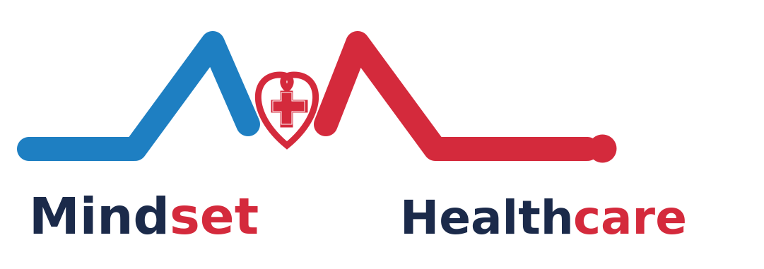
MINDSET HEALTHCARE
Go-to-Market & Operations Strategy
This section supplements the business plan and pitch deck. Figures marked as illustrative are placeholders pending validation against real pilot data, and should be reviewed alongside the financial plan before distribution to investors.

1. Organizational Roles & Management Structure
Mindset Healthcare's technology and operations function is organized around two core mandates: designing and building the technology platform, and running day-to-day service delivery through Marketing and Referral roles.

1.1 Core Functional Roles
- Marketing — brand building, campaign execution, and channel partnerships.
- Referral — managing the pipeline of patient referrals into partner hospitals and providers.

1.2 Management Functions
- Planning — roadmap and resourcing across the platform and provider network.
- Budget — cost control and spend allocation across functions.
- Forecasting — demand and revenue projections used to guide hiring and marketing spend.
- Referrers — relationship management with the clinicians and partners who refer patients.
- Clinician — clinical oversight and quality assurance across the provider network.

1.3 Departmental Structure
Beneath management sit two departments — Finance and Marketing — each with its own reporting lines:
- Finance — Accounts and POS (point-of-sale) machines, covering payment processing and reconciliation.
- Marketing — Branches, split into internal and external positioning models, covering how the brand is presented to internal stakeholders (providers, staff) versus the external market (patients, diaspora, partners).
The founder/team org chart in the source notes references named individuals and an acceptance date (18th) that should be confirmed and inserted here before this section is finalized.

2. Client Acquisition Build-Out
The client-facing (patient-side) go-to-market motion centers on a lightweight digital funnel supported by a time-boxed paid campaign, channel-specific social media strategies, and organic outreach to clinicians.

2.1 Digital Funnel
- Website with a clear value proposition and calls to action.
- Landing page with an integrated lead capture form.
- Social media presence to drive awareness and traffic into the funnel.

2.2 Launch Campaign
An initial paid social media marketing campaign is planned to run over a 4-week period.
- Duration: 4 weeks.
- Budget: ₦5,000 weekly for the 4-week period (illustrative — to be validated against actual channel costs and CAC targets).
The budget figure above is a placeholder carried over from planning notes and should be reconciled with the bottom-up financial assumptions in the business plan before this document is finalized.

2.3 Patient Application Funnel — Detailed Structure
Every channel feeds into the same underlying funnel, taking a prospective patient from first exposure through to a booked consultation and long-term retention. Eight stages give the team clear ownership and measurable drop-off points at each handoff.
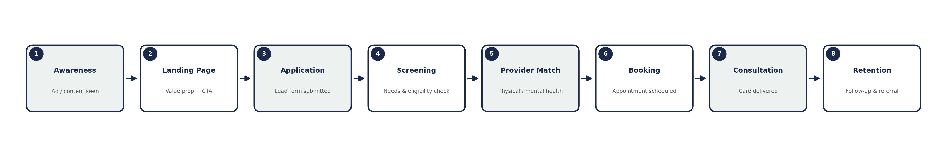
- Awareness — prospect sees a paid ad, organic post, or referral mention.
- Landing Page — clicks through to a page stating the value proposition (dual physical + mental health access) with a single clear call to action.
- Application — completes a short lead form: name, contact, location, and stated need (physical, mental health, or both).
- Screening — care coordinator reviews the submission for urgency and eligibility, and reaches out within a set response window.
- Provider Match — patient is matched to the right provider in the network, physical or mental health, based on need and location.
- Booking — appointment is scheduled directly with the matched provider or hospital.
- Consultation — care is delivered, either in person or via the platform's referral pathway into a partner hospital.
- Retention — post-visit follow-up, satisfaction check, and prompts for repeat use or referral to family/friends.
Each stage should carry a target conversion rate once pilot data is available, so drop-off can be diagnosed stage-by-stage rather than only at the top and bottom of the funnel.

2.4 Channel Strategies & Funnels
The four channels identified in planning notes split into two distinct funnels: Facebook feeds the patient-acquisition funnel above, while WhatsApp and Telegram serve as both patient-facing and support channels, and LinkedIn runs a separate B2B funnel aimed at onboarding clinicians and referrers rather than patients.

2.4.1 Facebook & Instagram — Paid Social (Patient Acquisition)
Primary paid-media channel for the launch campaign. Carries the bulk of the ₦5,000/week test budget in Section 2.2.
- Content: short video and carousel ads contrasting Mindset's dual physical + mental health offering against the fragmented status quo; patient testimonials once available.
- Targeting: urban Nigerian adults 24–45, layered with lookalike audiences once initial conversions are logged.
- Cadence: 3–4 posts/week organic, always-on ad set refreshed every 2 weeks to avoid ad fatigue.
- KPI focus: cost per lead, landing page conversion rate, cost per booked appointment.
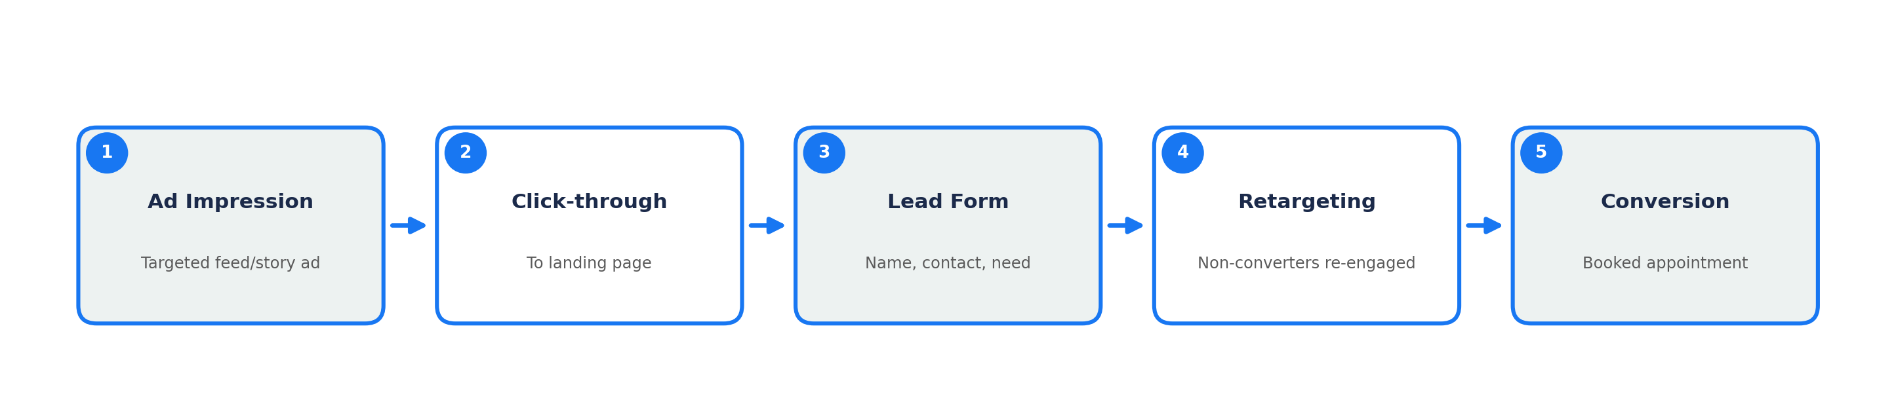

2.4.2 WhatsApp — Direct & Community (Patient Acquisition + Support)
Highest-trust channel for a Nigerian audience; used for both new-patient capture and ongoing care coordination.
- Content: WhatsApp Business catalog of services, status updates, and broadcast lists segmented by interest (physical vs. mental health).
- Community groups: seeded groups for health tips and Q&A, moderated by the care team, feeding warm leads into direct chat.
- Automation: a first-line bot/FAQ handles hours, services, and initial intake, handing off to a human care coordinator for anything beyond basic triage.
- KPI focus: chat-to-booking conversion rate, response time, repeat-contact rate.
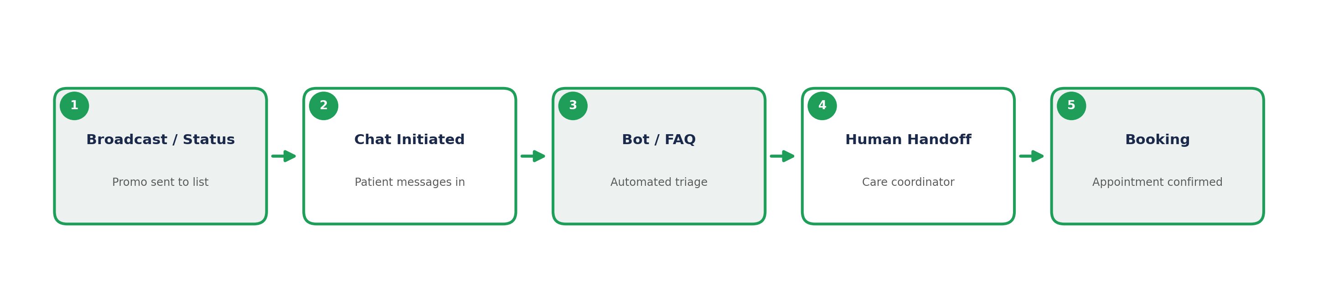

2.4.3 Telegram — Community & Nurture (Patient Acquisition)
Lower-friction, higher-privacy channel — useful for mental health content specifically, where anonymity increases willingness to engage.
- Content: a public channel for health education content and a moderated discussion group for peer support and Q&A.
- Nurture: prospects who engage in the group but aren't ready to book are moved into a periodic content drip rather than dropped.
- KPI focus: group growth rate, DM inquiry rate, booking-link click-through.
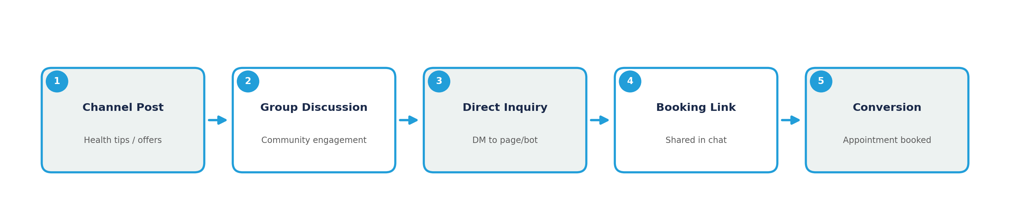

2.4.4 LinkedIn — Clinician & Referrer Outreach (B2B, Not Patient-Facing)
LinkedIn's funnel is structurally different — the target is doctors and referrers who will send patients into the network, not patients themselves.
- Content: thought-leadership posts on Nigeria's referral gap and Mindset's provider-network model, aimed at clinicians and hospital administrators.
- Outreach: targeted InMail/connection requests to clinicians in relevant specialties and geographies, followed by a discovery call.
- Groups: participation in existing clinician LinkedIn groups referenced in planning notes, to build credibility before direct outreach.
- KPI focus: discovery calls booked, referrers onboarded, referral volume per onboarded clinician.
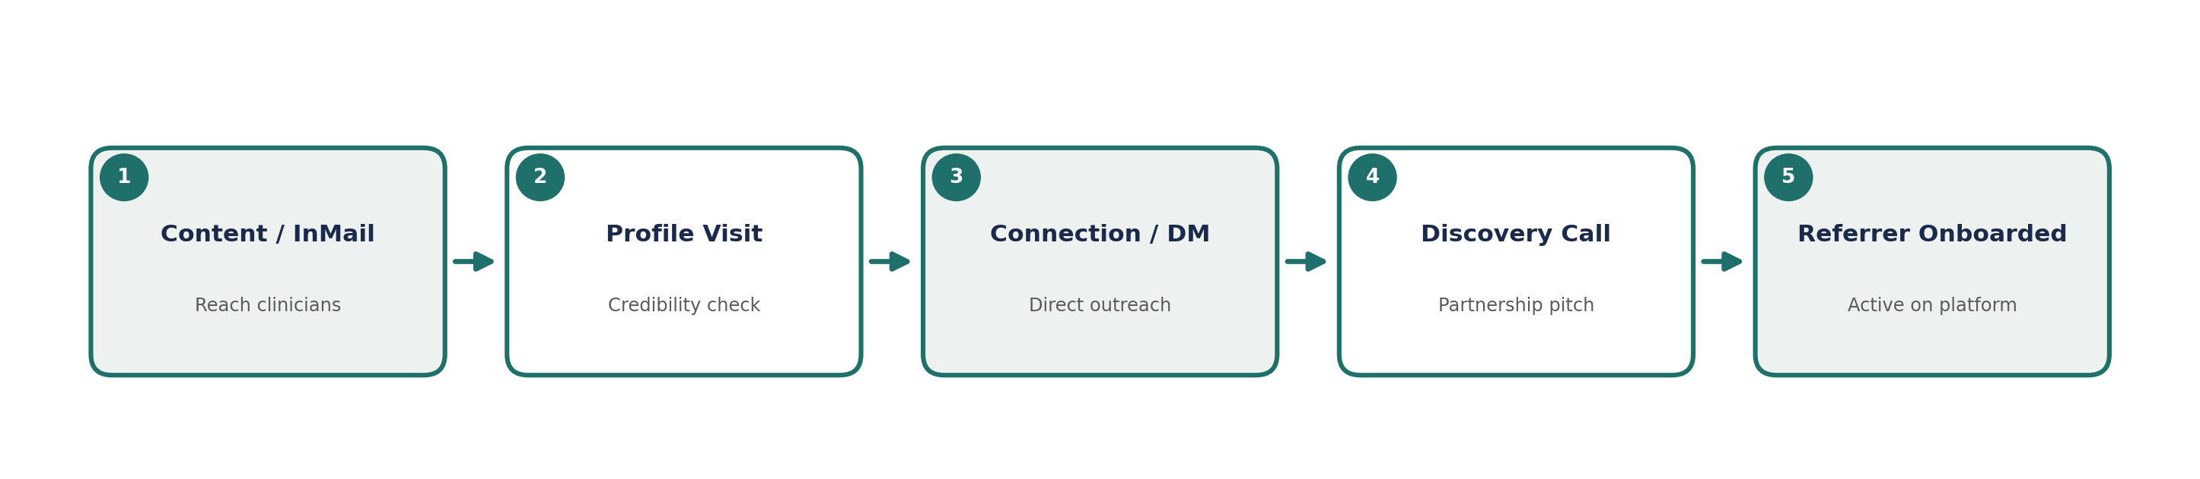
LinkedIn, Telegram, and WhatsApp groups were flagged in planning notes as outreach channels for doctors specifically — see Section 2.4.4 for that funnel, which is separate from the patient-facing use of WhatsApp and Telegram in 2.4.2–2.4.3.

3. Hospital Partnership Strategy
On the provider side, the priority is converting hospital relationships into active use of the Mindset Healthcare platform and a reliable stream of patient referrals.

3.1 Objectives
- Get hospitals to adopt and actively use the platform.
- Get hospitals to send patient referrals and train their staff on the referral workflow.

3.2 Target List
Outreach will prioritize the top 50 hospitals in Nigeria, mapped against the procedures each performs, to ensure the provider network covers the specialties most in demand.
- Compile and prioritize the top 50 hospitals in Nigeria.
- Map each hospital's procedures and specialties to match against expected patient demand.

4. Diaspora Market Strategy
A parallel growth channel targets the Nigerian diaspora — encouraging Nigerians living abroad to use Nigerian hospitals for care, whether for themselves on visits home or for family members in-country.

4.1 Approach
- Identify and reach Nigerians in the diaspora through community and professional networks in each target market.
- Position the top 50 Nigerian hospitals and their procedures as the trusted destination network for diaspora patients.

4.2 Priority Diaspora Markets
Brazil | India | China | Philippines / Canada
These markets were flagged as priority diaspora targets in planning notes. Rationale (size of Nigerian community, remittance patterns, existing ties) should be added once available.

5. Open Items Before Finalization
- Confirm founder/team names and roles for the organizational chart (Section 1.3).
- Validate the campaign budget and CAC assumptions in Section 2.2 against real data.
- Finalize and attach the top 50 hospital list with procedures (Sections 3.2 and 4.2).
- Confirm the rationale and sizing for each priority diaspora market.

