Paper Title* (use style: paper title)
*Note: Sub-titles are not captured in Xplore and should not be used

line 1: 1st Given Name Surname
line 2: dept. name of organization
(of Affiliation)
line 3: name of organization
(of Affiliation)
line 4: City, Country
line 5: email address or ORCID
line 1: 4th Given Name Surname
line 2: dept. name of organization
(of Affiliation)
line 3: name of organization
(of Affiliation)
line 4: City, Country
line 5: email address or ORCID
line 1: 2nd Given Name Surname
line 2: dept. name of organization
(of Affiliation)
line 3: name of organization
(of Affiliation)
line 4: City, Country
line 5: email address or ORCID
line 1: 5th Given Name Surname
line 2: dept. name of organization
(of Affiliation)
line 3: name of organization
(of Affiliation)
line 4: City, Country
line 5: email address or ORCID
line 1: 3rd Given Name Surname
line 2: dept. name of organization
(of Affiliation)
line 3: name of organization
(of Affiliation)
line 4: City, Country
line 5: email address or ORCID
line 1: 6th Given Name Surname
line 2: dept. name of organization
(of Affiliation)
line 3: name of organization
(of Affiliation)
line 4: City, Country
line 5: email address or ORCID

Abstract—This electronic document is a “live” template and already defines the components of your paper [title, text, heads, etc.] in its style sheet. *CRITICAL: Do Not Use Symbols, Special Characters, Footnotes, or Math in Paper Title or Abstract. (Abstract)
Keywords—component, formatting, style, styling, insert (key words)

Introduction

Attacks and Defenses on the Diffie-Hellman Protocol
We targeted the Diffie-Hellman (DH) key exchange protocol using a Man-in-the-Middle (MITM) attack. In this scenario, the adversary (Eve) intercepts and relays messages between the communicating parties (Alice and Bob) while independently establishing separate shared keys with each. Since the basic DH protocol lacks intrinsic identity authentication, Eve can easily impersonate the legitimate parties. This allows her to decrypt, eavesdrop, and tamper with all subsequent communications without detection.
To mitigate this vulnerability, we deployed the Station-to-Station (STS) protocol. STS enhances the standard DH exchange by integrating digital signatures to establish mutual authentication. By verifying the counterparty's signature during the key exchange, Alice and Bob can confirm they are communicating with the intended entity, effectively preventing Eve from successfully executing the MITM attack.

Attacks and Defenses on the RSA Algorithm
For the RSA public-key cryptosystem, we implemented Wiener's Attack. This cryptanalytic method relies on continued fraction theory and targets RSA implementations where the private exponent d is chosen to be insecurely small to optimize decryption speed. Specifically, if d < (n ^ 1/4) / 3, the attacker can efficiently recover the private key d using only the public modulus N and exponent e through the continued fraction expansion of e/N.
The defense mechanism against Wiener's Attack focuses on eliminating its mathematical prerequisites during key generation. By enforcing strict security standards that require the private exponent to be sufficiently large (d > (n ^ 1/4) / 3), we ensure that the continued fraction expansion of e/N cannot approximate k/d accurately. This renders Wiener's Attack mathematically infeasible.

List of Completed Tasks
The research and experiments conducted in this report accomplished the following:
- Implemented the Diffie-Hellman key exchange protocol.
- Successfully executed a Man-in-the-Middle (MITM) attack against the DH protocol.
- Deployed the Station-to-Station (STS) protocol and verified its effectiveness in blocking the MITM attack.
- Implemented the RSA public-key encryption algorithm.
- Successfully executed Wiener's Attack to compromise RSA instances using weak keys.
- Implemented secure key generation standards (ensuring sufficiently large d) to successfully defend against Wiener's Attack.

Related Work
The Diffie-Hellman (DH) key exchange protocol and the RSA encryption algorithm are the core technologies of cryptography, and their security directly determines the protection capabilities of various communication systems. This section reviews the literature on the attack and defense research of the two algorithms, summarizes the core achievements of four important papers, and analyzes the similarities and differences between our method and their methods.

Diffie-Hellman Attack and Defense Methods
Lim and Lee[1] proposed a key recovery attack targeting prime order DH protocols. Its core lies in exploiting the small group vulnerability in the DH implementation. When p−1 contains small prime factors, an adversary can register a malicious public key y = βg^{x} where β has small order. When the victim uses this malicious public key to calculate the shared key, the remainder information of the private key x with respect to the order β will be leaked. An attacker can recover the complete private key x by using the Pohlig-Hellman decomposition and the Chinese Remainder Theorem. Defense mechanisms involve two key requirements: 1. Verifying the order condition (i.e., rⁿ ≡ 1 mod p); 2. Using safe primes, with the additional condition that all factors of (p−1)/(2q) are greater than q.
The DH protocol is also threatened by man-in-the-middle attacks. Diffie et al. [2] discovered that the unauthenticated DH protocol has man-in-the-middle attacks and parameter tampering vulnerabilities, allowing attackers to tamper with public key parameters to generate trivial shared keys. For this reason, they proposed the STS protocol, which combines DH key exchange with digital signatures. The STS protocol requires the signing of public key parameters and the encrypted transmission using session keys. This not only binds identity authentication to key exchange, but also requires DH parameters to be verified through a trusted certificate. This resolves MITM very well.

RSA Attack and Defense Methods
Wiener [3] demonstrated a continued fraction attack recovering RSA secret exponents d shorter than N^{0.25}. The method expands e/N to find convergents k/dg, enabling polynomial-time key recovery. The short private key RSA system is thus vulnerable to cracking.The defensive measures include: First, making d>N^0.25; The second is to increase e (for example, e>N^1.5); Thirdly, select p and q to make gcd(p-1,q-1) large enough.
The RSA padding scheme once had security risks. Bellare and Rogaway[4] pointed out that early padding schemes (such as PKCS #1 v1.5) are vulnerable to chosen-ciphertext attacks and malleability—this allows attackers to obtain decryptions of chosen ciphertexts or tamper with ciphertexts to infer plaintexts. They introduced Optimal Asymmetric Encryption Padding (OAEP), a Feistel-based transform using two hash functions. It provides semantic security and plaintext awareness in the random oracle model, and only requires one RSA operation.

Similarities and Differences
Similarities: The attack/defense methods we have chosen all inherit the core ideas of the above-mentioned papers. The principle of our Wiener attack is the same as that in the above-mentioned paper: exploiting the short private key, and the defense (d-size detection) is also consistent with the threshold logic of that paper. The STS protocol used for DH also employs the same core - combining digital signatures with DH key exchange.
Differences: For DH, our Spoofing-based MITM targets network-layer spoofing, while the paper’s attack exploits mathematical small subgroup flaws. The paper’s scheme is PKI-dependent, while our STS is simplified for experiments. For RSA, our Wiener attack focuses on experimental quantification, whereas the paper concentrates on theoretical proof. Apart from that, the paper employs a multi-dimensional strategy, but our defense only adds d-size checks.

Method

The comparison and selecting of two Diffie-Hellman attack methods

1) The comparison of attack method
Our essay choose Spoofing-based MITM and Logjam Attack that are both the attack methods to Diffie-Hellman. We make a comparison on different perspectives, like attack prerequisites, attack cost, attack timeliness.
- Comparison of Two Diffie-Hellman-Targeted MITM Attacks
Dimension | Spoofing-based MITM | Logjam MITM
Attack goal | Hi-jack traffic, steal/inject content (exploit ARP/DNS flaws) | Crypto flaws (weak DH params/export cipher suites)
Attack cost | Extremely low (if ARP spoofing succeeds) | Extremely high (512-bit: 7d×2000-3000 cores; 1024-bit: ~45M core-years)
Attack timeliness | Real-time (ms-level traffic redirection) | Post-precomp: ~70s per discrete log (median)
Demonstration Feasibility | High (2025 ARP detection research; reproducible labs [7]) | Low (needs state-level resources [5])
Real-World Harm | Cross-protocol threat; high LAN risk | 2015: 8.4% Alexa HTTPS sites; post-2016: low threat [5]

2) Attack method selection
Our research use Spoofing-based MITM to simulate，the followings are the reasons：

Attack integrity advantage
We can make a complete demonstration of Spoofing-based MITM in our experimental environment: ARP spoofing success → traffic hijacking → key forgery → data decryption → tampering & injection.(Our experiment primarily simulated key forgery and tampering & injection). In their 2025 IEEE paper, Sumanasekara S G et al. validated the effectiveness of behavioral analysis + machine learning for ARP spoofing detection[7]. They showed that ARP spoofing can be stimulated.
In contrast, it’s so difficult for us to achieve the core threat of Logjam (512-bit discrete logarithm precomputation). Adrian D et al. explicitly estimated that 1024-bit discrete logarithm precomputation need 45 million core-years, equivalent to an investment in "special-purpose hardware" and "hundreds of millions of dollars"[5]. Thus, about Logjam we can only make theoretical analysis instead of achieving an experiment.

Quantification of Observations and Value Assessment
35.Spoofing-based MITM can carry out an attack on the D-H authentication flaw through ARP/DNS/DHCP spoofing. Specifically, each of the stages is quantifiable. Conti M, Dragoni N, Lesyk V. provided a structured classification framework based on the OSI model and a multi-dimensional comparison of defense techniques [6]. They also established measurable evaluation boundaries for the experiment (detection latency, deployment overhead, compatibility impact). On the contrary, the evaluation of Logjam relies on metrics that are difficult to reproduce and measure, such as Precomputation Cost, Resource Estimation [5].

Real-world threats
Although Logjam attack can decrypt weak DH parameters, its its threat is historical and resource-intensive: it requires millions of CPU hours for precomputation and has been fully blocked since 2015. Modern browsers have implemented more restrictive policy, servers have disabled DHE_EXPORT, vulnerability had been fixed by rejecting short groups [5].
In contrast, the threat of Spoofing based MITM has cross-protocol persistence: The review indicates that variants such as SSL peeling and Evil Twin remain active in TLS 1.3 and public WiFi [6]; Continuous research in 2025 further confirms that the threat of ARP spoofing has not yet been eliminated [7].
This study selects Spoofing based MITM as the simulation object because it represents the most active, efficient and universal threat model of the DH protocol at present. It is of more practical significance for the assessment of identity authentication mechanisms than the other one.（这段可要可不要）

The comparison and selecting of two Rivest-Shamir-Adleman attack methods
This paper choose two typical RSA attack methods to compare. One is the Wiener attack implemented based on continued fractions and the other is power analysis attack based on power side-channel. It analyzes their principles, application conditions, and threat effects from multiple dimensions.

1) The comparison of attack methods
- Comparison of Two Rivest-Shamir-Adleman Attacks
Dimension | Wiener Attack | Power Side-Channel Analysis Attack
Attack goal | By taking advantage of the mathematical flaw in the small private key exponent, and through the continued fraction approximation, the complete private key (d, n) can be directly recovered, thereby enabling the decryption of encrypted data and the forgery of signatures [9][10] | By analyzing the power consumption differences, the types of modular operations can be distinguished, and the key bit information can be leaked, which helps in inferring part of the key to reduce the difficulty of cracking [8]
Attack cost | Extremely low, only requiring a general-purpose computer and public key (e, n), no dedicated hardware is needed. The software implementation cost can be negligible [9] | High, requiring specialized equipment such as oscilloscopes and power trace meters, and the need to connect to the target device on-site. The hardware and time costs are significantly higher [8]
Attack timelines | Extremely fast, the 1024-bit key attack takes approximately 0.05 seconds, and the 2048-bit key attack only requires around 0.15 seconds, enabling real-time cracking [9] | Slow, the collection and analysis of only 100 power consumption traces takes several hours to a full day, and the complete key inference cycle often lasts for several days [8]
Demonstration Feasibility | High, Wang et al. (2020) provided a complete pseudo-code [10], which can be replicated throughout the entire process using only basic languages such as Python, without the need for special experimental conditions. | Low, it relies on dedicated hardware such as PAE coprocessors [8], and the power consumption trajectory is greatly affected by the environment, making it difficult to achieve stable reproduction in the course experiments.
Real-World Harm | Significant: Some embedded devices use short private keys to enhance efficiency. Attackers can remotely crack the system by merely obtaining the public key, thus posing a wide-ranging threat [10] | 2015: 8.4% Alexa HTTPS sites; post-2016: low threat [8]

2) Attack method selection
The study selected the Wiener attack as the simulation implementation object. The main reasons for this choice include:

Attack integrity advantage
The Wiener attack has deeply exposed the mathematical weakness of the small private key exponent in RSA. The related attack algorithm has become quite mature. Wang et al. (2020) provided a complete pseudo-code in their paper [10]. The entire process can be replicated by using only a basic programming language, and it is easy to implement. However, power analysis attacks rely on dedicated hardware such as PAE coprocessors [8], and the experimental equipment for the course is difficult to meet these requirements.

Quantification of Observations and Value Assessment
The Wiener attack does not require physical side-channel data. It can be carried out at the software level using only the public key (e, n). The evaluation indicators (attack time, size of d and success rate relationship) can be precisely quantified through mathematical calculations [9]; while the evaluation of power analysis attacks relies on the correlation coefficient of power consumption trajectories, which is greatly affected by device accuracy and has poor data repeatability, and is not suitable for the experimental scenarios in the course [8].

Real-world threats
By setting the minimum threshold for the private key index d (such as d > n^(1/4)), the Wiener attack [9] can be fundamentally prevented. The defense logic is clear. In practical applications, some embedded devices choose short private keys to improve decryption efficiency. If the key generation stage is not strictly verified, there is a clear security risk, making the actual threat of the Wiener attack significantly higher than the power analysis attack that requires physical contact [10].

The comparison and selecting of two Diffie-Hellman defend methods

1) The comparison of defense methods
Our essay chooses Station-to-Station (STS) Protocol and DH-EKE (Encrypted Key Exchange) Protocol as two typical defensive methods for Diffie-Hellman. The core difference between them lies in the color the Entropy of the trust foundation and the robustness against complex number theoretic attacks.
- STS vs. DH-EKE Protocol Comparison
Dimension | Station-to-Station (STS) Protocol | DH-EKE Protocol (Refs. [4][5])
Authentication Core | Digital signature (RSA/ECC high-entropy keys) | Pre-shared password (low-entropy)
Trust Model | Strong (relies on PKI/CA/pre-deployed public keys) | Weak (relies on user-memorized short strings)
MITM Resistance | Explicit: Verify signatures to block MITM | Implicit: Encrypt DH params with passwords (data consistency [8])
Attack Surface | Narrow; security depends on key length (e.g., RSA-2048) | Complex; number-theoretic pitfalls, parameter-sensitive [10]
Offline Attack Risk | Zero (large key space, untraversable) | High (offline dictionary attacks if flawed [10])

2) Defense method selection**
In this study, the Station-to-Station (STS) protocol was ultimately chosen as the defense algorithm for implementation and evaluation instead of DH-EKE. DH-EKE proposed the defense idea based on passwords. However, after in-depth analysis in combination with the literature, we found that DH-EKE has significant disadvantages in terms of safety and assessment feasibility [13] :

Security advantage: Absolute defense of STS vs. conditional defense of EKE
The STS protocol uses digital signatures to bind the public key parameters g^a and g^b of Diffie-Hellman. As long as the private key is not leaked, attackers cannot forge a legitimate signature in polynomial time, which provides ** unconditional computational security **.
In comparison, even if the design objective of DH-EKE is resist dictionary attacks [12], Patel(1997) pointed out that there is a serious implementation vulnerability [13]. Patel proved that if we do not select the right group parameters (for example, the modulus p contains a Small prime factor), attackers can use "Small Subgroup Partition Attacks" to obtain verification information. This actually opens the backdoor for the attackers to carry out offline dictionary attacks, helping him bypass the online guessing restrictions. Considering that it is actually difficult to ensure the perfect generation of parameters, we didn’t choose this method.

Experimental evaluability
The overhead of STS protocol mainly from two generation and sign/verify of digital signature. This is a fixed complex computing operation, which is convenient for measuring Latency and CPU load, so its data has high reproducibility.
The security of the DH-EKE protocol highly depends on the password entropy value. If we used weak passwords for testing, the protocol's defense will fail due to the vulnerability of the passwords themselves. However, if strong passwords are used, their high entropy will mask the potential number theory risks that may exist in the protocol itself. The uncertainty of different experimental results caused by password selection makes it difficult for us to accurately compare the security performance differences before and after the application of the protocol.

The gap between theory and reality
Although Jablon classified EKE as a strong password protocol [12], this is more based on the derivation of an ideal mathematical model. Patel reveals that in the complex Number theory environment (number Theoretic Attacks), EKE is easy to information leakage. To avoid introducing such complex number theory variables, this study selects the STS protocol based on a mature public key system. Therefore, we can ensure complete logic and original data.

The comparison and selecting of two RSA defend methods
This study focuses on the comparison of two RSA defense techniques: the "strict detection of the size of private key exponent d" mechanism specifically designed to counter Wiener attacks, and the general side-channel defense technique "RSA key blinding (Exponent Blinding)". The comparison dimension is designed based on the requirements of the course assignment and the actual application scenarios.

The comparison of defend methods
- Comparison of Two Rivest-Shamir-Adleman defense methods
Dimension | Wiener Attack | Power Side-Channel Analysis Attack
Core Principle | In the key generation stage, set the minimum threshold for d (such as d > n^(1/4)), to fundamentally eliminate small d private keys and make Wiener attacks impossible [9] | During the operation, the private key d is randomly transformed into d_i = d + r_i·φ(N) (where r_i is a random number), in order to break the correlation between power consumption and the key and defend against side-channel attacks [8]
Target | Specifically targeting mathematical attacks based on the small d defect | Defending against hardware side-channel (SPA/DPA) and timing side-channel attacks is ineffective against mathematical attacks [8]
Implementation Complexity | Low, only the d dimension condition check needs to be added in the key generation algorithm, without modifying the encryption and decryption process [10] | Medium, the underlying algorithm needs to be modified and a random number generation module should be added. Each operation requires re-blinding [8]
Defense Cost | Extremely small, only the key generation stage adds microsecond-level verification time, and the increase in decryption time is controlled within 10% [9] | High, the random number generation and blind operation increase the decryption time by 15% to 25%, and also increase the power consumption of the device [8]
Deployment difficulty | Easy, it can be seamlessly integrated into the existing RSA key generation process without the need to adjust the hardware [10] | Due to hardware limitations, some older embedded devices lack the ability to generate high-quality random numbers and have poor compatibility [8]

2) Defense method selection
This study selects the defense mechanism for the size of private key exponent d as the implementation and evaluation object. The main reasons are as follows:

The precise matching of defense targets
This mechanism directly targets the Wiener attack selected in this study. It achieves "precise defense" through the new boundary proposed by Pradana et al. (2023) - experimental verification shows that when d satisfies d ≥ √8.24264·N^(3/4 - t/2), the continued fraction expansion cannot yield an effective asymptotic fraction [9]; while key blinding has an uncertain defense effect against Wiener attacks. Only when r_i is sufficiently large can it increase the difficulty of the attack, but it cannot completely block it mathematically [8].

The controllability of the experimental assessment
The defense effectiveness can be directly verified through quantitative indicators: by comparing the success rates of Wiener attacks in two scenarios, namely when the size of d is within the "safe boundary" and when it is outside the boundary. The key generation algorithm proposed by Wang et al. (2020) can directly modify the parameters to control the size of d [10]; however, the defense effect of key blinding is affected by the randomness of the random number r_i, and the experimental data fluctuates greatly, making it difficult to quantitatively analyze.

Practicality of engineering applications
In the context of course assignments, the implementation of this mechanism only requires adding a line of d-size detection logic in the RSA key generation code, without the need for additional hardware support. However, key blinding requires integrating an encryption-level random number generation module, and some programming language standard libraries are insufficient to meet the requirements, significantly increasing the difficulty of the experiment.

Evaluation Metrics of D-H
To quantitatively evaluate the feasibility of the selected attack methods and the performance of the defense methods, this study defines the following key indicators to measure the system performance under different key lengths.

1) Attack Execution Time
The attack execution time is used to measure the relationship between the pure computational delay generated by a man-in-the-middle node when attacking a data packet and the key length. This study specifically recorded the attack times of the two methods. The tampering time records the memory processing time required for an attacker to perform a bit flip operation on the data packet payload. The time consumed for forgery is the sum of two parts of computing time: one is the time it takes for the attacker to generate the false public key parameter, and the other is the time it takes for the attacker to calculate the shared key and encrypt the forged signature during the identity forgery stage. This metric precisely quantifies the time required to break Diffie-Hellma under keys of different lengths.

2) Defense Success Rate
The defense success rate is defined as the percentage of tests where the client successfully detects an anomaly and terminates the handshake among the total number of attack attempts. This indicator is statistically analyzed under both "tampering mode" and "forgery mode" to verify the effectiveness of the digital signature mechanism in the STS protocol in the face of data tampering and identity forgery under different key lengths.

3) Defense Detection Overhead
The defense detection overhead aims to quantify the additional computational burden that the STS protocol incurs compared to the original Diffie-Hellman protocol. This indicator is decomposed into two parts: symmetric encryption overhead and asymmetric encryption overhead. Symmetric encryption overhead measures the execution time of key derivation functions and AES-GCM encryption and decryption operations; Asymmetric encryption overhead measures the execution time of RSA signature generation and RSA signature verification operations. By accumulating these two parts of time, this study can precisely assess the specific impact of introducing an identity authentication mechanism on the system processing performance under different key lengths.

Evaluation Metrics of RSA
Based on the characteristics of the RSA algorithm and the core differences in attack/defense mechanisms, referring to the D-H assessment framework, the following three types of quantitative indicators are defined:

1) Attack Execution Time
The definition is the total time consumed from the input public key (e, n) to the output private key d (or failure of the attack), measured in seconds. The key points are to analyze the impact of key length (1024/2048/4096 bits) and the size of d (secure/unsafe boundaries) on the attack time, and to verify the time complexity of the Wiener attack O(log N) [9].

2) Defense Success Rate
It is defined as the ratio of the number of failed Wiener attacks when the defense mechanism is enabled to the total number of attacks. The experiment conducted 100 repetitions of attacks, and success rates were statistically calculated in three scenarios: d = the security boundary value, d = the security boundary value × 2, and d = the insecure boundary value. This was done to evaluate the effectiveness of the defense mechanism.

3) Defense Detection Overhead
Quantify from two aspects: 1) Key generation cost: Compare the key generation time when d-size detection is enabled and when it is not; 2) Decryption cost: Compare the decryption operation time for different d sizes (safe boundary value / boundary value × 2), to evaluate the impact of the defense mechanism on system performance.

Evaluation

Attack Performance Analysis of DH
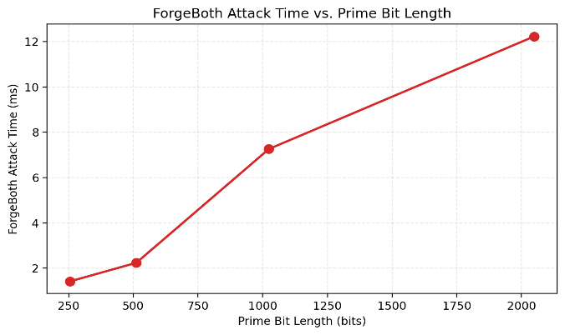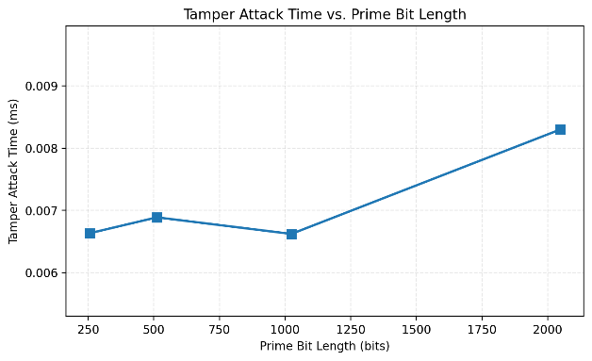
- Forge Attack Time vs. Prime Bit Length
- Tamper Attack Time vs. Prime Bit Length
For man-in-the-middle attacks, the experiment first evaluated the computational cost of the attacker under different key lengths. Figures 1 and 2 respectively show the changing trends of attack execution time with the increase of prime bit length in "forgery mode" and "tampering mode".
Experimental data show that there is a significant difference in orders of magnitude in the computational costs of the two attack modes. As shown in Figure 1, the execution time of the forgery attack shows a distinct growth feature as the bit length of the prime number increases. When the key length increases from 256 bits to 2048 bits, the attack time surges from approximately 1.5 milliseconds to over 12 milliseconds. This result confirms that the length of the Diffie-Hellman key directly determines the time consumption threshold for attackers. However, Figure 2 shows a completely different trend. The up and down fluctuating line indicates that there is no obvious connection between the key length and the attack time. Moreover, the time consumption of tampering attacks is extremely low, remaining within the range of 0.006 milliseconds to 0.009 milliseconds under all tested key lengths. This indicates that simple payload tampering such as bit flipping consumes almost no computing resources, and the network latency it causes is almost imperceptible to the victim in the actual environment. Research under this indicator shows that the larger the number of bits chosen for the key, the longer the forgery method of the man-in-the-middle attack takes and the more difficult it is to attack. As for tampering methods, it is difficult to effectively defend against them by increasing the number of key bits.

Defense Overhead Analysis of DH
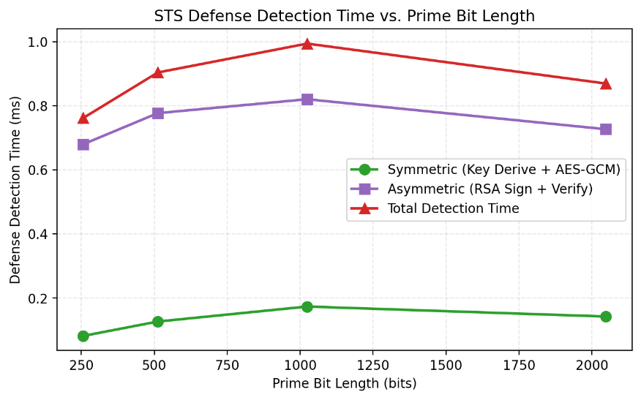
- STS Defense Detection Time vs. Prime Bit Length
The STS protocol inevitably incurs additional overhead. Figure 4 detailedly decomposes the time cost of the STS protocol in the defense detection process. We divide it into the symmetric encryption part (key derivation and AES-GCM) and the asymmetric encryption part (RSA signature and verification).
By analyzing Figure 3, it can be found that asymmetric encryption operations constitute the main bottleneck of defense overhead. Under all the tested key lengths, the time consumption of the asymmetric part accounted for more than 80% of the total detection time. It is worth noting that all the defense detection times show certain fluctuations with the increase of the Diffie-Hellman parameter length, but the overall fluctuation is not obvious. This indicates that there is no significant relationship between the overhead of defense detection and the key length. The total detection time remains at around 1 millisecond overall, which indicates that the computational delay introduced by the STS protocol is acceptable compared to the inherent delay of network transmission (usually ten milliseconds).

Defense success rate of DH
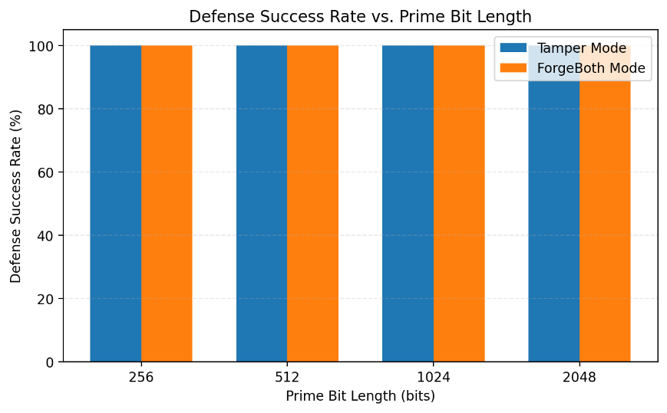
- Defense Success Rate vs. Prime Bit Length
To verify defense effectiveness of the STS protocol, the experiment tested the impact of keys of different lengths on the defense success rate under the protection of this protocol. Figure 3 shows the statistical results of the system against the "tampering mode" and the "forgery mode" respectively under key lengths ranging from 256 bits to 2048 bits.
The results show that the defense success rate of the STS protocol does not fluctuate with the variation of the prime key bit length of Diffie-Hellman but remains stable at 100% under all test lengths. This phenomenon indicates that the defense robustness of this protocol exhibits a distinct "decoupling" characteristic from the underlying key exchange parameters. The fundamental reason for this is that the STS protocol focuses its security defense on the identity authentication mechanism based on asymmetric encryption. Specifically, in the "forgery mode", the prerequisite for a successful attack is to forge a legitimate digital signature containing the victim's identity. The difficulty of this process depends on the strength of the RSA algorithm (fixed at 2048 bits in this experiment) but not on the Diffie-Hellman parameter length. Therefore, even in the weak parameter environment where the key length is short and theoretically easy to be brute-force cracked, the forged handshake packet still cannot pass the verification because the attacker lacks the RSA private key corresponding to the trusted anchor. Similarly, in the "tampering mode", defense relies on the integrity check of the AES-GCM authentication tag, which is also independent of the key agreement parameters. This result strongly demonstrates that the STS protocol establishes the robustness of defense by constructing an identity authentication barrier independent of key strength.

Attack Performance Analysis of RSA
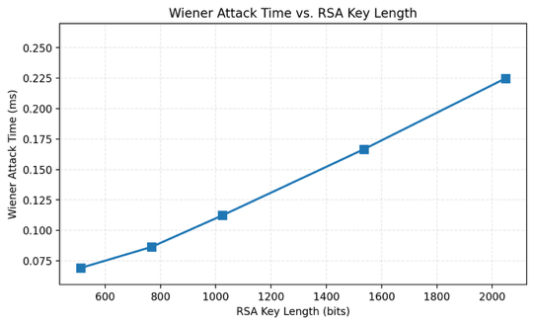
- Wiener Attack Time vs. RSA Key Length
This line graph clearly shows that for RSA keys with small exponent index flaws, the Wiener attack can efficiently complete key recovery within sub-millisecond times (0.075ms to 0.25ms), and the attack duration shows only a slight increase as the key length (600 to 2000 bits) increases. This confirms the core principle that the attack efficiency mainly depends on the size of the private key exponent d, and is basically independent of the bit length of the modulus n. Therefore, the chart intuitively reveals that simply increasing the key length cannot defend against such attacks. It is necessary to strictly verify the lower limit of the private key exponent during key generation to fundamentally eliminate the risks brought by this mathematical vulnerability.

Attack success rate of RSA
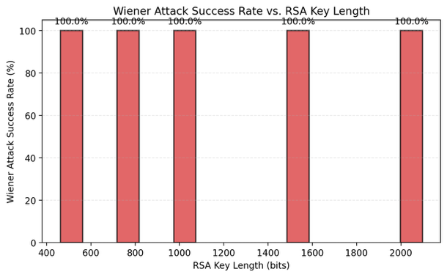
- Wiener Attack Success Rate vs. RSA Key Length
This bar chart provides an intuitive illustration that within the RSA key length range of 400 to 2000 bits, the success rate of the Wiener attack remains at 100%. This result clearly confirms that when the private key exponent d meets the attack conditions (i.e., d < (n ^ 1/4) / 3), regardless of how the key length increases, the attack can stably and deterministically recover the private key. Therefore, the chart powerfully reveals a key weakness in the security of the RSA system - the mathematical rigor of the parameter generation stage is crucial. Once a small d key is generated, the attacker can bypass the key length and achieve 100% cracking. This highlights the indispensable security measure of mandatorily verifying the lower limit of d during key generation.
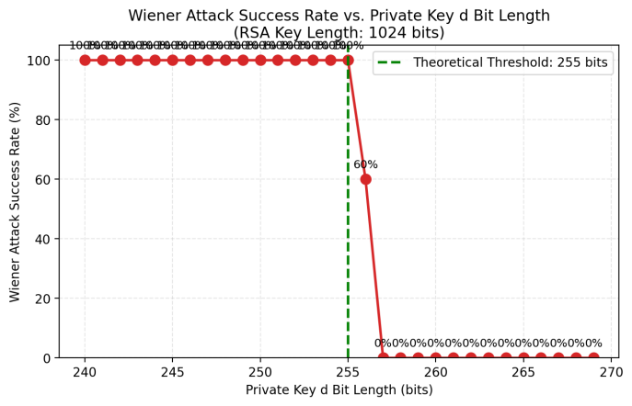
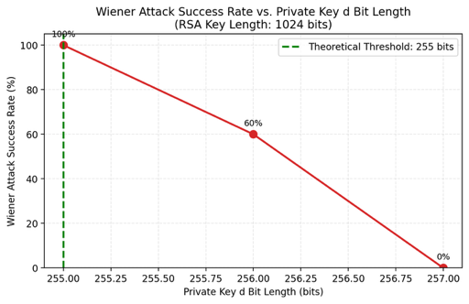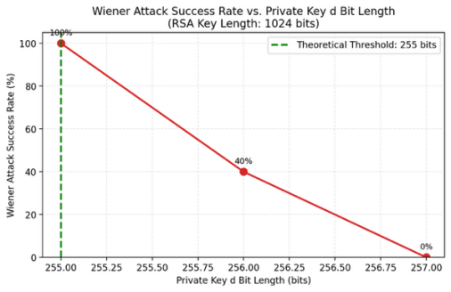
- Wiener Attack Success Rate vs. Private Key d Bit Length
This series of line graphs illustrates the critical effect of Wiener attack success rate as the private key index d (in bits) varies. The first graph clearly shows that when the RSA key length is 1024 bits and the bit length of the private key index d does not exceed 255, the attack success rate remains stable at 100%, which fully conforms to the mathematical boundary conditions of Wiener attack (d < n^(1/4)/3) - within this range, continued fraction approximation can deterministically recover the private key. However, at the critical point where the bit length of d reaches 256, the last two graphs reveal significant fluctuations in the success rate, which intuitively reflects that some keys are approaching or slightly exceeding the theoretical boundary of the attack, causing the attack result to shift from a guaranteed success to a probabilistic success. This critical fluctuation phenomenon strongly confirms the mathematical sensitivity of Wiener attack and warns that in RSA key generation, it is necessary to strictly ensure that the private key index d has sufficient security margin, rather than merely meeting the boundary conditions, in order to fundamentally prevent such attacks.

Discussion

Analysis of Attack Methods
The two attack vectors analyzed—DH MITM and RSA Wiener's Attack—present distinct advantages and limitations.

DH Man-in-the-Middle (MITM):
- Advantages: The primary strength is complete control. A successful attacker can not only eavesdrop but also modify or forge data in real-time. Deployment is straightforward on unauthenticated channels.
- Disadvantages: The attack has a high dependency on the lack of authentication. It fails immediately if the protocol includes any form of identity verification or post-exchange key validation.

RSA Wiener's Attack:
- Advantages: The attack is highly efficient, capable of recovering the private key d in polynomial time from the public key (N, e).
- Disadvantages: It relies on strict mathematical conditions. The attack is only viable if the private exponent is dangerously small (d < (n ^ 1/4) / 3). It is ineffective against modern, standard-compliant keys where d is large.

Analysis of Defense Methods
The deployed defenses—STS and Secure RSA Key Generation—effectively mitigate their respective threats, though with specific trade-offs.

Station-to-Station (STS) Protocol:
- Advantages: STS provides robust identity authentication. By binding the key exchange to digital signatures, it fundamentally prevents impersonation, ensuring the integrity of the communication session.
- Disadvantages: Security comes at the cost of increased computational overhead, as the protocol requires generating and verifying signatures during the handshake. Additionally, the system's security becomes dependent on the strength of the underlying signature algorithm.

RSA Secure Key Generation:
- Advantages: This defense addresses the root cause. By mathematically enforcing a threshold for the private exponent (d > n ^ 1/4), it eliminates the vulnerability with zero runtime overhead during encryption or decryption.
- Disadvantages: The defense is scope-specific. While it perfectly neutralizes Wiener's Attack, it offers no protection against other RSA vulnerabilities, such as factorization attacks (e.g., GNFS) or side-channel attacks.

Conclusion

- W. Diffie, P. C. van Oorschot, and M. J. Wiener, “Authentication and Authenticated Key Exchanges,” Designs, Codes and Cryptography, vol. 2, pp. 107–125, 1992.
- C. H. Lim and P. J. Lee, “A Key Recovery Attack on Discrete Log-Based Schemes Using a Prime Order Subgroup,” in Proc. Advances in Cryptology - ASIACRYPT'97, Lecture Notes in Computer Science, vol. 1334, Springer-Verlag, 1997, pp. 250–264.
- M. J. Wiener, “Cryptanalysis of Short RSA Secret Exponents,” IEEE Trans. Inf. Theory, vol. 36, no. 3, pp. 553–558, 1990, DOI: 10.1109/18.54902.
- M. Bellare and P. Rogaway, “Optimal Asymmetric Encryption,” in Proc. Advances in Cryptology - CRYPTO'94, Lecture Notes in Computer Science, vol. 839, Springer-Verlag, 1994, pp. 92–111.
- D. Adrian, K. Bhargavan, Z. Durumeric, et al., “Imperfect Forward Secrecy: How Diffie-Hellman Fails in Practice,” in Proc. 22nd ACM SIGSAC Conf. Comput. Commun. Secur., ACM, 2015, pp. 5–17.
- M. Conti, N. Dragoni, and V. Lesyk, “A Survey of Man-in-the-Middle Attacks,” IEEE Commun. Surv. Tuts., vol. 18, no. 3, pp. 2027–2051, 2016, DOI: 10.1109/COMST.2016.2548426.
- S. G. Sumanasekara and D. V. D. S. Abeysinghe, “Machine Learning-Based Detection of ARP Spoofing Attacks Using Behavioral Analysis,” in Proc. 2025 Int. Res. Conf. Smart Comput. Syst. Eng. (SCSE), IEEE, 2025, pp. 1–6.
- B. Zhao, L. Wang, K. Jiang, et al., “An Improved Power Attack on Small RSA Public Exponent,” in Proc. 2016 IEEE Int. Conf. Comput. Intell. Secur. (CIS), 2016, DOI: 10.1109/CIS.2016.0140.
- M. D. Pradana, S. S. Carita, and A. D. Handayani, “A New Boundary of Minimum Private Key on Wiener Attack Against RSA Algorithm,” in Proc. 2023 IEEE Int. Conf. Cryptogr., Informatics, Cybersecur. (ICoCICs), 2023, DOI: 10.1109/ICoCICs58778.2023.10276975.
- Z. Wang, W. Ma, and B. Gong, “An Attack Scheme of RSA Encryption System with Protocol Failure,” in Proc. 3rd Int. Conf. Smart BlockChain (SmartBlock), 2020, DOI: 10.1109/SmartBlock52591.2020.00023.
- S. M. Bellovin and M. Merritt, “Encrypted Key Exchange: Password-Based Protocols Secure Against Dictionary Attacks,” in Proc. 1992 IEEE Symp. Secur. Priv., IEEE, 1992, pp. 72–84, DOI: 10.1109/RISP.1992.213269.
- D. P. Jablon, “Strong Password-Only Authenticated Key Exchange,” ACM SIGCOMM Comput. Commun. Rev., vol. 26, no. 5, pp. 5–26, 1996, DOI: 10.1145/242896.242897.
- S. Patel, “Number-Theoretic Attacks on Secure Password Schemes,” in Proc. 1997 IEEE Symp. Secur. Priv., IEEE, 1997, pp. 292–302, DOI: 10.1109/SECPRI.1997.601340.

IEEE conference templates contain guidance text for composing and formatting conference papers. Please ensure that all template text is removed from your conference paper prior to submission to the conference. Failure to remove template text from your paper may result in your paper not being published.
We suggest that you use a text box to insert a graphic (which is ideally a 300 dpi TIFF or EPS file, with all fonts embedded) because, in an MSW document, this method is somewhat more stable than directly inserting a picture.
To have non-visible rules on your frame, use the MSWord “Format” pull-down menu, select Text Box > Colors and Lines to choose No Fill and No Line.

