Pollard's Rho algorithm is a probabilistic large integer prime factorization algorithm, which is often used in RSA cryptanalysis to simulate an attacker's attempt to factorize the modulus N=pq. It will use the iterative function f(x) = (x² + c) mod n to generate a pseudo-random sequence and look for collisions in the sequence. Then, the tortoise and hare race algorithm (fast and slow Pointers) is adopted to detect loops or collisions in the sequence. When a collision is detected, calculate the greatest common divisor of the difference between the two values and n. If a non-trivial factor is obtained, the decomposition is successful.
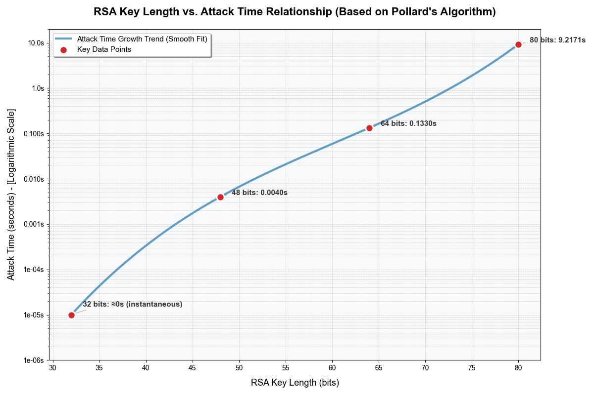
Compared with other algorithms, it has the advantages of low time complexity and small space occupation. Under normal circumstances, the expected time is approximately
O(N^(1/4)) ≈ O(√p), which is several orders of magnitude faster than other methods for RSA modules less than 200 bits. Moreover, its core implementation is simple and extremely sensitive to small factors. Usually, p can be found under √p, and the total length of N does not need to be considered.
Another common algorithm is Fermat factorization (also known as the "square difference" method). Unlike the Pollard algorithm, it can only be performed quickly when p and q are close. Although Fermat is simple, it only has an advantage in situations like "balanced RSA" that are contrary to the real world.
Therefore, Pollard ρ is still chosen as the attack demonstration tool.
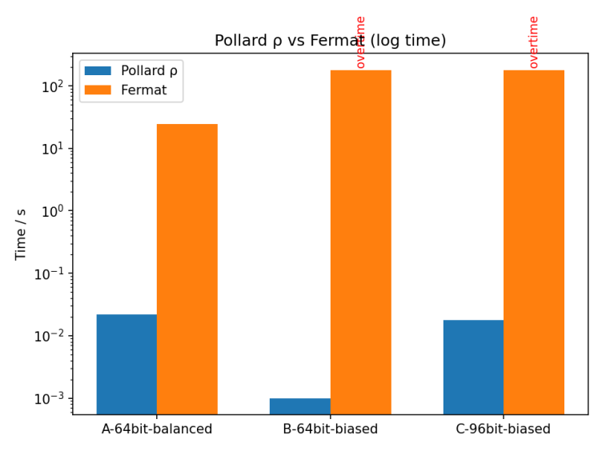
The Pollards algorithm is essentially still a probabilistic algorithm, and it cannot guarantee that a factor will definitely be found within a finite time. To avoid potential problems, we have added an additional time limit. When the algorithm accepts the max_time_seconds parameter, it will return a failure if the time limit is exceeded. The characteristics of the Pollards algorithm determine that in some cases, when the factor of n is very small, it may not be as efficient as the trial division. When n is a prime number, non-trivial factors cannot be found.
When designing the defense plan, we considered two main authentication mechanisms: certificate-based authentication and password-based authentication.

Certificate-based Authentication is an industry-standard solution. It relies on an external trust infrastructure, namely the Public Key Infrastructure (PKI), which is signed by a trusted certificate authority (CA) to permanently bind a public key to an identity. This method has the highest defense strength because it prevents attackers from forging a valid signature, thereby completely blocking man-in-the-middle attacks. However, from the perspective of systems engineering, the structure for implementing certificate authentication is complex and costly because it requires the establishment and maintenance of a complete PKI.

Besides, Password-based Authentication is a simpler and lower-cost alternative. It does not involve any external trust institutions or complex key infrastructure. In our project simulation, we chose to attempt to solve the trust issue of Diffie-Hellman by transmitting a preset Password. The main motivation for this choice is to achieve the lowest implementation cost and complexity. It only requires a small amount of code modification, without the need to build additional entities or change the communication structure, which is easier to implement and demonstrate in project demonstrations.

However, We ultimately chose to adopt password authentication in the project simulation, with the aim of vividly demonstrating the fundamental structural flaws of the Diffie-Hellman protocol. As we discovered in the implementation, since the communication channel is unencrypted before the key exchange is completed, attackers can easily intercept and replay the password. This clearly proves:

The DH protocol cannot ensure its own security through a simple internal mechanism (such as a password) without an external encryption layer. The D-H protocol itself is a peer-to-peer (P2P) protocol, and its design does not include an authentication mechanism, which provides a basic condition for man-in-the-middle attacks. Compared with attacks under the RSA protocol, man-in-the-middle attacks do not need to consider a series of problems brought about by the key length.

