Software Architecture and Design
Lab Manual
Basic Programming Practice – Week 1 Lab



Made By:
M Faizan Khan

Session: Fall 2025
(South China Normal University, China)

Instructions
- The purpose of this lab is to know the programming knowledge of the average students.
- Programming Language: You can use any language which you know for following programming tasks.
- Discussion: You are allowed to do discussion about the following programs.
- Submission Guidelines: How to submit the lab I will guide you later.
- Grading: The following lab can be graded and marks will be counted towards your final score. So, it is advised to each and every student to take following tasks seriously.

Lab Task 1
Write a Java program that calculates the daily wage of a factory worker. The daily wage of the worker is no. of hours worked* hour rate. The number of hours worked in a day and the hour rate are entered from the user.
If the hours worked in a day exceeds 8. Then the worker receives 1.5 times hour rate for every hour worked over 8.
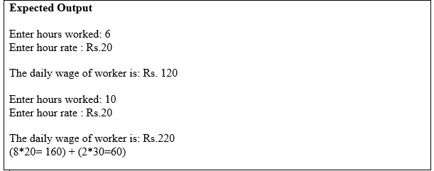

Lab Task 2
Write a C++ program to manage a list of student records. Implement a Student class with attributes such as name, ID, and grade. Allow the user to add new students, display all student records, and search for a student by ID. Store the records in a text file and load them at the start of the program. Ensure basic error handling for file operations.

Lab Task 3
Write a C++ program to implement a basic calculator that supports addition, subtraction, multiplication, and division. Use a switch case to handle different operations. Prompt the user to input two numbers and an operator, then display the result.

Lab Task 4
Giving the author class and the book class, answer the questions below:

Write the implementation for class author and book.
o Write main program that will Write a driver program that test the class as follow:
1. Define an array of 3 elements of type book.
2. Insert values for these 3 books.
3. Print values of these 3 books in a table.
Write a friend function for class book that will search for a given book according to its ISBN. If it is found you will print the information of that book (book_name, ISBN, author), if not it is not found print "Not found".

Lab Task 5
Create a C++ program to implement a circular queue using an array. Provide functions for enqueue, dequeue, and display. Test the circular queue with a series of enqueue and dequeue operations.

Lab Task 6
Write a C++ program to count the frequency of each character in a given string. Use an array or a map to store character frequencies, and display the results in a sorted order (by characters).
Submission: I will guide later that where to submit the lab files. Thanks.

