Week4 lab
GROUP MENBER
NAME | id
GuanDe Liu | 20233802067
HaoLong Li | 20233802031
HaoChen Huang | 20233802041

一．Problem statement

1. Reality

nowadays the E-commerce platforms all have some problems they have to face. For example:
1.the platforms maybe face the system jamming or crashing during the high traffic period, like when taobao in 11.11 they launched a discount campaign that attract many people to buy something in that day, the number of them may be up to 1 billion, so in that day the website would be very slow and dont work out.
2.the customer may be hacked when they pay to something, like when someone want to transfer money to others, but finally found the money had been transfer to some stranger account.
3.the platform may design too complicated that made the customer cant find the things they want easily, like there are too many things in home page ,and the main goods customer cant find it easily.

2.Ideal
we want to have a ideal system that it can solve the problems we supposed. First, the platform can withstand many people online operating at the same time, and the number should reach the level of 5 billion. Second, all the customers in formations should be protected and privacy, even the manager of the platform, he still have no permission to check the user's privacy, and all the information just save in user's local environment, the platform just save the basic in formations form the customers and also protect the security of payment. Third, the platform should be design very simply and usable. And made customers can easily find the things they want, but not full screen ad. Finally, this platform should be create an industry benchmark, and be trusted by customers.

3.Consequences
if some problems don’t be solved in time, it can be lead into a bigger problem. Like:
1. the customer don’t trust our platform again, and turn to other platform , and make our take in loss.
2. our platform's brand maybe become worse than before.
3.some accident may have some legal risks, like be hacked and leak the user's informations.etc..

4.Proposal
we need have a new platform to solve the problems that is historical legacy issues, and by the time, these problems will become more and more serious. Like nowadays' platform is not highly scalable and cannot meet future needs.
we have a good goals, that is building a high-performance, high-security,and scalable e-commerce platform prototype. And many people can join us and enjoy the service of the platform. and during the customers using the platform, we will give them a nice experience and needed service.
also have a fair environment to customer and seller.
二.
1.System structure design diagram
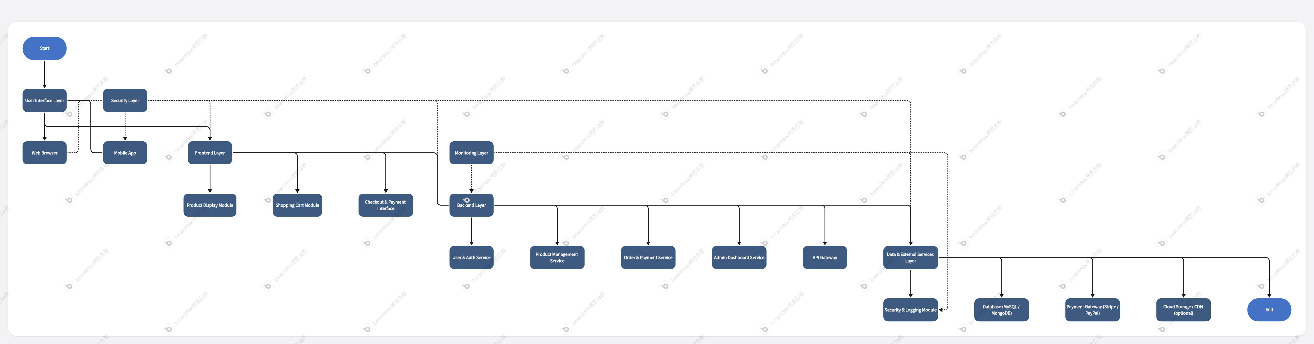
2.Module division diagram
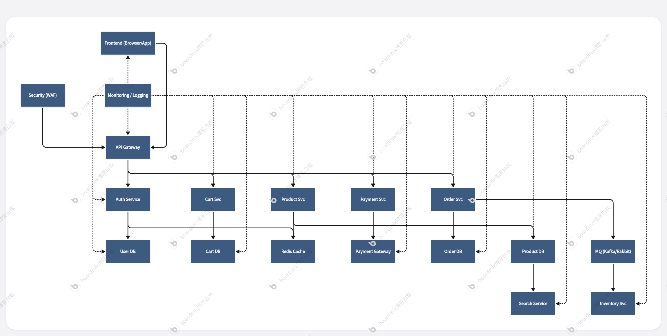

三．Testing and Evaluation Plan

1. Testing Objectives
Verify that the e-commerce platform meets functional, performance, security, and usability requirements, ensuring a stable, secure, and smooth shopping experience for users after launch.

2. Test Types and Content
Test Type | Test Content | Example Scenarios
Performance Testing | High concurrency handling, response time, system stability | Simulate 1000 users browsing/placing orders simultaneously
Security Testing | Payment security, data encryption, SQL injection, unauthorized access | Simulate payment process, penetration testing
Usability Testing | Interface friendliness, process smoothness | New user completes first purchase task
Functional Testing | Core business process integrity | Add item → Cart → Checkout → Order generation

3. Key Success Metrics
- Average page response time: < 2 seconds
- System uptime: ≥ 99%
- Payment success rate: ≥ 98%
- User satisfaction score: ≥ 4/5 (on a 5-point scale)
- Maximum supported concurrent users: ≥ 10,00

4. Testing Phases
Phase | Test Content | Participants
Unit Testing | Verify correctness of individual modules | Developers
Integration Testing | Verify interfaces and data flow between modules | Developers + Testers
System Testing | Full system function, performance, security tests | Testing Team
User Acceptance Testing (UAT) | Real user scenario validation | Clients / Business Representatives

5. Recommended Testing Tools
Test Type | Recommended Tools
Performance Testing | Locust
Security Testing | OWASP ZAP, Burp Suite
Usability Testing | User interviews, Surveys
Functional Automation | Selenium, Postman, Cypress

6. Test Deliverables
- Test Plan Document
- Test Case Suite
- Defect Report and Tracking Records
- Performance Test Report
- Security Vulnerability Assessment Report
- Usability Feedback Summary
- Final Test Summary Report

