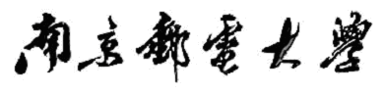

实验报告

（ 2024 / 2025 学年 第 一 学期）

题 目：programming experiment

专 业 信息安全

学 生 姓 名 薛瑞

班 级 学 号 B22041624

指 导 教 师 王磊

指 导 单 位 网络空间安全系

日 期 2024年 11月 28 日

Experiment3 C

(1) Task 1

(1) Write a C program that uses standard I/O libraries to display the contents of text files. The program is

compiled and linked by the make tool, which requires the generation of the.o file first, and then the generation

of the executable file, and the function of deleting the intermediate file (.o) in the makefile file.

#include <stdio.h>

int main(int argc, char* argv[])

{

char buf[1024] = { 0 };

FILE* fp = fopen(argv[1],"r");

if (argc < 2)

{

printf("please input source file!\n");

}

if (fp == NULL)

{

printf("open source %s failed\n", argv[1]);

return -1;

}

while (fgets(buf,1024, fp))

{

printf("%s\n", buf);

}

return 0;

}

Make sure your filename is c1.c

We can use the following makefile.

hello1:c1.o

gcc -o hello1 c1.o

c1.o:c1.c

gcc -c c1.c

clean:

rm -rf *.

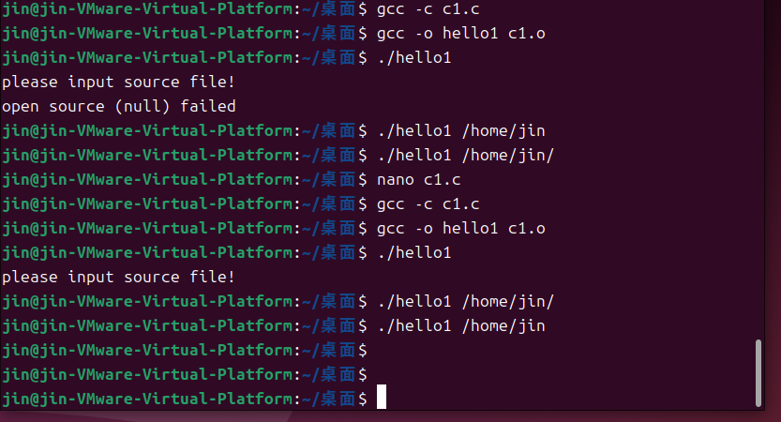

(2) Task 2

(2) Write a C program that displays all the file names in the current directory. The program is compiled and

linked by the make tool, which requires the generation of the.o file first, and then the generation of the

executable file, and the function of deleting the intermediate file (.o) in the makefile file.

include <stdio.h>

include <dirent.h>

include <sys/types.h>

int main(int argc, char* argv[])

{

DIR* dirp;

struct dirent* direntp;

if ((dirp = opendir(argv[1])) == NULL) {

printf("error\n");

// exit(1);

}

while ((direntp = readdir(dirp)) != NULL)

printf("%s\n", direntp->d_name);

closedir(dirp);

// exit(0);

}

Make sure your filename is c2.c

We can use the following makefile.

hello2:c2.o

gcc -o hello1 c2.o

c2.o:c2.c

gcc -c c2.c

clean:

rm -rf *.o

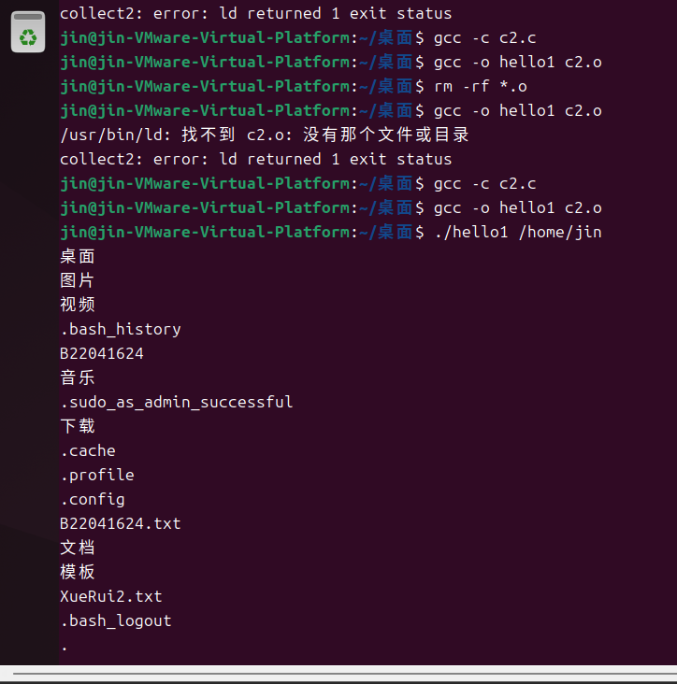

(3) Task 3

(3) Write a C program that changes the working directory of the current process. The program is compiled

and linked by the make tool, which requires the generation of the.o file first, and then the generation of the

executable file, and the function of deleting the intermediate file (.o) in the makefile file.

#include <stdio.h>

#include <stdlib.h>

#include <unistd.h>

int main(){

char buf[1024] = {0};

char buf2[1024]={0};

getcwd(buf, 1024);

printf("%s\n", buf);

if(chdir("/home")<0){

printf("error\n");

}

else

{

printf("success\n");

}

getcwd(buf2,1024);

printf("%s\n",buf2);

return 0;

}

Make sure your filename is c3.c

We can use the following makefile.

hello3:c3.o

gcc -o hello1 c3.o

c3.o:c3.c

gcc -c c3.c

clean:

rm -rf *.o

