- Obtain the system time, and check whether it is in the morning, afternoon, or evening.

- Input two number, check which one is greater, and output the result.
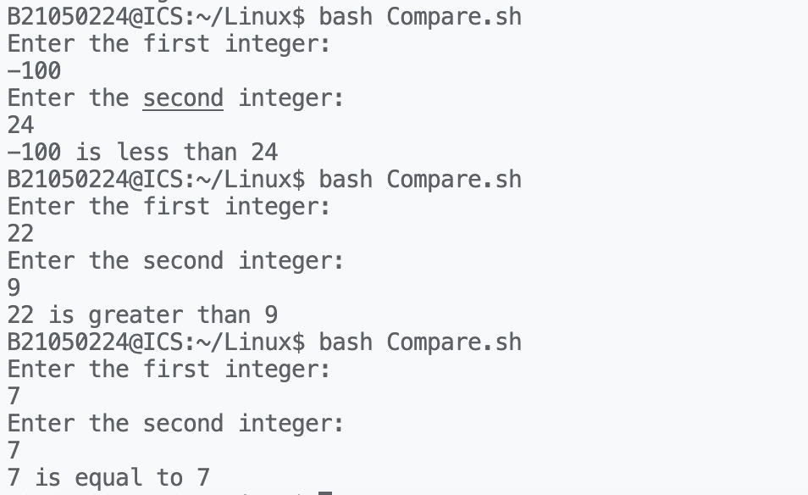
- Find the minimal value in a given list.
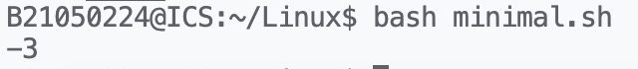
- Calculate the number of executive file in the current directory.
- Check whether a given number is a prime, you have to write a function, and call the function.

