**[一個優良使用者故事的6個特性 - INVEST 模式](http://www.blogjava.net/rocket/archive/2008/05/26/202981.html)**

Six Features of a Good User Story - INVEST Model  
一個優良使用者故事的6個特性 - INVEST 模式

**What is a User Story?** 使用者故事是什麼？  
  
A user story describes desired functionality from the customer(user) perspective. A good user story describes the desired functionality, who wants it, and how and why the functionality will be used. The basic components of a User Story are sometimes dubbed as the three C's:  
使用者故事其實描述的是客戶角度渴望的功能，一個好的使用者故事描述了迫切的功能，誰想要它，這個功能如何被使用，這個功能為何被使用。用個使用者故事的基本成分通常使用3個C開頭的字母來描述：

**Card** - the written description of the story, serves as and identification, reminder, and also helps in planning.   
卡片 - 包括故事的描述，為誰服務，唯一標識，提示資訊，對反覆運算計畫編制有所幫助

**Conversation** - this is the meat of the story; the dialogue that is carried out with the users; recorded notes; mockups; documents exchanged.   
討論 - 這是股市的具體內容,和使用者一起進行面對面的溝通，記錄筆記，模型，文檔交流

**Confirmation** - the acceptance test criteria that the user will utilize to confirm that the story is completed.   
確認 - 確立接受度測試的標準，這個標準是讓用戶來如何來確認這個故事已近完成的

**A user story is not technical. 使用者故事不是一個技術術語**

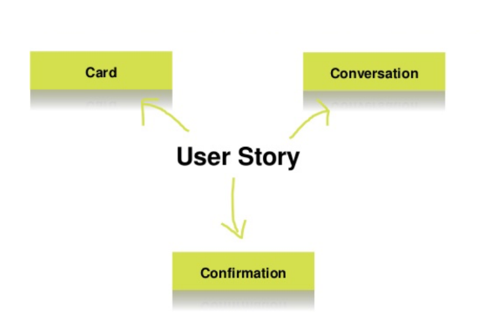

A well-written user story follows the INVEST model  
一個良好的使用者股市應該遵循INVEST模式

Independent, Negotiable, Valuable, Estimable, Small, Testable. Let's see what each one means:  
獨立的，便於溝通的，有價值的，可估計的，短小，可測試的。讓我們來看看每一個的意思

**Independent** - One user story should be independent of another (as much as possible). Dependencies between stories make planning, prioritization, and estimation much more difficult. Often enough, dependencies can be reduced by either combining stories into one or by splitting the stories differently.   
獨立的 - 一個使用者故事對於另一個使用者故事應該是獨立的（盡可能的）。故事之間的依賴性使得增加了計畫編制，確立有限級，故事估計這些工作非常困難。通常，可以通過組合使用者故事或者分割使用者故事來減少依賴性。

**Negotiable** - A user story is negotiable. The "Card" of the story is just a short description of the story which do not include details. The details are worked out during the "Conversation" phase. A "Card" with too much detail on it actually limits conversation with the customer.   
便於溝通的 - 一個使用者故事是便於溝通的。一個故事的卡片是包含故事詳情的簡短描述。這些詳情是通過討論階段來完成的。一張還有很多詳情的卡片實際上減少了和客戶的會談。

**Valuable** - Each story has to be of value to the customer (either the user or the purchaser). One very good way of making stories valuable is to get the customer to write them. Once a customer realizes that a user story is not a contract and is negotiable, they will be much more comfortable writing stories.   
**有價值的** - 每個故事必須對客戶具有價值（無論是用戶還是購買方）。一個讓使用者故事有價值的好方法是讓客戶來寫下它們。一旦一個客戶意識到一個使用者故事並不是一個契約而且可以進行協商的時候，他們將非常樂意寫下故事。

**應該避免出現使用者介面或技術方面的定義。**

**Estimable** - The developers need to be able to estimate (at a ballpark even) a user story to allow prioritization and planning of the story. Problems that can keep developers from estimating a story are: lack of domain knowledge (in which case there is a need for more Negotiation/Conversation); or if the story is too big (in which case the story needs to be broken down into smaller stories).   
**可估計的** - 開發者需要去估計一個使用者故事以便確定有限級並對故事進行規劃。但是讓開發者難以估計股市的問題來自：對於領域知識的缺乏（這種情況下需要更多的溝通），或者故事太大了（這時需要把故事切分成小些的）。

**Small** - A good story should be small in effort, typically representing no more than 2-3 person weeks of effort. A story which is more than that in effort can have more errors associated with scoping and estimation.   
短小 - 一個好的故事應該在工作量上短小，描述具有代表性，而且不超過2-3人周的工作量。超過這個範圍的使用者故事，講會在劃分範圍和估計時出現很多錯誤。

**Testable** - A story needs to be testable for the "Confirmation" to take place. Remember, we do not develop what we cannot test. If you can't test it then you will never know when you are done. An example of non-testable story: "software should be easy to use".   
**可測試的** - 一個使用者故事是可測試的來用於確認完成，記住，我們不開發不能測試的故事。如果你不能測試那麼你永遠不知道你什麼時候是完成了。一個不可測試的使用者故事例子：軟體應該是易於使用的。

**總結**  
Well-written User Stories are cornerstones for Agile Development. They should be independent of each other; the details should be negotiated between the users and the developers; the stories should be of value to the users; they should be clear enough for developers to be able to estimate them; they should be small; and they should be testable through the use of pre-defined test cases.

一個編寫良好的使用者故事是敏捷開發的基礎。它們應該相互獨立，詳情應該便於開發者和用戶進行溝通，應該對用戶有價值，應該對於開發者來說盡可能的清晰以便進行估計，應該短小，通過預定義的測試用例是可以對其進行測試的。