

Requirement & Design Specification
University Enterprise Internship Management System (UEIMS)
Version: 1.0

– Da Nang, May 2026 –

Record of Changes
Version | Date | A*  M, D | In charge | Change Description
V1.0 | 15/2 | A | KienNTHE11
*A - Added M - Modified D - Deleted

Contents
Record of Changes. 2
I. Overview.. 4
1. User Requirements. 4
1.1 Actors. 4
1.2 Use Cases. 4
2. Overall Functionalities. 5
2.1 Screens Flow.. 5
2.2 Screen Descriptions. 5
2.3 Screen Authorization. 5
2.4 Non-UI Functions. 6
3. System High Level Design. 6
3.1 Database Design. 6
3.2 Code Packages 7
II. Requirement Specifications. 8
III. Design Specifications 14
1. <<Feature Name>>. 14
1.1 <<SubFeature Name>>. 14
1.2 System Access. 15
IV. Appendix. 19
1. Assumptions & Dependencies 19
2. Limitations & Exclusions 19
3. Business Rules. 19
4. .. 19

I. Overview

1. User Requirements

1.1 Actors
# | Actor | Description
1 | System Administrator | Manage user accounts, assign roles, monitor audit logs, and maintain the stable operation and security of the entire system.
2 | Training Manager | Set up semesters, manage the official internship list, approve/reject enterprise registrations, control legal procedures, ensure internship discipline, monitor student progress and at-risk cases, send late report warnings, handle internship incidents reported by enterprises, submit final academic grades, and export grade reports.
3 | Enterprise | Manage company profiles, post job vacancies, screen CVs, schedule interviews, assign internal supervisors to interns, create and manage internship training plans, review and provide feedback on weekly reports, report critical student incidents, and submit final Rubrics evaluations to the University.
4 | Student | Search for internship positions, submit CVs for application, update work progress, fulfill the obligations of the internship module, and submit internal feedback on enterprise quality after the internship period. Access level is determined by current academic semester (Semester 1-4: browse only; Semester 5: apply for jobs; Semester 6: active internship; Semester 7-9: view results and submit enterprise feedback).

1.2 Use Cases

a. Diagram(s)
The system functionality is divided into logically cohesive sub-systems. Below is the global use case diagram providing a high-level overview, followed by detailed diagrams for each specific actor and sub-system.

1. Global System Use Case Diagram

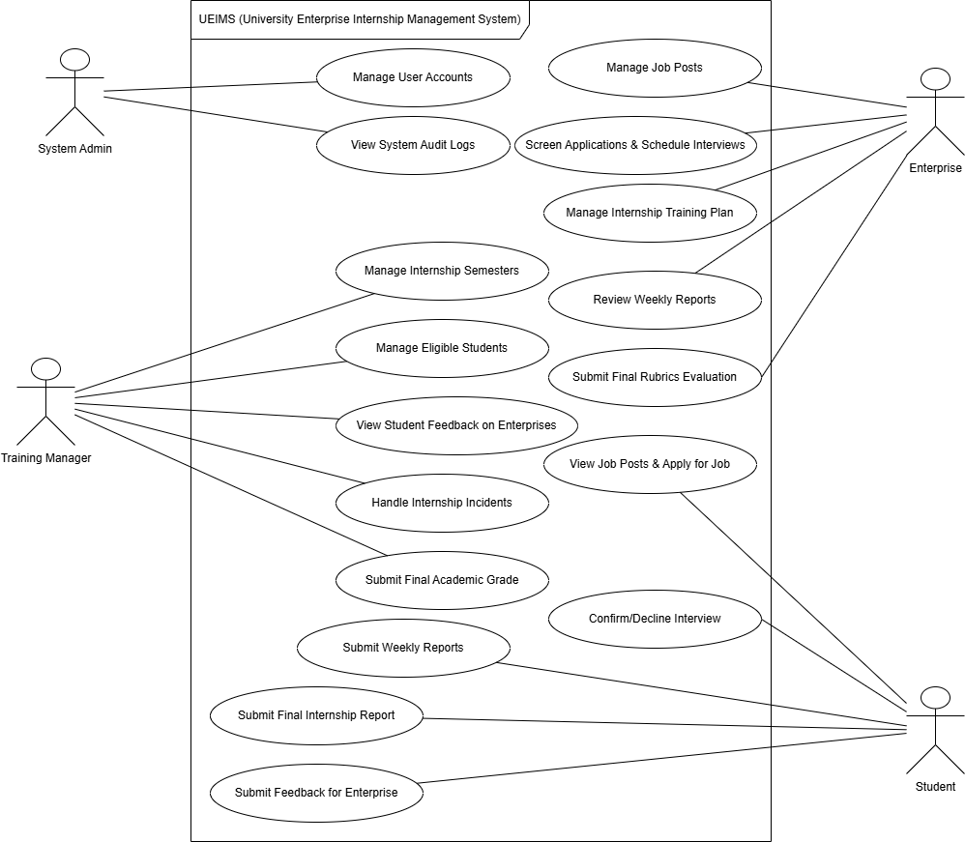

2. Admin & Authentication Subsystem 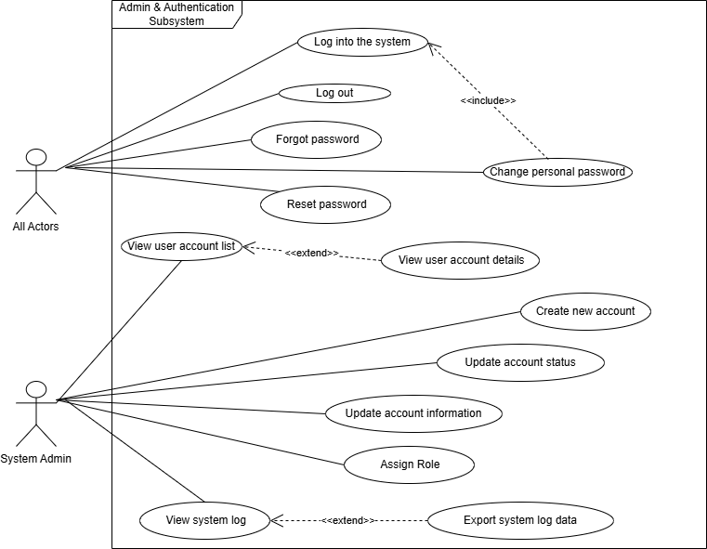

3. Training Manager Subsystem

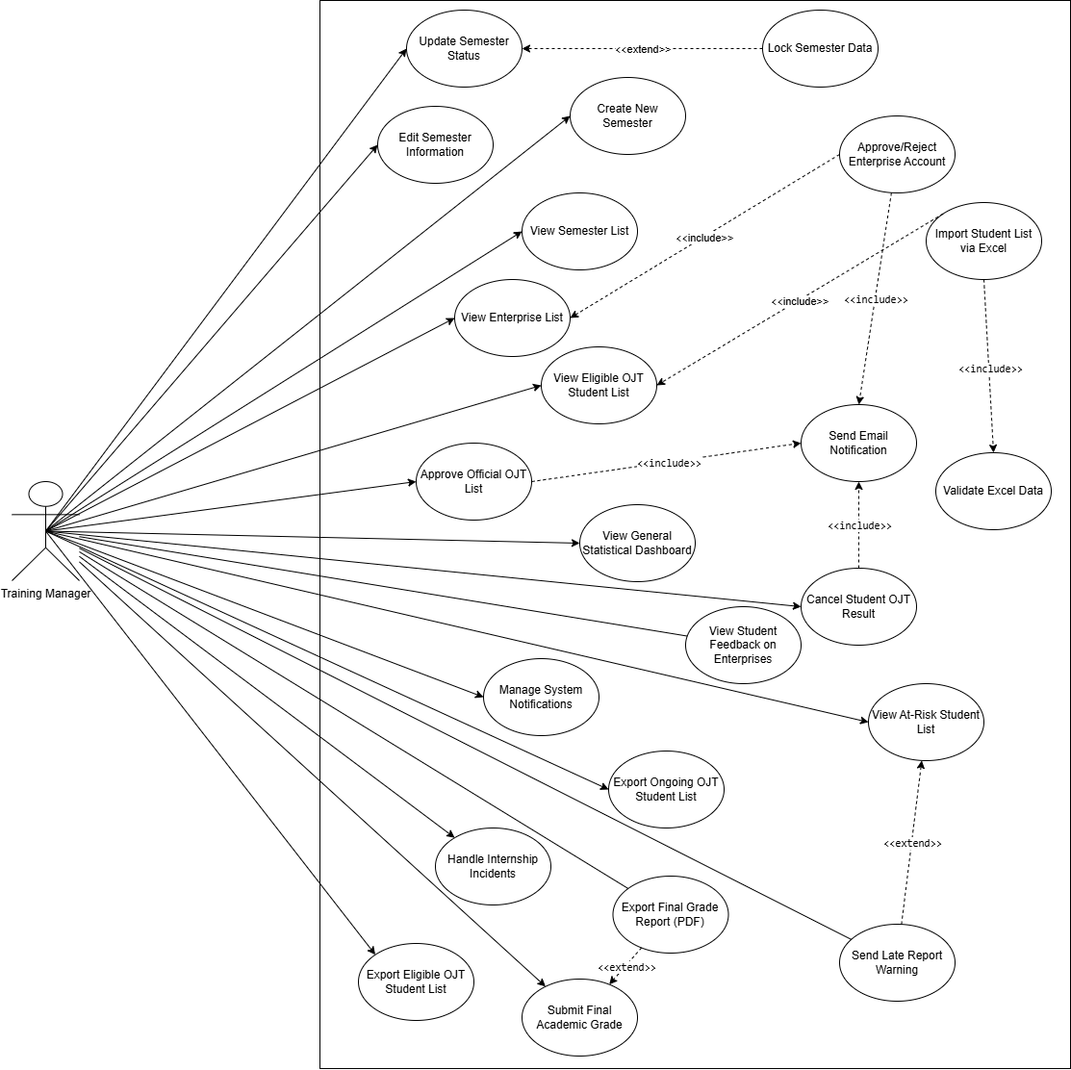

4. Enterprise Subsystem

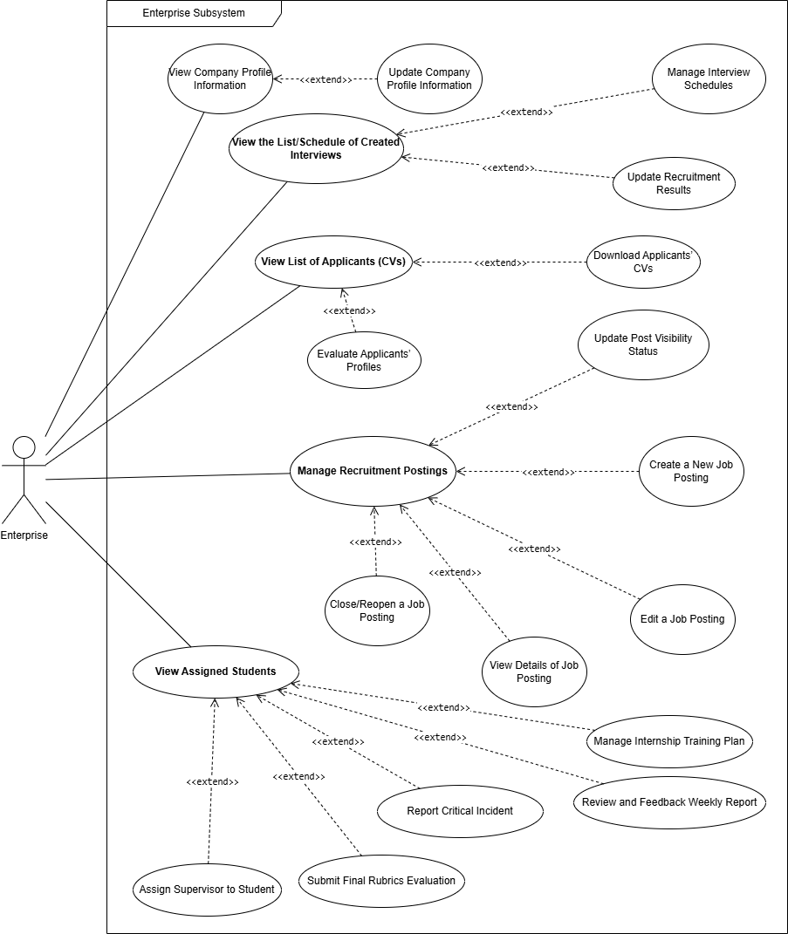

5. Student Subsystem

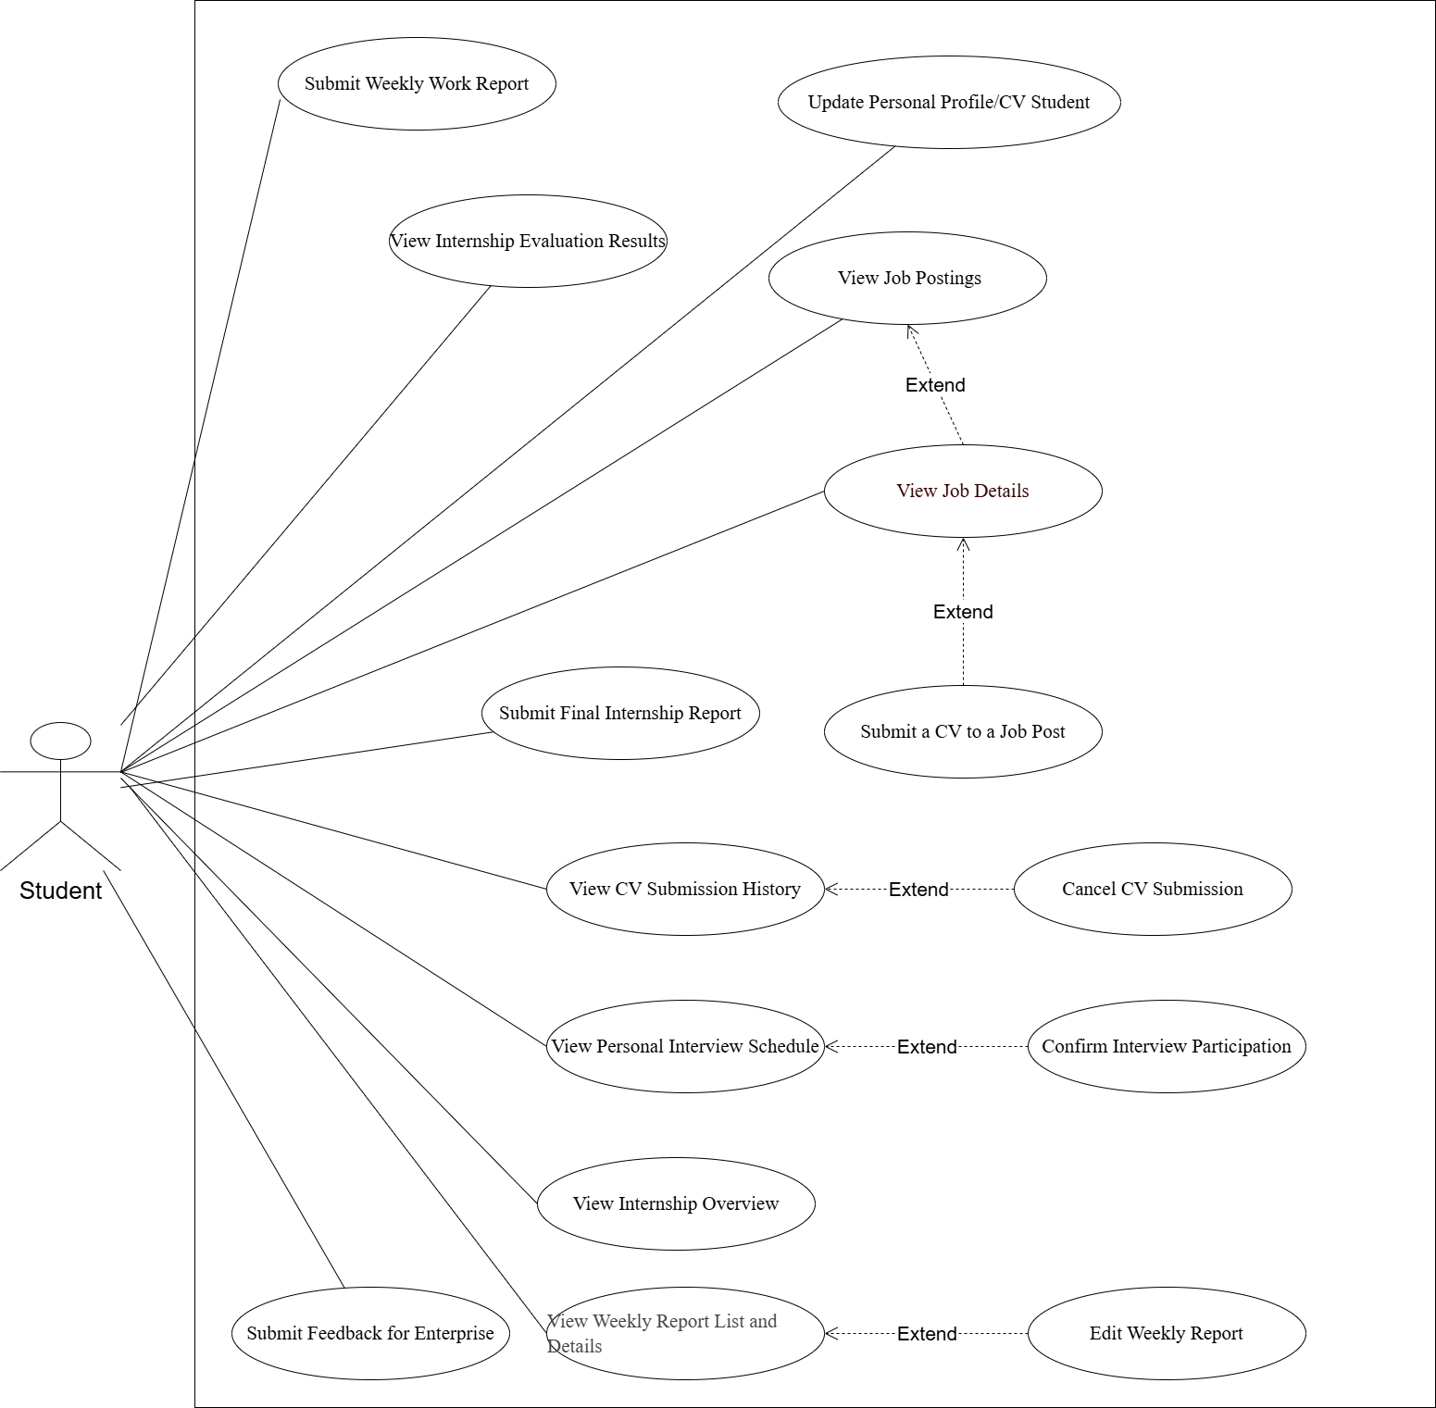

b. Descriptions
ID | Feature | Use Case | Use Case Description
UC-01 | Log into the System | All Actors | Authenticate identity using registered internal account credentials to access the system.
UC-02 | Log out | All Actors | Destroy the current session and redirect the user back to the Login page.
UC-03 | Forgot Password | All Actors | Request a secure password reset link sent to the user's registered email address.
UC-04 | Reset Password | All Actors | Configure a new password via email reset link or on first login with a temporary account.
UC-05 | Change Personal Password | All Actors | Proactively update the current active password for security maintenance.
UC-06 | View User Account List | System Admin | Display a paginated list of all user accounts with search and filter by status and role.
UC-07 | View User Account Details | System Admin | View detailed identity information, access logs, and role permissions of a specific account.
UC-08 | Create New Account | System Admin | Manually provision a new user account by entering identity info and assigning a role.
UC-09 | Update Account Information | System Admin | Edit basic user attributes (Full Name, Phone, etc.) to correct data errors.
UC-10 | Update Account Status | System Admin | Toggle an account between Active and Inactive status (Deactivate/Reactivate).
UC-11 | Assign Role | System Admin | Display the list of available system roles and assign a role to a user account.
UC-12 | View System Audit Logs | System Admin | Monitor critical action logs for security auditing and error tracing purposes.
UC-13 | Export System Log Data | System Admin | Extract audit log data into a downloadable Excel file for offline archiving.
UC-14 | View Semester List | Training Manager | Display the list of all internship semesters (past, current, upcoming) with key details.
UC-15 | Create New Semester | Training Manager | Set up a new semester with code, name, start/end dates, and initial configuration.
UC-16 | Edit Semester Information | Training Manager | Modify the timeline or descriptive details of an existing semester.
UC-17 | Update Semester Status | Training Manager | Open, Close, Activate, or Lock a semester to control system-wide actions.
UC-18 | View Enterprise List | Training Manager | Display and manage the list of partner enterprises registered in the system.
UC-19 | Approve/Reject Enterprise Registration | Training Manager | Verify legal status and grant or deny operational access to a newly registered enterprise.
UC-20 | View Eligible Student List | Training Manager | Track all students who meet OJT eligibility criteria with detailed academic information.
UC-21 | Import Eligible Students (Excel) | Training Manager | Bulk import eligible student records from the university system, including academic semester info.
UC-22 | Export Eligible Student List | Training Manager | Export the eligible student list to Excel for data reconciliation with the university system.
UC-23 | Approve Official OJT List | Training Manager | Finalize and confirm the official internship list, transitioning student status to active OJT.
UC-24 | Lock Semester Data (Approval Lock) | Training Manager | Prevent students and enterprises from modifying internship group assignments after approval.
UC-25 | Cancel Student Internship Result | Training Manager | Suspend or revoke internship results for students with severe disciplinary violations.
UC-26 | View General Statistical Dashboard | Training Manager | Display visual charts for interview pass rates, major distribution, and grade distribution.
UC-27 | Export Current OJT Student List | Training Manager | Extract all active OJT student data to an Excel file for reporting.
UC-28 | Manage System Notifications | Training Manager | Draft, edit, publish, and archive system-wide announcements for all users.
UC-29 | View At-Risk Students List | Training Manager | Display a compiled list of students with missing or late weekly reports for close monitoring.
UC-30 | View Student Feedback on Enterprises | Training Manager | Review all internal feedback submitted by students about their host enterprises to evaluate enterprise quality across semesters.
UC-31 | Send Late Report Warning | Training Manager | Filter students who missed weekly report deadlines and send direct warning notifications.
UC-32 | Handle Internship Incidents | Training Manager | Receive incident reports from enterprises or students, document corrective actions, and close the case.
UC-33 | Submit Final Academic Grade | Training Manager | Review enterprise Rubrics evaluation and input the final official course grade for each student.
UC-34 | Export Final Grade Report (PDF) | Training Manager | Export the aggregated grade transcript of all students into a formatted PDF document.
UC-35 | View Enterprise Profile | Enterprise | Display the company introduction page including size, sector, and contact information.
UC-36 | Edit Enterprise Profile | Enterprise | Update company description, address, logo, or representative contact person details.
UC-37 | Manage Job Posts | Enterprise | View, create, edit, and manage internship job postings on a centralized interface.
UC-38 | Close/Reopen Job Post | Enterprise | Hide a job post when positions are filled or reactivate it when more interns are needed.
UC-39 | View Application List (CVs) | Enterprise | View submitted applications with search, status filters, and advanced technology filters.
UC-40 | Download Applicant CV | Enterprise | Download a student's CV file in PDF format for internal company records.
UC-41 | Screen Application | Enterprise | Perform first-round CV screening by changing application status to Passed or Rejected.
UC-42 | View Interview Schedule | Enterprise | Display an overview of all scheduled interview appointments with student applicants.
UC-43 | Manage Interview Schedule | Enterprise | Propose available time slots, create, reschedule, postpone, or cancel interview appointments.
UC-44 | Record Interview Result | Enterprise | Record the Pass or Fail outcome of a student after completing the interview process.
UC-45 | Assign Supervisor to Students | Enterprise | Designate an internal staff member to directly supervise and guide an accepted intern.
UC-46 | View Assigned Students | Enterprise | View the list of interns currently assigned to the company for the active semester.
UC-47 | Manage Internship Training Plan | Enterprise | Create, update, and adjust the training roadmap based on the student's actual weekly progress.
UC-48 | View Student Weekly Report Details | Enterprise | Check the detailed content of an intern's weekly work report.
UC-49 | Review and Feedback Weekly Report | Enterprise | Approve or reject a student's weekly report with written comments and feedback.
UC-50 | Report Critical Incident | Enterprise | Submit an incident report to the university regarding serious student violations (absences, poor attitude, etc.).
UC-51 | Submit Final Rubrics Evaluation | Enterprise | Perform a one-time final evaluation using the 4-criteria grading form (Attitude, Professionalism, Skills, Progress).
UC-52 | Manage Student Profile/CV | Student | Update personal information, technical skills, and upload the latest CV file.
UC-53 | View Job Post List | Student | Browse available internship job postings with search and technology filters.
UC-54 | View Job Details | Student | Read job description, requirements, benefits, and application deadline before applying.
UC-55 | Apply for Job | Student | Submit a personal CV application to a desired internship position at a partner enterprise.
UC-56 | View My Application History | Student | Track the progress of all submitted applications (Pending, Reviewed, Interview Scheduled).
UC-57 | Withdraw Application | Student | Retract a submitted application before the enterprise has reviewed the CV.
UC-58 | View Interview Schedule | Student | View interview time, location, and meeting link from the enterprise invitation.
UC-59 | Confirm/Decline Interview | Student | Confirm or decline participation in a scheduled interview appointment from the enterprise.
UC-60 | Submit Feedback for Enterprise | Student | Submit a post-internship evaluation rating the enterprise on training quality, supervisor support, and work environment. Feedback is internal and visible only to Training Manager.
UC-61 | View Internship Plan Overview | Student | View the work plan and training objectives set up by the enterprise for the internship period.
UC-62 | View Weekly Report List & Details | Student | View all submitted weekly reports with their current status and feedback from the enterprise.
UC-63 | Submit Weekly Report | Student | Create and submit a weekly work progress report during the internship period.
UC-64 | Edit Weekly Report | Student | Revise and supplement report content based on rejection feedback from the enterprise.
UC-65 | Submit Final Internship Report | Student | Compile and submit the official final internship report (PDF) for academic grading.
UC-66 | View Internship Evaluation Results | Student | View final Rubrics scores, enterprise feedback, and official course grades.
UC-67 | View Student Dashboard & Status | Student | Allow students to access the main landing page (Home) to track their overall internship progress, statistics, schedules, and recent updates from enterprises.

2. Overall Functionalities

2.1 Screens Flow

2.1.1 Admin Screen Flow
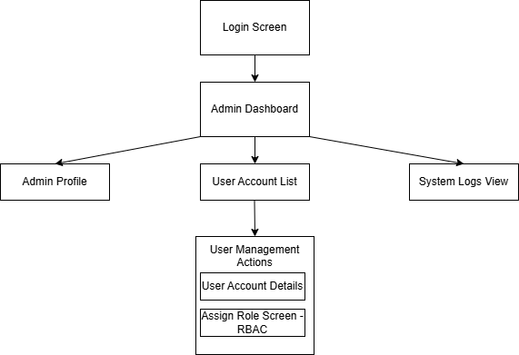

2.1.2 Training Manager Screen Flow
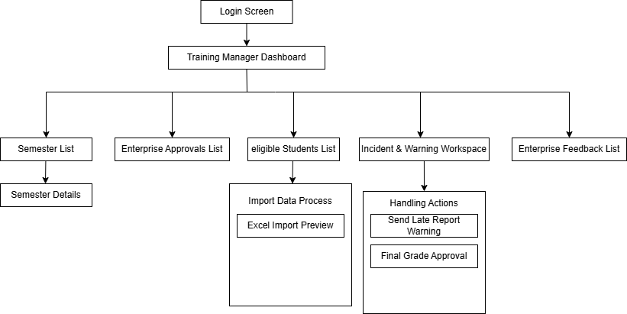

2.1.3 Enterprise Screen Flow
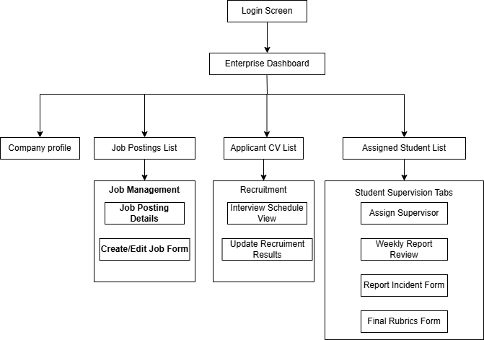

2.1.4 Student Screen Flow
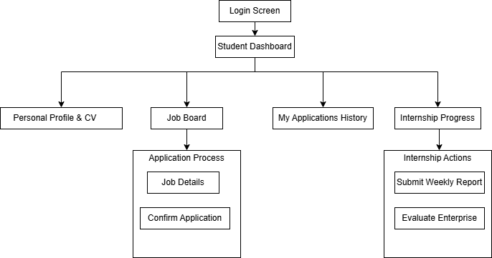

2.2 Screen Descriptions
# | Feature | Screen | Description
1 | Authentication | Login Screen | The landing interface for JWT authentication.
2 | Authentication | Forgot Password (Popup) | Allows users to input their email to request a password reset link.
3 | Authentication | Reset Password | The screen where users input and confirm their new password via a secure token.
4 | Authentication | Change Password (Popup) | Allows users to proactively change their password while logged in.
5 | System Administration | Admin Dashboard | The main landing dashboard for Admin, showing system metrics.
6 | System Administration | Admin Profile | Allows the Admin to view and edit their own account details.
7 | System Administration | User Account List | Displays a grid of all system accounts with search and filter capabilities.
8 | System Administration | User Account Details | Shows comprehensive details of a specific user account.
9 | System Administration | Create New User (Popup) | Form for the Admin to manually provision a new account.
10 | System Administration | Edit User Info (Popup) | Form to update basic user details like Name and Phone.
11 | System Administration | Assign Role Screen - RBAC | Interface to assign Many-To-Many roles to a user account.
12 | System Administration | System Logs View | Displays the audit trail of crucial actions for security tracking.
13 | System Administration | Export Logs (Popup) | Action to download system logs as an Excel file.
14 | Training Management | Training Manager Dashboard | The main landing dashboard for TM, showing academic metrics.
15 | Training Management | Semester List | Displays past and ongoing internship semesters.
16 | Training Management | Semester Details | Shows the timeline and configuration of a specific semester.
17 | Training Management | Create Semester (Popup) | Form to set up a new semester code and date boundaries.
18 | Training Management | Update Semester Status (Popup) | Allows changing semester states (Draft, Open, Active, Locked).
19 | Training Management | Enterprise Approvals List | Manages the list of partnered enterprises awaiting verification.
20 | Training Management | Approve/Reject Enterprise (Popup) | Action to grant or deny access to a newly registered enterprise.
21 | Training Management | Eligible Students List | Tracks university students meeting internship criteria.
22 | Training Management | Excel Import Preview (Popup) | Interface to upload the eligible student list via an Excel template.
23 | Training Management | Cancel Result (Popup) | Action to suspend a student's internship due to violations.
24 | Training Management | Enterprise Feedback List | Centralized view of all feedback submitted by students about enterprises (UC-30).
25 | Training Management | Feedback Details (Popup) | Shows detailed ratings and comments from a specific student feedback.
26 | Incident & Grading (TM) | Incident & Warning Workspace | Central hub for TM to monitor student compliance and issues.
27 | Incident & Grading (TM) | Send Late Report Warning | Action to dispatch a warning email to students missing deadlines.
28 | Incident & Grading (TM) | Resolve Incident (Popup) | Form to log the resolution approach for a reported incident and close the case.
29 | Incident & Grading (TM) | Final Grade Approval | Master list of supervised students for final OJT grading.
30 | Incident & Grading (TM) | Input Grade (Popup) | Form to enter the official Final Grade (0-10) and Pass/Fail status.
31 | Incident & Grading (TM) | Export PDF Report (Popup) | Action to generate and download the final grade transcript.
32 | Enterprise Recruitment | Enterprise Dashboard | Recruitment metrics and active mentorship overview for the company.
33 | Enterprise Recruitment | Company Profile | Displays the enterprise's introduction, scale, and contact info.
34 | Enterprise Recruitment | Profile Update (Popup) | Form to edit the company description, logo, and address.
35 | Enterprise Recruitment | Job Postings List | Centralized view of all recruitment posts created by the enterprise.
36 | Enterprise Recruitment | Job Posting Details | Shows the Job Description (JD) and requirements of a specific post.
37 | Enterprise Recruitment | Create/Edit Job Form (Popup) | Form to draft, publish, or modify an internship vacancy.
38 | Enterprise Recruitment | Close/Reopen Post (Popup) | Toggle to hide a post when full or reactivate it.
39 | Enterprise Recruitment | Applicant CV List | Displays applied students with CVs and status filters.
40 | Enterprise Recruitment | Evaluate Applicant (Popup) | Action to mark a CV as Passed Screening or Rejected.
41 | Enterprise Recruitment | Interview Schedule View | Dashboard of scheduled interview appointments with candidates.
42 | Enterprise Recruitment | Create Interview (Popup) | Form to propose slots and schedule a meeting with a candidate.
43 | Enterprise Recruitment | Update Recruitment Result | Action to record the Pass/Fail status after the interview process.
44 | Student Supervision (Ent) | Assigned Student List | List of interns currently under the Enterprise's guidance.
45 | Student Supervision (Ent) | Assign Supervisor (Popup) | Dropdown selection to designate an internal staff member for a student.
46 | Student Supervision (Ent) | Internship Plan | Table displaying the weekly roadmap for a specific student.
47 | Student Supervision (Ent) | Create Plan Item (Popup) | Form to add a task, target date, and objective for a week.
48 | Student Supervision (Ent) | Weekly Report Review | Interface displaying reports submitted by the assigned student.
49 | Student Supervision (Ent) | Provide Report Feedback (Popup) | Form to Approve/Reject a report and provide mandatory comments.
50 | Student Supervision (Ent) | Report Incident Form (Popup) | Form to escalate disciplinary issues (absences, attitude) to the University.
51 | Student Supervision (Ent) | Final Rubrics Form (Popup) | Grading form using a 4-criteria Rubrics (0-10 scale) for final evaluation.
52 | Student Application | Student Dashboard | The main landing dashboard for Student, showing timeline and status.
53 | Student Application | Personal Profile & CV | Student updates personal info, skills, and uploads PDF CV.
54 | Student Application | Job Board | Marketplace displaying available enterprise vacancies with tag filtering.
55 | Student Application | Job Details | Read-only view of a specific JD for the student.
56 | Student Application | Confirm Application (Popup) | Confirmation modal to send the profile to an enterprise.
57 | Student Application | My Applications History | Tracks the status of all jobs the student applied to.
58 | Student Application | Cancel Application (Popup) | Action to withdraw a pending application.
59 | Student Application | My Interviews (Popup) | List of interview invitations received from enterprises.
60 | Student Application | Confirm Attendance (Popup) | Action to accept or decline an interview schedule.
61 | Internship Progress | Internship Progress | Timeline view of training objectives and weekly submissions.
62 | Internship Progress | Submit Weekly Report (Popup) | Form to input tasks, issues, and lessons learned for the week.
63 | Internship Progress | Edit Weekly Report (Popup) | Interface to revise a report rejected by the Enterprise.
64 | Internship Progress | Evaluate Enterprise (Popup) | End-of-semester form for students to rate their internship experience (UC-55).
65 | Internship Progress | Final Report Submission (Popup) | Screen to upload the formal PDF final report for the university.
66 | Internship Progress | My Evaluation | Dashboard showing enterprise rubrics scores and final course grade.

2.3 Screen Authorization
Screen | System Admin | Training Manager | Enterprise | Student
Authentication & Core
User Login | X | X | X | X
Forgot/Reset Password | X | X | X | X
Role Dashboard | X | X | X | X
User Profile | X | X | X | X
System Administration
Users List | X
↳ Query All Data | X
↳ Add New Data | X
↳ Update All Data | X
Assign Role Screen | X
↳ Update Role Data | X
System Logs View | X
↳ Query All Data | X
Training Management
Semester List |  | X
↳ Query All Data |  | X
↳ Add New Data |  | X
↳ Update All Data |  | X
Enterprise Approvals List |  | X
↳ Update Status Data |  | X
Eligible Students List |  | X
↳ Query All Data |  | X
↳ Add New Data (Import) |  | X
Enterprise Feedback List |  | X
↳ Query All Data |  | X
Incident & Grading
Incident & Warning Workspace |  | X
↳ Query All Data |  | X
↳ Add New Data (Send Warning) |  | X
↳ Update Resolution Data |  | X
Final Grade Approval |  | X
↳ Update Final Grade Data |  | X
Enterprise Recruitment
Company Profile |  |  | X
↳ Update Own Data |  |  | X
Job Postings List |  |  | X
↳ Query Own Data |  |  | X
↳ Add New Data |  |  | X
↳ Update Own Data |  |  | X
Applicant CV List |  |  | X
↳ Query Received Data |  |  | X
↳ Update Status Data |  |  | X
Interview Schedule View |  |  | X
↳ Add New Data |  |  | X
↳ Update Result Data |  |  | X
Student Supervision
Assigned Student List |  |  | X
↳ Query Managed Data |  |  | X
↳ Update Supervisor Data |  |  | X
Student Internship Plan |  |  | X
↳ Add New Data |  |  | X
↳ Update Own Data |  |  | X
Weekly Report Review |  |  | X
↳ Query Managed Data |  |  | X
↳ Update Feedback Data |  |  | X
Final Rubrics Form |  |  | X
↳ Add New Data |  |  | X
Student Module
Job Board |  |  |  | X
↳ Query Active Data |  |  |  | X
↳ Add New Data (Apply) |  |  |  | X
My Applications History |  |  |  | X
↳ Query Own Data |  |  |  | X
↳ Update Own Data (Cancel) |  |  |  | X
My Interviews |  |  |  | X
↳ Update Own Data (Confirm) |  |  |  | X
Internship Progress |  |  |  | X
↳ Query Own Data |  |  |  | X
Weekly Reports |  |  |  | X
↳ Query Own Data |  |  |  | X
↳ Add New Data (Submit) |  |  |  | X
Evaluate Enterprise |  |  |  | X
↳ Add New Data (Feedback) |  |  |  | X

2.4 Non-UI Functions
# | Feature | System Function | Description
1 | Security & Auth | JWT Validator & Blacklist | Intercepts API requests to verify JWT signature and expiration. Crucially, it cross-references the token's JTI against the invalidated_tokens database table to reject tokens that were logged out, ensuring strict stateless security (BR-03).
2 | Security & Auth | Password Reset Token Generator | An API service that generates a cryptographically secure, time-sensitive (e.g., 24-hour) unique token when a user requests a password reset.
3 | Notification | SMTP Email Dispatcher | A background messaging service responsible for formatting and sending external emails (e.g., Account Creation credentials, Password Reset links, and Late Report Warnings).
4 | Training Management | Semester State Machine | A database-level trigger/service that automatically freezes related application and job posting data (making it immutable) when a Training Manager updates the semester status to LOCKED (BR-14).
5 | Incident & Grading | Automated Warning Cron Job | A scheduled batch job (running daily) that scans the weekly_reports table against the deadline. It automatically flags students who missed reports or received consecutive REJECTED statuses, feeding data to the At-Risk Students List.
6 | Student Supervision (Ent) | Evaluation Auto-Calculation | A backend logic function that automatically calculates the total Enterprise score based on the 4 Rubrics criteria (Attitude, Professionalism, Soft Skills, Progress) as soon as the Enterprise submits the evaluation form.
7 | Incident & Grading | PDF Generation Service | An internal service utilizing a PDF generation library (e.g., iText) to dynamically render the Final Grade Report template, populating it with student grades before sending the file stream to the Training Manager's browser.
8 | File Management | File Sanitization & Storage Service | An API middleware that validates uploaded CVs and Evidence files (checking for PDF/image extensions and enforcing the 5MB limit) before storing them securely in the storage bucket.
9 | Student Application | Profile Matching Engine | A background data-processing function that cross-references a student's technical skill tags (from their profile) against the required skills of active job postings to generate a sorted "Compatibility Score" on the Job Board.

3. System High Level Design

3.1 Database Design
[Provide the tables relationship like example below]

a. Database Schema
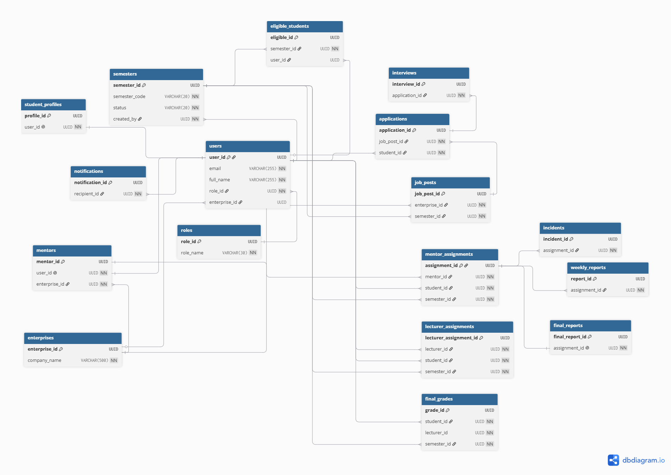

Overview

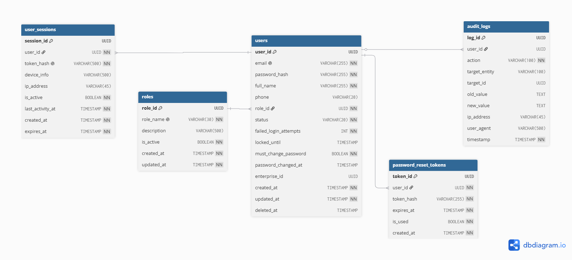

Authentication & User Management
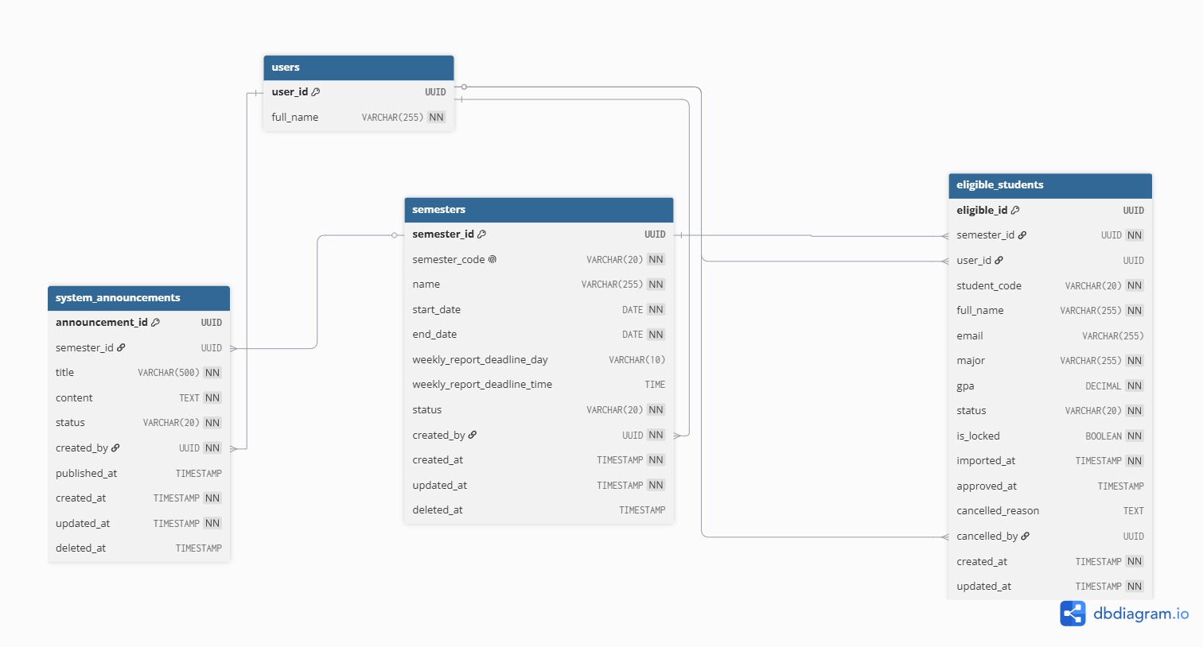

Semester & Training Management

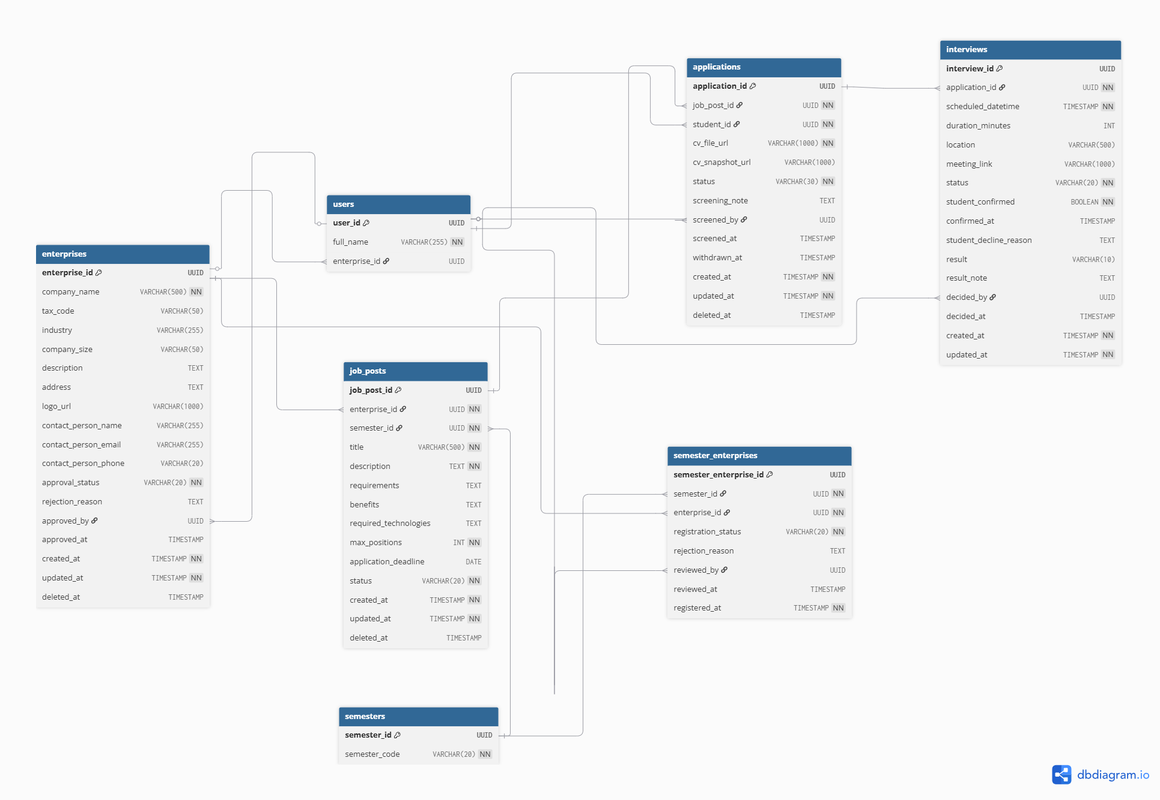

Enterprise & Recruitment

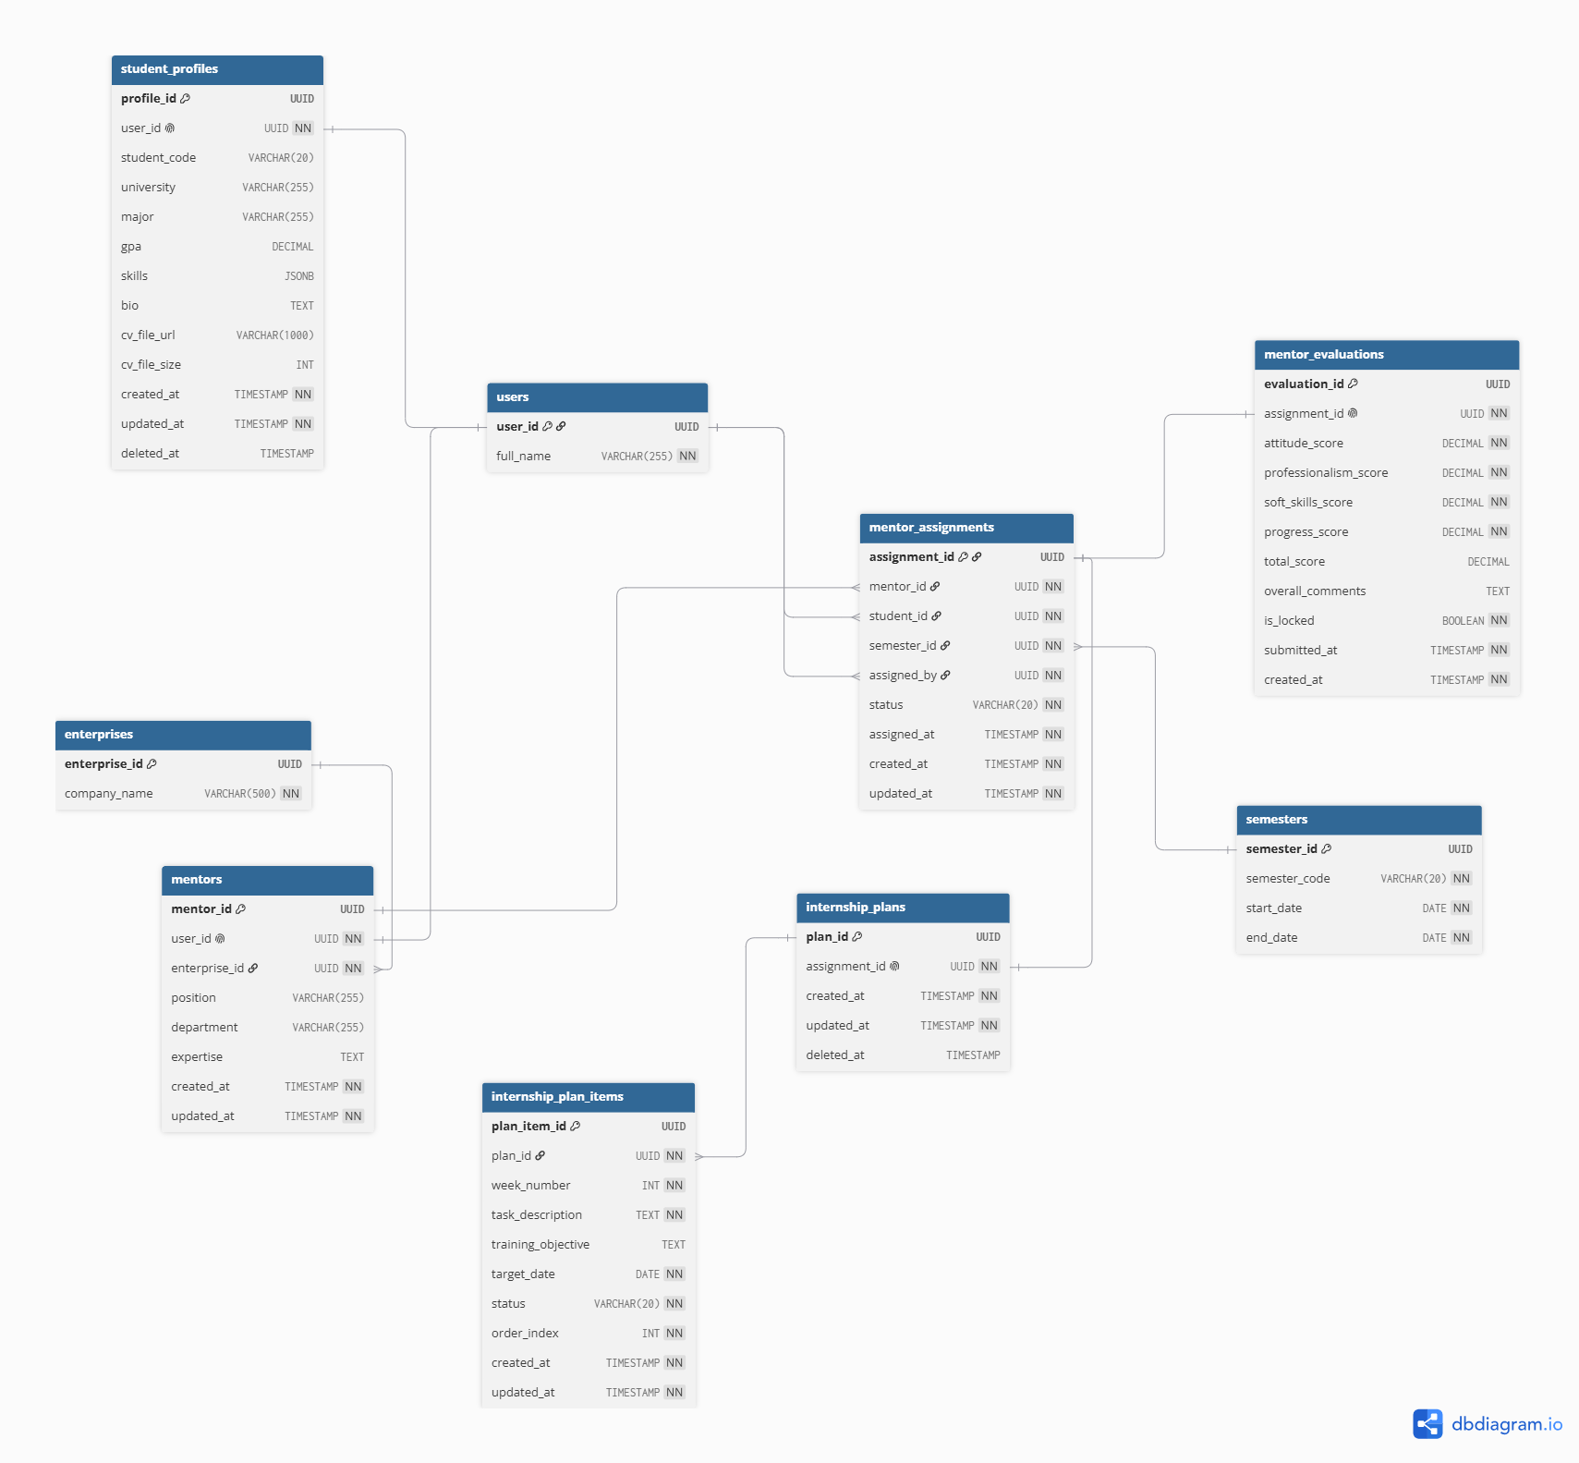
Student & Enterprise
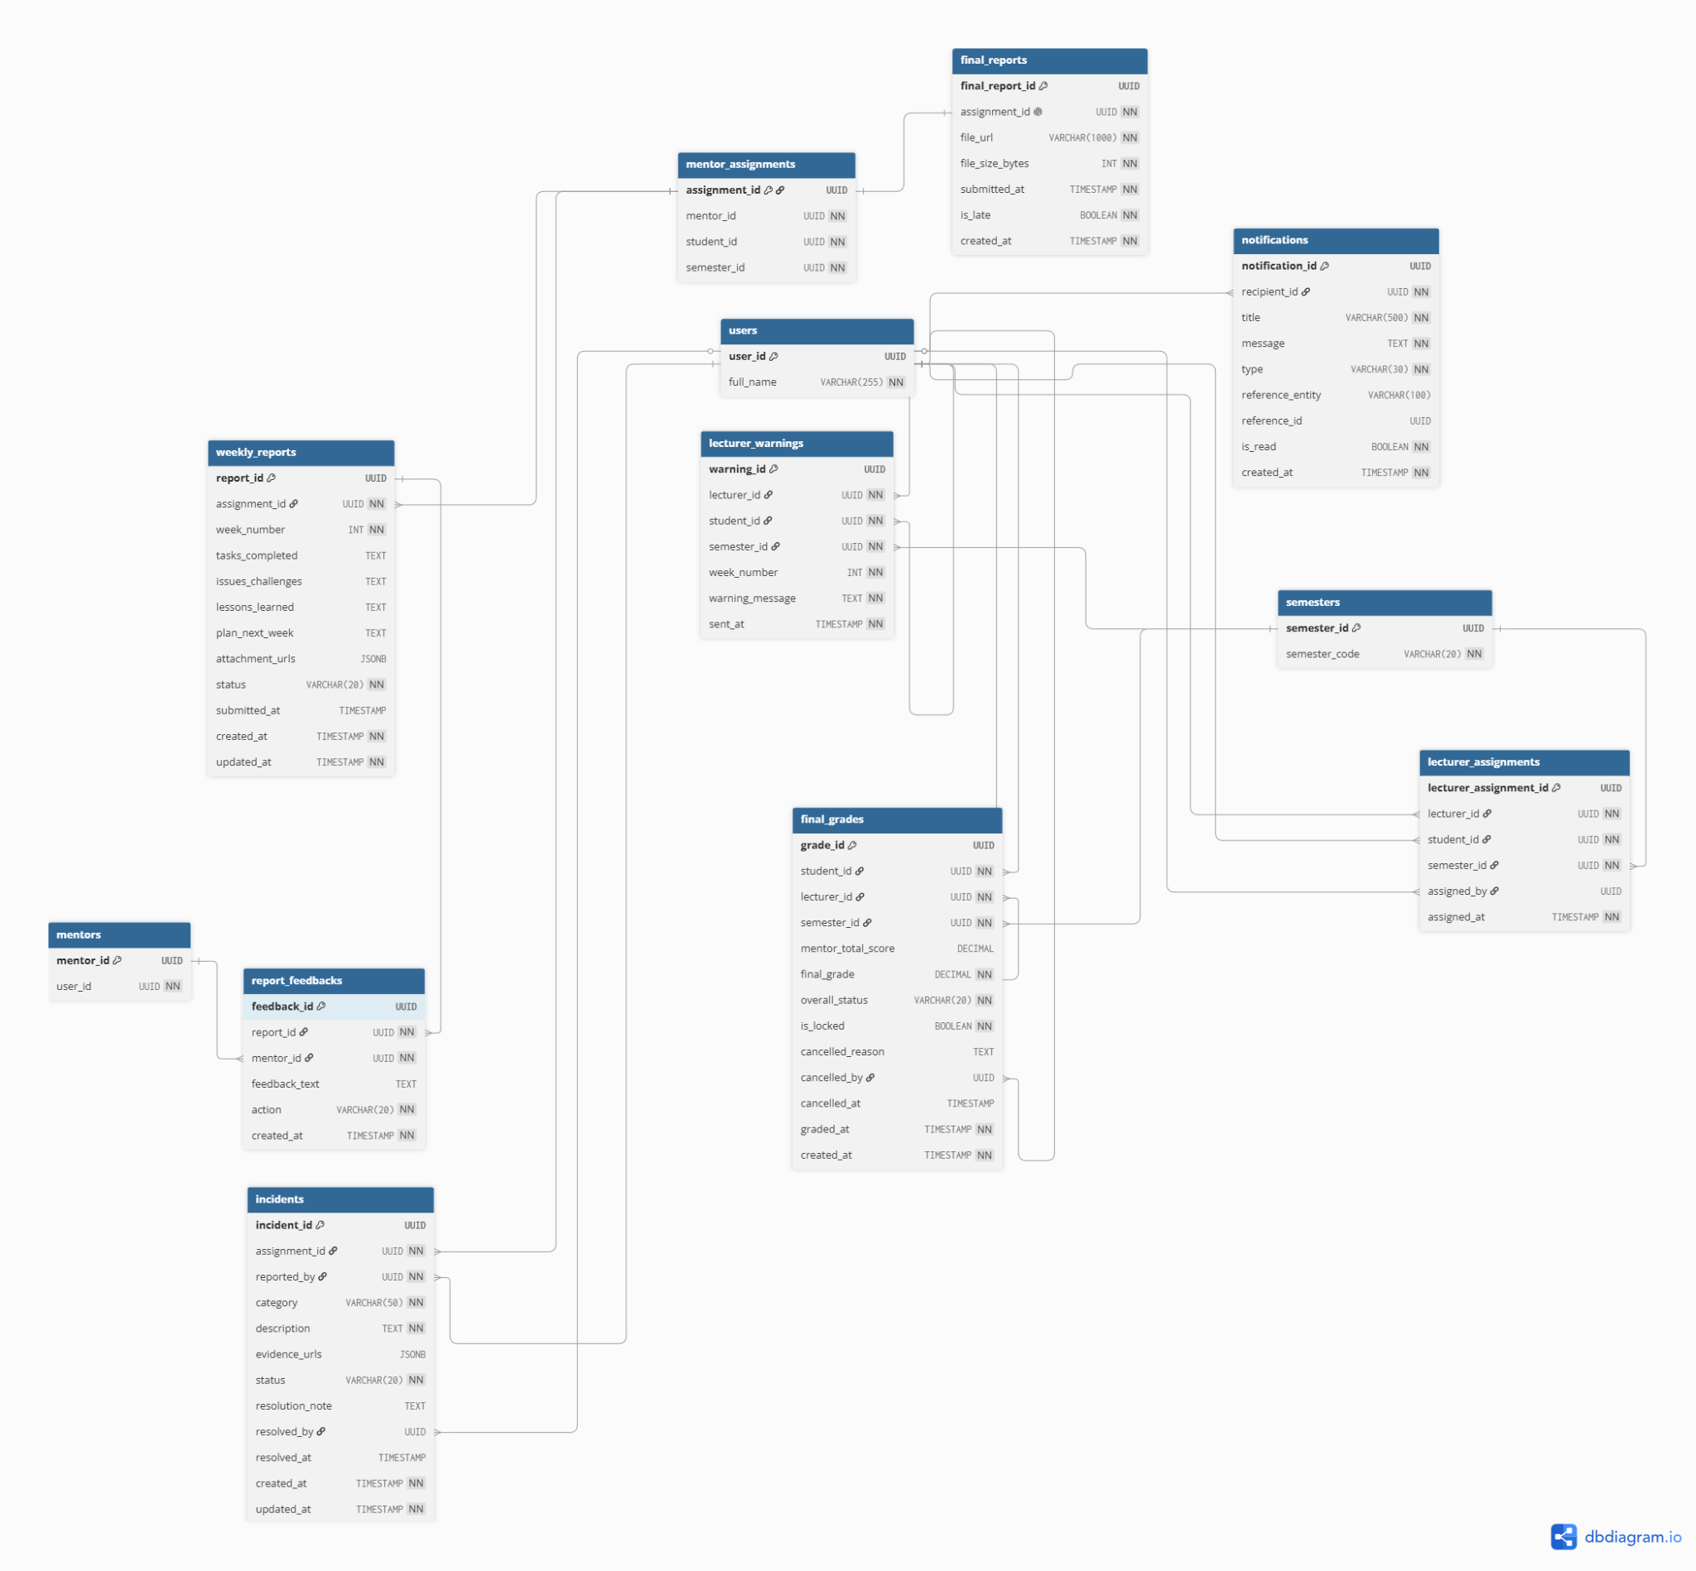
Reports & Incident & Grading & Notifications

b. Table Descriptions

No | Table | Description
01 | roles | Static authorization table for RBAC. Stores the 6 system roles: ADMIN, TRAINING_MANAGER, ENTERPRISE, Enterprise, Training Manager, STUDENT.  Primary key: role_id  Foreign keys: —
02 | users | Central table for all 6 actor types. Each user has exactly one role (BR-06). Supports soft delete, account locking after 5 failed attempts (BR-01), and forced password change on first login (BR-04).  Primary key: user_id  Foreign keys: role_id → roles.role_id, enterprise_id → enterprises.enterprise_id
03 | user_sessions | Active session tracking. Enforces single active session per user (BR-02) and 15-minute inactivity timeout (BR-03).  Primary key: session_id  Foreign keys: user_id → users.user_id
04 | password_reset_tokens | Temporary tokens for password reset workflow (UC-03, UC-04). Tokens expire after a set time and can only be used once.  Primary key: token_id  Foreign keys: user_id → users.user_id
05 | audit_logs | Immutable system activity log (UC-12, UC-13). All actions are append-only — UPDATE and DELETE are blocked by trigger trg_audit_immutable (BR-07).  Primary key: log_id  Foreign keys: user_id → users.user_id
06 | semesters | Internship semester configuration (UC-14 → UC-17). Status follows a strict state machine: DRAFT → OPEN → ACTIVE → CLOSED → LOCKED (BR-13). Dates cannot be modified once ACTIVE (BR-12). LOCKED semesters are fully read-only (BR-11).  Primary key: semester_id  Foreign keys: created_by → users.user_id
07 | eligible_students | Students eligible for OJT, imported via Excel by Training Manager (UC-20, UC-21). Requires minimum GPA ≥ 2.0 (BR-19). Status tracks student progress: ELIGIBLE → PENDING → ACCEPTED → MATCHED → OJT → CANCELLED. Records can be locked (BR-21) and frozen when semester is LOCKED (BR-14).  Primary key: eligible_id  Foreign keys: semester_id → semesters.semester_id, user_id → users.user_id, cancelled_by → users.user_id
08 | system_announcements | System-wide announcements created by Training Manager (UC-28). Supports DRAFT, PUBLISHED, and ARCHIVED statuses. Can be linked to a specific semester.  Primary key: announcement_id  Foreign keys: semester_id → semesters.semester_id, created_by → users.user_id
09 | enterprises | Enterprise/company profiles (UC-30, UC-31, UC-19). Approval workflow: PENDING → APPROVED / REJECTED. Rejection reason is mandatory when rejected (BR-15).  Primary key: enterprise_id  Foreign keys: approved_by → users.user_id
10 | semester_enterprises | Junction table: Enterprises register to participate in a specific semester (UC-18, UC-19). Each enterprise can register once per semester (UNIQUE constraint). Rejection reason is mandatory when rejected (BR-15).  Primary key: semester_enterprise_id  Foreign keys: semester_id → semesters.semester_id, enterprise_id → enterprises.enterprise_id, reviewed_by → users.user_id
11 | job_posts | Job postings by enterprises within a semester (UC-32, UC-33). Each post belongs to one enterprise (BR-25). Status: OPEN / CLOSED — new applications are blocked when CLOSED (BR-26).  Primary key: job_post_id  Foreign keys: enterprise_id → enterprises.enterprise_id, semester_id → semesters.semester_id
12 | applications | Student applications to job posts (UC-34 → UC-36, UC-44 → UC-46). Status flow: PENDING → SCREENING_PASSED / SCREENING_REJECTED → INTERVIEW_SCHEDULED → ACCEPTED / REJECTED / WITHDRAWN. One active application per student per job post (BR-35). CV snapshot is saved at submission time (BR-36). Withdrawal only before deadline (BR-37).  Primary key: application_id  Foreign keys: job_post_id → job_posts.job_post_id, student_id → users.user_id, screened_by → users.user_id
13 | interviews | Interview scheduling and results (UC-37, UC-38, UC-47, UC-48). Scheduled datetime must be in the future (BR-32). Only SCREENING_PASSED applications can have interviews (BR-33). Result (PASS/FAIL) can only be set when status = COMPLETED (BR-34). Student confirmation is irreversible (BR-38).  Primary key: interview_id  Foreign keys: application_id → applications.application_id, decided_by → users.user_id
14 | student_profiles | Student personal profiles and CV management (UC-41). One-to-one with users table (UNIQUE constraint). CV file size limited to 5MB (BR-28). PDF format only (BR-27).  Primary key: profile_id  Foreign keys: user_id → users.user_id (UNIQUE — 1:1)
15 | Enterprises | Enterprise-specific information linked to an enterprise (UC-55). One-to-one with users table (UNIQUE constraint). Each Enterprise belongs to exactly one enterprise.  Primary key: Enterprise_id  Foreign keys: user_id → users.user_id (UNIQUE — 1:1), enterprise_id → enterprises.enterprise_id
16 | Enterprise_assignments | Central table linking a Enterprise to a Student for a specific semester (UC-40, UC-55). Each Enterprise-student-semester combination is unique. Status: ACTIVE / COMPLETED / TERMINATED.  Primary key: assignment_id  Foreign keys: Enterprise_id → Enterprises.Enterprise_id, student_id → users.user_id, semester_id → semesters.semester_id, assigned_by → users.user_id
17 | internship_plans | Training plan header created by Enterprise for each assignment (UC-56, UC-49). One-to-one with Enterprise_assignments (UNIQUE constraint).  Primary key: plan_id  Foreign keys: assignment_id → Enterprise_assignments.assignment_id (UNIQUE — 1:1)
18 | internship_plan_items | Individual tasks/activities within a training plan (BR-42, BR-43). Each item has a week number, task description, and target date. Target date must fall within the semester date range (BR-43, enforced by trigger).  Primary key: plan_item_id  Foreign keys: plan_id → internship_plans.plan_id
19 | Enterprise_evaluations | Final rubric-based evaluation by Enterprise (UC-60). Four criteria scored 0–10: Attitude (20%), Professionalism (40%), Soft Skills (20%), Progress (20%). Total score is auto-calculated using GENERATED column (BR-47). Locked after submission (BR-48).  Primary key: evaluation_id  Foreign keys: assignment_id → Enterprise_assignments.assignment_id (UNIQUE — 1:1)
20 | weekly_reports | Student weekly work reports (UC-50, UC-51, UC-52, UC-57). One report per week per assignment (UNIQUE constraint). Status: NOT_SUBMITTED → SUBMITTED → APPROVED / REJECTED. Content cannot be edited once SUBMITTED or APPROVED (BR-UC52-01).  Primary key: report_id  Foreign keys: assignment_id → Enterprise_assignments.assignment_id
21 | report_feedbacks | Enterprise feedback on weekly reports (UC-58). Action: APPROVED or REJECTED. Feedback text is mandatory when rejecting (BR-44).  Primary key: feedback_id  Foreign keys: report_id → weekly_reports.report_id, Enterprise_id → Enterprises.Enterprise_id
22 | final_reports | Student final internship report submission (UC-53). One-to-one with Enterprise_assignments (UNIQUE constraint). PDF format only (BR-39). Late submission is tracked (BR-40).  Primary key: final_report_id  Foreign keys: assignment_id → Enterprise_assignments.assignment_id (UNIQUE — 1:1)
23 | Training Manager_assignments | Assigns a Training Manager to supervise Students during a semester (UC-61). Each Training Manager-student-semester combination is unique. Assigned by Training Manager.  Primary key: Training Manager_assignment_id  Foreign keys: Training Manager_id → users.user_id, student_id → users.user_id, semester_id → semesters.semester_id, assigned_by → users.user_id
24 | incidents | Critical incident reports by Enterprise or Training Manager (UC-59, UC-64). Categories: PROLONGED_ABSENCE, DISCIPLINARY_VIOLATION, POOR_ATTITUDE, CONFIDENTIALITY_BREACH, OTHER (BR-45). Resolution note is mandatory when status = RESOLVED (BR-50).  Primary key: incident_id  Foreign keys: assignment_id → Enterprise_assignments.assignment_id, reported_by → users.user_id, resolved_by → users.user_id
25 | Training Manager_warnings | Automated warnings sent to students for late weekly report submissions (UC-63, BR-49). Issued by the supervising Training Manager for a specific week.  Primary key: warning_id  Foreign keys: Training Manager_id → users.user_id, student_id → users.user_id, semester_id → semesters.semester_id
26 | final_grades | Final university grades assigned by Training Manager (UC-65, UC-66). Grade range: 0.0–10.0 (BR-51). Overall status: PASSED / FAILED / CANCELLED. One grade per student per semester (UNIQUE constraint). Locked after submission, with audit trail for cancellations.  Primary key: grade_id  Foreign keys: student_id → users.user_id, Training Manager_id → users.user_id, semester_id → semesters.semester_id, cancelled_by → users.user_id
27 | notifications | In-app notification system for all actors. Types: WARNING, INCIDENT, REPORT_FEEDBACK, INTERVIEW_INVITE, APPLICATION_UPDATE, GRADE_PUBLISHED, SYSTEM_ANNOUNCEMENT. Tracks read/unread status.  Primary key: notification_id  Foreign keys: recipient_id → users.user_id

3.2 Code Packages
[Provide the package diagram for each sub-system. The content of this section including the overall package diagram, the explanation, package and class naming conventions in each package. Please see the sample & description table format below]
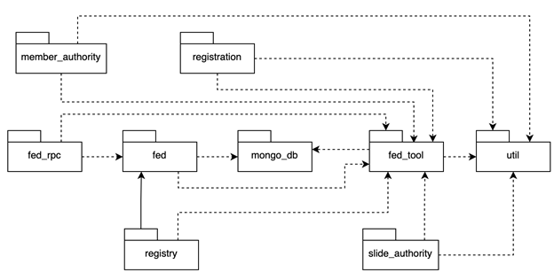
Package descriptions
No | Package | Description
01 | Member_authority | <Description of the package>
02 | registration | <Description of the package>
03 | …

II. Requirement Specifications

1. Common Functions & System Administration

1.1 UC-01_Log into the system

a. Functional Description
UC ID and Name: | UC-01 Log into the system
Created By: | QuangND | Date Created: | 19/May/2026
Primary Actor: | All Actors | Secondary Actors: | None
Trigger: | User accesses the Login page of the UEIMS.
Description: | Allows users to authenticate their identity to access the system using their registered internal accounts.
Preconditions: | PRE-1: User account has been created and authorized in the system.
Postconditions: | POST-1: User logs in successfully, system returns a Stateless JWT Access Token (containing User ID and mapped Permissions), and redirects to the Dashboard.  POST-2: The system tracks the successful login in the System Log..
Normal Flow: | 1.0 Login with an internal account  1. User enters Email and Password into the form and clicks the "Login" button. 2. System validates the login credentials (see 1.0.E1, 1.0.E2) and generates a secure JWT payload.  3. System logs the action and redirects the user to the Dashboard
Alternative Flows: | None
Exceptions: | 1.0.E1 Incorrect login credentials  1. System displays an error message: "Invalid email or password."  2. If failed 5 consecutive times, the system locks the account (BR-01).  3. User is prompted to re-enter credentials.  1.0.E2 Account is deactivated  1. System displays an error message: "Your account has been locked. Please contact the Admin."  2. Use case terminates.
Priority: | High, Must Have
Frequency of Use: | Very High (Every user session)
Business Rules: | BR-01, BR-02, BR-03
Other Information: | Passwords must never be transmitted as plain text. Passwords are securely hashed (BCrypt) in the database
Assumptions: | Assume that users remember their registered email addresses.

b. Business Rules

ID | Business Rule | Business Rule Description
BR-01 | Account Lockout | User accounts are temporarily locked for 30 minutes after 5 consecutive failed login attempts.
BR-02 | Simultaneous Session Control | A user can only maintain one active session. Logging in from a new device invalidates the previous session.
BR-03 | Token Expiration | User session tokens automatically expire after 15 minutes of complete inactivity.

1.2 UC-02_Log out

a. Functional Description
UC ID and Name: | UC-02 Log out
Created By: | QuangND | Date Created: | 19/May/2026
Primary Actor: | All Actors | Secondary Actors: | None
Trigger: | User clicks the "Logout" button on the system header or profile menu.
Description: | Destroys the user's active session by adding the JWT to the Blacklist table and redirects them back to the Login page..
Preconditions: | PRE-1: User is currently logged into the system.
Postconditions: | POST-1: The user's JWT ID (jti) is added to the invalidated_tokens blacklist.  POST-2: User is restricted from accessing internal pages without authenticating again.
Normal Flow: | 2.0 System Logout  1. User clicks the "Logout" button.  2. System calls the authentication service to insert the active token JTI into the invalidated_tokens table.  3. System redirects the user to the Login page.
Alternative Flows: | None
Exceptions: | None
Priority: | High, Must Have
Frequency of Use: | High (Every time a user finishes a session).
Business Rules: | BR-03
Other Information: | If the token is a JWT, it is appended to the server-side token blacklist until its natural expiration time to prevent reuse.
Assumptions: | None

b. Business Rules
ID | Business Rule | Business Rule Description
BR-03 | Token Expiration | User session tokens automatically expire after 15 minutes of complete inactivity.

1.3 UC-03_Forgot password

a. Functional Description
UC ID and Name: | UC-03 Forgot password
Created By: | QuangND | Date Created: | 19/May/2026
Primary Actor: | All Actors | Secondary Actors: | Email System (SMTP)
Trigger: | User clicks the "Forgot Password?" link on the Login screen.
Description: | Allows internal account users to request a password reset link via email when they forget their credentials.
Preconditions: | None
Postconditions: | POST-1: A secure, time-sensitive password reset link is generated and dispatched to the user's email. .
Normal Flow: | 3.0 Request password reset  1. User enters their registered Email address and clicks the "Send Request" button.  2. System verifies the existence of the email address in the database (see 3.0.E1).  3. System generates a secure, unique reset Token.  4. System dispatches an email containing the reset link embedded with the Token.  5. System displays a success message instructing the user to check their inbox.
Alternative Flows: | None
Exceptions: | 3.0.E1 Email does not exist (Branches from step 2 of 3.0)  1. System displays an error message: "Email address not found in the system."  2. User is prompted to re-enter the email address (rejoins step 1 of 3.0).
Priority: | High, Must Have
Frequency of Use: | Low
Business Rules: | None
Other Information: | To mitigate user enumeration attacks, the system response time remains consistent regardless of whether the email exists.
Assumptions: | The external SMTP server configuration is valid and operational.

b. Business Rules

None

1.4 UC-04_Reset password

a. Functional Description
UC ID and Name: | UC-04 Reset password
Created By: | QuangND | Date Created: | 19/May/2026
Primary Actor: | All Actors | Secondary Actors: | None
Trigger: | User clicks the reset link received in their email, or logs in for the first time with an Admin-issued temporary account.
Description: | Enforces the user to configure a new password to restore or secure account access.
Preconditions: | PRE-1: The security token contained within the URL parameters must be valid and unexpired.
Postconditions: | POST-1: The new password is encrypted and updated in the database.  POST-2: The specific reset token is permanently invalidated.
Normal Flow: | 4.0 Configure new password  1. User clicks the email reset link.  2. System validates the token parameters (see 4.0.E1) and renders the Reset Password interface.  3. User inputs a New Password, re-enters it in the Confirmation field, and clicks "Save Password".  4. System evaluates password complexity constraints (apply BR-04) and verifies field match (see 4.0.E2).  5. System encrypts the password data and updates the database records.  6. System invalidates the token and redirects the user to the Login page with a success confirmation.
Alternative Flows: | None
Exceptions: | 4.0.E1 Token invalid or expired (Branches from step 2 of 4.0)  1. System blocks access and displays an error screen: "This security link is invalid or has expired."  2. Use case terminates.  4.0.E2 Password mismatch or complexity failure (Branches from step 4 of 4.0)  1. System displays a validation error message on the user interface.  2. User is prompted to re-enter a valid password setup (rejoins step 3 of 4.0).
Priority: | High, Must Have
Frequency of Use: | Low
Business Rules: | BR-04
Other Information: | Upon successful password update, all other active sessions for this specific user ID are terminated.
Assumptions: | None

b. Business Rules
ID | Business Rule | Business Rule Description
BR-04 | Password Complexity | Passwords must be at least 8 characters long, containing uppercase, lowercase, numbers, and special characters.

1.5 UC-05_Change personal password

a. Functional Description
UC ID and Name: | UC-05 Change personal password
Created By: | QuangND | Date Created: | 19/May/2026
Primary Actor: | All Actors | Secondary Actors: | None
Trigger: | User navigates to the Account Settings/Profile menu and selects the "Change Password" tab.
Description: | Allows authenticated internal account users to proactively update their active passwords for security maintenance.
Preconditions: | PRE-1: User is successfully authenticated and logged into an internal system account.
Postconditions: | POST-1: The user's password record is modified with the newly encrypted data.
Normal Flow: | 5.0 Update personal password  1. User populates the Current Password, New Password, and Confirm New Password inputs, then clicks "Update".  2. System validates the input authenticity against the current password database record (see 5.0.E1).  3. System runs complexity checks (apply BR-05) and verifies matching fields (see 5.0.E2).  4. System encrypts the data and commits the change to the database.  5. System renders a success notification on the profile interface.
Alternative Flows: | None
Exceptions: | 5.0.E1 Verification failure of current password (Branches from step 2 of 5.0)  1. System rejects the transaction and flags the "Current Password" field with an incorrect data warning.  2. User is prompted to re-input the proper password (rejoins step 1 of 5.0).  5.0.E2 Password mismatch or complexity failure (Branches from step 3 of 5.0)  1. System highlights the validation errors on the form interface.  2. User is prompted to correct the input fields (rejoins step 1 of 5.0)
Priority: | Medium, Should Have
Frequency of Use: | Occasional
Business Rules: | BR-04
Other Information: | None
Assumptions: | None

b. Business Rules
ID | Business Rule | Business Rule Description
BR-04 | Password Complexity | Passwords must be at least 8 characters long, containing uppercase, lowercase, numbers, and special characters.

1.6 UC-06_View user account list

a. Functional Description
UC ID and Name: | UC-06 View user account list
Created By: | QuangND | Date Created: | 19/May/2026
Primary Actor: | System Admin | Secondary Actors: | None
Trigger: | Admin clicks the "Account Management" tab from the main navigation panel.
Description: | Displays a complete, paginated structural table containing all user accounts within the UEIMS database, equipped with search and filter parameters.
Preconditions: | PRE-1: User is successfully authenticated and logged into an internal system account.
Postconditions: | POST-1: System successfully displays the account record data table with default configuration properties.
Normal Flow: | 6.0 Display default account list  1. Admin triggers the Account Management menu view.  2. System fetches the user accounts from the database and displays the data fields (ID, Name, Email, Role, Status) in a tabulated view (see 6.0.E1).
Alternative Flows: | 6.1 Search and Filter execution (Branches from step 2 of 6.0)  1. Admin enters query strings (Name/Email) or filters by specific Role or Status configurations, then clicks "Search".  2. System processes the conditional database query and refreshes the data grid view.  3. Flow rejoins step 2 of 6.0.
Exceptions: | 6.0.E1 No data matching query parameters (Branches from step 2 of 6.0 or step 2 of 6.1)  1. System displays an empty data table view containing a "No records found" alert message.  2. Flow rejoins step 2 of 6.0.
Priority: | High, Must Have
Frequency of Use: | Medium
Business Rules: | None
Other Information: | Standard system interface default pagination limits rows to exactly 20 records per page.
Assumptions: | None

b. Business Rules
None

1.7 UC-07_View user account details

a. Functional Description
UC ID and Name: | UC-07 View user account details
Created By: | QuangND | Date Created: | 19/May/2026
Primary Actor: | System Admin | Secondary Actors: | None
Trigger: | Admin clicks the "View Details" control icon on a designated user profile row..
Description: | Displays the granular metadata profile, detailed permission logs, and audit trails associated with a specified individual account
Preconditions: | PRE-1: Admin is active on the main Account Management list page.
Postconditions: | POST-1: System renders the granular information modal view for the target user.
Normal Flow: | 7.0 Display account data context  1. Admin selects the account record row detail control.  2. System fetches full database parameters for the designated User ID (see 7.0.E1).  3. System renders a detailed overlay view showing Name, Email, Phone, Role, Status, Creation Date, and Last Login Timestamp metrics.
Alternative Flows: | None
Exceptions: | 7.0.E1 Record identifier missing or database mismatch (Branches from step 2 of 7.0)  1. System flashes an error banner: "Target record identifier could not be resolved."  2. Use case terminates.
Priority: | High, Must Have
Frequency of Use: | Medium
Business Rules: | None
Other Information: | For security validation, the password hash sequence string must never be sent to or exposed within the frontend view component structure.
Assumptions: | None

b. Business Rules
None

1.8 UC-08_Create new account

a. Functional Description
UC ID and Name: | UC-08 Create new account
Created By: | QuangND | Date Created: | 19/May/2026
Primary Actor: | System Admin | Secondary Actors: | Email System
Trigger: | Admin clicks the "Add New User" button on the Account Management interface.
Description: | Provisions a brand-new internal system user account by defining identities, operational scopes, and role bindings manually.
Preconditions: | PRE-1: Admin session contains authorized permission tokens to write user accounts.
Postconditions: | POST-1: New user data is registered into the CSDL.  POST-2: An automated transaction email containing random temporary access credentials is sent out to the user.
Normal Flow: | 8.0 Manual account provisioning  1. Admin invokes the initialization wizard panel.  2. System displays empty data fields for Name, Email, Phone, and Role allocation selection.  3. Admin completes the configuration forms and clicks the "Save" execution button.  4. System evaluates database constraints for Email value duplication (apply BR-05) (see 8.0.E1).  5. System securely auto-generates a temporary random password string sequence. 6. System hashes the temporary string and persists the record into the database. 7. System triggers the SMTP sub-system to dispatch the login info to the newly registered address.
Alternative Flows: | None
Exceptions: | 8.0.E1 Constraint conflict: Duplicate email identity detected (Branches from step 4 of 8.0)  1. System stops data storage and flags the input field: "This email address is already bound to another profile."  2. Admin is prompted to correct the structural data parameters (rejoins step 3 of 8.0).
Priority: | High, Must Have
Frequency of Use: | Occasional
Business Rules: | BR-05, BR-06
Other Information: | Student system access provisions are explicitly handled via mass automation upload datasets (Import Excel) rather than individual manual entries.
Assumptions: | The target user owns or controls the email account specified.

b. Business Rules
ID | Business Rule | Business Rule Description
BR-05 | Unique Email Constraint | The email address must be universally unique across all roles in the system.
BR-06 | Single Role Assignment | An account can only possess one primary role (e.g., a student cannot simultaneously be an enterprise representative).

1.9 UC-09_Update account information

a. Functional Description
UC ID and Name: | UC-09 Update account information
Created By: | QuangND | Date Created: | 19/May/2026
Primary Actor: | System Admin | Secondary Actors: | Email System
Trigger: | Admin clicks the "Edit" pencil utility tool link on a user record data row.
Description: | Updates identity text values (Full Name, Contact numbers) to maintain demographic data precision.
Preconditions: | PRE-1: Admin has successfully opened the targeted user profile record modification modal panel.
Postconditions: | POST-1: Structural changes are written into the database record attributes.
Normal Flow: | 9.0 Modify base identity attributes  1. System serves the data input form layout pre-loaded with current attribute values.  2. Admin modifies Name or Phone properties and clicks the "Update" control button.  3. System evaluates syntax constraints and processes the modification transaction.  4. System closes the interaction view and displays a success message.
Alternative Flows: | None
Exceptions: | None
Priority: | Medium, Should Have
Frequency of Use: | Occasional.
Business Rules: | BR-05
Other Information: | Within this interface context, core transactional tracking identifiers such as the User Email property remain strictly Read-Only to safeguard system integrity.
Assumptions: | None

b. Business Rules

ID | Business Rule | Business Rule Description
BR-05 | Unique Email Constraint | The email address must be universally unique across all roles in the system.

1.10 UC-10_Update account status

a. Functional Description
UC ID and Name: | UC-10 Update account status
Created By: | QuangND | Date Created: | 19/May/2026
Primary Actor: | System Admin | Secondary Actors: | None
Trigger: | Admin toggles the "Active/Inactive" switch matrix indicator on a user control vector.
Description: | Controls account lifecycle state parameters; accounts marked as Inactive are locked out from system features.
Preconditions: | PRE-1: Admin cannot change the state properties of their own active session context block.
Postconditions: | POST-1: Account execution properties are written as Active or Inactive in the database.
Normal Flow: | 10.0 Modify target account operational state  1. Admin invokes the state modifier control on a chosen profile item line.  2. System validates structural parameters against safety rules (see 10.0.E1) and prompts a validation popup message.  3. Admin selects "Confirm".  4. System writes Status = Inactive or Status = Active to the database record matrix table attributes.  5. System refreshes the listing data visualization and shows a success confirmation message.
Alternative Flows: | None
Exceptions: | 10.0.E1 Execution exception: Action validation failure (Branches from step 2 of 10.0)  1. System blocks the execution thread and warns: "Action denied. You cannot modify your own profile status or administrative structural locks."  2. Use case terminates.
Priority: | High, Must Have
Frequency of Use: | Occasional.
Business Rules: | None
Other Information: | Setting an active account status flag property to Inactive forces an immediate teardown of active session authentication blocks (Force Logout) on the next API call event.
Assumptions: | None

b. Business Rules
None

1.11 UC-11_Assign Role

a. Functional Description
UC ID and Name: | UC-11 Assign Role
Created By: | QuangND | Date Created: | 19/May/2026
Primary Actor: | System Admin | Secondary Actors: | None
Trigger: | Allows System Admin to map multiple operational roles and permissions to a single account using the new Many-To-Many RBAC architecture.
Description: | Maps or overrides system functional boundaries by binding or re-assigning role structures to a user account profile.
Preconditions: | PRE-1: Roles (Admin, TM, EN, ST, ME, LE) must be defined within the static system authorization tables.
Postconditions: | POST-1: Structural user role mapping reference records are updated in the database.
Normal Flow: | 11.0 Modify user role assignment mapping  1. Admin navigates to the role assignment menu workspace for a user profile. 2. System serves a choice matrix containing all valid system operational role options (Admin, TM, Enterprise, Student).  3. Admin selects the operational role parameters (can be multiple) and clicks "Save Configuration".  4. System evaluates constraints and inserts/overwrites the mapping records into the users_roles junction table.  5. System flashes an update confirmation notification.
Alternative Flows: | None
Exceptions: | None
Priority: | High, Must Have.
Frequency of Use: | Rare.
Business Rules: | BR-06
Other Information: | None
Assumptions: | None

b. Business Rules

ID | Business Rule | Business Rule Description
BR-06 | Single Role Assignment | An account can only possess one primary role (e.g., a student cannot simultaneously be an enterprise representative).

1.12 UC-12_View system Audit log

a. Functional Description
UC ID and Name: | UC-12 View System Audit log
Created By: | QuangND | Date Created: | 19/May/2026
Primary Actor: | System Admin | Secondary Actors: | None
Trigger: | Admin selects the "System Audit Logs" option segment from the sidebar navigation console layout.
Description: | Serves an administrative read-only stream audit view tracking transactions, login anomalies, data overrides, and system security logs.
Preconditions: | PRE-1: System log records must exist in the append-only data store log architecture.
Postconditions: | POST-1: System successfully displays the historical log table visualization grid framework.
Normal Flow: | 12.0 Display activity audit logs  1. Admin clicks the System Logs segment link tool.  2. System fetches the log payload schema fields (Timestamp, User ID, Action Type, IP Vector, Status Code) and prints the entries on a paginated grid list view.
Alternative Flows: | 12.1 Filter log payload criteria arrays (Branches from step 2 of 12.0)  1. Admin selects a specific event date horizon range or filters by targeted action profile categories and clicks "Filter".  2. System processes the conditional filter parameters across the data payload block and updates the data window visibility.  3. Flow rejoins step 2 of 12.0.
Exceptions: | None
Priority: | Medium, Should Have.
Frequency of Use: | Occasional (Invoked during security validation audits or system trace events).
Business Rules: | BR-07
Other Information: | None
Assumptions: | None

b. Business Rules
ID | Business Rule | Business Rule Description
BR-07 | Audit Log Append-Only | System logs are immutable. They can only be appended to and never deleted or modified.

1.13 UC-13_Export system log data

a. Functional Description
UC ID and Name: | UC-13 Export system log data
Created By: | QuangND | Date Created: | 19/May/2026
Primary Actor: | System Admin | Secondary Actors: | None
Trigger: | Admin clicks the "Export to Excel" action utility button on the System Logs control workspace.
Description: | Pulls the active system trace log dataset and packages the data into a downloadable Microsoft Excel document (.xlsx) sheet for archiving.
Preconditions: | PRE-1: Log tracing entries must be present on the active interface viewport context block.
Postconditions: | POST-1: An automated binary download stream delivers the processed spreadsheet directly onto the client local environment storage.
Normal Flow: | 13.0 Generate log spreadsheet export package  1. Admin initiates the spreadsheet generation tool via the Export button.  2. System measures record size dimensions against processing capacity limits (see 13.0.E1).  3. System maps data values to an .xlsx data frame file format.  4. System initializes a download delivery stream package down onto the user's client browser system context.
Alternative Flows: | None
Exceptions: | 13.0.E1 Data volume threshold breach (Branches from step 2 of 13.0)  1. System stops file compiling and warns: "Export aborted. Record count exceeds 50,000 threshold. Please shrink your search horizon filter properties."  2. Use case terminates.
Priority: | Low, Could Have
Frequency of Use: | Rare
Business Rules: | None
Other Information: | The export threshold for System Logs is set at 50,000 records (higher than the standard 10,000-record limit for other exports) because each log entry is significantly smaller in data size (~100 bytes) compared to structured business records. This higher threshold is technically safe and aligns with system performance benchmarks
Assumptions: | The active server memory footprint scope has sufficient room to buffer the generated output dataset spreadsheet arrays.

b. Business Rules
ID | Business Rule | Business Rule Description
BR-07 | Audit Log Append-Only | System logs are immutable. They can only be appended to and never deleted or modified.

2. Training Management Feature

2.1 UC-14_View Semester List

a. Functional Description
UC ID and Name: | UC-14 View Semester List
Created By: | HuanHM | Date Created: | 20/05/2026
Primary Actor: | Training Manager | Secondary Actors: | None
Trigger: | Training Manager needs to view, monitor, or manage existing semesters.
Description: | The Training Manager views the list of all semesters (past, current, and upcoming) with key information to support planning and management of the OJT process.
Preconditions: | PRE-1: The Training Manager is logged into the system with appropriate privileges.
Postconditions: | POST-1:The system displays an updated list of semesters with relevant details.  Training Manager can navigate to other related functions (Create, Edit, Update Status, Lock…).
Normal Flow: | 14.0 View List and Filter Semesters  1. The Training Manager navigates to the “Semester Management” module.  2. The System displays the list of all semesters with columns: Semester Code, Semester Name, Start Date, End Date, Status (Open/Closed/Active/Locked), Total Students, Total Enterprises.  3. The Training Manager can filter by Status or Academic Year.  4. The Training Manager can search by Semester Code or Name. 5. The Training Manager can click on a semester to view details or perform actions (Edit, Update Status, Lock Data).
Alternative Flows: | 14.1 Sorting and Pagination  1. Sorting: The Training Manager can sort the list by Start Date, End Date, or Status.  2. Pagination: The system supports pagination when the number of semesters is large.
Exceptions: | None
Priority: | High
Frequency of Use: | High (almost daily during management period)
Business Rules: | None
Other Information: | Should support export semester list to Excel.
Assumptions: | Semester data has been created in the system.

b. Business Rules
None

2.2 UC-15_Create New Semester

a. Functional Description
UC ID and Name: | UC-15 Create New Semester
Created By: | HuanHM | Date Created: | 20/05/2026
Primary Actor: | Training Manager | Secondary Actors: | None
Trigger: | A new OJT semester needs to be established (typically at the beginning of each academic period).
Description: | The Training Manager creates a new semester by defining basic information, time frame, and initial configuration to prepare for the entire OJT cycle.
Preconditions: | PRE-1: The Training Manager is logged into the system with appropriate privileges.  PRE-2: No overlapping semester with the same code or conflicting timeline exists.
Postconditions: | POST-1: new semester is successfully created with initial status “Draft”.  POST-2: The semester appears in the Semester List (UC-14).
Normal Flow: | 15.0 Create New Semester Record  1. The Training Manager navigates to the “Semester Management” module.  2. The Training Manager clicks “Create New Semester”.  3. The System displays the creation form.  4. The Training Manager enters: Semester Code (e.g., 2026-Summer), Semester Name, Start Date, End Date, and other configuration (optional).  5. The System validates the data (no duplicate code, logical timeline) [BR-03].  6. The Training Manager clicks “Save”.  7. The System creates the new semester with default status “Draft”.  8. The System displays a success message and offers to navigate to the new semester details.
Alternative Flows: | 15.1 Copy Settings from Template  The Training Manager can copy settings from a previous semester (template).
Exceptions: | 15.0.E1 Validation Error (Duplicate Code/Invalid Timeline)  1. Validation Error: If Semester Code already exists or timeline is invalid (End Date ≤ Start Date, overlapping with another semester), the System highlights the error and prevents saving.  15.0.E2 Duplicate Timeline Warning  2. Duplicate Timeline: If the new semester timeline overlaps with an existing one, the System shows a warning.
Priority: | High, Must Have
Frequency of Use: | Low (1–2 times per year)
Business Rules: | BR-08, BR-09, BR-10
Other Information: | Semester Code should follow a consistent naming convention.
Assumptions: | Training Manager has clear academic calendar information before creation.

b. Business Rules
ID | Business Rule | Business Rule Description
BR-8 | Unique Semester Code. | Semester codes (e.g., SU26) must be strictly unique system-wide.
BR-9 | Timeline Integrity | A semester's Start Date must strictly precede its End Date.
BR-10 | Initial Semester Status | Newly created semesters must inherently start with the "Draft" status.

2.3 UC-16_Edit Semester Information

a. Functional Description
UC ID and Name: | UC-16 Edit Semester Information
Created By: | HuanHM | Date Created: | 20/05/2026
Primary Actor: | Training Manager | Secondary Actors: | None
Trigger: | There is a need to adjust the information or timeline of an existing semester.
Description: | The Training Manager modifies basic information and timeline of a semester that has not been locked yet.
Preconditions: | PRE-1: The Training Manager is logged into the system with appropriate privileges.  PRE-2: The selected semester has not been locked (status ≠ Locked).
Postconditions: | POST-1: Semester information is successfully updated.  POST-2: Related rules (application period, notifications…) are affected accordingly.
Normal Flow: | 16.0 Modify Existing Semester Details  1. The Training Manager navigates to “Semester Management” module (UC-14).  2. The Training Manager selects the desired semester from the list.  3. The Training Manager clicks “Edit Semester”.  4. The System displays current semester information in editable form.  5. The Training Manager modifies necessary fields (Name, Start Date, End Date, etc.).  6. The System validates the changes [BR-11, BR-12].  7. The Training Manager clicks “Save”.  8. The System updates the semester information and displays a success message.
Alternative Flows: | None
Exceptions: | 16.0.E1 Invalid Timeline or Overlap  Invalid Timeline: If the new timeline is invalid or overlaps with another semester, the System shows error and prevents saving.  16.0.E2 Locked Semester  Locked Semester: If the semester is already “Locked”, the System disables the Edit function and shows a notification.  16.0.E3 Data Conflict on Active/Approved Semester  Data Conflict: If the semester status is “Active” or beyond, the System disables editing for core fields (Semester Code, Start Date, End Date, Eligibility Criteria) and displays a warning about potential impact.
Priority: | High
Frequency of Use: | Medium
Business Rules: | BR-11, BR-12
Other Information: | Changes to timeline may affect application periods and student access. Audit log should record all edits.
Assumptions: | Major changes to timeline should be done before the semester becomes active.

b. Business Rule
ID | Business Rule | Business Rule Description
BR-11 | Locked Semester Edit Block | Semesters holding a "Locked" status are read-only and cannot be edited.
BR-12 | Date Modification Constraint | Modifying dates of an "Active" semester is restricted and requires overriding confirmations..

2.4 UC-17_Update Semester Status

a. Functional Description
UC ID and Name: | UC-17 Update Semester Status
Created By: | HuanHM | Date Created: | 20/05/2026
Primary Actor: | Training Manager | Secondary Actors: | None
Trigger: | A change in the operational status of a semester (e.g., opening applications, closing period) is required.
Description: | Change the status of a semester (Close/Open/Active) to automatically prevent students from submitting applications for the wrong term.
Preconditions: | PRE-1: The Training Manager is logged into the system.  PRE-2: The semester data has not been locked.
Postconditions: | POST-1: The semester status is successfully updated to the target state. The full permissible status lifecycle is: Draft → Open → Active → Closed → Locked. The system enforces this one-directional state machine and rejects any backward or invalid transitions (BR-13). Note: The Locked terminal state is exclusively triggered via UC-24 (Lock Semester Data), not through this UC.
Normal Flow: | 17.0 Change Semester Operational Status  1. The Training Manager navigates to the “Semester Management” module.  2. The Training Manager selects the desired semester from the list.  3. The Training Manager clicks "Update Status" and selects the new status (e.g., Active, Closed, Open).  4. The System validates the status change (e.g., adherence to BR-13 (Status State Machine) ).  5. The System updates the semester status and displays a success message.
Alternative Flows: | 17.1 Restoring the Previous State  Rollback to Previous Status: Training Manager chooses to undo the last status change within a short time window (e.g., 5 minutes) before the change is fully applied across the system.
Exceptions: | 17.0.E1 Invalid Status Transition  Invalid Status Change: If the requested status transition is invalid (e.g., Active to Open), the System displays an error message and prevents the change.  17.0.E2 Data Lock Conflict  Data Lock Conflict: If the requested semester is currently in the “Locked” status (via UC-24), the System prevents status update and displays a message: “Semester data is locked. Contact System Admin to unlock.”
Priority: | High
Frequency of Use: | High
Business Rules: | BR-13, BR-14
Other Information: | 1. Requires system validation logic for permissible status changes.  2. State Transition Table (Governed by BR-13): Allowed transitions are: Open -> Active -> Closed -> Locked (UC-24).  3. Invalid transitions (e.g., Active to Open, Closed to Draft) must be blocked by the system.
Assumptions: | The available statuses (Open, Closed, Active) are clearly defined regarding their impact on user access.

b. Business Rules
ID | Business Rule | Business Rule Description
BR-13 | Status State Machine | Semester status only transitions forward: Draft → Open → Active → Closed → Locked.
BR-14 | Permanent Lock Implication | Setting status to "Locked" permanently freezes all related OJT data (Read-Only).

2.5 UC-18_View Enterprise List

a. Functional Description
UC ID and Name: | UC-18 View Enterprise List
Created By: | HuanHM | Date Created: | 20/05/2026
Primary Actor: | Training Manager | Secondary Actors: | None
Trigger: | The Training Manager clicks on the “Enterprise Management” menu item to access the list of registered enterprises.
Description: | Manage the list of affiliated enterprises that have submitted registration applications to the system.
Preconditions: | PRE-1: The Training Manager is logged into the system.
Postconditions: | POST-1: The system displays the complete and updated list of registered enterprises.
Normal Flow: | 18.0 View Enterprise List and Status  1. The Training Manager navigates to the “Enterprise Management” module.  2. The System displays the list of enterprises with key columns: Enterprise Name, Tax Code, Registration Date, and Account Status (Pending, Approved, Rejected).  3. The Training Manager can filter by status (Pending, Approved, Rejected) or search by name/Tax Code.  4. The Training Manager can select an enterprise to view detailed information.
Alternative Flows: | 18.1 Using Sorting Options  The Training Manager uses sorting options (by registration date, by name).
Exceptions: | None
Priority: | High
Frequency of Use: | High
Business Rules: | None
Other Information: | None
Assumptions: | Enterprise data is collected through the enterprise registration function.

b. Business Rules
None

2.6 UC-19_Approve/Reject Enterprise Registration

a. Functional Description
UC ID and Name: | UC-19 Approve/Reject Enterprise Registration
Created By: | HuanHM | Date Created: | 20/05/2026
Primary Actor: | Training Manager | Secondary Actors: | Email System  (SMTP)
Trigger: | New enterprise accounts are pending review.
Description: | Screen and verify the legal status before granting operational rights to new companies.
Preconditions: | PRE-1: The Training Manager is logged into the system.  PRE-2: The enterprise has completed its registration profile.
Postconditions: | POST-1: The enterprise account status is updated (Approved/Rejected). A notification is sent to the enterprise.
Normal Flow: | 19.0 Approve or Reject Account Status  1. The Training Manager views the list of pending enterprises (UC-18).  2. The Training Manager reviews detailed enterprise information (e.g., legal documents, address).  3. The Training Manager chooses to "Approve" or "Reject" the account.  4. If "Reject" is chosen, the Training Manager must enter a reason.  5. The System updates the account status (BR-15 if defined).  6. The System executes the “Non-UI Function: Send Email Notification” to the enterprise.  7. The System displays a success message.
Alternative Flows: | None
Exceptions: | 19.0.E1 Concurrency Conflict  Concurrency Conflict: If another Training Manager is editing the same enterprise record, the System locks the record temporarily and displays a message, requiring the user to refresh and retry.  19.0.E2 Email Service Failure (Critical)  Email Service Failure (Critical): If the notification email is critical for account activation, System aborts the transaction and logs a critical error, requiring manual retry.
Priority: | High, Must Have
Frequency of Use: | Medium
Business Rules: | BR-15
Other Information: | None
Assumptions: | Clear legal verification criteria are established.  The Non-UI Function 'Send Email Notification' is functional and configured correctly.

b. Business Rules

ID | Business Rule | Business Rule Description
BR-15 | Rejection Justification Mandatory | Training Managers must provide written reasons when rejecting Enterprise accounts.

2.7 UC-20_View Eligible OJT Student List

a. Functional Description
UC ID and Name: | UC-20 View Eligible Student List
Created By: | HuanHM | Date Created: | 20/05/2026
Primary Actor: | Training Manager | Secondary Actors: | None
Trigger: | The Training Manager clicks on the “Eligible OJT Students” menu item on the main navigation, or immediately following UC-21 (Import Excel).
Description: | Track the list of students who have met the university's standards for internship eligibility.
Preconditions: | PRE-1: The Training Manager is logged into the system.  PRE-2: The system contains updated data on eligible students (via manual entry or import UC-21).
Postconditions: | POST-1: The system displays the most recent list of eligible students.
Normal Flow: | 20.0 View Eligible Student List and Filter  1. The Training Manager navigates to the “Eligible OJT Students” module.  2. The System displays the list of eligible students with relevant information (Student ID, Name, Major, GPA, Status).  3. The Training Manager can filter and search the list (e.g., by Major, GPA range).  4. The Training Manager can initiate other actions on the list (e.g., Export UC-22, Import UC-21).
Alternative Flows: | 20.1 Advanced Search, Filtering, and Sorting  1. Advanced Search/Filter: The Training Manager applies complex filters (e.g., Major AND GPA > 3.0, or Enterprise Status is Pending AND Registration Date < 30 days).  2. Pagination and Sorting: The System automatically paginates the list (e.g., 50 records per page) and allows sorting by multiple columns (e.g., Student ID ascending, GPA descending).
Exceptions: | 20.0.E1 No Eligible Student Data Found  If the system does not have eligible student data (not entered or no eligible students found). Based on UC-14 and UC-18 logic, functions should generally handle few exceptions, except in the case of no data found. However, to comply with the general pattern, a potential exception should be added.  20.0.E2 Data Loading Timeout  If the list is too large (e.g., > 1000 students) and loading the data takes too long (> 5 seconds), the system displays a warning and reloads in summary view or prompts the user to apply a filter beforehand.
Priority: | High
Frequency of Use: | High
Business Rules: | BR-16
Other Information: | None
Assumptions: | Eligibility criteria (e.g., minimum GPA) are already applied when importing student data.

b. Business Rules

ID | Business Rule | Business Rule Description
BR-16 | TM Exclusive Access | Only the Training Manager role is authorized to view the Eligible OJT Student list.

2.8 UC-21_Import Student List via Excel

a. Functional Description
UC ID and Name: | UC-21 Import Eligible Students (Excel)
Created By: | HuanHM | Date Created: | 20/05/2026
Primary Actor: | Training Manager | Secondary Actors: | None
Trigger: | The Training Manager needs to import a large number of eligible students from the university’s academic system.
Description: | Upload a large list of eligible students from the university's academic system into the UEIMS system using an Excel file, helping to quickly update the list of students qualified for internship.
Preconditions: | PRE-1: The Training Manager is logged into the system.  PRE-2: A valid semester is selected.  PRE-3: The Excel file adheres to the required template format.
Postconditions: | POST-1: Valid student records are added/updated in the system. Import results (success and errors) are clearly reported.
Normal Flow: | 21.0 Import Student List via Excel  1. The Training Manager navigates to the "Eligible OJT Student List" module. 2. The Training Manager clicks "Import via Excel".  3. The Training Manager selects and uploads the Excel file.  4. The System executes <<include>> "Validate Excel Data" which specifically checks: Required fields (Student ID, Name, Major, GPA, Current Semester), Data format (GPA must be numeric, Student ID must be unique), and Semester validity.  5. The System displays a preview of data to be imported, including the number of valid and invalid records.  6. The Training Manager reviews and confirms the import.  7. The System imports valid records into the database and displays a summary report.
Alternative Flows: | 21.1 Only Submit Valid Documents  The Training Manager chooses to import only valid records and skips erroneous ones.
Exceptions: | 21.0.E1 Invalid File Format or Template  Invalid file format or incorrect template → System rejects the file and shows detailed error. - 5a. Many records fail validation → System highlights errors and allows the Training Manager to download the error log.  21.0.E2 Many Records Fail Validation  Duplicate Student ID: If a Student ID in the file already exists with a status other than “Eligible” in the selected semester, the System flags the record as Invalid and uses the existing record’s data (or overwrites based on BR-18 Data Integrity Rule). - 5c. Data Integrity Violation: If a record passes format check but violates a Business Rule (e.g., GPA < Min required GPA), the System rejects that record and logs the specific BR violation.
Priority: | High, Must Have
Frequency of Use: | Medium (1-2 times per semester)
Business Rules: | BR-17, BR-18, BR-19
Other Information: | Excel Template Detail: Mandatory columns: Student ID (Text, Unique), Full Name (Text), Major (Text), GPA (Decimal, Min 2.0), Current Semester (Number, from 1 to 9).
Assumptions: | The Excel file is exported from the university’s official academic management system.

b. Business Rules

ID | Business Rule | Business Rule Description
BR-17 | Excel Mandatory Fields | Excel imports require: Student ID (Unique), Full Name, Major, and GPA.
BR-18 | Duplicate ID Handling | New Excel imports overwrite existing student data ONLY IF current status is 'Eligible' or 'Pending'.
BR-19 | Minimum Eligibility GPA | Students must hold a GPA of 2.0 or higher to be imported into the Eligible list.

2.9 UC-22_Export Eligible Student List

a. Functional Description
UC ID and Name: | UC-22 Export Eligible Student List
Created By: | HuanHM | Date Created: | 20/05/2026
Primary Actor: | Training Manager | Secondary Actors: | None
Trigger: | The Training Manager needs to generate an external report of eligible students for data comparison or administrative purposes.
Description: | Extract the list of eligible students to an Excel file for data comparison or reporting purposes.
Preconditions: | PRE-1: The Training Manager is logged into the system.  PRE-2: The system contains an updated list of eligible students (UC-20, UC-21).
Postconditions: | POST-1: An Excel file containing the list of eligible students is successfully downloaded.
Normal Flow: | 22.0 Export Eligible Student List  1. The Training Manager navigates to the “Eligible OJT Student List” module.  2. The Training Manager applies necessary filters (e.g., by Major, by GPA range).  3. The Training Manager clicks the "Export to Excel" button.  4. The System compiles the filtered list of students with relevant details (Student ID, Name, Major, GPA).  5. The System generates and prompts the Training Manager to download the Excel file.
Alternative Flows: | 22.1 Advanced Search, Filtering, and Sorting  1. Advanced Search/Filter: The Training Manager applies complex filters (e.g., Major AND GPA > 3.0, or Enterprise Status is Pending AND Registration Date < 30 days).  2. Pagination and Sorting: The System automatically paginates the list (e.g., 50 records per page) and allows sorting by multiple columns (e.g., Student ID ascending, GPA descending).
Exceptions: | 22.0.E1 System Data Extraction Failure  1. The system fails to compile the list due to a connection issue or server error.  2. The system displays an error message: "The data export process failed due to a system error. Please try again later."  3. The use case terminates.  22.0.E2 Data Volume Threshold Exceeded  1. The system detects that the filtered dataset exceeds the maximum processing threshold (applies BR-20).  2. The system blocks file generation and displays a warning: "Data export failed. The number of records exceeded the maximum threshold. Please apply a more granular filter."  3. The use case terminates.
Priority: | High
Frequency of Use: | Medium
Business Rules: | BR-20
Other Information: | None
Assumptions: | None

b. Business Rules

ID | Business Rule | Business Rule Description
BR-20 | Export Volume Limit | Data exports are capped at a maximum of 10,000 records per transaction.

2.10 UC-23_Approve Official OJT List

a. Functional Description
UC ID and Name: | UC-23 Approve Official OJT List
Created By: | HuanHM | Date Created: | 20/05/2026
Primary Actor: | Training Manager | Secondary Actors: | None
Trigger: | The enterprise-student matching phase has been completed and final placement results are submitted for official approval.
Description: | The Training Manager reviews the final list of matched students and enterprises, formally approves the official OJT placements, updates the students’ status to “OJT”, triggers automated notifications, and applies data lock according to business rules.
Preconditions: | PRE-1: The Training Manager is logged into the system with appropriate privileges.  PRE-2: The enterprise interview and selection phase has been completed.
Postconditions: | POST-1: The approved students’ status is updated to “OJT”.  POST-2: The System locks the approved records from any further modification [BR-23].  POST-3: Automated confirmation emails are sent to the relevant students and enterprises.
Normal Flow: | 23.0 Approve Official OJT List  1. The Training Manager navigates to the “Approve Official OJT List” module.  2. The System displays a list of students who are ready for official approval.  3. The Training Manager reviews the list (optionally using filters by Major or Enterprise), selects the desired records, and clicks the “Approve Official List” button.  4. The System validates that all selected students hold an “Accepted” or “Matched” status [BR-22].  5. The System updates the status of the valid selected students to “OJT”.  6. The System executes the <<include>> UC “Send Email Notification”.  7. The System applies the Approval Data Lock on the approved records [BR-14].  8. The System displays a success message.
Alternative Flows: | 23.1 Filtering, Bulk Approval, and Partial Approval  1. Filter and Bulk Approval: The Training Manager uses filters (by Major, by Enterprise) and bulk selection to review and approve students in specific batches.  2. Partial Approval after Exception: The Training Manager reviews the list after validation (Exception 4a), selects only the valid records, and chooses to "Approve Valid Subset", leaving the invalid records highlighted for manual correction or subsequent action.
Exceptions: | 23.0.E1 Invalid Status Violation  1. If the System detects any selected student without “Accepted” or “Matched” status, it aborts the approval for those records, highlights them, and displays a validation error message [BR-02].  23.0.E2 Email Service Timeout  1. If the System fails to send notifications, the approval and data lock remain valid. The system queues the emails and alerts the Training Manager to retry later.  23.0.E3 Lock Execution Failure (Critical)  1. If a database error occurs while applying the Approval Lock, the entire transaction is rolled back, and a critical error is logged.
Priority: | High, Must Have
Frequency of Use: | Once or twice per semester (at the end of the matching phase).
Business Rules: | BR-21, BR-22
Other Information: | Requires stable integration with the university’s SMTP server or a third-party email service provider. Proper transaction rollback mechanism must be implemented for critical steps.  Security & Audit: All actions involving locking or deleting data must comply with the Audit Log (immutable records) standard.
Assumptions: | The placement data submitted by enterprises and students is accurate and finalized before the approval process begins.

b. Business Rules

ID | Business Rule | Business Rule Description
BR-21 | Approval Data Lock | Approving the Official OJT List automatically locks those students' placement records.
BR-22 | Prerequisite Status Validation | Official OJT approval is strictly limited to students with "Accepted" or "Matched" statuses.

2.11 UC-24_Lock Semester Data

a. Functional Description
UC ID and Name: | UC-24 Lock Semester Data (Approval Lock)
Created By: | HuanHM | Date Created: | 20/05/2026
Primary Actor: | Training Manager | Secondary Actors: | None
Trigger: | The official OJT list has been approved (UC-23), and the Training Manager wants to finalize the semester data, preventing further changes.
Description: | The Training Manager locks all internship data of the semester to prevent students and enterprises from making any further changes to groups, placements, or related information.
Preconditions: | PRE-1: The Training Manager is logged into the system.  PRE-2: The semester is in “Active” status.  PRE-3: The Official OJT List has been approved (UC-23).
Postconditions: | POST-1: All OJT placements in the semester are locked.  POST-2: The system records a Permanent Lock Log entry in the audit database.  POST-3: The semester status is irrevocably changed to “Locked” (except by System Admin manual override).
Normal Flow: | 24.0 Lock Semester Data (Approval Lock)  1. The Training Manager navigates to the “Semester Management” module.  2. The Training Manager selects the desired semester.  3. The Training Manager clicks “Lock Semester Data (Approval Lock)”.  4. The System displays a confirmation dialog with a summary of records to be locked.  5. The Training Manager is required to re-enter their password or a two-factor authentication code (Double Confirmation) and enters a reason (optional) before confirming the lock.  6. The System applies the lock to all related records (BR-14 Approval Lock on Semester).  7. The System notifies students and enterprises about the data lock.  8. The System changes the semester status to “Locked” and displays a success message.
Alternative Flows: | None
Exceptions: | 24.0.E1 Authorization Failure  1. If the user is a Training Manager but not authorized for system-wide locks.  2. The System displays an Access Denied message.  3. Use case terminates.
Priority: | High, Must Have
Frequency of Use: | Once per semester
Business Rules: | BR-14
Other Information: | This action is irreversible in normal cases. Only a System Administrator can unlock in special situations.  Security & Audit: All actions involving locking or deleting data must comply with the Audit Log (immutable records) standard.
Assumptions: | All official approvals have been completed before locking.

b. Business Rules

ID | Business Rule | Business Rule Description
BR-14 | Permanent Lock Implication | Setting status to "Locked" permanently freezes all related OJT data (Read-Only).

2.12 UC-25_Cancel Student Internship Result

a. Functional Description
UC ID and Name: | UC-25 Cancel Student Internship Result
Created By: | HuanHM | Date Created: | 20/05/2026
Primary Actor: | Training Manager | Secondary Actors: | System Administrator
Trigger: | A critical disciplinary or administrative issue requires voiding a student's OJT result (e.g., severe disciplinary violation).
Description: | Intervene to suspend processing or void the final score for students who have committed serious disciplinary violations.
Preconditions: | PRE-1: The Training Manager is logged into the system.  PRE-2: The student has a recorded internship result or placement status.
Postconditions: | POST-1: The student's OJT status is updated to “Cancelled” or “Disqualified”.  POST-2: The final score is set to Voided.  POST-3: A detailed audit log entry is successfully recorded for this administrative override action.
Normal Flow: | 25.0 Cancel Student Internship Result  1. The Training Manager navigates to the “Student OJT Management” module.  2. The Training Manager searches and selects the student record.  3. The Training Manager clicks "Cancel OJT Result".  4. The System requires the Training Manager to enter a detailed reason for cancellation and confirmation.  5. The System updates the student’s OJT status (e.g., to "Cancelled") and voids the final score.  6. The System requires System Administrator approval (if the data is locked or the student is in 'OJT' status).  7. The System logs the intervention action including the detailed reason (applies BR-23) and requires Admin signature (applies BR-24 if necessary)
Alternative Flows: | None
Exceptions: | 25.0.E1 Data Lock Conflict  If the student data is locked, the System requests System Administrator privileges or prevents the action to maintain integrity.
Priority: | High
Frequency of Use: | Low (only for critical incidents)
Business Rules: | BR-23, BR-24
Other Information: | Detailed logging of this high-privilege action is required for auditing.  Security & Audit: All actions involving locking or deleting data must comply with the Audit Log (immutable records) standard.
Assumptions: | This action is strictly an administrative override for exceptional cases.

b. Business Rules

ID | Business Rule | Business Rule Description
BR-23 | High-Privilege Action Logging | Cancelling a student's OJT result requires deep audit logging (User ID, Reason, Timestamp).
BR-24 | Admin Intervention Requirement | Cancelling an already "OJT" status student requires System Administrator validation.

2.13 UC-26_View General Statistical Dashboard

a. Functional Description
UC ID and Name: | UC-26 View General Statistical Dashboard
Created By: | HuanHM | Date Created: | 20/05/2026
Primary Actor: | Training Manager | Secondary Actors: | None
Trigger: | The Training Manager accesses the dashboard to monitor the overall status of the current internship semester.
Description: | Visually monitor key metrics such as placement rate, major distribution, and overall grade point average.
Preconditions: | PRE-1: The Training Manager is logged into the system.  PRE-2: At least one semester is in “Active” or “Closed” status, and data has been collected.
Postconditions: | POST-1: The Training Manager obtains an overview of the semester’s performance through interactive charts and statistics.
Normal Flow: | 26.0 View General Statistical Dashboard  1. The Training Manager navigates to the “Statistical Dashboard” module.  2. The System displays the overview dashboard for the current/active semester.  3. The System shows key metrics: Placement Rate, Total Students, Total Enterprises, Average Score, etc.  4. The Training Manager can view various charts (pie chart by major, bar chart by enterprise, line chart of weekly reports).  5. The Training Manager can switch between different semesters using a dropdown.  6. The Training Manager can export charts or data for reporting.
Alternative Flows: | 26.1 Applying Filters to Specific Data  The Training Manager applies filters (by Major, by Enterprise, by Status) to view specific data.
Exceptions: | 26.0.E1 No data available for the selected semester  If no data is available for the selected semester, the System displays an appropriate message.  26.0.E2 Data Loading Timeout  If a complex chart (e.g., bar chart by enterprise) takes longer than 5 seconds to load due to large data volume, the System displays a warning and offers to load a summary view instead.
Priority: | Medium, Should Have
Frequency of Use: | Medium (weekly or monthly review)
Business Rules: | None
Other Information: | 1. The dashboard should be responsive and support data export to Excel/PDF.  2. Performance: Dashboard should load key metrics within 3 seconds even with data volumes exceeding 10,000 student records.  3. UI/UX: Must support Responsive Design
Assumptions: | Sufficient data has been collected from students and enterprises during the semester.

b. Business Rules

None

2.14 UC-27_Export Current OJT Student List

a. Functional Description
UC ID and Name: | UC-27 Export Current OJT Student List
Created By: | HuanHM | Date Created: | 20/05/2026
Primary Actor: | Training Manager | Secondary Actors: | None
Trigger: | The Training Manager needs a comprehensive report of students currently participating in On-the-Job Training.
Description: | Extract the complete data of students currently on OJT (On-the-Job Training) into an Excel file.
Preconditions: | PRE-1: The Training Manager is logged into the system.  PRE-2: There must be students in the "OJT" status within the selected semester.
Postconditions: | POST-1: An Excel file containing the detailed list of current OJT students is successfully downloaded.
Normal Flow: | 27.0 Export Current OJT Student List  1. The Training Manager navigates to the “OJT Report” module.  2. The Training Manager selects the relevant Semester.  3. The Training Manager clicks the "Export OJT Students to Excel" button.  4. The System compiles detailed data, including Student ID, Name, Enterprise Name, Placement Details, and current Report Submission Status.  5. The System generates and prompts the Training Manager to download the Excel file.
Alternative Flows: | 27.1 Advanced Search, Filtering, and Sorting  1. Advanced Search/Filter: The Training Manager applies complex filters (e.g., Major AND GPA > 3.0, or Enterprise Status is Pending AND Registration Date < 30 days).  2. Pagination and Sorting: The System automatically paginates the list (e.g., 50 records per page) and allows sorting by multiple columns (e.g., Student ID ascending, GPA descending).
Exceptions: | 27.0.E1 No OJT Students Found  1. If no students are found with the "OJT" status in the selected semester.  2. The System displays a warning and aborts the export.  3. Use case terminates.  27.0.E2 Data Volume Threshold Exceeded  1. The System detects that the filtered dataset exceeds the maximum processing threshold (applies BR-12).  2. The System blocks file generation and displays a warning: "Data export failed. Number of records exceeds the maximum threshold. Please apply a more detailed filter."  3. Use case terminates.
Priority: | High
Frequency of Use: | Medium/High
Business Rules: | BR-20
Other Information: | None
Assumptions: | None

b. Business Rules

ID | Business Rule | Business Rule Description
BR-20 | Export Volume Limit | Data exports are capped at a maximum of 10,000 records per transaction.

2.15 UC-28_Manage System Notifications

a. Functional Description
UC ID and Name: | UC-28 Manage System Notifications
Created By: | HuanHM | Date Created: | 20/05/2026
Primary Actor: | Training Manager | Secondary Actors: | None
Trigger: | The Training Manager navigates to the “Notification Management” module and selects to create a new notification or modify an existing draft.
Description: | Includes drafting, editing content, publishing, and archiving system-wide notifications.
Preconditions: | PRE-1: The Training Manager is logged into the system.
Postconditions: | POST-1: The notification is created, modified, or its status is successfully updated (Draft, Published, Archived).
Normal Flow: | 28.0 Manage System Notifications  1. The Training Manager navigates to the “System Notification Management” module.  2. The Training Manager selects an action:  a) Create Draft: Composes title and content.  b) Edit Draft: Modifies an unpublished notification.  c) Publish: Makes the notification public (may trigger emails/display on dashboard).  d) Archive: Stores the old/inactive notification.  3. The System saves the changes and updates the notification status.  4. The System displays a success message.
Alternative Flows: | 28.1 Publishing with Target Audience Selection  Publish with Target Group: The Training Manager selects the specific audience for the notification (Students Only, Enterprises Only, All Users).
Exceptions: | 28.0.E1 Publishing Empty Content  1. The Training Manager attempts to publish a notification without a title or content.  2. The System prevents publishing the notification.  3. The System displays an error message stating that mandatory fields are missing.  4. Use case terminates.
Priority: | High
Frequency of Use: | High
Business Rules: | None
Other Information: | The system requires an intuitive content management interface (CMS) for drafting announcements.
Assumptions: | None

b. Business Rules
None

2.16 UC-29_View At-Risk Student List

a. Functional Description
UC ID and Name: | UC-29 View At-Risk Student List
Created By: | HuanHM | Date Created: | 20/05/2026
Primary Actor: | Training Manager | Secondary Actors: | None
Trigger: | The Training Manager needs to closely monitor the progress of OJT students, specifically concerning weekly report submissions.
Description: | The system aggregates a list of students who have failed to submit their weekly reports for close monitoring.
Preconditions: | PRE-1: The Training Manager is logged into the system.  PRE-2: The semester is currently active, and students are in the OJT phase.  PRE-3: Weekly report data has been recorded.
Postconditions: | POST-1:A list of students flagged as "at-risk for delayed progress" is displayed, allowing the Training Manager to intervene.
Normal Flow: | 29.0 View At-Risk Student List  1. The Training Manager navigates to the “OJT Progress Tracking” module.  2. The Training Manager selects the current Semester.  3. The System analyzes the weekly report submission data.  4. The System compiles and displays a list of students who meet the criteria for "at-risk" (e.g., missed more than 2 consecutive weekly reports).  5. The list includes key information: Student ID, Name, Total Reports Missed.  6. The Training Manager can select a student for detailed review or to send an alert.
Alternative Flows: | 29.1 Filtering by Risk Level  Filter by At-Risk Level: The Training Manager can filter the list based on the severity of the risk (e.g., Low, Medium, High).
Exceptions: | 29.0.E1 Data Inconsistency  1. If the weekly report data is incomplete or corrupted, the System warns about the accuracy of the displayed list.  2. Use case terminates or prompts the user to verify the source data.
Priority: | High
Frequency of Use: | Medium (Weekly)
Business Rules: | None
Other Information: | The threshold for "at-risk" status must be clearly defined (e.g., number of missed reports).
Assumptions: | Student weekly report data is accurately recorded in the system.

b. Business Rules
None

2.17 UC-30 View Student Feedback on Enterprises

a. Functional Description
UC ID and Name: | UC-30 View Student Feedback on Enterprises
Created By: | HuanHM | Date Created: | 20/05/2026
Primary Actor: | Training Manager | Secondary Actors: | None
Trigger: | Training Manager selects "Enterprise Feedback" from the monitoring dashboard.
Description: | Allows the Training Manager to view aggregated ratings and text feedback submitted by students regarding their internship experience at various enterprises. This data is strictly internal.
Preconditions: | PRE-1: Training Manager is logged into the system.  PRE-2: Students have submitted feedback records (via UC-50) for the selected semester.
Postconditions: | POST-1: System successfully displays the aggregated feedback dashboard.
Normal Flow: | 30.0 View Feedback Data  1. Training Manager navigates to the "Enterprise Feedback" menu.  2. System displays a dropdown list of Semesters.  3. Training Manager selects a specific Semester.  4. System queries the student_enterprise_feedbacks table and calculates average ratings for each enterprise.  5. System displays a paginated list of Enterprises with their Average Rating (1-5 stars).  6. Training Manager clicks on an Enterprise to view detailed individual student comments and scores.
Alternative Flows: | 30.1 Filter by Rating  1. Training Manager filters the view to show only enterprises with an average rating below 3 stars.  2. System updates the data grid view.
Exceptions: | 30.0.E1 No Feedback Data Found  1. If no students have submitted feedback for the selected semester, the system displays an empty state message: "No feedback data available for this semester."
Priority: | Medium, Should Have
Frequency of Use: | Occasional (Usually checked at the end of each semester).
Business Rules: | BR-28 (Confidentiality)
Other Information: | None
Assumptions: | Student weekly report data is accurately recorded in the system.

b. Business Rules
ID | Business Rule | Business Rule Description
BR-28 | Feedback Confidentiality | Student enterprise feedback is strictly internal. Only the Training Manager role can access feedback data. Enterprise accounts have no API or UI access to read this data.

2.18. UC-31: Send Late Report Warning

a. Functional Description

UC ID and Name: | UC-31: Send Late Report Warning
Created By: | Đỗ Minh Gia Bảo | Date Created: | 20/05/2026
Primary Actor: | Training Manager | Secondary Actors: | Student (as receiver)
Trigger: | Training Manager clicks the "Send Warning" button on the Late Reports tracking screen.
Description: | Allows the Training Manager to monitor student compliance and dispatch automated/manual warnings for late weekly reports.
Preconditions: | PRE-1: Training Manager has successfully logged into the system.  PRE-2: The system has identified students who missed the weekly deadline.
Postconditions: | POST-1: A warning notification (and/or email) is successfully sent to the selected students.  POST-2: The system logs the warning action in the student's record.
Normal Flow: | 31.0 Send Late Report Warning  1. Training Manager accesses the Tracking Dashboard.  2. System highlights students who have missed the weekly report deadline.  3. Training Manager selects students and clicks "Send Warning".  4. System dispatches warning emails to the students and logs the action into the training_warnings database table.
Alternative Flows: | None
Exceptions: | 31.0.E1 No Students Selected  1. If the Training Manager clicks "Send Warning" but hasn't checked any boxes in the student list.  2. System displays an error message: "Please select at least one student to send a warning."  3. Training Manager selects students and tries again.
Priority: | Should Have
Frequency of Use: | Weekly
Business Rules: | BR-25
Other Information: | While the system could automate this completely, having a manual trigger gives the Training Manager better control over their class discipline and allows for custom messaging.
Assumptions: | The system has an operational Email/In-app Notification service integrated (e.g., SMTP server configured).

b. Business Rules

ID | Business Rule | Business Rule Description
BR-25 | Warning Eligibility | Warning notifications can only be dispatched to students who missed the current active week's report.

2.19. UC-32: Handle Internship Incidents

a. Functional Description

UC ID and Name: | UC-32: Handle Internship Incidents
Created By: | Đỗ Minh Gia Bảo | Date Created: | 20/05/2026
Primary Actor: | Training Manager | Secondary Actors: | None
Trigger: | Training Manager clicks on a pending incident report from the "Incident Management" screen.
Description: | As a Training Manager, I want to review critical incidents reported by Enterprises (or Students), document the corrective actions taken, and close the incident ticket so that issues are formally resolved and tracked by the University.
Preconditions: | PRE-1: Training Manager has successfully logged into the system.  PRE-2: An incident report related to an assigned student exists and is currently in "Pending" or "Open" status.
Postconditions: | POST-1: The incident ticket's status is updated to "Closed" (or "Resolved").  POST-2: The resolution details are saved to the database.
Normal Flow: | 32.0 Handle and Close Incident  1. Training Manager accesses the "Incident Management" screen from the navigation menu.  2. System displays a list of incidents related to the Training Manager's assigned students.  3. Training Manager clicks on a specific "Pending" incident to view its details (including Incident Category, Description, and attached Evidence).  4. Training Manager investigates the issue (usually via external communication with the Enterprise and Student).  5. Training Manager enters the final decision and actions taken into the "Resolution Note" text area.  6. Training Manager clicks the "Mark as Resolved" (or "Close Incident") button.  7. System validates the input data.  8. System updates the incident status to "Resolved" and saves the note.  9. System displays a success message: "Incident has been resolved and closed successfully."
Alternative Flows: | None
Exceptions: | 32.0.E1 Missing Resolution Note  1. If the Training Manager clicks "Mark as Resolved" but leaves the "Resolution Note" field blank.  2. System prevents the action and displays an error message: "Please provide a detailed resolution note before closing this incident."  3. Training Manager types the required note and clicks the button again.
Priority: | Must Have
Frequency of Use: | Occasionally (Only when incidents occur)
Business Rules: | BR-26
Other Information: | Closed incidents cannot be deleted; they are archived securely in the system for future auditing or legal reference by the Training Manager.
Assumptions: | The Training Manager has already communicated offline with the involved parties to reach a conclusion before closing the ticket on the system.

b. Business Rules

ID | Business Rule | Business Rule Description
BR-26 | Incident Resolution Log | Training Managers must document the specific resolution approach before closing an incident ticket.

2.20. UC-33: Submit Final Academic Grade

a. Functional Description

UC ID and Name: | UC-33: Submit Final Academic Grade
Created By: | Đỗ Minh Gia Bảo | Date Created: | 20/05/2026
Primary Actor: | Training Manager | Secondary Actors: | None
Trigger: | Training Manager clicks the "Grade Student" button on the Final Grading screen.
Description: | Allows the Training Manager to aggregate the Enterprise's Rubrics score and finalize the official OJT grade for the student.
Preconditions: | PRE-1: Training Manager has successfully logged into the system.  PRE-2: The Enterprise has submitted the "Final Evaluation" for the student.
Postconditions: | POST-1: The student's final university grade is saved in the database.  POST-2: The student's internship status changes to "Completed" (or Passed/Failed).
Normal Flow: | 33.0 Grade Final Course Module  1. Training Manager navigates to the Grading section.  2. System aggregates evaluation scores from the Enterprise rubrics.  3. Training Manager inputs or confirms the final calculated score.  4. System saves the final grades into the database and updates the student's passing status.
Alternative Flows: | None
Exceptions: | 33.0.E1 Invalid Grade Input  1. If the Training Manager inputs a grade outside the allowed range (e.g., 11 or -1) or inputs non-numeric characters.  2. System prevents saving and displays an error message: "Please enter a valid numeric grade between 0.0 and 10.0."  3. Training Manager corrects the input and clicks "Save Grade" again.
Priority: | Must Have
Frequency of Use: | Once per student (at the end of the semester)
Business Rules: | BR-27
Other Information: | Once the grade is saved, the Training Manager cannot change it unless they request an unlock from the Training Manager.
Assumptions: | The Training Manager reviews both the Enterprise's score and the student's weekly reports before deciding the final grade.

b. Business Rules

ID | Business Rule | Business Rule Description
BR-27 | Grade Range | Final course grades must be decimal values strictly between 0.0 and 10.0 inclusive, with up to one decimal place allowed.

2.21. UC-34: Export Final Grade Report (PDF)

a. Functional Description
UC ID and Name: | UC-34: Export Final Grade Report (PDF)
Created By: | Đỗ Minh Gia Bảo | Date Created: | 20/05/2026
Primary Actor: | Training Manager | Secondary Actors: | None
Trigger: | Training Manager clicks the "Export Report (PDF)" button on the Final Grading screen.
Description: | As a Training Manager, I want to export a comprehensive final grade report of all my assigned students into a PDF file so that I can submit it to the University's Training Department as a formal academic record.
Preconditions: | PRE-1: Training Manager has successfully logged into the system.
Postconditions: | POST-1: A PDF file containing the formatted grade report is downloaded to the Training Manager's local device.
Normal Flow: | 34.0 Export PDF Report  1. Training Manager accesses the "Final Grading" screen.  2. Training Manager clicks the "Export Report (PDF)" button.  3. System compiles the final grades and status of all students assigned to this Training Manager for the current semester.  4. System formats the compiled data into the official University PDF template (including headers, signatures area, and student list).  5. System triggers the file download process.  6. The PDF is saved to the Training Manager's device.
Alternative Flows: | None
Exceptions: | 34.0.E1 Incomplete Grading Warning  1. If the Training Manager clicks "Export" but the system detects that some students have not yet received their final grades.  2. System displays a warning dialog: "Not all students have been graded yet. The exported report will be incomplete. Do you still want to proceed?"  3. Training Manager clicks "Yes" -> Proceed to step 3 of the normal flow.  4. Training Manager clicks "No" -> The download is canceled and UC stops.
Priority: | Should Have
Frequency of Use: | Once or twice per semester
Business Rules: | None
Other Information: | The exported PDF should automatically be named using a standard convention (e.g., Final_Grades_[Training ManagerName]_[Semester].pdf).
Assumptions: | The system has a PDF generation library installed (e.g., iText, PDFKit).

b. Business Rules
None

3. Enterprise Recruitment Feature

3.1 UC-35_View Enterprise profile

a. Functional Description
UC ID and Name: | UC-35 View Enterprise Profile
Created By: | TriLVM | Date Created: | 19/May/2026
Primary Actor: | Enterprises | Secondary Actors: | None
Trigger: | User clicks on the "Enterprise Profile" (or Profile) function on the system interface.
Description: | Allows users to view the company introduction page, company size, and field of operation.
Preconditions: | PRE-1: User has successfully logged into the system with an Enterprise account.  PRE-2: The enterprise's basic profile information exists in the database.
Postconditions: | POST-1: The system displays the enterprise's profile information completely and accurately on the screen.
Normal Flow: | 35.0 View profile information  1. User clicks on the "Enterprise Profile" menu on the interface.  2. System validates the user session and retrieves the corresponding enterprise data.  3. System displays the detailed profile information screen in read-only mode.
Alternative Flows: | None
Exceptions: | 35.0.E1 Data retrieval error (Branches from step 2 of 39.0)  1. System fails to retrieve data due to a connection timeout or server error.  2. System displays an error message: "Unable to load profile information at this time. Please try again later."  3. Use case terminates without altering any database state.
Priority: | Medium
Frequency of Use: | Low / Medium (Occasionally accessed to check information)
Business Rules: | None
Other Information: | The data on this screen is strictly displayed in Read-only mode.
Assumptions: | Assume that the Enterprise account is validly authorized and not locked or deactivated.

b. Business Rules
None

3.2 UC-36­_Edit Enterprise Profile

a. Functional Description
UC ID and Name: | UC-36 Edit Enterprise Profile
Created By: | TriLVM | Date Created: | 19/May/2026
Primary Actor: | Enterprises | Secondary Actors: | None
Trigger: | User (Enterprise) clicks on the "Edit Profile" (or Update Profile) button on the profile view screen.
Description: | Allows users to modify company information such as description, address, logo, or representative contact details.
Preconditions: | PRE-1: User has successfully logged into the system with an active Enterprise account.  PRE-2: User is currently on the Enterprise Profile View screen
Postconditions: | POST-1: The system updates the modified company information in the database.  POST-2: The system displays a success message and redirects the user back to the updated profile view screen.
Normal Flow: | 36.0 Edit profile information  1. User clicks the "Edit Profile" button on the screen.  2. System displays an editable form containing the current Enterprise details (Description, Address, Logo, Representative Contact Information).  3. User modifies the information, uploads a new logo (if needed), and clicks the "Save" button.  4. System validates the input data formatting and updates the database.  5. System displays a success message: "Profile updated successfully." and switches back to the read-only view screen with the new data.
Alternative Flows: | 36.1 Cancel editing (Branches from step 2 or 3 of 40.0)  1. User clicks the "Cancel" button instead of saving.  2. System discards all unsaved changes and returns the user to the read-only view screen without modifying any database state.
Exceptions: | 36.0.E1 Missing required fields (Branches from step 4 of 40.0)  1. System detects that mandatory fields (e.g., Enterprise Name, Address, or Contact Person) are left blank.  2. System highlights the empty fields and displays an error message: "Please fill in all required fields."  3. User is prompted to re-enter the data (rejoins step 3 of 320).
Priority: | High
Frequency of Use: | Low (Only accessed when the enterprise needs to change its profile information)
Business Rules: | None
Other Information: | Changes made in this use case will immediately affect how the Enterprise Profile is displayed to other system actors (such as Students or Admins).
Assumptions: | Assume that the user uploads standard, uncorrupted file formats for the Enterprise logo.

b. Business Rules
None

3.3 UC-37­_Manage Job Posts

a. Functional Description
UC ID and Name: | UC-37 Manage Job Posts
Created By: | TriLVM | Date Created: | 19/May/2026
Primary Actor: | Enterprises | Secondary Actors: | None
Trigger: | User (Enterprise) clicks on the "Recruitment Postings” option on the main dashboard.
Description: | Allows users to handle the entire job posting workflow on a centralized interface(viewing the post list, viewing Job Description details, creating new posts, editing existing posts, and closing/re-opening posts.)
Preconditions: | PRE-1: User has successfully logged into the system with an active Enterprise account.
Postconditions: | POST-1: The list of recruitment posts is fetched and rendered correctly.  POST-2: Any creation, modification, or status change of job posts is saved securely in the database.
Normal Flow: | 37.0 View Recruitment Post List and Details  1. User clicks on the "Recruitment Management" menu item.  2. System retrieves the full list of job postings belonging to this enterprise from the database and displays them on a centralized dashboard.  3. User clicks on a specific recruitment post.  4. System opens and displays the detailed Job Description (JD), requirements, and current application stats for that post.
Alternative Flows: | 37.1 Create New Recruitment Post (Branches from step 2 of 41.0)  1. User clicks the "Create New Post" button.  2. System displays a blank recruitment form.  3. User enters the required fields and clicks "Submit".  4. System validates the input data, saves the new posting to the database as an active or pending post, and redirects the user back to the list dashboard.  37.2 Edit Existing Recruitment Post (Branches from step 4 of 41.0)  1. User clicks the "Edit Post" button while viewing the JD details.  2. System opens the post form populated with the current data.  3. User modifies the desired fields and clicks "Save Changes".  4. System updates the modified information in the database and returns the user to the updated details screen.
Exceptions: | 37.0.E1 Data Loading Failure (Branches from step 2 or 4 of 41.0)  1. System encounters a database connection error.  2. System displays an error message: "Failed to load recruitment data. Please refresh the page or try again later."  3. Use case terminates.  37.1.E1 Incomplete Form Submission (Branches from step 4 of Alternative Flow 41.1 or 41.2)  1. System detects missing mandatory fields (e.g., Job Title or Deadline).  2. System highlights the invalid inputs and prompts the user with: "Please complete all required fields."  3. User corrects the fields (rejoins step 3 of 41.1 or 41.2).
Priority: | High, Must have
Frequency of Use: | High (Frequently accessed to monitor, add, or update hiring pipelines)
Business Rules: | BR-29
Other Information: | Creating or altering recruitment posts directly influences the list available to Student actors looking for jobs.
Assumptions: | Assume that the enterprise has the structural authorization to post jobs (e.g., their account is verified by system Admins).

b. Business Rules

ID | Business Rule | Business Rule Description
BR-29 | Post Ownership | Enterprises can exclusively manage (create/edit/close) their own job postings.

3.4 UC-38­_Close/Reopen Job Post

a. Functional Description
UC ID and Name: | UC-38 Close/Reopen Job Post
Created By: | TriLVM | Date Created: | 19/May/2026
Primary Actor: | Enterprises | Secondary Actors: | None
Trigger: | User (Enterprise) clicks on the status toggle switch or "Close/Re-open" action button on a recruitment post.
Description: | Allows users to quickly change the visibility status of a recruitment post between Active (Visible to students) and Inactive/Closed (Hidden from students).
Preconditions: | PRE-1: User has successfully logged into the system with an active Enterprise account.  PRE-2: The target recruitment post belongs to the logged-in Enterprise and exists in the database.
Postconditions: | POST-1: The list of recruitment posts is fetched and rendered correctly.  POST-2: The system updates the dashboard interface to reflect the new status immediately.
Normal Flow: | 38.0 Toggle post visibility  1. User clicks the visibility toggle switch (or "Close/Re-open" button) next to a specific job post.  2. System prompts the user with a confirmation dialog (e.g., "Are you sure you want to close this job posting?").  3. User confirms the action by clicking "Yes/Confirm".  4. System updates the status field of the post in the database (switching from Active to Closed, or vice-versa).  5. System updates the user interface display to show the new status and sends a transient toast notification: "Post status updated successfully."
Alternative Flows: | 38.1 Cancel status change (Branches from step 2 of 38.0)  1. User clicks "Cancel" or clicks outside the confirmation modal.  2. System closes the dialog window and reverts the UI toggle component to its original state without making any database changes.
Exceptions: | 38.0.E1 Database update failure (Branches from step 4 of 38.0)  1. System fails to update the post status due to a connection drop or database lock.  2. System rolls back the UI toggle switch to its initial state.  3. System displays an error message: "Failed to change post status. Please try again."  4. Use case terminates.
Priority: | High
Frequency of Use: | Medium (Used whenever a position is filled, paused, or reopened)
Business Rules: | BR-29, BR-30
Other Information: | When a post status is updated to "Closed/Inactive", the system must immediately hide the post from the general Student job search feed, and prevent any new applications from being submitted for that specific post.
Assumptions: | Assume the UI components correctly reflect the real-time state of the database before the user interacts with them.

b. Business Rules
ID | Business Rule | Business Rule Description
BR-29 | Post Ownership | Enterprises can exclusively manage (create/edit/close) their own job postings.
BR-30 | Closed Post Block | Setting a job post to "Closed" instantaneously blocks any new student applications.

3.5 UC-39_View Application List (CVs)

a. Functional Description
UC ID and Name: | UC-39 View Application List (CVs)
Created By: | TriLVM | Date Created: | 19/May/2026
Primary Actor: | Enterprises | Secondary Actors: | None
Trigger: | User (Enterprise) click on the "Applicants" or "Applicant List" menu item on the dashboard.
Description: | Allows users to view the list of students who applied to their recruitment posts, view detailed candidate profiles/CVs, and update application statuses.
Preconditions: | PRE-1: User has successfully logged into the system with an active Enterprise account..  PRE-2: Students have submitted applications to at least one of the Enterprise's active recruitment posts.
Postconditions: | POST-1: The candidate list and individual profiles are retrieved and displayed accurately.  POST-2: Any status changes made to an application are securely updated in the database.
Normal Flow: | 39.0 Manage Applicants list  1. User clicks on the "Applications"or "List of Applicants" menu item.  2. System retrieves and displays a list of all candidate applications filtered by recruitment posts.  3. User clicks on a specific student's application to view details.  4. System displays the candidate's application details, attached CV document, and current application status.  5. User reviews the information and updates the application status (e.g., changing status from "Pending" to "Shortlisted" or "Rejected").  6. System updates the application status in the database and refreshes the display.
Alternative Flows: | None
Exceptions: | 39.0.E1 Application Data Loading Error (Branches from step 2 or 4 of 39.0)  1. System encounters a server timeout or database connectivity issue.  2. System displays an error alert: "Unable to load application details. Please try again."  3. Use case terminates.  39.0.E2 Status Update Failure (Branches from step 6 of 39.0)  1. System fails to write the new application status to the database.  2. System reverts the status display component back to its previous state.  3. System displays an error message: "Failed to save status change. Please check your connection."  4. Use case terminates without changing any persistent states.
Priority: | High, Must Have
Frequency of Use: | High (Regularly checked during active hiring phases)
Business Rules: | None
Other Information: | Status updates performed in this use case may trigger automated background system tasks, such as updating the application status visible on the corresponding Student's dashboard tracking feed.
Assumptions: | Assume that uploaded student CV files are clean, uncorrupted, and saved in standard cross-platform readable formats (PDF).

b. Business Rules:
None

3.6 UC-40_Download Applicant CV

a. Functional Description
UC ID and Name: | UC-40 Download Applicant CV
Created By: | TriLVM | Date Created: | 19/May/2026
Primary Actor: | Enterprises | Secondary Actors: | None
Trigger: | User (Enterprise) clicks on the "Download CV" button next to a student’s profile entry.
Description: | Allows users to download a student's competency profile file in PDF format for internal storage and offline review.
Preconditions: | PRE-1: User has successfully logged into the system with an active Enterprise account.  PRE-2: User is navigating the candidate list or detailed application view (UC-35).  PRE-3: The target student has uploaded a valid CV file to the system.
Postconditions: | POST-1: The system securely retrieves and streams the requested PDF file to the user's local device browser storage.  POST-2: System increments the profile download counter log for metrics.
Normal Flow: | 40.0 Download CV file  1. User clicks the "Download CV" icon/button next to the student's name on the application management screen.  2. System verifies the file's existence on the storage server and checks user read-permissions for this application record.  3. System streams the PDF file payload to the browser and initiates the local file save operation.  4. System displays a transient success toast: "File download started automatically."
Alternative Flows: | None
Exceptions: | 40.0.E1 File not found or corrupted (Branches from step 2 of 40.0)  1. System detects that the physical PDF file is missing from the cloud storage bucket or the record path is broken.  2. System logs a data integrity warning in the backend console.  3. System displays an error message to the user: "The requested CV file is currently unavailable or has been removed by the applicant."  4. Use case terminates without downloading.
Priority: | High, Must Have
Frequency of Use: | High (Executed frequently during screening periods)
Business Rules: | BR-32
Other Information: | The downloaded file must preserve its native PDF rendering layout exactly as uploaded by the student.
Assumptions: | Assume the Enterprise user has sufficient disk space and an active network pipeline to accept file streams.

b. Business Rules

ID | Business Rule | Business Rule Description
BR-32 | CV Ownership Scope | Enterprises can only download CVs of students who applied directly to their active posts.

3.7 UC-41_ Screen Application

a. Functional Description
UC ID and Name: | UC-41 Screen Application
Created By: | TriLVM | Date Created: | 19/May/2026
Primary Actor: | Enterprises | Secondary Actors: | None
Trigger: | User (Enterprise) clicks on the evaluation action buttons ("Pass" or "Reject") while reviewing a candidate's application.
Description: | Allows users to screen round 1 applications by changing the application state to either "Pass Screening" or "Rejected".
Preconditions: | PRE-1: User has successfully logged into the system with an active Enterprise account.  PRE-2: User is on the detailed application view page (UC-35).  PRE-3: The application's current status is "Pending".
Postconditions: | POST-1: The application status is updated to either "Pass Screening" or "Rejected" in the database.  POST-2: The interface updates in real-time to display the newly assigned status.
Normal Flow: | 41.0 Screen application  1. User selects the decision option (clicks "Pass Screening" or "Reject") on the candidate evaluation panel.  2. System prompts a confirmation dialog to verify the decision.  3. User clicks "Confirm" on the dialog panel.  4. System processes the status change, updates the application state in the database, and locks the evaluation panel.  5. System displays a confirmation success alert: "Application status updated successfully."
Alternative Flows: | 41.1 Cancel Screen decision (Branches from step 2 of 41.0)  1. User clicks the "Cancel" button on the confirmation dialog.  2. System closes the dialog screen and returns the user to the active evaluation panel without altering any system database states.
Exceptions: | 41.0.E1 State lock conflict (Branches from step 4 of 41.0)  1. System detects that the application state has already been altered by another concurrent corporate session or system automated job.  2. System aborts the update execution block.  3. System displays a warning message: "This application status has already been modified. Please refresh the page."  4. Use case terminates.
Priority: | High, Must Have
Frequency of Use: | High (Executed continuously during corporate screening cycles)
Business Rules: | BR-31, BR-33
Other Information: | Transitioning an application status to "Pass Screening" makes the applicant eligible for the interview scheduling process.
Assumptions: | Assume that the enterprise representative evaluates candidate data fairly based on pre-established internal hiring criteria.

b. Business Rules

ID | Business Rule | Business Rule Description
BR-31 | CV Format Rule | All CVs must be strictly uploaded and processed in PDF format.
BR-33 | Applicant Evaluation Lock | An application moved to "Pass" or "Reject" cannot be reverted back to "Pending" by the enterprise.

3.8 UC-42_View Interview Schedule

a. Functional Description
UC ID and Name: | UC-42 View Interview Schedule
Created By: | TriLVM | Date Created: | 19/May/2026
Primary Actor: | Enterprises | Secondary Actors: | None
Trigger: | User (Enterprise) clicks on the "Interview Schedules" option on the main dashboard menu.
Description: | Displays a comprehensive overview screen showing all historical and upcoming interview appointments arranged between the enterprise and students.
Preconditions: | PRE-1: User has successfully logged into the system with an active Enterprise account.
Postconditions: | POST-1: The complete schedule list or calendar view populated with accurate interview appointments is rendered successfully.
Normal Flow: | 42.0 View interview schedule dashboard  1. User clicks on the "Interview Calendar" or "View Interview Schedules" option on the menu interface.  2. System retrieves the active session token and queries the database for all interview appointments tied to this Enterprise ID.  3. System displays the dynamic schedule list/calendar view dashboard showing appointment details (Student Name, Date, Time, Interview Format, and current status).
Alternative Flows: | 42.1 Filter schedule by status (Branches from step 3 of 42.0)  1. User selects a specific filter option (e.g., "Upcoming", "Completed", or "Canceled") from the status dropdown menu.  2. System filters the displayed dataset instantly on the UI to display only appointments matching the selected status criteria without a full page reload.
Exceptions: | 42.0.E1 Calendar data retrieval error (Branches from step 2 of 42.0)  1. System encounters a network timeout or internal database pipeline disconnect.  2. System renders an empty dashboard space featuring an error notification widget: "Unable to sync calendar schedules. Please refresh your browser or try again later."  3. Use case terminates.
Priority: | High, Must Have
Frequency of Use: | High (Checked regularly by corporate human resource staff to monitor daily/weekly appointment blocks)
Business Rules: | BR-34
Other Information: | Clicking directly into any individual appointment record on this dashboard serves as an authorization gateway to trigger modification workflows inside UC-42.
Assumptions: | Assume that system timezone configurations correctly sync to match the localized timezone parameters of the Enterprise client device.

b. Business Rules

ID | Business Rule | Business Rule Description
BR-34 | Interview Visibility Rules | Enterprises only see interview schedules linked to their own job posts.

3.9 UC-43_Manage Interview Schedules

a. Functional Description
UC ID and Name: | UC-43 Manage Interview Schedules
Created By: | TriLVM | Date Created: | 19/May/2026
Primary Actor: | Enterprises | Secondary Actors: | Email System
Trigger: | User (Enterprise) clicks on the scheduling management tools ("Propose Slots", "Create Interview", "Reschedule", or "Cancel") on the interview interface.
Description: | Allows users to handle the entire interview lifecycle, including proposing open time slots, creating new appointments, modifying times, postponing, and canceling interview sessions with candidates.
Preconditions: | PRE-1: User has successfully logged into the system with an active Enterprise account.  PRE-2: The target student has passed the initial screening phase (UC-37).
Postconditions: | POST-1: The new or updated interview schedule parameters are successfully recorded in the database.  POST-2: The interview status state updates correctly, and a system notification is prepared for the student.
Normal Flow: | 43.0 Create New Interview Schedule  1. User selects a qualified candidate and clicks the "Schedule Interview" button.  2. System displays an input form requiring fields such as Interview Date, Start/End Time, Interviewers, and Location/Online meeting link.  3. User enters the required interview details and clicks the "Save Schedule" button.  4. System validates the date-time formatting and checks for scheduling conflicts.  5. System saves the appointment into the database with a "Scheduled" status.  6. Email System automatically composes and sends a confirmation email containing the detailed schedule to the candidate's registered email address.  7. System updates the interface and displays a success alert: "Interview scheduled successfully."
Alternative Flows: | 43.1 Propose Open Slots (Branches from step 1 of 43.0)  1. The system suggests available time slots.  2. The user (enterprise) selects one of the suggestions and continues to enter the requirements.  43.2 Reschedule / Postpone Interview (Branches from step 3 of 43.0)  1. User selects an existing interview from the list and clicks "Reschedule".  2. System re-opens the date-time input form populated with current data.  3. User modifies the appointment time and clicks "Update".  4. System updates the record in the database and changes the pointment status to "Rescheduled".  5. Email System automatically sends a rescheduling alert email to the candidate with the updated date and time details.  43.3 Cancel Interview (Branches from step 3 of UC-43)  1. User clicks the "Cancel" button next to an interview session.  2. System prompts the user to enter a reason for the cancellation.  3. User provides the reason and confirms the action.  4. System updates the interview status to "Canceled" in the database.  5. Email System automatically sends a cancellation notice email along with the provided reason to the candidate.
Exceptions: | 43.0.E1 Past Date-Time Conflict (Branches from step 4 of 43.0 or 43.2)  1. System detects that the selected interview time is set in the past relative to the current server clock.  2. System halts the save routine and highlights the invalid time picker element.  3. System displays an error message: "Interview time cannot be scheduled in the past. Please select a future time."  4. User is returned to adjust the time field (rejoins step 3 of 43.2).  43.0.E2 Email Dispatch Failure (Branches from step 6 of 43.0)  1. Email System fails to dispatch the email notification due to mail server disconnection or an invalid candidate email address.  2. System logs the delivery failure record in the administration dashboard.  3. System alerts the Enterprise user: "Notification email failed to send. Please contact the candidate manually."  4. Use case terminates with the database state updated.
Priority: | High, Must Have
Frequency of Use: | High (Executed frequently during recruitment communication phases)
Business Rules: | BR-34, BR-35, BR-36
Other Information: | Any schedule modifications will also trigger immediate internal push alerts to corresponding Student's notifications center or Student's mail
Assumptions: | None

b. Business Rules
ID | Business Rule | Business Rule Description
BR-34 | Interview Visibility Rules | Enterprises only see interview schedules linked to their own job posts.
BR-35 | Interview Time Validation | Scheduled interview times must be in the future and cannot overlap with existing appointments.
BR-36 | Interview Eligibility Rule | Only applicants who passed the CV screening phase are eligible for interview scheduling.

3.10 UC-44 Record Interview Results

a. Functional Description
UC ID and Name: | UC-44 Record Interview Results
Created By: | TriLVM | Date Created: | 19/May/2026
Primary Actor: | Enterprises | Secondary Actors: | Email System
Trigger: | User (Enterprise) clicks on the grading or selection status button ("Pass" / "Fail") for a student who completed their interview.
Description: | Records the final Pass or Fail hiring status of a student after the interview phase has concluded.
Preconditions: | PRE-1: User has successfully logged into the system with an active Enterprise account.  PRE-2: The target student has passed the initial screening phase (UC-37)  PRE-3: The target student has an interview entry marked as completed in the system database.
Postconditions: | POST-1: The student's application state is permanently updated to "Passed" or "Failed" in the database.  POST-2: The system locks the application status row to prevent accidental double-grading.
Normal Flow: | 44.0 Record interview outcome  1. User locates the student profile within the interview evaluation grid and selects the final result option (clicks "Pass" or "Fail").  2. System displays a decision confirmation prompt requesting approval to log the entry.  3. User clicks "Confirm".  4. System updates the application state status variable inside the relational database.  5. Email System composes and dispatches an official result notification message directly to the applicant's account.  6. System refreshes & change the application control layout to read-only format and throws a toast: "Recruitment results saved."
Alternative Flows: | 44.1 Undo accidental selection (Branches from step 2 of 44.0)  1. User clicks the "Cancel" option on the modal overlay.  2. System rolls back the active dialog box instantly, preserving the initial state without modifying data streams.
Exceptions: | 44.0.E1 Missing evaluation justification for rejection (Branches from step 3 of 44.0)  1. System detects that the user selected "Fail" but left the mandatory "Evaluation Notes / Feedback" area blank.  2. System halts the submission process and highlights the text area field.  3. System displays a warning message: "Justification notes when failing a candidate."  4. User is prompted to enter feedback text before continuing.
Priority: | High, Must Have
Frequency of Use: | High (Executed systematically at the tail end of interview schedules)
Business Rules: | BR-37
Other Information: | Assigning a final status of "Pass" immediately updates the candidate's core index, making them eligible for Enterprise scheduling pipelines
Assumptions: | Assume that once an interviewer commits to a Pass or Fail classification, it implies corporate alignment.

b. Business Rules

ID | Business Rule | Business Rule Description
BR-37 | Recruitment Result Rules | Final recruitment results (Pass/Fail) can only be logged after the interview session concludes.

3.11 UC-45_ Assign Supervisor to Students

a. Functional Description
UC ID and Name: | UC-45 Assign Supervisor to Students
Created By: | TriLVM | Date Created: | 19/May/2026
Primary Actor: | Enterprises | Secondary Actors: | Email System
Trigger: | User (Enterprise) clicks on the "Assign Supervisor" button next to a student in a list of student who has successfully passed the recruitment process.
Description: | Allows the enterprise to assign a specific internal expert or specialist to directly Enterprise and guide a selected passing student.
Preconditions: | PRE-1: User has successfully logged into the system with an active Enterprise account.  PRE-2: The target student has achieved a "Passed" status in the recruitment results phase (UC-44).
Postconditions: | POST-1: The system links the selected Enterprise to the student's profile in the database.  POST-2: The student's onboard state updates to "Enterprise Assigned".
Normal Flow: | 45.0 Assign a Supervisor  1. User clicks "Assign Supervisor" on a student record.  2. System displays a dropdown list of available internal Supervisor.  3. User selects a Supervisor and clicks "Confirm".  4. System validates Supervisor capacity, updates the database link, and locks the panel.  5. System displays a success message: "Supervisor assigned successfully."
Alternative Flows: | 45.1 Modify assigned Supervisor(Branches from step 1 of 45.0)  1. User selects a student with an existing Enterprise and clicks "Change Supervisor".  2. User selects a new Supervisor from the unlocked list and clicks "Save".  3. System updates the database with the new Supervisor mapping.
Exceptions: | 45.0.E1 No Enterprise selected (Branches from step 3 of 45.0)  1. System detects that the user clicked "Confirm" while the Supervisor dropdown selection is still left blank/empty.  2. System halts the save routine and highlights the dropdown box.  3. System displays a warning message: "Please select a valid Enterprise from the list before confirming."  4. User is prompted to choose a Supervisor.
Priority: | Medium
Frequency of Use: | Medium (Executed at the end of each onboarding batch)
Business Rules: | None
Other Information: | The updated pairing immediately appears on both the Supervisor’s and Student's workspace dashboards.
Assumptions: | Internal supervisor profiles are actively configured prior to allocation.

b. Business Rules
None

3.12. UC-46: View Assigned Students

a. Functional Description
UC ID and Name: | UC-46: View Assigned Students
Created By: | Đỗ Minh Gia Bảo | Date Created: | 19/05/2026
Primary Actor: | Enterprise | Secondary Actors: | None
Trigger: | Enterprise clicks the "Assigned Students" (or "My Students") tab from the navigation menu.
Description: | As a Enterprise, I want to view the list of all students assigned to me so that I can easily track and manage their internship progress.
Preconditions: | PRE-1: Enterprise has successfully logged into the system.  PRE-2: The Enterprise Admin has assigned students to this Enterprise.
Postconditions: | POST-1: System successfully displays the list of assigned students.
Normal Flow: | 46.0 View Assigned Students  1. Enterprise accesses the "Assigned Students" screen from the menu.  2. System retrieves the list of students who are currently assigned to the logged-in Enterprise.  3. System displays the list of students in a data grid/table, including basic information: Student Code, Full Name, University/Major, and Current Status (e.g., In Progress, Completed).
Alternative Flows: | 46.1 Search and Filter Students  1. On the Assigned Students screen, Enterprise inputs search keywords (Student Name or Code) into the search bar, or selects a specific Status from the filter dropdown.  2. System retrieves and updates the list to display only students matching the search/filter criteria.  3. Return to step 3 of the normal flow.
Exceptions: | 46.0.E1 No assigned students found  1. If the Enterprise has not been assigned any students yet, the system displays a friendly message: "There are no students assigned to you at the moment."  2. UC stops here.
Priority: | Must Have
Frequency of Use: | Frequently (Daily/Weekly)
Business Rules: | None
Other Information: | Pagination should be applied if the list exceeds 20 students per page to ensure the UI is not overloaded.
Assumptions: | Enterprise's account is active and has been correctly mapped (linked) to a valid Enterprise in the system.

b. Business Rules
None

3.13. UC-47: Manage Internship Training Plan

a. Functional Description
UC ID and Name: | UC-47: Manage Internship Training Plan
Created By: | Đỗ Minh Gia Bảo | Date Created: | 19/05/2026
Primary Actor: | Enterprise | Secondary Actors: | None
Trigger: | Enterprise selects a specific student from the "Assigned Students" list and clicks on "View/Edit Plan".
Description: | As a Enterprise, I want to create, update, and manage the internship training plan for my assigned students so that they have a clear roadmap and measurable goals during their internship period.
Preconditions: | PRE-1: Enterprise has successfully logged into the system.  PRE-2: Enterprise has selected a valid assigned student.
Postconditions: | POST-1: The internship plan is successfully created or updated in the database.  POST-2: The student can view the newly updated plan on their end.
Normal Flow: | 47.0 Manage Internship Plan  1. Enterprise accesses the "Internship Plan" screen of a specific student.  2. System displays the current plan (if any) or a blank plan form.  3. Enterprise inputs or modifies plan details (including: Week Number, Task Descriptions, Training Objectives, and Expected Deadlines).  4. Enterprise clicks the "Save Plan" button.  5. System validates the submitted data.  6. System saves the internship plan to the database.  7. System displays a success message: "Internship plan has been saved successfully".
Alternative Flows: | None
Exceptions: | 47.0.E1 Invalid Input Data  1. If the Enterprise leaves mandatory fields blank (e.g., Task Description is empty) or inputs invalid dates.  2. System prevents saving and displays an error message highlighting the invalid fields.  3. Enterprise corrects the data and clicks "Save Plan" again.
Priority: | Must Have
Frequency of Use: | Occasionally (Usually at the beginning of the internship or when adjustments are needed).
Business Rules: | BR-38, BR-39
Other Information: | The plan can be exported to PDF if needed by the Enterprise.
Assumptions: | The student's internship status is "In Progress". If the internship is finished or canceled, the plan becomes read-only.

b. Business Rules
ID | Business Rule | Business Rule Description
BR-38 | Plan Mandatory Fields | Enterprise must provide "Task Description" and "Target Date" for each training plan item.
BR-39 | Plan Date Boundary Rule | Internship plan dates must fall strictly within the official Start and End dates of the semester.

3.14. UC-48: View Student Weekly Report Details

a. Functional Description
UC ID and Name: | UC-48: View Student Weekly Report Details
Created By: | Đỗ Minh Gia Bảo | Date Created: | 19/05/2026
Primary Actor: | Enterprise | Secondary Actors: | None
Trigger: | Enterprise clicks on a specific report record from the "Weekly Reports" list.
Description: | As a Enterprise, I want to view the detailed content of a student's weekly report so that I can evaluate their actual work progress, challenges faced, and lessons learned during that week.
Preconditions: | PRE-1: Enterprise has successfully logged into the system.  PRE-2: The student has submitted at least one weekly report.
Postconditions: | POST-1: System successfully displays the full detailed content of the selected weekly report.
Normal Flow: | 48.0 View Report Details  1. Enterprise accesses the "Weekly Reports" tab for a specific student.  2. System displays a list of submitted weekly reports.  3. Enterprise clicks on a specific report item (e.g., "Report - Week 1").  4. System retrieves the data and displays the detailed content, which includes: Tasks Completed, Issues/Challenges, Lessons Learned, Plan for Next Week, and any attached files (if applicable).  5. Enterprise reads the report.
Alternative Flows: | None
Exceptions: | 48.0.E1 Report Data Not Found  1. If the report data is corrupted, deleted, or the Enterprise accesses an invalid link.  2. System displays an error message: "Report data not found or has been removed."  3. System automatically redirects the Enterprise back to the Weekly Reports list.
Priority: | Must Have
Frequency of Use: | Weekly
Business Rules: | None
Other Information: | The report UI should clearly display the current status of the report (e.g., Pending Review, Approved, or Rejected).
Assumptions: | The student has submitted the report in a readable text format or valid file types supported by the system.

b. Business Rules
None

3.15. UC-49: Review and Feedback Weekly Report

a. Functional Description
UC ID and Name: | UC-49: Review and Feedback Weekly Report
Created By: | Đỗ Minh Gia Bảo | Date Created: | 19/05/2026
Primary Actor: | Enterprise | Secondary Actors: | None
Trigger: | Enterprise clicks the "Approve" or "Reject" button while viewing a student's pending weekly report.
Description: | As a Enterprise, I want to evaluate a student's weekly report, provide feedback, and either approve it or reject it (requesting a rework), so that the student knows if they are on the right track.
Preconditions: | PRE-1: Enterprise has successfully logged into the system.  PRE-2: The student has submitted a weekly report and its status is "Pending Review".
Postconditions: | POST-1: The weekly report's status is updated to "Approved" or "Rejected".  POST-2: The feedback is saved in the database and visible to the student.
Normal Flow: | 49.0 Approve Weekly Report  1. Enterprise views the details of a "Pending Review" weekly report.  2. Enterprise types comments or evaluation into the "Feedback/Comments" text area (Optional).  3. Enterprise clicks the "Approve" button.  4. System prompts a confirmation dialog: "Are you sure you want to approve this report?".  5. Enterprise confirms.  6. System updates the report's status to "Approved" and saves the feedback.  7. System commits the evaluation score to the database and notifies the Training Manager for record keeping.
Alternative Flows: | 49.1 Reject Weekly Report  1. Enterprise views the report and identifies issues that need to be fixed.  2. Enterprise types the reasons and instructions into the "Feedback/Comments" text area.  3. Enterprise clicks the "Reject" button.  4. System validates the feedback field.  5. System updates the report's status to "Rejected" and saves the feedback.  6. System displays a success message: "Report has been rejected. Student will be notified to resubmit."
Exceptions: | 49.1.E1 Missing Mandatory Feedback on Rejection  1. Enterprise clicks the "Reject" button but leaves the "Feedback/Comments" field empty.  2. System prevents the action and displays an error message: "Feedback is required when rejecting a report. Please provide a reason for the student."  3. Enterprise enters the required feedback and clicks "Reject" again.
Priority: | Must Have
Frequency of Use: | Weekly
Business Rules: | BR-40
Other Information: | Once a report is "Approved", the student can no longer edit it. If "Rejected", the student's Edit function is re-enabled for that specific report.
Assumptions: | The system has an internal notification service to automatically alert the student when their report is reviewed.

b. Business Rules
ID | Business Rule | Business Rule Description
BR-40 | Mandatory Feedback on Rejection | Enterprise MUST provide written feedback when rejecting a student's weekly report.

3.16. UC-50: Report Critical Incident

a. Functional Description
UC ID and Name: | UC-50: Report Critical Incident
Created By: | Đỗ Minh Gia Bảo | Date Created: | 19/05/2026
Primary Actor: | Enterprise | Secondary Actors: | Training Manager, Training Manager (as receivers of the report)
Trigger: | Enterprise clicks the "Report Incident" (or "Flag Issue") button next to a student's name in the Assigned Students list.
Description: | As a Enterprise, I want to report a critical incident regarding a student's behavior or performance (e.g., unexcused absence, poor attitude, confidentiality breach) directly to the University so that appropriate disciplinary actions can be taken in a timely manner.
Preconditions: | PRE-1: Enterprise has successfully logged into the system.  PRE-2: The student's internship status is currently active ("In Progress").
Postconditions: | POST-1: The incident is logged into the database and an urgent alert is dispatched directly to the Training Manager.
Normal Flow: | 50.0 Report Critical Incident  1. Enterprise clicks "Report Incident" on a student's profile.  2. System displays the Incident Report form.  3. Enterprise fills out the incident type, severity, and detailed description, then clicks "Submit".  4. System flags the student's status, logs the incident into the database, and notifies the Training Manager via email.
Alternative Flows: | None
Exceptions: | 50.0.E1 Missing Mandatory Information  1. If the Enterprise forgets to select an Incident Category or leaves the Description blank.  2. System prevents submission and highlights the missing fields in red with an error message: "Please select a category and provide a detailed description of the incident."  3. Enterprise fills in the missing information and clicks "Submit Report" again.
Priority: | Must Have
Frequency of Use: | Rarely (Only occurs in bad situations)
Business Rules: | BR-41
Other Information: | Once submitted, the Enterprise cannot delete the incident report. Only the Training Manager/Training Manager can resolve and close the incident ticket.
Assumptions: | The Training Manager checks system notifications regularly to handle these incidents promptly.

b. Business Rules
ID | Business Rule | Business Rule Description
BR-41 | Incident Report Completeness | Both "Incident Category" and "Incident Description" are mandatory to submit an incident report.

3.17 UC-51_Submit Final Rubrics Evaluation

a. Functional Description
UC ID and Name: | UC-51: Submit Final Rubrics Evaluation
Created By: | BaoNTG | Date Created: | 19/May/2026
Primary Actor: | Student | Secondary Actors: | None
Trigger: | Student clicks the "Submit Final Report" button on the Report Management screen or Dashboard when the internship term reaches its final phase.
Description: | Allows students to officially compile, write, and submit their comprehensive final internship report, logged project outcomes, and upload the formal final report file for grading and validation by both the Enterprise and the Training Manager .
Preconditions: | PRE-1: Student's internship status is active and currently assigned to an enterprise.  PRE-2: Student has completed the minimum required number of weekly reports as configured by the university.  PRE-3: No existing final report has been submitted or approved for this internship term.
Postconditions: | POST-1: A new final internship report record is successfully created in the database with a "Pending Review" status.  POST-2: The final report submission locks the student's weekly report portal from further standard modifications.
Normal Flow: | 51.0 Submit Final Internship Report  1.Student accesses the Final Report Submission screen.  2.System retrieves the internship details, aggregates the total hours logged from all weekly reports, and renders the final submission form.  3.Student inputs the final internship summary, core technologies utilized, and key project outcomes achieved.  4.Student clicks the "Upload Final Report" button and selects their formal report file (strictly in PDF format).  5.System validates the file format constraints and checks that the size does not exceed 20MB.  6.Student clicks the "Submit Final Report" button.  7.System records the data into the database, locks the form from future changes, sets the status to "Pending Review", and displays a success notification: "Final Internship Report submitted successfully!"
Alternative Flows: | 51.1 Student saves final report as draft  1.On the final report submission screen, at step 6 of the normal flow, the student clicks the "Save as Draft" button instead of submit.  2.System saves the current inputs into the database with a "Draft" status, keeping the form unlocked for future edits.  3.UC stops here.
Exceptions: | 51.0.E1 Final report already submitted  1.At step 2 of the normal flow, if the system detects an existing final report record for this student with a status of "Pending Review" or "Approved".  2.System blocks form access and displays an error message: "Action denied. You have already submitted your Final Internship Report for this term."  3.UC stops here.  51.0.E2 Invalid file format or oversized file  1.At step 5 of the normal flow, if the uploaded final report is not a PDF file or exceeds 20MB.  2.System blocks the upload process and displays an error warning: "Invalid file. Please upload your final report strictly in PDF format under 20MB."  3.Student returns to step 4 of the normal flow.
Priority: | High / Must Have
Frequency of Use: | Low (Executed exactly once per student at the end of their internship term)
Business Rules: | BR-42, BR-43, BR-44
Other Information: | None
Assumptions: | The university configuration defines the exact open window timeline during which the "Submit Final Report" button becomes visible and active for students.

b. Business Rules
ID | Business Rule | Business Rule Description
BR-42 | Rubrics All Criteria Mandatory | All 4 evaluation criteria must be scored before the enterprise can submit the final evaluation.
BR-43 | Weighted Score Formula | Final Score = (Attitude × 0.2) + (Professionalism × 0.4) + (Soft Skills × 0.2) + (Progress × 0.2).
BR-44 | One-Time Evaluation Lock | Once submitted, the enterprise's evaluation rubrics form is permanently locked. Modifications require a manual unlock request approved by the Training Manager.

4. Student Feature

4.1 UC-52_Manage Student Profile/CV

a. Functional Description
UC ID and Name: | UC-52: Manage Student Profile/CV
Created By: | BaoNTG | Date Created: 19/May/2026
Primary Actor: | Student | Secondary Actors: None
Trigger: | Student navigates to the "Profile Management" section from the system menu.
Description: | Allows students to update their personal contact details, manage their technical skill tags, and upload the latest version of their CV file to the system.
Preconditions: | PRE-1: User’s identity has been authenticated.
Postconditions: | POST-1: Student's profile data and technical skills in the database are updated.  POST-2: The new CV file is successfully saved and linked to the student's profile.
Normal Flow: | 52.0 Manage Student Profile/CV  1.Student accesses the Profile Management screen.  2.System fetches and displays the student's current profile information, technical skill tags, and the existing CV file metadata.  3.Student modifies personal details (e.g., phone number, email) and adds or removes technical skill tags.  4.Student clicks the "Upload CV" button and selects a new PDF CV file from their local device.  5.System validates the uploaded file format and file size.  6.Student clicks the "Save Changes" button.  7.System updates the student's profile data and CV file in the database, then displays a success notification: "Profile and CV updated successfully!"
Alternative Flow: | Flows:52.1 Student cancels the modification  1.On the Profile Management screen, at step 3 or step 4 of the normal flow, the student clicks the "Cancel" button.  2.System discards all unsaved inputs and reverts the interface fields back to the original database state.  3.Return to step 2 of the normal flow.
Exceptions: | 52.0.E1 Invalid file format or oversized file  1.At step 5 of the normal flow, if the system detects that the uploaded file is not in PDF format or exceeds 5MB.  2.System blocks the upload process, highlights the file input field, and displays an error message: "Invalid file. Please upload a PDF file under 5MB."  3.UC stops here.
Priority: | High / Must Have
Frequency of Use: | Low to Medium (Updated occasionally when student details change).
Business Rules: | BR-31, BR-45
Other Information: | If the system execution fails due to network disconnection during file upload, the transaction is completely rolled back to prevent profile corruption.
Assumptions: | None

b. Business Rules
ID | Business Rule | Business Rule Description
BR-31 | CV Format Rule | All CVs must be strictly uploaded and processed in PDF format.
BR-45 | CV Size Limit | CV files cannot exceed 5MB in storage size.

4.2 UC-53_View Job Post List

a. Functional Description
UC ID and Name: | UC-53: View Job Post List
Created By: | BaoNTG | Date Created: | 19/May/2026
Primary Actor: | Student | Secondary Actors: | None
Trigger: | Student selects the "Job Board" or "View Jobs" option from the main system navigation menu.
Description: | Allows students to browse a comprehensive list of active internship job vacancies from partner enterprises, with fully integrated tools for keyword searching, technical skill filtering, and automated profile compatibility matching.
Preconditions: | PRE-1: User’s identity has been authenticated.
Postconditions: | POST-1: System successfully filters and renders the list of available job postings based on the user's search criteria or matching preferences.
Normal Flow: | 53.0 View Job Post List  1.Student clicks on the "Job Board" menu.  2.System queries the active database, checks for postings whose application deadlines are valid, and displays the default list of job postings sorted by the newest date.  3.Student inputs search keywords (job title or company name) into the search bar, or selects specific technology tags from the filter dropdown.  4.System filters the database records in real-time and updates the screen to display only the job postings matching all active filter criteria.
Alternative Flows: | 53.1 Profile Compatibility Matching  1.On the Job Board screen, student toggles on the "Match My Profile" feature checkbox.  2.System retrieves the student’s technology skills from their personal profile and cross-references them against active job posting requirements.  3.System refreshes the interface to sort and display job positions matching the profile skills.  4.Return to step 4 of the normal flow.
Exceptions: | 53.0.E1 No job postings match the criteria  1.At step 4 of the normal flow or during alternative flow 53.1, if no records match the criteria.  2.System clears the job listing container and displays an informative notification message: "No matching job postings found. Please try refining your keywords or filters."  3.UC stops here.
Priority: | High / Must Have
Frequency of Use: | High (Accessed multiple times daily by active students seeking internships).
Business Rules: | None
Other Information: | If the connection drops during search querying, the system keeps the previously loaded list intact and displays a network retry banner.
Assumptions: | Enterprise users have already populated the database with active, verified job vacancies.

b. Business Rules:
None
Student enterprise feedback is strictly internal. Only the Training Manager role can access feedback data. Enterprise accounts have no API or UI access to read this data.

4.3 UC-54_View Job Details

a. Functional Description
UC ID and Name: | UC-54: View Job Details
Created By: | BaoNTG | Date Created: | 19/May/2026
Primary Actor: | Student | Secondary Actors: | None
Trigger: | Student clicks on a specific job posting card or title from the Job Board list view.
Description: | Allows students to view the complete and comprehensive details of a specific internship job vacancy, including the job description (JD), specific candidate requirements, salary or stipend benefits, location, and the final application deadline before deciding to apply.
Preconditions: | PRE-1: User’s identity has been authenticated.  PRE-2: Student has successfully navigated to the Job Board list view (UC-53).
Postconditions: | POST-1: System successfully displays the full job information page to the student.
Normal Flow: | 54.0 View Job Details  1.Student selects and clicks on a desired job vacancy card from the list view.  2.System retrieves the complete details of the selected job posting record from the database.  3.System displays the full Job Details screen containing the job description (JD), requirements list, student benefits, enterprise profile, application deadline, and renders an active "Apply Now" action button.
Alternative Flows: | 54.1 View Job Details from Direct Shared Link  1.Student clicks on a valid direct URL link to the job posting (bypassing the list view menu entirely).  2.System verifies the user's login authentication state.  3.System checks if the job posting ID exists and is currently active.  4.Return to step 3 of the normal flow.
Exceptions: | 54.0.E1 Job posting does not exist or has been deleted  1.At step 2 of the normal flow or during alternative flow 54.1, if the system detects that the job post ID is invalid or has been removed by the enterprise.  2.System redirects the student back to the main Job Board page (UC-53) and displays an error alert: "Error: The job posting you are looking for does not exist or has been removed."  3.UC stops here.
Priority: | High / Must Have
Frequency of Use: | High (Accessed frequently as students browse through multiple jobs to read descriptions).
Business Rules: | None
Other Information: | The UI should support clean formatting for rich-text representations within the Job Description section.
Assumptions: | None

b. Business Rules
None

4.4 UC-55_Apply for Job

a. Functional Description
UC ID and Name: | UC-55: Apply for Job
Created By: | BaoNTG | Date Created: | 19/May/2026
Primary Actor: | Student | Secondary Actors: | None
Trigger: | Student clicks the "Apply Now" button on a specific Job Details screen (UC-54).
Description: | Allows students to officially apply for an internship position by submitting their profile snapshot and current CV file directly to a partner enterprise.
Preconditions: | PRE-1: User’s identity has been authenticated.  PRE-2: Student has uploaded a valid CV file to their personal profile (UC-52).  PRE-3: Student has no ACTIVE application for this specific job posting (Any previous application for this job must hold a status of "Withdrawn").
Postconditions: | POST-1: A new application record is created in the database with a "Pending" status (or an existing "Withdrawn" record is updated to "Pending").  POST-2: The student's profile information and CV file state at the exact moment of application are frozen and locked into the submission.
Normal Flow: | 55.0 Apply for Job  1.Student accesses the details screen of an active job post.  2.Student clicks the "Apply Now" button.  3.System triggers and renders a confirmation pop-up screen displaying the name of the student's current uploaded CV.  4.System displays a critical warning alert: "Are you sure you want to apply? You can only submit your application ONCE for each job posting. No modifications are allowed after submission."  5.Student clicks the "Confirm & Submit" button on the confirmation pop-up.  6.System validates the current submission timestamp against the job post's application deadline.  7.System records the submission into the database, sets its evaluation state to "Pending", and displays a success message: "Application submitted successfully!"
Alternative Flows: | 55.1 Student cancels the application prompt  1.On the confirmation pop-up, at step 4 of the normal flow, the student clicks the "Cancel" or "Close" button on the modal.  2.System closes the pop-up immediately without recording any application records or modifying database flags.  3.UC stops here (Student returns to the Job Details view).
Exceptions: | 55.0.E1 Job posting application deadline has expired  1.At step 6 of the normal flow, if the system validates that the current system date and time have passed the deadline.  2.System aborts the transaction, rolls back database changes, locks the interface, and displays an error message: "Application failed. This job posting has reached its deadline and is closed for registration."  3.UC stops here.  55.0.E2 Duplicate application detected  1.At step 6 of the normal flow, if the system identifies an existing application record from the same student ID for this job post ID, and its status is NOT "Withdrawn" (e.g., status is Pending, Approved, or Interview Scheduled).  2.System blocks the application process, rejects the database commit, displays a notification: "You have already applied for this position. Duplicate submissions are strictly prohibited.", and disables the submission button.  3.UC stops here.
Priority: | High / Must Have
Frequency of Use: | Medium (Executed whenever a student finds a matching job position during hiring waves).
Business Rules: | BR-30, BR-46, BR-47
Other Information: | In accordance with the UI specifications, the confirmation prompt modal must follow an oval/pop-up notation over the blurred background screen.
Assumptions: | None

b. Business Rules
ID | Business Rule | Business Rule Description
BR-30 | Closed Post Block | Setting a job post to "Closed" instantaneously blocks any new student applications.
BR-46 | Single Active Application | A student can only have 1 active application submitted to a specific job post at any time.
BR-47 | Application Snapshot | Student profiles are snapshotted at submission; future profile edits do not alter past applications.

4.5 UC-56_View My Application History

a. Functional Description
UC ID and Name: | UC-56: View My Application History
Created By: | BaoNTG | Date Created: | 19/May/2026
Primary Actor: | Student | Secondary Actors: | None
Trigger: | Student selects the "Application History" or "Submitted Jobs" option from the system dashboard menu.
Description: | Allows students to view a complete historical log of all the internship positions they have applied to, including details of the company, position, date submitted, and the real-time review status of each application.
Preconditions: | PRE-1: User’s identity has been authenticated.
Postconditions: | POST-1: System renders the real-time application tracking dashboard for the
Normal Flow: | 56.0 View CV Submission History  1.Student clicks the "Application History" option on the menu.  2.System queries the database for all application records associated with the logged-in Student ID.  3.System displays the list of submitted applications ordered by the most recent date, including information: Company Name, Job Title, Applied Date, and Current Status (e.g., Pending, Approved, Rejected).
Alternative Flows: | 56.1 Student Cancels an Eligible Application  1.On the Application History screen, student locates a job application record with a "Pending" status and an active deadline.  2.Student triggers the withdrawal by clicking the adjacent "Withdraw" action button.  3.System executes the extend use case: UC-57: Withdraw Application.  4.Return to step 3 of the normal flow.
Exceptions: | 56.0.E1 No application history found  1.At step 2 of the normal flow, if the student has never submitted any applications.  2.System displays an empty state message: "You haven't submitted any applications yet. Explore the Job Board to start your internship search!"  3.UC stops here.
Priority: | High / Must Have
Frequency of Use: | High (Students check this screen regularly to track whether they are approved or invited to interviews).
Business Rules: | None
Other Information: | Status indicators should be color-coded for enhanced user visuality (e.g., Orange for Pending, Green for Scheduled, Red for Rejected).
Assumptions: | None

b. Business Rules:
None

4.6 UC-57_Withdraw Application

a. Functional Description
UC ID and Name: | UC-57: Withdraw Application
Created By: | BaoNTG | Date Created: | 19/May/2026
Primary Actor: | Student | Secondary Actors: | None
Trigger: | Student clicks the "Withdraw" or "Cancel Application" button next to an eligible application record on the Application History screen (UC-56).
Description: | Allows students to cancel and withdraw a previously submitted job application. Once successfully withdrawn, the student is allowed to modify their CV and resubmit if the job posting deadline has not yet expired.
Preconditions: | PRE-1: User’s identity has been authenticated.  PRE-2: Student is currently viewing their Application History screen (UC-56).  PRE-3: The target application record currently holds a "Pending" status.
Postconditions: | POST-1: The application status in the database is updated to "Withdrawn".  POST-2: The enterprise can no longer view or process this specific application.  POST-3: The system re-enables the "Apply Now" button for this job post for the student (allowing resubmission before deadline constraints).
Normal Flow: | 57.0 Withdraw Application  1.Student clicks the "Withdraw" button on an eligible pending application.  2.System triggers a confirmation modal asking: "Are you sure you want to withdraw your application? You can re-apply later only if the job posting is still open."  3.Student clicks the "Confirm Withdrawal" button.  4.System validates the current timestamp against the job post's application deadline and verifies that the company has not altered the "Pending" status.  5.System updates the application status to "Withdrawn" in the database and displays a success alert: "Application successfully withdrawn."
Alternative Flows: | 57.1 Student aborts the withdrawal process  1.On the confirmation modal, at step 2 of the normal flow, the student clicks the "No, Keep It" or "Close" button.  2.System closes the prompt modal without altering any status flags in the database.  3.Return to step 1 of the normal flow.
Exceptions: | 57.0.E1 Job posting deadline has expired  1.At step 4 of the normal flow, if the current system time is greater than (>) the job post's application deadline.  2.System rejects the cancellation request, blocks the database update, and displays an error alert: "Withdrawal failed. The application deadline for this job posting has expired, and the candidate list is locked."  3.UC stops here.  57.0.E2 Application status is no longer Pending  1.At step 4 of the normal flow, if the enterprise has changed the status (e.g., to Approved or Interview Scheduled) right before the student clicks confirm.  2.System aborts the withdrawal transaction, updates the screen with the new active status, and displays an error message: "Cannot withdraw. Your application is already being processed or has been reviewed by the enterprise."  3.UC stops here.
Priority: | Must Have
Frequency of Use: | Low (Only used when students make errors or want to replace their submitted CVs)
Business Rules: | BR-48
Other Information: | "Warning: If a student withdraws their application close to the exact deadline, the system does not guarantee or extend time for re-submission."
Assumptions: | None

b. Business Rules
ID | Business Rule | Business Rule Description
BR-48 | Withdrawal Deadline | Students can only withdraw their CV before the job posting's defined deadline.

4.7 UC-58_View Interview Schedule

a. Functional Description
UC ID and Name: | UC-58: View Interview Schedule
Created By: | BaoNTG | Date Created: | 19/May/2026
Primary Actor: | Student | Secondary Actors: | None
Trigger: | Student clicks on the "Interview Schedule" (or "Invitations") tab from the dashboard navigation menu.
Description: | As a Student, I want to view the specific time slots, locations, formats, and online meeting links for all interview invitations sent to me by enterprises so that I can prepare and manage my interview calendar.
Preconditions: | PRE-1: Student has successfully logged into the system.
Postconditions: | POST-1: System successfully displays the personalized interview calendar or table view containing active schedules.
Normal Flow: | 58.0 View Interview Schedule  1.Student selects the "Interview Schedule" option from the main menu.  2.System queries the database for all interview records linked to the logged-in Student ID.  3.System displays the schedule interface showing a list of interviews along with details: Time, Location, Type (Online/Offline), Link (Zoom/Meet if online), and Current Status (e.g., Pending Confirmation, Confirmed, Completed, Missed).
Alternative Flows: | 58.1 Student Opens an Active Invitation to Confirm  1.On the Interview Schedule screen, student locates an interview slot containing a "Pending Confirmation" badge.  2.Student clicks the action button to view details and accept.  3.System executes the include/extend use case: UC-59: Confirm/Decline Interview.  4.Return to step 3 of the normal flow.
Exceptions: | 58.0.E1 No interview invitations available  1.At step 2 of the normal flow, if the query returns an empty dataset for the student.  2.System displays a blank schedule page with an informative message: "You have no upcoming interview invitations at this moment."  3.UC stops here.
Priority: | Must Have
Frequency of Use: | Medium (Checked when students receive automated email notifications about new interview offers)
Business Rules: | None
Other Information: | None
Assumptions: | None

b. Business Rules:
None

4.8 UC-59_Confirm/Decline Interview

a. Functional Description
UC ID and Name: | UC-59: Confirm/Decline Interview
Created By: | BaoNTG | Date Created: | 19/May/2026
Primary Actor: | Student | Secondary Actors: | None
Trigger: | Student clicks the "Confirm Attendance" or "Accept Invitation" button inside a specific schedule slot (UC-58).
Description: | As a Student, I want to officially confirm my attendance or decline an interview invitation so that the partner enterprise is notified and can manage their interview timeline accordingly.
Preconditions: | POST-1: The specific interview invitation status is updated to "Confirmed" or "Declined" in the database.  POST-2: The enterprise is automatically notified of the student's decision (including the refusal reason if declined).  POST-3: If the invitation expires or is missed (via Exception 58.0.E1), or if the student formally declines the invitation, the system automatically updates the linked job application status (UC-55) to "Rejected" (or closes it) to fully close the application cycle.
Postconditions: | POST-1: The specific interview invitation status is updated to "Confirmed" in the database.  POST-2: The enterprise is automatically notified of the student's acceptance.  POST-3: If the invitation expires or is missed (via Exception 58.0.E1), the system automatically updates the linked job application status (UC-55) to "Rejected" to fully close the application cycle.
Normal Flow: | 59.0 Confirm/Decline Interview  1.Student locates a pending interview invitation on the schedule interface.  2.Student clicks the "Confirm Attendance" button.  3.System opens a validation pop-up prompt asking: "Are you sure you want to accept this interview schedule? The company will be notified of your commitment."  4.Student clicks the "Yes, Confirm" button on the pop-up prompt.  5.System checks if the interview slot is still active and verifies the current timestamp.  6.System changes the interview record status to "Confirmed" in the database and displays a success banner: "Interview confirmed successfully!"
Alternative Flows: | 59.1 Student aborts the confirmation prompt  1.On the validation pop-up prompt, at step 4 of the normal flow, the student clicks the "Cancel" or "Close" button.  2.System closes the prompt modal and leaves the interview status unchanged as "Pending Confirmation".  3.Return to step 1 of the normal flow.  59.2 Student declines the interview invitation  1.At step 1 of the normal flow, the student clicks the "Decline Invitation" button next to the pending interview schedule slot.  2.System triggers a pop-up modal containing a mandatory text input field labeled "Reason for Refusal" and a critical warning alert: "Are you sure you want to decline this interview? This action will formally withdraw you from this application cycle."  3.Student inputs their specific reason into the text field.  4.Student clicks the "Confirm Decline" button.  5.System validates that the "Reason for Refusal" input field is not empty.  6.System changes the interview record status to "Declined", logs the text reason into the database, and displays a confirmation notification: "You have declined the interview invitation. The company has been notified."  7.System triggers an automated background update to transition the main job application status (UC-58) to "Rejected".  8.UC stops here.
Exceptions: | 59.0.E1 Interview schedule has already started or expired  1.At step 5 of the normal flow, if the current system date/time has passed the scheduled interview start time before the student clicks confirm.  2.System blocks the confirmation transaction, updates the record status to "Expired/Missed" in the database.  3.System triggers an automated background update to set the main application status (UC-58) to "Rejected".  4.System displays an error notice: "Action failed. This interview invitation has expired as the scheduled time has already passed."  5.UC stops here.  59.2.E1 Reason for refusal is left blank (Ref: BR-40)  1.At step 5 of the alternative flow 59.2, if the system detects that the student left the "Reason for Refusal" field empty or filled with only whitespace.  2.System blocks the submission, highlights the input box in red, and displays an error message: "Action denied. You must provide a valid reason for declining the interview invitation."  3.Student returns to step 3 of alternative flow 59.2.
Priority: | Must Have
Frequency of Use: | Medium (Executed once per valid interview invitation)
Business Rules: | BR-49
Other Information: | None
Assumptions: | Upon successful interview completion and official acceptance by the enterprise, an authorized administrator or the system's background workflow will transition the student profile into an "Active Intern" state, linking them directly to their assigned Enterprise ID to unlock subsequent internship features (UC-61).

b. Business Rules
ID | Business Rule | Business Rule Description
BR-49 | Attendance Irreversibility | Once an interview attendance is confirmed or formally declined by a student, they cannot undo, modify, or reverse the status via the student UI.

4.9 UC-60_Submit Feedback for Enterprise

a. Functional Description
UC ID and Name: | UC-60: Submit Feedback for Enterprise
Created By: | BaoNTG | Date Created: | 19/May/2026
Primary Actor: | Student | Secondary Actors: | None
Trigger: | Student clicks the "Submit Enterprise Feedback" option from the navigation menu or from a system prompt after the internship concludes.
Description: | Allows students to submit a post-internship evaluation form rating the enterprise on training quality, supervisor support, and work environment. The feedback is internal and visible only to the Training Manager, enabling the university to assess and improve future enterprise partnerships.
Preconditions: | PRE-1: Student has successfully logged into the system.  PRE-2: Student's internship status is "Completed" or in the final evaluation phase.  PRE-3: Student has not already submitted feedback for this enterprise (BR-53).
Postconditions: | POST-1: A new feedback record is created in the database linked to the student and enterprise.  POST-2: The Training Manager can view the submitted feedback via UC-30.
Normal Flow: | 60.0 Submit Feedback for Enterprise  1. Student clicks on the "Enterprise Feedback" option from the menu.  2. System verifies that the student's internship has concluded and that no prior feedback exists.  3. System displays the feedback form with rating categories: Training Quality (1-5 stars), Supervisor Support (1-5 stars), Work Environment (1-5 stars), and an Overall Rating (1-5 stars), plus a "Written Comments" text area.  4. Student selects ratings for each category.  5. Student enters optional written comments in the text area.  6. Student clicks the "Submit Feedback" button.  7. System validates that all mandatory rating fields have been completed and values are valid integers between 1-5 (BR-55).  8. System saves the feedback to the database and displays a success message: "Thank you! Your feedback has been submitted successfully."
Alternative Flows: | None
Exceptions: | 60.0.E1 Feedback already submitted (Branches from step 2)  1. System blocks access and displays a message: "You have already submitted feedback for this enterprise. You can only submit once per semester."  2. Use case terminates.  60.0.E2 Missing mandatory ratings (Branches from step 7)  1. System highlights the missing rating fields in red.  2. Student is prompted to complete all required ratings (rejoins step 4)
Priority: | Medium, Should Have
Frequency of Use: | Low (Once per student at the end of the semester)
Business Rules: | BR-28 (Feedback Confidentiality), BR-53 (Single Feedback Per Semester), BR-55 (Feedback Rating Scale)
Other Information: | Student identity is recorded but completely hidden from the Enterprise accounts to encourage honest and constructive feedback
Assumptions: | Student provides objective and truthful feedback based on their actual real-world experience at the enterprise.

b. Business Rules:
ID | Business Rule | Business Rule Description
BR-28 | Feedback Confidentiality | Student enterprise feedback is strictly internal. Only the Training Manager role can access feedback data. Enterprise accounts have no API or UI access to read this data.
BR-53 | Single Feedback Per Semester | A student can only submit one feedback entry per enterprise per semester. Duplicate submissions are blocked by the system.
BR-55 | Feedback Rating Scale | Enterprise feedback scores must be integer values between 1 and 5 inclusive for each evaluation criterion (Training Quality, Supervisor Support, Work Environment, Overall).

4.10 UC-61_View Internship Plan Overview

a. Functional Description
UC ID and Name: | UC-61: View Internship Plan Overview
Created By: | BaoNTG | Date Created: | 19/May/2026
Primary Actor: | Student | Secondary Actors: | None
Trigger: | Student clicks on the "Internship Roadmap" or "Training Plan" option from the navigation menu.
Description: | Allows students to view their overall internship milestones, detailed work plans, and specific training objectives established by their assigned Enterprise.
Preconditions: | PRE-1: Student has successfully logged into the system.  PRE-2: Student has been officially assigned to an enterprise and a specific Supervisor.
Postconditions: | POST-1: System successfully displays the complete training plan and roadmap milestones to the student.
Normal Flow: | 61.0 View Internship Plan Overview  1.Student selects the "Internship Roadmap" option from the main menu.  2.System queries the database for the active internship timeline and roadmap data linked to the logged-in Student ID.  3.System renders the roadmap interface, displaying milestones, weekly objectives, task descriptions, and required outcomes set by the Enterprise.
Alternative Flows: | None
Exceptions: | 61.0.E1 Roadmap not yet initialized  1.At step 2 of the normal flow, if the Enterprise has not yet populated or approved the training plan for this student.  2.System displays a placeholder screen with a notification: "Your internship roadmap is being prepared by your Enterprise Supervisor. Please check back later!"  3.UC stops here.
Priority: | Must Have
Frequency of Use: | Low to Medium (Checked at the beginning of the internship or when a new phase starts)
Business Rules: | None
Other Information: | None
Assumptions: | None

b. Business Rules
None

4.11 UC-62_View Weekly Report List & Details

a. Functional Description
UC ID and Name: | UC-62: View Weekly Report List & Details
Created By: | BaoNTG | Date Created: | 19/May/2026
Primary Actor: | Student | Secondary Actors: | None
Trigger: | Student clicks on the "Report History" or "My Reports" option from the navigation menu.
Description: | Allows students to view a chronological historical list of all their weekly progress reports, including real-time status indicators, text feedback, and evaluation scores from the Enterprise.
Preconditions: | PRE-1: Student has successfully logged into the system.
Postconditions: | POST-1: System successfully renders the historical list of weekly reports and allows drilling down into specific report details.
Normal Flow: | 62.0 View Weekly Report List & Details  1.Student clicks the "Report History" option on the dashboard menu.  2.System queries the database for all weekly report records linked to the logged-in Student ID.  3.System displays the reports in chronological order, showing Week Number, Submission Date, Status (Draft, Pending Review, Reviewed, Rejected), and Grade/Score (if graded).  4.Student clicks on a specific report row to view full details.  5.System opens a detailed view/modal showing the complete submitted content alongside text feedback and evaluation notes from the Enterprise.
Alternative Flows: | None
Exceptions: | 62.0.E1 No reports found  1.At step 2 of the normal flow, if the student is in their first week and has not created any report or draft yet.  2.System displays an empty state screen with a message: "No reports found. You haven't submitted any weekly reports yet."  3.UC stops here.
Priority: | Must Have
Frequency of Use: | High (Frequently checked weekly to track Enterprise's review progress)
Business Rules: | None
Other Information: | None
Assumptions: | None

b. Business Rules
None

4.12 UC-63_Submit Weekly Report

a. Functional Description
UC ID and Name: | UC-63: Submit Weekly Report
Created By: | BaoNTG | Date Created: | 19/May/2026
Primary Actor: | Student | Secondary Actors: | None
Trigger: | Student clicks the "Submit Report" button on the Internship Dashboard or Report Management screen.
Description: | Student clicks the "Submit Report" button on the Internship Dashboard or Report Management screen.
Preconditions: | PRE-1: Student's internship status is active and currently assigned to an enterprise.  PRE-2: No final approved or pending report exists for the current active week.
Postconditions: | POST-1: A new weekly report record is successfully created in the database with a "Pending Review" status.
Normal Flow: | 63.0 Submit Weekly Report  1.Student accesses the Report Submission form screen.  2.System displays the form, automatically calculating the current active report week based on the official internship timeline configuration set in the roadmap (UC-61).  3.Student inputs the summary of tasks performed, hours logged, and issues encountered.  4.Student clicks the "Attach File" button to upload a supporting document (PDF/Word format).  5.System validates the file format and checks that the size does not exceed 10MB.  6.Student clicks the "Submit Report" button.  7.System records the data into the database, locks editing, sets status to "Pending Review", and displays a success message: "Weekly report submitted successfully!"
Alternative Flows: | 63.1 Student saves report as draft  1. On the submission form screen, at step 6 of the normal flow, the student clicks the "Save as Draft" button instead of submit.  2.System saves the current inputs into the database with a "Draft" status, keeping the form open for future edits.  3.UC stops here.
Exceptions: | 63.0.E1 Report for the current week already exists  1.At step 2 of the normal flow, if a report for the active week is already in "Pending Review" or "Reviewed" status.  2.System blocks form input and displays an error message: "You have already submitted a report for this week."  3.UC stops here.  63.0.E2 Invalid file format or oversized file  1.At step 5 of the normal flow, if the attachment is not in PDF/Docx format or exceeds 10MB.  2.System blocks the upload process and displays an error warning: "Invalid file type or size. Please upload a PDF or Word document under 10MB."  3.UC stops here.
Priority: | Must Have
Frequency of Use: | Weekly (Once per week)
Business Rules: | BR-56
Other Information: | None
Assumptions: | None

b. Business Rules
ID | Business Rule | Business Rule Description
BR-56 | Submission Window Restriction | Students can only submit reports for the current active week generated by the system roadmap schedule. Retroactive submission for past weeks is blocked unless authorized by the Training Manager.

4.13 UC-64_Edit Weekly Report

a. Functional Description
UC ID and Name: | UC-64: Edit Weekly Report
Created By: | BaoNTG | Date Created: | 19/May/2026
Primary Actor: | Student | Secondary Actors: | None
Trigger: | Student clicks the "Edit" button next to a "Draft" report or a "Rejected" report on the Report History screen (UC-62).
Description: | Allows students to modify, update, and supplement the content or attachments of an existing report that is either in "Draft" state or has been rejected/returned by the Enterprise with feedback.
Preconditions: | PRE-1: Student is viewing their report list (UC-62)  PRE-2: The targeted report record must hold either a "Draft" status or a "Rejected" status.
Postconditions: | POST-1: The modified content is updated in the database.  POST-2: If re-submitted, the status changes back to "Pending Review".
Normal Flow: | 64.0 Edit Weekly Report  1.Student selects an eligible "Draft" or "Rejected" report and clicks "Edit".  2.System loads the previously saved report text and file metadata into the input form.  3.Student modifies the description text or removes/replaces the attached file.  4.System validates file constraints if a new file is uploaded.  5.Student clicks the "Resubmit Report" (or "Save Changes") button.  6.System updates the record in the database, updates status to "Pending Review", and displays a success notification.
Alternative Flows: | None
Exceptions: | 64.0.E1 Status changed externally  1.At step 5 of the normal flow, if the Enterprise changed the report status right before the student clicks submit.  2.System aborts the commit and displays an error message: "Action failed. The report status has changed and can no longer be edited."  3.UC stops here.
Priority: | Must Have
Frequency of Use: | Medium (Used when reports need correction based on Enterprise feedback)
Business Rules: | BR-56
Other Information: | None
Assumptions: | None

b. Business Rules
ID | Business Rule | Business Rule Description
BR-56 | Weekly Report Submission Window | Students are only permitted to submit a weekly report during its designated "Active" week. Retroactive (past) and advance (future) submissions are strictly blocked. Late submissions are only accepted via explicit Training Manager override.

4.14 UC-65_Submit Final Internship Report

a. Functional Description
UC ID and Name: | UC-65: Submit Final Internship Report
Created By: | BaoNTG | Date Created: | 19/May/2026
Primary Actor: | Student | Secondary Actors: | None
Trigger: | Student clicks the "Submit Final Report" button on the Report Management screen or Dashboard when the internship term reaches its final phase.
Description: | Allows students to officially compile, write, and submit their comprehensive final internship report, logged project outcomes, and upload the formal final report file for grading and validation by both the Enterprise and the Training Manager.
Preconditions: | PRE-1: Student's internship status is active and currently assigned to an enterprise.  PRE-2: Student has completed the minimum required number of weekly reports as configured by the university.  PRE-3: No existing final report has been submitted or approved for this internship term.
Postconditions: | POST-1: A new final internship report record is successfully created in the database with a "Pending Review" status.  POST-2: The final report submission locks the student's weekly report portal from further standard modifications.
Normal Flow: | 65.0 Submit Final Internship Report  1.Student accesses the Final Report Submission screen.  2.System retrieves the internship details, aggregates the total hours logged from all weekly reports, and renders the final submission form.  3.Student inputs the final internship summary, core technologies utilized, and key project outcomes achieved.  4.Student clicks the "Upload Final Report" button and selects their formal report file (strictly in PDF format).  5.System validates the file format constraints and checks that the size does not exceed 20MB.  6.Student clicks the "Submit Final Report" button.  7.System records the data into the database, locks the form from future changes, sets the status to "Pending Review", and displays a success notification: "Final Internship Report submitted successfully!"
Alternative Flows: | 65.1 Student saves final report as draft  1.On the final report submission screen, at step 6 of the normal flow, the student clicks the "Save as Draft" button instead of submit.  2.System saves the current inputs into the database with a "Draft" status, keeping the form unlocked for future edits.  3.UC stops here.
Exceptions: | 65.0.E1 Final report already submitted  1.At step 2 of the normal flow, if the system detects an existing final report record for this student with a status of "Pending Review" or "Approved".  2.System blocks form access and displays an error message: "Action denied. You have already submitted your Final Internship Report for this term."  3.UC stops here.  65.0.E2 Invalid file format or oversized file  1.At step 5 of the normal flow, if the uploaded final report is not a PDF file or exceeds 20MB.  2.System blocks the upload process and displays an error warning: "Invalid file. Please upload your final report strictly in PDF format under 20MB."  3.Student returns to step 4 of the normal flow.
Priority: | High / Must Have
Frequency of Use: | Low (Executed exactly once per student at the end of their internship term)
Business Rules: | BR-50, BR-51,BR-45
Other Information: | The user interface should support clear visual data representations, such as progress bars or spider charts, for different skill evaluation metrics.
Assumptions: | The university configuration defines the exact open window timeline during which the "Submit Final Report" button becomes visible and active for students.

b. Business Rules
ID | Business Rule | Business Rule Description
BR-50 | Final Report Format | The final internship report must be strictly submitted in PDF format.
BR-51 | Absolute Hard Deadline | The server rejects any final report submissions received after the exact minute of the deadline configured in the system roadmap.
BR-45 | File Size Limit | Final report files must not exceed 20MB in storage size.

4.15 UC-66_View Internship Evaluation Results

a. Functional Description
UC ID and Name: | UC-66: View Internship Evaluation Results
Created By: | BaoNTG | Date Created: | 19/May/2026
Primary Actor: | Student | Secondary Actors: | None
Trigger: | Student selects the "Internship Evaluation" or "Final Results" option from the main navigation menu.
Description: | Allows students to view their final assessment results, comprehensive grading criteria scores, professional skill ratings, and official remarks provided by the Enterprise and Training Manager after completing the internship term.
Preconditions: | PRE-1: Student has successfully logged into the system.  PRE-2: Student has officially submitted their final report (UC-61), and the evaluation records have been populated by the reviewers.
Postconditions: | POST-1: System successfully displays the detailed scorecards, behavioral evaluations, and final grading breakdown to the student.
Normal Flow: | 66.0 View Internship Evaluation Results  1.Student clicks on the "Internship Evaluation" option from the navigation menu.  2.System queries the database for final assessment and grading records associated with the logged-in Student ID.  3.System fetches the multi-criteria evaluation matrix (e.g., Technical Skills, Discipline, Teamwork, Attendance) along with the final letter/numerical grade.  4.System renders the evaluation dashboard, displaying the specific scores, Enterprise's summary feedback, and the Training Manager's final sign-off approval.
Alternative Flows: | None
Exceptions: | 66.0.E1 Evaluation results not yet published  1.At step 2 of the normal flow, if the Enterprise or Training Manager has not yet completed or submitted the final grading forms in the database.  2.System displays a secure placeholder view with an informative message: "Your final internship evaluation is currently being processed by the Enterprise and Training Manager. Please check back once grading is officially published."  3.UC stops here.
Priority: | Must Have
Frequency of Use: | Low (Accessed frequently only at the end of the semester when grades are released)
Business Rules: | BR-52 ,BR-54
Other Information: | The user interface should support clear visual data representations, such as progress bars or spider charts, for different skill evaluation metrics.
Assumptions: | None

b. Business Rules
ID | Business Rule | Business Rule Description
BR-52 | Grade Access Control | Internship evaluation scores are accessible only to the student owning the record and the Training Manager. The data is strictly read-only for students.
BR-54 | Semester-Based Student Access | Students are only authorized to access historical results and evaluation data if their current_semester value is 7-9.

4.15 UC-67: View Student Dashboard & Status

a. Functional Description
UC ID and Name: | UC-67: View Student Dashboard & Status
Created By: | BaoNTG | Date Created: | 19/May/2026
Primary Actor: | Student | Secondary Actors: | None
Trigger: | Student logs into the system or selects the "Dashboard" link from the sidebar.
Description: | Allows students to access the main landing page to track overall internship progress, view statistics, monitor interview schedules, and receive recent updates from enterprises.
Preconditions: | PPRE-1: Student has successfully logged into the system.
Postconditions: | POST-1: System successfully renders the personalized dashboard view with accurate, up-to-date internship data.
Normal Flow: | 67.0 View Student Dashboard & Status  1. Student accesses the Dashboard from the sidebar navigation.  2. System retrieves the student’s profile, active semester, and current internship placement details.  3. System fetches aggregated statistics (application counts, interview schedules, report submission status, and logged hours).  4. System displays the "Up Next" interview table, "Application Status Rate" chart, and "Recent Activities" feed.  5. Dashboard renders the "Internship Process" progress bar based on the student's current internship week.
Alternative Flows: | None
Exceptions: | 67.0.E1 No Active Placement Found  1. If the student does not have an active enterprise_assignment for the current semester.  2. System displays a friendly message: "You are not currently assigned to any internship. Please visit the Job Board to apply."  3. UC stops here.
Priority: | Must Have
Frequency of Use: | High (Accessed every time the student logs in)
Business Rules: | BR-54
Other Information: | The UI should support clear visual data representations, such as progress bars or donut charts.
Assumptions: | None

b. Business Rules
ID | Business Rule | Business Rule Description
BR-54 | Semester-Based Student Access | Students are only authorized to access historical results and evaluation data if their current_semester value is 7-9.

III. Design Specifications

1. Common Functions & System Administration

1.1 System Access

a. Login Screen
This screen allows user to be authenticated to the system screens/functionalities.
- Related use cases: UC-01_Log into the system

UI Design
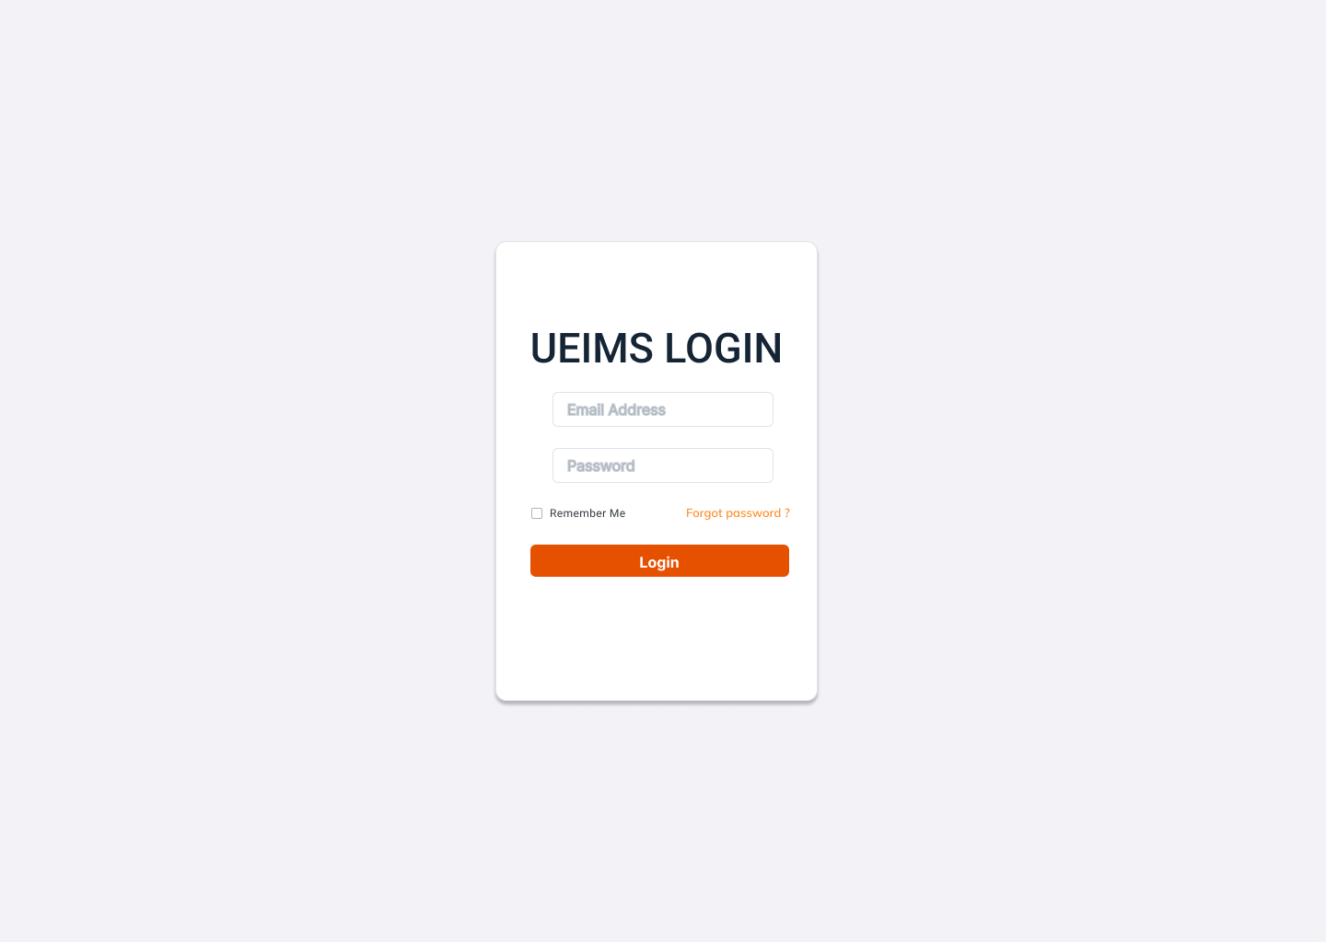

Field Name | Field Type | Description
Email* | Text Box | This is for user to input valid email address for logging in
Password* | Password Box | This is for user to input password for logging in
Remember Me | Checkbox | User checks to save the login session persistently
Forgot password ? | Hyperlink | User clicks to redirect to the password recovery page
Login | Button | User clicks to authenticate him/herself into the system

Database Access
Table | CRUD | Description
users | R | Verify Email & Password information
roles | R | Specify the authorizations of the logged-in user
user_sessions | C | Record the active login session

SQL Commands:
1/ Verify Email & Password information
SELECT user_id, full_name, email, role_id, status
FROM users
WHERE email = ? AND status = 'ACTIVE';

2/ Specify the authorizations of the logged-in user
SELECT role_name
FROM roles
WHERE role_id = ?;

3/ Record active session
INSERT INTO user_sessions (user_id, token_hash, device_info, ip_address, expires_at)
VALUES (?, ?, ?, ?, ?);

1.2 Account Management

a. User Accounts Screen
This screen allows the admin to view, search, filter, and manage all user accounts in the system.
- Related use cases: UC-06_View user account list, UC-07_View user account details, UC-10_Ban user account

UI Design
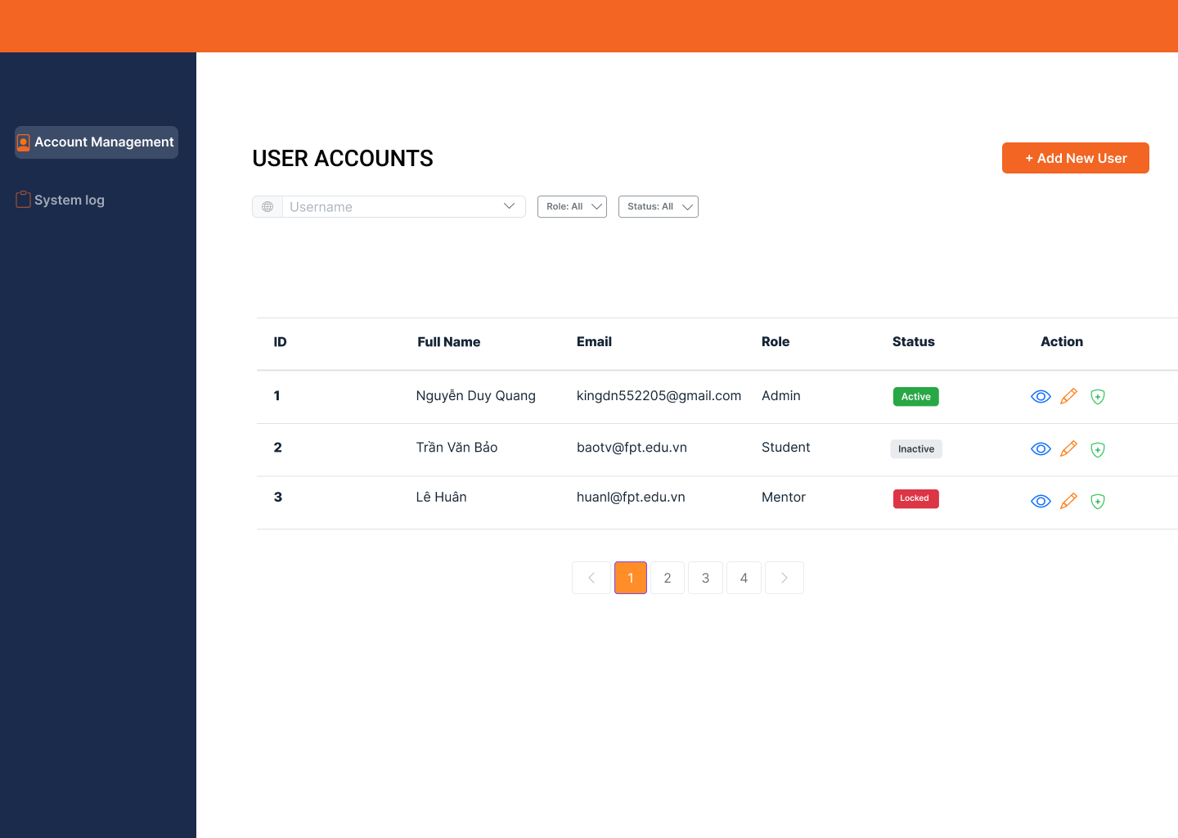

Field Name | Field Type | Description
Search Fields
Username | Text Box | Allow to search using the name or email
Role | Combo Box | Allow to filter the list by assigned role. Default: All
Status | Combo Box | Allow to filter the list by status. Default: All
+Add New User | Button | Click to open the Pop-up to create a new user
Data Table
ID | Integer | Auto-increased identifier of the user account
Full Name | Text | Full name of the user
Email | Text | Email address of the user
Role | Text | Assigned role of the user
Status | Text | Current status of the user (Active/Inactive/Locked)
Data Actions
View | icon | Click to open the User Details page for viewing the relevant account
Edit | icon | Click to open the User Details page for updating the relevant account
Protect / Unban | icon | Shown when the data status is inactive or locked. This is to activate the relevant account
Ban | icon | Shown when the data status is active. This is to deactivate the relevant account

Database Access
Table | CRUD | Description
users, roles | R, U | Query the list of current users from the database with filters Update status of a specific user to ACTIVE/INACTIVE/LOCKED

SQL Commands:
1/ Query the list of current users from the database
SELECT u.user_id, u.full_name, u.email, r.role_name, u.status
FROM users u
JOIN roles r ON u.role_id = r.role_id
WHERE (u.full_name ILIKE ? OR u.email ILIKE ?)
AND (u.role_id = ? OR ? IS NULL)
AND (u.status = ? OR ? IS NULL)
ORDER BY u.created_at DESC
LIMIT ? OFFSET ?;

2/ Update status of a specific user (Ban / Unban / Lock)
UPDATE users
SET status = ?, updated_at = CURRENT_TIMESTAMP
WHERE user_id = ?;

b. Pop-up Create New User
This pop-up screen allows the admin to manually create a new user account and assign a role.
- Related use cases: UC-08_Create new account

UI Design
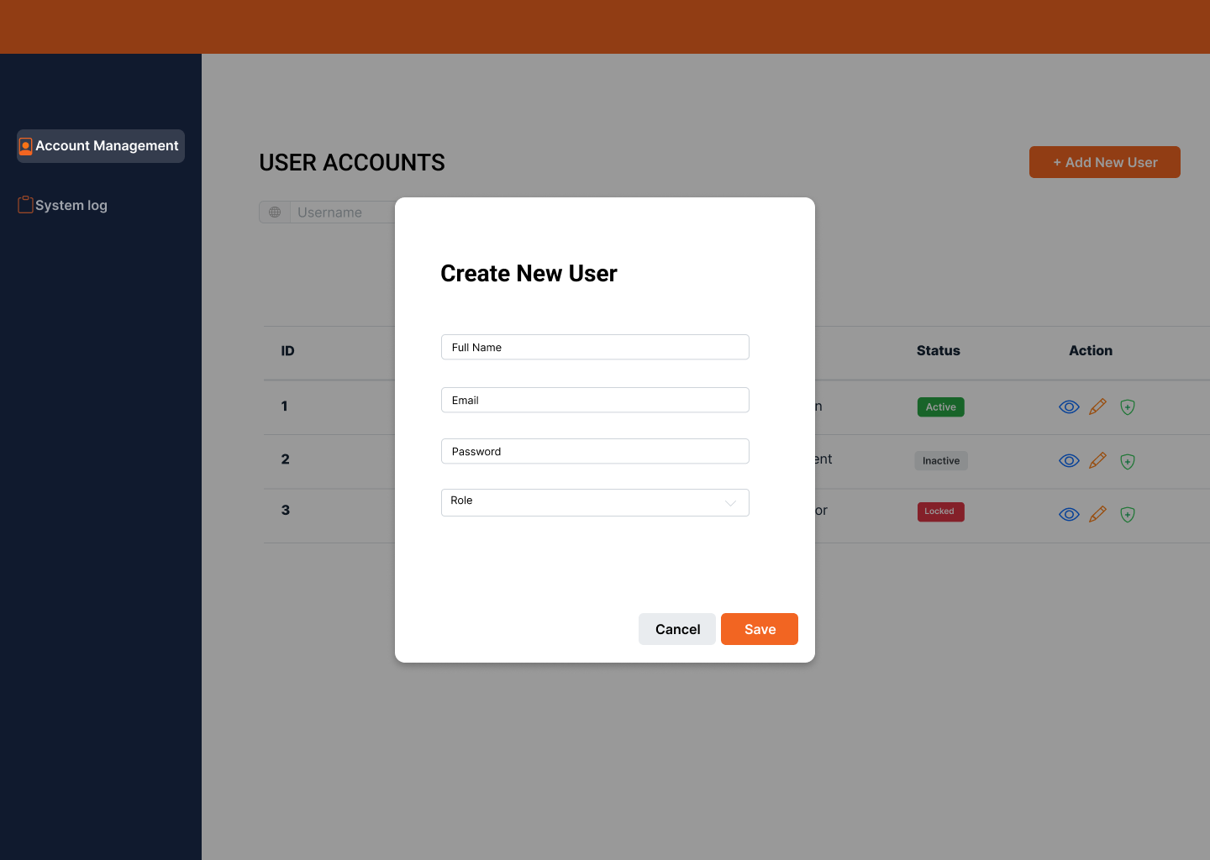

Field Name | Field Type | Description
Full Name | Text Box | Admin inputs the user's full name
Email | Text Box | Admin inputs the user's email
Password | Password Box | Admin inputs the default password
Role | Combo Box | Admin selects the role for the new user
Cancel | Button | Admin clicks to close the pop-up without saving
Save | Button | Admin clicks to confirm and create the new account

Database Access
Table | CRUD | Description
users | C, R | Verify if email already exists to prevent duplication. Insert new user information

SQL Commands:
1/ Verify if email already exists
SELECT COUNT(*)
FROM users
WHERE email = ?;

2/ Insert new user information
INSERT INTO users (full_name, email, password_hash, role_id, status, created_at)
VALUES (?, ?, ?, ?, 'ACTIVE', CURRENT_TIMESTAMP);

1.3 System Auditing

a. System Logs Screen
This screen displays the immutable system activity log for tracking user actions.
- Related use cases: UC-11_View System Logs, UC-12_Export System Logs

UI Design
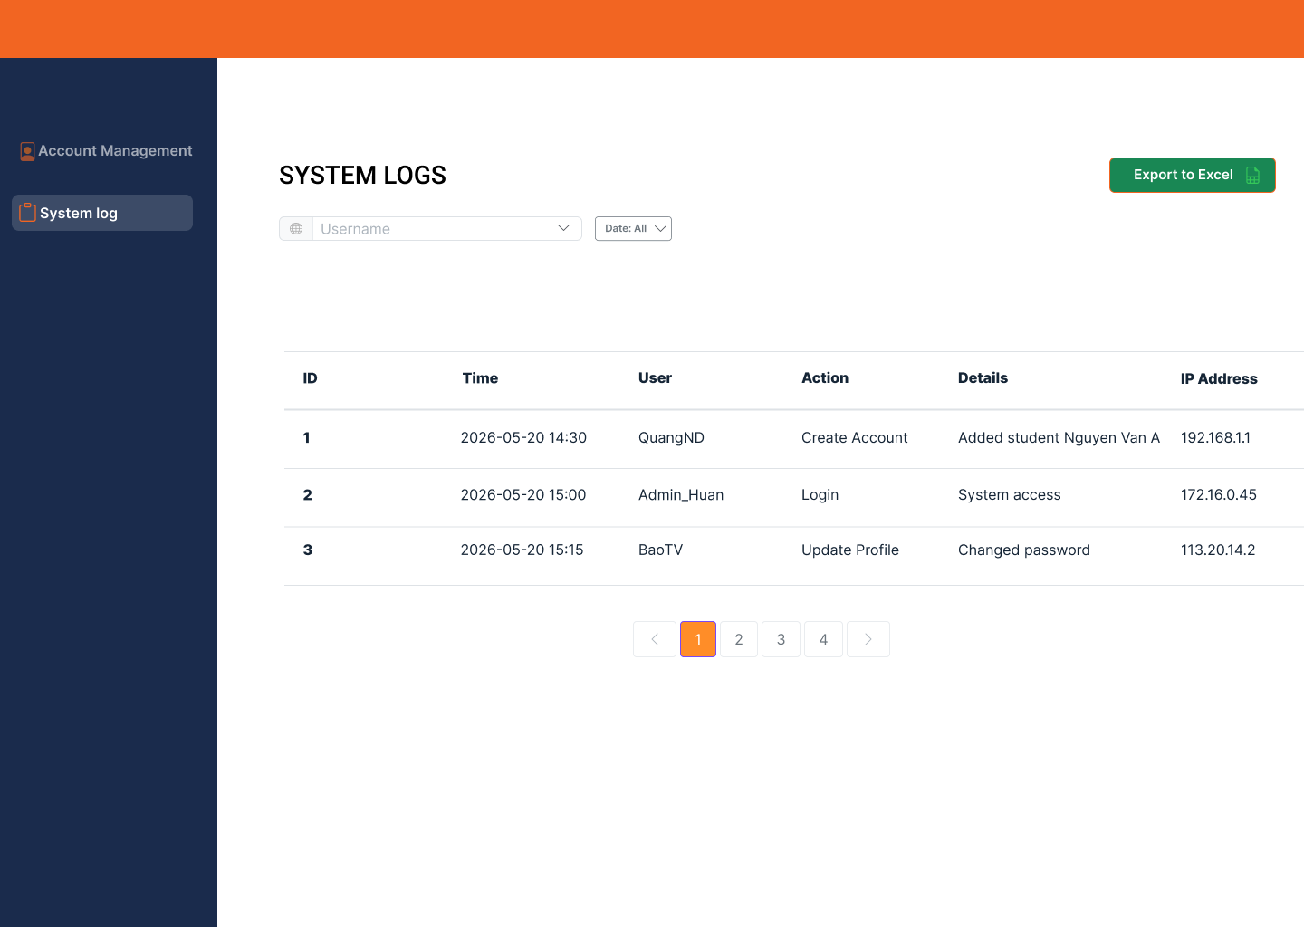

Field Name | Field Type | Description
Search Fields
Username | Text Box | Allow to search logs by the actor's name
Date | Date Picker | Allow to filter logs by a specific date. Default: All
Export to Excel | Button | Click to export the current log data to an Excel file
Data Table
ID | Integer | Auto-increased identifier of the log log entry
Time | DateTime | The exact time the action was performed
User | Text | The name of the user who performed the action
Action | Text | The type of action performed
Details | Text | Detailed description of the action and entity affected
IP Address | Text | The IP address of the user

Database Access
Table | CRUD | Description
audit_logs, users | R | Query the list of system logs with pagination Query all matching system logs for Export

SQL Commands:
1/ Query the list of system logs from the database (with pagination)
SELECT
l.log_id,
l.timestamp as Time,
u.full_name as User,
l.action as Action,
CONCAT(l.target_entity, ' - ', l.new_value) as Details,
l.ip_address as IP_Address
FROM audit_logs l
LEFT JOIN users u ON l.user_id = u.user_id
WHERE (u.full_name ILIKE ?)
AND (DATE(l.timestamp) = ? OR ? IS NULL)
ORDER BY l.timestamp DESC
LIMIT ? OFFSET ?;

2/ Query all logs for Export function (without pagination)
SELECT
l.log_id,
l.timestamp as Time,
u.full_name as User,
l.action as Action,
CONCAT(l.target_entity, ' - ', l.new_value) as Details,
l.ip_address as IP_Address
FROM audit_logs l
LEFT JOIN users u ON l.user_id = u.user_id
WHERE (u.full_name ILIKE ?)
AND (DATE(l.timestamp) = ? OR ? IS NULL)
ORDER BY l.timestamp DESC;

—----- Template của trường ở dưới —----------------

3. Enterprise

3.1 Enterprise Dashboard

4. Student

4.1 Student Dashboard
This screen provides students with a high-level overview of their current internship progress, accumulated work hours, and active placement details.
- Related use cases: UC-67: View Student Dashboard & Status

Field Name | Field Type | Description

DashBoard
Sidebar Navigation | Panel / Menu List | Fixed vertical navigation menu on the left containing links: Dashboard, Job Board, Interview Schedule, Internship Roadmap, Weekly Reports.
User Profile Summary | Avatar & Text | Displays the logged-in student's avatar, full name ("Alex Chen"), and academic status ("CS Sophomore") at the bottom left corner.
Applications Card | Metric Card | Displays the total number of job applications submitted by the student (e.g., "14").
Interviews Card | Metric Card | Displays the total number of interview schedules assigned to the student (e.g., "5").
Weekly Reports Card | Metric Card | Displays the completion ratio of submitted weekly progress reports over the required total (e.g., "4/12").
Logged Hours Card | Metric Card | Displays the accumulated internship hours completed by the student formatted as "120/480 Hour".
Internship Process | Progress Bar | A horizontal tracking bar indicating the overall completion percentage of the internship program (e.g., "30%").
Up Next Table | Data Table | Lists the student's upcoming interview timelines and details.
Calendar Widget | Calendar Interface | A monthly grid display highlighting the current date and specific project/interview deadlines (e.g., "July 2026").
Application Status Rate | Chart (Donut) | Visual circle breakdown displaying application outcomes by percentage tags: Refuse (36%), Confirm (38%), Waiting (25%).
Recent Activities | Vertical List | Live feed tracking the latest system updates, advisor grading notes, or recruiter actions related to the student.

Database Access

[Provide the design description for the screen/function to access the database here: what table the screen/function would access, which transactions does it make (C-Create, R-Read, U-Update, or D-Delete), and how/purpose of the access (by providing Description and SQL commands)]
Table | CRUD | Description
users | R | Retrieve the logged-in student's basic profile details (Full name).
applications | R | Count the total number of job application rows submitted by this student and calculate status metrics for the "Application Status Rate" chart.
interviews | R | FFetch and list upcoming interview arrangements (Company name, type, date, job position) for the "Up Next" data table.
weekly_reports | R | Query all submitted/approved weekly progress records to calculate the completed report ratio.
enterprise_assignments | R | Link the student to their internship placement to aggregate reports and track internship progress.

SQL Commands

[Provide the detailed SQL (select, insert, update...) which are used in implementing the screen/function]
1/ Retrieve student profile details
SQL
SELECT user_id, full_name
FROM users
WHERE user_id = :student_id;

2/ Count total submitted applications
SQL
SELECT COUNT(application_id) AS total_applications
FROM applications
WHERE student_id = :student_id AND deleted_at IS NULL;

3/ Fetch status breakdown for Donut Chart (Application status rate)
SQL
SELECT
status,
COUNT(application_id) AS status_count,
ROUND(COUNT(application_id) * 100.0 / SUM(COUNT(application_id)) OVER(), 2) AS status_percentage
FROM applications
WHERE student_id = :student_id AND deleted_at IS NULL
GROUP BY status;

4/ Count total interview schedules
SQL
SELECT COUNT(i.interview_id) AS total_interviews
FROM interviews i
JOIN applications a ON i.application_id = a.application_id
WHERE a.student_id = :student_id
AND i.status IN ('SCHEDULED', 'CONFIRMED');

5/ Fetch upcoming interview details for the "Up Next" data table
SQL
SELECT
e.company_name,
i.status AS type,
i.scheduled_datetime AS date,
j.title AS job_position
FROM interviews i
JOIN applications a ON i.application_id = a.application_id
JOIN job_posts j ON a.job_post_id = j.job_post_id
JOIN enterprises e ON j.enterprise_id = e.enterprise_id
WHERE a.student_id = :student_id
AND i.scheduled_datetime >= CURRENT_TIMESTAMP
ORDER BY i.scheduled_datetime ASC;

6/ Calculate submitted report ratio
SQL
SELECT
COUNT(wr.report_id) AS submitted_reports_count
FROM weekly_reports wr
JOIN enterprise_assignments ea ON wr.assignment_id = ea.assignment_id
WHERE ea.student_id = :student_id
AND wr.status = 'APPROVED';

4.2 Job Board

a. Job Board Screen
This screen allows students to browse the list of available internship job openings, filter by skills or search keywords, view detailed job information, and apply for the position.
- Related use cases: UC-53: View Job Post List, UC-54: View Job Details, UC-55: Apply for Job.

UI Design

Field Name | Field Type | Description
Trending Keywords | Chip / Tag List | Displays popular skill tags (e.g., "Web Designer", "Frontend") for quick filtering.
Search Bar | Input Field | Allows searching for internships by job title or enterprise name.
Related Skills Filter | Dropdown | Allows students to filter job postings based on their technical skills.
Reset Filter | Button | Clears all currently applied search and skill filters.
Job Card Grid | Data Grid | Displays a collection of internship cards containing Title, Internship Type, Salary, Company, and Deadline.
Bookmark Icon | Icon Button | Allows students to save a specific job post for later.
Pagination | Navigation | Page selector (01, 02, 03...) to navigate through multiple pages of internship listings.

Database Access
Table | CRUD | Description
job_posts | R | Retrieve the list of active job posts to display in the board grid (UC-53).
enterprises | R | Fetch company details (name, logo) associated with each job post (UC-54).
applications | C | Initiate the process of submitting an application for an internship (UC-55).
student_profiles | R | Access the student's skill set to power the "Related Skills" filter functionality.

SQL Commands:

1/ Retrieve job posts with enterprise information (UC-53)
SQL
SELECT
jp.job_post_id, jp.title, jp.salary_type, e.company_name, e.logo_url, jp.application_deadline
FROM job_posts jp
JOIN enterprises e ON jp.enterprise_id = e.enterprise_id
WHERE jp.status = 'OPEN' AND jp.deleted_at IS NULL
ORDER BY jp.created_at DESC;

2/ Filter jobs by keyword and company name (UC-53)
SQL
SELECT jp.title, e.company_name
FROM job_posts jp
JOIN enterprises e ON jp.enterprise_id = e.enterprise_id
WHERE jp.status = 'OPEN'
AND (jp.title ILIKE :keyword OR e.company_name ILIKE :keyword);

3/ Apply for an internship position (UC-55)
SQL
INSERT INTO applications (student_id, job_post_id, application_date, status)
VALUES (:student_id, :job_post_id, CURRENT_DATE, 'PENDING');

—-------------------------------------------------------------------------------------------------------------

IV. Appendix

1. Assumptions
1.1. Organizational & Business Assumptions:
- A1. Formal University-Enterprise Partnerships: It is assumed that the University has established formal, legally binding partnership agreements (MOU/MOA) with all participating Enterprises before they are registered and approved on the system by the Training Manager. The system does not verify or manage these legal agreements; it only tracks the digital approval status.
- A2. User Computer Literacy & Internet Access: It is assumed that all 4 types of system users (System Admin, Training Manager, Enterprise representative, and Student) possess at minimum basic computer literacy skills — including the ability to navigate web browsers, fill out online forms, upload/download files, and manage email accounts. All users are also assumed to have stable and reliable internet access during their usage sessions.
- A3. Enterprise Commitment to Intern Development: It is assumed that approved Enterprises will genuinely commit to providing meaningful, real-world projects and professional tasks for the interns throughout the entire duration of the internship semester. The system cannot enforce or verify the quality of the actual work assigned to students at the enterprise premises.
- A4. Truthfulness of Student Data: It is assumed that all information provided by Students in their profiles, uploaded CVs, weekly reports, and final internship reports is truthful, accurate, and represents their own original work. The system does not incorporate plagiarism detection or identity verification mechanisms.
- A5. Timely Enterprise Engagement: It is assumed that Enterprise representatives will log into the system at regular intervals (at minimum weekly) to review student weekly reports, provide feedback, update interview results, and complete the final Rubrics evaluation before the semester deadline. The system provides notification reminders but cannot force user engagement.
- A6. Timely Training Manager Engagement: It is assumed that the Training Manager will actively monitor the system dashboard, process pending enterprise registrations, review at-risk student alerts, handle incident reports, and submit final academic grades within the timeframes defined by the academic calendar. Delays in TM actions may cascade into delayed student grade finalization.

1.2. Technical Assumptions:
- A7. Standardized Evaluation Criteria: It is assumed that the University's grading scale (0.0 to 10.0) and the 4-criteria Rubrics framework (Attitude 20%, Professionalism 40%, Soft Skills 20%, Progress 20%) are officially standardized by the University's Academic Board and will remain unchanged during the lifetime of an active semester. Any mid-semester changes to the grading formula would require a system update.
- A8. Prompt Interview Result Updates: It is assumed that Enterprise representatives will promptly update the Pass/Fail interview outcome on the system (UC-40) within 3 business days after conducting interviews. Delayed updates may block subsequent workflow steps (e.g., supervisor assignment, training plan creation).
- A9. Accurate Semester Data from University: It is assumed that the academic semester information (semester number 1-9) assigned to each student in the university's core database is accurate and up-to-date at the time of Excel import (UC-20). Incorrect semester data would result in students receiving wrong permission levels on the platform.
- A10. Honest Student Feedback: It is assumed that Students will provide honest and constructive feedback when evaluating their host Enterprise (UC-50). Since feedback is non-anonymous (the student's identity is recorded), it is assumed that students will not be pressured or intimidated by Enterprises regarding their feedback submissions. The confidentiality of feedback data (visible only to Training Manager) is designed to mitigate this risk.

2. Dependencies
2.1. Infrastructure Dependencies:
- D1. Cloud Hosting Infrastructure: The system's availability, performance, and uptime depend entirely on the reliability of the chosen cloud hosting provider (e.g., AWS EC2/RDS, Microsoft Azure, Google Cloud Platform, or University-managed on-premise servers). The system requires a minimum guaranteed uptime of 99.5% during active semester periods to ensure uninterrupted access for all 4 user roles.
- D2. Relational Database Management System (RDBMS): The system depends on PostgreSQL (version 14 or higher) as the primary persistent data store. All business-critical data — including user accounts, semester configurations, applications, weekly reports, evaluations, and feedback — is stored in this database. Database backup and disaster recovery procedures must be established by the infrastructure team.

2.2. External Service Dependencies:
- D3. Email/SMTP Delivery Service: The system relies on a third-party email delivery service (e.g., SendGrid, AWS SES, or a University-managed SMTP server) for dispatching critical system communications, including: account creation credentials, password reset links, interview schedule notifications, late report warning alerts, and incident report notifications. If the email service is down, users will not receive time-sensitive notifications.
- D4. External Video Conferencing Platforms: For the interview scheduling module (UC-39), the system stores and displays external meeting links (Google Meet, Zoom, Microsoft Teams) but does not host or manage the actual video call infrastructure. The availability and functionality of these platforms are outside the system's control.
- D5. PDF Generation Libraries: The system depends on stable, well-maintained third-party libraries (e.g., iText for Java/Spring Boot, or PDFKit/Puppeteer for Node.js) to accurately generate and format downloadable PDF documents for: Final Grade Reports (UC-66), student CV downloads, and final internship report exports. Library version updates or deprecations may require code adjustments.

2.3. Data Source Dependencies:
- D6. Core University Academic Database: The initial student onboarding process depends on the University's core academic system to provide an accurate, verified Excel file containing the baseline data of eligible students, including: Student ID, Full Name, Major, GPA, and Current Semester (1-9). The UEIMS does not independently verify this data against the university's records after import.
- D7. Predefined Excel Import Template: The bulk import feature (UC-20) strictly depends on the Training Manager uploading student data using a predefined, version-controlled Excel template (.xlsx). Deviations from the template structure (e.g., missing columns, incorrect data types, extra sheets) will cause the import parser to reject the file and display specific validation error messages.

2.4. Data Source Dependencies:
- D8. Internal Authentication & Authorization Framework: Since third-party Single Sign-On (SSO) providers are excluded from the current project scope, the system relies entirely on its own internal security stack for user authentication and role-based authorization. This includes: JWT (JSON Web Token) for session management, BCrypt algorithm for one-way password hashing, and a custom RBAC (Role-Based Access Control) middleware that enforces permissions for all 4 roles (Admin, Training Manager, Enterprise, Student).

3. Limitations
3.1. Performance & Storage Limitations:
- L1. File Upload Size Restriction: To optimize server storage costs and prevent abuse, all file uploads across the system (student CV PDFs, incident evidence screenshots, final internship report PDFs) are strictly limited to a maximum of 5MB per individual file. Files exceeding this limit will be rejected at the API level with a clear error message.
- L2. Data Export Volume Cap: To prevent server memory overload during large data extraction operations, all export-to-Excel and export-to-PDF functions are capped at a maximum of 10,000 records per single export transaction. If the dataset exceeds this threshold, the user must apply filters to reduce the record count before exporting.
- L3. Concurrent User Capacity: The system is designed and load-tested to support up to 500 concurrent active sessions under normal operating conditions. Performance degradation (slower response times, increased latency) may occur during peak usage periods if concurrent sessions significantly exceed this threshold.

3.2. Feature & Functionality Limitations:
- L4. No Real-Time Messaging or Chat: The system does not include an integrated, real-time chat or instant messaging module (comparable to Slack, Microsoft Teams, or Facebook Messenger). All communication between users is strictly asynchronous and channeled through formal text areas within the system (e.g., report feedback fields, incident description areas, announcement posts).
- L5. No Native Video Interview Hosting: The system does not host, record, or manage native video or audio calls for enterprise recruitment interviews. The interview scheduling module (UC-39) only stores metadata — specifically the scheduled date/time and an external meeting link (e.g., a Zoom or Google Meet URL). The actual interview execution occurs entirely outside the UEIMS platform.
- L6. Basic Statistical Analytics Only: The Training Manager's statistics dashboard (UC-26) provides only fundamental, pre-built statistical visualizations, including: interview pass/fail rates, student distribution by major/enterprise, and grade distribution histograms. The system does not feature advanced analytics capabilities such as AI-driven predictive models, trend forecasting, natural language processing of report content, or custom query builders.
- L7. No Offline Functionality: As a purely web-based platform, the UEIMS requires a continuous, active internet connection for all operations. Users cannot perform any system tasks (submitting reports, grading students, reviewing applications) while disconnected. There is no local data caching, offline mode, or background synchronization mechanism.
- L8. Single Language Interface: The system's user interface, error messages, notification templates, and documentation are developed exclusively in English. Dynamic multi-language translation or localization for other languages (e.g., Vietnamese, Japanese) is not supported in the current version.

3.3. Compatibility Limitations:
- L9. Modern Browser Requirement: The system's UI/UX is designed, tested, and optimized exclusively for modern evergreen web browsers: Google Chrome (v90+), Microsoft Edge (v90+), Mozilla Firefox (v88+), and Apple Safari (v14+). Legacy browsers, most notably Internet Explorer 11 and older versions, are explicitly unsupported and may exhibit layout rendering errors or JavaScript incompatibilities.
- L10. Responsive Web Only (No Native Mobile App): While the system's web interface is responsive and adapts to different screen sizes (desktop, tablet, mobile), it is not a native mobile application. Push notifications, biometric authentication, and other mobile-native features are not available.

4. Exclusions
- E1. Financial, Payroll, & Compensation Management: The system strictly manages the academic training lifecycle. It completely excludes any features related to tracking, calculating, or disbursing internship allowances, stipends, enterprise payroll, tax documentation, social insurance, or any form of financial compensation for the students or enterprises.
- E2. Legal Contract & Digital Signature Management: The system excludes the drafting, storage, verification, or management of legal internship employment contracts, Non-Disclosure Agreements (NDAs), or any documents requiring legally binding digital signatures (e.g., DocuSign, Adobe Sign) between the Student and the Enterprise.
- E3. General-Purpose Job Board or Alumni Recruitment: The platform is designed exclusively for the structured academic OJT semester. It will not function as a general-purpose post-graduation job recruitment portal, alumni career services platform, or freelance marketplace. Job postings are strictly limited to internship positions within the context of an active University semester.
- E4. AI-Powered Automated Screening or Grading: While the system manages the end-to-end recruitment and grading workflows, it explicitly excludes the use of Artificial Intelligence (AI), Machine Learning (ML), or Natural Language Processing (NLP) to: automatically screen or rank student CVs, auto-grade the textual content of weekly or final reports, or generate automated feedback.
- E5. Background Verification & Security Checks: The system does not perform criminal record checks, financial credit checks, academic integrity investigations, or any form of deep background verification on students on behalf of Enterprises. Such verifications, if required, must be conducted independently by the Enterprise through their own HR processes.
- E6. Enterprise Internal HR & Operations Management: The system's scope is strictly limited to the student's internship lifecycle within the university-enterprise partnership. It excludes features for managing the enterprise's internal HR workflows (employee attendance tracking, internal performance reviews, project management tools, or enterprise-level reporting unrelated to student interns).
- E7. Third-Party Single Sign-On (SSO) Integration: Integration with external identity providers such as Google SSO, Microsoft Azure Active Directory, Facebook Login, or university-specific LDAP/CAS authentication systems is excluded from the current project phase. All authentication is handled internally (see Dependency D8).
- E8. Automated Notification Escalation & SLA Enforcement: The system provides basic notification dispatching (email alerts, in-app notifications) but does not enforce Service Level Agreements (SLAs). For example, if an Enterprise fails to review a weekly report within 7 days, the system will not automatically escalate the issue, reassign the student, or impose penalties. Such escalations require manual intervention by the Training Manager.

5. Business Rules
[Provide common business rules that you must follow. The information can be provided in the table format as the sample below]

ID | Name | Category | Rule Definition
BR-01 | Account Lockout | Constraints | User accounts are temporarily locked for 30 minutes after 5 consecutive failed login attempts.
BR-02 | Simultaneous Session Control | Constraints | A user can only maintain one active session. Logging in from a new device invalidates the previous session.
BR-03 | Token Expiration | Constraints | User session tokens automatically expire after 15 minutes of complete inactivity.
BR-04 | Password Complexity | Constraints | Passwords must be at least 8 characters long, containing uppercase, lowercase, numbers, and special characters.
BR-05 | Unique Email Constraint | Constraints | The email address must be universally unique across all roles in the system.
BR-06 | Single Role Assignment | Facts | An account can only possess one primary role (e.g., a student cannot simultaneously be an enterprise representative).
BR-07 | Audit Log Append-Only | Constraints | System logs are immutable. They can only be appended to and never deleted or modified.
BR-08 | Unique Semester Code | Constraints | Semester codes (e.g., SU26) must be strictly unique system-wide.
BR-09 | Timeline Integrity | Constraints | A semester's Start Date must strictly precede its End Date.
BR-10 | Initial Semester Status | Facts | Newly created semesters must inherently start with the "Draft" status.
BR-11 | Locked Semester Edit Block | Constraints | Semesters holding a "Locked" status are read-only and cannot be edited.
BR-12 | Date Modification Constraint | Constraints | Modifying dates of an "Active" semester is restricted and requires overriding confirmations.
BR-13 | Status State Machine | Facts | Semester status only transitions forward: Draft → Open → Active → Closed → Locked.
BR-14 | Permanent Lock Implication | Constraints | Setting status to "Locked" permanently freezes all related OJT data (Read-Only).
BR-15 | Rejection Justification Mandatory | Constraints | Training Managers must provide written reasons when rejecting Enterprise accounts.
BR-16 | TM Exclusive Access | Constraints | Only the Training Manager role is authorized to view the Eligible OJT Student list.
BR-17 | Excel Mandatory Fields | Constraints | Excel imports require: Student ID (Unique), Full Name, Major, GPA, and Current Semester.
BR-18 | Duplicate ID Handling | Constraints | New Excel imports overwrite existing student data ONLY IF current status is 'Eligible' or 'Pending'.
BR-19 | Minimum Eligibility GPA | Constraints | Students must hold a GPA of 2.0 or higher to be imported into the Eligible list.
BR-20 | Export Volume Limit | Constraints | Data exports are capped at a maximum of 10,000 records per transaction.
BR-21 | Approval Data Lock | Constraints | Approving the Official OJT List automatically locks those students' placement records.
BR-22 | Prerequisite Status Validation | Constraints | Official OJT approval is strictly limited to students with "Accepted" or "Matched" statuses.
BR-23 | High-Privilege Action Logging | Constraints | Cancelling a student's OJT result requires deep audit logging (User ID, Reason, Timestamp).
BR-24 | Admin Intervention Requirement | Constraints | Cancelling an already "OJT" status student requires System Administrator validation.
BR-25 | Warning Eligibility | Constraints | Warning notifications can only be dispatched to students who missed the current active week's report.
BR-26 | Incident Resolution Log | Constraints | Training Managers must document the specific resolution approach before closing an incident ticket.
BR-27 | Grade Range | Constraints | Final course grades must be decimal values strictly between 0.0 and 10.0 inclusive, with up to one decimal place allowed.
BR-28 | Feedback Confidentiality | Constraints | Student enterprise feedback is strictly internal. Only the Training Manager role can access feedback data. Enterprise accounts have no API or UI access to read this data.
BR-29 | Post Ownership | Facts | Enterprises can exclusively manage (create/edit/close) their own job postings.
BR-30 | Closed Post Block | Constraints | Setting a job post to "Closed" instantaneously blocks any new student applications.
BR-31 | CV Format Rule | Constraints | All CVs must be strictly uploaded and processed in PDF format.
BR-32 | CV Ownership Scope | Facts | Enterprises can only download CVs of students who applied directly to their active posts.
BR-33 | Applicant Evaluation Lock | Constraints | An application moved to "Pass" or "Reject" cannot be reverted back to "Pending" by the enterprise.
BR-34 | Interview Visibility Rules | Facts | Enterprises only see interview schedules linked to their own job posts.
BR-35 | Interview Time Validation | Constraints | Scheduled interview times must be in the future and cannot overlap with existing appointments.
BR-36 | Interview Eligibility Rule | Constraints | Only applicants who passed the CV screening phase are eligible for interview scheduling.
BR-37 | Recruitment Result Rules | Constraints | Final recruitment results (Pass/Fail) can only be logged after the interview session concludes.
BR-38 | Plan Mandatory Fields | Constraints | Enterprise must provide "Task Description" and "Target Date" for each training plan item.
BR-39 | Plan Date Boundary Rule | Constraints | Internship plan dates must fall strictly within the official Start and End dates of the semester.
BR-40 | Mandatory Feedback on Rejection | Constraints | Enterprise MUST provide written feedback when rejecting a student's weekly report.
BR-41 | Incident Report Completeness | Constraints | Both "Incident Category" and "Incident Description" are mandatory to submit an incident report.
BR-42 | Rubrics All Criteria Mandatory | Constraints | All 4 evaluation criteria must be scored before the enterprise can submit the final evaluation.
BR-43 | Weighted Score Formula | Computations | Final Score = (Attitude × 0.2) + (Professionalism × 0.4) + (Soft Skills × 0.2) + (Progress × 0.2).
BR-44 | One-Time Evaluation Lock | Constraints | Once submitted, the enterprise's evaluation rubrics form is permanently locked. Modifications require a manual unlock request approved by the Training Manager.
BR-45 | CV Size Limit | Constraints | CV files cannot exceed 5MB in storage size.
BR-46 | Single Active Application | Constraints | A student can only have 1 active application submitted to a specific job post at any time.
BR-47 | Application Snapshot | Facts | Student profiles are snapshotted at submission; future profile edits do not alter past applications.
BR-48 | Withdrawal Deadline | Constraints | Students can only withdraw their CV before the job posting's defined deadline.
BR-49 | Attendance Confirmation Irreversibility | Constraints | Once an interview attendance is confirmed by a student, they cannot cancel it via the UI.
BR-50 | Final Report Format | Constraints | The final internship report must be strictly submitted in PDF format.
BR-51 | Absolute Hard Deadline | Constraints | The server rejects any final report submissions received after the exact minute of the deadline.
BR-52 | Grade Access Control | Facts | Internship evaluation scores are accessible only to the student owning the record, the Enterprise that submitted the evaluation, and the Training Manager for grading purposes.
BR-53 | Single Feedback Per Semester | Constraints | A student can only submit one feedback entry per enterprise per semester. Duplicate submissions are blocked by the system.
BR-54 | Semester-Based Student Permissions | Facts | Student access to system features is determined by their current_semester value: Semester 1-4 can only browse job posts; Semester 5 can apply for jobs; Semester 6 can submit weekly reports and participate in active internship; Semester 7-9 can view historical results and submit enterprise feedback.
BR-55 | Feedback Rating Scale | Constraints | Enterprise feedback scores must be integer values between 1 and 5 inclusive for each evaluation criterion (Training Quality, Supervisor Support, Work Environment, Overall).
BR-56 | Weekly Report Submission Window | Constraints | Students are only permitted to submit a weekly report during its designated "Active" week. Retroactive (past) and advance (future) submissions are strictly blocked. Late submissions are only accepted via explicit Training Manager override.

6. ..

