Exporting / Importing XML Catalog

On a clean workspace, create an empty project. Right click on the project folder in the resource explorer and choose: “Export”

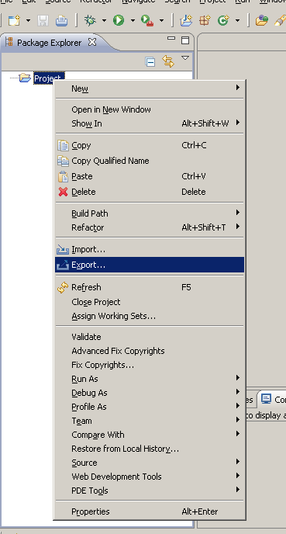

In the wizard that appears on screen, select “XML” –> “XML Catalog”

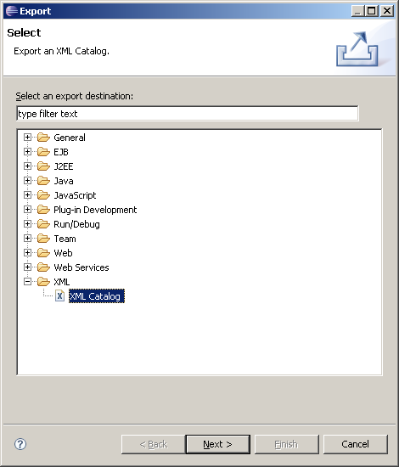

Click on “Next”. Then select then project folder and assign a file name “catalogFile.xml”. Finally click on “Finish”. Ensure that all titles and labels in the wizard are properly translated.

Importing XML Catalog

Right click on the project folder from the previous scenario and choose “Import”

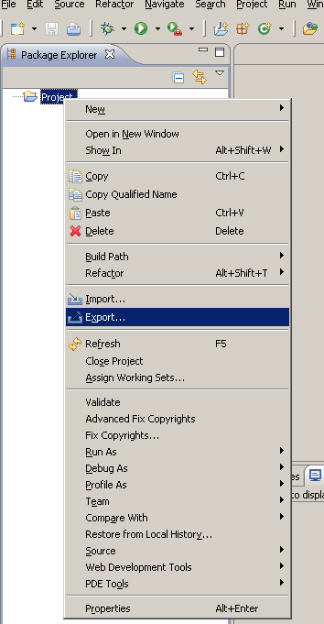

In the Wizard that appears on screen, select “XML” -> “XML Catalog”

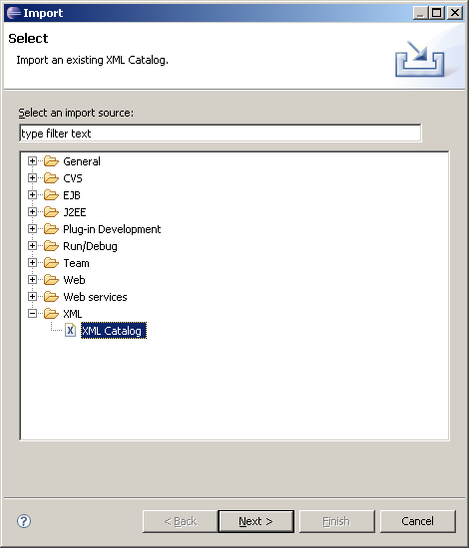

Click on “Next”. In the next wizard page, select the file created in the previous scenario: “catalogFile.xml”

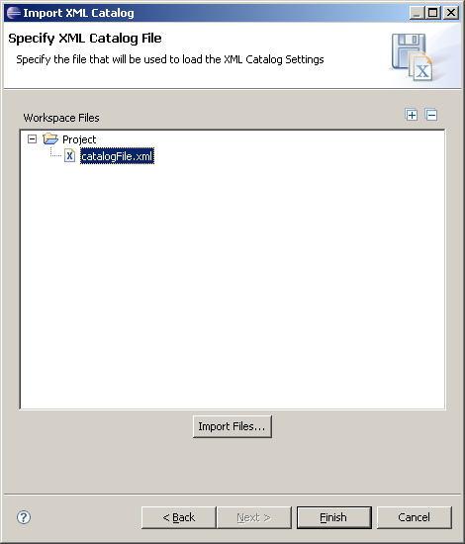

Click on “Finish”. Make sure all titles and labels in the wizard are properly translated.
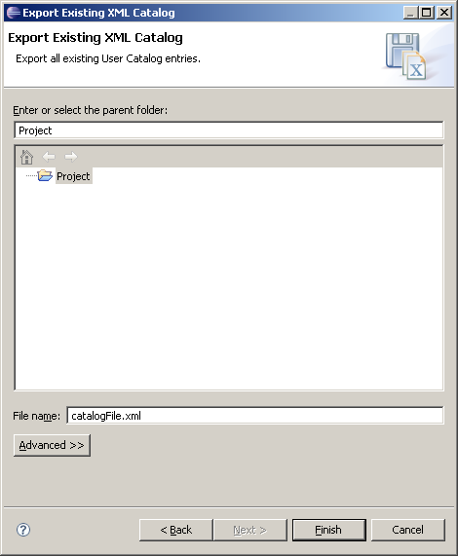

XSD Editor Outline Overview

1. Open the XML Schema Editor on any xsd file.
2. Look at the Outline view, there are two buttons for the tree view outline, or the zoom overview. Test the hover text for each button and ensure they are translated.

 Outline

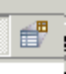 Overview

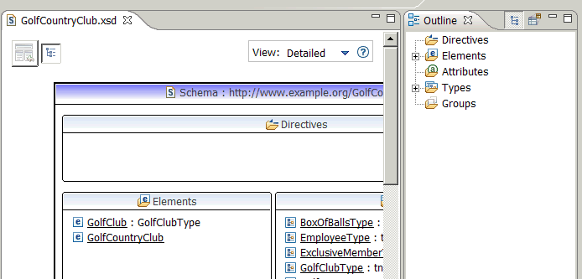

Validation Filters

From the workbench main menu click on “Window” -> “Preferences”

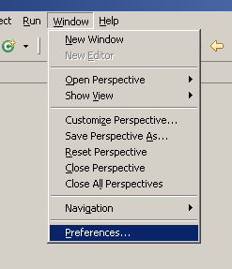

In the preferences dialog box, click on the “Validation” node in the left hand side tree to access the validation options:

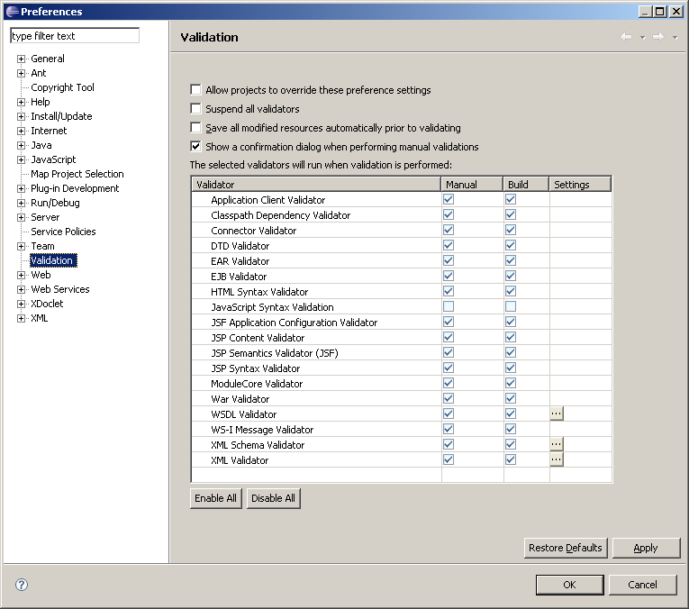

Click on the small button with a three-dot label that appears under the “Settings” row in the “WSDL Validator” entry from the list of validators. The validator settings dialog box will appear:

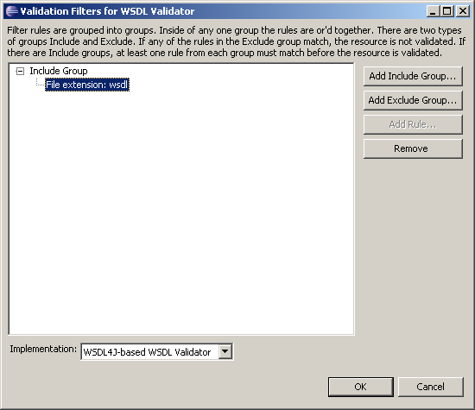

Click on the “Include Group” item in the tree, the “Add rule” button in the right hand side of the dialog box should become enabled, click on it. A wizard with 5 radio buttons will appear:

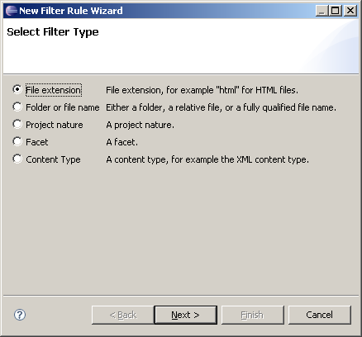

With the first radio button selected (“File extension”) click on “Next”, a new Wizard page will appear. Next click on “Back” to return to the previous page. Now select the next radio button “Folder or file name” and click on “Next”, then on “Back”. Repeat this same procedure with the remaining three radio buttons: “Project nature”, “Facet”, “Content Type”. All controls and labels in all of the wizard pages must be properly translated.

New WSDL File Wizard

- “File” -> “New” -> “Other” -> “Web Services” -> “WSDL”
- Select a folder and enter a file name and then press Next.

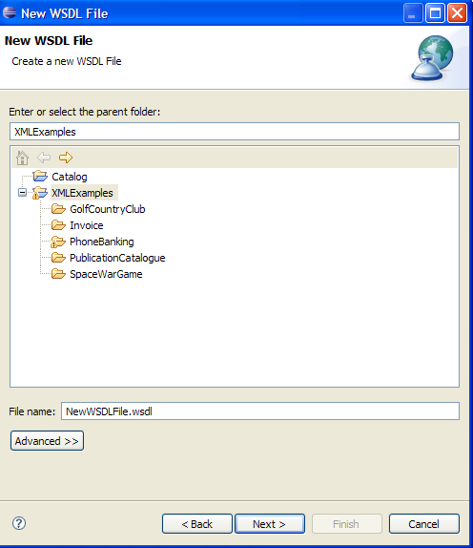

- Verify the default Options page looks like this:

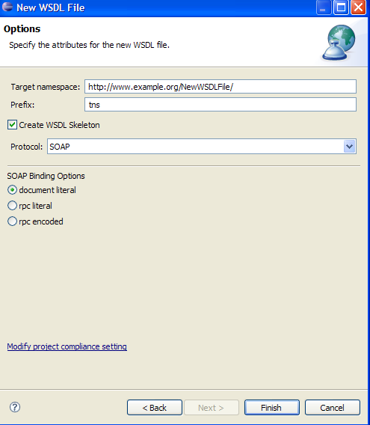

- Select “rpc encoded” and verify a warning message appears at the top.

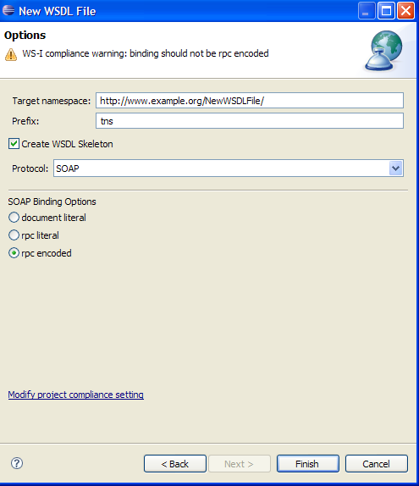

- Verify selecting “HTTP” in the Protocol combobox will give you a different warning at the top of the wizard.

