Outputs

#3

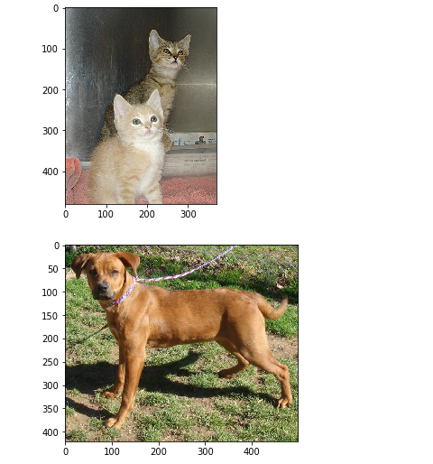

#8

Epoch 1/10

100/100 [==============================] - 134s 1s/step - loss: 0.6970 - accuracy: 0.5384 - val_loss: 0.6868 - val_accuracy: 0.5444

Epoch 2/10

100/100 [==============================] - ETA: 0s - loss: 0.6686 - accuracy: 0.5919

C:\Users\Dell\anaconda3\lib\site-packages\PIL\TiffImagePlugin.py:770: UserWarning: Possibly corrupt EXIF data. Expecting to read 32 bytes but only got 0. Skipping tag 270

" Skipping tag %s" % (size, len(data), tag)

C:\Users\Dell\anaconda3\lib\site-packages\PIL\TiffImagePlugin.py:770: UserWarning: Possibly corrupt EXIF data. Expecting to read 5 bytes but only got 0. Skipping tag 271

" Skipping tag %s" % (size, len(data), tag)

C:\Users\Dell\anaconda3\lib\site-packages\PIL\TiffImagePlugin.py:770: UserWarning: Possibly corrupt EXIF data. Expecting to read 8 bytes but only got 0. Skipping tag 272

" Skipping tag %s" % (size, len(data), tag)

C:\Users\Dell\anaconda3\lib\site-packages\PIL\TiffImagePlugin.py:770: UserWarning: Possibly corrupt EXIF data. Expecting to read 8 bytes but only got 0. Skipping tag 282

" Skipping tag %s" % (size, len(data), tag)

C:\Users\Dell\anaconda3\lib\site-packages\PIL\TiffImagePlugin.py:770: UserWarning: Possibly corrupt EXIF data. Expecting to read 8 bytes but only got 0. Skipping tag 283

" Skipping tag %s" % (size, len(data), tag)

C:\Users\Dell\anaconda3\lib\site-packages\PIL\TiffImagePlugin.py:770: UserWarning: Possibly corrupt EXIF data. Expecting to read 20 bytes but only got 0. Skipping tag 306

" Skipping tag %s" % (size, len(data), tag)

C:\Users\Dell\anaconda3\lib\site-packages\PIL\TiffImagePlugin.py:770: UserWarning: Possibly corrupt EXIF data. Expecting to read 48 bytes but only got 0. Skipping tag 532

" Skipping tag %s" % (size, len(data), tag)

C:\Users\Dell\anaconda3\lib\site-packages\PIL\TiffImagePlugin.py:788: UserWarning: Corrupt EXIF data. Expecting to read 2 bytes but only got 0.

warnings.warn(str(msg))

100/100 [==============================] - 116s 1s/step - loss: 0.6686 - accuracy: 0.5919 - val_loss: 0.6266 - val_accuracy: 0.6463

Epoch 3/10

100/100 [==============================] - 105s 1s/step - loss: 0.6368 - accuracy: 0.6550 - val_loss: 0.5825 - val_accuracy: 0.6856

Epoch 4/10

100/100 [==============================] - 97s 966ms/step - loss: 0.6047 - accuracy: 0.6759 - val_loss: 0.5737 - val_accuracy: 0.7287

Epoch 5/10

100/100 [==============================] - 92s 920ms/step - loss: 0.5664 - accuracy: 0.7081 - val_loss: 0.5380 - val_accuracy: 0.7319

Epoch 6/10

100/100 [==============================] - 88s 877ms/step - loss: 0.5361 - accuracy: 0.7309 - val_loss: 0.5022 - val_accuracy: 0.7538

Epoch 7/10

100/100 [==============================] - 87s 867ms/step - loss: 0.5166 - accuracy: 0.7534 - val_loss: 0.4895 - val_accuracy: 0.7619

Epoch 8/10

100/100 [==============================] - 85s 850ms/step - loss: 0.4973 - accuracy: 0.7578 - val_loss: 0.6113 - val_accuracy: 0.6612

Epoch 9/10

100/100 [==============================] - 85s 854ms/step - loss: 0.4730 - accuracy: 0.7731 - val_loss: 0.4703 - val_accuracy: 0.7769

Epoch 10/10

100/100 [==============================] - 83s 829ms/step - loss: 0.4684 - accuracy: 0.7800 - val_loss: 0.4819 - val_accuracy: 0.7631

#9

