Abstract

Evaluation of any Patent and its content are equally important. Medical patents are the ones which lead to major developments in field of medical research.This paper presents an evaluation of trend of medical patents filed,granted and published over two decades starting from 1997 to 2017.Equally important is the place of origin and the people behind these patents and help us in knowing the geo-distribution of the driving force behind that particular patent.Various Medical patents sites of different countries have been scrapped first to provide relevant data and then the data has been visualized to see various trends over the years and their eventual distribution in terms of their authors.

Introduction

Raw data containing information of a patent like Grant Date,Filing Date,Publishing Date and its authors was first collected which was then cleansed and converted to a data having attributes in terms of number of patents published/granted/filed and other in every year from 1997 to 2017 of 10 major innovating and leading countries was visualized and trends have been noted and duly ratified.

The intent behind this is to see how the published and filed patents vary in growth and in their commercial and research value.

Data Exploration & Methodology

The relation amongst different attributes has been studied and evaluated based on heat-maps plotted by means of Matplotlib and Geo-pandas.Histogram and Line-Plots were also plotted to duly compare the different countries experience in field of publication to granting of medical plants.

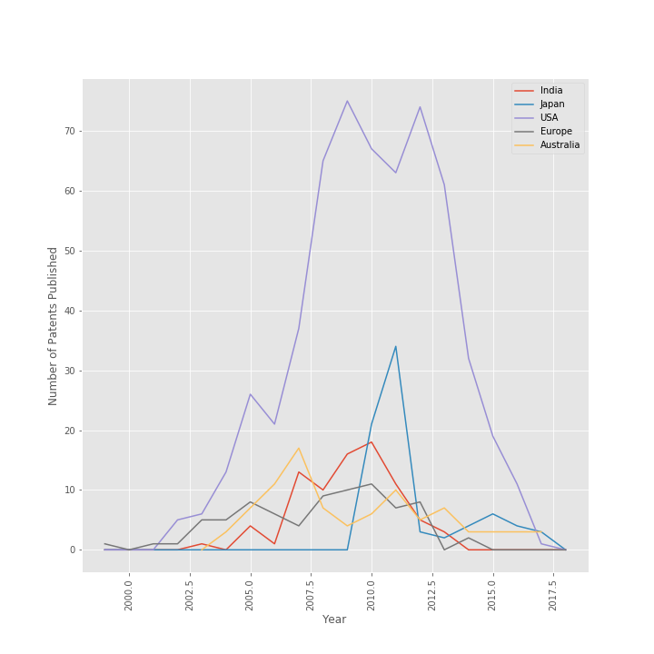2009,2010 and 2011 have been the years with general trend of having the surge in the number of medical patents published. Where 2001-2002 mark the lowest points in the history of medical patents that have been published. Over the years the number of patents published globally has seen ups and downs and there has been no particular rise in the number of patents during the last two decades. It is observed that the increase in patents filed has nominal effect(a weak correlation) on the increase in the patents published. Countries like China, USA, India and Japan have been contributed most significantly in the recent years.

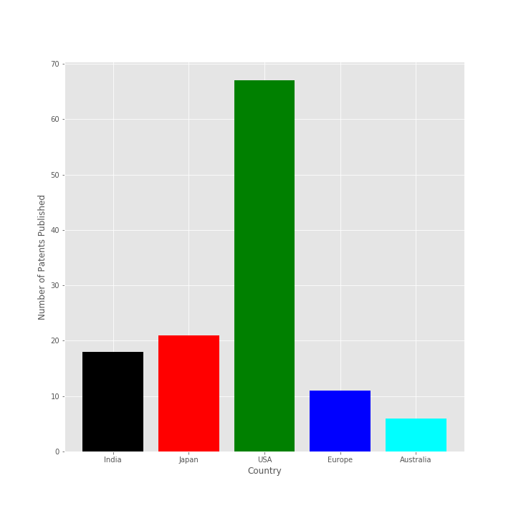  
*(This bar-plot is for the year 2010)*

It has been duly observed that most of the patents granted 'N' status(which means non-commercial patents) have a strong correlation ranging from 0.9 to 0.95 for most of the countries with the patents granted to individual except for the case of United States of America where there is a weak correlation.Most of the patent's authors have been categorized into Individual,Companies,Research Organizations and joint university collaborators. It is seen that most contribution towards publications of new patents(mostly commercial which forms the bulk) has been by Companies.Number of patents granted to Companies has a correlation of 0.93 to 0.95 with number of of patents granted.Also the number of patents granted to Companies strongly correlate with number of patents granted 'Y'(Commercial patents) status.The inference that can be drawn is that most of patents work done by companies strongly correlate to commercialization of their so patents.While most of the research patents(commercial/non-commercial) are contributed by other University students,individuals or Research Organization.

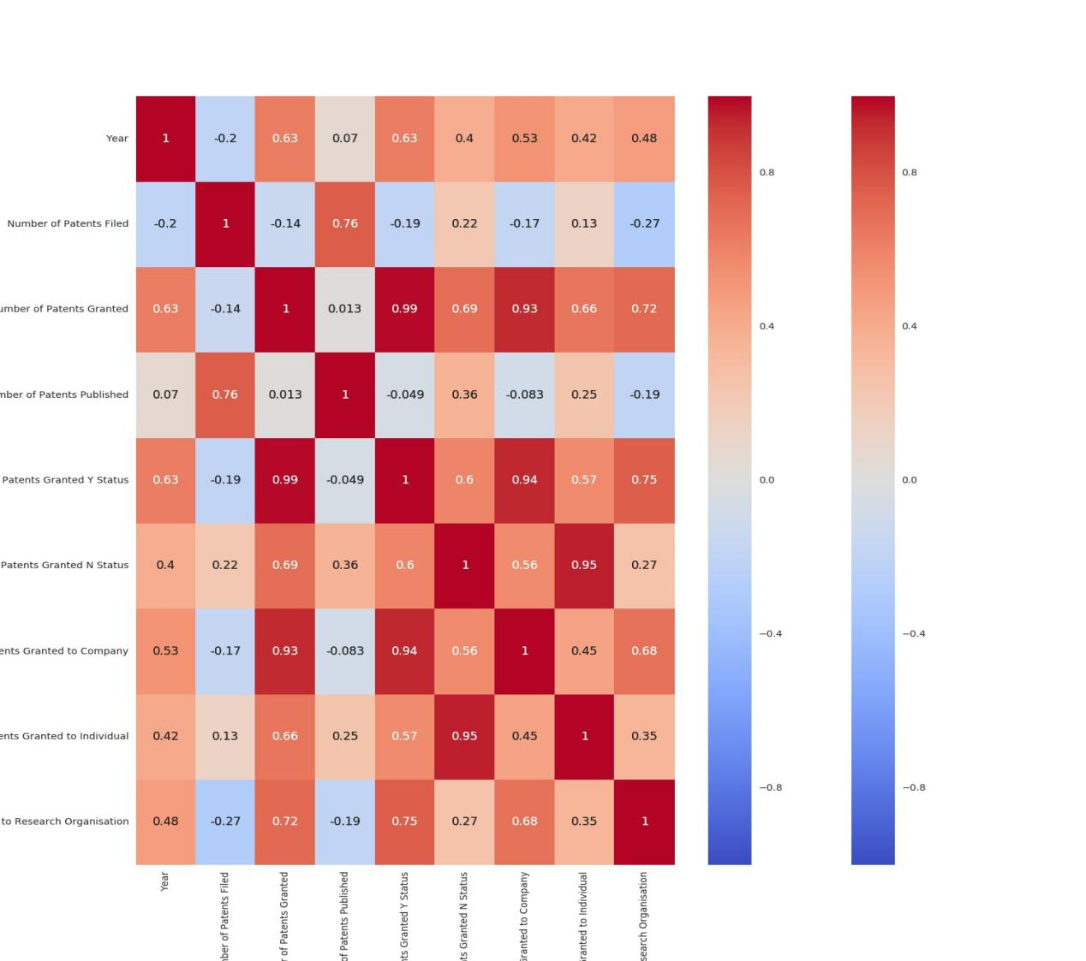

*(This heat-map is for India.The correlations between various attributes can easily be studied and seen)*

For the most of the countries,research has been duly influenced by commercialization except for the case of United States Of America where there exists a large number of non-commercial patents in major numbers.It is seen that number of patents filed has particularly diverse correlation with number of patents published for different countries.For countries like India,the correlation factor is as low as 0.75 and for countries like USA it soars as high as 0.95.This depicts differnce in the work culture of the two countries.Countries like China and India have contributed most significantly in numbers in terms of patents published.

References

* Government patent Websites like <https://www.uspto.gov> and <http://eng.kipris.or.kr/enghome/main.jsp> .
* Designing Data Visualizations: Representing Informational Relationships Book by Julie Steele and Noah Iliinsky
* Databricks Community Edition (Matplotlib & ggplot) for plotting and other computation