Introduction to Cloud Solutions Lab Report
Use this template to document your work as you complete the lab assignment in QA.

Your Information
Your Name: Deon Brown
Lab Title: Creating AWS EC2 Instances Using Templates

Instructions
Follow the instructions to answer the questions related to the lab and add the required screenshots. Submit your completed report following the instructions in Canvas.

Section 1
1. Step 10: What do the YAML and JSON templates share in common? Both are formatted so that a computer can process them.

2. Step 10: How do the YAML and JSON templates differ from one another? Json is strict with using {} [] () Brackets, braces, and parenthesis.

3. Step 14 Screenshot: YAML template with URL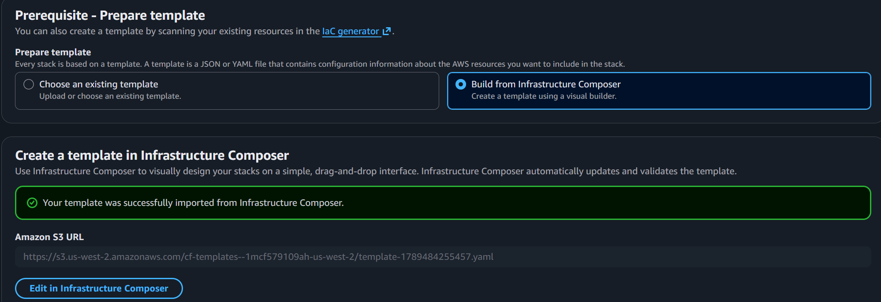

4. Step 30 screenshot: JSON template with URL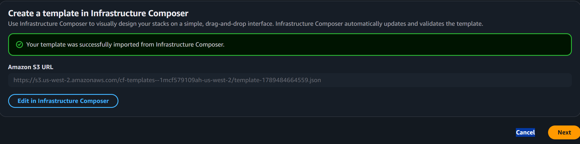

Section 2
5. Step 14: If you received a validation error, what steps did you take to resolve it? To solve my error I needed to have everything from the template under Resources:. To do that I had to arrow down a line and hit tab twice

6. Step 14: What do validation errors indicate about the contents of template file?

7. Step 17 screenshot: YAML template with URL 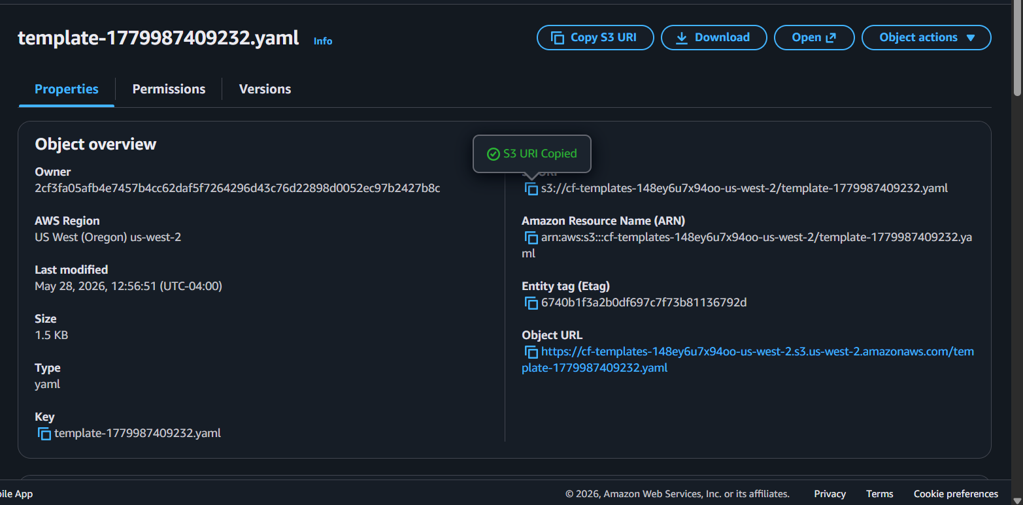
s3://cf-templates-148ey6u7x94oo-us-west-2/template-1779987409232.yaml

8. Step 28 screenshot: 3 template files saved to local CYB260L folder.

