Class Project Phase I: CSE 460
Submission Template

- For this question, refer to “Module1_Case_Study_Usecases and the usecase diagram.pdf” posted under module 1 for level of details expected.

List of Actors
Citizen:
Description:
A citizen is a resident who uses SmartCity Hub to discover community events, register for events, submit reports about city-related issues, and track the status of previously submitted service requests. Citizens can also view city announcements and other community information.
City Administrator:
Description:
A City Administrator manages information and activities available through SmartCity Hub. The administrator can create and manage community events and announcements, review service requests submitted by citizens, assign requests to appropriate departments, monitor citizen engagement, and manage flagged or inappropriate content.
Department Manager
Description:
A Department Manager manages service requests assigned to a city department. The manager can review assigned requests, assign work to department workers, update the status of service requests, and generate reports concerning department activities and service requests.

List of Use Cases
Login
Description:
Allows users to access the SmartCity Hub system according to their assigned role. The system verifies the user's credentials and provides access to the appropriate features.
- Display Login Screen
- Verify Credentials
- Display User Dashboard
Browse Community Events
Description:
Allows citizens to browse upcoming community events. Events may be organized into categories such as Community Service, Sports, Public Safety, Education, Environment, and Cultural Activities.
- Display Events
- View Event Details
- Filter Events by Date
- Filter Events by Event Type
Register for Event
Description:
Allows a citizen to register to participate in a community event. The citizen selects an available event, confirms the registration, and the system records the registration.
- Select Event
- Confirm Registration
- Save Registration
Submit Service Request
Description:
Allows a citizen to report a city-related issue such as a broken streetlight, pothole, graffiti, water leak, or noise complaint. The citizen selects the type of issue, provides information describing the problem, and submits the request.
- Select Issue Type
- Enter Issue Details
- Submit Request
- Generate Request ID
Track Service Request
Description:
Allows a citizen to view the current status of a previously submitted service request. The system retrieves the request and displays its current progress or resolution status.
- Locate Service Request
- Display Request Status
- Display Request Details
Manage City Content
Description:
Allows a City Administrator to maintain information presented to citizens through SmartCity Hub. Managing events and managing announcements are specialized forms of managing city content.
- Manage Events
- Manage Announcements
Manage Events
Description:
Allows a City Administrator to create, update, or remove community events displayed through SmartCity Hub.
- Create Event
- Update Event
- Remove Event
Manage Announcements
Description:
Allows a City Administrator to create, update, or remove announcements that provide information to citizens.
- Create Announcement
- Update Announcement
- Remove Announcement
Manage Service Requests
Description:
Allows a City Administrator to review service requests submitted by citizens and assign requests to the appropriate city department.
- Review Request
- Assign Request to Department
- View Request Details
Manage Department Tasks
Description:
Allows a Department Manager to manage service requests assigned to the department. The manager can review assigned requests, assign work, and update request progress or resolution status.
- View Assigned Requests
- Assign Task
- Update Request Status
Generate Reports
Description:
Allows a Department Manager to generate simple reports and analytics concerning service requests and department activities.
- Retrieve Request Data
- Generate Report
- Display Report

- Copy and paste your use case diagram here. The Use case diagram need to have includes, extends, and generalization relationships that properly identify relationship among use cases. Refer to “Module1_Case_Study_Usecases and the usecase diagram.pdf” posted under module 1 and the Sun Devil case study example for level of details expected

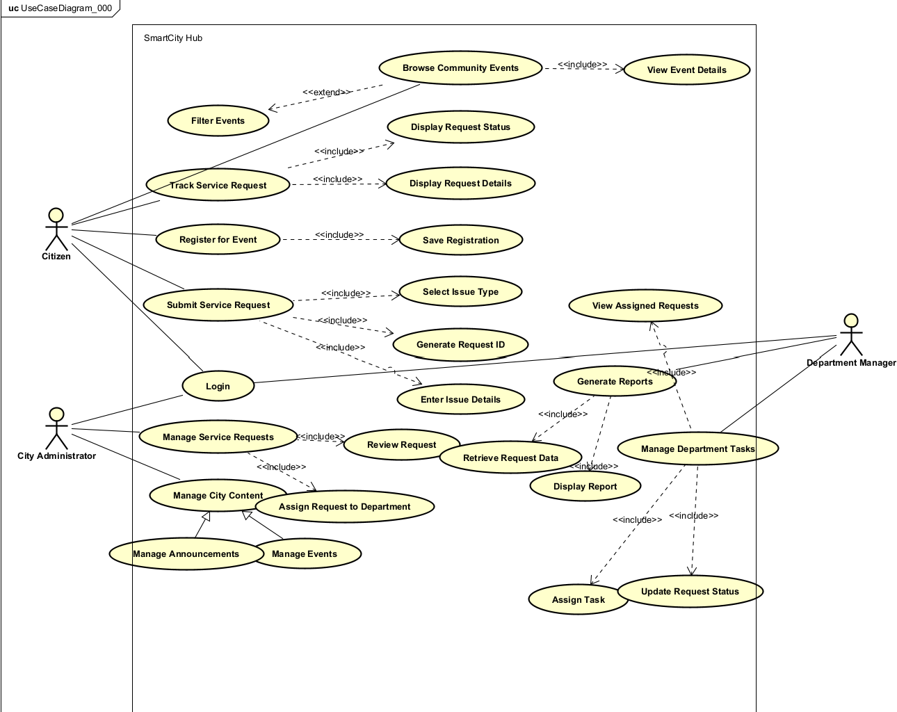

- List of objects and their classification (Module 3 and 4 covers topics related to objects and their classification)
Object | Classification | Description
User | Entity | Stores common information for system users.
Citizen | Entity | Represents a citizen who interacts with city services and events.
CityAdministrator | Entity | Represents an administrator responsible for city content and service requests.
DepartmentManager | Entity | Represents a manager responsible for department tasks and requests.
Event | Entity | Represents a community event available through SmartCity Hub.
ServiceRequest | Entity | Represents a city-related issue submitted by a citizen.
Announcement | Entity | Represents information or announcements published by the city.
Department | Entity | Represents a city department responsible for handling service requests.
SmartCityUI | Boundary | Provides the user interface through which users interact with SmartCity Hub.
SmartCityController | Control | Coordinates interactions between the user interface and system entities.

Copy and paste your class diagram here . All the classes in the class diagram should have related methods and attributes (In phase II, we will further refine this initial class diagram, but key attributes and methods need to be identified in part I)

