SmartCity Hub — Phase III, Part 1
Team #: __________ Team member(s): __________________________

Architecture explanation and comparison

Selected architecture
I chose a client-server architecture with a layered, modular Spring Boot backend. Vue 3 will provide the web interface for citizens, city administrators, and department managers. Spring Boot will expose REST endpoints and handle authentication, authorization, and business rules. PostgreSQL will store accounts, community events, announcements, departments, and service requests. The application will be developed locally first, with Azure deployment planned after the core functionality works.

Responsibilities and design
The Vue client will show event lists, registration forms, service-request tracking, and management screens. Spring REST controllers will receive HTTP requests and return JSON. Service classes will coordinate the business logic, while repository classes will access PostgreSQL using Spring Data JPA. This separation keeps interface code independent from database code and supports the Factory, Observer, and Strategy patterns introduced in Phase II.

Alternative: microservices
I considered a microservices architecture, where user accounts, events, requests, and notifications would run as independently deployed services. That approach can support independent scaling and releases, but it also requires service-to-service communication, distributed troubleshooting, additional deployment configuration, and more complex security. For the current project, one modular backend is easier to develop, test, and maintain while still allowing features to be organized into separate packages.

Benefits and deployment plan
The selected architecture reduces coupling and makes future changes easier. For instance, a new event-filtering strategy can be added without rewriting the Vue interface or request-management logic. A REST API also allows a future mobile client to reuse the backend. The proposed production deployment uses Azure Static Web Apps for Vue, Azure App Service for Spring Boot, and Azure Database for PostgreSQL. These are planned services; deployment will be verified separately after local development.

C4 system context diagram
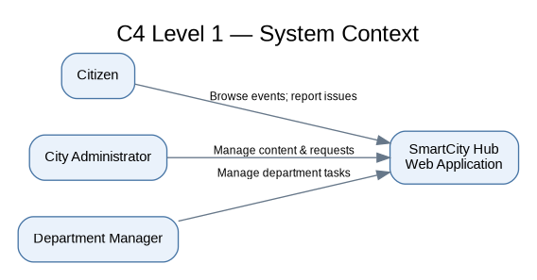
Figure 1. External users and their interactions with SmartCity Hub.

C4 backend component diagram
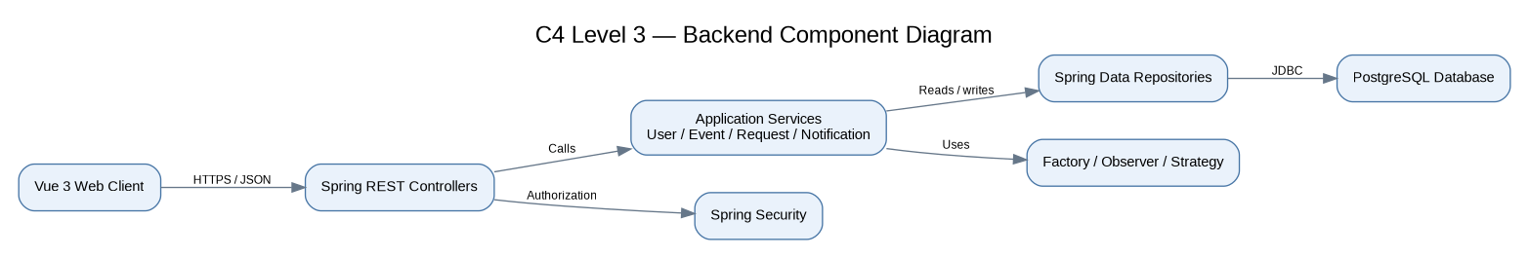
Figure 2. Main components within the Spring Boot backend and its connections to the Vue client and database.

Extra credit — planned deployment diagram
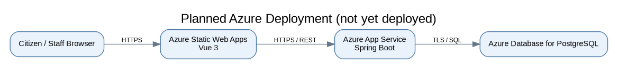
Figure 3. Proposed Azure hosting arrangement; deployment is not yet complete.

Phase I code [10 points]
Google Drive code link: [Add after uploading working increment 1]

Video link [5 points]
3–5 minute demo link: [Add after recording and uploading]

