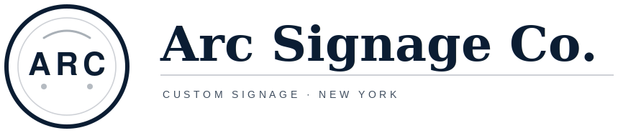 | Arc Signage Co LLC  1974 Crotona Ave, Bronx, NY 10457  (347) 450-2110 (call or text)  jc@arcsignco.com  arcsignco.com | INVOICE
  Invoice No. | INV-[YYYY]-[MMDD]-[XXX]
  Invoice date | [DATE]
  Due date | [DUE DATE]
  Estimate ref. | ARC-[YYYY]-[MMDD]-[XXX]

Bill to / Client  Client name: [CLIENT NAME]  Company: [COMPANY]  Contact: [CONTACT NAME / TITLE]  Phone: [PHONE]  Email: [EMAIL]  Billing address: [BILLING ADDRESS] | Project  Project name: [PROJECT NAME]  Site address: [SITE ADDRESS]  GC / Owner: [GC / OWNER — if applicable]  GC / Owner contact: [NAME · PHONE · EMAIL — if applicable]  Scope summary: [ONE-LINE SCOPE SUMMARY]

# | Description | Qty | Unit | Rate | Amount
01 | Design  Design / artwork adaptation, layout, and proofs for client approval. [DETAILS] | [QTY] | [UNIT] | [RATE] | [AMOUNT]
02 | Engineering drawings  Shop / fabrication drawings. PE-stamped drawings, if required, are provided by a third-party licensed Professional Engineer. [DETAILS] | [QTY] | [UNIT] | [RATE] | [AMOUNT]
03 | Fabrication  [SIGN TYPE · SIZE · MATERIALS · FINISH · ILLUMINATION] | [QTY] | [UNIT] | [RATE] | [AMOUNT]
04 | Installation  Delivery and installation within New York / tri-state. [SITE CONDITIONS · ACCESS · EQUIPMENT] | [QTY] | [UNIT] | [RATE] | [AMOUNT]
05 | Permit coordination  Coordination and document support for permit applications filed by the responsible licensed party. Agency and filing fees not included. [DETAILS] | [QTY] | [UNIT] | [RATE] | [AMOUNT]
06 | [ADDITIONAL ITEM]  [DESCRIPTION] | [QTY] | [UNIT] | [RATE] | [AMOUNT]

Payment terms  • 50% deposit due before any work starts; work is scheduled once the deposit is received.  • 25% due when production is confirmed, before install.  • Final 25% plus any additional costs due Net 30.
  Subtotal | [SUBTOTAL]
  Sales tax (8.875%) | [TAX]
  Total | [TOTAL]
  Deposit (50%) | [DEPOSIT]
  Production (25%) | [PRODUCTION]
  Final (25%) + additional costs | [FINAL]
  Amount paid | [AMOUNT PAID]
  Balance due | [BALANCE DUE]

Lead time  Approximately 6 weeks after written approval, deposit, and final artwork approval.  Payment methods  • ACH, check, or wire. Checks payable to Arc Signage Co LLC.  • Credit card by online payment link; a 3.5% processing fee applies.  • Please include the invoice number in the payment memo.  • Our banking details never change by email. Call (347) 450-2110 to verify before sending payment. | Exclusions  • Electrical work by the project's licensed electrician; Arc is not an electrical contractor.  • PE-stamped engineering drawings, when required, are provided by a third-party licensed Professional Engineer.  • Permit, filing, and agency fees (e.g., LPC / DOB), unless listed above as a line item.  • Structural, masonry, or wall repair and painting.  • Rush premium beyond the stated lead time (available on request).  Notes & assumptions  • Client provides final artwork / logo files (vector preferred).  • Final artwork and shop drawings are subject to client sign-off before production.  • Standard installation conditions assumed; unusual substrates or site conditions may require a change order.  • 1-year warranty on Arc-supplied fabrication and installation workmanship.  • Sales tax (8.875%) applies unless the client provides a valid sales tax exemption or resale certificate before invoicing.

Remit payment to
Payee: Arc Signage Co LLC  Checks payable to: Arc Signage Co LLC  Mail checks to: 83 Post Avenue, Apt 34, New York, NY 10034  Card: [ONLINE PAYMENT LINK] | Bank: [BANK NAME]  ACH routing: [ACH ROUTING NO.]  Wire routing: [WIRE ROUTING NO.]  Account no.: [ACCOUNT NO.]  SWIFT (intl.): [SWIFT CODE]

Thank you for your business!
Questions about this invoice? Call or text (347) 450-2110 or email jc@arcsignco.com.

