Heriot-Watt University

MSc Robotics : B81EZ

Smart Cabinet Project
Autonomous Tray Transfer & Docking System
Design Concept Note
Submitted by:
Vivek Devarapalli | vd4009@hw.ac.uk
Supervised by:
Professor Mauro Dragone

Contents
1 What I Am Building - The Idea 2
2 Why This Design - The Requirements 2
3 How It Works - The 5-Phase Sequence 3
4 Sensor Strategy - IR vs Camera 3
4.1 Pros and Cons Analysis 3
4.2 My Decision 4
5 Hardware I Am Using 4
6 The 3D Design - Current Progress 4
7 What Still Needs Work 5

1 What I Am Building -The Idea
The Smart Cabinet is an autonomous tray-delivery system designed to work alongside the Temi social robot in a care or hospital environment. The problem it solves is simple: a patient needs food or medication delivered, but a human carer is not always available. The cabinet holds the prepared tray, and the entire process of loading it onto Temi and sending Temi to the patient happens without any human involvement.

The cabinet uses a CNC-style horizontal gantry (shown in the 3D model screenshots attached) to push the tray onto Temi's back holder. A height-adjustable desk platform ensures the tray is always at the correct height for the robot, regardless of minor floor-level variation. An ESP32 microcontroller coordinates the full sequence from sensing Temi's arrival to confirming the tray has been received.

2 Why This Design -The Requirements
The design was developed to meet the following requirements. These cover not only the docking action but the full safe transfer of a loaded tray from the cabinet to the robot.

Requirement | Target Value | Reasoning
Payload capacity | ≤3 kg (Temi back holder limit) | Temi’s back holder is rated at 3 kg maximum; tray + food must stay within this limit
Lateral docking accuracy | ± 5 mm | Needed for the tray to slide cleanly onto Temi's holder
Transfer time | < 10 seconds | Keeps the delivery workflow fast
Z-axis travel range | 200 mm | Covers Temi tray height variation floor-to-floor
Safety stop response | < 50 ms | Motor must halt if an obstruction is detected
No human intervention | Full auto | Core purpose of the project

3 How It Works -The 5-Phase Sequence
The full system operates in five sequential phases. Each phase must confirm completion before the next one begins. This interlocking approach ensures no tray is ever transferred unless every sensor and motor has verified it is safe to do so.

Phase | Name | What Happens | Confirmed By
1 | Global navigation | Temi uses its internal SLAM map to reach the kitchen zone and spots the ArUco marker on the cabinet | Marker detected by Temi's camera
2 | Local docking | IR emitter/receiver array guides Temi to within ±5 mm of the docking centreline; ESP32 handshake triggers | All 3 IR receivers equalised
3 | Height calibration | Three-step sequence: (A) Move desk to TEMI_TRAY_HEIGHT via ball screw; (B) After tray transfer, descend 5–10 mm to release load and clear the tray holder; (C) Once Temi departs, return desk to HOME_POSITION | Position sensor at target Z
4 | Tray transfer | CNC gantry lowers the tray to desk level; pusher motor drives a 280 mm horizontal stroke onto Temi | Encoder stroke complete
4.5 | Release (NEW) | Desk moves to TEMI_TRAY_HEIGHT − 10 mm; mechanical clearance ensures tray is fully supported by Temi and cabinet does not snag on tray holder as robot departs | Pusher encoder confirms 280 mm stroke complete
5 | Confirmation | Pusher encoder confirms 280 mm stroke complete; no IR sensor is fitted on Temi’s back holder, so tray seating is inferred from full stroke completion plus a 500 ms settle timeout before the LOADED signal is sent | Break-beam triggered
— | Post-Docking Reset | After IR signal loss or Wi-Fi handshake confirms Temi has departed, desk returns to HOME_POSITION to await next cycle | IR loss or Wi-Fi departure signal
Figure 1 — Height Calibration Block Diagram (Revised Phase 3)
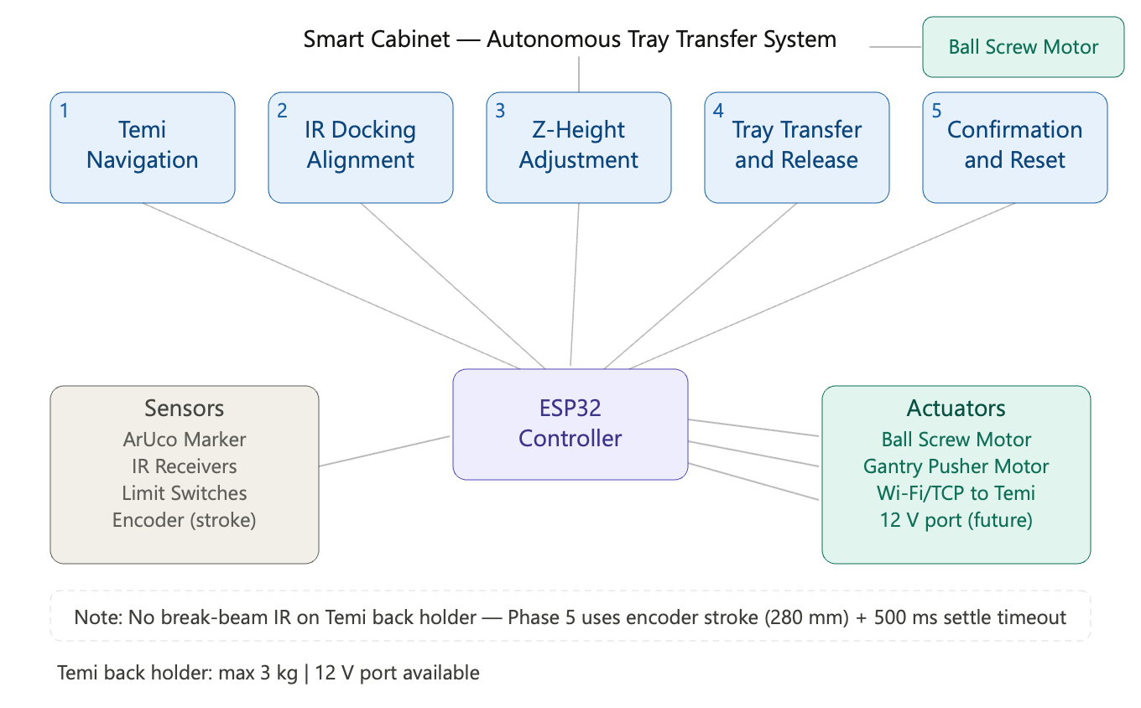

3.1 Step-by-Step Block Diagrams
The following seven flowcharts detail the working logic of each phase in the 5-phase (plus Phase 4.5) state machine. Each diagram follows rectangles for process steps, diamonds for decision nodes, rounded terminals for start/end, and a hardware reference sidebar. All diagrams are numbered sequentially as Figs. 1–7.
Fig. 1 - Phase 1: Global Navigation
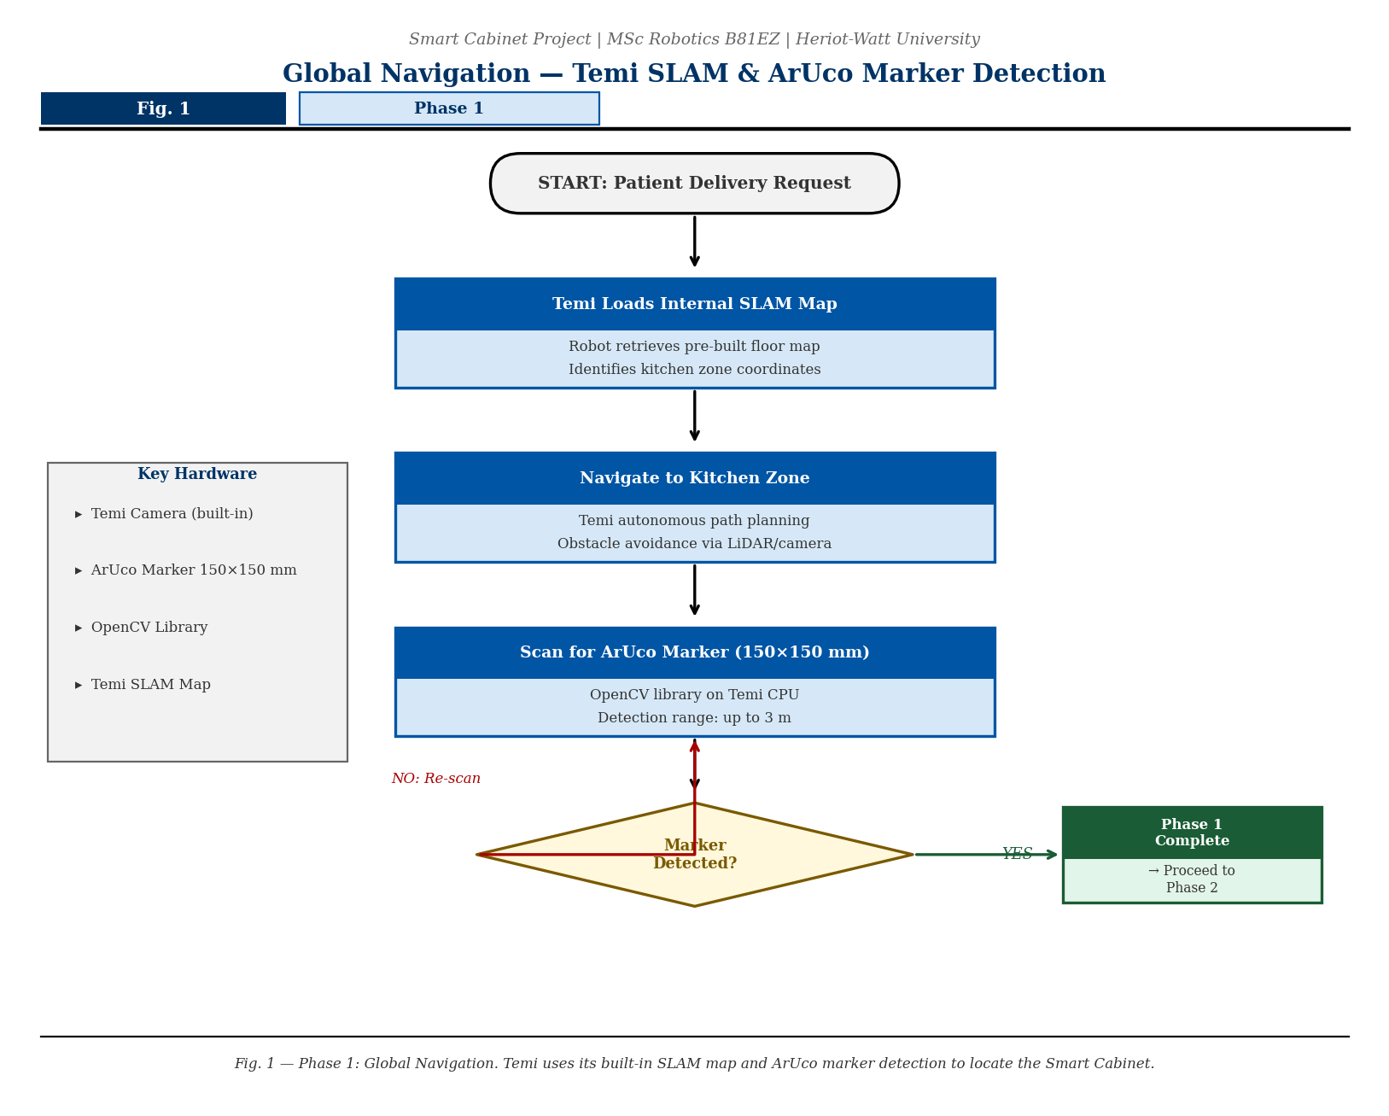
Temi loads its SLAM map, navigates to the kitchen zone, and detects the cabinet ArUco marker. The robot steers itself into the approach corridor and confirms visual lock before proceeding.

Fig. 2 - Phase 2: Local Docking
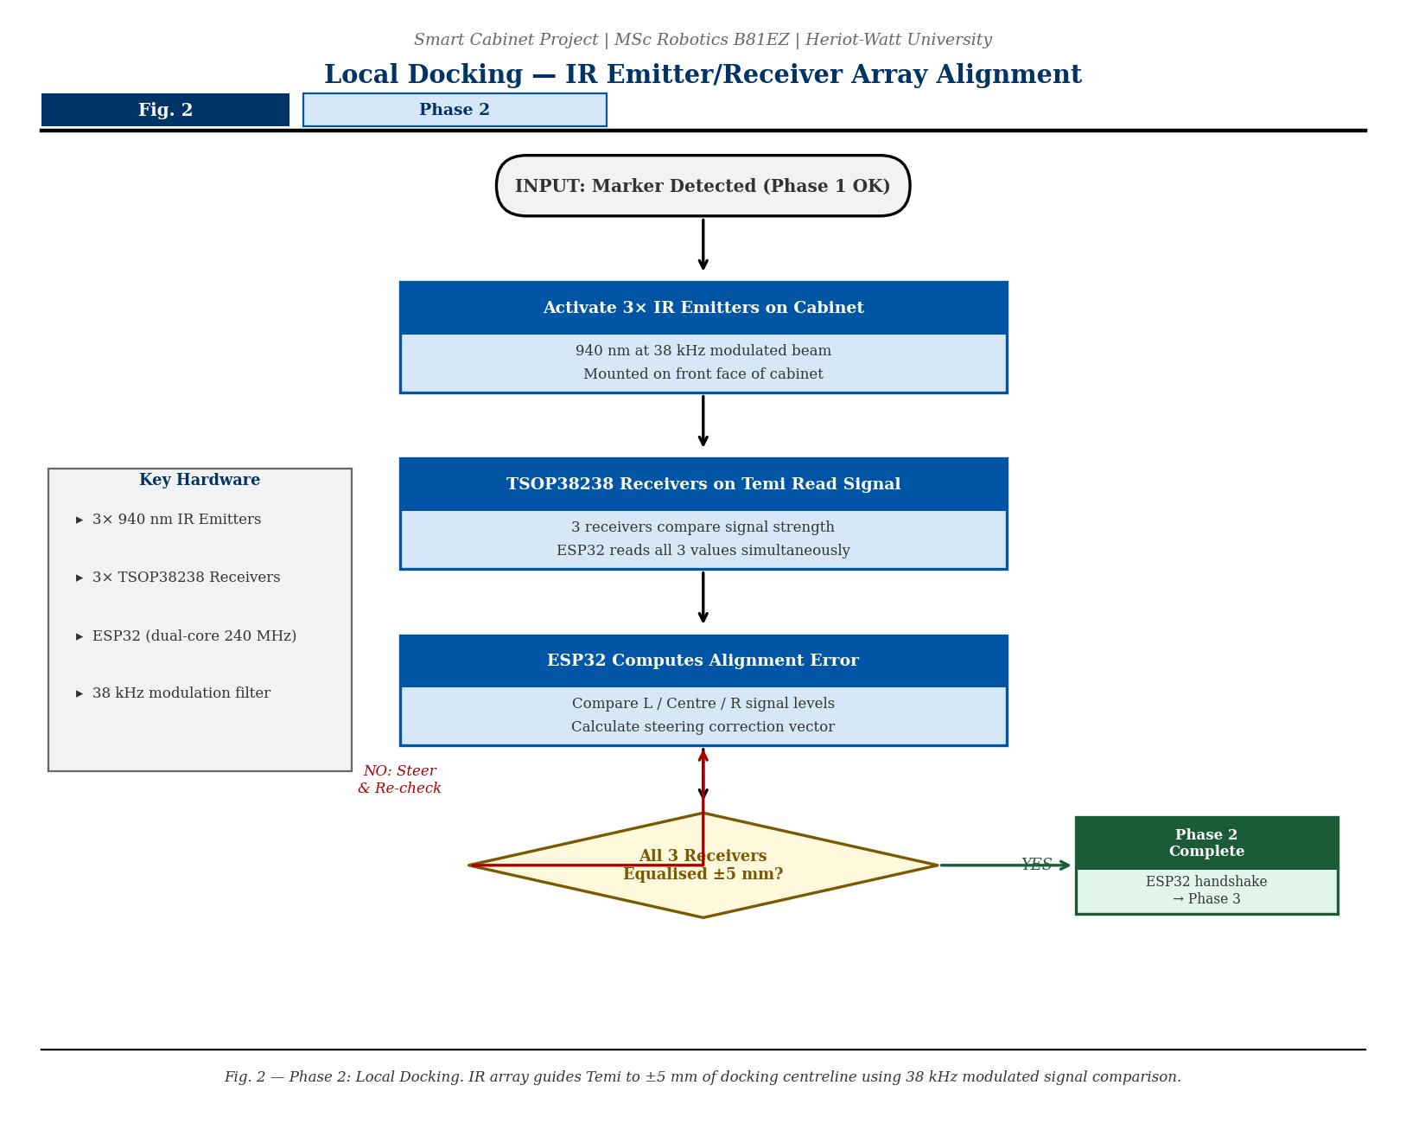
Three 940 nm IR emitters on the cabinet transmit a 38 kHz modulated beam. Three TSOP38238 receivers on Temi compare signal strength; the ESP32 steers Temi until all three readings equalise, confirming centreline alignment to within ±5 mm.

Fig. 3 - Phase 3 Step A: Target Acquisition
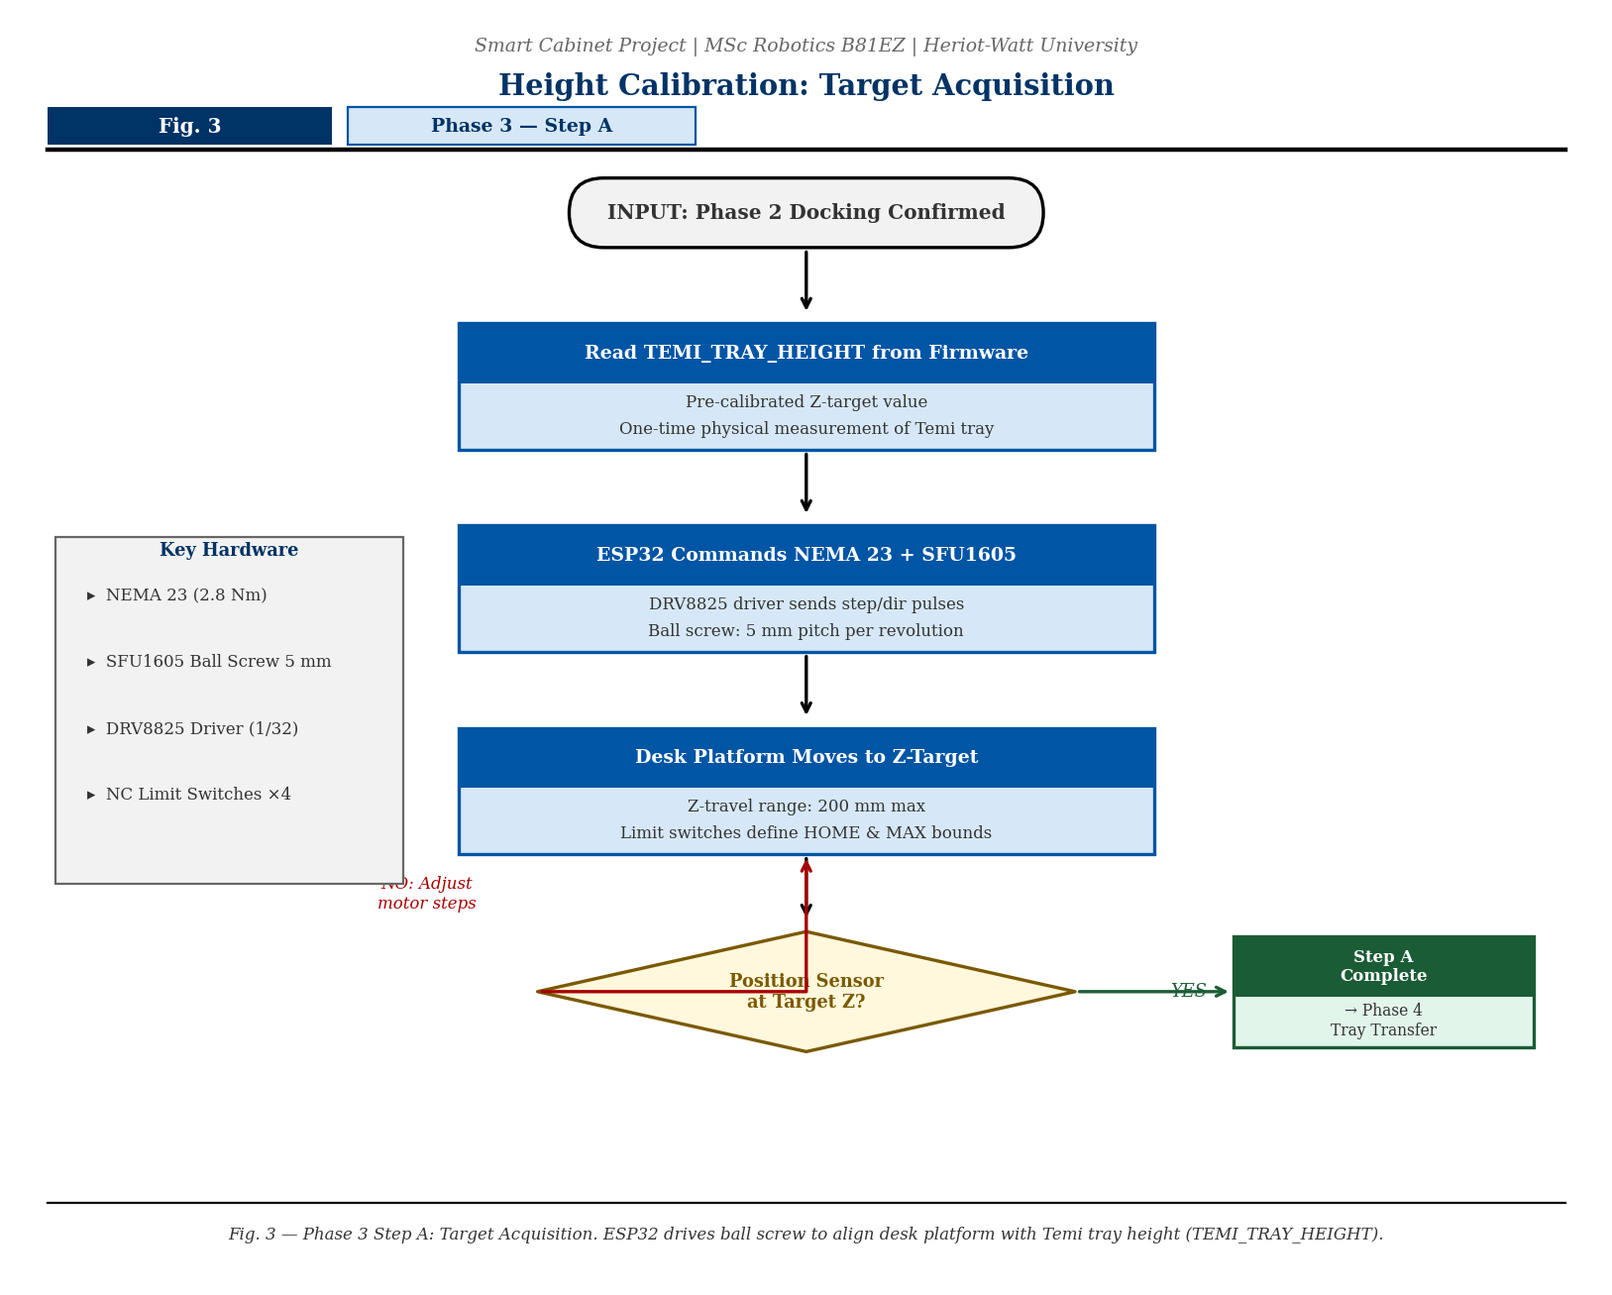
The ESP32 reads the pre-calibrated TEMI_TRAY_HEIGHT value from firmware and commands the NEMA 23 motor via the DRV8825 driver to drive the SFU1605 ball screw until the desk platform reaches the target Z-coordinate. A position sensor confirms arrival.

Fig. 4 - Phase 4: Tray Transfer
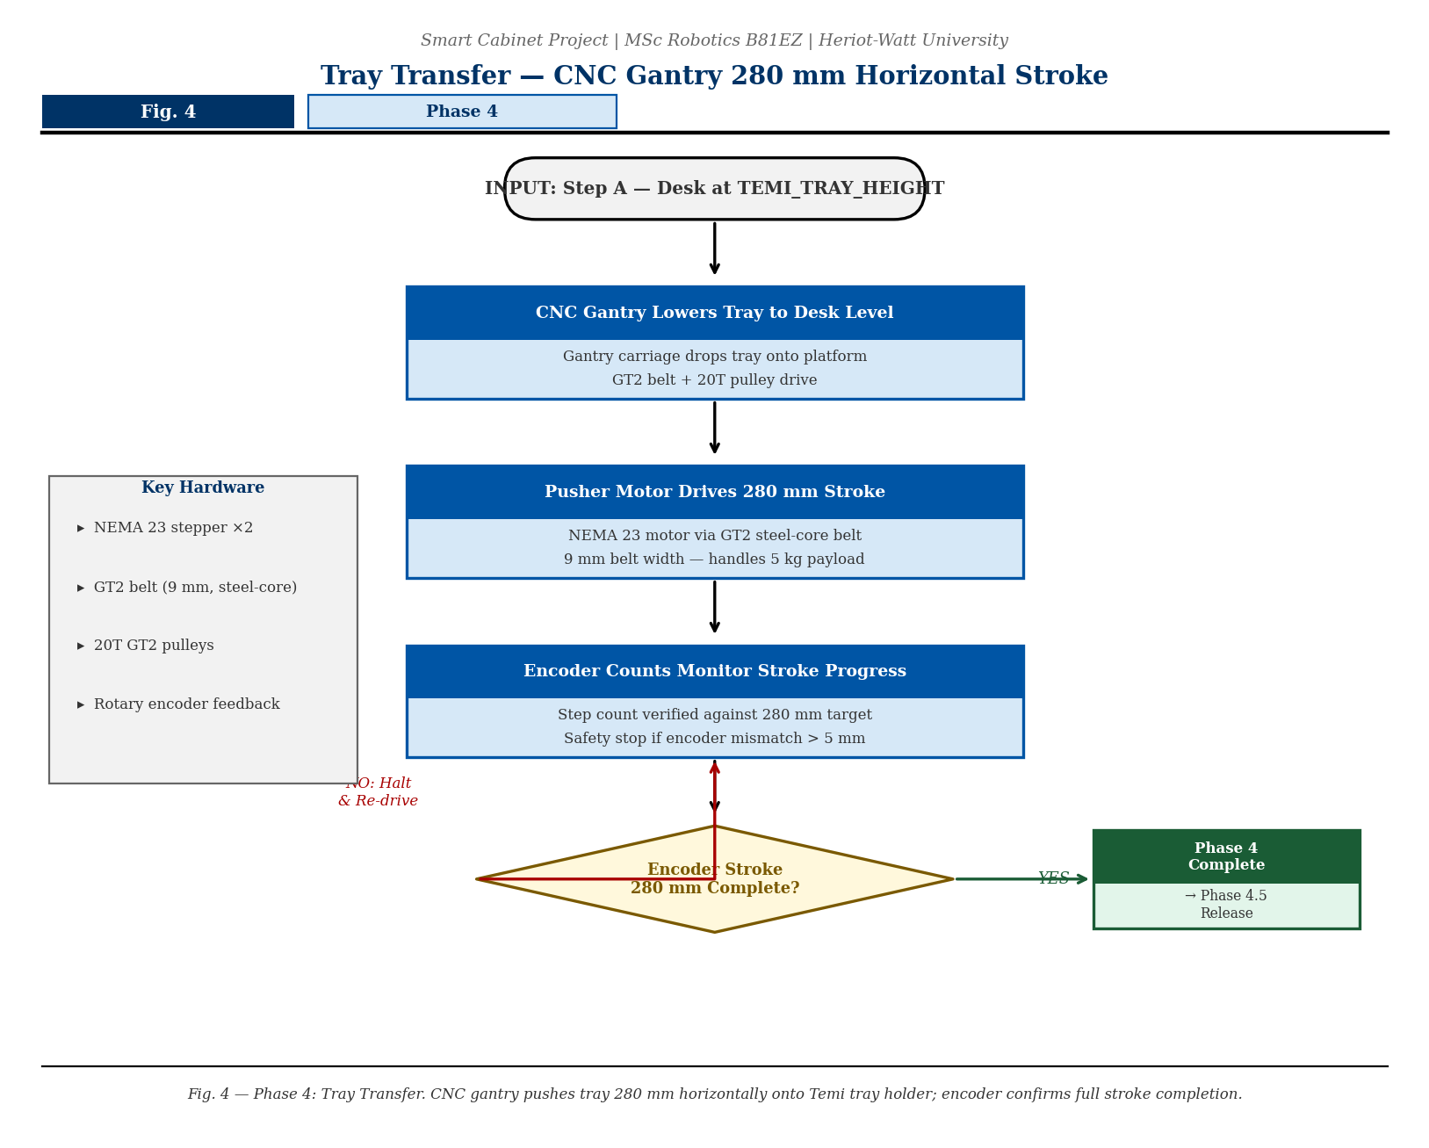
The CNC gantry carriage lowers the tray to desk level; the pusher motor then drives a 280 mm horizontal stroke via GT2 steel-core belt and 20T pulleys, sliding the tray onto Temi’s holder. Encoder step counts confirm the full stroke is complete.

Fig. 5 - Phase 4.5 (NEW): Release / Drop-off Maneuver
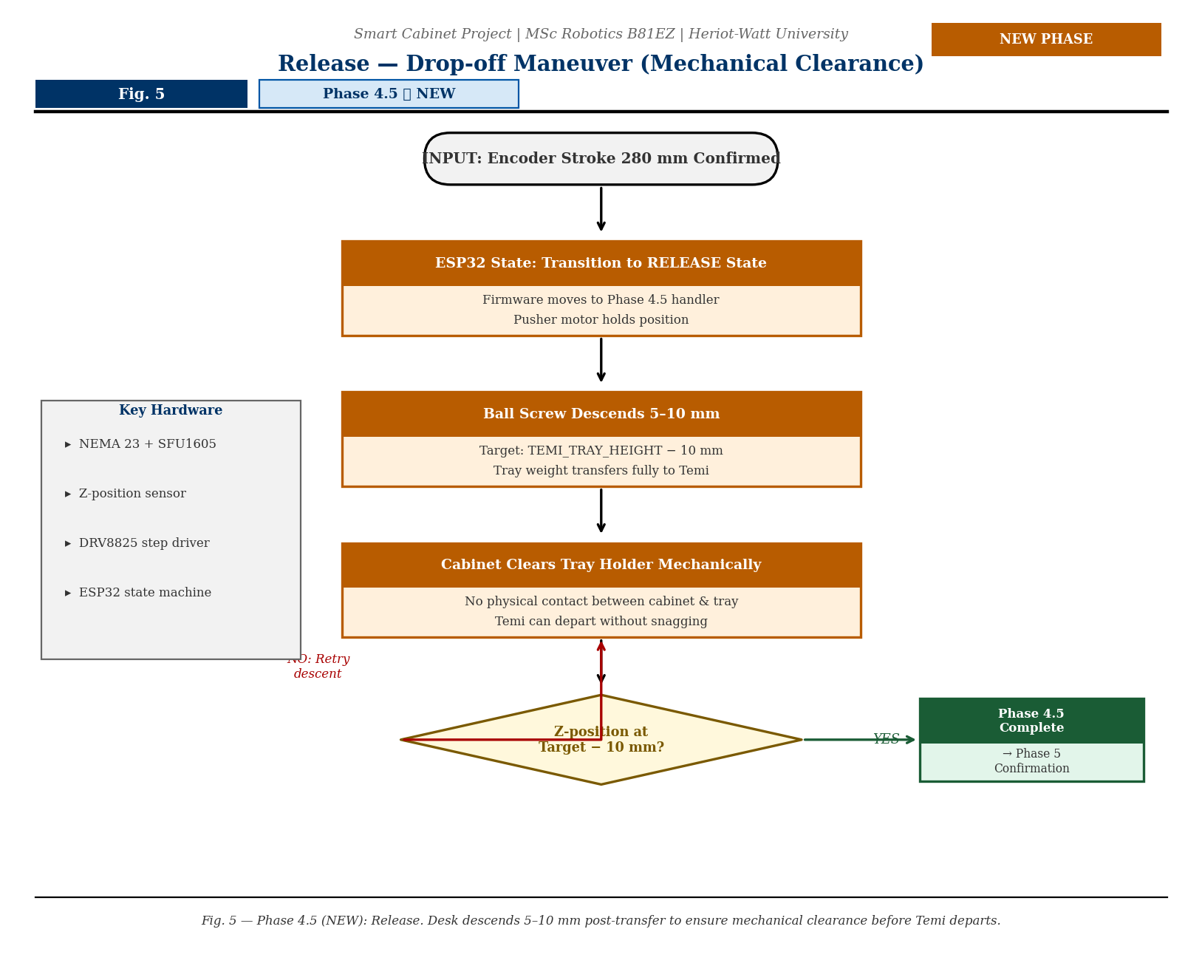
After the encoder confirms stroke completion, the ESP32 firmware enters the new RELEASE state. The ball screw descends a further 5–10 mm below TEMI_TRAY_HEIGHT, transferring the full tray load to Temi and creating mechanical clearance so the cabinet frame cannot snag the tray holder as Temi departs.

Fig. 6 - Phase 5: Confirmation
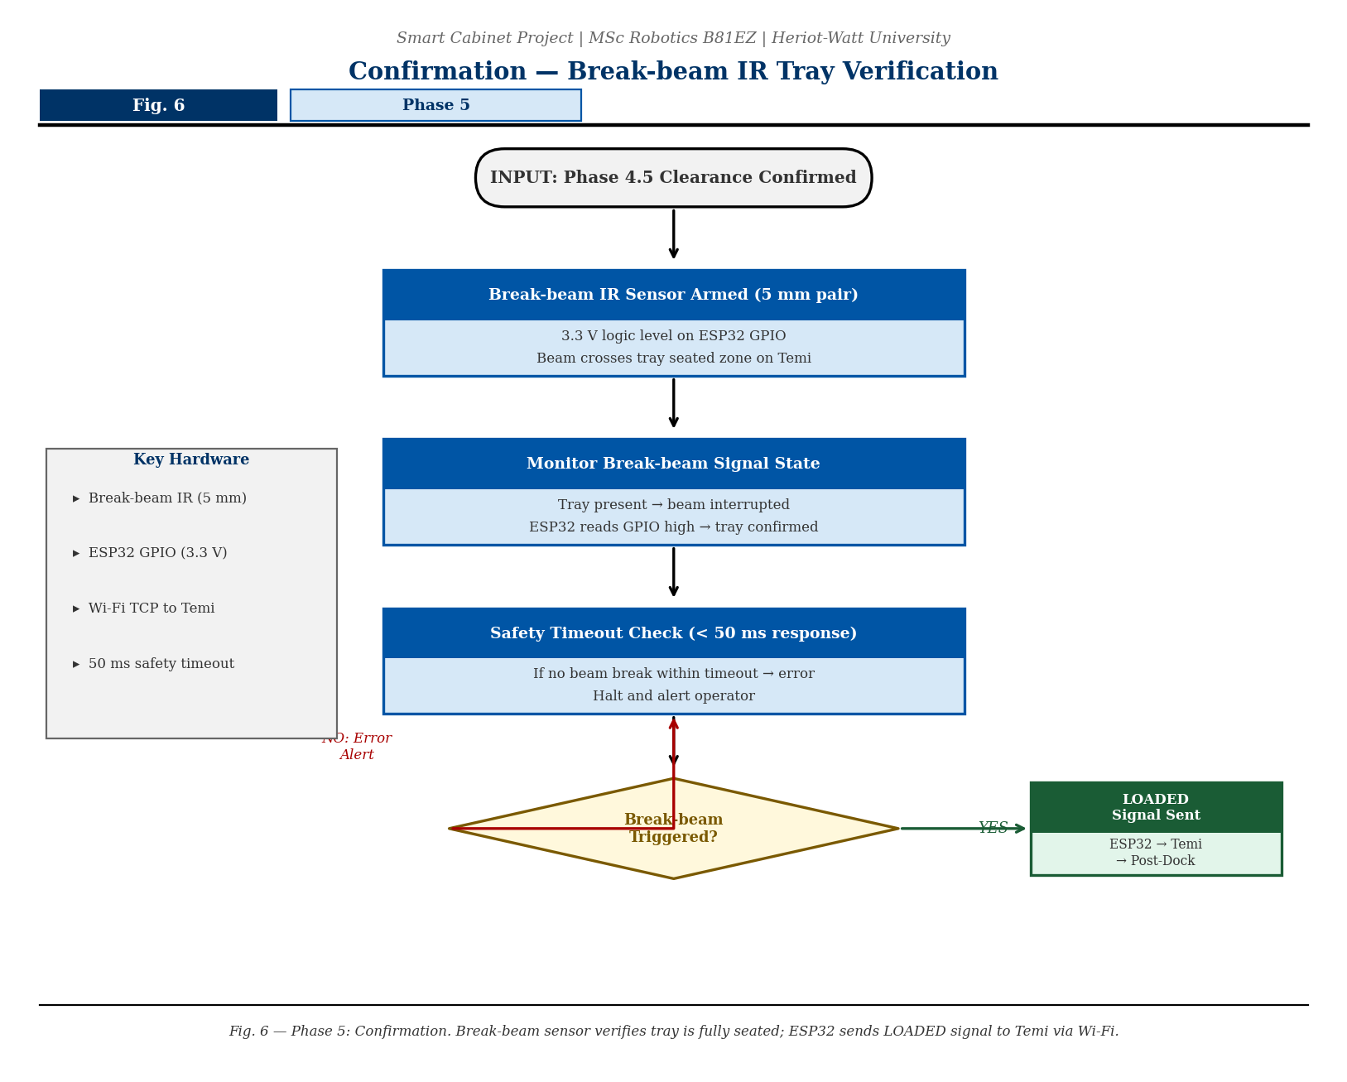
Because Temi’s back holder has no IR sensor, tray-seated confirmation uses encoder stroke count (280 mm complete) plus a 500 ms settle window. The ESP32 then broadcasts the LOADED signal to Temi via Wi-Fi TCP, authorising Temi to depart. The break-beam sensor described in earlier drafts has been removed from this phase; it is retained only as an optional future enhancement.

Fig. 7 - Phase 3 Steps B+C and Post-Docking Reset
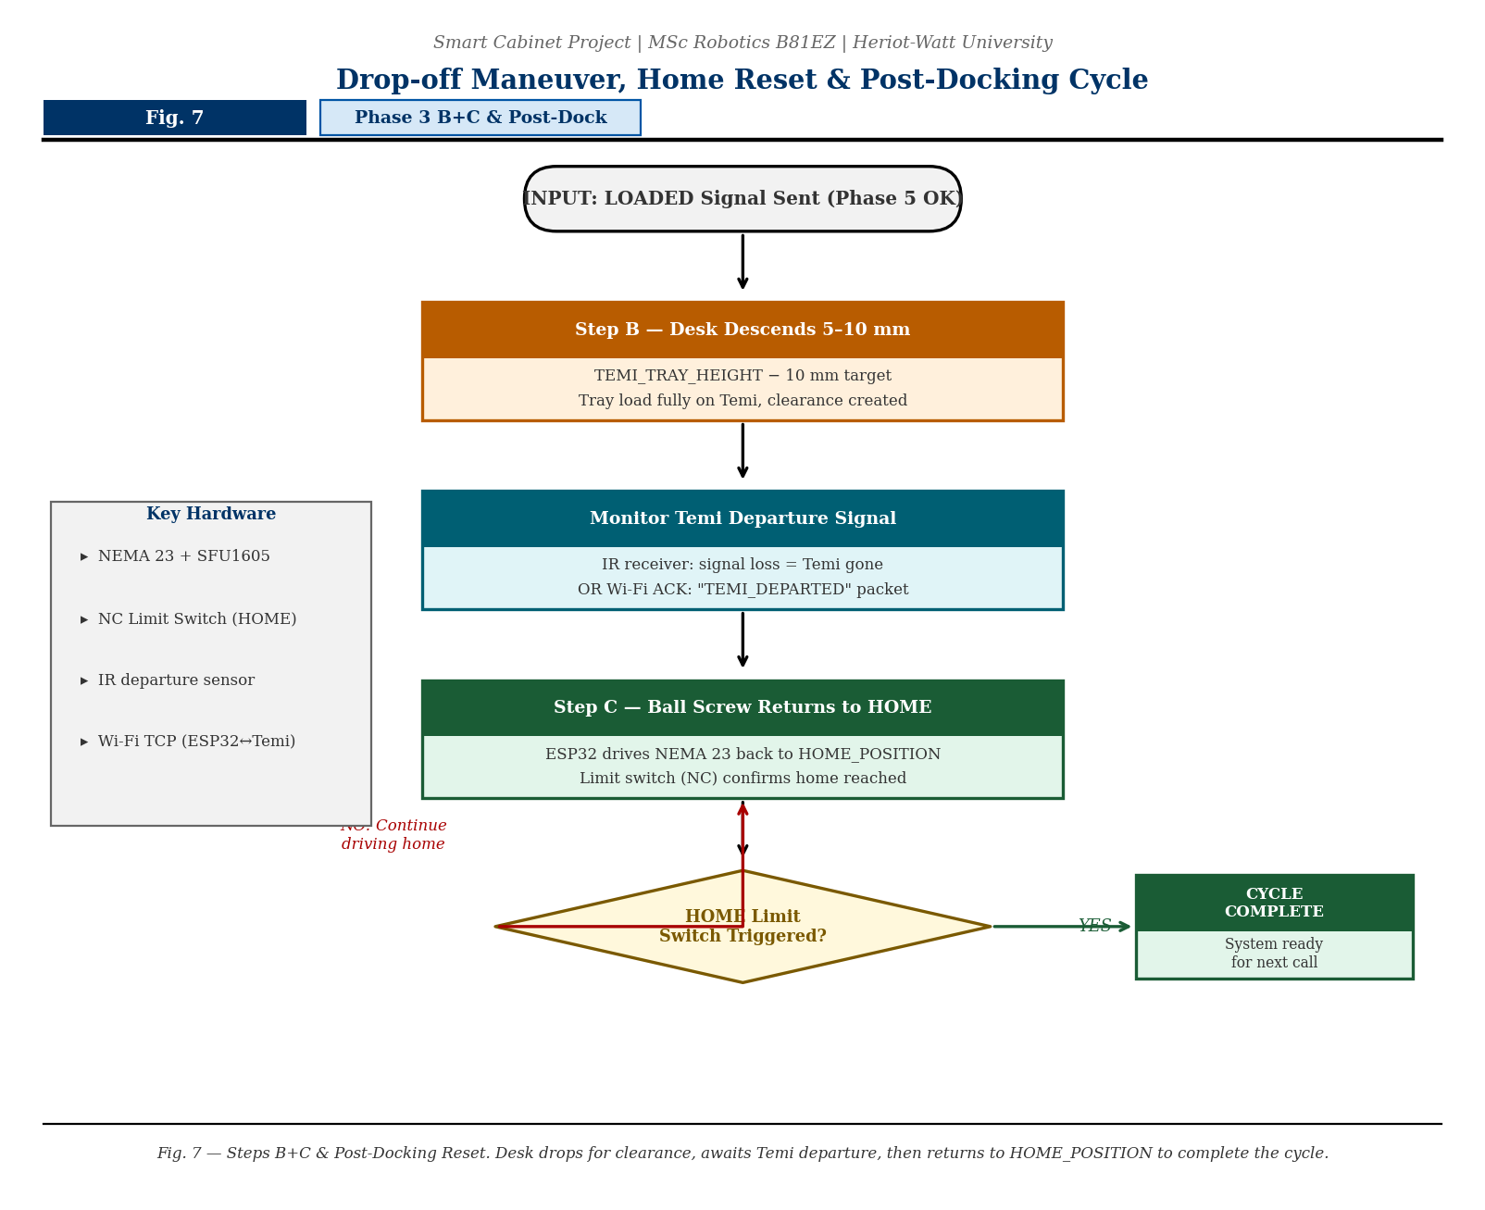
Step B descends the desk 5–10 mm for clearance. Once IR signal loss or a Wi-Fi departure acknowledgement confirms Temi has left, Step C drives the ball screw back to HOME_POSITION. The mechanical NC limit switch confirms the home position, completing the full delivery cycle and readying the system for the next call.

4 Sensor Strategy - IR vs Camera
Mauro asked me to compare possible solutions and justify my choice. I investigated two approaches for the docking alignment phase.

4.1 Pros and Cons Analysis

Option A - Camera / Machine Vision (ArUco Markers)
Temi's own camera spots a printed ArUco marker on the cabinet and calculates its offset. The robot steers itself into alignment. A previous student prototyped this and code already exists.

Advantages | Disadvantages
High accuracy at close range (sub-2 mm with calibration) | Sensitive to kitchen lighting changes and steam/condensation
Open-source libraries (OpenCV, ArUco) freely available | Higher processing load needs Temi CPU or external SBC
No extra electronics needed on cabinet side | Camera needs periodic recalibration
6-DOF pose estimate from a single marker | Marker must stay clean and unobstructed

Option B - IR Emitter / Receiver Array (My Selected Approach)
Three 940 nm IR emitters on the cabinet transmit a 38 kHz modulated beam. Three TSOP38238 receivers on Temi compare signal strength. The ESP32 steers Temi until all three readings equalise, confirming centreline alignment the same principle used in Temi's own charging dock.

Advantages | Disadvantages
Hardware-level response - no image processing delay | Effective range: 0.3–2.5 m only
Immune to kitchen lighting variation and steam | Strong direct sunlight can occasionally interfere
Low cost and simple wiring | 2D alignment only - no depth information from IR alone
Mirrors Temi's own charging-dock architecture | Requires hardware additions to both Temi and cabinet
38 kHz modulation filters out stray IR interference

4.2 My Decision
I am using IR for the close-range docking phase (Phase 2) because it is reliable in a kitchen environment regardless of lighting, and it directly mirrors an approach already validated on the Temi hardware. The ArUco marker is retained for Phase 1 (wide-area navigation from up to 3 m away), giving a hybrid approach that uses the strengths of both methods. This is the same Sensor Fusion logic used in industrial automated guided vehicle (AGV) systems.

5 Hardware I Am Using
The following components form the core of the system. I selected these based on the 3 kg payload constraint imposed by Temi’s back holder and the need for reliable positioning without slip or stretch.

Component | Model / Spec | Why I Chose It
ESP32 microcontroller | Dual-core 240 MHz, Wi-Fi | Central brain controls motors, reads sensors, talks to Temi
NEMA 23 stepper ×2 | 2.8 Nm holding torque | Sufficient torque for a 3 kg tray without step-loss or drift; chosen with overhead margin
Ball screw (Z-axis) | SFU1605, 5 mm pitch | Self-locking under gravity tray cannot slip if power cuts
GT2 belt + 20T pulleys | 9 mm width, 8 mm bore, steel-core | Zero-backlash; 9 mm width handles the 3 kg tray load without stretching
IR emitter/receiver ×3 | 940 nm + TSOP38238, 38 kHz | Docking alignment immune to ambient kitchen lighting
Break-beam IR sensor | 5 mm pair, 3.3 V logic | Optional future addition tray-seated confirmation currently uses encoder stroke count; break-beam retained as upgrade path
Limit switches ×4 | Mechanical NC, 5 A | Hard end-stops on both axes prevents mechanical over-run
ArUco fiducial marker | Printed, 150×150 mm | Wide-area visual lock for Temi's camera in Phase 1
DRV8825 stepper drivers | 2 A, 1/32 microstepping | Smooth, quiet motor control with current limiting
12 V / 10 A PSU | Regulated switching supply | Powers all actuators and electronics

6 The 3D Design — Current Progress
I have been building the 3D model in Blender. The screenshots attached show three views of the current design. Here is what has been modelled so far and what each part represents.

What the model shows
- Two vertical rail columns with a horizontal crossbar - this is the main cabinet frame. The columns house the linear bearings and the ball screw drive for the height-adjustable desk.
- Two NEMA 23 motor housings at the top of each column (labelled Motor 1 and Motor 2 in the hand sketch), each with GT2 20-tooth pulleys visible.
- A horizontal gantry carriage spanning between the columns - this is the pusher that drives the tray horizontally onto Temi in Phase 4.
- Support wheels at the base of each column (visible in the top-view screenshot) - these allow the cabinet to be repositioned and absorb floor vibration.
- The overall assembly is shown from three angles: perspective view, top-down, and front/side elevation.

What is not yet modelled
- The IR emitter and receiver housings (planned as 3D-printed brackets on the front face of the cabinet).
- The height-adjustable desk platform sliding element - the guide rails are present but the moving deck needs to be added.
- The ArUco marker mount on the cabinet base.
Note: The design is a working concept at this stage. The geometry, motor positions, and axis layout are correct. The mechanical clearances and bracket details will be refined in the next iteration.

7 What Still Needs Work
I want to be transparent with Professor Dragone about what this is: a solid concept with a clear engineering direction, not a finished design. The following items are identified as the next steps.

Item | Description | Priority
IR docking circuit | Mount IR array on cabinet front face; calibrate alignment at 0.3–2 m range on the Temi | High
Break-beam integration | Wire sensor into ESP32 GPIO and test tray-loaded detection logic | High
Blender desk platform | Add the moving desk element to the 3D model with correct travel range | Medium
ESP32 firmware | Complete the 5-phase state machine and Wi-Fi/TCP communication protocol with Temi | Medium
Limit switch firmware | Interrupt handler to halt motor drivers on any end-stop trigger | Medium
Temi height measurement | Physical measurement of Temi's tray height to calibrate Z-axis target position | Low
Render / final model | Clean Blender render for the full portfolio submission | Low

8 Tray Design
The tray is the physical interface between the Smart Cabinet and Temi’s back holder. It must be rigid enough not to flex under a loaded meal, light enough to keep the total payload within Temi’s 3 kg back-holder limit, and geometrically compatible with the holder so it slides on and stays seated without any retaining clip or sensor confirmation.

8.1 Design Constraints
Constraint | Value | Reason
Maximum tray mass (empty) | ≤500 g | Leaves ≥2.5 kg for food/medication within Temi’s 3 kg holder limit
Tray footprint (L × W) | ≤260 mm × 200 mm | Must fit within the 280 mm pusher stroke and the Temi back holder platform
Tray height (edge lip) | 15–20 mm raised lip | Prevents food sliding off during Temi’s transit; low enough for pusher plate to clear
Material | 3 mm PETG or ABS (3D-printed) | Lightweight, food-safe, easy to reprint if damaged; smooth underside slides without friction on the back holder
Pusher contact surface | Flat rear face, full tray width | Ensures the gantry pusher plate contacts the tray evenly without tipping

8.2 Tray-to-Holder Sliding Interface
Because Temi’s back holder has no IR sensor to detect tray arrival, the tray must self-locate reliably using mechanical geometry alone. The design uses two shallow alignment ridges (3 mm tall, 5 mm wide) running the full length of the tray underside. These ridges engage matching grooves or edge guides on the Temi holder platform, keeping the tray centred during the 280 mm pusher stroke and preventing side-slip once seated.
A small positive stop (5 mm step) at the front edge of the Temi holder acts as an end-stop for the tray during Phase 4 so the pusher stroke does not drive the tray beyond the holder platform. This stop must be confirmed by physical measurement when access to Temi is available (see Section 7, “Temi height measurement”).

9 Temi Back Holder Design Notes
Temi’s built-in back holder is the receiving surface for the tray transfer. Understanding its hard constraints is essential because these constraints drive the tray geometry, the gantry stroke length, the Phase 4.5 descent depth, and the confirmation strategy used in Phase 5. This section documents what is known about the holder and how each constraint is handled.

9.1 Known Hardware Constraints
Parameter | Value / Status | Impact on Design
Maximum load | 3 kg (tray + payload) | Drives tray mass target (≤500 g empty); all system requirements updated from 5 kg to 3 kg
Tray-seated IR sensor | NOT present | Phase 5 confirmation strategy changed: use encoder stroke count (280 mm) + 500 ms settle timeout instead of break-beam IR
12 V power port | Available on holder | Enables future tray add-ons (e.g. heated plate, LED tray indicator, or a break-beam sensor upgrade); currently unused by this design
Holder platform height (from floor) | TBD — physical measurement needed | This value is stored as TEMI_TRAY_HEIGHT in ESP32 firmware and must be set before first use

9.2 12 V Port — Usage Plan
Temi’s back holder exposes a 12 V DC output port. This is not currently used by the baseline Smart Cabinet design, but it represents a significant upgrade path. The port could power a small break-beam IR sensor board mounted on the tray itself, eliminating the tray-seating uncertainty described in Phase 5. It could also power a heated tray insert, an LED status indicator strip, or a small buzzer to alert carers that a delivery has been loaded. The design deliberately keeps this option open by not occupying the tray underside with fixed connectors — any future 12 V accessory will connect via a blind-mate connector on the front face of the tray to a mating socket on the holder platform.

10 User Interface — Design in Progress
A web-based user interface for the Smart Cabinet has been partially prototyped. The existing code implements a basic control panel that communicates with the ESP32 over Wi-Fi. The full UI specification is being developed and will be submitted as a follow-up document. This section records what is already built and what the UI needs to do.

10.1 Current State of the UI Code
The existing UI is a single-page web application served by the ESP32 over its Wi-Fi access point. It provides manual override controls (start cycle, abort, home axes), a live status display showing the current phase and any error codes, and a simple tray-ready button for the kitchen operator to confirm a tray has been loaded into the cabinet. The interface is functional for bench testing but is not yet styled for use by care staff in a clinical environment.

10.2 Planned Additions (Ideas to Develop)
A detailed UI specification will be provided once the next set of ideas has been gathered. The following areas are identified as requiring UI design work: room/patient selection so the operator can choose the delivery destination before loading; delivery status tracking so carers can see whether Temi is in transit, docked, or idle; error notification with plain-language messages rather than raw error codes; and a calibration screen to allow authorised staff to update TEMI_TRAY_HEIGHT without reflashing firmware. Additional ideas will be added in the next design file.
Working Concept Note — MSc Robotics — Heriot-Watt University — April 2026

