PASSWORD: Cpanel, Server FTP, SSH

BWGbph9QCX7w!sr

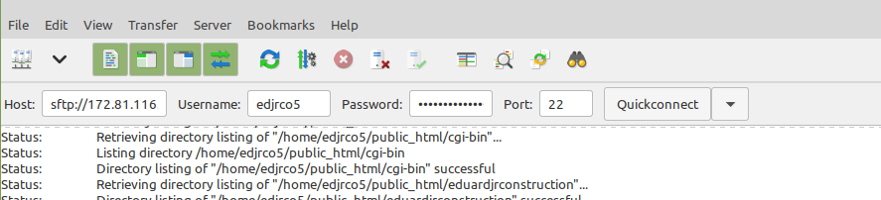

PASSWORD: Cpanel, Server FTP, SSH

BWGbph9QCX7w!sr

172.81.116.154

OR HOST <http://ftp.edjrconstruction.com/> in IP box

OR HOST vps64310.inmotionhosting.com in IP box



