## kill the current process using a port on localhost in Windows

**netstat -ano | findstr 8080**

**taskkill /f /pid 7777(yourPID)**

## Redis

<https://1upnote.me/post/2018/06/install-config-redis-on-mac-homebrew/>

brew services start/stop redis

redis-server

redis-server /usr/local/etc/redis.conf

## **Mac**

<https://support.apple.com/en-us/HT201236>

**Cmd + shift + .**

Hide / show hidden files

**^ + cmd + H**

highlight shortcut () in preview

**^ cmd D**

Look up dictionary

**Cmd L**

Chrome choose search bar

**Fn delete**

Delete backwards

**Open .**

Open current directory in terminal

## Vim

To find a word in Vi/Vim, simply type the / or ? key, followed by the word you’re searching for.

## Git

Git’s internal state management systems (three “trees” - node and pointer-based structures)

### The commit tree(HEAD)

Is sync with local filesystem and is representative of the immediate changes made to content in files or directories.

Git status - show changes to the Working Directories

### The staging index tree

Tracking working directories

### The working directory tree

Git add ...

Update what will be committed

Git checkout -- ...

To discard changes in working directory

**git grep -R ‘keyword’ ./directory**

**Git diff filename**

**Git diff -p [filename]**

|  |  |
| --- | --- |
| git diff **head** | 工作区 vs **版本库** |
| git diff | 工作区 vs 暂存区 |
| git diff --cached | 暂存区 vs 版本库 |

暂存区（stage）-> 工作区

git reset --soft

版本库 -> 暂存区

git reset --mixed

版本库 -> 暂存区 -> 工作区

git reset --hard

放弃修改(❓)

git checkout

创建分支

git checkout -b <BRANCH_NAME>

创建远程分支

git push <REMOTE_NAME> <BRANCH_NAME>

E.g. git push origin king

git push <REMOTE_NAME> <LOCAL_BRANCH_NAME>:<REMOTE_BRANCH_NAME>

E.g. git push origin king:develop

### For example:

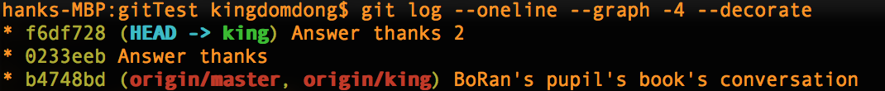

1. give up the latest two commits:

**git reset --soft head~2**



1. Merge the latest two commits to one

**git commit -m “git reset --soft TO one commit”**



### Changes from master in dev_branch

**Scenario:** If others haven’t cloned this repository

$ Git checkout dev_branch

$ Git reset --hard master

Scenario: if you have pushed to a remote already, you have to do:

$ git push --force

## Ctrl + R

repeats to run test runned in system last time

## Terminal

To have launchd start h2 now and restart at login:

  brew services start h2

Or, if you don't want/need a background service you can just run:

  h2

<http://192.168.2.199:8082/login.jsp?jsessionid=bf41854d02f9b5ba7cfe97863e704982>

IDEA default:

jdbc:h2:tcp://localhost:9092/default

H2 embedded:

jdbc:h2:~/test

H2 server:

jdbc:h2:tcp://localhost/~/test

## IDEA

### ⌃ space J

Smart line join