# Git

# [how to 'undiverge' branches'?](https://stackoverflow.com/questions/2452226/master-branch-and-origin-master-have-diverged-how-to-undiverge-branches)

... o ---- o ---- A ---- B origin/master (upstream work)

\

C master (your work)

git rebase origin/master

... o ---- o ---- A ---- B origin/master (upstream work)

\ \

C ---- M master (your work)

$ git rebase origin/master

... o ---- o ---- A ---- B origin/master (upstream work)

\

C' master (your work)

$ git pull --rebase

### 2)

git reset --hard origin/develop_xc

Delete remote branches:

git push origin --delete stage1

Questions:

git fetch --all

## Concepts

Fast-forward

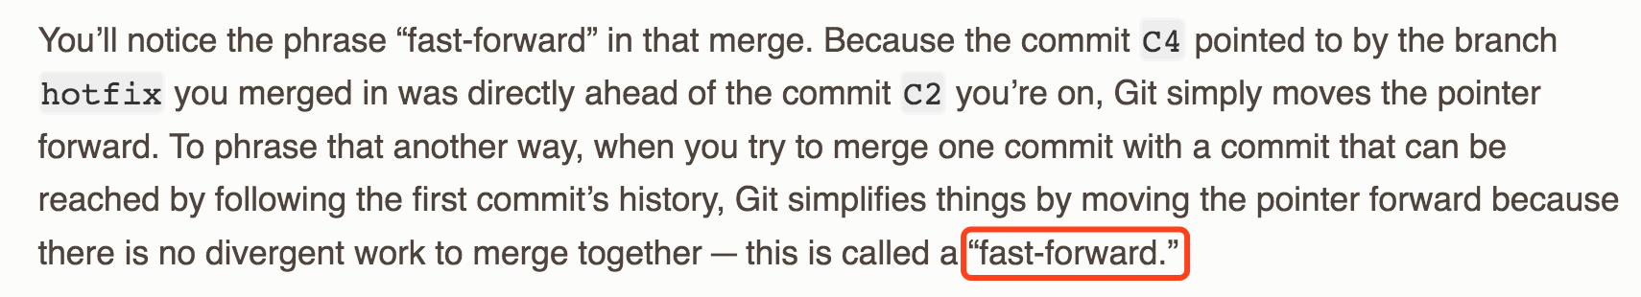

master is fast-forwarded to hotfix