WeLib

What is WeLib?
# Source: ScreenShots Source: Provided by: [Persons Table -> ID Column: 1, Name_En Column: Motasem Essam] -> Tool: [Lightshot Program] -> From [Site: https://welib.org/] on [9/21/2025]
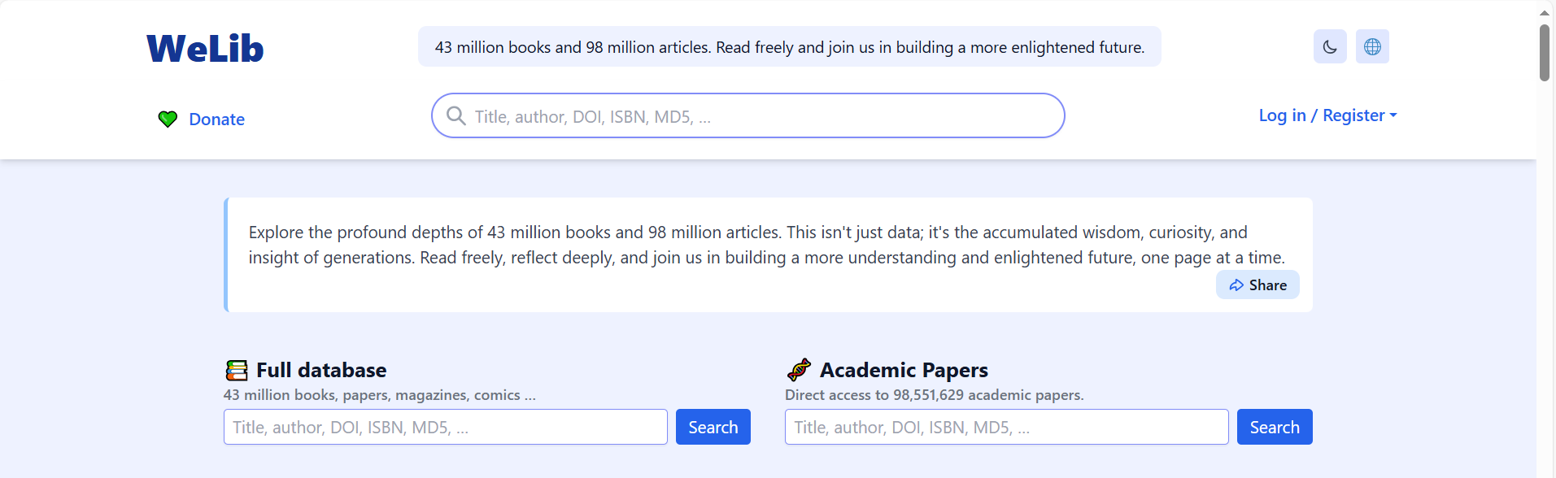
# Source: AI Source: Provided by: [Data Path: Persons Table -> ID Column: 1, Name_En Column: Motasem Essam] -> From: [ChatGPT] on [9/21/2025]
- WeLib.org claims to provide access to millions of books and academic papers (e.g., 43 million books, 98 million papers).
- Some users online describe it as a kind of alternative to sites like PDFDrive or Anna’s Archive, hosting or mirroring large digital libraries.

Risks and Red Flags
# Source: AI Source: Provided by: [Data Path: Persons Table -> ID Column: 1, Name_En Column: Motasem Essam] -> From: [ChatGPT] on [9/21/2025]
- ScamAdviser flagged the site as suspicious:
  - The domain owner is hidden (WHOIS privacy).
  - The website is relatively new, with no long-term track record.
  - Reports exist of spammy or unsafe behavior.
- On Reddit and forums, users warn that it may be malicious, unsafe, or misleading, and could host pirated content.

Bottom Line
# Source: AI Source: Provided by: [Data Path: Persons Table -> ID Column: 1, Name_En Column: Motasem Essam] -> From: [ChatGPT] on [9/21/2025]
WeLib might look like a huge free library, but:
- Content may be pirated and illegal.
- There are security risks (malware, unsafe downloads, phishing).
- Using it could expose you to legal or privacy issues.

