StudyLib

What is StudyLib
# Source: ScreenShots Source: Provided by: [Persons Table -> ID Column: 1, Name_En Column: Motasem Essam] -> Tool: [Lightshot Program] -> From [Site: https://studylib.net/] on [4/21/2026]
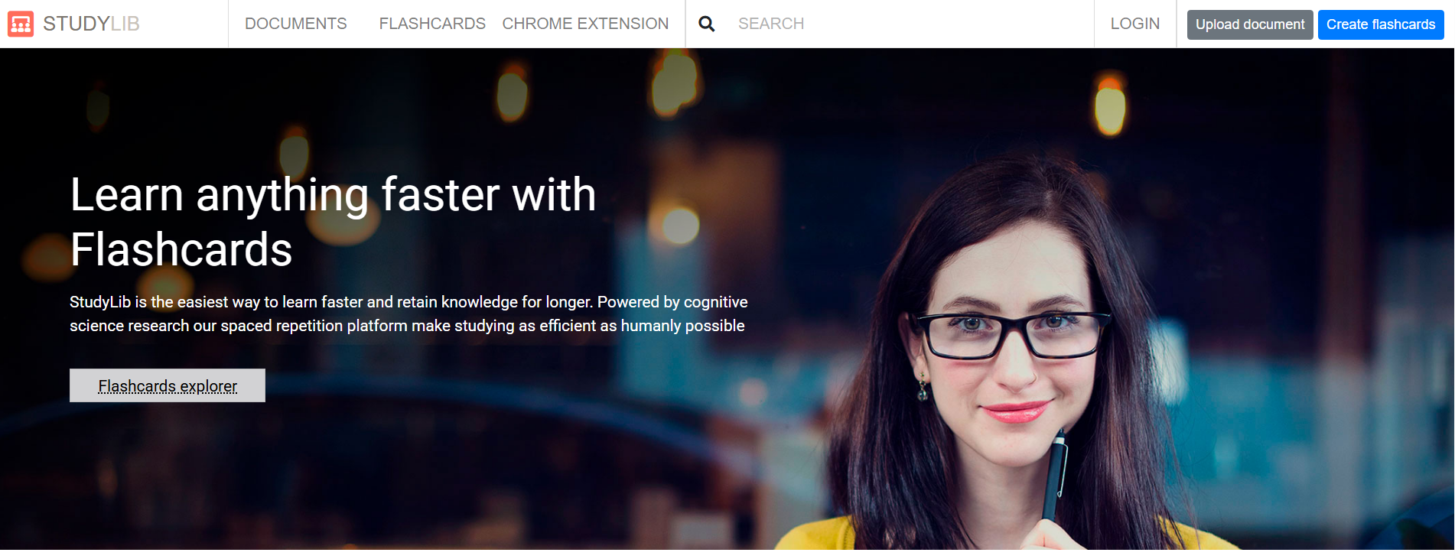
# Source: AI Source: Provided by: [Data Path: Persons Table -> ID Column: 1, Name_En Column: Motasem Essam] -> From: [ChatGPT] on [4/21/2026]
StudyLib is an online platform where users can upload, share, and access study materials such as:
- Lecture notes
- Textbook excerpts
- Summaries
- Essays and assignments
- Presentations and PDFs

What it’s mainly used for
# Source: AI Source: Provided by: [Data Path: Persons Table -> ID Column: 1, Name_En Column: Motasem Essam] -> From: [ChatGPT] on [4/21/2026]
- Finding free academic resources
- Reviewing notes for subjects like psychology, business, science, etc.
- Sharing your own documents with others

Important things to know
# Source: AI Source: Provided by: [Data Path: Persons Table -> ID Column: 1, Name_En Column: Motasem Essam] -> From: [ChatGPT] on [4/21/2026]
- Content is user-uploaded
→ Quality and accuracy can vary a lot
- Copyright concerns
→ Some materials may be uploaded without permission (e.g., textbook pages)
- Not an official academic source
→ Should not be relied on as a primary reference in assignments

Is it safe to use?
# Source: AI Source: Provided by: [Data Path: Persons Table -> ID Column: 1, Name_En Column: Motasem Essam] -> From: [ChatGPT] on [4/21/2026]
- Generally safe to browse and read
- But:
  - Don’t assume everything is correct
  - Avoid downloading suspicious files
  - Don’t submit content from it as your own work (plagiarism risk)

Summary
# Source: AI Source: Provided by: [Data Path: Persons Table -> ID Column: 1, Name_En Column: Motasem Essam] -> From: [ChatGPT] on [4/21/2026]
StudyLib is basically a free document-sharing library for students, useful for quick reference—but it’s best used alongside reliable sources, not as a main one.

