Project Sprint #1

The Solitaire game is described in CS449HomeworkOverview. You should read the description very carefully.

In this assignment, you aim to specify the requirements (i.e., user stories and acceptance criteria) of the target software that allows a human player to play a Solitaire game. These requirements will be fully implemented by the end of sprint 3. The minimum features include choosing the board size and type, starting a new game, making a move, determining if a game is over. The following is a sample GUI layout.

Board size
7
Board Type  - English  - Hexagon  - Diamond | 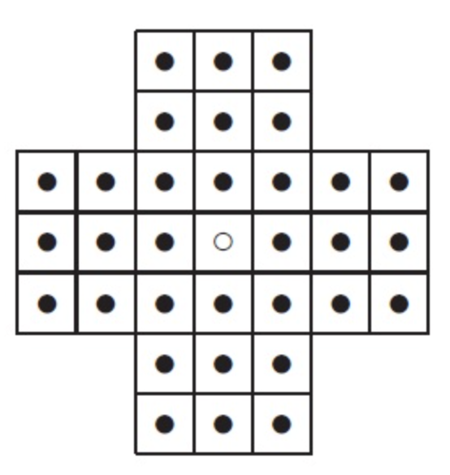 | New Game
Figure 1. Sample GUI layout of the first working program by the end of Sprint 3

Use the following tables to document your user stories and acceptance criteria.

You are required to use the free ChatGPT or another LLM to complete two user stories and two of their respective acceptance criteria. You must ensure that the generated user stories are correct and fix them if not. At the end of the submission, provide screenshots of your LLM prompts and answers, along with the description of errors the LLM made that you had to correct. Points will be deducted if no screenshots/description are provided.

For the other user stories and acceptance criteria, you are not required to use LLM.

- User Stories (3 points)

- User Story Template: As a <role>, I want <goal> [so that <benefit>]

ID | User Story Name | User Story Description | Priority | Estimated effort (hours)
1 | Choose a board size | As a player, I want to choose the size of the board before I start a game, so that I can play a shorter or longer game. | Medium | 3
2 | Choose the board type | As a player, I want to choose the board type (English, Hexagon, or Diamond) before I start a game, so that I can play the board layout I prefer. | Medium | 2
3 | Start a new game of the chosen board size and type | As a player, I want to start a new game using the board size and type I chose so that I get a correctly set-up board where every hole holds a peg except the center hole. | High | 8
4 | Make a move in a game | As a player, I want to jump a peg over an adjacent peg into an empty hole two positions away so that the jumped peg is removed so that I get closer to leaving only one peg on the board. | High | 10
5 | A game is over | As a player, I want the game to detect automatically when no valid moves remain and show how many pegs are left so that I know the game has ended and how well I played. | High | 6

- Acceptance Criteria (AC) (12 points): Add/delete rows as needed.

User Story ID and Name | AC  ID | Description of Acceptance Criterion | Status (completed, toDo, inPprogress)
1. Choose a board size | 1.1 | AC 1.1 Default board size  Given the player has just opened the application  When the main window is displayed  Then the board size field shows 7 | toDo
1. Choose a board size | 1.2 | AC 1.2 Choose a valid board size  Given the board size field is displayed  When the player enters an odd number from (min to max range) and clicks New Game  Then the size is accepted and the new board is produced matching the entered number. | toDo
1. Choose a board size | 1.3 | AC 1.3 Reject an even board size  Given the board size field is displayed  When the player enters an even number and clicks New Game  Then an error message is displayed | toDo
1. Choose a board size | 1.4 | AC 1.4 Reject a board size below the minimum  Given the board size field is displayed  When the player enters a number less than the minimum and clicks New Game  Then an error message is displayed | toDo
1. Choose a board size | 1.5 | AC 1.5 Reject a board size below the maximum  Given the board size field is displayed  When the player enters a number more than the maximum and clicks New Game  Then an error message is displayed | toDo
1. Choose a board size | 1.6 | AC 1.6 Reject a non-numeric or empty board size  Given the board size field is displayed  When the player enters text, a decimal, or leaves the field empty, and clicks New Game  Then the message "Board size must be an odd number from min to max" is displayed | toDo
2. Choose the board type | 2.1 | AC 2.1 Default board type  Given the player has just opened the application  When the main window is displayed  Then English is selected and Hexagon and Diamond are not selected | toDo
2. Choose the board type | 2.2 | AC 2.2 Choose the Hexagon board  Given English is selected  When the player selects Hexagon  Then Hexagon is selected and English and Diamond are deselected | toDo
2. Choose the board type | 2.3 | AC 2.3 Choose the Diamond board  Given English is selected  When the player selects Diamond  Then Diamond is selected and English and Hexagon are deselected | toDo
2. Choose the board type | 2.4 | AC 2.4 Switch back to the English board  Given Hexagon or Diamond is selected  When the player selects English  Then English is selected and the other two types are deselected | toDo
3. Start a new game of the chose board size and type | 3.1 | AC 3.1 Default game when the application opens  Given the player opens the application  When the main window is displayed  Then a English board is shown | toDo
3. Start a new game of the chose board size and type | 3.2 | AC 3.2 Start a new Hexagon game  Given Hexagon is selected and a valid board size is entered  When the player clicks New Game  Then a hexagon-shaped board of the chosen size is displayed | toDo
3. Start a new game of the chose board size and type | 3.3 | AC 3.3 Start a new Diamond game  Given Diamond is selected and a valid board size is entered  When the player clicks New Game  Then a Diamond-shaped board of the chosen size is displayed | toDo
3. Start a new game of the chose board size and type | 3.4 | AC 3.4 Start a new game after a game is over  Given a game has ended and the game-over message and rating are displayed  When the player clicks New Game  Then a fresh board of the selected size and type is displayed | toDo
4. Make a move in a game | 4.1 | AC 4.1 Select a peg  Given a game is in progress  When the player clicks a hole that holds a peg  Then that peg is highlighted as the selected peg | toDo
4. Make a move in a game | 4.2 | AC 4.2 Make a valid orthogonal move  Given a valid game is in progress, a peg is selected, the orthogonally adjacent hole holds a peg, and the next orthogonally adjacent hole is empty  When the player selects the empty hole  Then the selected peg moves into that hole and the jumped peg is removed | toDo
4. Make a move in a game | 4.3 | AC 4.3 Make a valid Diagonal move  Given a valid game is in progress, a peg is selected, the diagonally adjacent hole holds a peg, and the next diagonally adjacent hole is empty  When the player selects the empty hole  Then the selected peg moves into that hole and the jumped peg is removed | toDo
4. Make a move in a game | 4.4 | AC 4.4 Reject an invalid jump  Given a peg is selected and an empty hole lies two positions away, but the hole between is also empty  When the player clicks the empty hole  Then no peg moves and no peg is removed | toDo
4. Make a move in a game | 4.5 | AC 4.5 Reject a destination that is not two holes away in a straight line  Given a peg is selected  When the player clicks an empty hole that is one hole away, more than two holes away, or not on the same row, column, or diagonal  Then no peg moves and no peg is removed | toDo
4. Make a move in a game | 4.6 | AC 4.6 Ignore clicks outside the board  Given a game is in progress  When the player clicks a spot that is not a hole  Then nothing is selected and the board is unchanged | toDo
4. Make a move in a game | 4.7 | AC 4.7 Click an empty hole with no peg selected  Given a game is in progress and no peg is selected  When the player clicks an empty hole  Then nothing is selected and the board is unchanged | toDo
4. Make a move in a game | 4.8 | AC 4.8 Change the selected peg  Given a peg is selected  When the player clicks a different hole that holds a peg  Then the newly clicked peg becomes the selected peg and the first peg is no longer highlighted | toDo
4. Make a move in a game | 4.9 | AC 4.9 Cancel a selection  Given a peg is selected  When the player clicks the same peg again  Then the peg is no longer selected and the board is unchanged | toDo
5. A game is over | 5.1 | AC 5.1 The game continues while a valid move remains  Given a game is in progress  When the player makes a move after which at least one valid move still exists  Then the game is not over and the player can keep making moves | toDo
5. A game is over | 5.2 | AC 5.2 The game ends automatically when no valid moves remain  Given a game is in progress  When the player makes a move after which no peg on the board can make a valid move  Then the game ends and displays a “Game Over” message | toDo
5. A game is over | 5.3 | AC 5.3 Rating "Outstanding" for 1 peg left  Given a game is in progress  When the game ends with only 1 peg left  Then the rating “Outstanding” is displayed | toDo
5. A game is over | 5.4 | AC 5.4 Rating "Very Good" for 2 pegs left  Given a game is in progress  When the game ends with only 2 pegs left  Then the rating “Very Good” is displayed | toDo
5. A game is over | 5.5 | AC 5.5 Rating “Good" for 3 pegs left  Given a game is in progress  When the game ends with only 3 pegs left  Then the rating “Good” is displayed | toDo
5. A game is over | 5.6 | AC 5.6 Rating “Average" for 4 or more pegs left  Given a game is in progress  When the game ends with more than 3 pegs left  Then the rating “Average” is displayed | toDo
5. A game is over | 5.7 | AC 5.7 No moves can be made after the game is over  Given a game is over  When the player clicks any peg or hole on the board  Then nothing is selected and the board does not change | toDo
5. A game is over | 5.8 | AC 5.8 Game over detection for every board  Given a game is in progress on a Hexagon or Diamond board  When the player is out of moves and the game ends  Then ratings are displayed. | toDo

LLM Feedback

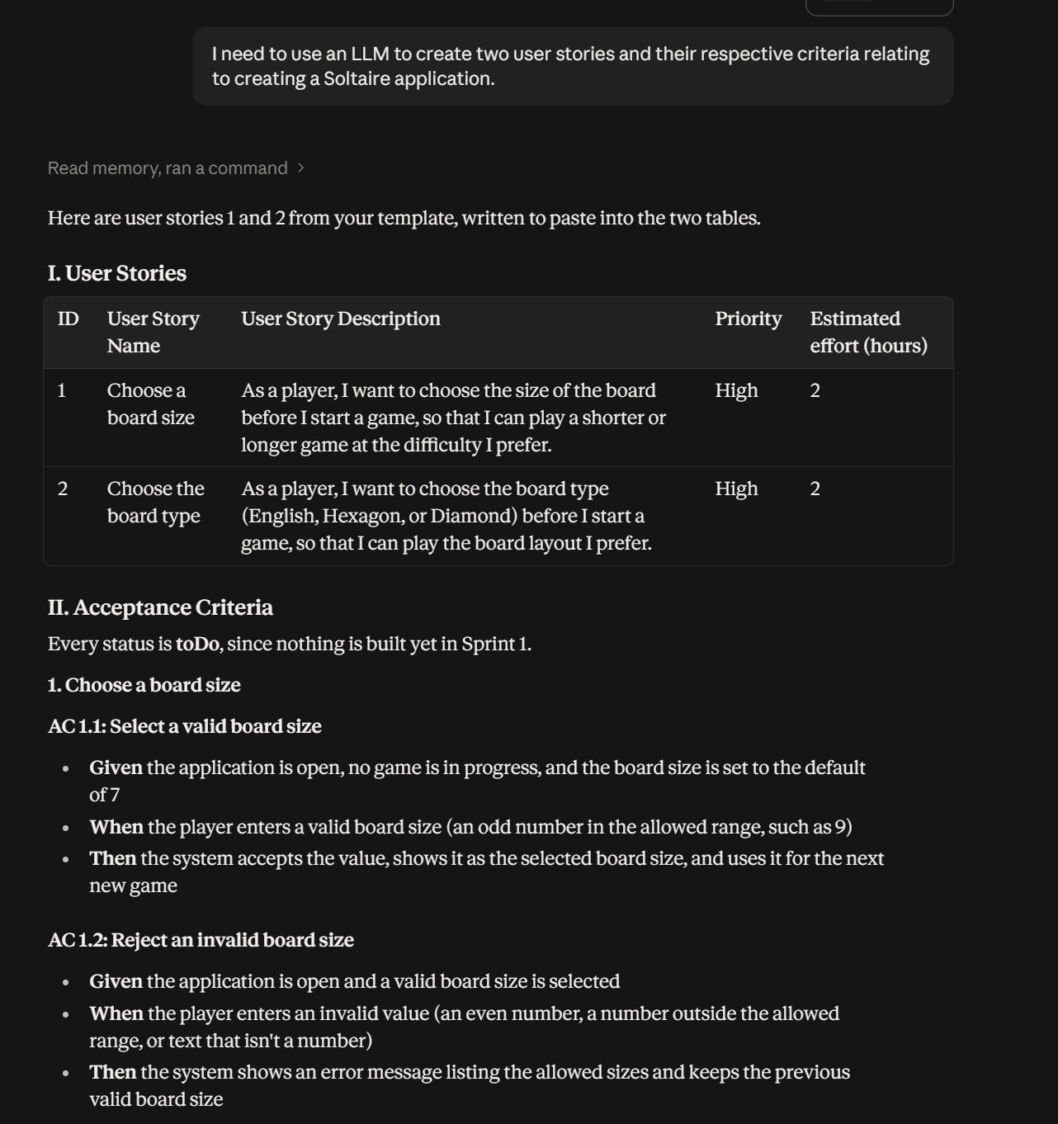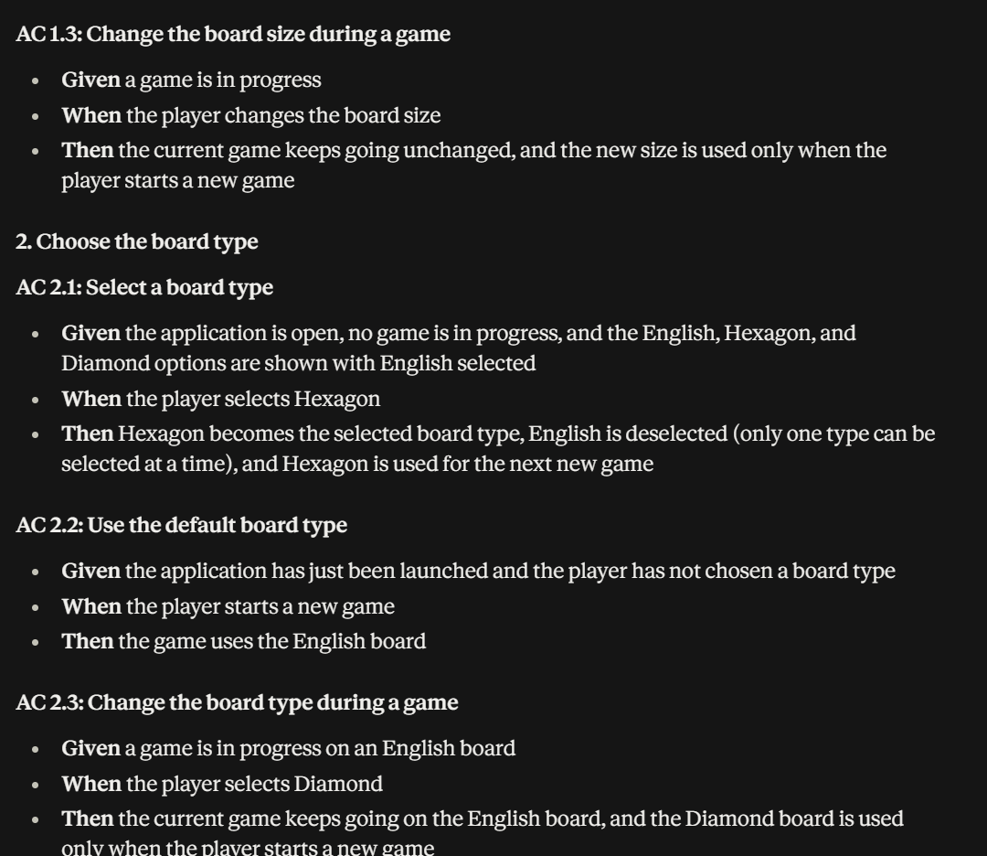

The use of LLM gave a great starting point for creating user stories and acceptance criteria. Some points of criticism lie around some of the assumptions it makes about sizing. The LLM gave default values for board sizes etc. While this could be useful it also made me start to brainstorm how I would approach this and ultimately decided that max board sizes will revolve around screen space. Users should not have to implement scrolling or zooming to play the game. There were other assumptions made by the LLM as well such as the board types but I believe alternate types (than those discussed in project doc) should be viewed as more of a stretch goal if time permits.

