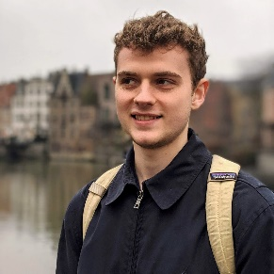

@alexanderameye

alexanderameye.github.io

+32 487 17 61 04

alexanderameye@gmail.com

**ALEXANDER AMEYE**

I am eager to learn and have an entrepreneurial spirit. I want to be part of a motivated team and strive for excellence in what I create. I am a dynamic team player and enjoy human connections.

**EDUCATION**

**EXPERIENCE**

**Freelance** /*Graphics Programmer*

2015 - Present

Designing, creating, and publishing several assets for the Unity Asset Store inside of a highly competitive market segment. Combined with creating commissioned rendering solutions for client studios.

**Leveraged Knowledge:** C#, Shader Programming, UI/UX Design, Customer Relations and Support, Project Management, Community Management, Marketing

**KU Leuven Buddy Project** /*Buddy*

2018 - 2020

I was paired with incoming international students and guided them on a practical and social level.

**PAL Project** /*Tutor*

2019

I worked as a teaching assistant in the peer assistant learning project for a Python programming course.

**Master’s Thesis** /*Developer*

2020 - 2021

Development of an editor tool facilitating the design and creation of augmented reality experiences in the context of an interactive city tour.

**Leveraged Knowledge:** C#, Mobile AR, Mobile Development, UI/UX Design, Project Management, API design

**KU Leuven**

Leuven, Belgium | 2020 - 2021

Master in Electronics and ICT Engineering Technology - Internet Computing

Thesis - Editor tool for an augmented reality tourist map.

**Relevant Coursework:** Fundamentals of Computer Graphics, Media Processing, Games & Tangibles, Machine Learning, Data Science

Leuven, Belgium | 2017 - 2020

Bachelor’s in Engineering Technology

Electronics and ICT

**Relevant Coursework:** Object-Oriented Programming and Databases, Software Development

**Sungkyunkwan University**

Seoul, South Korea | 2019

Erasmus student exchange

College of Software

**Relevant Coursework:** Computer Networks, Introduction to Computer Architectures, Operating Systems

**LANGUAGES**

Dutch | native

English | fluent

French | intermediate

**CODE**

C#, C++, Java

HLSL

Python, Rust

JavaScript, HTML, CSS

**TOOLS**

Unity3D, Blender

Android Studio

Git, Docker, k8s

**INTERESTS**

Computer graphics

Web performance

**ACHIEVEMENTS**

**Unity Awards 2020** /*Best artistic tool*

Nominee

In recognition of my asset *Stylized Water For URP.*