|  |  |
| --- | --- |
|  | MINISTRY OF EDUCATION AND TRAINING |

FPT UNIVERSITY

Report Week 2 – Topic Introduction

**Indoor Commodity Tracking System Application Bluetooth Low Energy**

|  |  |
| --- | --- |
| **Group 2** | |
| **Group members** | **Tạ Đức Huy – SE61754**  **Mai Thế Quân – SE61192**  **Đoàn Văn Phát – SE61827** |
| **Supervisor** | **Mr. Nguyễn Đức Lợi** |
| **Ext. Supervisor** | **N/A** |
| **Capstone Project code** | **BTRACKING** |

-Ho Chi Minh City, **September 14th 2018**

1. Problem Definition

**1.1 Name of this Capstone Project**

* **Official name**: Indoor Commodity Tracking System Application Bluetooth Low Energy
* **Abbreviation:** BTRACKING

**1.2 Problem Abstract**

At present, GPS positioning and tracking technology is very popular. However, its accuracy is not high, especially in the home. Nowadays the world is pushing the industrial revolution of 4.0, in which the demand for projects to monitor location in an indoor area increased. For example, monitoring and patient care at the hospital, tracking the location of objects in exhibits, etc. Therefore, location-based technology using BLE technology is becoming more common.

**1.3 Project Overview**

**1.3.1 The Proposed System**

* + - The system uses low-power bluetooth technology integrated in devices (device 1) mounted on the objects to be monitored. These devices will continuously emit an identifying information for that device.
    - Another type of device (device 2) is attached to the space around the architecture. It will pick up waves emitted by devices mounted on the objects. In each system, we need a minimum of 3 pieces for this type of device
    - After device 2 receives the signal, it sends the result to the central gateway using the wifi signal. The central gateway will calculate the position of the object by algorithm to determine the location based on the received signal strength and then send the results to the online server. For each object, we need to arrange the location so that at least 3 devices of type 2 receive the signal from the device attached to the object. When the object is far from the receiver station, the received signal will be weak, near the signal will be strong. From there we can calculate the radius of the object's distance to the receiver. To know the exact location, we will compute the intersection of the three circles formed by the three receivers in the previous step. After that, we can track the exact location of the object with a radius of <0.5m via the administration website.
    - At the site admin, you can know the location of the object, set the rules where the object or group of objects can access. You can also create rules for sending alarms, turning on alarms whenever there are any location changes or anomalies that you have set.
    - In addition, the system will integrate additional alarms in emergency situations, which are directly connected to the server through the wifi connection.
    - In fact, this project can be used to track, protect exhibits in museums, showrooms, exhibitions, machines, valuable objects; patient monitoring in the hospital; Identify the presence of students in the school, supervise the prisoners, ...
    - The pros point of the project is that device 1 can operate up to 3 years to replace the battery. It is possible to accurately determine indoor locations that GPS or other location-based technologies can not meet. Bring ease and convenience to the manager by setting rules by individual or group of objects.

**1.3.2 Boundaries of the System**

Our system provides these functions:

* + - Determine the location of the object in the house.
    - Monitor the location of the object.
    - Set rules for objects (only located in certain areas, do not encroach on certain areas).
    - Group objects to manage.
    - Show the location history of the object.
    - Loudspeaker alert sound, app if any abnormal.

**1.3.3 Future plans**

* + - Analyze the trend of moving objects.
    - Tracking more information of object (heart rate monitoring, blood oxygen levels, acceleration, sudden change of position, ...).
    - Apply to schools for student attendance.

**1.3.4 Development Environment**

**1.3.4.1 Hardware requirements**

|  |  |
| --- | --- |
| Component | Hardware |
| SoC | CC2640/NRF51822 |
| Communication | Bluetooth Low Energy |
| Devices | - Battery  - Reset button |
| Power source | Sony CMOS BR2325 Battery 3.3V |

For passive devices:

|  |  |
| --- | --- |
| Component | Hardware |
| Mainboard | BTracking active V1 |
| Communication | Wifi and Bluetooth Low Energy |
| Devices | CP210x USB to UART Bridge  Power and filtering module  ESP32 Module with BLE |
| Power source | 5V |

For active devices:

For Local server

|  |  |
| --- | --- |
| Component | Hardware |
| Mainboard | Raspberry Pi 3/3+ |
| Communication | Wifi |
| Power source | 5V |

|  |  |
| --- | --- |
| Component | Hardware |
| Mainboard | BTracking Alarm V1 |
| Communication | Wifi |
| Devices | CP210x USB to UART Bridge  Power and filtering module  ESP32 Module with BLE  Mono Speaker 5W |
| Power source | 5V |

For alarm device:

**1.3.4.2 Software requirements**

|  |  |
| --- | --- |
| Software | Name / Version |
| Operating system | Windows 10, Ubuntu |
| Web programming | Yii Framework |
| Modeling tool | Draw.io, Star UML |
| IDE | Visual Studio Code, Visual Studio 2017, Php Storm |
| DBMS | MySQL |
| Source control | Github |
| Project management tool | Trello |
| Web browser | Chrome 42 or above |

## Project Organization

* 1. **Software Process Model**

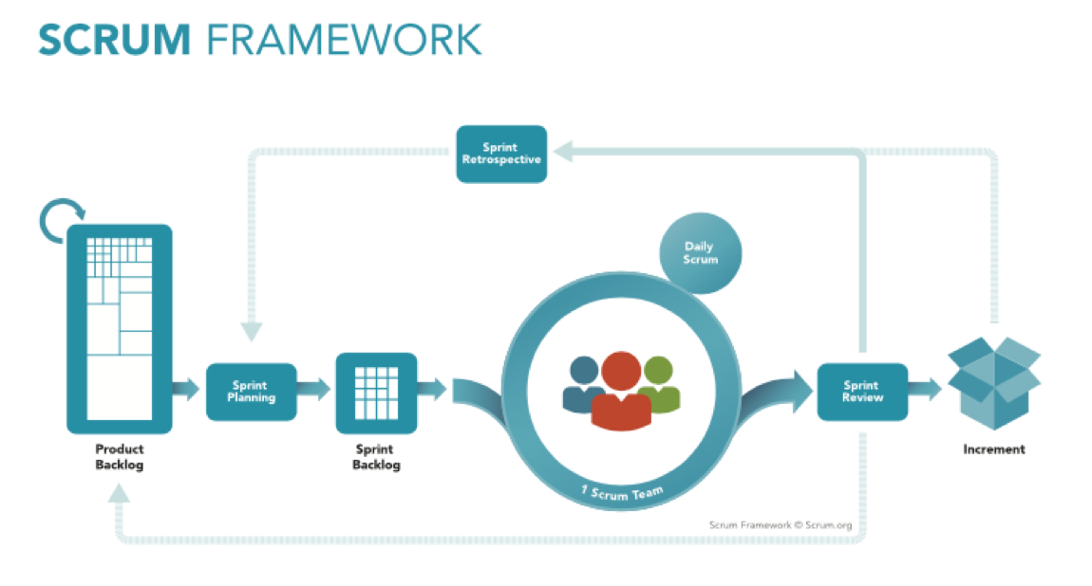In this project, we apply the Agile Scrum framework for some reasons. First of all, we are inexperienced with many new technologies which are used for developing the project. So, we divide the development process into several Sprints. In each Sprint, we try to research new technologies, construct the system and test all needed functions at the same time. Secondly, it is more flexible to adapt changes because the requirements are not clear at the beginning and it takes a large amount of time to clarify them. Last but not least, using Agile Scrum framework helps us to recognize problems occurring in the development process earlier, so, if we do make mistakes, we will learn and resolve them to complete the final product.

* 1. **Roles and Responsibility**

|  |  |  |  |
| --- | --- | --- | --- |
| No | Full name | Roles | Responsibilities |
| 1 | Nguyễn Đức Lợi | Supervisor, Project Manager | * Specify user requirements and system requirements. * Give advices, technical supports and solutions. * Supervise the development process. |
| 2 | Tạ Đức Huy | Team leader, developer, tester | * Manage all progresses. * Clarify requirements. * Create development plan. * Divide and assign tasks for members. * Design database * Coding. * Testing. * Prepare and verify documents. |
| 3 | Mai Thế Quân | Team member, developer, tester | * Clarify requirements. * Coding. * Testing. * Prepare documents. |
| 4 | Đoàn Văn Phát | Team member, developer, tester | * Clarify requirements. * Design GUI * Coding. * Testing. * Prepare documents. * Manage budgets. |

* 1. **Tools and Techniques**

|  |  |
| --- | --- |
| Tools / Techniques | Name / Version |
| Operating system | Windows 10, Ubuntu |
| Frontend | JavaScript, jQuery, CSS, HTML, Bootstrap |
| Backend | Yii2 Framework |
| Embedded | C/C++, NodeJS |
| Modeling tool | Draw.io, Star UML |
| IDE | Visual Studio Code, PHP Storm |
| DBMS | MySQL |
| Source control | Github |
| Project management tool | Trello |

## Project Management Plan

* 1. **Project management plan detail**

|  |  |  |  |  |  |
| --- | --- | --- | --- | --- | --- |
| Phase | Overall | Description | Assignees | Estimated Duration | Risks |
| Sprint 1 | **Define and analyze requirements** | - Define requirements and scope.  - Research on Beacon, ESP and MQTT. | All team members | 2 weeks | - Misunderstand requirements.  - Difficult to approach new technologies and hardware. |
| - What is Beacon location system?  - Analyze requirements.  - Research hardware: Beacon, ESP 32, Rasberry and MQTT.  - Block diagram.  - Choose code language: backend, frontend and embedded  - Research on the module ESP32 and test transmitting and receiving data.  - Make a comparison between Google Location and Beacon Location.  - Report 1: Introduction. | Tạ Đức Huy  Đoàn Văn Phát |
| - What is Beacon?  - What is MQTT?  - Research hardware: Beacon, ESP 32, Rasberry.  - How to calculate distance from Beacon to ESP? | Mai Thế Quân |
| Sprint 2 | **Research algorithm and system design** | - Design Use case diagram.  - Describe each use case in diagram.  - Report 2: Project Management Plan.  - Report 3: Requirement Specification. | All team members | 1 week | - New platform: Rasberry MCU.  - New protocol: MQTT.  - Hard to find references and technical supports.  - Problem with algorithm. |
| - Test:   * MQTT communicate between Rasberry and Web Server.   - Research:  + Algorithm to calculate coordinates of Beacon | - Tạ Đức Huy  - Đoàn Văn Phát |
| - Research:   * Algorithm to calculate distance from ESP 32 to Beacon | Mai Thế Quân |
| Sprint 3 | **Implementation and unit test** | - Flowchart of the system.  - Report 4: Design Description  - Programming firmware:   * Communication between Gateway and webserver * Communication between Gateway and Nodes. * Control Beacon. * Send Beacon’s coordinates to Server. * Announce when Beacon is out of Beacon’s area.   - Unit test. | All team members | 4 weeks | - Struggles in implementation.  - Hardware problems.  - Serious bugs.  - Time consuming for some difficult functions. |
| - Build a web application:   * Authentication as needed. * Use MQTT to communicate with the Gateway. * Store Beacon’s information: beacon id, coordinates, status, etc. * Control Beacon: power on/off * Create schedule for lamps.   - Test all functions above. | - Tạ Đức Huy  - Đoàn Văn Phát |
| * Distance from Beacon to ESP32 * Calculate coordinates of Beacon * Process Sound when Beacon is out of its area. | * Đoàn Văn Phát * Mai Thế Quân |
| Sprint 4 | **System completion and testing** | - Complete all required functions.  - System testing.  - Test cases.  - Report 5: System Implementation & Test.  - Additional features (if could):   * GPS function | All team members | 2 weeks | - System errors.  - Hardware problems. |
| Sprint 5 | **Demo-environment and documents completion** | - Develop a demo-environment.  - Deploy the web application.  - Verify all documents.  - Report 6: User’s Manual | All team members | 1. weeks |  |

## Coding Convention

* C/C++ Convention: Used for modifying the PLM Stack and programming the STM32 microcontroller.
  + Name conventions:
    - Using Pascal case for class names.
    - Using Camel case for functions, variables.
    - The #define and global variables must be uppercase and separated by underscore. Ex: GLOBAL_VARIABLE.
* Comment conventions:
  + - Place comments on the separate lines with functions.
    - Place comments at the end of each line, which has a calculation formula.
* More details about coding conventions for C/C++ language by Google: <https://google.github.io/styleguide/cppguide.html>