Power Factor Improvement Using Noble Techniques

Dr.Debani Prasad Mishra  
*Electrical and Electronics Engineering   
IIIT Bhubaneswar*Bhubaneswar, India  
debani@iiit-bh.ac.in

Himanshu Mohapatra  
*Electrical and Electronics Engineering   
IIIT Bhubaneswar*Bhubaneswar, India  
b321017@iiit-bh.ac.in Sai Prajyan Padhi  
*Electrical and Electronics Engineering   
IIIT Bhubaneswar*Bhubaneswar, India  
b321033@iiit-bh.ac.in

Bhaswati Pati  
*Electrical and Electronics Engineering   
IIIT Bhubaneswar*Bhubaneswar, India  
b321011@iiit-bh.ac.in

*Abstract*—This study examines how the rapid advancement of power semiconductor devices has resulted in a widespread use of power electronic systems in a variety of industries, such as traction systems, commercial, residential, and aerospace. Power semiconductor converter devices introduce distortion to the line through the electrical current they use, which raises Total Harmonic Distortion (THD) and lowers Power Factor (PF). As such, there is always a need to improve power factor and reduce line current harmonics. Therefore, a circuit for Power Factor Correction (PFC) must be designed using an active filtering approach and incorporate a boost converter positioned across the load. This approach seeks to minimize switching losses while simultaneously improving the quality of the current.

Keywords—Power Factor, Boost Converter, Total Harmonic Distortion (THD), Semi-Conductors, PFC

# **I**ntroduction

The use of inductive loads in industries is increasing daily, causing the efficiency of the power system to decrease due to a drop in the power factor. This drop can result in high penalties for consumers. Power Factor Control is a method to mitigate this issue by reducing the negative impact of loads that cause the power factor to drop below one. The ratio of the apparent power provided to the circuit to the actual (real) power that accomplishes work is known as the power factor in AC circuits. The circuit's capacity to do a task in a certain amount of time is its real power. With this project, power factor correction will be ongoing without the need for labour intensive manual capacitive bank loading. The maximum reactive power absorption that a load may provide is known as power factor rectifying. Reactive power is a charge that is listed on an electricity account and is aimed directly at businesses that do not clearly use energy efficiently. A commonly used technique for lowering electrical loads, cutting down on energy waste, increasing plant efficiency, and lowering electricity costs is the use of power factor correction capacitors, which can greatly minimize reactive power losses.

## Historial background

In 1899, legislation was passed to prevent incandescent lamps from flickering due to power interference from AC mains. IEC 555-2, introduced in 1978, required consumer products to incorporate power factor correction. As local DC distribution networks were replaced by AC energy transmission, reactive power imbalances led to issues with voltage regulation and stability. Switched reactive power compensation, like shunt reactors and capacitors, was used to regulate steady-state system voltages. Synchronous condensers and other revolving machinery based dynamic reactive compensation. The first DC-controlled reactors and thyristor-controlled devices were developed in the 1960s. This summary summarizes PF compensation's history from its inception to the current transmission system. [1]

## Challenges Due To High THD And Low Power Factor

The growing use of power electronic converters presents a significant challenge in maintaining power quality standards, especially in non-linear loads. To improve input power factor and THD, it's crucial to synchronize the current waveform with the voltage waveform, which is essential for maintaining power quality standards.

Fig. 1. Percentage Of Problems In Power Quality

Power electronic devices can lead to a distorted and nonlinear current waveform, resulting in an unfavourable outcome. For example, it can increase the current drawn for the same load level, leading to higher power system losses, maintenance, and operational costs. Additionally, it can destabilize the grid by introducing unwanted harmonic components, causing voltage drops that may result in numerous problems and even blackouts in the power system. As the demand for power electronic converters grows, maintaining power quality standards becomes challenging, particularly for nonlinear loads due to voltage clamping, DC offset injection, and notching. To avoid the negative effects of poor power factor and heavy penalties imposed by discom companies on industries and commercial consumers, active filtration is required to improve the power factor. In this project, we propose analyzing AC parameters and compensating the power factor to a desired value to ensure optimal power quality. [2]

## Research Objectives

In order to maintain the power factor within specified bounds and realize the working circuit of a unity power factor converter, the project suggests an active filtering approach for input power factor correction in nonlinear converters. The primary objective of the project is to improve the wave shape of the load current by using the boost power factor correction method and then compare input power factor, THD, and current waveform through modeling a normal single-phase rectifier and the same model equipped with the closed-loop control scheme that will enhance and improve the power factor, THD, and current waveform.

# **D**esign

The design can be broadly divided into several systems. The design includes-

* PWM Generator
* THD
* Phase locked loop (PLL)
* PID Controller
* MOSFET

## PWM Generator

Pulse Width Modulation (PWM) generator is an electronic device that produces an on-screen signal with variable duty cycle. Pulse width modulation is commonly used in control systems to regulate the power supplied to devices such as motors, LEDs, and many other components. [3] The ratio of the circuit's on-time to off-time is represented by the duty cycle. The PWM generators generally work on:

* **Counter:** PWM is generated using a counter in a microcontroller or dedicated PWM controller. The counter is set up in such a way that it counts to a limit in which its set in then it resets itself and starts the counting process again.
* **Duty Cycle:** The duty cycle is the ratio of time the signal is in the on state to the time the circuit was in off state. It's expressed in the form of fraction as ratio is being taken.
* **Output Control: The output control of the PWM is determined by the fact if the counter value is less than the compare value then the output is high vice-versa if its value is greater the value will be lower and this process repeats itself and thus creating a square wave with varying duty cycle.** [4]

## THD

Total harmonic distortion, also known as fundamental frequency distortion, is a measurement system that calculates the total distortion of a signal. It calculates the signal energy that are distributed in the harmonic frequencies which are the integral multiple of the fundamental frequency. [5]

THD= $\sqrt{\frac{1}{(CDF)2}-1 }$

Where,

THD-Total Harmonic Distortion

CDF-Current Distortion Factor

## Phase Locked loop(PLL)

A control system known as a PLL generates an output signal whose phase is correlated with the phase of an input signal. PLLs are utilized in many different electronic gadgets, including as mobile phones and TVs. PLLs can be used to measure the sinusoidal signals by measuring the characteristics of the output signal. PLLs are generally employed when there is a need of stable and precise frequencies concisely it helps in frequency synthesis. It’s also used when there is a need of demodulation and synchronization of the signals. They play a pivotal role in maintaining synchronization and stability in various applications. PLLs are widely used in telecommunication, wireless communication, and audio processing due to their versatility, consisting of phase detectors, loop filters, voltage controlled oscillators, feedback loop and capture range. [6]

## PID

The proportional-integral-derivative (PID) controller is a popular kind of feedback system used in industrial control systems and engineering test cases involving regulating temperature, flow, pressure, speed. It is designed to mechanically control a process to maintain a desired setpoint by regulating the output. [7].

PID controllers use three basic controls as actions:

1. **Proportional:** Proportional term is directly proportional to the error, It involves correcting a target that corresponds to their difference thus resulting in not reaching the target value.
2. **Integral:** The integral term has a relationship with the total error over a certain duration. It aids in getting rid of any steady-state mistake
3. **Derivative: The derivative term is based on how quickly the error is changing over time**. It helps in predicting the future behaviour of the error and helps to prevent overshooting.

The PID controller's output is provided by the formula:

$$\text{v}\left(\text{t}\right)\text{=K}\text{i }\text{e(t)+}\text{K}\text{v}\int{e\left(t\right)dt}+\text{K}\text{i}\frac{de}{dt}$$

where,

v(t)=PID Control variable

$\text{K}\text{i}$ =Proportional gain

$\text{K}\text{v}$ =Integral gain

e(t)=Error value

dt=change in time

## MOSFET

A voltage-controlled unipolar device called as MOSFET (metal oxide semiconductor field effect transistor) aids in the amplification or switching of electrical signals. It’s divided into 2 types N channel where the electrons are in majority and P channel where the holes are the charge carriers. MOSFET structurally consists of three terminals gate, source and drain.

When the gate-to-source voltage exceeds a minimum threshold value, this virtual channel is created.it operates in three modes cut off, saturation and linear. It has wide range of use in the industry. MOSFET’s are used in microprocessors and memory devices. They are also for applications like amplifiers and voltage regulators. In power electronics power MOSFET’s are used for switching applications due to their switching speed and efficiency. [8]

# **U**nity **P**ower **F**actor **C**onvertors

These converters enable the current waveform to align with the voltage waveform, regardless of the load type and impedance in the case of a variable load. [9]

In addition, there is a proposal to utilize a DC-DC converter that will provide the flexibility of changing the impedance offered to the grid to a resistive load, irrespective of the nature of the load at the consumer end.

*A. Causes Of Low Power Factor*

* Mercury vapor lamps or lamps with chokes that are commonly used can be a source of low power factor because they are inductive loads. This means that they draw current from the power system that is out of phase with the voltage, which can cause the power factor to drop.
* Power and distribution transformers can also be a source of low power factor, particularly when they are unloaded. When a transformer is completely unloaded, it is very inductive and has a low power factor. This is because there is no real power being consumed by the transformer, so all of the power that is drawn from the system is reactive power.
* Induction motors are another common source of low power factor, particularly when they are operating under a light load or are unloaded. Induction motors are inductive loads, and their power factor drops as the load on the motor decreases. In mining operations, equipment such as hoists, shovels, drills, pumps, shearers, and conveyors can all be sources of low power factor due to their use of induction motors.

Overall, any equipment or load that draws current from the power system that is out of phase with the voltage can cause the power factor to drop. Identifying and addressing low power factor sources is crucial as it can lead to increased energy costs and decreased system efficiency. [10]

*B. Power Factor Correction*

Power factor correction is a process to improve the efficiency and stability of electrical transmission networks or reduce costs for individual customers. Capacitive power factor correction minimizes the inductive element of current and losses in supply circuits that feature induction motors. The Static Power, Factor Correction technique employs capacitors connected to each starter and controlled by each starter. [11]

To improve power factor, capacitor banks can be installed in parallel, synchronous condensers, and phase advancers. The resistive and inductive components of motor current are influenced by load and loss current, respectively. Active Power Factor Control (PFC) types like Boost, Buck, and Buck-boost PFC have their own advantages and disadvantages. Active PFC is more effective than passive PFC but is more expensive and complex to implement.

*C. Active Power Factor Correction Methodology*

A power factor correction (PFC) stage, either passively or actively, can be inserted between the diode bridge and DC/DC converter to solve phase delay and current distortion problems. Adding inductance between the bridge and input capacitor is a need for passive PFC. [12]

Between the isolated DC/DC converter and the diode bridge, Active Power Factor Correction (PFC) employs a full power converter stage to provide higher power factor performance with less deterioration across a broad working range. Since the boost inductor is located on the input side of the converter, the boost converter is the most popular option for an active PFC because of its low input current distortion (low di/dt).

1. *Critical Conduction Mode:* The power factor correction method, Critical Conduction Mode (CRCM) PFC or Transition Mode (TM) PFC, is widely used due to its simple control mechanism and ability to achieve a reasonable power factor with minimal components. The control mechanism generates a constant on-time throughout the line cycle and initiates the next turn-on event when the switch is turned off. Although this method offers many advantages, it can be expensive to implement if not included during initial construction. Additionally, one of the benefits of this method is that any unnecessary capacitors are removed from the circuit when the motor is turned off.
2. *Continuous Conduction Mode:* Continuous conduction mode (CCM) aims to regulate the input current to follow the line voltage. The CCM employs a consistent switching frequency, while adapting the MOSFET duty cycle in response to the line voltage. This is accomplished through an error amplifier that detects input current. The input signal is made up of the PFC output voltage, the instantaneous input voltage, and a feedforward constant to account for changes in line voltage.

CCM typically has a significantly lower inductor current ripple than CRCM, with most designs targeting a ripple current between 25% and 35.5% of the average input current.

However, in CCM, the MOSFET drain is exposed to the full output voltage during turn-on. The MOSFET's conduction losses are reduced by smaller ripple currents, but hard switching increases switching loss due to delayed inductor current reactivation. [13]

*D. Benefits Of PFC*

Improving the power factor of a facility has various benefits, such as:

* Encouraging higher efficiency: Power companies often impose power factor surcharges on facilities with low power factors, resulting in higher utility bills. Improving the power factor reduces these surcharges, leading to greater efficiency.
* Reducing demand charges: Some utilities impose demand charges based on the highest power used during peak periods. Improving the power factor can reduce the demand for reactive power and, hence, the demand charges.
* Increasing load-carrying capabilities: Power factor correction improves the load-carrying capacity of circuits, allowing them to handle more loads without tripping circuit breakers or overheating wires.
* Improving voltage: PFC can improve the voltage at the end of the line, reducing voltage drops and improving the efficiency of electrical equipment.
* Reducing power-system losses: Capacitors used for power factor correction reduce losses in the power system. Improving the power factor can decrease losses as losses are directly proportional to the square of the current. While capacitors have losses, they are relatively small compared to the KVAR rating. [14]

IV. **U**TILISATION **O**F **B**OOST **C**ONVERTOR

At the output side, buck converters have current smoothing property, while boost converters smoothen the current at the input side due to the relative placement of the smoothing inductor.

The output voltage and current formulas are:

V0 = VinIin = Io

Hence effective resistance seen from the grid side is

Rin= Ro(1-D)

Further by utilising certain control schemes the input impedance can be further regulated as it depends on duty cycle.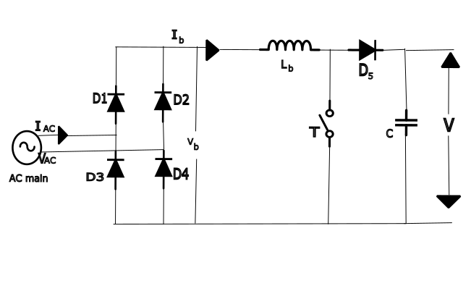 Fig. 2. Boost Converter without control scheme

*A. Boost PFC*

PFC circuits have common applications in power supplies to enhance their efficiency and power quality. The boost PFC converter is a popular topology used for PFC circuits. It comprises a boost converter, a rectifier, and a filter capacitor. The boost converter as shown in figure 2 increases the DC voltage to a level that the power supply can use. The rectifier and filter capacitor changes AC voltage to DC with low ripple, while the PFC circuit shapes input current and enhances power factor. [15]

Designing a PFC circuit involves selecting the appropriate semiconductor devices and passive components and estimating power losses. The design process can be complex, but there are design methodologies available that can assist engineers in designing PFC circuits. Power supplies with PFC circuits can help improve power quality and reduce power consumption by enhancing the power factor and reducing harmonic currents. This can result in lower energy costs, reduced environmental impact, and improved reliability of electrical systems. [16]

*B. Implementation Of The Control Scheme In The Model*

The control scheme consists of the PLL block which measures the angular frequency which is the fed to a sin block, the resultant is multiplied with a gain of 1.414 which gives out the rms result of supply side voltage, the absolute function block only allows positive value and gives the reference of a rectified output voltage. further the output load voltage is multiplied with a gain block whose value is taken according to the base output voltage this is done to convert it into its per unit value which is compared with the constant 1 per unit block this difference in magnitude of the reference 1 p.u. and the actual fluctuating output voltage is fed to a PI controller to obtain minimum steady state error in the control signal. The voltage wave shape is obtained by multiplying sin and magnitude components using a product block. The error signal is then fed to a PI controller and a PWM generator, which generates switching pulses for the MOSFET in the boost convertor. [17]

1. *Current control scheme:* A ref currents similar to that of the output is taken further it is subtracted with the rectified load current fed to a PI controller and then fed to PWM generator whose output is given to the boost convertor. It is the inner control scheme.
2. *Voltage control scheme:* The output voltage is adjusted by comparing the ref voltage with the actual output voltage, which is then fed to a PI controller, and the result is cascaded. Due to saturation of flux the voltage control scheme is replaced with the downstream voltage regulators.

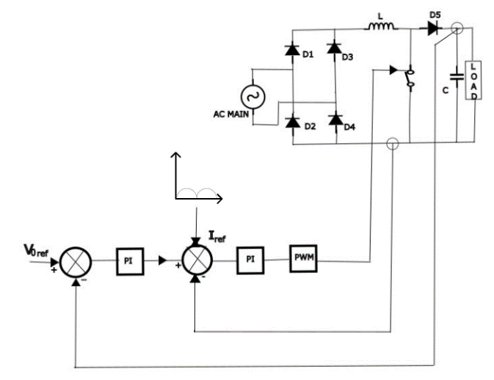

Fig. 3. Boost PFC with control scheme

*C. Simulink Model And Its Working*

The control scheme with boost PFC as shown above in the figure 3 involves using a PLL block to measure the angular frequency. This is then fed to a sin block, and the result is multiplied by a gain of 1.414 to obtain the RMS value of the supply-side voltage. The absolute function block ensures only positive values, providing a reference for the rectified output voltage. The output load voltage is then multiplied by a gain block, determined based on the base output voltage, to convert it into its per-unit value. This value is then compared with a constant 1 per unit block to obtain the difference in magnitude between the reference 1 per unit and the actual fluctuating output voltage. The control signal is minimized by a PI controller, which then multiplies the sin and magnitude components to obtain the voltage wave shape. This is compared with the load current shape. The error signal is then sent to a PWM generator to generate the MOSFET switching pulses in the boost converter.

# V**. R**ESULTS

In the given Waveform as shown below in figure 4, the first waveform is of the dc output voltage as no proper filtration is provided so the ripple is quite high in the output dc voltage.

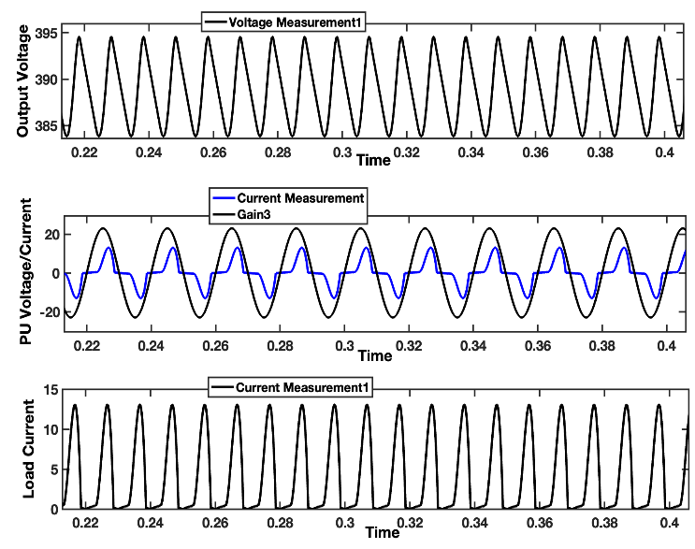

Fig. 4. Waveform Of Voltage & Current At Supply Side Before PF Improvement

The second waveform supply voltage and current as it can be seen the V & I waveforms are out of phase, the current waveform is more lagging to voltage waveform. The third waveform is about the output dc current. These waveforms are of before active filtration is done with high inductance load.

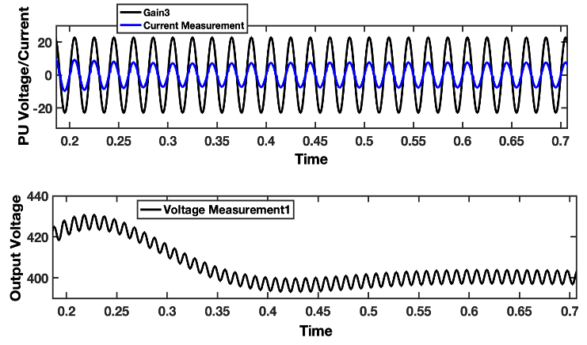

Fig. 5. Waveform Of Voltage & Current At Supply Side After PF Improvement

In the given Waveform as shown in figure 5, the first waveform is of Supply voltage and current and as it can be seen the V & I waveforms have φ=0 and second waveform is dc output voltage it can be seen after the filtration the ripple is quite low in the output dc voltage in comparison, to others. These waveforms are of after active filtration and are done with low inductance load.

# VI**. C**ONCLUSION

The given waveform as shown in figure 6 the power factor curve it can be seen as the load is of low inductive nature so dip is less and the power factor is not equal to unity.

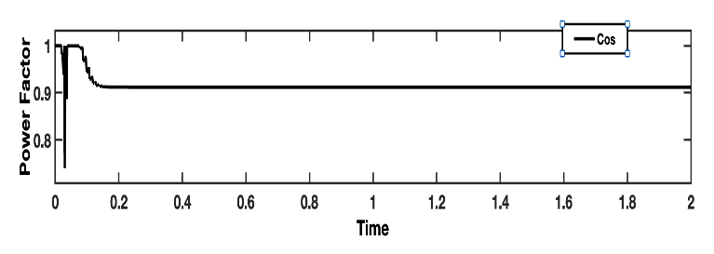Fig. 6. Power Factor Before PF Improvement

The given waveform as shown in figure 7 is the power factor curve after the active filtration using boost PFC method it can be seen as the load is of high inductive nature and the power factor is approximately 1 after compensation.

.

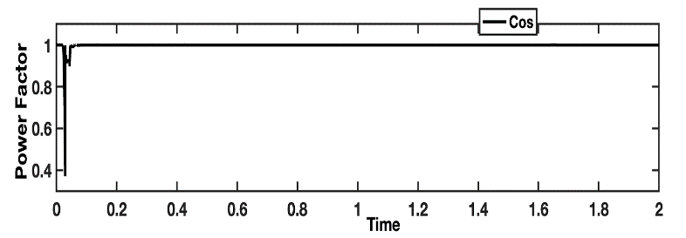

Fig. 7. Power Factor After PF Improvement

VII. **F**UTURE **S**COPE

Frequent load changes can cause harmonic problems in capacitor bank switching. Optimal active filter design and algorithm design can prevent this issue. Utilization of proper control schemes and optimization strategies can replace the dependence on costly harmonic filters. Efficient management of the unity power factor for non-linear loads can significantly reduce pf tariffs and low pf penalties on commercial & industrial consumers. A higher power rating of SMPS can be manufactured and fabricated, keeping the unity power factor convertor in mind, which will not only improve the quality of waveform but further reduce switching losses.

##### **A**cknowledgment

# We want to express our sincere appreciation to Dr. Debani Prasad Mishra, Assistant Professor and Head of the Department of Electrical Engineering at the International Institute of Information Technology in Bhubaneswar, for their unwavering support and guidance throughout the completion of this paper. Their valuable insights and expertise have been instrumental in shaping the outcome of this project, and we are grateful for their contribution.

# **R**eferences

|  |  |
| --- | --- |
| [1] | B. M. H. a. A. A. E. Mohammed, "Design and simulation of DC/DC boost converter," *2008 12th International Middle-East Power System Conference,* pp. 335-340, 2008. |
| [2] | S. B. a. H. B. Y. Shtessel, ""Unity Power Factor Control in Three-Phase AC/DC Boost Converter Using Sliding Modes," *in IEEE Transactions on Industrial Electronics, vol. 55,* no. 55, pp. 3874-3882, 2008. |
| [3] | N. S. A. C. A. P. S. P. a. G. P. ". M. P. G. W. D. O. C. i. I. A. v. 1. p. 1.-1. 2. d. 1. K. Samperi, "GaN Monolithic PWM Generator With Dynamic Offset Compensation," *IEEE Access, vol. 11,* pp. 126892-126899, 2023. |
| [4] | T. T. a. W. K. M. A. Sayed, "Advanced PWM Switching Technique for Accurate Unity Power Factor of Bidirectional Three-Phase Grid-Tied DC–AC Converters," *in IEEE Transactions on Industry Applications,* vol. 55, pp. 7614-7627, 2019. |
| [5] | R. R. a. A. K. E. Barbie, "Closed-Form Analytic Expression of Total Harmonic Distortion in Single-Phase Multilevel Inverters With Staircase Modulation," *IEEE Transactions on Industrial Electronics, vol. 67,* pp. 5213-5216, 2020. |
| [6] | Y.-F. K. Y.-Y. K. J.-C. Lin, "5 GHz Phase-Locked Loop With a Phase-Adjusting Function," *IEEE Microwave and Wireless Technology Letters ( Volume: 33.* |
| [7] | O. H. a. R. S. Shree, "Design and Analysis of Proportional Integral Derivative Controller and it’s hybrids," *2019 IEEE 5th International Conference for Convergence in Technology (I2CT),* pp. 1-6, 2019. |
| [8] | A. B. P. E. a. W. L. Z. Feng, "SPICE models for predicting EMC performance of a MOSFET based half-bridge configuration,," *2021 IEEE 1st International Power Electronics and Application Symposium (PEAS), Shanghai, China,* pp. 1-5, 2021. |
| [9] | P. M. -Y. F. a. M. H. b. M. Daut, "Near-Unity Power Factor, Voltage Step-Up/Down Conversion Pulse-Width Modulated Switching Rectification for Wireless Power Transfer Receiver," *in IEEE Transactions on Power Electronics,* vol. 34, pp. 10960-10969, 2019. |
| [10] | K. A.-H. a. G. R. M. C. Ghanem, "Comparative study of AC/DC convertors with unity power factor," *Proceedings 1995 Canadian Conference on Electrical and Computer Engineering,* vol. 2, pp. 858-861, 1995. |
| [11] | N. R. A.-H. a. R. Tou, "New three-phase AC-DC convertor of booster type with unity power factor," *1994 Proceedings of Canadian Conference on Electrical and Computer Engineering,* pp. 14-17, 1994. |
| [12] | K. K. a. R. B. N. A. Rahman, "Boost Active Power Factor Correction Converter Using Various Current Controllers in Double Loop Control Algorithm," *2020 IEEE International Conference on Power and Energy (PECon),* pp. 24-28, 2020. |
| [13] | F. P. a. I. Barbi, "Power factor correction of non-linear loads employing a single phase active power filter: control strategy, design methodology and experimentation," *PESC97. Record 28th Annual IEEE Power Electronics Specialists Conference. Formerly Power Conditioning Specialists Conference 1970-71. Power Processing and Electronic Specialists Conference 1972,* pp. 412-417, 1997. |
| [14] | M. P. G. S. a. G. V. E. Dallago, "Novel current transducer in a single-phase active power factor correction system," *in IEEE Transactions on Power Electronics,* Vols. 529-535, p. 15, 2000. |
| [15] | M. A. a. E. B. F. M. Shahir, "High Gain DC-DC Boost Converter Applied in Hybrid System of Photovoltaic and Battery," *2021 International Symposium on Devices, Circuits and Systems (ISDCS,* pp. 1-4, 2021. |
| [16] | M. R. B. a. H. A. F. Bonab, "A High Efficiency Nonisolated Buck–Boost Converter Based on ZETA Converter," *in IEEE Transactions on Industrial Electronics,* vol. 67, pp. 1991-1998, 2020. |
| [17] | P. Z. e. al, "A Carrier-Based Discontinuous PWM Scheme With Optimal PWM Sequences for a Five-Level Flying Capacitor Rectifier," *in IEEE Transactions on Power Electronics,* vol. 37, pp. 13178-13191, 2022. |

# 