CMPE 324 Final Report
Date: 15/05/2026
Course: CMPE 324 Project
Platform: Arduino

Group Members
- 22302588 - Sinenkosi Somkhanda Gumbi – Computer Engineer
- 22114886 - Eraste Bololo Mata Lipwa - Computer Engineer
- 22205158 - Voiz Muzofirshoev - Computer Engineer

Final Circuit Diagram

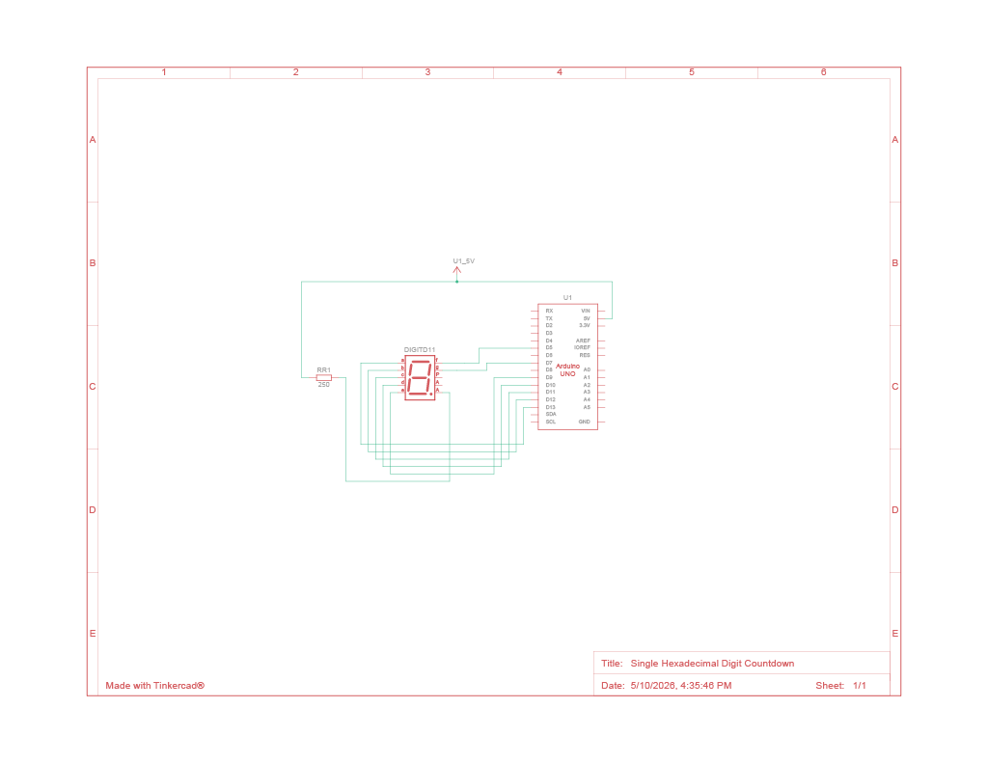Components Used
- 7 Segment Display (Common Anode)
- Arduino Uno
- Breadboard
- 330 Ω Resistor

Detailed System Explanation
The system performs a hexadecimal countdown from F to 0 using an Arduino Uno and a common anode 7-segment display. GPIO pins are configured as outputs to control each segment of the display. The program continuously updates the display using predefined hexadecimal patterns stored in a lookup table.

Complete Program Code
// Microprocessor project
// Implementation of single hexadecimal digit countdown (F-0)
// Microcontroller: Arduino Uno
// Display: 7 segment display (common anode)

#define DELAY 1000

// Identifying pins to which segments are attached
enum Pins {A = 13, B = 12, C = 11, D = 10, E = 9, F = 5, G = 7};
int DISPLAY_PINS[7] = {A, B, C, D, E, F, G};

// Pattern to numbers.
// 1 = SEGMENT ON, 0 = SEGMENT OFF.
bool NUMS[16][7] = {
//{A, B, C, D, E, F, G}
{1, 1, 1, 1, 1, 1, 0}, // 0
{0, 1, 1, 0, 0, 0, 0}, // 1
{1, 1, 0, 1, 1, 0, 1}, // 2
{1, 1, 1, 1, 0, 0, 1}, // 3
{0, 1, 1, 0, 0, 1, 1}, // 4
{1, 0, 1, 1, 0, 1, 1}, // 5
{1, 0, 1, 1, 1, 1, 1}, // 6
{1, 1, 1, 0, 0, 0, 0}, // 7
{1, 1, 1, 1, 1, 1, 1}, // 8
{1, 1, 1, 0, 0, 1, 1}, // 9
{1, 1, 1, 0, 1, 1, 1}, // A
{0, 0, 1, 1, 1, 1, 1}, // b
{1, 0, 0, 1, 1, 1, 0}, // C
{0, 1, 1, 1, 1, 0, 1}, // d
{1, 0, 0, 1, 1, 1, 1}, // E
{1, 0, 0, 0, 1, 1, 1} // F
};

// ==============================================================================

void setupPins();
void showNum(int);
void countDown();

// ==============================================================================

void setup()
{
setupPins(); // Puts pins connected to LED segments in output mode
}

void loop()
{
countDown();
}

// =============================================================================

void showNum(int num)
{
/*
* Display any given hexadecimal digit on the seven segments display
* num: hex digit passed as int
*/

// Deciding which segment should be ON/OFF given the digit pattern
for(int i = 0; i < 7; i++)
digitalWrite(DISPLAY_PINS[i], !NUMS[num][i]);
}

void setupPins()
{
/* Set GPIO ports to output mode
* Only those used to connect the display
*/
for(int i = 0; i < 7; i++)
pinMode(DISPLAY_PINS[i], OUTPUT);
}

void countDown()
{
/* Implementation for countdown
* Time transition is determined by the macro DELAY
*/
for(int i = 15; i >= 0; i--)
{
showNum(i);
delay(DELAY); // ! second delay in between
}
}

Explanation of Delay Implementation
The project uses a software-based delay through the delay(1000) function. This creates a 1-second pause between each hexadecimal digit. A timer-based approach was considered, but software delay was selected because the project only performs a single repeated task and does not require multitasking.

GPIO Usage and Pin Mapping
Segment | Arduino Pin | Identifier
A | 13 | A
B | 12 | B
C | 11 | C
D | 10 | D
E | 9 | E
F | 5 | F
G | 7 | G

Challenges Encountered and Solutions
One challenge was selecting suitable resistor values for the display. This was solved by using a 330 Ω resistor to protect the LEDs while maintaining visibility.
Another challenge was ensuring the correct display of hexadecimal digits on a common anode display. This was solved by applying active-low logic in the code. Although this only became an issue when we had attempted the second version of the code we had made. This was solved by using a different pin connection layout.

Results and Observations
The system successfully displayed a hexadecimal countdown from F to 0 with a stable 1-second delay between transitions. The display output was clear and consistent, and all hexadecimal characters appeared correctly without flickering.

