LIVING EVIDENCE GUIDE
Cerebral Small Vessel Disease
Cerebral Amyloid Angiopathy and Brain Arteriolosclerosis
Foundations -> explicit questions -> evidence -> contradictions -> decisive experiments
A question-driven learning and research system with cohort lineage, diagnostic validation profiles, falsifiable hypotheses, worked reasoning cases, and a living-update queue.
Version 0.5.1 | 18 August 2026
Educational and research use - not patient-specific clinical guidance

Contents
Release snapshot
How to Think About Cerebral Small Vessel Disease
Cerebral Small Vessel Disease: A Field Primer
Diagnostic Criteria and Rating Systems
Diagnostic Transportability: What the Criteria Can and Cannot Do
Biomarkers and Tools
Debates, Hypotheses, and Open Questions
Research Agenda: From Knowledge Gaps to Testable Projects
From Reading Archive to Research Program
Evidence Completeness Map
Contradiction and Falsification Atlas
Cohort Lineage and Independence
Diagnostic Evidence Profiles
Worked Reasoning Cases
Living Update Workflow
Reading Path: From First Principles to Research Fluency
Appendix A. Research Question and Completeness Atlas
Appendix B. Contradiction and Falsification Atlas
Appendix C. Cohort Lineage and Independence
Appendix D. Diagnostic Evidence Profiles
Appendix E. Phenotype Differential Matrix
Appendix F. Worked Reasoning Cases
Appendix G. Living Update Queue
Appendix H. Living Claim-Evidence Ledger
Appendix I. Pivotal Study Atlas
Appendix J. Criteria, Biomarker, and Tool Registry
Appendix K. Curated Source Registry

Release snapshot Back to contents
Version 0.5.1 is a synchronized question-driven learning and evidence system, not a completed systematic review. The Word edition, repository records, and website are generated from the same maintained chapters and evidence tables.
Object | Count | What changed
Scholarly sources | 61 | Curated; citation-only and extracted records are distinguishable
Structured pivotal studies | 21 | Design, population, result, limitations, and provisional appraisal
Living claims | 24 | Normalized confidence and explicit claim boundaries
Evidence relationships | 67 | Support, challenge, qualification, context, null, or method
Criteria/tools | 19 | Context of use, inputs, outputs, validation, and failure modes
Answerable research questions | 40 | Bounded, emerging, or critical-gap status
Cohort lineage records | 10 | Reuse and independence are explicit
Diagnostic evidence profiles | 7 | Seven-link validation chain
Falsifiable hypotheses | 12 | For, against, alternatives, falsifier, and decisive experiment
Original figures | 14 | Designed for causal, diagnostic, and evidence-method understanding
Interpretive warning. A polished criterion or biomarker can still be population-dependent. Always inspect the intended context, reference standard, spectrum, and external validation.
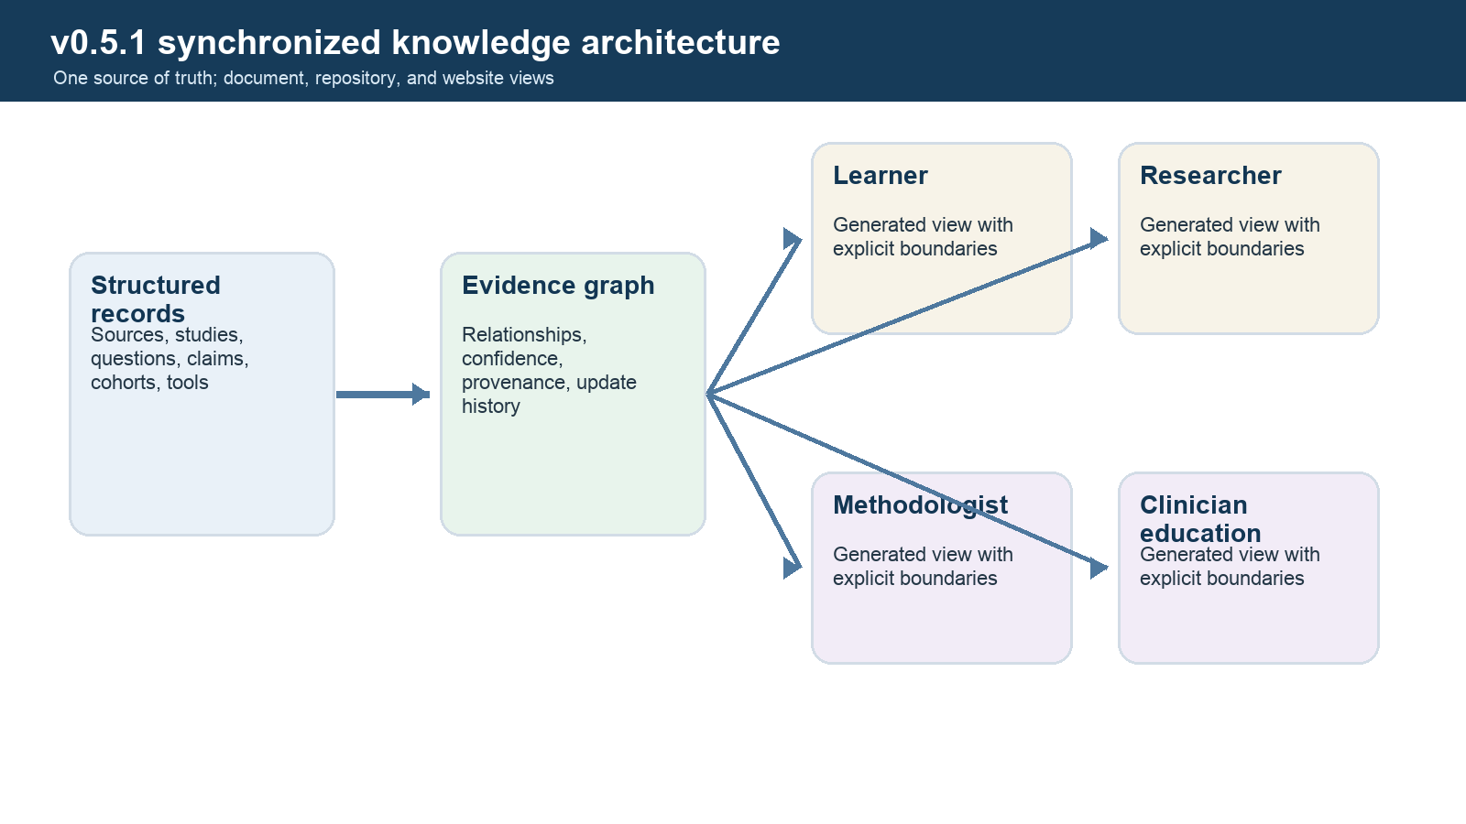
Figure 1. Synchronized knowledge architecture connecting canonical chapters and evidence records to the Word edition, repository, and website.

How to Think About Cerebral Small Vessel Disease Back to contents

Learning objectives
By the end of this opening module, you should be able to distinguish a visible lesion from its cause, explain why CAA and arteriolosclerosis overlap without being interchangeable, and describe what evidence would be required to turn an imaging association into a diagnostic biomarker.

The field studies a hidden system
Most cerebral small vessels cannot be resolved directly on ordinary clinical MRI. Investigators therefore reason from effects: a microbleed, lacune, white-matter signal abnormality, enlarged perivascular space, diffusion change, impaired vascular reactivity, cognitive trajectory, or microscopic lesion. These observations are real, but the path from observation to cause is uncertain.
The central discipline of this field is therefore calibrated inference. A lesion is first described in standardized terms. Its location, morphology, multiplicity, age, acquisition method, and clinical context are recorded. Only then is it used to update the probability of CAA, arteriolosclerosis, another vasculopathy, an embolic source, inflammation, trauma, treatment effect, or mixed disease.
Core rule: an imaging marker can be reproducible without being etiologically specific, and a pathology can be clinically important without having a unique visible marker.

Five levels that must remain separate
Observation
What was measured? Examples include a round susceptibility focus, FLAIR hyperintensity, a cortical sulcal hemosiderin pattern, a high ARTS score, or vascular amyloid in a sampled tissue block. Acquisition and measurement error live at this level.
Phenotype
How are observations organized? Examples include a strictly lobar hemorrhagic pattern, a deep perforator pattern, or diffuse white-matter injury. Phenotypes are more informative than isolated lesions but remain descriptions.
Etiologic inference
Which vessel-wall pathology is more likely, and by how much? This is where tissue-referenced diagnostic-accuracy studies matter. The answer depends on the population: a marker's positive predictive value in a hemorrhage clinic is not its value in asymptomatic community screening.
Mechanism
Why did the pathology or lesion develop? Perivascular clearance failure, blood-brain barrier disruption, smooth-muscle loss, altered pulsatility, inflammation, hypoperfusion, venous dysfunction, and impaired repair are candidate mechanisms. Spatial association or severity ordering can support a mechanism but rarely proves temporal causation.
Clinical action
What should be done? Action requires more than diagnostic probability. It incorporates competing ischemic and hemorrhagic risks, indication strength, treatment effects, patient values, and current guidance. This guide is educational and does not provide patient-specific management.

The minimum sufficient mental model
Small-vessel disease can be understood as a chain with feedback:
susceptibility and exposures -> vessel wall/neurovascular unit -> physiology -> microscopic tissue injury -> visible markers -> network dysfunction and clinical outcomes
Feedback occurs at every level. Tissue injury alters perfusion and clearance. Amyloid deposition damages smooth muscle and may further impair clearance. Inflammation can remove amyloid, increase permeability, or contribute to injury depending on stage and context. A useful hypothesis specifies which arrow it addresses and what observation would distinguish it from alternatives.

Why location matters but never settles the diagnosis
CAA preferentially affects cortical and leptomeningeal vessels. Non-amyloid arteriolosclerotic disease prominently affects penetrating arterioles supplying deep gray nuclei, deep white matter, brainstem, and cerebellum, while also occurring elsewhere. This produces an important probabilistic contrast between lobar and deep injury.
The contrast is not absolute. Lesion-level pathology has shown that arteriolosclerosis can underlie lobar microbleeds in false-positive probable CAA cases. Conversely, mixed CAA and arteriolosclerosis are common. The appropriate question is therefore not “Which disease owns this lesion?” but “How much does this lesion, in this compartment and context, change the competing probabilities?”

Three kinds of validation
Technical validation
Does the measurement repeat across raters, scans, scanners, sites, software versions, and plausible image quality? Technical reliability is necessary before biological interpretation.
Biological or diagnostic validation
Does the measurement correspond to the target pathology or state using an independent reference standard? The reference must be appropriate and measured without knowledge of the index test when possible.
Clinical validation and utility
Does the measurement predict an outcome, improve an existing model, change a decision, or improve patient-important outcomes? Association with cognition is not the same as pathology discrimination; pathology discrimination is not the same as clinical benefit.
ARTS illustrates the distinction. It has pathology-linked development, reported technical reproducibility, and associations with cognitive and vascular outcomes. These are three valuable but separate bodies of evidence. They do not yet establish a universally calibrated clinical diagnosis of arteriolosclerosis.

A self-check before moving on
- Can you describe a microbleed without naming its cause?
- Can you explain why specificity and positive predictive value change with the population?
- Can you distinguish repeatability, pathology accuracy, prognostic association, and clinical utility?
- Can you name at least three co-pathologies that could distort a vascular-cognition association?
If not, revisit this module after reading the field primer. The rest of the archive assumes these distinctions.
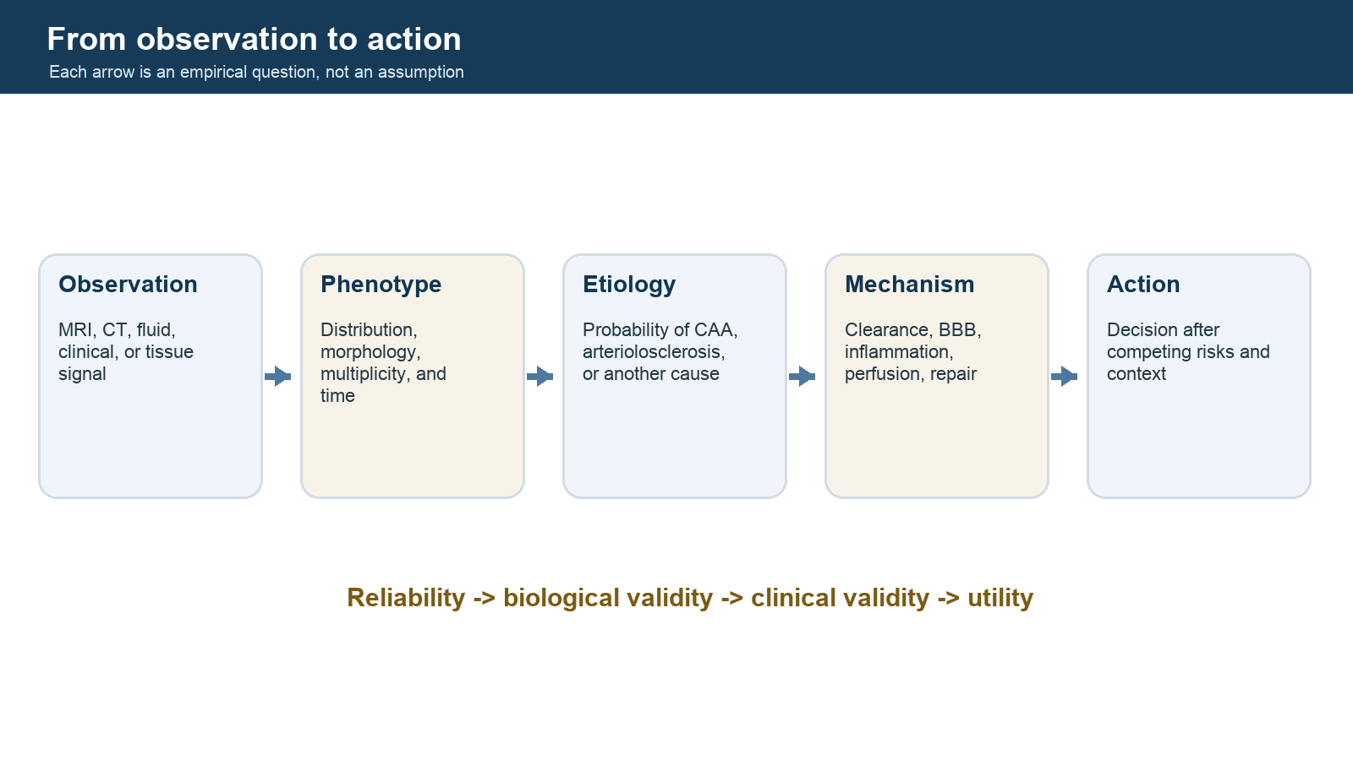
Figure 2. Five-level inference ladder separating observation, phenotype, etiology, mechanism, and clinical action.

Cerebral Small Vessel Disease: A Field Primer Back to contents

Purpose and learning objective
The aim is not merely to recognize the abbreviations CAA, WMH, CMB, or STRIVE. The aim is to be able to reason from anatomy to vessel-wall pathology, from vessel-wall pathology to tissue injury, from tissue injury to imaging, and from imaging to a diagnosis without confusing any one layer for another.
The central discipline of this field is inference across scale:
Causal chain: Risk and susceptibility → small-vessel wall and neurovascular-unit change → physiological dysfunction → microscopic tissue injury → visible MRI or CT markers → clinical syndromes and disability. The arrows are not one-to-one: imaging has incomplete etiologic specificity and imperfect sensitivity to microscopic injury.
A visible lesion is therefore an informative footprint, not a transparent photograph of the causal vessel pathology.

1. What counts as cerebral small vessel disease?
"Cerebral small vessel disease" (cSVD) is an umbrella term for disorders affecting small arteries, arterioles, capillaries, and venules of the brain. Many of these vessels are below the resolution of routine clinical imaging. Their presence is inferred from downstream lesions, functional measurements, or tissue examination.
The two most common age-related vessel-wall pathologies are:
- Non-amyloid arteriolosclerosis: thickening, stiffening, and remodeling of small penetrating vessels, especially in deep brain and white matter territories. It is associated with age, hypertension, diabetes, and other metabolic or vascular exposures, but these associations are neither exclusive nor sufficient.
- Cerebral amyloid angiopathy: deposition of amyloid-beta, particularly Aβ40, in leptomeningeal and cortical vessel walls. Sporadic CAA rises sharply with age and commonly coexists with Alzheimer disease, but it is anatomically and biologically distinct from parenchymal amyloid plaques.
Other cSVDs include monogenic arteriopathies (for example NOTCH3-related CADASIL, HTRA1-related disease, and COL4A1/2 disorders), inflammatory small-vessel disease, immune-mediated CAA-related inflammation, radiation-related vasculopathy, venous collagenosis, and less common protein-deposition angiopathies. These are not peripheral curiosities: they reveal mechanisms and remind us that similar imaging phenotypes can arise from different causes.
A vocabulary trap
"Arteriosclerosis" means hardening/remodeling of arteries broadly. "Atherosclerosis" is an intimal lipid-rich plaque disease of larger arteries. "Arteriolosclerosis" concerns arterioles. "Lipohyalinosis" and "fibrinoid necrosis" describe particular histologic patterns, not universal synonyms for every non-amyloid cSVD lesion. In brain aging literature, brain arteriolosclerosis (B-ASC) is often the preferred pathology label, but definitions and sampling protocols still vary.

2. Anatomy: the route from surface artery to tissue
Pial arteries travel along the brain surface. Penetrating arterioles enter the cortex and deep structures, branch into precapillary arterioles and capillaries, and drain through venules. Unlike many systemic vascular beds, the brain operates inside a rigid skull, requires continuous high-energy supply, and has tight barrier and flow regulation.
The neurovascular unit includes endothelial cells, basement membrane, pericytes, vascular smooth-muscle cells, astrocytic endfeet, neurons, microglia, extracellular matrix, and perivascular immune cells. The cerebral arteriolar vascular unit emphasizes the same coordinated system around arterioles. Injury to one component can alter flow, barrier integrity, immune signaling, or waste clearance in the others.
Four functions to keep separate
- Delivery: oxygen and substrate reach tissue through blood flow.
- Autoregulation and reactivity: vascular tone adjusts to blood pressure, carbon dioxide, neural activity, and metabolic demand.
- Barrier function: endothelial junctions and associated cells restrict uncontrolled movement between blood and brain.
- Fluid and solute clearance: interstitial and cerebrospinal fluids exchange and drain along perivascular routes. Competing or complementary models include intramural periarterial drainage (IPAD), glymphatic flow, diffusion, dispersion, and lymphatic outflow.
The direction, driving forces, and relative contributions of these clearance routes in humans remain debated. Enlarged MRI-visible perivascular spaces do not directly measure flow.

3. Brain arteriolosclerosis
Pathology
B-ASC is commonly recognized as hyaline, relatively acellular wall thickening with loss or degeneration of smooth-muscle elements and narrowing or distortion of the lumen in small vessels. Semiquantitative neuropathology scales commonly range from none to severe. Quantitative approaches include a sclerotic index, often written as 1 - (internal diameter / external diameter), but section angle, tissue processing, vessel selection, region, and collapsing of the lumen can bias measurement.
The 2021 Blevins review is essential because it makes three points that are easy to miss:
- B-ASC is extremely common in the oldest-old yet understudied.
- There is no single universally applied diagnostic and sampling method.
- The label may contain biologically different subtypes rather than one homogeneous disease.
Candidate causal pathways
- chronic pressure and pulsatility stress transmitted to penetrating vessels;
- endothelial dysfunction and blood-brain barrier leakage;
- smooth-muscle and pericyte injury;
- extracellular-matrix remodeling and fibrosis;
- impaired autoregulation and cerebrovascular reactivity;
- hypoperfusion or unstable perfusion;
- inflammation, oxidative stress, metabolic dysfunction, and cellular senescence;
- impaired perivascular fluid handling;
- reciprocal interactions with autonomic regulation and systemic vascular disease.
These pathways can coexist. Hypertension may cause arteriolar remodeling, but arteriolar dysfunction could also impair central regulation of systemic physiology. Cross-sectional autopsy associations cannot establish that direction.
Expected injury pattern, with important exceptions
Because non-amyloid arteriopathy often involves deep penetrating vessels, it is associated with deep intracerebral hemorrhage, deep microbleeds, lacunes, white-matter injury, and small subcortical infarcts. However, the mapping is not exclusive. The Perosa et al. 2023 pathology study showed that arteriolosclerosis can underlie lobar microbleeds in cases falsely classified as CAA, especially when lesions were juxtacortical or in subcortical white matter rather than centered in the cortical ribbon.
That result does not invalidate Boston criteria. It demonstrates why a high-performing probabilistic rule is not equivalent to perfect lesion-level specificity.

4. Cerebral amyloid angiopathy
Pathology and distribution
CAA is defined by amyloid deposition in small vessels of the leptomeninges and cerebral cortex, with variable capillary involvement. Deep penetrating arterioles of basal ganglia, thalamus, and brainstem are generally spared in typical sporadic CAA. The vessel wall can progress from focal deposits around smooth-muscle cells to circumferential replacement, loss of wall elements, cracking or double-barrel change, fibrinoid remodeling, and rupture.
Two common neuropathologic patterns are often discussed:
- CAA type 1: cortical capillary involvement is present; more strongly associated with APOE ε4 and Alzheimer disease-related biology.
- CAA type 2: amyloid is present in leptomeningeal and cortical arteries/arterioles without capillary involvement.
Severity, distribution, and vasculopathic change matter. A binary CAA-present/absent label discards biologically important information.
Relationship to Alzheimer disease
CAA and Alzheimer disease frequently coexist because both involve Aβ, age, and APOE-related susceptibility. They are not interchangeable:
- vascular deposits are relatively enriched for Aβ40, while plaques are relatively enriched for Aβ42;
- CAA has a characteristic leptomeningeal/cortical vascular distribution;
- CAA can occur without advanced Alzheimer disease, especially in hereditary forms;
- Alzheimer disease can occur with little or no CAA;
- cognitive effects can be additive or interactive through infarction, disconnection, impaired vascular reactivity, inflammation, and hemorrhage.
Analyses that call all amyloid-related signal "Alzheimer pathology" erase this distinction.
The four-stage progression framework
Koemans and colleagues proposed a useful, explicitly provisional sequence:
- Initial vascular amyloid deposition. Soluble Aβ handling and vascular deposition change before overt tissue injury.
- Altered vascular physiology. Reactivity, pulsatility, barrier function, and clearance become abnormal.
- Non-hemorrhagic brain injury. White-matter microstructural damage, cortical microinfarcts, network disconnection, and cognitive effects emerge.
- Hemorrhagic lesions. Lobar microbleeds, convexity subarachnoid hemorrhage, cortical superficial siderosis, and lobar intracerebral hemorrhage appear.
Hereditary Dutch-type CAA data suggest that this evolution may span decades. The framework is valuable because it predicts a long prehemorrhagic intervention window. It remains a model, not a proven invariant sequence for every sporadic case.
How a CAA vessel may rupture
The intuitive model is simple mechanical weakening by accumulating amyloid. Human ex vivo MRI-pathology work adds a more dynamic possibility: the final rupture site can contain little detectable amyloid and show fibrinoid remodeling, leakage, smooth-muscle loss, astrocytic and microglial activation, and perivascular inflammation. One interpretation is that amyloid initiates injury, followed by local remodeling or clearance that leaves a structurally fragile segment. This is supported by small, carefully localized pathology studies but is not yet a complete causal account.

5. Perivascular clearance: one of the field's central debates
Soluble Aβ is produced in brain tissue and must be cleared. A major hypothesis is that Aβ moves along basement membranes of capillaries and arteries toward extracranial drainage pathways. Aging, stiffening, loss of smooth-muscle function, altered pulsatility, basement-membrane change, or obstruction by deposited Aβ could impair this clearance and create a feed-forward loop.
Evidence supporting the concept includes:
- vascular anatomy and tracer studies in experimental systems;
- preferential amyloid deposition along vessels and drainage-relevant compartments;
- association between severe centrum semiovale perivascular spaces and CAA;
- ex vivo work linking white-matter perivascular-space dilation to vascular Aβ in the overlying cortex;
- hereditary CAA observations suggesting physiologic dysfunction before hemorrhage.
Important counterweights are:
- rodents and humans differ in anatomy, scale, sleep, posture, heart rate, and experimental conditions;
- fixation and postmortem intervals alter spaces and fluid distributions;
- MRI-visible PVS are structural spaces, not direct measures of solute direction or speed;
- IPAD, glymphatic, diffusion, dispersion, venous, and lymphatic models use overlapping terms but make different mechanistic claims;
- amyloid deposition may itself enlarge spaces, reverse causality, or share an upstream cause with PVS dilation.
The best current position is not "CAA is proven to be a clearance disease." It is that impaired perivascular handling is a strong mechanistic candidate requiring human, directional, longitudinal validation.

6. From vessel injury to visible brain injury
Ischemic and non-hemorrhagic consequences
- Recent small subcortical infarct: imaging evidence of a recent infarction in one perforating-arteriole territory.
- Lacune: a fluid-filled subcortical cavity, generally up to 15 mm, representing the healed end stage of several possible small lesions.
- White matter hyperintensity (WMH): T2/FLAIR hyperintensity without CSF-like cavitation. Histology can include myelin loss, axonal damage, gliosis, rarefaction, edema, and small infarcts; etiology is not specific.
- Cortical microinfarct: a microscopic ischemic lesion, only a subset of which is visible on conventional MRI. High-resolution MRI detects more but introduces new mimics and thresholds.
- Diffusion microstructural injury: altered mean diffusivity, fractional anisotropy, free water, and network metrics may reveal damage before a lesion becomes visible.
- Atrophy: downstream volume loss that can be vascular, neurodegenerative, or mixed.
Hemorrhagic consequences
- Cerebral microbleed (CMB): a small susceptibility signal void with blooming, generally 2-5 mm but sometimes operationalized up to 10 mm. It represents hemosiderin from prior leakage/bleeding, not necessarily an active bleed.
- Cortical superficial siderosis (cSS): chronic blood-breakdown products along the superficial cortex, often interpreted as the residue of repeated convexity subarachnoid bleeding in CAA.
- Convexity subarachnoid hemorrhage (cSAH): acute blood in cortical sulci over the convexity; in older patients CAA is important, but venous thrombosis, vasoconstriction, vasculitis, and other causes must be excluded.
- Intracerebral hemorrhage (ICH): a macrohemorrhage. Lobar location favors CAA; deep location favors non-amyloid arteriopathy. Cerebellar location is anatomically heterogeneous and is not counted as lobar or deep in Boston v2.0.
Mimics are part of the definition
Susceptibility lesions can be vessels, calcification, cavernomas, trauma-related deposits, or artifacts. PVS can mimic lacunes; lacunes can be confused with old hemorrhage; WMH can reflect demyelination, inflammation, edema, toxic-metabolic injury, or genetic disease. A research protocol must define acquisition, planes, size, signal behavior, anatomic boundaries, and adjudication.

7. The clinical spectrum
cSVD is not synonymous with a stroke seen on a scan. Its manifestations include:
- lacunar ischemic stroke and deep or lobar hemorrhage;
- cognitive slowing, executive dysfunction, reduced processing speed, and later multidomain impairment;
- gait slowing, balance impairment, falls, parkinsonian features, and loss of independence;
- apathy, depression, emotional dysregulation, urinary symptoms, and neurobehavioral change;
- subtle accumulated disability despite no recognized stroke;
- acute or subacute inflammatory syndromes.
CAA has several particularly characteristic presentations:
- lobar ICH;
- transient focal neurologic episodes (TFNEs or "amyloid spells"), often spreading positive or negative sensory/motor symptoms related to cSAH/cSS and cortical spreading depolarization rather than embolic TIA;
- progressive cognitive impairment from non-hemorrhagic injury, network disruption, coexisting Alzheimer disease, and hemorrhagic lesions;
- CAA-related inflammation (CAA-ri), with subacute cognitive/behavioral change, headache, seizures, focal deficits, asymmetric vasogenic edema, and hemorrhagic markers;
- treatment-associated ARIA in the context of anti-Aβ immunotherapy, which is biologically adjacent to CAA but not identical to spontaneous CAA-ri.

8. Why cognition is hard to attribute
Older brains usually contain several pathologies. A person can have B-ASC, CAA, Alzheimer disease neuropathologic change, LATE-NC, Lewy body disease, atherosclerosis, infarcts, and hippocampal sclerosis together. Their clinical effects can be additive, synergistic, thresholded by brain reserve, or partly redundant.
Important examples from the supplied literature are:
- B-ASC remains associated with cognition after adjustment for common neurodegenerative and vascular lesions in several autopsy cohorts.
- Multiregional arteriolosclerosis is associated with hippocampal sclerosis of aging, but that association does not prove a direct causal chain.
- The medial temporal lobe is a convergence zone for vascular injury, tau, TDP-43, neuronal loss, and distinctive vascular architecture.
- Vessel density can correlate with tau and TDP-43 burden, yet a correlation can represent angiogenesis, selective survival, regional anatomy, compensation, or measurement effects.
The right question is rarely "vascular or neurodegenerative?" A better question is "which pathologies, in which regions and time windows, explain unique or interacting variance in which clinical domains?"

9. How to interpret diagnostic criteria
Criteria are engineered for a context of use. Boston v2.0 aims to identify sporadic CAA in patients aged 50 or older with a compatible clinical presentation and appropriate MRI. It is not a population-screening definition of all preclinical CAA. Edinburgh criteria address CAA probability in lobar ICH using acute CT features and, when available, APOE. STRIVE-2 standardizes lesion description for research; it does not diagnose a specific vessel-wall disease.
Four distinctions matter:
- Rule-in versus rule-out: probable CAA prioritizes useful specificity; possible CAA captures a broader, less specific group.
- Accuracy versus prevalence: positive predictive value changes when criteria are applied to a population with different disease prevalence.
- Patient-level versus lesion-level truth: a person can meet probable CAA criteria while one particular lobar microbleed was caused by another pathology.
- Clinical validation versus biological completeness: criteria can work well while omitting early physiology or molecular biomarkers.

10. What the field knows with relatively high confidence
- cSVD is heterogeneous and is a major contributor to stroke, cognitive impairment, gait dysfunction, and disability.
- CAA and arteriolosclerosis are distinct vessel-wall pathologies that frequently coexist.
- Routine MRI mostly detects consequences, not the small vessel wall directly.
- Lesion distribution carries etiologic information but is not perfectly specific.
- CAA can cause hemorrhagic and non-hemorrhagic injury and contributes to cognitive impairment independent of a large symptomatic hemorrhage.
- B-ASC is common, clinically consequential, and methodologically under-standardized.
- Mixed vascular and neurodegenerative pathology is the rule in advanced age.
- MRI acquisition and processing choices substantially change visible lesion counts.
- Pathology remains the reference standard for definite CAA and direct assessment of B-ASC, but pathology has its own sampling and temporal limitations.

11. What remains unsettled
- the dominant human routes and driving forces for perivascular clearance;
- whether BBB leakage is an initiating event, consequence, or both in different cSVD subtypes;
- how many biologically distinct processes are hidden inside the label B-ASC;
- how to diagnose prehemorrhagic CAA specifically during life;
- which WMH, PVS, diffusion, or vascular-reactivity patterns truly distinguish CAA from arteriolosclerosis;
- how CAA, B-ASC, Alzheimer pathology, LATE-NC, and hippocampal sclerosis interact regionally and temporally;
- which biomarkers are sufficiently robust, diverse, and treatment-responsive for clinical trials;
- whether modifying a biomarker changes clinically meaningful outcomes;
- how anti-amyloid treatment perturbs vascular amyloid and why severe ARIA occurs in a small subset.

12. A researcher's working mental model
For every observation, write down six fields:
- Level: risk factor, vessel wall, physiology, tissue, imaging, or clinical.
- Time: before, near, or after the outcome of interest.
- Location: cortical ribbon, juxtacortical white matter, deep white matter, deep gray nuclei, brainstem, cerebellum, leptomeninges, or vessel compartment.
- Specificity: which competing processes can produce the same observation?
- Reference: tissue, longitudinal outcome, another biomarker, expert label, or no independent reference.
- Context of use: discovery, diagnosis, prognosis, monitoring, trial enrichment, or mechanism.
This six-field discipline is the shortest route from superficial familiarity to research-grade understanding.

Core references
- Blevins BL, et al. Brain arteriolosclerosis. Acta Neuropathologica. 2021;141:1-24. doi:10.1007/s00401-020-02235-6
- Charidimou A, et al. Emerging concepts in sporadic cerebral amyloid angiopathy. Brain. 2017;140:1829-1850. doi:10.1093/brain/awx047
- Duering M, et al. Neuroimaging standards for research into small vessel disease - advances since 2013. Lancet Neurology. 2023;22:602-618. doi:10.1016/S1474-4422(23)00131-X
- Greenberg SM. Cerebral Amyloid Angiopathy. New England Journal of Medicine. 2026;394:1836-1845. doi:10.1056/NEJMra2411298
- Koemans EA, et al. Progression of cerebral amyloid angiopathy: a pathophysiological framework. Lancet Neurology. 2023;22:632-642. doi:10.1016/S1474-4422(23)00114-X
- Perosa V, et al. Histopathological correlates of lobar microbleeds in false-positive cerebral amyloid angiopathy cases. Annals of Neurology. 2023;94:856-870. Journal record
- van Veluw SJ, et al. Is CAA a perivascular brain clearance disease? Cellular and Molecular Life Sciences. 2024;81:239. doi:10.1007/s00018-024-05277-1
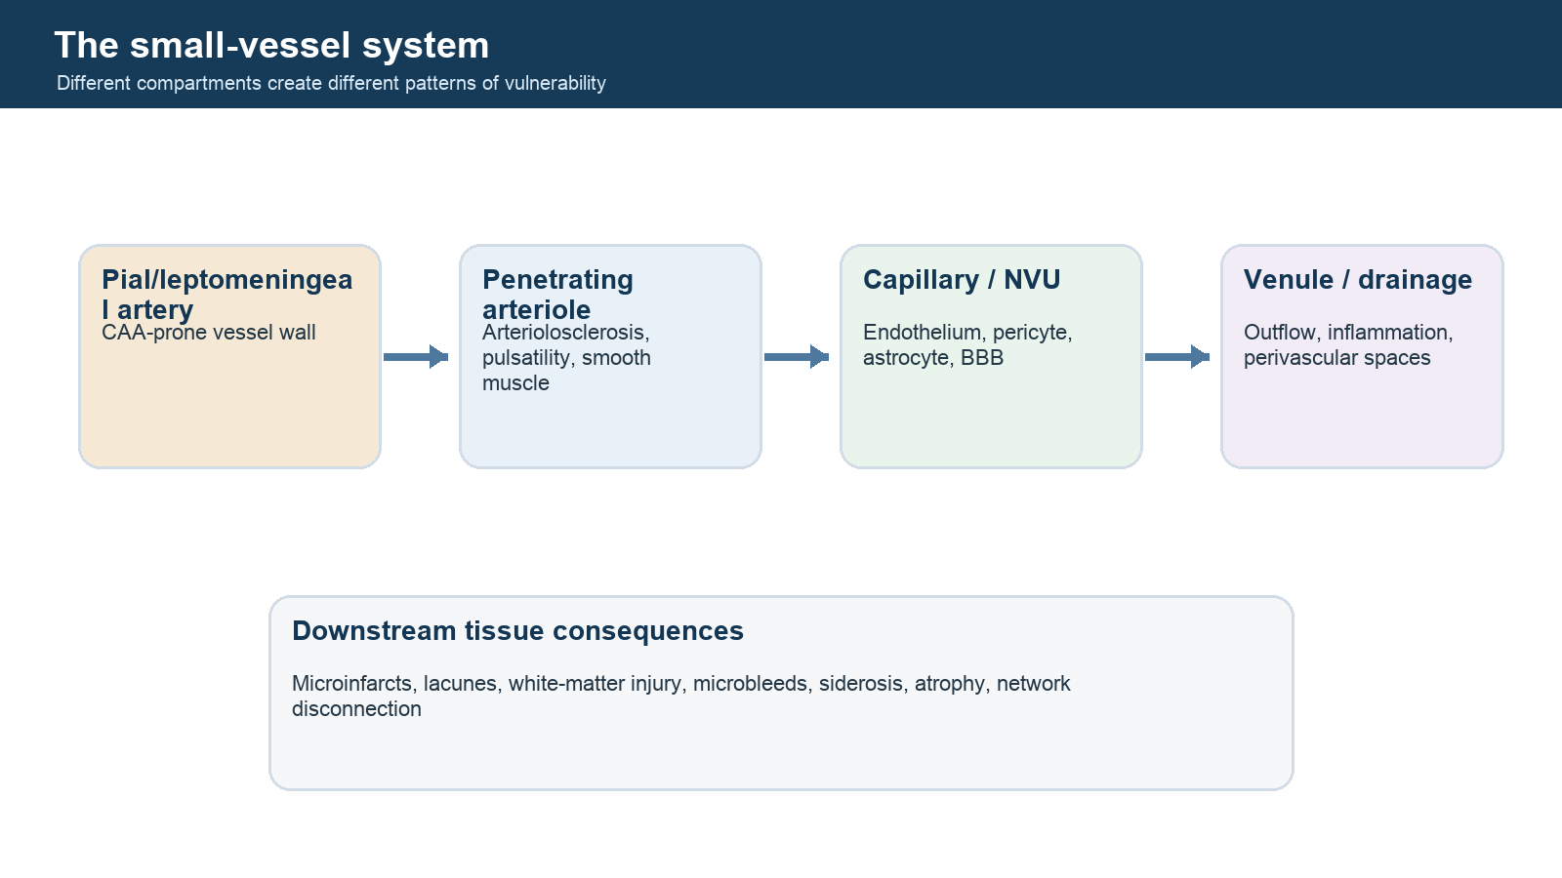
Figure 3. Small-vessel compartments from pial artery to venule and their downstream tissue consequences.

Diagnostic Criteria and Rating Systems Back to contents

1. First decide what job the instrument performs
Record 1
Instrument: STRIVE-2
Primary job: Standardize neuroimaging description and research reporting
Unit: Lesion/scan
Reference concept: Imaging phenotype consensus
What it does not do: Diagnose one cSVD etiology
Record 2
Instrument: Boston criteria v2.0
Primary job: Classify likelihood of sporadic CAA
Unit: Patient
Reference concept: Neuropathologic CAA
What it does not do: Stage every phase of CAA or identify the cause of each lesion
Record 3
Instrument: Edinburgh CT/genetic criteria
Primary job: Estimate moderate/severe CAA underlying a lobar ICH
Unit: Patient with lobar ICH
Reference concept: Neuropathology
What it does not do: Diagnose non-ICH presentations or all CAA
Record 4
Instrument: CAA-ri criteria
Primary job: Identify inflammatory CAA clinicoradiologically
Unit: Patient
Reference concept: Tissue inflammation plus vascular amyloid
What it does not do: Replace exclusion of infection, neoplasm, and mimics
Record 5
Instrument: MARS/BOMBS
Primary job: Rate microbleed presence, count, and location reproducibly
Unit: Lesion/scan
Reference concept: Expert imaging label
What it does not do: Establish the causal vessel pathology
Record 6
Instrument: Total SVD / CAA-SVD scores
Primary job: Summarize visible lesion burden
Unit: Patient/scan
Reference concept: Construct and outcome validity
What it does not do: Provide a pathologic diagnosis or continuous mechanistic measure
Record 7
Instrument: VCING/NACC pathology scales
Primary job: Standardize postmortem lesion assessment
Unit: Tissue/brain
Reference concept: Histomorphology and cognitive associations
What it does not do: Eliminate sampling error or antemortem-postmortem interval

2. STRIVE-2: describe what is visible
STRIVE stands for STandards for ReportIng Vascular changes on nEuroimaging. STRIVE-1 (2013) created a common vocabulary. STRIVE-2 (2023) preserved the phenotype-first principle, clarified evolution and mimics, and expanded attention to cortical microinfarcts, quantitative imaging, high-field MRI, vascular function, connectivity, and automated methods.
Core feature definitions in practical language
Feature | Core imaging definition | Best-seen sequences | Main mimics/limitations
Recent small subcortical infarct | Recent lesion in the territory of one perforating arteriole, usually with diffusion restriction early and a compatible time course | DWI/ADC, T2/FLAIR, T1 | Small embolic infarct, inflammatory lesion; size alone does not prove mechanism
Lacune of presumed vascular origin | Round/ovoid subcortical CSF-like cavity, up to 15 mm, consistent with healed small infarct/hemorrhage or cavitation | T1, T2, FLAIR | PVS, old larger infarct; a FLAIR rim is helpful but not universal
WMH of presumed vascular origin | White-matter T2/FLAIR hyperintensity without CSF-like cavitation | FLAIR, T2, T1 | Demyelination, edema, gliosis, migraine-associated lesions, treatment effects; "presumed vascular" is not pathologic proof
Perivascular space | CSF-like round, ovoid, or linear space following a penetrating vessel; commonly <=2 mm perpendicular to the vessel | T2, T1, 3D high resolution | Lacunes and cysts; visible enlargement does not measure clearance flow
Cerebral microbleed | Usually 2-5 mm, sometimes up to 10 mm, susceptibility signal void with blooming | SWI or T2*-GRE; phase/QSM for calcification | Veins, calcification, cavernoma, iron-rich structures, motion and air-bone artifacts
Cortical superficial siderosis | Thin susceptibility hypointensity in or over superficial cortex, focal or disseminated | SWI or T2*-GRE | Vessel, hemorrhagic transformation, trauma; infratentorial superficial siderosis has a different differential
Brain atrophy | Brain volume loss not explained solely by a specific focal injury | 3D T1, longitudinal volumetry | Neurodegeneration, hydration, scanner/processing effects; not cSVD-specific
Cortical cerebral microinfarct | Strictly cortical, T1 hypointense and T2/FLAIR hyperintense lesion, operational upper limit about 4 mm for MRI-visible lesions | High-resolution 3D T1/T2/FLAIR, 7T improves detection | PVS, partial volume, cortical lesions of other causes; most microscopic lesions remain invisible

The most important STRIVE rule
Use descriptive terms without embedding an unproven cause. For example, report "strictly lobar cerebral microbleeds" rather than "CAA microbleeds" until the patient-level evidence is integrated. Report the sequence, field strength, slice thickness, echo time, lesion definition, rating instrument, and adjudication method because detection is sequence-dependent.
STRIVE-2 is not a replacement for STRIVE-1
The 2023 paper explicitly builds on the 2013 standard. A protocol should cite both when using original feature definitions plus newer guidance. It should predefine how new, disappearing, cavitating, or morphologically changing lesions are handled longitudinally.

3. Boston criteria: evolution and purpose
The Boston criteria began as clinical-pathologic criteria for CAA-related hemorrhage. Revisions progressively incorporated additional hemorrhagic markers and then non-hemorrhagic white-matter features:
- Original criteria: multiple lobar hemorrhages in an older patient, with other causes excluded.
- Modified Boston criteria (often called v1.5): incorporated cortical superficial siderosis as a hemorrhagic marker.
- Boston v2.0 (2022): lowered the age threshold to 50, broadened compatible presentations, and allowed severe centrum semiovale PVS or a multispot WMH pattern to combine with one lobar hemorrhagic lesion.
Boston v2.0 categories
The following is a research summary; use the published table and clinical expertise for formal application.
Definite CAA
Full postmortem examination shows:
- a compatible presentation (spontaneous ICH, TFNE, cSAH, or cognitive impairment/dementia);
- severe CAA with vasculopathy; and
- no other diagnostic lesion explaining the presentation.
Probable CAA with supporting pathology
Clinical data plus limited tissue from hematoma evacuation or cortical biopsy show:
- a compatible presentation;
- some CAA in the specimen; and
- no other diagnostic lesion.
Sampling is limited: a negative small specimen cannot reliably exclude segmental CAA.
Probable CAA by clinical and MRI data
All framework requirements apply:
- age 50 years or older;
- spontaneous ICH, TFNE, or cognitive impairment/dementia;
- no alternative cause of the hemorrhagic lesions; and
- no deep ICH or deep CMB on susceptibility-sensitive MRI.
In addition, one of these imaging combinations is required:
- at least two strictly lobar hemorrhagic lesions in any combination of lobar ICH, lobar CMB, or cSS/cSAH foci; or
- one strictly lobar hemorrhagic lesion plus one white-matter feature: severe centrum semiovale PVS or WMH multispot pattern.
Cerebellar hemorrhagic lesions are counted as neither lobar nor deep in v2.0.
Possible CAA
The same age, compatible-presentation, exclusion, and no-deep-hemorrhagic-lesion framework applies, plus either:
- one strictly lobar hemorrhagic lesion; or
- one qualifying white-matter feature.
Performance in the development study
For probable CAA, sensitivity and specificity varied by cohort and presentation. In the combined autopsy-standard group, reported sensitivity was about 74.5% and specificity about 95.0%. This is strong rule-in performance in the studied spectrum, not a universal constant. The criteria were derived from hospital-based, selected cases with compatible clinical presentations and tissue; performance can change in community screening, younger populations, underrepresented groups, low-quality MRI, or atypical presentations.
What Boston v2.0 does not establish
- It does not identify asymptomatic vascular amyloid before qualifying lesions appear.
- It does not prove that every counted lobar CMB was produced by CAA.
- It does not grade molecular burden or current activity.
- It does not incorporate amyloid PET, CSF, plasma, vascular reactivity, or diffusion metrics as formal criteria.
- It is not intended for hemorrhage with an evident alternative cause such as trauma, hemorrhagic tumor, vascular malformation, hemorrhagic transformation, or CNS vasculitis.
- The absence of deep hemorrhagic lesions is a classification requirement; mixed lobar and deep disease remains clinically and biologically important even when it falls outside probable CAA.

4. Edinburgh CT and genetic criteria
The Edinburgh model was developed for patients with lobar intracerebral hemorrhage, especially when MRI is unavailable or unsuitable. It uses:
- subarachnoid extension of the ICH on CT;
- finger-like projections from the hematoma; and
- APOE ε4 possession, when genotyping is available.
In the development cohort:
- no predictor present corresponded to a low predicted probability (about 7%);
- subarachnoid hemorrhage or APOE ε4 alone corresponded to an intermediate range (about 44-64%);
- subarachnoid hemorrhage plus either finger-like projections or APOE ε4 corresponded to a high probability (at least 95%).
The study used a small, population-based autopsy cohort and internal bootstrap validation. Its authors explicitly called for external validation. CT markers should be rated with a standardized instrument such as CHARTS, and acquisition/reconstruction matter.
Conceptual contrast with Boston
- Boston v2.0 addresses several CAA presentations and relies on MRI when no tissue is available.
- Edinburgh addresses the cause of a lobar ICH using acute CT morphology, optionally plus APOE.
- The instruments are complementary rather than competitors.

5. CAA-related inflammation criteria
CAA-ri is a potentially treatment-responsive inflammatory syndrome associated with vascular amyloid. Pathology spans predominantly perivascular inflammation and destructive transmural/intramural vasculitis; current guidance prefers CAA-ri as the umbrella term and reserves ABRA/CAA-related vasculitis for pathologically demonstrated angio-destructive disease.
Probable CAA-ri: the clinicoradiologic pattern
The validated 2016 framework requires:
- age 40 years or older;
- acute or subacute compatible symptoms such as headache, impaired consciousness or behavior, focal neurologic deficits, or seizures, not directly explained by an acute ICH;
- unifocal or multifocal corticosubcortical or deep WMH that is asymmetric and extends to immediately subcortical white matter, with asymmetry not explained by prior ICH;
- at least one corticosubcortical hemorrhagic lesion such as macrohemorrhage, microbleed, or cSS; and
- exclusion of neoplastic, infectious, and other causes.
In the original validation, probable CAA-ri achieved reported sensitivity of 82% and specificity of 97%; possible CAA-ri was less specific. Definite diagnosis requires tissue showing vascular amyloid plus appropriate perivascular, intramural, or transmural inflammation. Because disease is patchy, biopsy site selection matters and a negative biopsy may not exclude it.
Distinguish three related phenomena
Phenomenon | Trigger/context | Typical imaging concept | Key distinction
Non-inflammatory CAA | Spontaneous age-related/hereditary vascular amyloid | Lobar CMB/ICH, cSAH/cSS, WM injury | No required acute inflammatory syndrome
CAA-ri | Spontaneous immune response associated with vascular amyloid | Asymmetric vasogenic edema plus hemorrhagic markers, sometimes enhancement | Subacute syndrome; can respond to immunosuppression
ARIA | Anti-Aβ treatment context | ARIA-E edema/effusion; ARIA-H microhemorrhage/siderosis | Treatment-emergent entity with protocol-specific grading and monitoring

Their overlap is mechanistically informative but they are not synonyms.

6. Neuropathology standards for arteriolosclerosis and CAA
B-ASC assessment
Common semiquantitative scales grade none, mild, moderate, or severe arteriolosclerosis, often in occipital white matter or multiple prespecified regions. Severe disease can include marked wall thickening, splitting/degeneration of the media, luminal narrowing or occlusion, and associated changes. Quantitative sclerotic indices measure wall-to-lumen geometry.
Minimum reporting should include:
- sampled regions and number of blocks;
- vessel compartment and size definition;
- stains and immunohistochemistry;
- grading rubric and whether the worst, mean, or regional score was used;
- interrater reliability and adjudication;
- whether CAA, inflammation, fibrinoid necrosis, mineralization, and atherosclerosis were separately rated;
- postmortem interval, fixation, section thickness, and image-analysis method.
CAA assessment
CAA should be characterized by compartment (leptomeningeal, cortical, capillary), region, severity, and vasculopathic change. Aβ immunohistochemistry and Congo red/polarization are complementary. Consensus protocols such as Love et al. and neuropathology data systems improve comparability, but regional sampling remains a fundamental limitation.
VCING
The Vascular Cognitive Impairment Neuropathology Guidelines integrate arteriolosclerosis, infarcts, hemorrhage, CAA, myelin loss, PVS dilation, hemosiderin leakage, and large-artery atheroma to estimate the likelihood that cerebrovascular disease contributed to cognitive impairment. VCING is an attribution framework, not a direct antemortem diagnostic test.

7. Visual rating instruments and burden scores
Microbleeds
- MARS (Microbleed Anatomical Rating Scale): records definite/possible microbleeds and their lobar, deep, and infratentorial locations; designed for reproducibility across observers and sequences.
- BOMBS (Brain Observer MicroBleed Scale): structured assessment developed around common disagreement sources and anatomic distribution.
Both improve measurement reliability. Neither converts location into pathologic certainty.
White-matter hyperintensities
- Fazekas scale: separate ordinal ratings for periventricular and deep WMH. It is fast and widely used, but coarse and subject to ceiling effects.
- Scheltens scale: more regionally detailed.
- Quantitative WMH volume is more continuous but sensitive to algorithm, training data, preprocessing, scanner, and manual correction.
Perivascular spaces
Visual scales commonly rate the number of PVS in the basal ganglia and centrum semiovale using the most affected slice/hemisphere and ordinal categories. Region matters: basal-ganglia PVS are often associated with non-amyloid arteriopathy, while severe centrum semiovale PVS support CAA in a compatible setting. These are group-level tendencies with overlap.
Total SVD score (general/non-amyloid-oriented)
The widely used 0-4 score assigns one point each for a qualifying burden of lacunes, CMBs, basal-ganglia PVS, and WMH. It is interpretable and useful for burden stratification but compresses heterogeneous lesions, thresholds continuous variables, weights each component equally, and changes meaning when components or cutoffs are modified.
CAA-SVD score
The 0-6 CAA-oriented score typically includes:
- 2-4 lobar CMBs: 1 point; at least 5: 2 points;
- focal cSS (up to 3 sulci): 1 point; disseminated cSS (4 or more sulci): 2 points;
- more than 20 centrum semiovale PVS: 1 point;
- confluent deep or irregular periventricular WMH meeting defined Fazekas thresholds: 1 point.
It summarizes visible CAA-associated burden; it is not the Boston diagnostic criteria. Avoid calling a modified score "the CAA-SVD score" without listing exact components.

8. A criteria application checklist for research
- Define the eligible clinical presentation and age range.
- Verify MRI contains an adequate susceptibility-sensitive sequence; record GRE versus SWI and parameters.
- Exclude alternative causes before counting lesions toward CAA.
- Map every hemorrhagic lesion as lobar, deep, infratentorial/cerebellar, or uncertain using a prespecified atlas/rule.
- Distinguish cortical ribbon from juxtacortical and subcortical white matter when possible.
- Rate cSS/cSAH foci independently from CMB count.
- Apply severe CSO-PVS and WMH-multispot definitions exactly.
- Record the final diagnostic category and each component so the classification is auditable.
- Preserve an "unclassifiable/insufficient imaging" state; do not force missing data to negative.
- If using pathology, model region sampled and MRI-to-tissue interval.
- Report reader training, blinding, reliability, adjudication, and scanner/sequence mix.
- Perform sensitivity analyses for uncertain lesions and alternate thresholds.

Key sources
- Charidimou A, et al. Boston criteria v2.0. Lancet Neurology. 2022. doi:10.1016/S1474-4422(22)00208-3
- Duering M, et al. STRIVE-2. Lancet Neurology. 2023. doi:10.1016/S1474-4422(23)00131-X
- Wardlaw JM, et al. STRIVE-1. Lancet Neurology. 2013. doi:10.1016/S1474-4422(13)70047-8
- Rodrigues MA, et al. Edinburgh CT and genetic criteria. Lancet Neurology. 2018. doi:10.1016/S1474-4422(18)30006-1
- Auriel E, et al. CAA-ri criteria validation. JAMA Neurology. 2016. doi:10.1001/jamaneurol.2015.4078
- Gregoire SM, et al. MARS. Neurology. 2009. doi:10.1212/WNL.0b013e3181c34a7d
- Cordonnier C, et al. BOMBS. Stroke. 2009. doi:10.1161/STROKEAHA.108.526996
- Skrobot OA, et al. VCING. Brain. 2016. doi:10.1093/brain/aww214
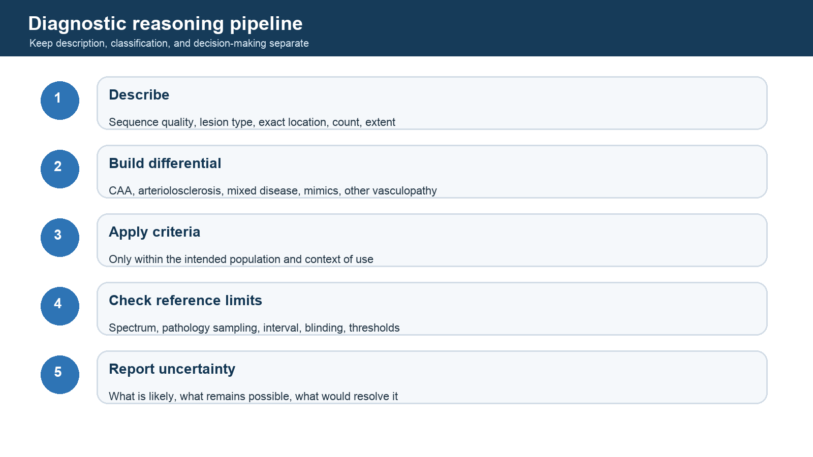
Figure 4. Five-step diagnostic reasoning pipeline from description through uncertainty reporting.

Diagnostic Transportability: What the Criteria Can and Cannot Do Back to contents

Why a diagnostic criterion has no context-free accuracy
Sensitivity and specificity are properties of a test in a particular spectrum of disease, acquisition conditions, reference standard, and interpretation process. Positive and negative predictive values additionally depend on prevalence. A criterion derived among symptomatic patients selected for MRI and tissue is answering a different question from one applied to an asymptomatic community sample.
This is not a technical footnote. It is one of the most important current lessons in CAA diagnosis.

Boston criteria v2.0 in the derivation setting
The 2022 multicentre study included adults aged 50 years or older with spontaneous intracerebral hemorrhage, cognitive impairment, or transient focal neurologic episodes, along with adequate MRI and histopathologic evaluation. Probable CAA required either at least two strictly lobar hemorrhagic lesions or one strictly lobar hemorrhagic lesion plus severe centrum-semiovale perivascular spaces or a multispot white-matter hyperintensity pattern, with no deep hemorrhagic lesion and no better alternative cause.
Performance was strong within those sampled clinical settings. Sensitivity and specificity were 74.8% and 84.6% in derivation, 92.5% and 89.5% in temporal validation, and 80.2% and 81.5% in geographic validation. In the full-autopsy subset they were 74.5% and 95.0%, respectively.
Those numbers support Boston v2.0 for the intended symptomatic clinical spectrum. They do not establish equivalent screening performance.

Community and nonhemorrhagic validation
In 134 ROSMAP participants with in vivo 3T MRI and autopsy, probable CAA v2.0 sensitivity was 38.8% and specificity 83.5%. The updated white-matter features increased sensitivity relative to earlier versions, but sensitivity remained limited. True-positive cases had more strictly cortical lobar microbleeds than false-positive cases, strengthening the hypothesis that exact cortical versus juxtacortical localization contains additional etiologic information.
In a separate 54-person Mayo community and memory-clinic MRI-autopsy cohort without symptomatic intracerebral hemorrhage, probable CAA v2.0 sensitivity was 28.6%, specificity 65.3%, and AUC 0.47. Broadening to possible plus probable CAA raised sensitivity but sharply reduced specificity.
The correct synthesis is not that Boston v2.0 “failed.” It is that a classification rule optimized in one clinical spectrum should not be assumed to solve a different use case. Preclinical or cognitive-only CAA likely requires additional biomarkers and possibly different thresholds.

Interpreting individual features
Strictly lobar hemorrhagic lesions
They are among the strongest available MRI clues for CAA, especially when multiple and accompanied by cortical superficial siderosis or convexity subarachnoid hemorrhage. They remain probabilistic. Arteriolosclerosis, trauma, cavernous malformations, treatment effects, and other processes can create mimics or true lobar hemorrhagic lesions.
Cortical superficial siderosis
Its sulcal distribution and extent can be diagnostically and prognostically informative. It must be distinguished from other sources of chronic subarachnoid blood products and interpreted with susceptibility-sensitive sequences.
Centrum-semiovale perivascular spaces
Severe CSO-PVS add information in combination with a lobar hemorrhagic feature. Spatial pathology supports a relationship to overlying cortical CAA, but PVS also occur with aging and other small-vessel processes and do not directly measure fluid flow.
Multispot white-matter hyperintensity pattern
This is a qualifying feature within Boston v2.0, not a standalone CAA biomarker. Its incremental performance appears smaller than that of CSO-PVS in available community validation, and WMH remain etiologically nonspecific.

The Edinburgh criteria answer a narrower question
The Edinburgh CT and genetic model was developed for adults with lobar intracerebral hemorrhage. It combines subarachnoid extension, finger-like projections, and APOE e4. Among 62 lobar ICH cases in the autopsy cohort, the three-variable model achieved a c-statistic of 0.92; the proposed rule-in combination had 96% specificity. Its strengths are a masked pathology reference and practical CT morphology. Its boundaries are equally important: small development set, internal validation, genotype dependence, and no claim to classify non-ICH presentations.

A practical evidence-reading checklist
Before accepting any accuracy number, ask:
- What was the intended context of use?
- How were participants selected?
- What clinical presentations were present?
- Which MRI sequences and field strengths were required?
- Was the index test rated blind to pathology?
- Was the reference full autopsy, limited biopsy, hematoma evacuation, or clinical follow-up?
- How long separated imaging and pathology?
- Were mixed pathologies measured?
- Were thresholds prespecified?
- Was calibration reported, not only discrimination?
- Has the result been reproduced outside the development ecosystem?

Current research implication
The next diagnostic advance is unlikely to come from adding one more nonspecific lesion to a checklist. Higher-value directions include exact lesion compartment, continuous spatial burden, vessel physiology, molecular/fluid information, acquisition-aware models, and multimodal validation against multiregion pathology. These models must be developed separately for symptomatic diagnosis, preclinical detection, treatment-risk estimation, and prognosis.
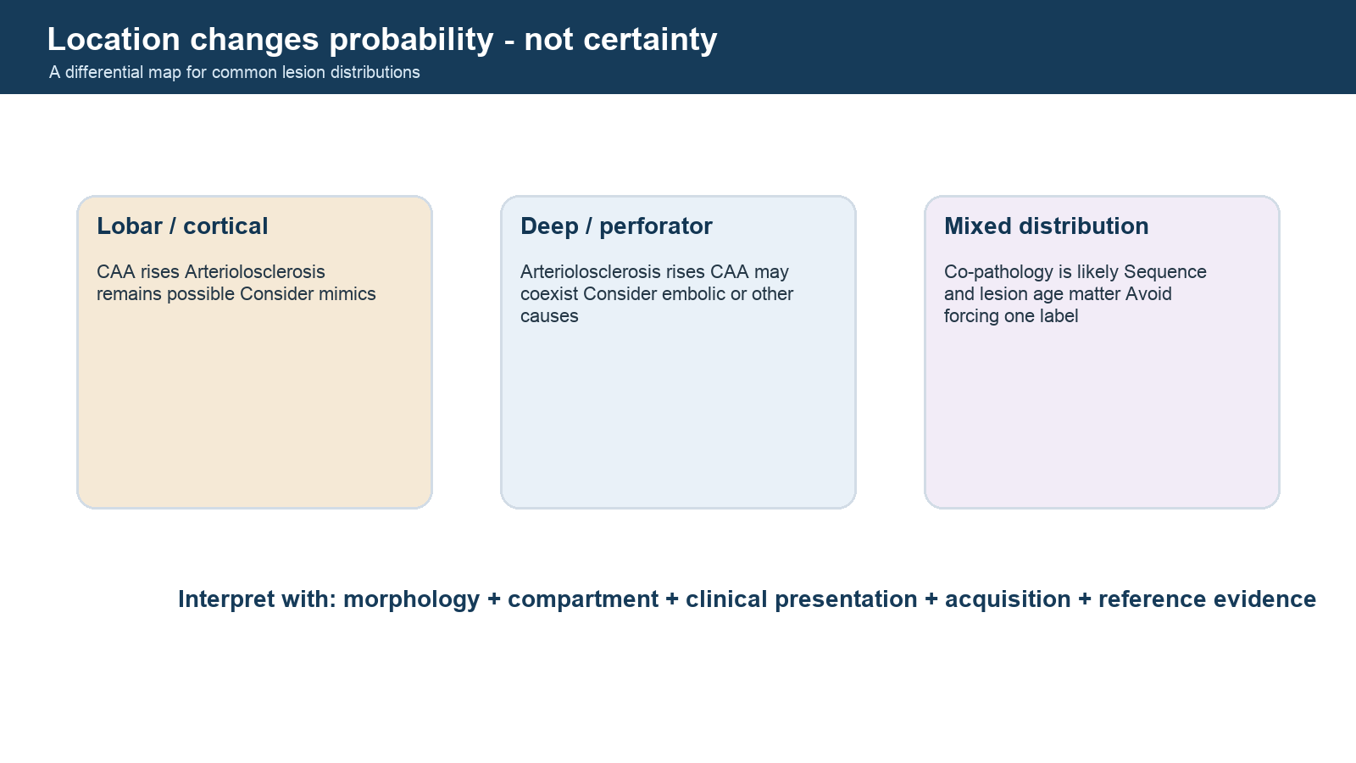
Figure 5. Three-column differential showing lobar, deep, and mixed lesion distributions as probabilistic evidence.

Biomarkers and Tools Back to contents

1. A biomarker is defined by its context of use
A number is not "validated" in the abstract. It can be validated for one or more specific jobs:
- susceptibility/risk: identify people more likely to develop disease or an outcome;
- diagnostic: identify current disease or subtype;
- prognostic: predict course among people with disease;
- monitoring: track change over time;
- predictive: identify differential response or harm from an intervention;
- pharmacodynamic/response: show that a biological process changed after treatment;
- trial enrichment/stratification: select or balance participants.
Technical repeatability, association with cognition, pathology prediction, and treatment responsiveness are different validation layers.

2. ARTS: the arteriolosclerosis biomarker
What it is
ARTS is a fully automated, containerized MRI-based classifier designed to output a score related to the likelihood of brain arteriolosclerosis. It combines:
- 3D T1-weighted MRI;
- T2-weighted FLAIR for WMH-related features;
- diffusion tensor imaging, including regional fractional-anisotropy information;
- age at MRI and sex.
The public package accepts DICOM (preferred by its documentation) or NIfTI and was distributed for Singularity-based execution on Linux/macOS and high-performance computing. Check the current package requirements before using Apptainer as a drop-in replacement.
Development logic
ARTS was trained using ex vivo MRI and neuropathology, then translated to in vivo imaging. Its central scientific value is the attempt to learn a pathology-linked arteriolosclerosis signature rather than treating total WMH as if it were specific.
Evidence to date
- The initial publication reported prediction of arteriolosclerosis, scan-rescan reproducibility, and association with two-year cognitive decline in nondemented older adults.
- MarkVCID instrumental validation reported extremely high inter-rater reliability, high test-retest repeatability, and strong inter-scanner reproducibility in the validation design.
- Clinical/biological validation linked higher baseline ARTS scores with worse baseline performance and faster decline in processing-speed/executive measures in independent cohorts.
- A later diverse cohort of 1,226 older adults linked higher ARTS with incident MCI, dementia, stroke, and several vascular risk factors, with heterogeneity across racial/ethnic groups.
What ARTS does not yet justify
- It should not be called a definitive clinical diagnosis of arteriolosclerosis.
- Its output is not a direct image of the vessel wall.
- Validation in very old cohorts does not automatically generalize to midlife, rare genetic cSVD, unusual scanner/protocol distributions, or different disease spectra.
- Age and sex are inputs; fairness and transportability must be evaluated, not assumed.
- Association with outcomes does not prove that changing the ARTS score changes outcomes.
- The composite model can capture correlates of arteriolosclerosis, comorbid pathology, aging, or tissue consequences unless competing pathologies are explicitly tested.
Access and reproducibility record
- Tool page: NITRC ARTS biomarker
- MarkVCID protocol/resources: MarkVCID2 protocols
- Initial paper: ARTS: a novel in-vivo classifier
- Validation report: ARTS instrumental and clinical validation
For any ARTS analysis, preserve software version, container hash, input series identifiers, acquisition parameters, DICOM-to-NIfTI conversion provenance, all quality-control failures, demographic inputs, exclusions, and raw output before transformation.

3. MarkVCID biomarker kits
MarkVCID is an NIH-funded multisite program intended to move promising VCID biomarkers toward trial readiness using common protocols and staged instrumental, biological, and clinical validation.
Current major MRI/fluid kits include:
Record 1
Kit: ARTS
Input: T1, FLAIR, DTI, age, sex
Output concept: Arteriolosclerosis likelihood score
Current intended use: Susceptibility/risk and trial stratification
Main cautions: Transportability, age range, pathology overlap
Record 2
Kit: PSMD
Input: Preprocessed diffusion MRI
Output concept: 95th minus 5th percentile width of skeletonized mean diffusivity
Current intended use: Diffuse white-matter injury/risk
Main cautions: Sensitive to diffusion QC, processing, CSF contamination; not etiologic
Record 3
Kit: Free water
Input: Diffusion MRI
Output concept: Extracellular free-water fraction
Current intended use: Tissue injury/risk
Main cautions: Model and acquisition dependence; inflammation/atrophy can influence
Record 4
Kit: Cerebrovascular reactivity
Input: Controlled CO2/BOLD MRI
Output concept: Vascular response to stimulus
Current intended use: Vascular dysfunction/target engagement candidate
Main cautions: Gas delivery, physiology, motion, site harmonization
Record 5
Kit: WMH volume
Input: T1 + FLAIR
Output concept: Automated lesion volume
Current intended use: Vascular burden/enrichment
Main cautions: Algorithm/scanner/domain shift; low specificity
Record 6
Kit: Plasma NfL
Input: Plasma assay
Output concept: Axonal injury marker
Current intended use: Risk stratification
Main cautions: General injury marker, not cSVD-specific
Record 7
Kit: OCTA vessel skeleton density
Input: Retinal OCT angiography
Output concept: Retinal microvascular density
Current intended use: Candidate accessible microvascular marker
Main cautions: Device/segmentation dependence; brain specificity uncertain
Resources: MarkVCID consortium, MarkVCID1 results, and MarkVCID2 protocols.

4. CAA biomarkers
Hemorrhagic MRI markers
Strictly lobar CMBs, cSS/cSAH, and lobar ICH are the most established clinical imaging signals. cSS extent is also prognostic for recurrent lobar ICH in CAA cohorts. Sequence sensitivity is a major confounder: SWI detects more lesions than many GRE protocols, and field strength/echo time affect counts.
Non-hemorrhagic MRI markers
- severe centrum semiovale PVS;
- posterior or multispot WMH patterns;
- cortical microinfarcts;
- diffusion damage and PSMD;
- reduced structural-network efficiency;
- altered cerebrovascular reactivity;
- cortical thinning and atrophy;
- BBB permeability and vascular-function measures.
These markers may occur earlier or correlate more closely with cognition than microbleed count. Most lack the etiologic specificity to stand alone.
Amyloid PET
Amyloid PET can be sensitive to cerebral amyloid but cannot readily separate vascular from parenchymal amyloid. A negative scan may be useful in selected diagnostic contexts; a positive scan is less specific because Alzheimer-type plaques are common. Tracer, reference region, partial-volume correction, disease stage, and coexisting AD must be modeled.
CSF
Across studies, CAA is often associated with lower CSF Aβ40 and Aβ42, while tau patterns help distinguish or identify coexisting AD. Meta-analyses and newer cohorts support signal, but assay platforms, diagnostic reference standards, and overlap limit stand-alone use. CSF biomarkers are not part of Boston v2.0.
Blood
Plasma proteomic, vascular-injury, inflammatory, Aβ, and APOE-related signatures are active research areas. Recent exploratory studies report candidate protein panels associated with lobar CMBs or neuropathologic CAA. These require independent, prospective, spectrum-appropriate replication and comparison against AD, arteriolosclerosis, renal function, age, and systemic vascular disease.
Genetic information
- APOE ε4 is associated with CAA presence/amyloid deposition and capillary CAA.
- APOE ε2 is associated with severe vasculopathic/hemorrhagic manifestations in several cohorts.
- APP mutations cause hereditary CAA syndromes such as Dutch-type CAA; other genes/proteins cause rarer amyloid angiopathies.
Genetic association is not deterministic diagnosis in sporadic disease. Ancestry, allele frequency, selection, and treatment context matter.

5. Visual rating tools
Tool | Measures | Recommended archive item
MARS | CMB certainty, count, and anatomy | Rating form, training cases, rater ID, sequence parameters
BOMBS | CMB presence/distribution with mimic guidance | Scale version, adjudication log
CHARTS | Anatomic features of cerebral hemorrhage on CT | Completed form and reader reliability
Fazekas | Periventricular and deep WMH severity | Both component scores, not only total
Scheltens | Regional WMH burden | Region-level values and total
Potter/Wardlaw PVS scales | PVS burden by region | Basal ganglia and centrum semiovale separately
cSS focal/disseminated and multifocality scales | Extent/distribution of superficial siderosis | Sulci/foci map, not only binary presence

Rating forms and atlases should be versioned. Training examples should include mimics and uncertainty, not only textbook-positive cases.

6. Open and common computational tools
WMH segmentation
- LST-LGA/LPA: SPM-based lesion growth/prediction algorithms; widely used, originally developed in multiple-sclerosis contexts and often adapted to aging WMH.
- BIANCA: FSL supervised classifier for white-matter hyperintensities; requires representative training labels and careful thresholding.
- SAMSEG: sequence-adaptive Bayesian segmentation in FreeSurfer; supports lesion segmentation in multimodal data.
- WMH Segmentation Challenge containers: standardized benchmark methods; benchmark rank does not guarantee transportability to a new cohort.
- nnU-Net/custom U-Net pipelines: powerful when trained and externally validated; susceptible to scanner and population domain shift.
For all automated WMH tools, perform blinded manual QC, record failure categories, assess small-lesion false positives, and compare performance across scanner, site, race/ethnicity, age, lesion burden, and co-pathology.
Diffusion and microstructure
- PSMD toolbox: miac-research/psmd, using FSL/TBSS-based skeletonization and histogram analysis.
- FSL diffusion tools: TOPUP, EDDY, DTIFIT, and TBSS; acquisition-specific QC is essential.
- Free-water models: implementation and fitting choices vary; keep code/version and parameter maps.
Microbleed detection
Automated CMB detectors are improving but face severe class imbalance and mimics from vessels, calcification, and susceptibility artifact. Evaluate lesion-level sensitivity and false positives per scan, not only voxel Dice or patient-level AUC. External validation on different SWI/GRE protocols is essential.
Structural/network analysis
- FreeSurfer: cortical thickness, volume, and surface reconstruction.
- FSL/ANTs: registration, segmentation, and image processing.
- MRtrix3: tractography and structural connectomics.
- QSIPrep/fMRIPrep-like reproducible pipelines: useful for standardized preprocessing, but cSVD lesions can break assumptions and require lesion-aware QC.
Digital pathology
The Perosa/Scherlek workflow trained separate deep-learning models for parenchymal Aβ plaques, vascular Aβ, iron/calcium, astrocytes, microglia, and fibrin extravasation. The key methodological lesson is to retain marker-specific outputs and expert QC rather than collapsing all staining into one pathology score.
Useful platforms include QuPath and slide-specific deep-learning frameworks. Cross-laboratory stain normalization, scanner differences, annotation policy, tissue folds, vessel-size definitions, and spatial registration to MRI are first-order problems.

7. Literature and evidence-archive tools
Need | Tool class | Examples | Quality control
Citation library | Reference manager | Zotero, EndNote | Save DOI/PMID, tags, notes, lawful link, duplicate merge history
Biomedical search | Curated index | PubMed/MEDLINE, Embase | Store exact query, date, filters, and result count
Forward/backward citation search | Citation graph | OpenAlex, Web of Science, Scopus, Semantic Scholar | Verify metadata against DOI/publisher
Screening | Review platform | Rayyan, Covidence, ASReview | Export decisions and exclusion reasons
Living alerts | Automated search | PubMed/MyNCBI, Crossref/OpenAlex scripts | Deduplicate and manually triage
Reproducible extraction | Structured records | CSV/JSON + templates in this repository | Two-person review for high-stakes claims

Discovery tools such as Connected Papers, ResearchRabbit, and Litmaps are useful for finding neighborhoods of papers but should not define completeness. Search strategy and eligibility rules should be documented independently.

8. Minimum tool-record schema
Every tool record should contain:
- name, version, owner, and stable URL;
- license and redistribution terms;
- intended context of use;
- required inputs and accepted formats;
- preprocessing and quality-control requirements;
- output definition and scale direction;
- training/development population;
- technical, biological, clinical, and external validation evidence;
- known failure modes and excluded populations;
- compute/runtime/container requirements;
- last verified date and maintainer status;
- primary citation and independent evaluations.
Use templates/TOOL_RECORD_TEMPLATE.md to add new entries.

9. A practical validation ladder
- Analytical validity: does the measurement accurately quantify its intended signal on controlled data?
- Repeatability: does it agree across raters and repeat scans?
- Reproducibility: does it agree across scanners, sites, and implementations?
- Biological validity: does it associate with tissue or a credible mechanistic reference?
- Clinical validity: does it identify or predict a meaningful clinical state/outcome?
- Incremental validity: does it add information beyond age, risk factors, and standard imaging?
- Transportability and fairness: does it work in new sites, protocols, ancestries, ages, and comorbidity patterns?
- Responsiveness: does it change over time or after an intervention in an interpretable way?
- Clinical utility: does using it improve decisions or outcomes?
Most cSVD biomarkers have not completed the full ladder. That is not failure; it is the research map.
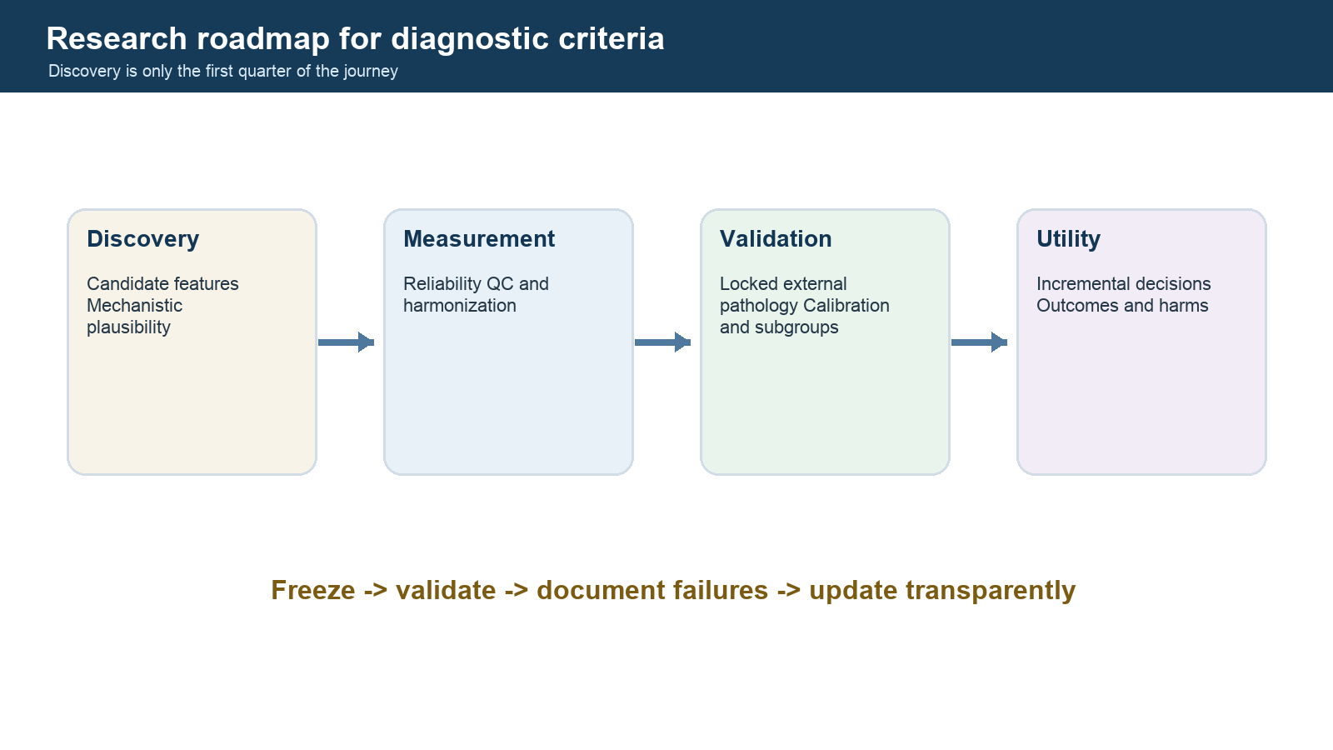
Figure 6. Four-stage research roadmap from feature discovery through clinical utility.

Debates, Hypotheses, and Open Questions Back to contents

How to read this chapter
Each section distinguishes the hypothesis, observations that support it, observations that constrain it, and a study that could discriminate among explanations. "Evidence against" often means evidence against a simple or universal version, not proof that the whole mechanism is false.

1. Is CAA fundamentally a perivascular clearance disease?
Hypothesis
Soluble Aβ normally exits brain along perivascular pathways. Aging or vascular dysfunction reduces clearance; Aβ accumulates in vessel walls; deposition further impairs drainage, producing a feed-forward loop.
Supporting observations
- Vascular deposition follows compartments plausibly involved in interstitial-fluid drainage.
- Experimental tracer work demonstrates periarterial/perivascular movement.
- Severe centrum semiovale PVS are associated with CAA in imaging cohorts and contribute to Boston v2.0.
- Perosa et al. spatially linked dilated white-matter PVS to Aβ accumulation and smooth-muscle loss in overlying cortical vessels.
- Hereditary CAA data suggest molecular/physiologic abnormalities long before hemorrhage.
Constraints and alternatives
- MRI-visible PVS are a structural endpoint and do not measure flow direction or Aβ flux.
- PVS enlargement may be caused by amyloid, atrophy, inflammation, or shared aging processes.
- IPAD and glymphatic models differ in routes and driving forces; the field sometimes combines them too loosely.
- Anesthesia, sleep, posture, arterial pulsation, and species strongly affect experimental flow.
- Parenchymal and vascular amyloid can share production and clearance factors without one route being dominant.
Discriminating study
A longitudinal human study in presymptomatic hereditary CAA combining dynamic molecular tracer methods, quantitative PVS morphology, vascular reactivity, CSF/plasma Aβ kinetics, arterial pulsatility, sleep/posture measures, and repeated MRI, with preregistered temporal predictions. A mechanistic model should predict which variable changes first and where.

2. Does vascular dysfunction precede visible tissue injury?
Hypothesis
Impaired cerebrovascular reactivity, autoregulation, BBB function, and microvascular flow occur before WMH, microinfarcts, or hemorrhage and define a treatable stage.
Supporting observations
- Dutch-type CAA studies support early reactivity abnormalities.
- The Koemans framework orders physiologic dysfunction before non-hemorrhagic and hemorrhagic injury.
- Diffusion and network measures often correlate with cognition beyond visible lesion counts.
Constraints
- Most sporadic studies are cross-sectional.
- Vascular reactivity depends on baseline CO2, medications, hematocrit, neural activation, vascular anatomy, and analysis.
- Tissue injury can itself impair measured reactivity, creating reverse causation.
Discriminating study
Repeated physiology and tissue-imaging measurements in initially lesion-free, high-risk participants, analyzed with within-person change and negative-control regions. Demonstrate that physiologic change predicts subsequent spatially matched injury after controlling for baseline occult damage.

3. Is BBB leakage a cause, consequence, or amplifier?
Hypotheses
- Barrier failure is an early upstream lesion allowing plasma proteins, inflammation, and edema to damage tissue.
- Barrier leakage occurs after vessel-wall injury and is mainly a marker.
- Both are correct in subtype- and stage-dependent feedback loops.
Evidence
Kozberg et al. observed leakage and smooth-muscle loss in mildly amyloid-affected vessels and leakage in remodeled vessels, while later vessel stages showed more perivascular inflammation. This spatial pathology supports a staged model but comes from a small autopsy series and cannot establish within-person temporal sequence.
Discriminating study
Register in vivo dynamic contrast-enhanced MRI and fluid markers to ex vivo whole-hemisphere MRI and serial histology. Sample vessels across regions prospectively, not only visible lesions, and quantify amyloid, junction proteins, fibrinogen, smooth muscle, matrix remodeling, immune cells, and microhemorrhage.

4. Why can a ruptured CAA vessel contain little amyloid at the rupture site?
Competing explanations
- local immune or proteolytic removal of Aβ precedes rupture but leaves a weakened wall;
- fibrinoid remodeling physically replaces the amyloid-bearing segment;
- the apparent depletion is a sampling/sectioning problem;
- hemorrhage destroys or displaces antigen;
- adjacent rather than directly sampled vessel segments contain the causal amyloid;
- some lobar microbleeds have a non-CAA cause.
What would decide the issue
Three-dimensional serial reconstruction of entire culprit vessels, with spatially resolved Aβ species, smooth muscle, collagen/basement membrane, fibrin, iron, complement, proteases, and immune cells, compared with nonruptured vessels from the same brain and arteriolosclerosis controls.

5. Are strictly lobar microbleeds specific to CAA?
Conventional model
Strictly lobar distribution strongly favors CAA; deep distribution favors arteriolosclerosis. This is diagnostically useful and underlies Boston criteria.
Challenge
Perosa et al. found true lobar CMBs caused by arteriolosclerosis in three pathology-negative, clinically false-positive CAA cases. Lesions tended toward juxtacortical/subcortical white matter rather than cortical ribbon.
Balanced conclusion
Anatomic distribution is a high-value probabilistic biomarker, not a deterministic lesion label. Patient-level diagnostic specificity can be high even when lesion-level specificity is imperfect. Higher-resolution localization relative to cortical ribbon and penetrating-vessel anatomy may improve etiologic inference.
Needed evidence
Large prospective MRI-autopsy datasets with lesion-by-lesion coregistration, standardized SWI/QSM, whole-vessel serial histology, and controls spanning mixed CAA/B-ASC. Report both patient-level and lesion-level accuracy.

6. Can WMH patterns distinguish CAA from arteriolosclerosis?
Proposed pattern
Posterior-predominant or multispot subcortical WMH may support CAA; confluent periventricular/deep WMH and deep lesions may support non-amyloid arteriopathy.
Problem
WMH are a final common pathway of edema, demyelination, axonal loss, rarefaction, gliosis, and incomplete infarction. Age, blood pressure, AD, CAA, B-ASC, venous disease, and technical segmentation all influence them.
The multispot pattern contributes to Boston v2.0 in combination with a lobar hemorrhagic lesion, but added diagnostic performance was smaller than that of severe CSO-PVS in the derivation work. A 2025 pilot linked multispot count to amyloid PET burden in 21 participants; the small sample and parenchymal/vascular PET ambiguity require caution.
Research direction
Move from a single pattern label to spatially explicit lesion morphology, rim/perfusion/permeability/diffusion features, vascular territories, and pathology-linked training. Validate against both CAA and B-ASC severity rather than against clinical labels alone.

7. Are enlarged PVS a clearance biomarker, severity marker, or epiphenomenon?
Possibilities
- direct structural consequence of impaired fluid clearance;
- marker of vessel stiffening and smooth-muscle loss;
- consequence of atrophy or tissue loss;
- route-dependent response to CAA in centrum semiovale and B-ASC in basal ganglia;
- nonspecific aging feature with disease-modified distribution.
Key methodological issue
Most studies count visible spaces on one slice or use thresholded segmentations. They do not measure flow, vessel identity, connectivity, or whether the PVS surrounds an artery or vein.
Needed tools
High-resolution 3D vessel/PVS imaging, arterial-versus-venous labeling, fluid-dynamic measurements, and tissue validation along the same penetrating vessel.

8. Is brain arteriolosclerosis one disease or a family of lesions?
Unitary view
Age, hypertension, diabetes, and metabolic/inflammatory stress converge on hyaline wall thickening, smooth-muscle loss, and luminal narrowing.
Heterogeneity view
The same semiquantitative score may combine fibrosis, muscular remodeling, basement-membrane duplication, leakage, mineralization, inflammatory change, fibrinoid injury, and region-specific processes with different causes and consequences.
Why it matters
A heterogeneous pathology label weakens biomarker specificity and can hide treatment-responsive subtypes. A classifier trained on a binary or coarse autopsy label inherits that ambiguity.
Discriminating study
Unsupervised and hypothesis-driven spatial pathology across multiple regions using vessel morphometry, matrix proteomics, cell phenotyping, and clinical exposures. Replicate clusters, relate them to MRI/ARTS, and test differential cognitive and stroke outcomes.

9. Does arteriolosclerosis cause hippocampal sclerosis and LATE-NC?
Evidence for a relationship
Multiregional arteriolosclerosis has been associated with hippocampal sclerosis of aging in large autopsy datasets, and B-ASC often coexists with LATE-NC. The medial temporal lobe is vulnerable to vascular and proteinopathic injury.
Alternative explanations
- common aging or genetic susceptibility;
- systemic vascular/metabolic exposure affects both;
- selection/collider bias in autopsy cohorts;
- neurodegeneration alters vascular demand or structure;
- regional tissue loss changes vessel-density measurements;
- unmeasured co-pathology mediates the association.
Needed evidence
Longitudinal antemortem vascular biomarkers plus regional MRI, followed by standardized LATE/hippocampal pathology. Use mediation models only after establishing temporal order and explicitly test common-cause models.

10. Is CAA independent of Alzheimer disease or part of one amyloid continuum?
Continuum arguments
Shared Aβ production, APOE susceptibility, age dependence, and frequent coexistence imply linked clearance and deposition biology.
Distinct-disease arguments
Different Aβ isoform enrichment, vascular versus parenchymal compartment, clinical syndromes, hereditary CAA without typical AD pathology, and cases of AD without severe CAA support separable processes.
Better formulation
CAA and AD are partially coupled compartment-specific amyloid disorders. The coupling strength likely varies by genotype, disease stage, Aβ species, vascular physiology, and clearance pathway. Analyses should model both burdens rather than forcing a binary choice.

11. Is neuroinflammation protective or destructive in CAA?
Protective possibilities
Microglia, macrophages, antibodies, and complement may clear vascular Aβ and contain injury.
Destructive possibilities
The same response may increase protease activity, barrier leakage, edema, smooth-muscle loss, and rupture. CAA-ri and ARIA show that immune-mediated vascular amyloid mobilization can be clinically harmful.
Central question
Which immune programs, in which vascular compartments and disease stages, promote safe clearance versus destructive remodeling?
Decisive approach
Spatial single-cell and proteomic analysis of vessels across CAA grade and rupture state, paired with longitudinal imaging in anti-Aβ-treated and untreated cohorts. Treat treatment-associated ARIA as a perturbation experiment but account for dose, antibody, APOE, baseline CMB/cSS, and AD severity.

12. Does intensive vascular-risk control prevent cSVD cognitive decline?
Blood-pressure trials show that intensive control can slow WMH accumulation in selected populations, and vascular health is a rational intervention target. Remaining uncertainties include the optimal target by age/frailty, whether established CAA behaves differently, competing ischemic and hemorrhagic risks, and how much cognitive benefit is mediated by cSVD rather than other pathways.
The research error is to infer mechanism solely because a risk-factor intervention changes a downstream marker. Mediation requires measurement of the proposed pathway and attention to treatment-induced competing effects.

13. Should anti-amyloid therapy be viewed as a CAA experiment?
Anti-Aβ antibodies mobilize amyloid and can cause ARIA-E/H, with risk influenced by APOE, baseline hemorrhagic lesions, treatment, and likely vascular amyloid. This offers evidence that vascular amyloid handling and inflammation are mechanistically connected.
However, treatment-associated ARIA is not a pure experiment on spontaneous CAA: participants have AD, drug exposure is nonphysiologic, MRI surveillance alters detection, and trial exclusion criteria truncate the CAA spectrum. The most informative studies integrate baseline CAA markers, drug-specific exposure, longitudinal fluid/imaging measures, and pathology when available.

14. Do composite SVD scores clarify or obscure?
Value
They summarize burden, improve statistical power, reduce multiple testing, and can stratify prognosis.
Cost
They threshold continuous biology, weight lesions arbitrarily, mix causes and stages, and can hide opposing component effects. A 0-4 total SVD score and a 0-6 CAA-SVD score are not interchangeable.
Best practice
Report the composite and all components. Predefine missing-data handling. Test whether results persist with continuous measures, alternative weights, and latent-variable models.

15. A living hypothesis matrix
Record 1
Claim: CAA includes impaired perivascular clearance
Current confidence: Moderate
Strongest support: Anatomy, experimental tracers, PVS-pathology spatial evidence
Strongest limitation: Human flow direction and temporal order unresolved
Priority next step: Longitudinal dynamic human study
Record 2
Claim: Physiology changes before hemorrhage
Current confidence: Moderate-high in hereditary CAA; moderate in sporadic CAA
Strongest support: Hereditary trajectories and CVR data
Strongest limitation: Extrapolation to sporadic disease
Priority next step: Presymptomatic sporadic biomarkers
Record 3
Claim: BBB leakage participates in CAA remodeling
Current confidence: Moderate
Strongest support: Localized histopathology
Strongest limitation: Small cross-sectional samples
Priority next step: MRI-to-whole-vessel pathology
Record 4
Claim: Lobar CMBs are pathognomonic of CAA
Current confidence: Low as an absolute claim
Strongest support: Strong group-level distribution
Strongest limitation: Arteriolosclerosis false positives
Priority next step: Lesion-level MRI-pathology atlas
Record 5
Claim: B-ASC is a single homogeneous pathology
Current confidence: Low
Strongest support: Common grading systems
Strongest limitation: Marked morphologic/regional heterogeneity
Priority next step: Molecular-spatial subtyping
Record 6
Claim: ARTS measures clinically meaningful B-ASC risk
Current confidence: Moderate and strengthening
Strongest support: Pathology-linked development, reproducibility, cognitive/outcome associations
Strongest limitation: Generalizability and causal responsiveness
Priority next step: Prospective diverse intervention cohorts
Record 7
Claim: Inflammation is purely harmful in CAA
Current confidence: Low
Strongest support: CAA-ri/ARIA injury
Strongest limitation: Clearance may also be protective
Priority next step: Stage/cell-specific perturbation
Record 8
Claim: Mixed pathology explains much late-life cognitive variance
Current confidence: High
Strongest support: Repeated autopsy cohorts
Strongest limitation: Attribution and interaction models remain difficult
Priority next step: Longitudinal multimodal-pathology cohorts
Update this matrix when new data change confidence, not merely when a new paper appears.
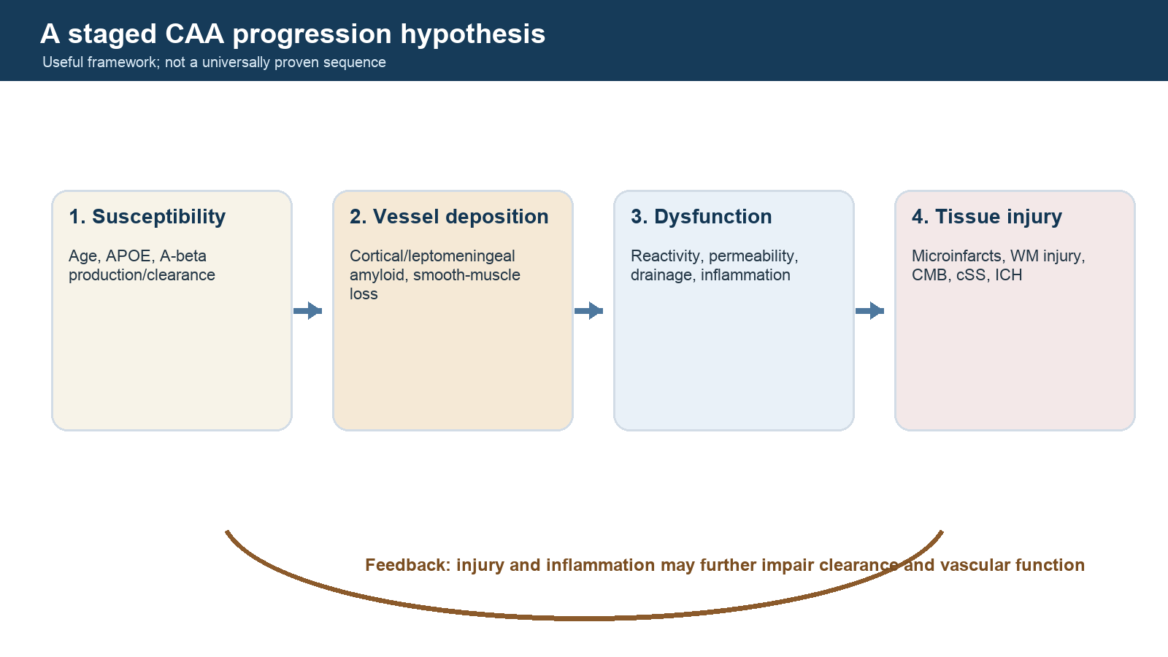
Figure 7. Four-stage CAA progression hypothesis with a feedback loop from tissue injury to clearance and vascular function.

Research Agenda: From Knowledge Gaps to Testable Projects Back to contents

1. The highest-value missing link
The field has strong descriptions at three levels - autopsy vessel pathology, MRI lesion burden, and late clinical outcomes - but far fewer datasets connecting all three with temporal and spatial precision. The highest-value program is therefore:
Longitudinal, multimodal, regionally registered human phenotyping with eventual pathology, designed to distinguish CAA, arteriolosclerosis, and mixed disease before late irreversible lesions dominate.

2. Ten priority research questions
- Which physiology or molecular markers identify prehemorrhagic CAA with adequate specificity against AD and B-ASC?
- Can B-ASC be divided into reproducible molecular/morphologic subtypes with different risk factors and outcomes?
- Does barrier leakage spatially and temporally precede specific WMH, microinfarcts, or microbleeds?
- Which PVS features reflect impaired clearance rather than atrophy or nonspecific aging?
- Can cortical-ribbon versus juxtacortical CMB localization reduce false-positive CAA classification?
- How do CAA and B-ASC interact when both are present: additive, synergistic, or regionally competitive?
- Which cSVD markers explain cognitive decline independently of AD, LATE-NC, and brain reserve?
- Are ARTS, PSMD, free water, and CVR responsive to intervention and predictive of meaningful benefit?
- Which immune programs produce safe vascular Aβ clearance versus ARIA/CAA-ri-like injury?
- How do biomarker performance and thresholds differ across ancestry, sex, age, scanner, and care setting?

3. Near-term projects using existing cohorts
Project A: lesion-location refinement for lobar microbleeds
Question: Does exact depth relative to the cortical ribbon distinguish CAA-linked from arteriolosclerosis-linked lobar CMBs?
Design: rate CMB centroid and distance to gray-white junction on high-resolution SWI/QSM; compare with Boston category, ARTS, deep SVD markers, and pathology where available.
Critical controls: veins/calcification, sequence parameters, cortical atrophy, lesion size, susceptibility blooming, mixed pathology.
Deliverable: open operational localization rule plus lesion-level and patient-level accuracy.
Project B: pathology-aware WMH phenotyping
Question: Which WMH morphology and microstructure distinguish CAA, B-ASC, and mixed disease?
Design: combine spatial WMH maps, multispot features, PSMD/free water, perfusion/CVR, ARTS, and neuropathology severity using nested cross-validation and held-out sites.
Avoid: training on Boston labels and then claiming pathology specificity without tissue validation.
Project C: B-ASC regional heterogeneity
Question: Is occipital white-matter arteriolosclerosis representative of frontal, temporal, hippocampal, basal-ganglia, and brainstem disease?
Design: multiregion morphometry and cell/matrix markers; estimate within-brain heterogeneity and the number of regions needed for stable classification.
Deliverable: sampling recommendation and uncertainty interval for a whole-brain B-ASC estimate.
Project D: mixed-pathology cognitive models
Question: How much longitudinal cognitive variance is uniquely and jointly explained by CAA, B-ASC, ADNC, LATE-NC, infarcts, and network integrity?
Design: hierarchical models with domain-specific slopes, age/time-to-death, education/reserve, scanner, and selection weights. Predefine interactions and avoid stepwise significance fishing.
Project E: ARTS transportability audit
Question: Does ARTS preserve calibration and prognostic value across age, ancestry, sex, vascular-risk burden, scanner vendor, field strength, and AD co-pathology?
Design: locked-container external validation with calibration plots, decision curves, subgroup uncertainty, failure audit, and comparisons against age/sex, WMH alone, and PSMD.

4. Medium-term prospective studies
A preclinical CAA observatory
Recruit hereditary CAA carriers and sporadic high-risk participants without symptomatic hemorrhage. Repeat:
- SWI/QSM and high-resolution structural MRI;
- DTI/free water/PSMD;
- CVR, perfusion, pulsatility, and permeability;
- amyloid/tau PET when justified;
- plasma and CSF Aβ species, inflammatory and vascular markers;
- sleep, blood pressure, gait, and sensitive cognition;
- retinal/OCTA markers.
The analysis should test a preregistered temporal graph based on the four-stage CAA framework. Record treatment and anti-amyloid exposure.
A living MRI-autopsy bridge
Enroll participants with consent for brain donation. Maintain acquisition consistency, obtain last-life MRI where feasible, scan intact fixed hemispheres, identify lesions ex vivo, sample them with 3D registration, and serially reconstruct culprit vessels. Include lesion-negative control regions and non-CAA controls.

5. Experimental studies that would translate
- Manipulate arterial pulsatility separately from mean pressure in models with human-like vascular amyloid.
- Test whether restoring smooth-muscle contractility improves Aβ clearance without increasing rupture.
- Perturb barrier pathways at defined CAA stages and measure both clearance and hemorrhage.
- Compare immune-cell states during successful Aβ removal versus destructive remodeling.
- Use human induced pluripotent stem cell vascular units with APOE and APP genotypes, while acknowledging the absence of aged 3D anatomy.
- Validate model findings in spatial human pathology before calling them therapeutic targets.

6. Measurement priorities
Harmonization
- minimum MRI sequences and metadata;
- STRIVE-compliant definitions;
- lesion-rating training sets with mimics;
- common neuropathology blocks and vessel-size definitions;
- shared stain and digital-pathology QC;
- prospective recording of missingness and image failure.
Continuous measures with interpretable anchors
Retain lesion counts, volumes, spatial maps, and quantitative tissue measures rather than only ordinal categories. Use categories for clinical interpretability, not as the only stored data.
Negative controls
- control brain regions not predicted by the mechanism;
- imaging markers with similar technical behavior but different biology;
- outcomes outside the proposed pathway;
- non-CAA amyloid and non-amyloid cSVD comparator groups.

7. Causal-inference discipline
Before a mediation or causal model, draw the proposed graph. Include:
- age and survival to imaging/autopsy;
- hypertension, diabetes, kidney disease, smoking, and medications;
- APOE/ancestry and socioeconomic exposures;
- ADNC, LATE-NC, Lewy body disease, and macrovascular disease;
- scanner/sequence and segmentation quality;
- clinical referral and brain-donation selection;
- time between imaging, symptoms, death, and tissue sampling.
Do not adjust automatically for downstream lesions or colliders. Report total and direct-effect estimands separately when appropriate.

8. Data and software architecture for the future repository
Public layer
- Markdown concept pages and evidence maps;
- citation metadata and lawful links;
- deidentified aggregate examples or openly licensed images;
- protocol checklists and tool records;
- versioned code and synthetic test data.
Restricted layer
- protected clinical data and identifiers;
- original copyrighted PDFs without redistribution rights;
- raw images and pathology slides under data-use agreements;
- crosswalks and linkage keys.
Never make the public website depend on access to the restricted layer. Generate public aggregate outputs through a documented release process.

9. Proposed website information architecture
The future site should have four linked entry routes: Foundations (anatomy, physiology, and STRIVE imaging markers); Diseases (CAA, arteriolosclerosis, and other cSVDs); Research reasoning (criteria, phenotypes, debates, hypotheses, methods, and tools); and an Evidence library (papers, claims, cohorts, datasets, and protocols).
Each hypothesis page should display supporting, constraining, and null evidence side by side. Each criterion page should show intended population, required inputs, reference standard, performance, exclusions, and common misuses.

10. Definition of success
This knowledge base succeeds if a reader can:
- explain why imaging phenotype and vessel pathology are different layers;
- apply and critique Boston/Edinburgh/STRIVE concepts correctly;
- state what ARTS measures and what remains unvalidated;
- describe competing clearance, barrier, inflammatory, and vascular-function hypotheses;
- identify mixed pathology and spectrum bias in a paper;
- turn a broad claim into a discriminating, spatially and temporally explicit study.
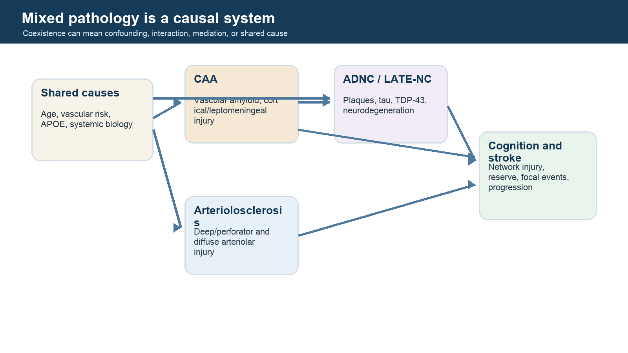
Figure 8. Causal diagram showing shared causes, CAA, arteriolosclerosis, ADNC/LATE-NC, and cognitive or stroke outcomes.

From Reading Archive to Research Program Back to contents

The archive should expose uncertainty, not merely summarize consensus
A useful research knowledge base must help the reader discover where apparently compatible statements actually depend on different populations, measurements, or causal models. Its unit of work is therefore the claim, not the paper.
For each claim, this release records the supported interpretation, what is not established, evidence that supports or challenges it, a provisional appraisal, and the observation most likely to change confidence. This prevents review papers from silently accumulating authority and prevents negative evidence from disappearing.

Highest-value unresolved problems
Antemortem identification of arteriolosclerosis
Arteriolosclerosis lacks a broadly accepted in vivo diagnostic framework comparable to Boston criteria. ARTS is an important pathology-linked beginning, but transportability, calibration, fairness, lesion-level interpretation, and treatment sensitivity remain open. A next-generation model should combine continuous lesion location, diffusion, vascular physiology, clinical exposures, and acquisition metadata, while keeping a locked external pathology cohort untouched until the analysis plan is frozen.
Specificity of lobar microbleeds
The field needs lesion-level rather than only person-level validation. Each candidate CMB should be localized relative to cortical ribbon, juxtacortical white matter, sulci, veins, and vessels, then matched to serial histopathology. The decisive result is not merely another association between “lobar CMB count” and CAA grade; it is a map of which lesion morphologies and compartments arise from which vessel lesions.
Prehemorrhagic CAA
Criteria work best when hemorrhagic markers are already present. Preclinical diagnosis will require a different target: vessel dysfunction or molecular change before blood products appear. Longitudinal vascular reactivity, permeability, perfusion, diffusion, PVS, PET, and fluid measures should be evaluated for temporal ordering, not just cross-sectional group differences.
Mixed pathology and cognition
CAA, arteriolosclerosis, ADNC, LATE-NC, atherosclerosis, infarcts, and neurodegeneration commonly coexist. Standard regression adjustment can fail when variables are measured with different error, lie on causal pathways, or interact. Research should report total, direct, mediated, and interactive effects where assumptions permit, accompanied by causal diagrams and sensitivity analyses rather than a single “independent association.”
Pathology as an imperfect reference
Autopsy is the best available etiologic reference but is not error-free. Disease is patchy, tissue sampling is incomplete, routine grades vary, and MRI may precede death by years. Whole-hemisphere ex vivo MRI, spatially registered blocks, digital vessel quantification, and consensus regional sampling can reduce—but not eliminate—reference error.

A decisive study design for candidate arteriolosclerosis criteria
- Define the target condition and severity scale before examining imaging associations.
- Use multiregion, blinded pathology with explicit CAA, ADNC, LATE-NC, infarct, and atherosclerosis measurement.
- Predefine the eligible MRI-to-death interval and model interval continuously.
- Require and record sequence availability, field strength, resolution, and susceptibility technique.
- Rate images blinded to pathology and pathology blinded to images.
- Develop features only in a training cohort.
- Freeze preprocessing, features, thresholds, and missing-data handling.
- Evaluate discrimination, calibration, clinical utility, and subgroup performance in a locked external cohort.
- Perform lesion-level spatial validation for the features claiming etiologic specificity.
- Publish the full protocol, data dictionary, failure cases, container version, and negative analyses.

Evidence milestones for the next release
- Complete full-text extraction for every essential source.
- Dual-review QUADAS-3 appraisal of Boston and Edinburgh validation studies.
- Dual-review PROBAST appraisal of ARTS development and validation reports.
- Create at least 100 result-level evidence edges, with effect estimates and uncertainty when reported.
- Add a contradiction ledger for every high-priority diagnostic and mechanistic claim.
- Add prospective search alerts and retraction/correction checks.
- Build the website only after the data schema survives the three pilot claim families: Boston transportability, lobar CMB specificity, and ARTS validation.

Final research habit
For every appealing hypothesis, write down the closest alternative explanation and the observation that would separate them. That habit—not the number of papers collected—is what turns the archive into a tool for connecting dots without inventing connections.
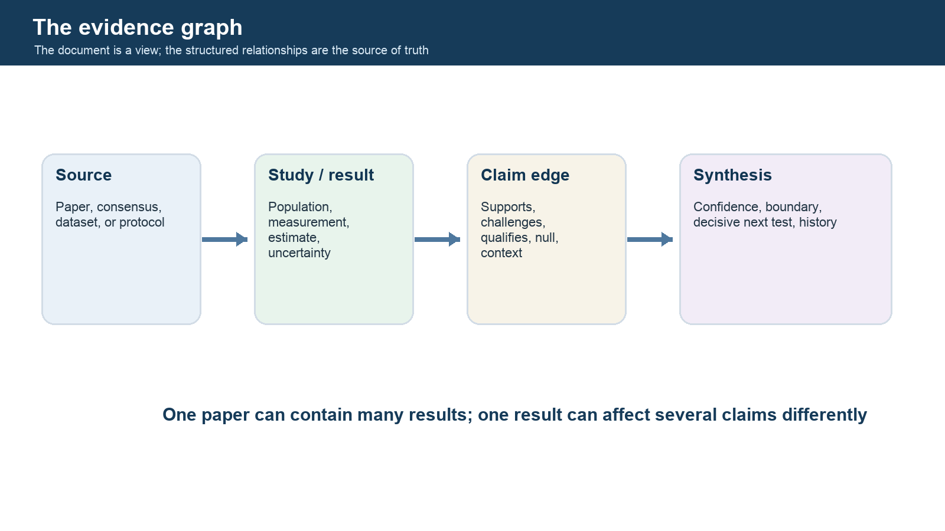
Figure 9. Evidence graph connecting sources to study results, claim relationships, and synthesis judgments.

Evidence Completeness Map Back to contents
The atlas is organized around answerable questions. A topic is not considered complete merely because it has a review paragraph.

Status vocabulary
- Bounded: a defensible answer exists within a clearly limited population or context.
- Emerging: coherent evidence exists, but important validation or causal tests remain.
- Critical gap: the question is central and current evidence cannot support a stable answer.

Portfolio snapshot
- Bounded: 6 questions
- Emerging: 14 questions
- Critical Gap: 20 questions

Domain map
Aria
- Q037 [critical gap]: Which baseline and dynamic markers predict symptomatic or severe ARIA?
Caa Diagnosis
- Q005 [bounded]: How accurately does Boston v2.0 identify CAA in symptomatic referral populations?
- Q006 [critical gap]: How accurately does Boston v2.0 perform in nonhemorrhagic cognitive presentations?
- Q007 [critical gap]: Can Boston v2.0 be used for community screening?
- Q008 [emerging]: Does cortical versus juxtacortical microbleed localization improve CAA specificity?
- Q010 [emerging]: Does severe centrum semiovale PVS add independent diagnostic information for CAA?
- Q011 [emerging]: Is the multispot WMH pattern independently informative for CAA?
- Q012 [bounded]: When do CT morphology and APOE genotype add value after lobar ICH?
Caa Prognosis
- Q009 [bounded]: How should cortical superficial siderosis extent and progression be used for prognosis?
Arteriolosclerosis Biomarker
- Q017 [critical gap]: Does ARTS externally predict pathology-confirmed arteriolosclerosis?
- Q018 [critical gap]: Does ARTS add clinically meaningful information beyond conventional measures?
Arteriolosclerosis Diagnosis
- Q013 [critical gap]: What ante-mortem MRI phenotype best predicts pathology-confirmed brain arteriolosclerosis?
- Q014 [critical gap]: How specific are deep microbleeds for nonamyloid arteriolosclerosis?
- Q015 [critical gap]: Which lacune locations and morphologies are most informative for arteriolosclerosis?
- Q016 [critical gap]: Can WMH spatial patterns distinguish arteriolosclerosis from CAA, AD, and mixed disease?
Cognition
- Q033 [critical gap]: How much cognitive decline is mediated by infarcts, white-matter injury, network disruption, and neurodegeneration?
Fluid Biomarkers
- Q025 [critical gap]: Can CSF or plasma distinguish CAA from AD and mixed amyloid disease?
Genetics
- Q034 [emerging]: Which findings from hereditary CAA transport to sporadic CAA?
- Q035 [bounded]: How does APOE modify CAA burden, hemorrhage, inflammation, and ARIA risk?
Inflammatory Caa
- Q036 [bounded]: How accurately do clinicoradiologic criteria identify CAA-ri among realistic mimics?
Measurement
- Q003 [bounded]: What minimum MRI protocol is required to phenotype hemorrhagic and nonhemorrhagic cSVD reproducibly?
- Q004 [emerging]: Which cSVD measures are repeatable enough for longitudinal or treatment-response use?
Mechanism
- Q020 [emerging]: Is impaired perivascular clearance an initiating cause, amplifier, or consequence of CAA?
- Q021 [emerging]: Does vascular physiological dysfunction precede irreversible tissue injury?
- Q022 [emerging]: Is BBB leakage an early driver of CAA and arteriolosclerosis or a downstream marker?
- Q023 [emerging]: Which inflammatory pathways are causal, protective, or secondary in CAA?
- Q024 [critical gap]: How do pulsatility, stiffness, autoregulation, and smooth-muscle loss interact in deep perforator injury?
Mixed Pathology
- Q030 [emerging]: How do vascular amyloid and AD neuropathologic change interact to produce cognition?
- Q031 [critical gap]: How do arteriolosclerosis and CAA jointly shape MRI phenotypes and outcomes?
- Q032 [emerging]: What links arteriolosclerosis to hippocampal sclerosis and LATE-related pathology?
Molecular Imaging
- Q026 [emerging]: Can regional amyloid PET distinguish vascular from parenchymal amyloid at the patient level?
Multimodal Diagnosis
- Q029 [critical gap]: Does multimodal integration improve etiologic inference beyond MRI alone?
Pathology
- Q001 [critical gap]: What vessel-wall features constitute brain arteriolosclerosis, and which should remain separate constructs?
- Q002 [critical gap]: How should regional arteriolosclerosis measurements be aggregated into a person-level burden?
- Q019 [critical gap]: How reproducible are visual and quantitative arteriolosclerosis ratings across regions and laboratories?
Prognosis
- Q039 [critical gap]: Which combination best predicts hemorrhage, cognitive decline, disability, and death?
Progression
- Q038 [critical gap]: What is the temporal sequence from vascular dysfunction to nonhemorrhagic and hemorrhagic injury?
Quantitative Mri
- Q027 [emerging]: Which diffusion metric best captures clinically meaningful SVD microstructural injury?
- Q028 [emerging]: Are PSMD and free-water measures responsive and interpretable enough for trials?
Trials
- Q040 [critical gap]: Which biomarkers are sufficiently reliable, causal, and responsive to serve as trial endpoints?
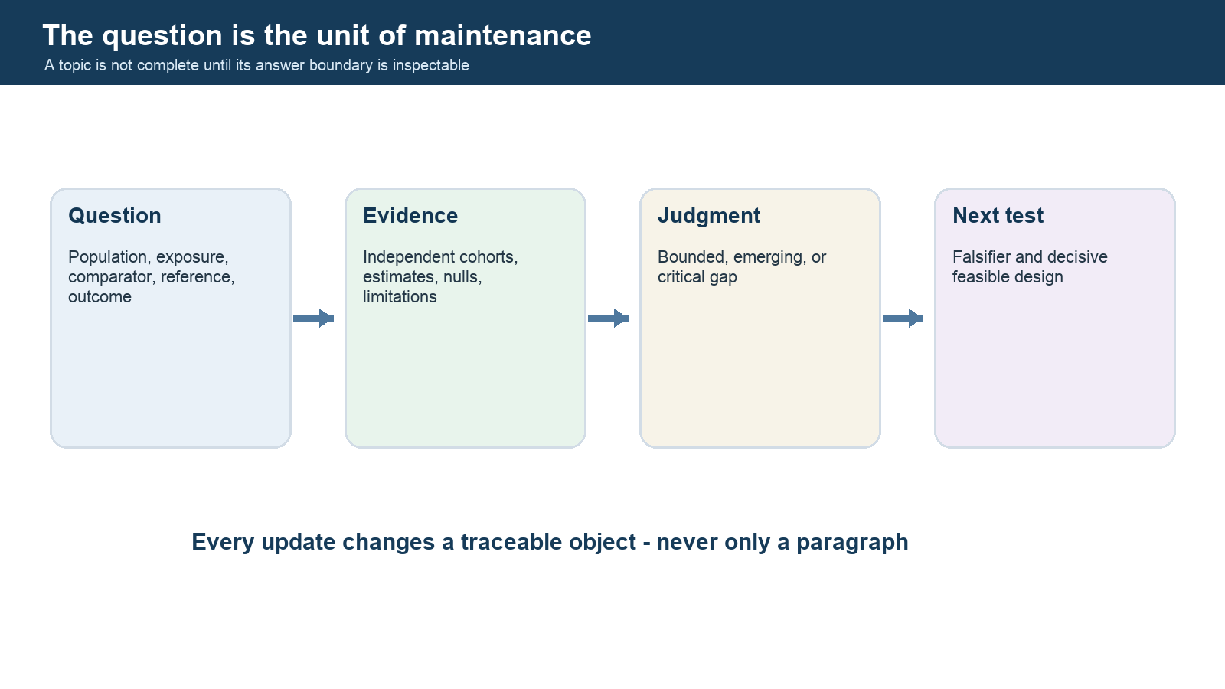
Figure 10. Four-stage research-question lifecycle from explicit review frame to decisive next test.

Contradiction and Falsification Atlas Back to contents
A useful hypothesis page contains the strongest case for the claim, the strongest challenge, alternative explanations, a falsifier, and a decisive experiment. Confidence is not a vote count.

H001 | Perivascular clearance failure is an initiating driver of sporadic CAA
For: Anatomical plausibility, vascular amyloid distribution, hereditary/experimental models, and spatial PVS-pathology associations
Against: Human flow direction and temporal onset are not directly established; clearance impairment may be secondary to vessel injury
Alternative: Production, vessel affinity, age-related matrix change, pulsatility, and BBB dysfunction
Falsifier: Normal direct clearance before and during early vascular amyloid accumulation despite sensitive measurement
Decisive experiment: Longitudinal compartment-specific human transport study beginning before imaging disease

H002 | Vascular physiological dysfunction precedes structural cSVD injury
For: Longitudinal CVR predicts later WMH/PVS progression; staged CAA frameworks place physiology before tissue injury
Against: Reverse causation and shared vascular risks remain possible; clinical outcomes were not predicted at one year in MSS3
Alternative: Existing microscopic tissue injury could impair measured reactivity
Falsifier: Repeated normal physiology immediately before incident lesions in adequately powered cohorts
Decisive experiment: Repeated physiology and structural imaging with cross-lagged and intervention analyses

H003 | BBB leakage is an early causal amplifier of CAA vessel injury
For: Leakage and inflammation increase with histologic vessel injury and fit ARIA/CAA-ri biology
Against: Human evidence is mainly cross-sectional and leakage can follow vessel damage
Alternative: Inflammation, ischemia, and amyloid toxicity independently generate permeability
Falsifier: No leakage before progression when measured serially with sensitive methods
Decisive experiment: Serial DCE-MRI/fluid markers with spatial pathology and treatment perturbation

H004 | A strictly lobar hemorrhagic pattern is sufficiently specific for CAA
For: Strong pathology-linked enrichment and established Boston criteria performance in symptomatic cohorts
Against: Nonamyloid arteriolosclerosis can produce some lobar/juxtacortical microbleeds; performance falls in other spectra
Alternative: Trauma, embolic lesions, vascular malformations, treatment effects, and mixed disease
Falsifier: High rate of non-CAA pathology among rigorously localized strictly lobar lesions
Decisive experiment: Lesion-matched MRI-histology plus external diagnostic validation

H005 | CSO-PVS are an in-vivo marker of regional cortical CAA burden
For: Spatial MRI-pathology association with overlying cortical amyloid and smooth-muscle loss
Against: PVS are common with aging and multiple SVD mechanisms; rating and causal interpretation vary
Alternative: Atrophy, altered interstitial fluid, venous factors, and other small-vessel pathology
Falsifier: No regional association in larger blinded pathology cohorts after confounding control
Decisive experiment: Multiregion MRI-autopsy mapping with reproducible automated PVS quantification

H006 | A deep/perforator MRI pattern can diagnose brain arteriolosclerosis
For: Biological plausibility and candidate associations of deep lesions, WMH, infarcts, diffusion, and vascular risks
Against: No accepted pathology-validated criteria; lesions are downstream, mixed, and sequence-dependent
Alternative: CAA, embolism, diabetes, aging, AD, inflammation, and other arteriopathies
Falsifier: Poor external calibration against standardized multiregion pathology
Decisive experiment: Large derivation plus independent locked MRI-autopsy validation

H007 | Arteriolosclerosis independently causes cognitive decline
For: Autopsy associations persist after adjustment in several aging cohorts
Against: Residual confounding, measurement error, mediation by infarcts/WMH, and cohort reuse
Alternative: ADNC, LATE, hippocampal sclerosis, frailty, and vascular risks
Falsifier: No association after robust measurement-error and causal-pathway modeling across independent cohorts
Decisive experiment: Replicated longitudinal autopsy mediation analysis with harmonized pathology

H008 | ARTS is a valid in-vivo biomarker of arteriolosclerosis
For: Pathology-linked development, reported AUC, translation to in-vivo MRI, and repeatability work
Against: Limited independent pathology validation, selected cohorts, and uncertain incremental utility
Alternative: ARTS may reflect general aging, WMH/diffusion injury, or vascular risk burden
Falsifier: Failure of locked calibration/discrimination in an independent MRI-autopsy cohort
Decisive experiment: Independent preregistered external pathology validation against strong baselines

H009 | CAA-ri and treatment-related ARIA lie on one inflammatory vascular-amyloid continuum
For: Overlapping ARIA-E/ARIA-H imaging, vascular amyloid, permeability, inflammation, and occasional clinicopathologic resemblance
Against: Distinct triggers, treatment exposure, natural history, ascertainment, and incomplete direct comparative data
Alternative: Shared downstream injury from different initiating mechanisms
Falsifier: Consistently nonoverlapping immune, imaging, and pathology signatures in direct comparisons
Decisive experiment: Harmonized prospective CAA-ri versus ARIA multi-omic/imaging/pathology study

H010 | Regional amyloid PET can distinguish CAA from AD
For: Meta-analysis finds lower global CAA uptake than AD and relatively higher occipital-to-global uptake
Against: Most reference diagnoses are clinical; AD co-pathology and tracer heterogeneity blur compartments
Alternative: Disease stage, tracer affinity, atrophy, and mixed parenchymal/vascular amyloid
Falsifier: No patient-level separation against compartment-specific autopsy pathology
Decisive experiment: Prospective multi-tracer PET-to-autopsy threshold validation

H011 | A fluid biomarker panel can distinguish CAA from AD and arteriolosclerosis
For: Disease-related amyloid, neuronal, inflammatory, endothelial, and pericyte signals are detectable
Against: Substantial construct overlap, assay heterogeneity, and little pathology-linked external validation
Alternative: Systemic vascular disease, renal function, age, AD, and nonspecific neurodegeneration
Falsifier: No incremental accuracy beyond clinical/MRI models in representative pathology cohorts
Decisive experiment: Locked multisite plasma/CSF panel tested against mixed autopsy pathology

H012 | Mixed CAA, arteriolosclerosis, and neurodegenerative pathology interact rather than merely add
For: Frequent co-occurrence, shared vascular/amyloid pathways, spatial vulnerability, and heterogeneous phenotypes
Against: Interaction estimates are underpowered, scale-dependent, and vulnerable to measurement error
Alternative: Independent additive effects plus age-related co-occurrence
Falsifier: Consistently additive models with good calibration across independent cohorts and scales
Decisive experiment: Large replicated multiregion pathology-imaging cohort with prespecified interaction scales
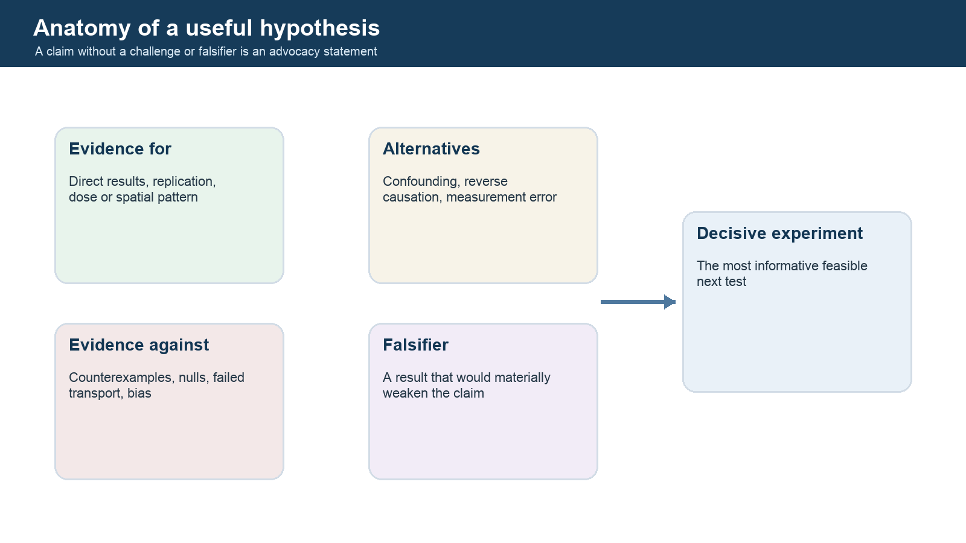
Figure 11. Five-part hypothesis framework including supporting evidence, challenges, alternatives, falsifier, and decisive experiment.

Cohort Lineage and Independence Back to contents
A new paper is not automatically an independent replication. Reused cohorts, nested autopsy subsets, and consortium analyses must be tracked before judging consistency.

COH001 | Boston v2.0 multicentre tissue cohort
Recruitment: Symptomatic referral patients with MRI and tissue
Known reuse: Derivation, temporal, geographic, and full-autopsy analyses within one publication
Bias relevance: Tissue verification and referral spectrum can inflate transportability
Independence note: Validation subsets are separated but arise from the same coordinated study program

COH002 | ROSMAP
Recruitment: Religious Orders Study and Rush Memory and Aging Project
Known reuse: Boston transportability, ARTS development, arteriolosclerosis, cognition, and mixed-pathology studies
Bias relevance: Volunteer, highly educated, older cohort; repeated reuse is not independent replication
Independence note: Publications may use overlapping participants and differently filtered subsets

COH003 | Mayo nonhemorrhagic MRI-autopsy cohort
Recruitment: Community/memory presentations without hemorrhage
Known reuse: Boston v2.0 nonhemorrhagic validation
Bias relevance: Small selected pathology subset and nonhemorrhagic spectrum
Independence note: Independent setting from Boston derivation but modest sample

COH004 | Mild Stroke Study 3
Recruitment: Edinburgh/Lothian minor ischemic stroke services
Known reuse: Cross-sectional and longitudinal CVR/SVD analyses
Bias relevance: Stroke enrichment limits generalization to community aging and specific vessel pathology
Independence note: Analyses using the same cohort should not be counted as independent replication

COH005 | MarkVCID multisite consortium
Recruitment: Older adults across participating US sites
Known reuse: PSMD, free water, CVR, clinical and fluid protocols
Bias relevance: Heterogeneous sites improve transportability but outcomes often remain associative
Independence note: Sites may be analyzed independently, but consortium-wide papers share infrastructure and some participants

COH006 | ADNI
Recruitment: Research volunteers across cognitive stages
Known reuse: ARTS translation and outcome association
Bias relevance: AD-focused selection and exclusions limit arteriolosclerosis generalization
Independence note: May be external to ROSMAP development but not representative clinical care

COH007 | Edinburgh lobar ICH pathology cohort
Recruitment: Adults with spontaneous lobar ICH
Known reuse: Edinburgh CT and genetic criteria
Bias relevance: Applies to lobar ICH, not cognitive or asymptomatic presentations
Independence note: Distinct context from MRI-based Boston criteria

COH008 | Specialist CAA-ri comparative cohort
Recruitment: CAA-ri and non-inflammatory CAA specialty care
Known reuse: CAA-ri spectrum characterization
Bias relevance: Referral enrichment and incorporation of imaging into diagnosis
Independence note: Useful comparative phenotype evidence; not population accuracy

COH009 | International postmortem CAA protocol network
Recruitment: Eleven neuropathology groups
Known reuse: Consensus protocol development, appraisal, and validation
Bias relevance: Consensus improves comparability but does not eliminate sampling error
Independence note: Method paper rather than participant-outcome cohort

COH010 | Hereditary CAA family cohorts
Recruitment: Mutation-defined families, including Dutch-type CAA
Known reuse: Natural history, risk factors, and mechanistic staging
Bias relevance: Founder effects, mutation specificity, younger age, and limited numbers
Independence note: Different mutations should not be pooled without biological justification
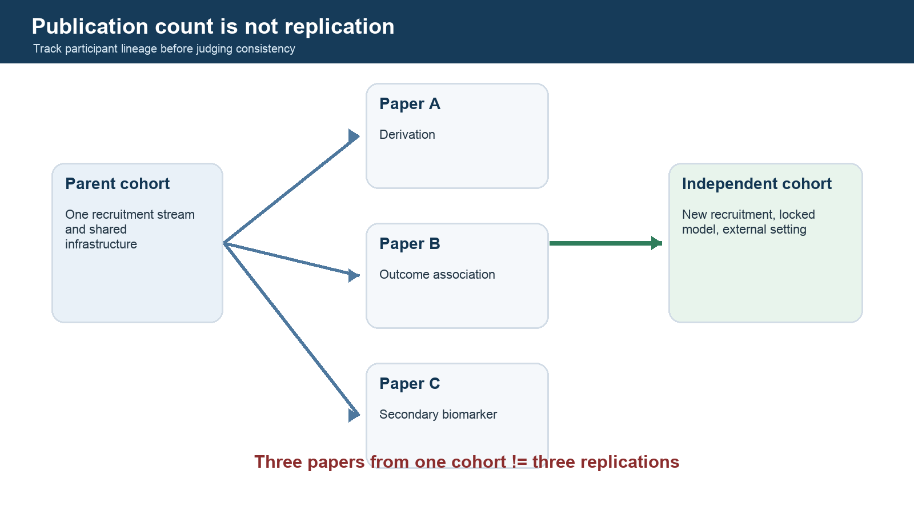
Figure 12. Cohort lineage diagram distinguishing repeated publications from independent external replication.

Diagnostic Evidence Profiles Back to contents
Every diagnostic criterion or biomarker is evaluated along a validation chain. Strength at one link does not substitute for another.

DP001 | Boston criteria v2.0
Context: Etiologic classification of sporadic CAA in defined age/presentation contexts
Technical: Depends on high-quality hemorrhagic and nonhemorrhagic MRI marker rating
Biological: Markers are associated with CAA but are not individually pathognomonic
Diagnostic: Strongest in symptomatic tissue-selected cohorts; lower in community and nonhemorrhagic validations
Prognostic: Criteria category is not itself a complete outcome-risk model
Incremental value: Adds nonhemorrhagic markers over earlier versions; context-dependent
Transportability: Limited outside populations resembling validation cohorts
Clinical utility: Useful diagnostic framework when applied within intended context
Failure mode: Spectrum effects, mixed pathology, inadequate MRI, and using criteria as universal screening
Next validation: Prospective presentation-specific external validation with full reference standard

DP002 | ARTS
Context: Research prediction of pathology-linked arteriolosclerosis risk
Technical: Promising repeatability evidence, including conference-level validation
Biological: Development linked MRI/demographic features to autopsy pathology
Diagnostic: Development AUC reported; independent external pathology accuracy not established
Prognostic: Associations with cognition and vascular outcomes reported
Incremental value: Not yet demonstrated against strong conventional baselines across independent cohorts
Transportability: Uncertain beyond ROSMAP/ADNI-related research settings
Clinical utility: Not established
Failure mode: Conflating reproducibility or outcome association with diagnostic validation
Next validation: Locked independent MRI-autopsy validation with calibration and decision analysis

DP003 | CVR MRI
Context: Physiological measurement of vascular reserve in SVD/VCID
Technical: Multisite protocol evidence exists; acquisition and gas delivery remain demanding
Biological: Measures vascular responsiveness and predicts some structural progression
Diagnostic: No pathology-specific CAA or arteriolosclerosis threshold
Prognostic: Associated with cognition and one-year WMH/PVS progression; not all clinical outcomes
Incremental value: Needs comparison with conventional MRI and vascular risks
Transportability: Promising across research sites; routine-care feasibility limited
Clinical utility: Research only
Failure mode: Treating a general vascular-function signal as an etiologic diagnosis
Next validation: Pathology-linked and intervention-responsive multisite qualification

DP004 | Regional amyloid PET
Context: Research differentiation of CAA, AD, and controls
Technical: Tracer and pipeline dependent
Biological: Detects fibrillar amyloid but vascular/parenchymal compartment assignment is indirect
Diagnostic: Group-level regional differences; no validated universal patient threshold
Prognostic: Insufficient for routine CAA prognosis
Incremental value: Unclear beyond MRI and AD biomarkers
Transportability: Limited by tracer, stage, and reference-standard heterogeneity
Clinical utility: Not standalone CAA diagnosis
Failure mode: Calling amyloid positivity vascular CAA in an older person with AD
Next validation: Multi-tracer PET-to-autopsy study with mixed-pathology modeling

DP005 | CAA-ri clinicoradiologic criteria
Context: Recognition of inflammatory CAA syndrome
Technical: Requires appropriate FLAIR, susceptibility, diffusion, and often contrast imaging
Biological: Phenotype reflects inflammatory/permeability injury around amyloid-laden vessels
Diagnostic: Validated in selected cohorts; mimic-rich external performance remains uncertain
Prognostic: Not a complete treatment-response or relapse model
Incremental value: Can reduce unnecessary biopsy when syndrome and imaging align
Transportability: Best in specialist contexts with alternative-diagnosis assessment
Clinical utility: Clinically useful with expert evaluation
Failure mode: Missing infection, neoplasm, PRES, vasculitis, or therapy-associated ARIA
Next validation: Prospective blinded accuracy study including realistic mimics

DP006 | Total SVD score
Context: Compact summary of MRI burden
Technical: Simple and reproducible when component ratings are reliable
Biological: Combines downstream injury markers from potentially different etiologies
Diagnostic: Not intended to diagnose a vessel pathology
Prognostic: Associated with clinical and network outcomes in several cohorts
Incremental value: May summarize burden efficiently but can discard spatial and continuous information
Transportability: Reasonable for burden comparisons with harmonized definitions
Clinical utility: Descriptive/prognostic research adjunct
Failure mode: Interpreting a burden score as CAA or arteriolosclerosis
Next validation: Outcome-specific comparison with continuous and spatial measures

DP007 | ARIA monitoring framework
Context: Safety monitoring during anti-amyloid therapy
Technical: Standardized serial MRI and communication are central
Biological: ARIA-E and ARIA-H reflect therapy-associated permeability/inflammatory and hemorrhagic injury
Diagnostic: Designed for treatment context, not spontaneous CAA diagnosis
Prognostic: Baseline markers inform risk; severe-event prediction remains limited
Incremental value: Provides operational safety value beyond unsystematic MRI review
Transportability: Therapy-, protocol-, and healthcare-system dependent
Clinical utility: High within current treatment pathways using drug-specific guidance
Failure mode: Confusing ARIA with infarct, PRES, spontaneous CAA-ri, or other mimics
Next validation: Large real-world registry with standardized MRI and adjudicated severe outcomes
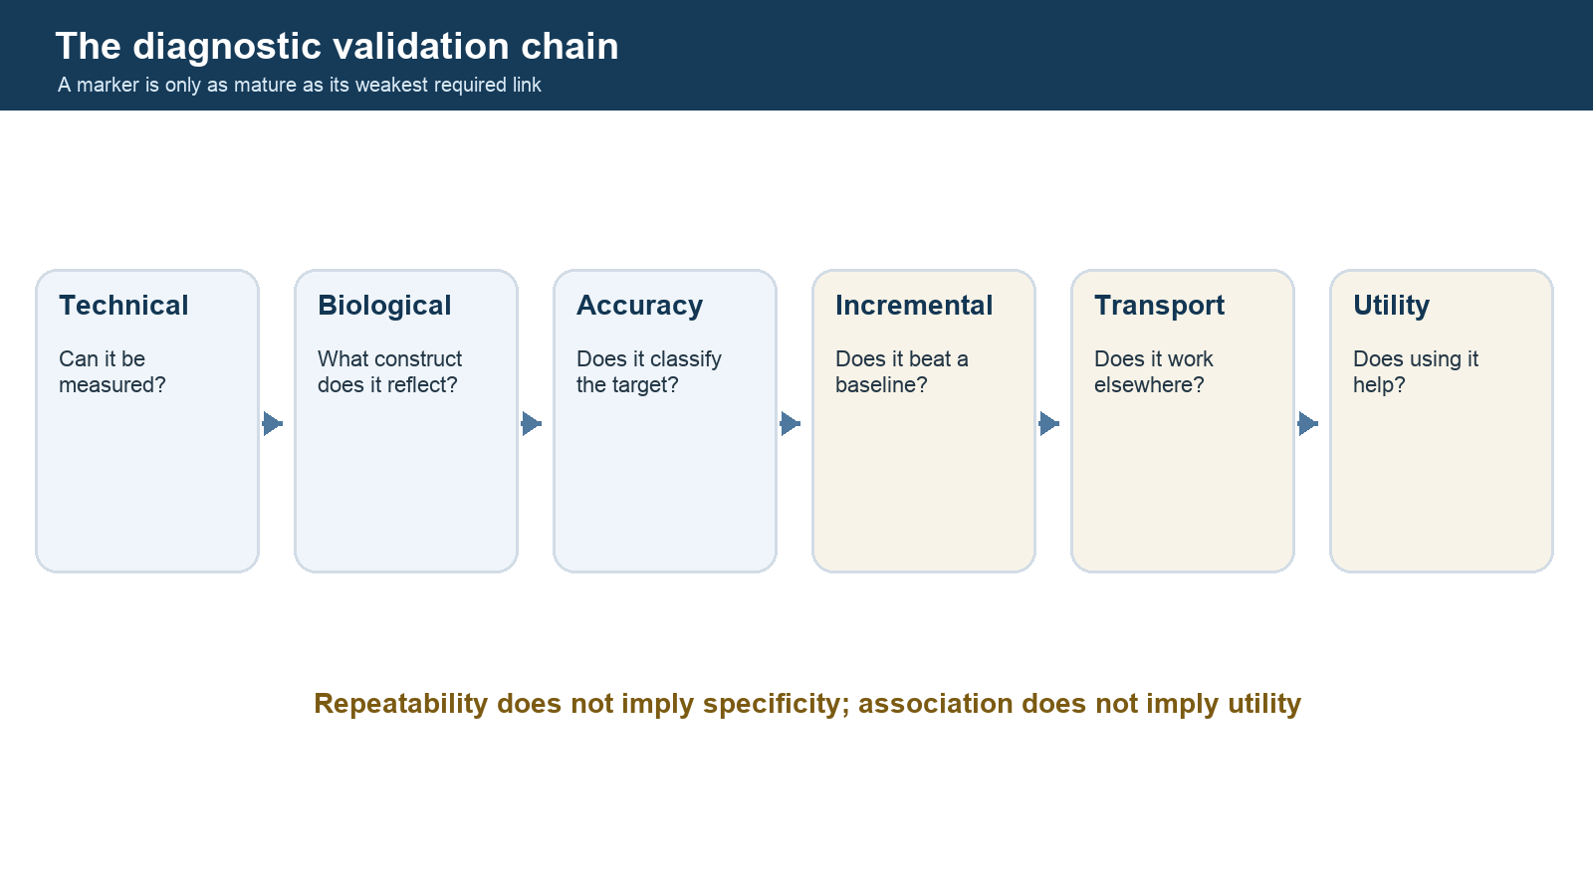
Figure 13. Six-link diagnostic validation chain from technical validity through clinical utility.

Worked Reasoning Cases Back to contents
These cases teach evidence-calibrated reasoning. They are educational examples, not patient-specific clinical advice.

UC001 | Lobar ICH with disseminated cSS
Scenario: An older adult presents with spontaneous lobar ICH, multiple strictly lobar microbleeds, and disseminated cSS.
Reasoning: The phenotype strongly increases CAA probability in the intended symptomatic context. Apply current criteria, confirm sequence adequacy, and separately estimate recurrence and treatment risk.
Do not conclude: Do not infer that every cognitive symptom is caused by CAA or that competing pathology is absent.

UC002 | Cognitive presentation without hemorrhage
Scenario: A memory-clinic patient has WMH, CSO-PVS, and no hemorrhagic marker.
Reasoning: Boston v2.0 transportability is weaker in this spectrum. Consider AD and mixed pathology, verify MRI quality, and treat any CAA inference as uncertain.
Do not conclude: Do not use criteria performance from lobar ICH cohorts as if it were screening performance.

UC003 | Mixed lobar and deep microbleeds
Scenario: MRI shows both lobar and deep microbleeds with extensive WMH.
Reasoning: Model mixed or competing pathologies. Fine-grained lesion location and cSS may help, but neither distribution alone supplies a pathology diagnosis.
Do not conclude: Do not force a binary CAA-versus-hypertensive label.

UC004 | High ARTS score
Scenario: A research participant has a high ARTS score and worsening cognition.
Reasoning: Separate model output, pathology prediction, technical repeatability, outcome association, and clinical utility. Inspect cohort similarity and calibration.
Do not conclude: Do not label the participant pathology-positive without validated context and reference evidence.

UC005 | Subacute encephalopathy with asymmetric FLAIR
Scenario: An older adult develops seizures and cognitive change with asymmetric parieto-occipital FLAIR hyperintensity and lobar microbleeds.
Reasoning: CAA-ri is important, but infection, neoplasm, PRES, vasculitis, and seizure-related change require assessment. Treatment exposure determines whether ARIA enters the differential.
Do not conclude: Do not equate an ARIA-E-like appearance with one etiology.

UC006 | Positive amyloid PET in suspected CAA
Scenario: An older patient with cognitive impairment has positive amyloid PET and a small lobar microbleed burden.
Reasoning: PET confirms fibrillar amyloid but not its vascular compartment. Integrate regional PET, tau/CSF, MRI pattern, and mixed-pathology probability.
Do not conclude: Do not call a positive scan diagnostic of CAA.

UC007 | Reduced CVR with WMH progression
Scenario: A research participant has low CVR and increasing WMH over one year.
Reasoning: This supports vascular dysfunction as a risk marker for tissue progression, while etiology and causal reversibility remain unresolved.
Do not conclude: Do not infer CAA or arteriolosclerosis specificity from CVR alone.

UC008 | Radiology-report candidate phenotype
Scenario: A report mentions WMH, chronic infarcts, and deep microbleeds without direct image review.
Reasoning: Use the report for candidate generation and triage. Confirm sequence availability, negation, image-level location, and pathology reference before model development.
Do not conclude: Do not turn report text into validated diagnostic criteria.

Living Update Workflow Back to contents

Update cycle
- Run and archive reproducible searches.
- Deduplicate by scholarly work, not local filename.
- Screen against explicit question-level criteria.
- Extract design, cohort lineage, reference standard, result, limitation, and status.
- Add supporting, qualifying, challenging, null, contextual, and methodological edges.
- Appraise bias and applicability independently when publication-grade use is intended.
- Reassess claims and hypotheses without automatically upgrading confidence.
- Regenerate the guide, website exports, validation reports, and changelog.

Priority queue
- U001 P0 | R052: Obtain and duplicate-extract full text for nonhemorrhagic Boston v2.0 validation Done when: Two extractions reconciled; QUADAS appraisal completed
- U002 P0 | Q013: Build comprehensive MRI-to-pathology arteriolosclerosis search Done when: Database searches, screening, and evidence table completed
- U003 P0 | Q001: Inventory neuropathology definitions, regions, stains, and aggregation rules Done when: Construct crosswalk and consensus candidates created
- U004 P0 | DP002: Locate independent ARTS pathology validation or confirm absence Done when: Search documented and profile updated
- U005 P1 | COH002: Map participant overlap across ROSMAP-derived publications Done when: Publication-to-subset lineage documented
- U006 P1 | Q008: Extract lesion-level cortical versus juxtacortical pathology evidence Done when: All located lesion-matched studies appraised
- U007 P1 | Q025: Build CAA-versus-AD fluid biomarker evidence table Done when: Assay, comparator, reference, and accuracy fields extracted
- U008 P1 | Q037: Add current therapy-specific ARIA risk and monitoring evidence Done when: Current workgroup plus drug-specific authoritative sources mapped
- U009 P1 | Q031: Extract mixed CAA-arteriolosclerosis imaging-pathology interactions Done when: At least two independent cohorts or explicit evidence gap recorded
- U010 P2 | all: Add second-reviewer fields and adjudication log Done when: Duplicate workflow piloted on all P0 studies
- U011 P2 | all: Add saved PubMed query export and deduplication workflow Done when: New citations can be imported without overwriting reviewed records
- U012 P2 | all: Prototype question, claim, cohort, and diagnostic-profile views from JSON Done when: No-PHI static prototype renders from generated exports
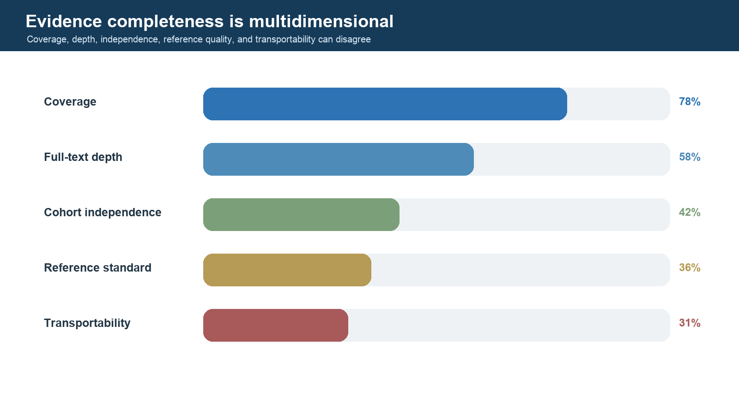
Figure 14. Illustrative completeness bars showing why source count alone does not establish evidence maturity.

Reading Path: From First Principles to Research Fluency Back to contents
This sequence uses the attached papers as anchors. Do not try to memorize every lesion on the first pass. Each pass has a different purpose.

Pass 1: build the map
Module 1 - imaging vocabulary
Read Duering et al. (STRIVE-2), focusing on the glossary, temporal evolution, mimics, and the reason for phenotype-first language. Keep STRIVE-1 available for the original definitions.
You should be able to: distinguish recent small subcortical infarct, lacune, WMH, PVS, CMB, cSS, cortical microinfarct, and atrophy without claiming etiology.
Module 2 - the two major vessel pathologies
Read Blevins et al. for brain arteriolosclerosis, then Greenberg 2026 or Charidimou 2017 for CAA.
You should be able to: draw the pial-to-penetrating vessel anatomy; explain B-ASC versus CAA histology and distribution; list overlapping downstream lesions.
Module 3 - criteria
Read Boston v2.0 and Edinburgh CT criteria. Recreate each algorithm from memory, then check the original table. Read the criteria-development methods, not only the final rules.
You should be able to: state intended population, reference standard, rule-in/rule-out goal, major exclusions, and spectrum limitations.

Pass 2: understand the mechanisms
Module 4 - disease progression
Read Koemans et al. alongside the 2026 Greenberg review.
Questions: What evidence orders amyloid deposition, physiology, non-hemorrhagic injury, and hemorrhage? Which evidence comes from hereditary rather than sporadic CAA?
Module 5 - clearance
Read van Veluw et al. 2024, then Perosa et al. 2022.
Questions: Which claims are IPAD-specific, glymphatic, or generic perivascular clearance? What does an enlarged PVS measure? What observations could result from reverse causation?
Module 6 - barrier, inflammation, and rupture
Read Kozberg et al. 2022, followed by van den Brink et al. 2024.
Questions: At what vessel grades do leakage, smooth-muscle loss, and inflammation appear? What can spatial postmortem staging establish, and what can it not establish about time?

Pass 3: study specificity and mixed pathology
Module 7 - false positives and lesion-level truth
Read Perosa et al. 2023.
Questions: How can probable CAA be false positive? Where were lesions located relative to the cortex? Why can patient-level criteria remain useful despite lesion-level etiologic overlap?
Module 8 - medial temporal lobe and co-pathology
Read the Perosa/Viswanathan medial-temporal review, Neltner/Nelson on multiregional arteriolosclerosis and hippocampal sclerosis, LATE-NC staging, and Rodríguez et al. on entorhinal vessel density.
Questions: Which associations are independent after adjustment? Which directions are plausible? How can selection into autopsy cohorts bias relationships?

Pass 4: measurement and translation
Module 9 - quantitative pathology
Read Perosa/Scherlek 2021.
Questions: How were expert labels generated? Was validation independent? What sources of stain/scanner/domain shift remain? Why retain marker-specific models?
Module 10 - in-vivo biomarkers
Read the ARTS development and MarkVCID validation papers; review the current kit protocol. Then compare ARTS with WMH volume, PSMD, free water, and CVR.
Questions: What is the exact context of use? What was the pathology reference? Does the biomarker add beyond age/sex and WMH? Has calibration been tested in your intended cohort?

Pass 5: become a critical synthesist
For every major hypothesis in docs/04_DEBATES_HYPOTHESES_OPEN_QUESTIONS.md, identify:
- one human tissue paper;
- one longitudinal human study;
- one experimental study;
- one null, conflicting, or specificity-limiting result;
- one experiment that would distinguish the leading explanations.
Write the result with templates/CLAIM_EVIDENCE_TEMPLATE.md. This turns reading into an evidence graph rather than a collection of summaries.

Suggested first 15 papers
- Duering et al. 2023 - STRIVE-2.
- Blevins et al. 2021 - brain arteriolosclerosis.
- Greenberg 2026 - current CAA overview.
- Charidimou et al. 2022 - Boston v2.0.
- Rodrigues et al. 2018 - Edinburgh CT/genetic criteria.
- Koemans et al. 2023 - CAA progression framework.
- van Veluw et al. 2024 - clearance debate.
- Perosa et al. 2022 - PVS-pathology spatial link.
- Kozberg et al. 2022 - BBB leakage/inflammation.
- van den Brink et al. 2024 - neuroinflammation synthesis.
- Perosa et al. 2023 - false-positive CAA microbleeds.
- Perosa/Scherlek et al. 2021 - quantitative digital pathology.
- Bangen et al./Arfanakis group - ARTS development.
- MarkVCID ARTS validation.
- Skrobot et al. 2016 - VCING.

Reading-note rule
Never write only "the authors found X." Record population, sample size, selection, exposure/marker, outcome/reference standard, timing, location, effect estimate with uncertainty, adjustment set, failure/missingness, and the narrowest justified conclusion.

Appendix A. Research Question and Completeness Atlas Back to contents
The question is the maintained unit. Each record states the current answer boundary, the missing piece, and the most decisive feasible design. Critical gap means important and unresolved - not unimportant.

Pathology
Q001 | What vessel-wall features constitute brain arteriolosclerosis, and which should remain separate constructs?
CRITICAL GAP | ESSENTIAL
Current answer: The label is heterogeneous and operational definitions vary.
Missing piece: Consensus construct ontology linked to reproducible quantitative measurements.
Decisive design: Multicentre digital-pathology calibration with shared slides and blinded raters
Frame: Population=Older adult human brain tissue; index/exposure=Hyalinosis, sclerosis, fibrosis, wall thickening, luminal narrowing, smooth-muscle loss; reference=Region- and vessel-level quantitative pathology; outcome=Construct validity and reproducibility
Q002 | How should regional arteriolosclerosis measurements be aggregated into a person-level burden?
CRITICAL GAP | ESSENTIAL
Current answer: No universally accepted aggregation rule exists.
Missing piece: Sampling theory for spatially heterogeneous disease.
Decisive design: Dense multiregion sampling with bootstrap stability and external outcome validation
Frame: Population=Autopsy cohorts with multiregion sampling; index/exposure=Regional vessel pathology; reference=Whole-brain sampling model; outcome=Person-level validity and prediction

Measurement
Q003 | What minimum MRI protocol is required to phenotype hemorrhagic and nonhemorrhagic cSVD reproducibly?
BOUNDED | HIGH
Current answer: Core structural and susceptibility-sensitive sequences are necessary, but protocol effects remain substantial.
Missing piece: Prospective sequence-ablation evidence across scanners.
Decisive design: Multivendor scan-rescan study with blinded sequence-ablation reading
Frame: Population=Adults undergoing cSVD research MRI; index/exposure=T1, T2, FLAIR, DWI, susceptibility, and optional quantitative sequences; reference=STRIVE-aligned acquisition and expert image review; outcome=Feature detectability, reliability, and missingness
Q004 | Which cSVD measures are repeatable enough for longitudinal or treatment-response use?
EMERGING | HIGH
Current answer: Some tools are repeatable, but repeatability does not imply biological or clinical validity.
Missing piece: Common change thresholds and error decomposition.
Decisive design: Multisite scan-rescan plus longitudinal progression study
Frame: Population=Stable and progressing cSVD cohorts; index/exposure=Visual ratings and quantitative biomarkers; reference=Prespecified repeatability and smallest-detectable-change standards; outcome=Reliability and sensitivity to change

Caa Diagnosis
Q005 | How accurately does Boston v2.0 identify CAA in symptomatic referral populations?
BOUNDED | ESSENTIAL
Current answer: Performance is strongest in populations resembling the derivation and symptomatic validation cohorts.
Missing piece: Independent prospective validation with uniform full reference standards.
Decisive design: Prospective multicentre blinded diagnostic cohort
Frame: Population=Age 50+ with ICH, TFNE, or cognitive presentation; index/exposure=Boston v2.0; reference=Neuropathology; outcome=Sensitivity, specificity, likelihood ratios, calibration
Q006 | How accurately does Boston v2.0 perform in nonhemorrhagic cognitive presentations?
CRITICAL GAP | ESSENTIAL
Current answer: Available validation suggests substantially weaker performance than in symptomatic hemorrhagic cohorts.
Missing piece: Larger representative pathology-linked cohorts.
Decisive design: Prospective memory-clinic-to-autopsy validation with competing AD pathology
Frame: Population=Memory-clinic or cognitive presentations without hemorrhage; index/exposure=Boston v2.0; reference=Autopsy or representative biopsy; outcome=Diagnostic accuracy and net benefit
Q007 | Can Boston v2.0 be used for community screening?
CRITICAL GAP | ESSENTIAL
Current answer: Community sensitivity is limited and predictive values depend strongly on prevalence.
Missing piece: Prospective population-based evaluation and consequences of false classification.
Decisive design: Population screening study with autopsy follow-up and decision analysis
Frame: Population=Community-dwelling older adults; index/exposure=Boston v2.0; reference=Autopsy; outcome=Accuracy, predictive value, downstream burden
Q008 | Does cortical versus juxtacortical microbleed localization improve CAA specificity?
EMERGING | ESSENTIAL
Current answer: Histopathology suggests some false-positive lobar lesions arise from nonamyloid arteriolosclerosis.
Missing piece: Automated reproducible localization and prospective pathology validation.
Decisive design: Lesion-matched MRI-histology study with competing arteriolosclerosis
Frame: Population=Older adults with lobar microbleeds; index/exposure=Fine-grained lesion-to-cortex localization; reference=Lesion-level histopathology; outcome=Incremental specificity and reproducibility

Caa Prognosis
Q009 | How should cortical superficial siderosis extent and progression be used for prognosis?
BOUNDED | HIGH
Current answer: cSS is associated with recurrence risk, but treatment decisions require absolute and context-specific risk.
Missing piece: Calibrated external models and treatment interaction evidence.
Decisive design: Prospective competing-risk cohort with prespecified cSS progression
Frame: Population=Probable or pathology-confirmed CAA; index/exposure=Focal/disseminated cSS and interval change; reference=Recurrent hemorrhage and functional outcomes; outcome=Absolute risk and incremental value

Caa Diagnosis
Q010 | Does severe centrum semiovale PVS add independent diagnostic information for CAA?
EMERGING | HIGH
Current answer: CSO-PVS contributes to Boston v2.0 and spatial pathology evidence supports biological relevance.
Missing piece: Large external pathology-linked incremental-value study.
Decisive design: Blinded MRI-autopsy cohort with model comparison
Frame: Population=Suspected CAA; index/exposure=CSO-PVS severity; reference=Neuropathology; outcome=Incremental discrimination and calibration
Q011 | Is the multispot WMH pattern independently informative for CAA?
EMERGING | HIGH
Current answer: It contributes to Boston v2.0, but independent validation remains limited.
Missing piece: Standardized definition, reliability, and external pathology validation.
Decisive design: Multicentre blinded imaging-pathology study
Frame: Population=Suspected CAA or mixed SVD; index/exposure=Multispot WMH rating; reference=Neuropathology; outcome=Reliability and incremental accuracy
Q012 | When do CT morphology and APOE genotype add value after lobar ICH?
BOUNDED | HIGH
Current answer: The model can support CAA inference when MRI is unavailable, within its intended ICH context.
Missing piece: External validation across ancestries and modern care pathways.
Decisive design: Prospective pragmatic diagnostic-impact study
Frame: Population=Spontaneous lobar ICH; index/exposure=Edinburgh CT plus APOE model; reference=Pathology; outcome=Accuracy, feasibility, and net benefit

Arteriolosclerosis Diagnosis
Q013 | What ante-mortem MRI phenotype best predicts pathology-confirmed brain arteriolosclerosis?
CRITICAL GAP | ESSENTIAL
Current answer: No accepted MRI diagnostic criteria exist; current features are candidate phenotypes.
Missing piece: Large representative MRI-autopsy derivation and locked external validation.
Decisive design: Two-cohort prospective or nested autopsy prediction study
Frame: Population=Older adults with MRI before death; index/exposure=Deep microbleeds, lacunes, WMH topography, diffusion, physiology, and demographics; reference=Standardized multiregion pathology; outcome=External discrimination, calibration, and net reclassification
Q014 | How specific are deep microbleeds for nonamyloid arteriolosclerosis?
CRITICAL GAP | ESSENTIAL
Current answer: Deep distribution is compatible with perforator disease but is not a direct pathology diagnosis.
Missing piece: Lesion-matched pathology with CAA and mixed-disease controls.
Decisive design: Multiregion lesion-to-vessel histology study
Frame: Population=Older adults with deep or mixed microbleeds; index/exposure=Deep lesion burden and microanatomic localization; reference=Lesion- and person-level pathology; outcome=Etiologic likelihood ratios
Q015 | Which lacune locations and morphologies are most informative for arteriolosclerosis?
CRITICAL GAP | HIGH
Current answer: Lacunes are heterogeneous downstream injuries and current descriptors are not pathology-specific.
Missing piece: Mechanism-adjudicated spatial pathology validation.
Decisive design: Prospective MRI plus autopsy or surgical histology study
Frame: Population=Adults with lacunes; index/exposure=Location, shape, cavity characteristics, and surrounding tissue; reference=Regional arteriolar pathology and infarct mechanism adjudication; outcome=Specificity and reliability
Q016 | Can WMH spatial patterns distinguish arteriolosclerosis from CAA, AD, and mixed disease?
CRITICAL GAP | ESSENTIAL
Current answer: WMH are sensitive to tissue injury but highly nonspecific.
Missing piece: External pathology-linked spatial model with sequence harmonization.
Decisive design: Multicohort MRI-autopsy radiomics study with locked thresholds
Frame: Population=Older adults with WMH; index/exposure=Periventricular/deep pattern, shape, texture, and longitudinal expansion; reference=Multiregion pathology with mixed-disease modeling; outcome=Incremental etiologic classification

Arteriolosclerosis Biomarker
Q017 | Does ARTS externally predict pathology-confirmed arteriolosclerosis?
CRITICAL GAP | ESSENTIAL
Current answer: ARTS has promising development evidence but lacks strong independent pathology validation.
Missing piece: External locked validation outside ROSMAP-related development data.
Decisive design: Independent preregistered MRI-autopsy validation
Frame: Population=Independent older-adult cohorts; index/exposure=ARTS score; reference=Standardized pathology; outcome=Discrimination, calibration, and decision utility
Q018 | Does ARTS add clinically meaningful information beyond conventional measures?
CRITICAL GAP | ESSENTIAL
Current answer: Associations and technical repeatability do not yet establish incremental clinical utility.
Missing piece: Head-to-head incremental-value and decision-curve analysis.
Decisive design: External cohort with locked model and prespecified utility thresholds
Frame: Population=Older adults with MRI; index/exposure=ARTS added to baseline model; reference=Pathology, cognition, vascular events; outcome=Incremental value and net benefit

Pathology
Q019 | How reproducible are visual and quantitative arteriolosclerosis ratings across regions and laboratories?
CRITICAL GAP | ESSENTIAL
Current answer: Quantitative methods are emerging, but a shared calibrated reference is absent.
Missing piece: Public reference slide set and round-robin study.
Decisive design: International blinded digital-pathology challenge
Frame: Population=Shared human tissue sections; index/exposure=Visual grades and digital morphometry; reference=Consensus reference and repeat reads; outcome=Interrater, interlab, and stain robustness

Mechanism
Q020 | Is impaired perivascular clearance an initiating cause, amplifier, or consequence of CAA?
EMERGING | HIGH
Current answer: Clearance impairment is coherent and spatially associated, but human direction and flux remain uncertain.
Missing piece: Direct human transport measurement before and during amyloid accumulation.
Decisive design: Longitudinal hereditary/sporadic multimodal transport study
Frame: Population=Preclinical, hereditary, and sporadic CAA; index/exposure=Direct or proxy clearance measures; reference=Longitudinal compartment-specific transport; outcome=Temporal and causal ordering
Q021 | Does vascular physiological dysfunction precede irreversible tissue injury?
EMERGING | HIGH
Current answer: CVR can precede WMH/PVS progression in SVD, but etiologic and causal specificity remain unresolved.
Missing piece: Repeated physiology and imaging with causal mediation and intervention.
Decisive design: Multisite longitudinal cohort with repeated measures
Frame: Population=Individuals across preclinical and clinical SVD stages; index/exposure=CVR, pulsatility, perfusion, and barrier measures; reference=Longitudinal lesion progression; outcome=Temporal precedence and mediation
Q022 | Is BBB leakage an early driver of CAA and arteriolosclerosis or a downstream marker?
EMERGING | HIGH
Current answer: Leakage co-localizes with vessel injury and inflammation, but temporal direction in humans is uncertain.
Missing piece: Prospective serial permeability imaging anchored to pathology or strong etiologic models.
Decisive design: Spatial longitudinal imaging-pathology study
Frame: Population=Human tissue and in-vivo SVD stages; index/exposure=DCE-MRI and molecular leakage markers; reference=Spatial pathology and longitudinal change; outcome=Timing and mediation
Q023 | Which inflammatory pathways are causal, protective, or secondary in CAA?
EMERGING | HIGH
Current answer: Inflammation participates in CAA-ri and ARIA; its role in non-inflammatory CAA is less defined.
Missing piece: Mechanistically targeted longitudinal human studies with treatment perturbation.
Decisive design: Parallel CAA/CAA-ri/ARIA immune-phenotyping study
Frame: Population=Sporadic CAA, CAA-ri, ARIA, and models; index/exposure=Immune cells, complement, cytokines, antibodies; reference=Intervention-sensitive mechanistic endpoints; outcome=Causal contribution and heterogeneity
Q024 | How do pulsatility, stiffness, autoregulation, and smooth-muscle loss interact in deep perforator injury?
CRITICAL GAP | HIGH
Current answer: A plausible network exists, but direct human causal chains are sparse.
Missing piece: Synchronized hemodynamics, high-resolution vessel imaging, and pathology.
Decisive design: Longitudinal multimodal deep-perforator study
Frame: Population=Aging and hypertensive SVD; index/exposure=Hemodynamic and vessel-wall measures; reference=Regional pathology and tissue injury; outcome=Mechanistic mediation

Fluid Biomarkers
Q025 | Can CSF or plasma distinguish CAA from AD and mixed amyloid disease?
CRITICAL GAP | ESSENTIAL
Current answer: No standalone marker currently has adequate specificity and validation.
Missing piece: Pathology-linked multisite head-to-head assay study.
Decisive design: Prospective blinded diagnostic study with locked assays
Frame: Population=CAA, AD, mixed pathology, and controls; index/exposure=Amyloid isoforms, p-tau, GFAP, NfL, vascular markers; reference=Autopsy or validated multimodal reference; outcome=Incremental patient-level accuracy

Molecular Imaging
Q026 | Can regional amyloid PET distinguish vascular from parenchymal amyloid at the patient level?
EMERGING | ESSENTIAL
Current answer: Group-level regional differences exist, but pathology-specific patient thresholds are not validated.
Missing piece: Prospective multi-tracer PET-to-autopsy validation.
Decisive design: Prespecified multicentre diagnostic study
Frame: Population=Suspected CAA, AD, and mixed disease; index/exposure=Regional tracer ratios and spatial models; reference=Autopsy compartment-specific amyloid; outcome=Threshold accuracy and transportability

Quantitative Mri
Q027 | Which diffusion metric best captures clinically meaningful SVD microstructural injury?
EMERGING | HIGH
Current answer: Several measures are reproducible and associated with cognition, but construct and etiologic specificity differ.
Missing piece: Head-to-head harmonized comparison with pathology and longitudinal outcomes.
Decisive design: MarkVCID-style multicentre benchmark
Frame: Population=cSVD and VCID cohorts; index/exposure=PSMD, free water, DTI, NODDI, and related metrics; reference=Reproducibility, cognition, progression, and pathology; outcome=Incremental validity and responsiveness
Q028 | Are PSMD and free-water measures responsive and interpretable enough for trials?
EMERGING | HIGH
Current answer: Technical and biological validation is advancing, but treatment responsiveness is not established.
Missing piece: Prospective trial-embedded repeatability and responsiveness study.
Decisive design: Multisite intervention study with prespecified change thresholds
Frame: Population=VCID and cSVD intervention cohorts; index/exposure=PSMD and white-matter free water; reference=Change reliability and meaningful outcome; outcome=Treatment sensitivity and minimal important change

Multimodal Diagnosis
Q029 | Does multimodal integration improve etiologic inference beyond MRI alone?
CRITICAL GAP | ESSENTIAL
Current answer: Multimodal integration is plausible but rarely tested against representative pathology.
Missing piece: Locked multimodal model with missing-data strategy and external validation.
Decisive design: Two-stage development/validation MRI-autopsy study
Frame: Population=Suspected CAA or arteriolosclerosis; index/exposure=MRI plus fluid, PET, genetics, physiology, and clinical data; reference=Pathology; outcome=Calibration, incremental value, transportability

Mixed Pathology
Q030 | How do vascular amyloid and AD neuropathologic change interact to produce cognition?
EMERGING | HIGH
Current answer: The pathologies often coexist; shared amyloid biology does not imply identical compartmental effects.
Missing piece: Large multiregion pathology cohort with preregistered interaction and mediation models.
Decisive design: Longitudinal autopsy cohort with independent replication
Frame: Population=Older adults with autopsy and longitudinal cognition; index/exposure=CAA and ADNC jointly; reference=Standardized pathology and cognitive trajectories; outcome=Additive versus interactive effects
Q031 | How do arteriolosclerosis and CAA jointly shape MRI phenotypes and outcomes?
CRITICAL GAP | ESSENTIAL
Current answer: Mixed pathology is common, but many diagnostic studies simplify it as exclusion or noise.
Missing piece: Factorial pathology-linked imaging analysis with sufficient dual-pathology cases.
Decisive design: Multicohort MRI-autopsy interaction study
Frame: Population=Older adults with both pathologies represented; index/exposure=Joint pathology burden and spatial distribution; reference=Multiregion pathology; outcome=Interaction, mediation, and classification error
Q032 | What links arteriolosclerosis to hippocampal sclerosis and LATE-related pathology?
EMERGING | HIGH
Current answer: Associations exist, but shared age, vascular injury, and selective vulnerability remain competing explanations.
Missing piece: Longitudinal and spatial mediation with replication.
Decisive design: Independent multiregion autopsy cohorts
Frame: Population=Oldest-old autopsy cohorts; index/exposure=Regional arteriolosclerosis burden; reference=Hippocampal sclerosis and TDP-43 staging; outcome=Independent association and mechanism

Cognition
Q033 | How much cognitive decline is mediated by infarcts, white-matter injury, network disruption, and neurodegeneration?
CRITICAL GAP | HIGH
Current answer: Multiple pathways likely operate simultaneously; simple adjusted regressions may obscure them.
Missing piece: Temporal causal models with measurement-error correction and sensitivity analysis.
Decisive design: Harmonized longitudinal multimodal autopsy cohort
Frame: Population=Longitudinal aging cohorts; index/exposure=Pathology and intermediate imaging/network measures; reference=Repeated cognition and autopsy; outcome=Path-specific mediated effects

Genetics
Q034 | Which findings from hereditary CAA transport to sporadic CAA?
EMERGING | HIGH
Current answer: Hereditary CAA is mechanistically informative but differs in age, mutation, penetrance, and co-pathology.
Missing piece: Direct parallel phenotyping with formal transport analysis.
Decisive design: Matched hereditary-sporadic longitudinal study
Frame: Population=Hereditary and sporadic CAA cohorts; index/exposure=Shared imaging, fluid, physiology, and pathology measures; reference=Harmonized longitudinal phenotypes; outcome=Transportability and temporal sequence
Q035 | How does APOE modify CAA burden, hemorrhage, inflammation, and ARIA risk?
BOUNDED | HIGH
Current answer: APOE contributes meaningful risk information in some contexts but is neither necessary nor sufficient.
Missing piece: Ancestry-diverse calibrated models with treatment interactions.
Decisive design: Large prospective real-world registry linked to standardized MRI
Frame: Population=Sporadic CAA and anti-amyloid-treated populations; index/exposure=APOE genotype; reference=Pathology and adjudicated outcomes; outcome=Incremental and interaction effects

Inflammatory Caa
Q036 | How accurately do clinicoradiologic criteria identify CAA-ri among realistic mimics?
BOUNDED | ESSENTIAL
Current answer: Criteria perform well in selected cohorts, but mimic-rich external accuracy is incompletely defined.
Missing piece: Prospective blinded study with infection, neoplasm, PRES, and vasculitis controls.
Decisive design: Multicentre diagnostic cohort
Frame: Population=Adults with subacute encephalopathy, seizures, or asymmetric FLAIR lesions; index/exposure=CAA-ri criteria; reference=Biopsy or adjudicated longitudinal diagnosis; outcome=Accuracy and biopsy avoidance

Aria
Q037 | Which baseline and dynamic markers predict symptomatic or severe ARIA?
CRITICAL GAP | ESSENTIAL
Current answer: Known risk factors guide monitoring, but severe-event prediction remains limited.
Missing piece: Large prospective real-world treatment registry with harmonized serial MRI.
Decisive design: Registry-based external model development and validation
Frame: Population=Anti-amyloid-treated patients; index/exposure=Baseline CMB/cSS, APOE, dose, emerging imaging/fluid markers; reference=Adjudicated ARIA severity and outcomes; outcome=Absolute risk and dynamic prediction

Progression
Q038 | What is the temporal sequence from vascular dysfunction to nonhemorrhagic and hemorrhagic injury?
CRITICAL GAP | ESSENTIAL
Current answer: A staged framework is plausible, but individual-level transition evidence remains incomplete.
Missing piece: Dense longitudinal multimodal sampling beginning before symptoms.
Decisive design: Hereditary-plus-sporadic natural-history platform
Frame: Population=Preclinical through symptomatic CAA and arteriolosclerosis; index/exposure=Repeated physiology, barrier, diffusion, lesion, and amyloid measures; reference=Longitudinal transitions and pathology; outcome=Ordering and transition rates

Prognosis
Q039 | Which combination best predicts hemorrhage, cognitive decline, disability, and death?
CRITICAL GAP | ESSENTIAL
Current answer: Several markers are prognostic, but unified externally calibrated models are uncommon.
Missing piece: Outcome-specific external validation and decision analysis.
Decisive design: International prospective registry with locked models
Frame: Population=Phenotyped CAA and cSVD cohorts; index/exposure=Imaging, fluid, genetic, physiological, and clinical markers; reference=Prospective adjudicated outcomes; outcome=Calibration, competing risks, and net benefit

Trials
Q040 | Which biomarkers are sufficiently reliable, causal, and responsive to serve as trial endpoints?
CRITICAL GAP | ESSENTIAL
Current answer: No arteriolosclerosis biomarker and few CAA biomarkers meet the full chain from repeatability to clinical surrogacy.
Missing piece: Trial-embedded qualification with prespecified causal and clinical validation.
Decisive design: Multistage biomarker-qualification program
Frame: Population=Intervention-ready CAA and arteriolosclerosis cohorts; index/exposure=Imaging, physiological, fluid, and digital-pathology biomarkers; reference=Treatment-induced change linked to patient benefit; outcome=Responsiveness and surrogacy

Appendix B. Contradiction and Falsification Atlas Back to contents
A useful hypothesis survives contact with its best counterevidence. These records prevent narrative enthusiasm from replacing a testable scientific claim.
H001 | Perivascular clearance failure is an initiating driver of sporadic CAA
Lens | Current record
Confidence | Moderate
Strongest evidence for | Anatomical plausibility, vascular amyloid distribution, hereditary/experimental models, and spatial PVS-pathology associations
Strongest evidence against | Human flow direction and temporal onset are not directly established; clearance impairment may be secondary to vessel injury
Alternative explanations | Production, vessel affinity, age-related matrix change, pulsatility, and BBB dysfunction
Falsifier | Normal direct clearance before and during early vascular amyloid accumulation despite sensitive measurement
Decisive experiment | Longitudinal compartment-specific human transport study beginning before imaging disease
H002 | Vascular physiological dysfunction precedes structural cSVD injury
Lens | Current record
Confidence | Moderate
Strongest evidence for | Longitudinal CVR predicts later WMH/PVS progression; staged CAA frameworks place physiology before tissue injury
Strongest evidence against | Reverse causation and shared vascular risks remain possible; clinical outcomes were not predicted at one year in MSS3
Alternative explanations | Existing microscopic tissue injury could impair measured reactivity
Falsifier | Repeated normal physiology immediately before incident lesions in adequately powered cohorts
Decisive experiment | Repeated physiology and structural imaging with cross-lagged and intervention analyses
H003 | BBB leakage is an early causal amplifier of CAA vessel injury
Lens | Current record
Confidence | Moderate
Strongest evidence for | Leakage and inflammation increase with histologic vessel injury and fit ARIA/CAA-ri biology
Strongest evidence against | Human evidence is mainly cross-sectional and leakage can follow vessel damage
Alternative explanations | Inflammation, ischemia, and amyloid toxicity independently generate permeability
Falsifier | No leakage before progression when measured serially with sensitive methods
Decisive experiment | Serial DCE-MRI/fluid markers with spatial pathology and treatment perturbation
H004 | A strictly lobar hemorrhagic pattern is sufficiently specific for CAA
Lens | Current record
Confidence | Moderate
Strongest evidence for | Strong pathology-linked enrichment and established Boston criteria performance in symptomatic cohorts
Strongest evidence against | Nonamyloid arteriolosclerosis can produce some lobar/juxtacortical microbleeds; performance falls in other spectra
Alternative explanations | Trauma, embolic lesions, vascular malformations, treatment effects, and mixed disease
Falsifier | High rate of non-CAA pathology among rigorously localized strictly lobar lesions
Decisive experiment | Lesion-matched MRI-histology plus external diagnostic validation
H005 | CSO-PVS are an in-vivo marker of regional cortical CAA burden
Lens | Current record
Confidence | Moderate
Strongest evidence for | Spatial MRI-pathology association with overlying cortical amyloid and smooth-muscle loss
Strongest evidence against | PVS are common with aging and multiple SVD mechanisms; rating and causal interpretation vary
Alternative explanations | Atrophy, altered interstitial fluid, venous factors, and other small-vessel pathology
Falsifier | No regional association in larger blinded pathology cohorts after confounding control
Decisive experiment | Multiregion MRI-autopsy mapping with reproducible automated PVS quantification
H006 | A deep/perforator MRI pattern can diagnose brain arteriolosclerosis
Lens | Current record
Confidence | Low
Strongest evidence for | Biological plausibility and candidate associations of deep lesions, WMH, infarcts, diffusion, and vascular risks
Strongest evidence against | No accepted pathology-validated criteria; lesions are downstream, mixed, and sequence-dependent
Alternative explanations | CAA, embolism, diabetes, aging, AD, inflammation, and other arteriopathies
Falsifier | Poor external calibration against standardized multiregion pathology
Decisive experiment | Large derivation plus independent locked MRI-autopsy validation
H007 | Arteriolosclerosis independently causes cognitive decline
Lens | Current record
Confidence | Moderate
Strongest evidence for | Autopsy associations persist after adjustment in several aging cohorts
Strongest evidence against | Residual confounding, measurement error, mediation by infarcts/WMH, and cohort reuse
Alternative explanations | ADNC, LATE, hippocampal sclerosis, frailty, and vascular risks
Falsifier | No association after robust measurement-error and causal-pathway modeling across independent cohorts
Decisive experiment | Replicated longitudinal autopsy mediation analysis with harmonized pathology
H008 | ARTS is a valid in-vivo biomarker of arteriolosclerosis
Lens | Current record
Confidence | Low
Strongest evidence for | Pathology-linked development, reported AUC, translation to in-vivo MRI, and repeatability work
Strongest evidence against | Limited independent pathology validation, selected cohorts, and uncertain incremental utility
Alternative explanations | ARTS may reflect general aging, WMH/diffusion injury, or vascular risk burden
Falsifier | Failure of locked calibration/discrimination in an independent MRI-autopsy cohort
Decisive experiment | Independent preregistered external pathology validation against strong baselines
H009 | CAA-ri and treatment-related ARIA lie on one inflammatory vascular-amyloid continuum
Lens | Current record
Confidence | Moderate
Strongest evidence for | Overlapping ARIA-E/ARIA-H imaging, vascular amyloid, permeability, inflammation, and occasional clinicopathologic resemblance
Strongest evidence against | Distinct triggers, treatment exposure, natural history, ascertainment, and incomplete direct comparative data
Alternative explanations | Shared downstream injury from different initiating mechanisms
Falsifier | Consistently nonoverlapping immune, imaging, and pathology signatures in direct comparisons
Decisive experiment | Harmonized prospective CAA-ri versus ARIA multi-omic/imaging/pathology study
H010 | Regional amyloid PET can distinguish CAA from AD
Lens | Current record
Confidence | Low
Strongest evidence for | Meta-analysis finds lower global CAA uptake than AD and relatively higher occipital-to-global uptake
Strongest evidence against | Most reference diagnoses are clinical; AD co-pathology and tracer heterogeneity blur compartments
Alternative explanations | Disease stage, tracer affinity, atrophy, and mixed parenchymal/vascular amyloid
Falsifier | No patient-level separation against compartment-specific autopsy pathology
Decisive experiment | Prospective multi-tracer PET-to-autopsy threshold validation
H011 | A fluid biomarker panel can distinguish CAA from AD and arteriolosclerosis
Lens | Current record
Confidence | Low
Strongest evidence for | Disease-related amyloid, neuronal, inflammatory, endothelial, and pericyte signals are detectable
Strongest evidence against | Substantial construct overlap, assay heterogeneity, and little pathology-linked external validation
Alternative explanations | Systemic vascular disease, renal function, age, AD, and nonspecific neurodegeneration
Falsifier | No incremental accuracy beyond clinical/MRI models in representative pathology cohorts
Decisive experiment | Locked multisite plasma/CSF panel tested against mixed autopsy pathology
H012 | Mixed CAA, arteriolosclerosis, and neurodegenerative pathology interact rather than merely add
Lens | Current record
Confidence | Low
Strongest evidence for | Frequent co-occurrence, shared vascular/amyloid pathways, spatial vulnerability, and heterogeneous phenotypes
Strongest evidence against | Interaction estimates are underpowered, scale-dependent, and vulnerable to measurement error
Alternative explanations | Independent additive effects plus age-related co-occurrence
Falsifier | Consistently additive models with good calibration across independent cohorts and scales
Decisive experiment | Large replicated multiregion pathology-imaging cohort with prespecified interaction scales

Appendix C. Cohort Lineage and Independence Back to contents
Multiple publications from one recruitment stream do not constitute independent replication. Use this atlas before counting consistency across papers.
COH001 | Boston v2.0 multicentre tissue cohort
Recruitment: Symptomatic referral patients with MRI and tissue
Pathology: Biopsy, hematoma evacuation, or autopsy; full-autopsy subset
Known reuse: Derivation, temporal, geographic, and full-autopsy analyses within one publication
Bias relevance: Tissue verification and referral spectrum can inflate transportability
Independence: Validation subsets are separated but arise from the same coordinated study program
Mapped studies: S001 (derivation and internal/temporal/geographic validation)
COH002 | ROSMAP
Recruitment: Religious Orders Study and Rush Memory and Aging Project
Pathology: Extensive autopsy program
Known reuse: Boston transportability, ARTS development, arteriolosclerosis, cognition, and mixed-pathology studies
Bias relevance: Volunteer, highly educated, older cohort; repeated reuse is not independent replication
Independence: Publications may use overlapping participants and differently filtered subsets
Mapped studies: S006 (ARTS pathology-linked development); S008 (outcome association); S009 (autopsy association); S012 (community Boston validation)
COH003 | Mayo nonhemorrhagic MRI-autopsy cohort
Recruitment: Community/memory presentations without hemorrhage
Pathology: Autopsy
Known reuse: Boston v2.0 nonhemorrhagic validation
Bias relevance: Small selected pathology subset and nonhemorrhagic spectrum
Independence: Independent setting from Boston derivation but modest sample
Mapped studies: S013 (nonhemorrhagic Boston validation)
COH004 | Mild Stroke Study 3
Recruitment: Edinburgh/Lothian minor ischemic stroke services
Pathology: None as primary reference
Known reuse: Cross-sectional and longitudinal CVR/SVD analyses
Bias relevance: Stroke enrichment limits generalization to community aging and specific vessel pathology
Independence: Analyses using the same cohort should not be counted as independent replication
Mapped studies: S018 (longitudinal CVR prediction)
COH005 | MarkVCID multisite consortium
Recruitment: Older adults across participating US sites
Pathology: Variable; not the reference for most instrumental studies
Known reuse: PSMD, free water, CVR, clinical and fluid protocols
Bias relevance: Heterogeneous sites improve transportability but outcomes often remain associative
Independence: Sites may be analyzed independently, but consortium-wide papers share infrastructure and some participants
Mapped studies: S017 (multisite CVR validation)
COH006 | ADNI
Recruitment: Research volunteers across cognitive stages
Pathology: Limited autopsy subset
Known reuse: ARTS translation and outcome association
Bias relevance: AD-focused selection and exclusions limit arteriolosclerosis generalization
Independence: May be external to ROSMAP development but not representative clinical care
Mapped studies: S008 (outcome association/transport)
COH007 | Edinburgh lobar ICH pathology cohort
Recruitment: Adults with spontaneous lobar ICH
Pathology: Neuropathology in enrolled diagnostic sample
Known reuse: Edinburgh CT and genetic criteria
Bias relevance: Applies to lobar ICH, not cognitive or asymptomatic presentations
Independence: Distinct context from MRI-based Boston criteria
Mapped studies: S002 (CT/genetic criterion development)
COH008 | Specialist CAA-ri comparative cohort
Recruitment: CAA-ri and non-inflammatory CAA specialty care
Pathology: Subset
Known reuse: CAA-ri spectrum characterization
Bias relevance: Referral enrichment and incorporation of imaging into diagnosis
Independence: Useful comparative phenotype evidence; not population accuracy
Mapped studies: S021 (CAA-ri comparative phenotype)
COH009 | International postmortem CAA protocol network
Recruitment: Eleven neuropathology groups
Pathology: Postmortem tissue is the target
Known reuse: Consensus protocol development, appraisal, and validation
Bias relevance: Consensus improves comparability but does not eliminate sampling error
Independence: Method paper rather than participant-outcome cohort
COH010 | Hereditary CAA family cohorts
Recruitment: Mutation-defined families, including Dutch-type CAA
Pathology: Variable
Known reuse: Natural history, risk factors, and mechanistic staging
Bias relevance: Founder effects, mutation specificity, younger age, and limited numbers
Independence: Different mutations should not be pooled without biological justification

Appendix D. Diagnostic Evidence Profiles Back to contents
The validation links are separate. Technical repeatability cannot substitute for biological specificity; diagnostic accuracy cannot substitute for utility.
DP001 | Boston criteria v2.0
Validation link | Judgment
Context | Etiologic classification of sporadic CAA in defined age/presentation contexts
Technical validity | Depends on high-quality hemorrhagic and nonhemorrhagic MRI marker rating
Biological validity | Markers are associated with CAA but are not individually pathognomonic
Diagnostic accuracy | Strongest in symptomatic tissue-selected cohorts; lower in community and nonhemorrhagic validations
Prognostic validity | Criteria category is not itself a complete outcome-risk model
Incremental value | Adds nonhemorrhagic markers over earlier versions; context-dependent
Transportability | Limited outside populations resembling validation cohorts
Clinical utility | Useful diagnostic framework when applied within intended context
Failure mode | Spectrum effects, mixed pathology, inadequate MRI, and using criteria as universal screening
Next validation | Prospective presentation-specific external validation with full reference standard
DP002 | ARTS
Validation link | Judgment
Context | Research prediction of pathology-linked arteriolosclerosis risk
Technical validity | Promising repeatability evidence, including conference-level validation
Biological validity | Development linked MRI/demographic features to autopsy pathology
Diagnostic accuracy | Development AUC reported; independent external pathology accuracy not established
Prognostic validity | Associations with cognition and vascular outcomes reported
Incremental value | Not yet demonstrated against strong conventional baselines across independent cohorts
Transportability | Uncertain beyond ROSMAP/ADNI-related research settings
Clinical utility | Not established
Failure mode | Conflating reproducibility or outcome association with diagnostic validation
Next validation | Locked independent MRI-autopsy validation with calibration and decision analysis
DP003 | CVR MRI
Validation link | Judgment
Context | Physiological measurement of vascular reserve in SVD/VCID
Technical validity | Multisite protocol evidence exists; acquisition and gas delivery remain demanding
Biological validity | Measures vascular responsiveness and predicts some structural progression
Diagnostic accuracy | No pathology-specific CAA or arteriolosclerosis threshold
Prognostic validity | Associated with cognition and one-year WMH/PVS progression; not all clinical outcomes
Incremental value | Needs comparison with conventional MRI and vascular risks
Transportability | Promising across research sites; routine-care feasibility limited
Clinical utility | Research only
Failure mode | Treating a general vascular-function signal as an etiologic diagnosis
Next validation | Pathology-linked and intervention-responsive multisite qualification
DP004 | Regional amyloid PET
Validation link | Judgment
Context | Research differentiation of CAA, AD, and controls
Technical validity | Tracer and pipeline dependent
Biological validity | Detects fibrillar amyloid but vascular/parenchymal compartment assignment is indirect
Diagnostic accuracy | Group-level regional differences; no validated universal patient threshold
Prognostic validity | Insufficient for routine CAA prognosis
Incremental value | Unclear beyond MRI and AD biomarkers
Transportability | Limited by tracer, stage, and reference-standard heterogeneity
Clinical utility | Not standalone CAA diagnosis
Failure mode | Calling amyloid positivity vascular CAA in an older person with AD
Next validation | Multi-tracer PET-to-autopsy study with mixed-pathology modeling
DP005 | CAA-ri clinicoradiologic criteria
Validation link | Judgment
Context | Recognition of inflammatory CAA syndrome
Technical validity | Requires appropriate FLAIR, susceptibility, diffusion, and often contrast imaging
Biological validity | Phenotype reflects inflammatory/permeability injury around amyloid-laden vessels
Diagnostic accuracy | Validated in selected cohorts; mimic-rich external performance remains uncertain
Prognostic validity | Not a complete treatment-response or relapse model
Incremental value | Can reduce unnecessary biopsy when syndrome and imaging align
Transportability | Best in specialist contexts with alternative-diagnosis assessment
Clinical utility | Clinically useful with expert evaluation
Failure mode | Missing infection, neoplasm, PRES, vasculitis, or therapy-associated ARIA
Next validation | Prospective blinded accuracy study including realistic mimics
DP006 | Total SVD score
Validation link | Judgment
Context | Compact summary of MRI burden
Technical validity | Simple and reproducible when component ratings are reliable
Biological validity | Combines downstream injury markers from potentially different etiologies
Diagnostic accuracy | Not intended to diagnose a vessel pathology
Prognostic validity | Associated with clinical and network outcomes in several cohorts
Incremental value | May summarize burden efficiently but can discard spatial and continuous information
Transportability | Reasonable for burden comparisons with harmonized definitions
Clinical utility | Descriptive/prognostic research adjunct
Failure mode | Interpreting a burden score as CAA or arteriolosclerosis
Next validation | Outcome-specific comparison with continuous and spatial measures
DP007 | ARIA monitoring framework
Validation link | Judgment
Context | Safety monitoring during anti-amyloid therapy
Technical validity | Standardized serial MRI and communication are central
Biological validity | ARIA-E and ARIA-H reflect therapy-associated permeability/inflammatory and hemorrhagic injury
Diagnostic accuracy | Designed for treatment context, not spontaneous CAA diagnosis
Prognostic validity | Baseline markers inform risk; severe-event prediction remains limited
Incremental value | Provides operational safety value beyond unsystematic MRI review
Transportability | Therapy-, protocol-, and healthcare-system dependent
Clinical utility | High within current treatment pathways using drug-specific guidance
Failure mode | Confusing ARIA with infarct, PRES, spontaneous CAA-ri, or other mimics
Next validation | Large real-world registry with standardized MRI and adjudicated severe outcomes

Appendix E. Phenotype Differential Matrix Back to contents
The first column is an observation, not a diagnosis. Every row lists important alternatives and the evidence most capable of resolving the etiologic question.
Observation | Raises probability | Alternatives / discriminators | Common error
Strictly lobar cerebral microbleeds | CAA | Alternatives: Nonamyloid arteriolosclerosis, trauma, embolic phenomena, vascular malformation, treatment-related injury Discriminators: Cortical versus juxtacortical position, cSS, convexity SAH, age/presentation, sequence quality | Calling every lobar microbleed CAA
Deep cerebral microbleeds | Deep perforator arteriopathy | Alternatives: Mixed CAA/SVD, other vasculopathies, trauma Discriminators: Basal ganglia/thalamus/brainstem pattern, lacunes, vascular risks, mixed lobar burden | Treating distribution as a direct diagnosis of arteriolosclerosis
Mixed lobar and deep microbleeds | Mixed SVD or deep perforator disease with lobar lesions | Alternatives: Severe CAA with coincidental deep lesions, other arteriopathies Discriminators: Full lesion map, cSS, PVS pattern, hemorrhage history, pathology | Forcing one mutually exclusive etiology
Cortical superficial siderosis | CAA-related superficial bleeding | Alternatives: Trauma, surgery, vascular malformation, other subarachnoid bleeding Discriminators: Distribution, convexity SAH, history, vascular imaging | Ignoring non-CAA sources of prior bleeding
Severe CSO-PVS | CAA-associated phenotype | Alternatives: Aging, mixed SVD, atrophy, clearance dysfunction from other causes Discriminators: Basal ganglia comparison, hemorrhagic markers, regional pathology | Equating visible PVS with measured glymphatic flow
Severe basal-ganglia PVS | Deep perforator SVD | Alternatives: Aging, mixed disease Discriminators: Deep lacunes/microbleeds, vascular risks, region-specific pathology | Assuming PVS severity is etiologically unique
Confluent periventricular/deep WMH | Chronic SVD tissue injury | Alternatives: AD, demyelination, inflammatory disease, migraine, edema, toxic/metabolic causes Discriminators: Age, morphology, diffusion, enhancement, tempo, lesion distribution | Using WMH as a synonym for arteriolosclerosis
Multispot WMH pattern | CAA within a compatible context | Alternatives: Other multifocal white-matter processes and rating variability Discriminators: Boston markers, reproducible definition, pathology | Assuming incorporation into criteria equals independent validation
Asymmetric vasogenic edema/sulcal FLAIR hyperintensity | CAA-ri or ARIA in the correct context | Alternatives: PRES, infection, neoplasm, autoimmune vasculitis, seizure-related change Discriminators: Treatment exposure, lobar CMB/cSS, enhancement, diffusion, CSF, systemic workup | Ignoring therapy context and mimics
Positive amyloid PET | Fibrillar amyloid | Alternatives: Parenchymal AD amyloid, vascular CAA, or both Discriminators: Regional pattern, tau/CSF, MRI CAA markers, pathology | Calling amyloid positivity CAA
Reduced CVR | Vascular dysfunction | Alternatives: Large-vessel disease, medications, CO2 delivery differences, systemic physiology, general SVD Discriminators: Territory, vascular imaging, protocol QA, pathology context | Assigning a specific vessel-wall pathology
Elevated ARTS score | Model-predicted arteriolosclerosis risk in similar research cohorts | Alternatives: General aging, WMH/diffusion injury, vascular risk burden Discriminators: External calibration, pathology, baseline model comparison | Calling a score a clinical diagnosis

Appendix F. Worked Reasoning Cases Back to contents
These educational cases demonstrate how to use the evidence map without converting it into patient-specific clinical decision support.
UC001 | Lobar ICH with disseminated cSS
Scenario: An older adult presents with spontaneous lobar ICH, multiple strictly lobar microbleeds, and disseminated cSS.
Reasoning: The phenotype strongly increases CAA probability in the intended symptomatic context. Apply current criteria, confirm sequence adequacy, and separately estimate recurrence and treatment risk.
Do not conclude: Do not infer that every cognitive symptom is caused by CAA or that competing pathology is absent.
Records to open: DP001;H004;O001;O004;Q005;Q009
UC002 | Cognitive presentation without hemorrhage
Scenario: A memory-clinic patient has WMH, CSO-PVS, and no hemorrhagic marker.
Reasoning: Boston v2.0 transportability is weaker in this spectrum. Consider AD and mixed pathology, verify MRI quality, and treat any CAA inference as uncertain.
Do not conclude: Do not use criteria performance from lobar ICH cohorts as if it were screening performance.
Records to open: DP001;Q006;Q007;Q010;Q011
UC003 | Mixed lobar and deep microbleeds
Scenario: MRI shows both lobar and deep microbleeds with extensive WMH.
Reasoning: Model mixed or competing pathologies. Fine-grained lesion location and cSS may help, but neither distribution alone supplies a pathology diagnosis.
Do not conclude: Do not force a binary CAA-versus-hypertensive label.
Records to open: O003;H004;H006;Q014;Q031
UC004 | High ARTS score
Scenario: A research participant has a high ARTS score and worsening cognition.
Reasoning: Separate model output, pathology prediction, technical repeatability, outcome association, and clinical utility. Inspect cohort similarity and calibration.
Do not conclude: Do not label the participant pathology-positive without validated context and reference evidence.
Records to open: DP002;H008;Q017;Q018
UC005 | Subacute encephalopathy with asymmetric FLAIR
Scenario: An older adult develops seizures and cognitive change with asymmetric parieto-occipital FLAIR hyperintensity and lobar microbleeds.
Reasoning: CAA-ri is important, but infection, neoplasm, PRES, vasculitis, and seizure-related change require assessment. Treatment exposure determines whether ARIA enters the differential.
Do not conclude: Do not equate an ARIA-E-like appearance with one etiology.
Records to open: DP005;DP007;O009;Q036;Q037
UC006 | Positive amyloid PET in suspected CAA
Scenario: An older patient with cognitive impairment has positive amyloid PET and a small lobar microbleed burden.
Reasoning: PET confirms fibrillar amyloid but not its vascular compartment. Integrate regional PET, tau/CSF, MRI pattern, and mixed-pathology probability.
Do not conclude: Do not call a positive scan diagnostic of CAA.
Records to open: DP004;H010;O010;Q026
UC007 | Reduced CVR with WMH progression
Scenario: A research participant has low CVR and increasing WMH over one year.
Reasoning: This supports vascular dysfunction as a risk marker for tissue progression, while etiology and causal reversibility remain unresolved.
Do not conclude: Do not infer CAA or arteriolosclerosis specificity from CVR alone.
Records to open: DP003;H002;O011;Q021
UC008 | Radiology-report candidate phenotype
Scenario: A report mentions WMH, chronic infarcts, and deep microbleeds without direct image review.
Reasoning: Use the report for candidate generation and triage. Confirm sequence availability, negation, image-level location, and pathology reference before model development.
Do not conclude: Do not turn report text into validated diagnostic criteria.
Records to open: Q003;Q013;Q014;Q016

Appendix G. Living Update Queue Back to contents
The queue converts evidence gaps into reviewable work. P0 items protect central conclusions; P1 items strengthen important domains; P2 items improve publication and website readiness.
Priority | Object | Task | Done when
P0 | R052 | Obtain and duplicate-extract full text for nonhemorrhagic Boston v2.0 validation | Two extractions reconciled; QUADAS appraisal completed
P0 | Q013 | Build comprehensive MRI-to-pathology arteriolosclerosis search | Database searches, screening, and evidence table completed
P0 | Q001 | Inventory neuropathology definitions, regions, stains, and aggregation rules | Construct crosswalk and consensus candidates created
P0 | DP002 | Locate independent ARTS pathology validation or confirm absence | Search documented and profile updated
P1 | COH002 | Map participant overlap across ROSMAP-derived publications | Publication-to-subset lineage documented
P1 | Q008 | Extract lesion-level cortical versus juxtacortical pathology evidence | All located lesion-matched studies appraised
P1 | Q025 | Build CAA-versus-AD fluid biomarker evidence table | Assay, comparator, reference, and accuracy fields extracted
P1 | Q037 | Add current therapy-specific ARIA risk and monitoring evidence | Current workgroup plus drug-specific authoritative sources mapped
P1 | Q031 | Extract mixed CAA-arteriolosclerosis imaging-pathology interactions | At least two independent cohorts or explicit evidence gap recorded
P2 | all | Add second-reviewer fields and adjudication log | Duplicate workflow piloted on all P0 studies
P2 | all | Add saved PubMed query export and deduplication workflow | New citations can be imported without overwriting reviewed records
P2 | all | Prototype question, claim, cohort, and diagnostic-profile views from JSON | No-PHI static prototype renders from generated exports

Appendix H. Living Claim-Evidence Ledger Back to contents
Each card states the narrow interpretation supported, what is not established, and the evidence that changes confidence. Ratings are provisional single-reviewer judgments.
C001 | Impaired perivascular clearance contributes to CAA
Field | Current judgment
Confidence | Moderate
Supported interpretation | Clearance failure is a biologically coherent contributor and may participate in feedback with vascular amyloid
Not established | That impaired outward flow is the initiating cause in sporadic human CAA or that MRI-visible PVS directly measure clearance
Key limitation | Human direction and flux are not directly measured
Decisive next test | Longitudinal compartment-specific human transport measurement with regional temporal predictions
Evidence trace
- SUPPORTS | S004/R012 - EPVS burden tracked overlying cortical CAA and vessel smooth-muscle loss Limitation: Cross-sectional and small; does not measure flow
- QUALIFIES | R011 - Multiple clearance routes and driving forces remain plausible Limitation: Review-level synthesis; heterogeneous models
- CONTEXT | R010 - Clearance dysfunction is placed in an early-to-progressive disease framework Limitation: Framework is not a direct test
C002 | Vascular physiological dysfunction precedes hemorrhage in CAA
Field | Current judgment
Confidence | Low
Supported interpretation | Physiologic abnormalities plausibly occur before overt hemorrhagic lesions
Not established | A universal temporal sequence or sufficient accuracy for preclinical diagnosis
Key limitation | Sparse longitudinal sporadic CAA data
Decisive next test | Repeated CVR, perfusion, permeability, and lesion imaging in initially hemorrhage-free participants
Evidence trace
- SUPPORTS | R010 - Physiologic changes are proposed before overt hemorrhagic injury Limitation: Temporal sequence is better supported in hereditary than sporadic CAA
- CONTEXT | R004 - Physiologic dysfunction is integrated with hemorrhagic and cognitive phenotypes Limitation: Narrative review
C003 | BBB leakage is an early event in CAA vessel remodeling
Field | Current judgment
Confidence | Low
Supported interpretation | Leakage is detectable at mildly amyloid-positive vessels and is present in remodeled vessels
Not established | That leakage initiates inflammation or rupture rather than reflecting concurrent injury
Key limitation | Cross-sectional inference from seven autopsy cases
Decisive next test | Serial in vivo permeability followed by spatial whole-vessel pathology
Evidence trace
- SUPPORTS | S005/R013 - Leakage and SMA loss were detectable at mild vessel amyloid grade Limitation: Cross-sectional vessel grades treated as temporal stages
- QUALIFIES | S005/R013 - Inflammation predominated at later vessel grades rather than earliest grade Limitation: Small selected series
- CONTEXT | R014 - Leakage and inflammation may have stage-dependent roles Limitation: Mechanisms across syndromes are not identical
C004 | A strictly lobar hemorrhagic pattern increases the probability of CAA
Field | Current judgment
Confidence | Moderate
Supported interpretation | Distribution is diagnostically informative in symptomatic populations when mimics and deep lesions are considered
Not established | That every lobar CMB is caused by CAA or that performance transfers unchanged to screening populations
Key limitation | Arteriolosclerosis can produce lobar CMBs and accuracy is spectrum-dependent
Decisive next test | Large lesion-level MRI-pathology coregistration across symptomatic and community cohorts
Evidence trace
- SUPPORTS | S001/R006 - Boston v2.0 probable CAA showed strong specificity, especially in full-autopsy subset Limitation: Tissue-selected referral spectrum
- CHALLENGES | S003/R015 - Seven confirmed lobar CMBs were linked to arteriolosclerosis without CAA Limitation: Demonstrates possibility, not frequency
- QUALIFIES | S012/R051 - Probable v2.0 sensitivity 38.8% and specificity 83.5%; cortical CMB count separated true from false positives Limitation: Selected older MRI-autopsy subset
- CHALLENGES | S013/R052 - Probable v2.0 AUC 0.47 in nonhemorrhagic presentations Limitation: Small and imprecise but directly tests transport
- METHOD | R046 - CMB detection depends on sequence, mimics, size, and rating conventions Limitation: Review rather than etiologic validation
C005 | Severe centrum-semiovale PVS add information for CAA classification
Field | Current judgment
Confidence | Moderate
Supported interpretation | CSO-PVS can improve sensitivity when combined with hemorrhagic features in Boston v2.0
Not established | That PVS are specific for CAA or directly quantify clearance
Key limitation | Incremental value varies by population and rating method
Decisive next test | External pathology validation with arterial/venous mapping and prespecified thresholds
Evidence trace
- SUPPORTS | S001/R006 - Severe CSO-PVS contributed to the v2.0 rule combining hemorrhagic and white-matter features Limitation: Incremental value is model- and population-dependent
- SUPPORTS | S004/R012 - MRI-visible PVS corresponded to histologic enlargement and overlying CAA Limitation: Not a standalone diagnostic-accuracy study
- QUALIFIES | S012/R051 - CSO-PVS increased sensitivity more than the multispot WMH feature Limitation: Overall sensitivity remained limited
C006 | The multispot WMH pattern adds information for CAA classification
Field | Current judgment
Confidence | Low
Supported interpretation | The pattern can contribute to Boston v2.0 classification
Not established | That it is a strong standalone or pathology-specific CAA marker
Key limitation | Marginal incremental performance and limited direct validation
Decisive next test | Large blinded MRI-pathology study against arteriolosclerosis and mixed-pathology controls
Evidence trace
- SUPPORTS | S001/R006 - Multispot WMH was retained as one nonhemorrhagic v2.0 feature Limitation: Feature is used only in combination
- QUALIFIES | S012/R051 - WMH multispot added less sensitivity than CSO-PVS Limitation: Rating and cohort spectrum may affect performance
- CONTEXT | R042 - Multispot lesions were associated with cerebrovascular amyloid burden Limitation: Very small pilot; PET signal is not pathology-specific
C007 | Brain arteriolosclerosis is a heterogeneous family of vessel-wall changes
Field | Current judgment
Confidence | Moderate
Supported interpretation | Regional, morphologic, etiologic, and measurement heterogeneity should be represented explicitly
Not established | A universally accepted molecular subtype system
Key limitation | Routine semiquantitative grading collapses different lesions
Decisive next test | Multiregion molecular-spatial clustering with external replication
Evidence trace
- SUPPORTS | R003 - Arteriolosclerosis definitions, regions, severity scales, and proposed etiologies vary Limitation: Primary heterogeneity studies require fuller extraction
- SUPPORTS | S009/R033 - Regional and digital morphology revealed multiregional arteriolar changes Limitation: Historical scoring remains coarse
- METHOD | R025 - Standardization is necessary but contribution-to-cognition differs from lesion identity Limitation: Consensus cannot establish biological subtypes
C008 | Brain arteriolosclerosis contributes independently to cognitive impairment
Field | Current judgment
Confidence | Moderate
Supported interpretation | Autopsy cohorts support an association after accounting for major co-pathologies
Not established | A single pathway, a precise individual-level effect, or reversibility
Key limitation | Residual confounding and measurement error in co-pathologies
Decisive next test | Prospective pathology-linked biomarkers with domain-specific cognitive slopes
Evidence trace
- SUPPORTS | R003 - Arteriolosclerosis is repeatedly associated with cognitive and motor impairment Limitation: Effect estimates and adjustment differ
- SUPPORTS | R025 - Vascular pathologies can contribute to cognitive impairment after considering co-pathology Limitation: Framework is not an antemortem diagnostic rule
- CONTEXT | S006/R017 - A pathology-linked MRI score associated with later cognitive decline Limitation: Mediation by arteriolosclerosis is not established
C009 | Brain arteriolosclerosis is associated with hippocampal sclerosis/LATE-related pathology
Field | Current judgment
Confidence | Moderate
Supported interpretation | Repeated autopsy data support a multiregional association
Not established | That arteriolosclerosis causes LATE-NC or hippocampal sclerosis
Key limitation | Cross-sectional autopsy data cannot determine temporal direction
Decisive next test | Longitudinal vascular biomarkers followed by standardized LATE-NC pathology
Evidence trace
- SUPPORTS | S009/R033 - Multiregional arteriolosclerosis was associated with HS-ageing; digital arterioles showed wall/morphology differences Limitation: Cross-sectional association
- QUALIFIES | R034 - Modern LATE staging reframes older HS-ageing associations and requires TDP-43 context Limitation: Does not test vascular causation
- CONTEXT | S016/R050 - Vascular and protein pathologies were mapped together Limitation: Complete result extraction pending
C010 | Nonhemorrhagic tissue injury contributes importantly to cognition in CAA
Field | Current judgment
Confidence | Moderate
Supported interpretation | Diffusion, network, white-matter, and ischemic injury are plausible contributors beyond overt ICH
Not established | Their independent causal proportion after AD, LATE, and arteriolosclerosis are fully controlled
Key limitation | Co-pathology and mediation are incompletely measured
Decisive next test | Longitudinal multimodal change models with AD/LATE biomarkers and incident lesions
Evidence trace
- SUPPORTS | R010 - Ischemic, white-matter, and network injury are placed within progression before/alongside hemorrhage Limitation: Framework combines heterogeneous evidence
- SUPPORTS | R029 - Total SVD burden associated with lower network efficiency Limitation: Cross-sectional and composite score
- QUALIFIES | R004 - Cognitive impairment reflects hemorrhagic, ischemic, network, and co-pathology mechanisms Limitation: Relative causal shares remain uncertain
C011 | ARTS predicts pathology-linked arteriolosclerosis risk in older research cohorts
Field | Current judgment
Confidence | Low
Supported interpretation | ARTS shows approximately 0.8 discrimination under short MRI-death intervals in development/testing cohorts
Not established | Clinical diagnostic accuracy in younger or representative populations, calibrated thresholds, or treatment responsiveness
Key limitation | Small pathology test set and incomplete external pathology replication
Decisive next test | Locked multisite pathology validation with calibration and prespecified subgroup analysis
Evidence trace
- SUPPORTS | S006/R017 - AUC approached 0.8 when MRI-death interval was short Limitation: Small pathology sample and incomplete calibration
- QUALIFIES | S006/R017 - AUC fell as MRI-death interval lengthened Limitation: Threshold of 2.4 years is sample-dependent
- CONTEXT | S007/R018 - Container produced highly reproducible scores Limitation: Reproducibility does not validate pathology specificity
C012 | ARTS is technically reproducible across repeat scans and scanners
Field | Current judgment
Confidence | Moderate
Supported interpretation | Available studies report excellent repeatability and reproducibility
Not established | Etiologic specificity, clinical benefit, or biological change sensitivity
Key limitation | Key multisite report is currently a supplement abstract
Decisive next test | Full protocol and results report with failure rates and version-locked container
Evidence trace
- SUPPORTS | S006/R017 - Scan-rescan ICC 0.99 Limitation: Single development ecosystem
- SUPPORTS | S007/R018 - Inter-rater ICC 0.9999, retest 0.996, inter-scanner 0.955 Limitation: Supplement abstract with limited failure-mode detail
C013 | Higher ARTS scores are associated with cognitive decline and vascular outcomes
Field | Current judgment
Confidence | Moderate
Supported interpretation | Multiple older-adult cohorts show associations with cognition and incident MCI, dementia, or stroke
Not established | That the associations are mediated specifically by arteriolosclerosis or improve decisions beyond established predictors
Key limitation | Predictor composition and residual confounding complicate causal interpretation
Decisive next test | External incremental-value and decision-curve studies with pathology-informed mediation
Evidence trace
- SUPPORTS | S006/R017 - Higher ARTS related to two-year decline, especially perceptual speed Limitation: Multiple testing and causal specificity concerns
- SUPPORTS | S007/R018 - Higher ARTS associated with worse baseline and longitudinal executive/perceptual speed measures Limitation: Clinical validation was not pathology validation
- SUPPORTS | S008/R019 - Higher score associated with incident MCI, dementia, stroke, and vascular risks Limitation: Incremental utility and mediation remain uncertain
C014 | Inflammation participates in CAA vessel injury and ARIA
Field | Current judgment
Confidence | Moderate
Supported interpretation | Inflammatory states are consistently linked to CAA-ri, ARIA, and late-stage vessel remodeling
Not established | A uniform harmful role at all stages or a simple inflammation-to-rupture sequence
Key limitation | Inflammation can be cause, response, or attempted clearance
Decisive next test | Spatial immune-state comparison across stable clearance, edema, remodeling, and rupture
Evidence trace
- SUPPORTS | S005/R013 - Perivascular astrocyte/microglial responses concentrated at later remodeled vessel grades Limitation: Small cross-sectional series
- SUPPORTS | R014 - Inflammation is implicated across spontaneous and treatment-related amyloid vascular injury Limitation: Stage and direction vary
- CONTEXT | R040 - ARIA-E/H risk and monitoring connect vascular amyloid, permeability, and hemorrhage Limitation: Management consensus is not a direct mechanism experiment
C015 | CAA and Alzheimer disease share amyloid biology but remain compartmentally distinct diseases
Field | Current judgment
Confidence | Moderate
Supported interpretation | Shared A-beta/APOE/age biology and frequent coexistence do not erase differences between vessel wall and parenchyma
Not established | A single unitary disease model
Key limitation | Compartment-specific temporal interactions remain uncertain
Decisive next test | Joint molecular and longitudinal modeling of vascular and parenchymal amyloid
Evidence trace
- SUPPORTS | R004 - CAA and AD share amyloid biology but have distinct clinical/pathologic expressions Limitation: Narrative synthesis
- SUPPORTS | R005 - Compartment-specific disease and overlapping AD biology are both emphasized Limitation: Review-level
- CONTEXT | S010/R035 - Vasculature relates spatially to tau/TDP-43 in vulnerable regions Limitation: Does not directly test CAA-AD unity
- CONTEXT | S016/R050 - Vascular and proteinopathies coexist in the same anatomical system Limitation: Temporal/causal relationships unresolved
C016 | Composite SVD scores summarize burden but do not identify etiology
Field | Current judgment
Confidence | High
Supported interpretation | Ordinal scores can stratify total visible burden and prognosis
Not established | Continuous severity, lesion mechanism, equal biological weighting, or one underlying disease
Key limitation | Thresholding and equal weights discard spatial and continuous information
Decisive next test | External comparison with continuous latent spatial measures
Evidence trace
- SUPPORTS | R027 - A 0-4 score summarizes presence of four MRI feature classes Limitation: Equal weighting and thresholds
- SUPPORTS | S014/R028 - CAA-SVD score organizes CAA-oriented visible MRI burden Limitation: Not a diagnostic criterion or continuous measure
- QUALIFIES | R029 - Composite burden related to network efficiency Limitation: Association does not identify lesion cause
C017 | Boston v2.0 accuracy is strongly dependent on clinical context
Field | Current judgment
Confidence | High
Supported interpretation | Performance is materially higher in symptomatic tissue-selected cohorts than in community or nonhemorrhagic samples
Not established | Universal sensitivity or specificity across referral, memory, and screening settings
Key limitation | Available community validations remain selected autopsy-MRI subsets
Decisive next test | Prospective multicentre validation across prespecified intended-use populations
Evidence trace
- SUPPORTS | S001/R006 - Probable v2.0 achieved sensitivity 74.8-92.5% and specificity 81.5-95.0% across reported samples Limitation: Tissue-selected symptomatic spectrum
- SUPPORTS | S012/R051 - Sensitivity fell to 38.8% with specificity 83.5% Limitation: Selected community autopsy subset
- SUPPORTS | S013/R052 - Probable v2.0 sensitivity 28.6%, specificity 65.3%, AUC 0.47 Limitation: Small sample and wide uncertainty
C018 | No fluid biomarker is currently sufficiently specific and validated for routine standalone CAA diagnosis
Field | Current judgment
Confidence | Moderate
Supported interpretation | CSF and plasma measures remain research tools whose signals overlap with Alzheimer pathology
Not established | That fluid measures have no future role in multimodal or treatment-risk models
Key limitation | Few pathology-referenced studies and substantial AD overlap
Decisive next test | Large pathology-anchored multimodal studies with prespecified cutoffs and external validation
Evidence trace
- SUPPORTS | R031 - CSF A-beta patterns differ on average but overlap limits individual diagnosis Limitation: Small heterogeneous studies and clinical rather than pathology reference
- CONTEXT | R032 - PET can be sensitive to amyloid but parenchymal plaque signal limits specificity Limitation: Tracer and comparator heterogeneity
- SUPPORTS | R053 - No fluid marker considered sufficiently specific and validated for routine standalone diagnosis Limitation: Review conclusion awaits more pathology-anchored cohorts
C019 | Cerebrovascular reactivity is a reproducible physiological correlate of SVD-related cognition and imaging progression, but is not etiologically specific
Field | Current judgment
Confidence | Moderate
Supported interpretation | Multisite and longitudinal evidence supports CVR as a vascular-function marker related to cognition and later tissue injury
Not established | That CVR identifies CAA or arteriolosclerosis, adds clinical utility beyond conventional MRI, or is treatment-responsive
Key limitation | No pathology-specific reference standard and nontrivial gas-challenge implementation
Decisive next test | Standardized multisite longitudinal CVR with pathology or validated etiologic reference, incremental-value analysis, and intervention responsiveness
Evidence trace
- SUPPORTS | S017/R054 - CVR-cognition associations reproduced across sites Limitation: Concurrent association and no pathology reference
- SUPPORTS | S018/R060 - Lower baseline CVR predicted WMH and PVS progression but not clinical outcomes Limitation: Single region and SVD-enriched stroke population
C020 | CAA-related inflammation has an ARIA-E-like clinical-radiological phenotype that differs from non-inflammatory CAA
Field | Current judgment
Confidence | Moderate
Supported interpretation | Asymmetric parenchymal/sulcal FLAIR abnormalities and gyral swelling strongly characterize referred CAA-ri cohorts
Not established | That imaging alone always distinguishes CAA-ri from infection, neoplasm, PRES, vasculitis, or treatment-related ARIA
Key limitation | Retrospective specialist samples and incomplete biopsy verification
Decisive next test | Prospective blinded multicentre accuracy study against adjudicated clinicopathologic diagnosis with alternative inflammatory controls
Evidence trace
- SUPPORTS | S019/R057 - FLAIR abnormalities and lobar microbleeds were highly prevalent Limitation: Heterogeneous retrospective evidence
- SUPPORTS | S021/R061 - ARIA-E features were much more common in CAA-ri Limitation: Referral cohort and incomplete pathology
C021 | Regional amyloid PET patterns may add differential information for CAA versus AD, but current evidence does not support standalone pathology-specific diagnosis
Field | Current judgment
Confidence | Low
Supported interpretation | Group-level occipital-to-global and global retention differences are reproducible enough to justify prospective testing
Not established | A validated patient-level threshold that separates vascular from parenchymal amyloid across tracers and disease stages
Key limitation | Clinical reference standards, tracer heterogeneity, and extensive AD co-pathology
Decisive next test | Prospective multi-tracer PET-to-autopsy study with prespecified regional thresholds and mixed-pathology modeling
Evidence trace
- SUPPORTS | S020/R059 - Regional and global PET group differences were detected Limitation: Predominantly clinical CAA reference
- QUALIFIES | R032 - High amyloid positivity in older adults and AD limits specificity Limitation: Older, smaller literature
C022 | Spontaneous CAA-related inflammation and treatment-related ARIA share vascular-amyloid, permeability, and inflammatory features but are not interchangeable entities
Field | Current judgment
Confidence | Moderate
Supported interpretation | The overlap is a productive mechanistic analogy that informs detection and monitoring
Not established | That the conditions have identical initiating events, natural history, risk factors, or optimal treatment
Key limitation | Mechanistic evidence is partly inferential and clinical data on severe ARIA predictors remain limited
Decisive next test | Harmonized longitudinal imaging, fluid, genetic, and pathology comparison of spontaneous CAA-ri and therapy-associated ARIA
Evidence trace
- SUPPORTS | R055 - Workgroup links vascular amyloid, inflammation, permeability, ARIA-E and ARIA-H Limitation: Mechanistic synthesis rather than direct comparison
- CONTEXT | S021/R061 - CAA-ri expresses prominent ARIA-E-like abnormalities Limitation: No treated ARIA comparison group
C023 | Hereditary CAA is a powerful temporal and mechanistic model but does not automatically transport to sporadic late-life CAA
Field | Current judgment
Confidence | Moderate
Supported interpretation | Monogenic disease can clarify sequence and penetrance under a defined causal lesion
Not established | That effect sizes, ages, co-pathology, or treatment response match sporadic disease
Key limitation | Rare variants and younger, highly selected families differ from typical late-life multimorbidity
Decisive next test | Parallel harmonized longitudinal phenotyping of hereditary and sporadic CAA with shared biomarkers and explicit transport models
Evidence trace
- SUPPORTS | R056 - Defined mutations produce earlier and often severe phenotypes useful for mechanistic inference Limitation: Sparse, heterogeneous rare-disease literature
- CONTEXT | R010 - Cross-model evidence supports a staged disease sequence Limitation: Sequence is a synthesis framework rather than one validated natural-history model
C024 | Blood biomarkers can index components of vascular injury but currently lack standalone specificity for CAA or brain arteriolosclerosis
Field | Current judgment
Confidence | Moderate
Supported interpretation | Endothelial, inflammatory, pericyte, and injury markers can support mechanistic stratification and multimodal models
Not established | A validated single blood test for either target vessel pathology
Key limitation | Construct overlap, assay heterogeneity, confounding, and few pathology-linked cohorts
Decisive next test | Blinded multisite pathology-linked plasma study with prespecified assays, competing pathologies, and incremental-value analysis
Evidence trace
- SUPPORTS | R058 - Multiple biological domains show candidate signals, but clinical validation is immature Limitation: Heterogeneous assays, populations, and reference standards
- SUPPORTS | R053 - No marker has sufficient specificity and validation for routine standalone CAA diagnosis Limitation: Narrative review; rapidly changing assays

Appendix I. Pivotal Study Atlas Back to contents
These records distinguish direct full-text extraction from abstract or citation-level coverage. Appraisals are provisional and should be duplicated before publication.
S001 | Boston v2.0 derivation and validation
multicentre retrospective diagnostic accuracy | N=341 | 10 North American and European academic centres
Population: Age >=50 with spontaneous ICH, cognitive impairment, or TFNE and MRI plus tissue
Index/exposure: Boston v2.0 MRI-clinical criteria
Reference: Neuropathologic CAA assessment from biopsy, hematoma evacuation, or autopsy
Key result: Derivation 74.8%/84.6%; temporal validation 92.5%/89.5%; geographic validation 80.2%/81.5%; full-autopsy subset 74.5%/95.0%, AUC 0.848
Limitations: Retrospective tissue-selected sample; heterogeneous tissue extent and clinical presentations; not validated as population screening
Appraisal: QUADAS-3; some concerns
Applicability: Strongest for symptomatic referral populations resembling enrolled cases
Extraction: full_text_extracted | Open source record R006
S002 | Edinburgh CT and APOE model
prospective population-based inception cohort; model development and diagnostic accuracy | N=110 | Lothian, Scotland
Population: Adults with first-ever CT-diagnosed ICH who died and underwent research autopsy
Index/exposure: CT subarachnoid extension, finger-like projections, and APOE e4
Reference: Masked standardized neuropathology
Key result: Among 62 lobar ICH cases, 36 had moderate/severe CAA; three-variable model c-statistic 0.92; rule-in specificity 96%
Limitations: Only 62 lobar ICH cases; internal bootstrap validation; genotype may not be available; restricted to lobar ICH
Appraisal: QUADAS-3; some concerns
Applicability: Applicable to acute lobar ICH evaluated by CT; not other CAA presentations
Extraction: full_text_extracted | Open source record R007
S003 | False-positive probable CAA lesion pathology
MRI-guided lesion-level autopsy case series | N=3 | MGH brain donation program
Population: Three patients meeting probable CAA during life but without CAA on routine neuropathology
Index/exposure: Lobar CMB location on in vivo, ex vivo 3T, and selected 7T MRI
Reference: Serial histopathology of targeted lesions and culprit vessels
Key result: Seven true CMB correlates were retrieved; culprit vessels showed moderate/severe arteriolosclerosis and no CAA; lesions tended toward juxtacortical/subcortical WM
Limitations: Extreme selected case series; only three patients and seven confirmed CMBs; localization hypothesis exploratory
Appraisal: pathology case-series prompts; high
Applicability: Demonstrates counterexamples, not frequency or diagnostic accuracy
Extraction: full_text_extracted | Open source record R015
S004 | PVS and overlying cortical CAA
spatial ex vivo MRI-histopathology study | N=24 | MGH brain donation program
Population: Autopsy cases with definite CAA and non-CAA controls
Index/exposure: In vivo/ex vivo MRI-visible PVS and segmented histologic EPVS
Reference: Regional and single-vessel histopathology
Key result: EPVS were mainly around WM portions of perforating cortical arterioles; burden associated with CAA severity in overlying cortex; affected vessels showed smooth-muscle loss and vascular amyloid
Limitations: 19 CAA and 5 controls; selected autopsy material; cross-sectional spatial association cannot establish flow direction
Appraisal: pathology-spatial prompts; high
Applicability: Supports spatial biological plausibility; not standalone diagnostic accuracy
Extraction: full_text_extracted | Open source record R012
S005 | BBB leakage and inflammation across CAA vessel grades
cross-sectional vessel-level autopsy study | N=7 | MGH
Population: Seven definite CAA cases: two MRI-targeted severe cases and five consecutive cases
Index/exposure: CAA vessel grade
Reference: Immunohistochemistry for fibrin(ogen), SMA, GFAP, and CD68
Key result: Leakage and SMA loss were more frequent at mild amyloid grade than grade 0; all remodeled grade 3/4 vessels showed leakage; inflammation predominated later
Limitations: Seven cases; many vessel observations are not independent persons; temporal order inferred from cross-sectional grades
Appraisal: pathology-mechanism prompts; high
Applicability: Mechanistic hypothesis generation; not proof that leakage initiates rupture
Extraction: full_text_extracted | Open source record R013
S006 | ARTS development and pathology testing
prediction model development, translation, and external cohort association | N=119 training; 79 pathology test; 369, 72, and 244 cognitive cohorts | MAP/ROS, MARS, ADNI
Population: Community-based older adults with ex vivo MRI/pathology plus separate in vivo test and cognitive cohorts
Index/exposure: WMH, regional FA, age, and sex combined in automated ARTS score
Reference: Semiquantitative autopsy arteriolosclerosis for diagnostic testing
Key result: Mean ex vivo AUC 0.78; in vivo test AUC 0.79 when MRI-death interval <=2.4 years; scan-rescan ICC 0.99; higher score associated with decline in selected cognitive domains
Limitations: Small pathology samples; performance worsened with longer MRI-death interval; oldest-old cohorts; calibration and clinical thresholds not established
Appraisal: PROBAST; high
Applicability: Candidate research biomarker; not a clinical diagnostic test
Extraction: abstract_plus_full_text_web_extracted | Open source record R017
S007 | ARTS instrumental and clinical validation abstract
conference-supplement abstract | N=20 inter-rater; 41 retest; 20 four-scanner; 156 Rush; 906 ARIC | MarkVCID consortium
Population: Older adults in multisite technical datasets and Rush/ARIC cognitive cohorts
Index/exposure: Containerized ARTS score
Reference: Technical repeatability/reproducibility; cognitive trajectories rather than pathology for clinical validation
Key result: ICC 0.9999 inter-rater, 0.996 test-retest, 0.955 inter-scanner; baseline ARTS associated with cognitive level and decline
Limitations: Supplement abstract rather than complete report; limited appraisal detail; cognitive association does not revalidate pathology specificity
Appraisal: PROBAST; unclear/high
Applicability: Strong technical signal; biological and clinical utility remain separate
Extraction: abstract_extracted | Open source record R018
S008 | ARTS vascular risk and incident outcomes
longitudinal observational cohort | N=1226 | MAP, MARS, AA Core, LATC, and ROS
Population: Diverse older adults without dementia at baseline
Index/exposure: Baseline ARTS score
Reference: Standard cohort adjudication of MCI, dementia, stroke, and vascular risks
Key result: Higher ARTS score was associated with incident MCI, dementia, stroke, and several vascular risk factors
Limitations: Observational associations; score includes age/sex and MRI injury features; outcome association does not prove arteriolosclerosis specificity or treatment responsiveness
Appraisal: cohort prompts; some concerns
Applicability: Supports prognostic association in older adults, not clinical diagnosis
Extraction: abstract_extracted | Open source record R019
S009 | Arteriolosclerosis and hippocampal sclerosis of ageing
multi-cohort autopsy association with digital pathology subset | N=2018 | Three autopsy cohorts
Population: Autopsied adults age >=80 across UK-ADC, NACC, and Nun Study
Index/exposure: Regional semiquantitative arteriolosclerosis and vessel morphology
Reference: Neuropathologic HS-ageing
Key result: 226 HS-ageing cases and 1792 controls; arteriolosclerosis across multiple regions associated with HS-ageing; digital subset showed thicker/larger SMA-positive arterioles
Limitations: Autopsy selection; historical semiquantitative ratings; cross-sectional association; HS-ageing terminology predates current LATE framework
Appraisal: autopsy-cohort prompts; some concerns
Applicability: Strong association evidence; causal direction unresolved
Extraction: full_text_extracted | Open source record R033
S010 | Entorhinal vessel density and proteinopathy
ex vivo 7T MRI and histopathology spatial association | N=12 | MGH
Population: Twelve human postmortem medial temporal lobe samples
Index/exposure: Manually labelled vessels on 100-micron ex vivo MRI
Reference: Semiquantitative p-tau and TDP-43 pathology
Key result: Perirhinal cortex was more vascularized than entorhinal cortex; vessel density correlated with p-tau and TDP-43; severe preclinical tau regions had higher density
Limitations: Twelve cases; cross-sectional; manual tracing; higher density can reflect baseline anatomy, remodeling, or selection
Appraisal: pathology-spatial prompts; high
Applicability: Exploratory spatial biology, not a diagnostic biomarker
Extraction: full_text_extracted | Open source record R035
S011 | Deep-learning quantitative histopathology models
methods development and validation | N=47 | Multiple autopsy sources
Population: Digitized slides from 47 AD, CAA, and control autopsy cases
Index/exposure: Six CNN models for plaques, vascular amyloid, iron/calcium, astrocytes, microglia, and fibrin
Reference: Three expert human raters and prior semiquantitative scores
Key result: Validation was good to excellent for marker models and enabled continuous mixed-effects analyses
Limitations: Training data small and staining/platform specific; human annotations are imperfect reference; external laboratory transport not established
Appraisal: methods-validation prompts; some concerns
Applicability: Research quantification workflow, not autonomous diagnosis
Extraction: full_text_extracted | Open source record R016
S012 | Boston v2.0 in ROSMAP community sample
community-based MRI-autopsy diagnostic accuracy | N=134 | Longitudinal community cohorts
Population: Deceased ROSMAP participants with in vivo 3T MRI and detailed autopsy
Index/exposure: Boston v1.0, v1.5, and v2.0
Reference: Moderate-to-severe autopsy CAA
Key result: Probable v2.0 sensitivity 38.8%, specificity 83.5%, PPV 57.6%, NPV 70.3%; cortical CMB count distinguished true from false positives
Limitations: Only 134 of a much larger autopsy cohort had usable in vivo MRI; older selected sample; interval and sequence limitations
Appraisal: QUADAS-3; some concerns/high selection
Applicability: Directly relevant to community-dwelling older adults; not identical to clinical referrals
Extraction: full_text_web_extracted | Open source record R051
S013 | Boston v2.0 without hemorrhagic presentation
MRI-autopsy diagnostic accuracy | N=54 | Mayo Clinic Study of Aging and ADRC
Population: Community and memory-clinic participants without symptomatic ICH
Index/exposure: Boston v1.5 and v2.0
Reference: Moderate-to-severe lobar autopsy CAA
Key result: Probable v2.0 sensitivity 28.6%, specificity 65.3%, AUC 0.47; any CAA sensitivity 75.0%, specificity 38.5%
Limitations: Small sample and wide confidence intervals; spectrum differs from derivation population; MRI-to-autopsy interval
Appraisal: QUADAS-3; high/imprecise
Applicability: Highly relevant warning for asymptomatic or cognitive-only use
Extraction: full_text_web_extracted | Open source record R052
S014 | CAA-SVD burden score development
observational construct-validation study | N=not extracted | single/referral cohorts
Population: Patients with CAA and MRI markers
Index/exposure: Ordinal composite of lobar CMBs, cSS, CSO-PVS, and WMH
Reference: Clinical diagnosis/pathology variables depending analysis
Key result: Composite associated with clinically meaningful disease features
Limitations: Thresholded equal-weight components; etiologic overlap; not a diagnostic criterion; detailed extraction pending
Appraisal: cohort prompts; not rated
Applicability: Burden description/prognosis only
Extraction: citation_only | Open source record R028
S015 | Clinicoradiologic criteria for CAA-related inflammation
retrospective diagnostic accuracy | N=not extracted | specialist referral cohorts
Population: Patients evaluated for suspected CAA-related inflammation
Index/exposure: Clinicoradiologic probable/possible CAA-ri criteria
Reference: Biopsy or clinicoradiologic follow-up
Key result: Probable criteria showed useful sensitivity and specificity in the reported validation
Limitations: Selected rare syndrome; incorporation and verification biases possible; full extraction pending
Appraisal: QUADAS-3; not rated
Applicability: Specialist evaluation of subacute inflammatory presentations
Extraction: citation_only | Open source record R008
S016 | Small vessel disease and medial temporal proteinopathies
quantitative autopsy study | N=152 | autopsy cohort
Population: Human medial temporal lobe autopsy cases
Index/exposure: AI and manual vascular pathology measures
Reference: Regional AD-related and TDP-43 pathology measures
Key result: Study maps coexisting vascular and protein pathology across medial temporal regions
Limitations: Cross-sectional postmortem design; causal order cannot be determined; complete result extraction pending
Appraisal: pathology-spatial prompts; not rated
Applicability: Mixed-pathology mapping rather than antemortem diagnosis
Extraction: abstract_extracted | Open source record R050
S017 | MarkVCID multisite CVR validation
predefined multisite validation study | N=263 | Three US research sites
Population: Older adults enrolled at three MarkVCID analysis sites
Index/exposure: BOLD MRI CVR during 5% carbon-dioxide inhalation
Reference: Concurrent MoCA and executive-function item-response score
Key result: CVR was positively associated with MoCA at every site and with executive function in the combined analysis.
Limitations: Association with cognition is not pathology validation, diagnostic accuracy, or proof of etiologic specificity; gas challenge limits scalability.
Appraisal: QUIPS/biomarker validation; some concerns
Applicability: Supports a physiological VCID biomarker, not a CAA- or arteriolosclerosis-specific test.
Extraction: abstract_plus_web_extracted | Open source record R054
S018 | Mild Stroke Study 3 longitudinal CVR
prospective observational cohort | N=163 follow-up analyses | Edinburgh/Lothian stroke services
Population: Patients with minor ischemic stroke enriched for MRI SVD features
Index/exposure: Baseline BOLD CVR during 6% carbon-dioxide challenge
Reference: One-year quantitative MRI progression and clinical outcomes
Key result: Lower baseline CVR in normal-appearing tissue predicted greater WMH and PVS progression after adjustment; CVR was not associated with 1-year clinical outcomes.
Limitations: Stroke-enriched single-region cohort, one-year horizon, multiple tissue/outcome analyses, and no direct vessel-wall pathology.
Appraisal: QUIPS; some concerns
Applicability: Supports temporal prediction of tissue injury in SVD but not etiologic classification.
Extraction: full_text_web_extracted | Open source record R060
S019 | CAA-ri marker meta-analysis
systematic review and random-effects meta-analysis | N=378 | Mostly retrospective specialist cohorts
Population: Probable or definite CAA-ri across 21 cohorts
Index/exposure: Clinical, MRI, genetic, and CSF features
Reference: Probable/definite CAA-ri with variable biopsy availability
Key result: Cognitive decline occurred in 70%; FLAIR white-matter lesions in 98%; lobar microbleeds in 96%; cSS in 51%; estimates for many features were heterogeneous.
Limitations: Predominantly retrospective reports, variable definitions and biopsy verification, selection bias, and high heterogeneity.
Appraisal: AMSTAR-2/QUADAS concepts; high or unclear in component evidence
Applicability: Describes the recognized CAA-ri phenotype; does not by itself validate a treatment rule.
Extraction: abstract_extracted | Open source record R057
S020 | Regional amyloid PET meta-analysis
systematic review and meta-analysis | N=16 cohorts; 271 CAA participants | Prospective observational imaging cohorts
Population: CAA, AD, hypertensive ICH, and healthy-control groups
Index/exposure: Global and regional amyloid PET retention
Reference: Predominantly clinical CAA criteria; limited pathology correlation
Key result: CAA showed lower global retention than AD, higher retention than hypertensive ICH/controls, and relatively higher occipital-to-global uptake than AD.
Limitations: Most CAA cases met probable clinical criteria rather than pathology confirmation; only two tracers dominated; threshold and timing heterogeneity.
Appraisal: AMSTAR-2/diagnostic applicability; some concerns
Applicability: Supports regional signal as a research candidate, not a standalone diagnostic threshold.
Extraction: full_text_web_extracted | Open source record R059
S021 | CAA-ri versus non-inflammatory CAA spectrum
retrospective comparative cohort | N=195 (37 CAA-ri; 158 CAA) | Specialist referral cohort
Population: CAA-ri compared with non-inflammatory sporadic CAA
Index/exposure: Clinical and standardized MRI feature review
Reference: Clinical CAA-ri classification; pathology available only in a subset
Key result: Parenchymal hyperintensity, sulcal hyperintensity, and gyral swelling were far more common in CAA-ri than non-inflammatory CAA; CAA-ri also had more numerous lobar microbleeds.
Limitations: Retrospective referral sample, modest CAA-ri count, incorporation/circularity risk, and incomplete pathology verification.
Appraisal: QUADAS-3 concepts; some concerns
Applicability: Useful for differential recognition in specialist settings; external prospective accuracy remains needed.
Extraction: full_text_web_extracted | Open source record R061

Appendix J. Criteria, Biomarker, and Tool Registry Back to contents
A tool is useful only for a stated job. This registry separates description, diagnosis, burden, prognosis, technical measurement, and research enrichment.
T001 | STRIVE-1
Field | Record
Job | research description and harmonization
Target | MRI manifestations of cSVD
Inputs | Multisequence structural MRI
Output | Standard names and definitions
Validation | Widely adopted terminology
Reference | Consensus and measurement reliability rather than etiologic pathology
Strength | Established common language
Failure mode | Phenotype terms may be misused as disease labels
Status | Research/clinical descriptive standard
Key sources: R002
T002 | STRIVE-2
Field | Record
Job | research description, acquisition, and emerging markers
Target | Visible and quantitative neuroimaging features of cSVD
Inputs | MRI with sequence-dependent requirements
Output | Updated definitions and recommendations
Validation | Consensus update; feature-specific validation varies
Reference | Feature-specific imaging/pathology and reliability evidence
Strength | Phenotype-first framework and updated methods
Failure mode | Does not diagnose CAA or arteriolosclerosis
Status | Research standard
Key sources: R001
T003 | Boston criteria v2.0
Field | Record
Job | Estimate likelihood of sporadic CAA in adults >=50 with relevant clinical presentation
Target | CAA causing clinical/imaging phenotype
Inputs | Clinical presentation, MRI hemorrhagic markers, absence of deep hemorrhagic lesions, selected WM features
Output | Possible/probable CAA categories
Validation | Validated in symptomatic temporal/geographic cohorts; lower performance in community/nonhemorrhagic samples
Reference | Neuropathologic CAA
Strength | Best established noninvasive CAA framework
Failure mode | Spectrum dependence; mimics; sequence sensitivity; not population screening
Status | Clinical and research classification with specialist interpretation
Key sources: R006; R051; R052
T004 | Edinburgh CT and genetic criteria
Field | Record
Job | Rule in/out CAA-associated lobar ICH when MRI is unavailable or not primary
Target | CAA as cause of lobar ICH
Inputs | Acute CT morphology and APOE e4 genotype
Output | Probability/rule-in/rule-out category
Validation | Internally validated; external validation still important
Reference | Masked autopsy neuropathology
Strength | Uses widely available acute CT features
Failure mode | Small derivation set; genotype availability; restricted to lobar ICH
Status | Specialist/research use
Key sources: R007
T005 | Clinicoradiologic CAA-ri criteria
Field | Record
Job | Recognize probable CAA-related inflammation
Target | Inflammatory CAA syndrome
Inputs | Subacute clinical syndrome, MRI edema/asymmetry and hemorrhagic evidence, exclusion of alternatives
Output | Possible/probable CAA-ri
Validation | Validated in selected specialist cohorts
Reference | Biopsy and/or expert follow-up diagnosis
Strength | Can support timely immunotherapy evaluation
Failure mode | Rare syndrome, mimics, verification and referral bias
Status | Clinical specialist framework
Key sources: R008
T006 | Consensus CAA postmortem protocol
Field | Record
Job | Standardize sampling and severity assessment
Target | Vascular amyloid distribution and severity
Inputs | Specified brain regions and amyloid stains
Output | Region- and vessel-based CAA assessment
Validation | Consensus/appraisal protocol
Reference | Histopathology itself
Strength | Improves comparability of tissue studies
Failure mode | Sampling still misses patchy lesions; interlaboratory variation
Status | Research/neuropathology
Key sources: R026
T007 | VCING
Field | Record
Job | Estimate likelihood that vascular pathology contributed to cognitive impairment
Target | Vascular contribution to cognitive impairment
Inputs | Standardized neuropathology including infarcts and vessel disease
Output | Low/intermediate/high likelihood contribution
Validation | Validated for contribution framework
Reference | Clinical-pathologic association
Strength | Forces integration of lesion burden and cognition
Failure mode | Not an antemortem etiologic diagnosis; incomplete for all mixed pathologies
Status | Research/neuropathology
Key sources: R025
T008 | Total SVD score
Field | Record
Job | Summarize visible MRI SVD burden
Target | Total conventional MRI lesion burden
Inputs | MRI ratings of lacunes, CMBs, WMH, and PVS
Output | 0-4 score
Validation | Multiple observational associations
Reference | Clinical/construct outcomes
Strength | Simple and reproducible summary
Failure mode | Equal weighting, thresholding, mixed etiologies
Status | Research descriptive/prognostic
Key sources: R027
T009 | CAA-SVD score
Field | Record
Job | Summarize CAA-oriented MRI burden
Target | Visible MRI burden associated with CAA
Inputs | Lobar CMBs, cSS, CSO-PVS, WMH
Output | 0-6 score
Validation | Construct and outcome associations
Reference | Clinical/pathologic variables across studies
Strength | Compact disease-burden summary
Failure mode | Not a diagnostic rule; components overlap with non-CAA disease
Status | Research descriptive/prognostic
Key sources: R028; R029
T010 | MARS
Field | Record
Job | Standardize cerebral microbleed detection and location
Target | CMB presence and anatomical distribution
Inputs | T2*-GRE or SWI MRI
Output | Count and location ratings
Validation | Inter/intrarater validation
Reference | Expert visual ratings
Strength | Anatomical structure and explicit categories
Failure mode | Sequence and mimic sensitivity; labor intensive
Status | Research/clinical rating
Key sources: R023
T011 | BOMBS
Field | Record
Job | Improve agreement for brain microbleeds
Target | CMB presence, certainty, location, and mimics
Inputs | T2*-weighted MRI
Output | Structured CMB record
Validation | Reliability validation
Reference | Expert consensus/reference ratings
Strength | Explicit mimic handling
Failure mode | Still dependent on reader and acquisition
Status | Research/clinical rating
Key sources: R024
T012 | ARTS
Field | Record
Job | Research prediction/enrichment for arteriolosclerosis risk
Target | Probability-linked arteriolosclerosis signal
Inputs | T1 MRI, FLAIR/WMH, diffusion FA, age, sex, container prerequisites
Output | Continuous ARTS confidence score
Validation | Pathology-linked development/test; strong reported repeatability; transportability incomplete
Reference | Semiquantitative autopsy arteriolosclerosis for original diagnostic test
Strength | First openly available automated pathology-linked B-ASC score
Failure mode | Older selected cohorts; MRI-death interval; no clinical cutoff; score is not pathology
Status | Research only
Key sources: R017; R018; R019
T013 | PSMD
Field | Record
Job | Quantify diffuse white-matter microstructural injury
Target | Peak width of skeletonized mean diffusivity
Inputs | Diffusion MRI and processing pipeline
Output | Continuous PSMD
Validation | Multisite instrumental and biological validation
Reference | Reproducibility and clinical association
Strength | Automated, sensitive continuous measure
Failure mode | Not etiologically specific; acquisition and processing dependence
Status | Research biomarker
Key sources: R021; R022
T014 | White-matter free water
Field | Record
Job | Measure extracellular/free-water-related tissue change
Target | Diffuse white-matter microstructural injury
Inputs | Multishell or model-appropriate diffusion MRI
Output | Voxel/region continuous free-water measure
Validation | Instrumental/biological validation evolving
Reference | Repeatability and clinical association
Strength | Potential sensitivity to subtle injury
Failure mode | Model and motion dependence; nonspecific biology
Status | Research biomarker
Key sources: R020; R021
T015 | WMH segmentation algorithms
Field | Record
Job | Quantify WMH volume and spatial distribution
Target | MRI-defined WMH
Inputs | FLAIR plus optional T1; algorithm-specific preprocessing
Output | Masks, volume, spatial features
Validation | Benchmark performance exists; external transport varies
Reference | Expert masks and challenge datasets
Strength | Scalable continuous measurement
Failure mode | Domain shift, lesion mimics, scanner effects, opaque QC
Status | Research; clinical use depends on product
Key sources: R045
T016 | Digital histopathology CNN marker suite
Field | Record
Job | Quantify vascular amyloid, plaques, iron/calcium, glia, and fibrin
Target | Histopathologic marker burden
Inputs | Digitized stained slides and trained Aiforia models
Output | Continuous marker areas/counts
Validation | Good-to-excellent internal expert-referenced performance
Reference | Expert annotations and prior scores
Strength | Enables continuous spatial pathology analyses
Failure mode | Laboratory/stain/platform domain shift; external validation limited
Status | Research only
Key sources: R016
T017 | Carbon-dioxide challenge cerebrovascular reactivity MRI
Field | Record
Job | research measurement of vascular reserve and dysfunction
Target | Change in cerebral MRI signal or flow response to a vasoactive challenge
Inputs | Standardized BOLD or perfusion MRI, gas delivery/end-tidal monitoring, preprocessing, region definition
Output | Regional or voxelwise CVR magnitude and related parameters
Validation | Multisite cognitive association and longitudinal imaging prediction; pathology specificity untested
Reference | Reproducibility, cognition, and longitudinal SVD imaging rather than vessel pathology
Strength | Measures vascular function before irreversible structural injury
Failure mode | Gas challenge, analysis, motion, vascular anatomy, and systemic physiology reduce scalability and specificity
Status | Research biomarker
Key sources: R054; R060; R020; R021
T018 | Regional amyloid PET pattern analysis
Field | Record
Job | research differential assessment of CAA, AD, and controls
Target | Global and regional fibrillar amyloid tracer retention
Inputs | Amyloid PET, tracer-specific processing, reference region, structural imaging, prespecified regional ratios
Output | Global uptake and regional distribution metrics
Validation | Group-level differences; no universal pathology-validated patient threshold
Reference | Usually clinical CAA/AD classifications; sparse pathology
Strength | Directly probes fibrillar amyloid distribution in vivo
Failure mode | Cannot reliably assign vascular versus parenchymal amyloid in mixed disease
Status | Research adjunct; not standalone CAA diagnosis
Key sources: R032; R059
T019 | ARIA detection and monitoring framework
Field | Record
Job | MRI surveillance during anti-amyloid therapy
Target | ARIA-E edema/effusion and ARIA-H hemorrhagic abnormalities
Inputs | Baseline and serial FLAIR, diffusion, T2*-GRE or SWI, clinical context, treatment timing
Output | Presence, type, severity, evolution, and action-relevant communication
Validation | Consensus-based monitoring with therapy-specific evidence; real-world severe-event prediction remains limited
Reference | Trial and clinical imaging definitions plus outcomes
Strength | Connects standardized detection to safety workflows
Failure mode | ARIA, spontaneous CAA-ri, infarction, PRES, infection, and other mimics may overlap
Status | Clinical safety framework; use current drug-specific guidance
Key sources: R040; R055

Appendix K. Curated Source Registry Back to contents
This is a curated source map, not a completed systematic review. Consult the screening and extraction-status files before using it as evidence of completeness.

Essential sources
- [R055] Amyloid-related imaging abnormalities in anti-amyloid therapies for Alzheimer's disease: an update from the Alzheimer's Association ARIA workgroup (2026). Alzheimer's & Dementia; expert workgroup review. Source. Current workgroup synthesis of ARIA mechanisms, detection, monitoring, risk mitigation, and evidence gaps.
- [R004] Cerebral Amyloid Angiopathy (2026). New England Journal of Medicine; review. Source. Current concise field overview.
- [R009] Diagnosis and management of cerebral amyloid angiopathy: a scientific statement from the International CAA Association and the World Stroke Organization (2025). International Journal of Stroke; scientific statement. Source. Current international diagnostic/management consensus; recommendations vary in strength.
- [R052] Boston Criteria v2.0 for Cerebral Amyloid Angiopathy Without Hemorrhage: An MRI-Neuropathologic Validation Study (2024). Neurology; diagnostic accuracy. Source. Mayo community/memory cohort; probable CAA sensitivity 28.6%, specificity 65.3%, AUC 0.47.
- [R011] Is CAA a perivascular brain clearance disease? (2024). Cellular and Molecular Life Sciences; review. Source. Evidence for and against clearance models.
- [R051] Sensitivity and Specificity of the Boston Criteria Version 2.0 for the Diagnosis of Cerebral Amyloid Angiopathy in a Community-Based Sample (2024). Neurology; diagnostic accuracy. Source. ROSMAP autopsy cohort; v2.0 sensitivity 38.8% and specificity 83.5% for probable CAA.
- [R018] The ARTS marker of arteriolosclerosis: instrumental and clinical validation (2024). Alzheimer's & Dementia; biomarker validation. Source. MarkVCID repeatability/reproducibility and cognition.
- [R014] The role of neuroinflammation in cerebral amyloid angiopathy (2024). eBioMedicine; review. Source. Integrates spontaneous CAA, CAA-ri, and ARIA mechanisms.
- [R015] Histopathological correlates of lobar microbleeds in false-positive cerebral amyloid angiopathy cases (2023). Annals of Neurology; lesion-level MRI-pathology. Source. Arteriolosclerosis can produce lobar CMBs.
- [R001] Neuroimaging standards for research into small vessel disease - advances since 2013 (2023). Lancet Neurology; consensus/position paper. Source. Use with STRIVE-1; phenotype-first terminology.
- [R010] Progression of cerebral amyloid angiopathy: a pathophysiological framework (2023). Lancet Neurology; personal view/framework. Source. Four-stage sequence across decades.
- [R013] Blood-brain barrier leakage and perivascular inflammation in cerebral amyloid angiopathy (2022). Brain Communications; human pathology. Source. Vessel-grade localized pathology in seven cases.
- [R012] Perivascular space dilation is associated with vascular amyloid-beta accumulation in the overlying cortex (2022). Acta Neuropathologica; human MRI-pathology. Source. Spatially localized evidence; association not flow measurement.
- [R006] The Boston criteria version 2.0 for cerebral amyloid angiopathy (2022). Lancet Neurology; diagnostic accuracy. Source. MRI-neuropathology derivation and validation.
- [R017] ARTS: a novel in-vivo classifier of arteriolosclerosis for the older adult brain (2021). NeuroImage: Clinical; biomarker development. Source. Pathology-linked development and cognitive validation.
- [R003] Brain arteriolosclerosis (2021). Acta Neuropathologica; review. Source. Comprehensive pathology-to-clinical review.
- [R007] The Edinburgh CT and genetic diagnostic criteria for lobar intracerebral haemorrhage associated with cerebral amyloid angiopathy (2018). Lancet Neurology; diagnostic accuracy. Source. CT/APOE model for lobar ICH; requires external validation.
- [R005] Emerging concepts in sporadic cerebral amyloid angiopathy (2017). Brain; review. Source. Foundational modern mechanistic synthesis.
- [R008] Validation of clinicoradiological criteria for the diagnosis of cerebral amyloid angiopathy-related inflammation (2016). JAMA Neurology; diagnostic accuracy. Source. Probable CAA-ri sensitivity/specificity study.
- [R025] Vascular cognitive impairment neuropathology guidelines (2016). Brain; consensus/validation. Source. Neuropathologic contribution-to-cognition framework.
- [R002] Neuroimaging standards for research into small vessel disease and its contribution to ageing and neurodegeneration (2013). Lancet Neurology; consensus/position paper. Source. Original standardized MRI feature definitions.

High sources
- [R040] Amyloid-related imaging abnormalities in anti-amyloid therapies: update from the Alzheimer's Association ARIA workgroup (2026). Alzheimer's & Dementia; workgroup review. Source. State-of-science recommendations; explicitly not a practice guideline.
- [R061] Clinical-radiological spectrum of cerebral amyloid angiopathy-related inflammation (2026). Annals of Neurology; retrospective comparative cohort. Source. Compared 37 CAA-ri and 158 non-inflammatory sporadic CAA cases; ARIA-E features were much more frequent in CAA-ri.
- [R053] Fluid biomarkers in cerebral amyloid angiopathy: current limitations and future directions (2026). Expert Review of Neurotherapeutics; review. Source. Current review concludes that no fluid marker has sufficient specificity and validation for routine CAA diagnosis.
- [R019] ARTS is associated with vascular risk factors, MCI, dementia, and stroke (2025). Alzheimer's & Dementia; longitudinal cohort. Source. Diverse cohort; subgroup heterogeneity should be retained.
- [R059] Cerebral amyloid angiopathy and amyloid load distribution detected on amyloid-positron emission tomography: a systematic review and meta-analysis (2025). European Stroke Journal; systematic review and meta-analysis. Source. Sixteen prospective cohorts and 271 CAA participants; regional PET patterns are promising but require pathology-linked validation.
- [R050] Relationship between cerebral small vessel disease and proteinopathies in the medial temporal lobe (2025). Communications Biology; quantitative autopsy study. Source. 152 cases; AI and manual pathology measures across MTL.
- [R038] The pathogenesis of cerebral small vessel disease and vascular cognitive impairment (2025). Physiological Reviews; review. Source. Detailed modern physiology/pathogenesis review.
- [R060] Association of cerebrovascular reactivity with 1-year imaging and clinical outcomes in small vessel disease: an observational cohort study (2024). Neurology; prospective observational cohort. Source. Mild Stroke Study 3; 163 participants with adequate baseline CVR and follow-up MRI; lower CVR predicted WMH and PVS progression but not 1-year clinical outcomes.
- [R022] Biological validation of peak-width of skeletonized mean diffusivity as a VCID biomarker (2024). Alzheimer's & Dementia; biomarker validation. Source. Cognition association beyond WMH in several cohorts.
- [R058] Blood-based biomarkers of cerebral small vessel disease (2024). Ageing Research Reviews; narrative review. Source. Reviews endothelial, inflammatory, oxidative, pericyte, and cardiovascular biomarker candidates; emphasizes validation needs.
- [R041] Cardiovascular management in asymptomatic cerebral microbleeds and suspected CAA (2024). Stroke; review. Source. Risk framing for incidental markers.
- [R054] Cerebrovascular reactivity MRI as a biomarker for cerebral small vessel disease-related cognitive decline: Multi-site validation in the MarkVCID Consortium (2024). Alzheimer's & Dementia; multisite validation study. Source. Predefined multisite analysis; N=263; CVR was associated with global and executive cognition across sites.
- [R057] Clinical, neuroimaging, and genetic markers in cerebral amyloid angiopathy-related inflammation: a systematic review and meta-analysis (2023). Stroke; systematic review and meta-analysis. Source. Twenty-one cohorts and 378 patients; pooled clinical and imaging feature prevalence with substantial heterogeneity for many estimates.
- [R034] LATE-NC staging in routine neuropathologic diagnosis: an update (2023). Acta Neuropathologica; consensus. Source. Necessary for mixed-pathology attribution.
- [R021] Instrumental validation of free water, PSMD, and white matter hyperintensities (2022). Alzheimer's & Dementia; multisite validation. Source. Reliability and reproducibility; not etiologic specificity.
- [R056] Main features of hereditary cerebral amyloid angiopathies: a systematic review (2022). Cerebral Circulation - Cognition and Behavior; systematic review. Source. Maps genetics, pathogenesis, neuroimaging, neuropathology, and clinical manifestations of hereditary CAA.
- [R016] Deep learning assisted quantitative assessment of histopathological markers of Alzheimer's disease and cerebral amyloid angiopathy (2021). Acta Neuropathologica Communications; methods. Source. Marker-specific deep-learning models.
- [R020] MarkVCID cerebral small vessel consortium: enrollment, clinical, fluid protocols (2021). Alzheimer's & Dementia; methods. Source. Biomarker-kit and context-of-use framework.
- [R030] Cortical superficial siderosis and recurrent intracerebral hemorrhage risk in cerebral amyloid angiopathy (2019). International Journal of Stroke; prospective/meta-analysis. Source. cSS extent as recurrent-ICH prognostic marker.
- [R037] Small vessel disease: mechanisms and clinical implications (2019). Lancet Neurology; review. Source. Mechanistic synthesis across vessel wall, BBB, and tissue.
- [R045] Standardized assessment of automatic segmentation of white matter hyperintensities (2019). Scientific Reports; benchmark. Source. Multicenter challenge; benchmark-to-cohort transport remains critical.
- [R031] Core cerebrospinal fluid biomarker profile in cerebral amyloid angiopathy (2018). Neurology; meta-analysis. Source. Aβ40/Aβ42/tau patterns; larger validation needed.
- [R032] Amyloid PET in sporadic cerebral amyloid angiopathy: a systematic critical update (2017). Journal of Cerebral Blood Flow & Metabolism; systematic-review. Source. Sensitivity/specificity limits from coexisting plaques.
- [R028] Small vessel disease burden in cerebral amyloid angiopathy (2016). JAMA Neurology; imaging-pathology. Source. CAA-oriented 0-6 burden score.
- [R047] Cortical superficial siderosis: detection and clinical significance (2015). Brain; review. Source. Core cSS definition and significance.
- [R033] Arteriolosclerosis that affects multiple brain regions is linked to hippocampal sclerosis of ageing (2014). Brain; autopsy cohorts. Source. Association across three autopsy series; causal direction unresolved.
- [R026] Development, appraisal, validation and implementation of a consensus protocol for assessment of cerebral amyloid angiopathy in post-mortem brain tissue (2014). American Journal of Neurodegenerative Disease; consensus. Source. Sampling and severity standardization.
- [R027] Stroke subtype, vascular risk factors, and total MRI brain small-vessel disease burden (2014). Neurology; construct validation. Source. Original 0-4 burden construct.
- [R036] Cerebral small vessel disease: from pathogenesis and clinical characteristics to therapeutic challenges (2010). Lancet Neurology; review. Source. Foundational overview; update with newer reviews.
- [R046] Cerebral microbleeds: a guide to detection and interpretation (2009). Lancet Neurology; review. Source. Foundational mimic and sequence guide.
- [R024] Improving interrater agreement about brain microbleeds: development of BOMBS (2009). Stroke; rating-scale validation. Source. Structured microbleed rating with mimic sources.
- [R023] The Microbleed Anatomical Rating Scale (2009). Neurology; rating-scale validation. Source. MARS rating form and reliability.

Medium sources
- [R039] Clinical management of cerebral amyloid angiopathy (2025). Journal of Clinical Medicine; review. Source. Useful overview; scientific statement is higher-priority guidance.
- [R042] White matter hyperintensity multispot pattern lesions and cerebrovascular amyloid burden (2025). Stroke; pilot observational. Source. N=21; exploratory PET association.
- [R035] Entorhinal vessel density correlates with phosphorylated tau and TDP-43 pathology (2024). Alzheimer's & Dementia; ex vivo MRI-pathology. Source. Twelve-case spatial association; direction unknown.
- [R044] Computer-aided extraction of select MRI markers of cerebral small vessel disease (2022). NeuroImage: Clinical; systematic-review. Source. Review CMB/PVS/lacune methods; verify final journal citation.
- [R049] Vascular pathologies and Alzheimer's disease-related proteinopathies of the medial temporal lobe (2022). Current Trends in Neurology; narrative-review. . Supplied PDF; use as map, verify primary studies.
- [R029] Total small vessel disease burden and brain network efficiency in cerebral amyloid angiopathy (2018). Journal of the American Heart Association; observational. Source. Links burden score with network efficiency.
- [R048] Cerebral amyloid angiopathy with and without hemorrhage (2015). Neurology; MRI-pathology. Source. Supports distinct hemorrhagic phenotypes and APOE relationships.

Low sources
- [R043] Cerebrovascular morphology in aging and disease (2022). Frontiers/related methods; methods. Source. Discovery resource; prioritize peer-reviewed validation.

