**HOTEL BOOKING CANCELLATION DASHBOARD**

**1 Define Key Metrics**: Identify the key of hotel booking cancellation prediction. This include total bookings, total cancellation percentage, cancelled count by market segment, etc.

2 **Select a Dashboard Tool**: I Have chosen Microsoft Power BI to make this Dashboard.

3 **Data Collection and Integration**: Collect data from Kaggle website .It provides lots of datasets. Integrate data sources into your dashboard tool to ensure real-time or regular updates.

4 **Design Layout**: Design the layout of dashboard. Organize it in a clear and intuitive way so users can quickly understand the information presented. Typically, have sections for different filters, total bookings, and multiple plots regarding gives you some summery about cancellation reasons.

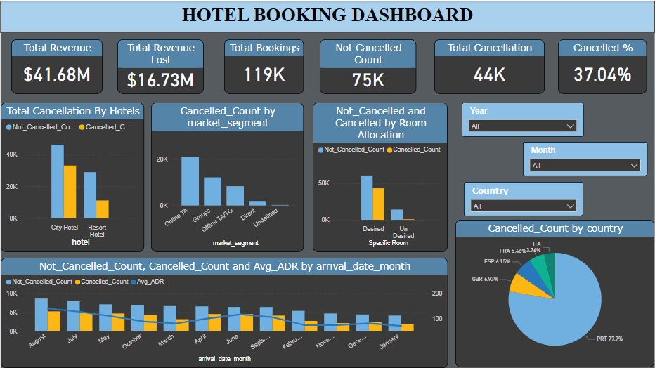

**5 Cancellation Plots :** Display total cancellation by hotel types using bar chart, pie chart which country has done more cancellation.

6 **Filters and Drill-downs**: In filters , It gives freedom to user for explore data in deep . For example, use can see data according to the year wise, country wise as well as user can explore data by any specific month.

**7 Conclusion:** By looking this Dashboard we can easily say that Portugal has a more cancellation among other countries, in market segment cancellation value by online travel agent is high. And also, City hotels has more bookings and cancellations than resort type. Adr from January to march is low but it rises in middle of the year. High numbers of reservation in August that means adr never affects in the middle of the year.