**HOTEL BOOKING CANCELLATION PREDICTION**

**1 Define Key Metrics**: Identify the hotel booking cancellation reasons. This could include total booking in hotels, Cancellation Percentage in different areas like market segment, Month data, Distribution Channels etc.

2 **Select a Tool**: I use Python Language for this data analysis and prediction. And jupyter notebook IDE for write a code.

3 **Data Collection and Integration**: Collect data from Kaggle website . This dataset contains 119390 observations for a City Hotel and a Resort Hotel. Each observation represents a hotel booking between the 1st of July 2015 and 31st of August 2017, including booking that effectively arrived and booking that were canceled.

4 **Design Layout**: Design the all plots in jupyter notebook IDE with the help of matplotlib library. Organize it in a clear and intuitive way so users can quickly understand the information . And write short summery for the plots just below the cells.

**5 Cancellation Data:** Display the cancellation prediction using different plots like bar plot, pie chart on the types of hotels, agents booking, Country wise.

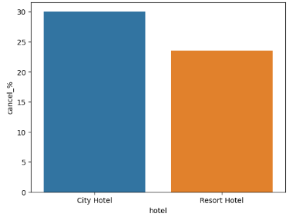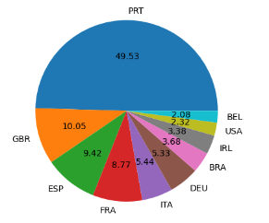

**6 Conclusion:** By looking this ipynb file and after watching every plot and analysis we can easily say that

* Almost 30 % of City Hotel bookings got canceled. reason may be resort hotels are more expensive. City hotels needs to be focused more seeing the cancellation ratio, may be in maintenance, facilities, etc.
* Bar plot shows that most of the customers prefer Bed and Breakfast.
* Portugal has highest cancellation. Portugal country must be focus on increase the facilities and decrease the prices.
* Agent 9 as highest number of booking but Agent 9 has highest number of cancellation after agent 1.
* Room type A is most used hotel should increase the number of A type room to maximize the revenue.
* In the distribution channels TA/TO has highest booking cancellation %. Therefore, a booking via TA/TO is 30% likely to get cancelled.
* ADR is the most influencing factor on the cancellation rate.
* According to time stamp plot march have a more cancellation and August have maximum reservation and minimum cancellation may be the prices are low in august so more reservations.
* Almost 75% customers coming through online agents cancel their booking, this may be due to reasons like, the online picture was very good and when the customer visited it may not be up to the mark due to lack of facilities, spaces, etc So may be the hotels can portray the real picture in online ads to avoid this.