1. What is one categorical variable from the spreadsheet? Make both a bar graph and a

pie chart to display the data. Make these by hand. Include a calculation of the central

angles in the pie chart. Draw your bar graph as precisely as possible using your ruler.

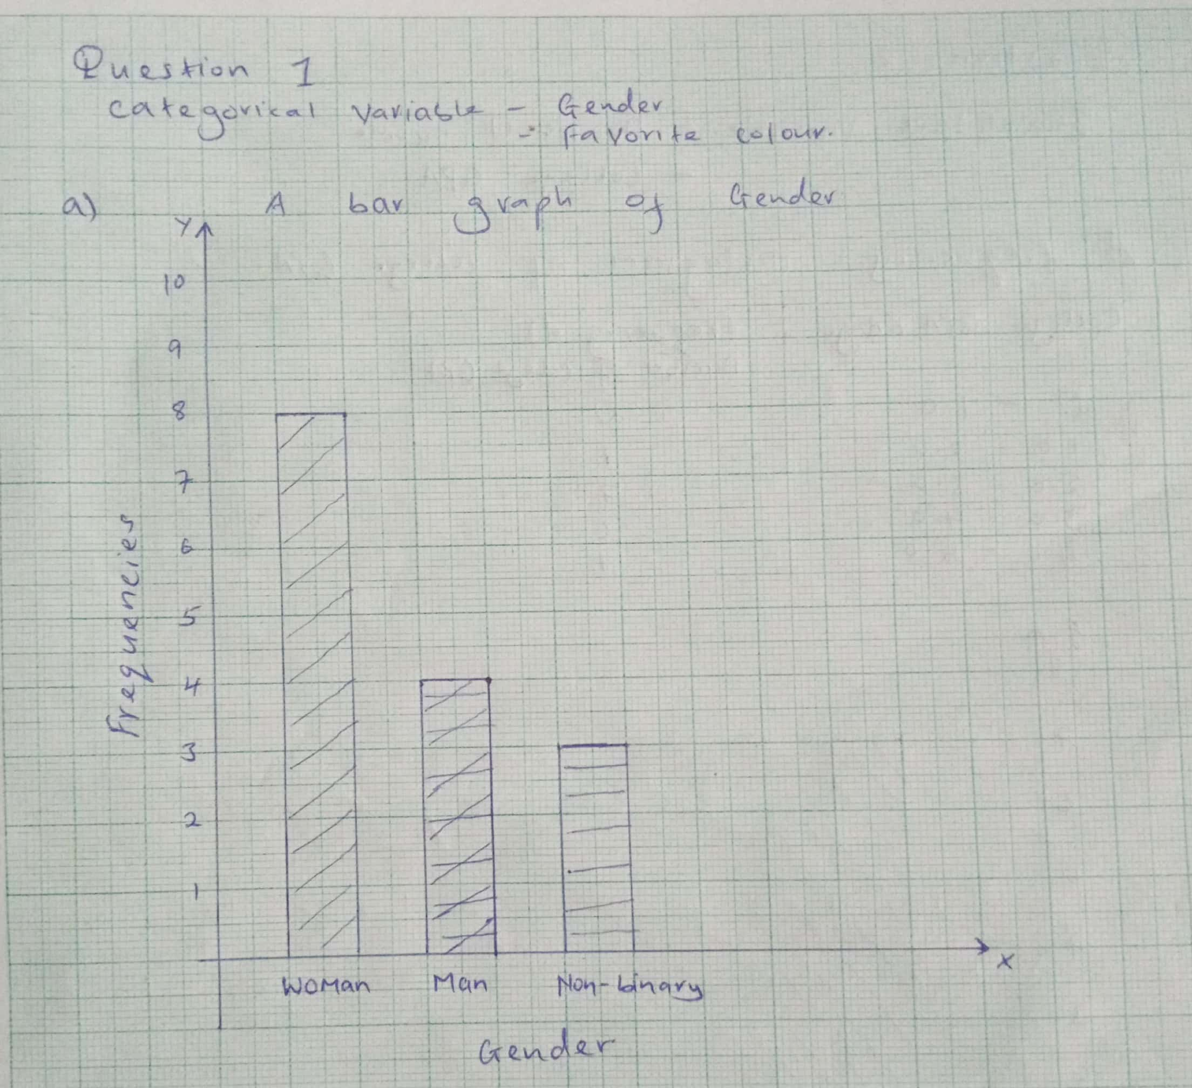

Draw your pie chart as precisely as possible using your compass and protractor.

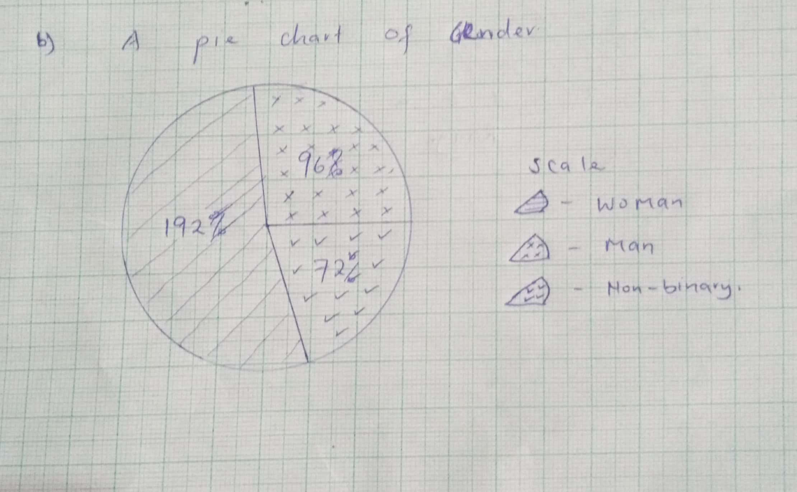

2. What is one quantitative variable from the spreadsheet? Decide on a reasonable range

of values to group these into and make a histogram. Show your calculations. Draw

your histogram as precisely as possible using either graph paper or a ruler.

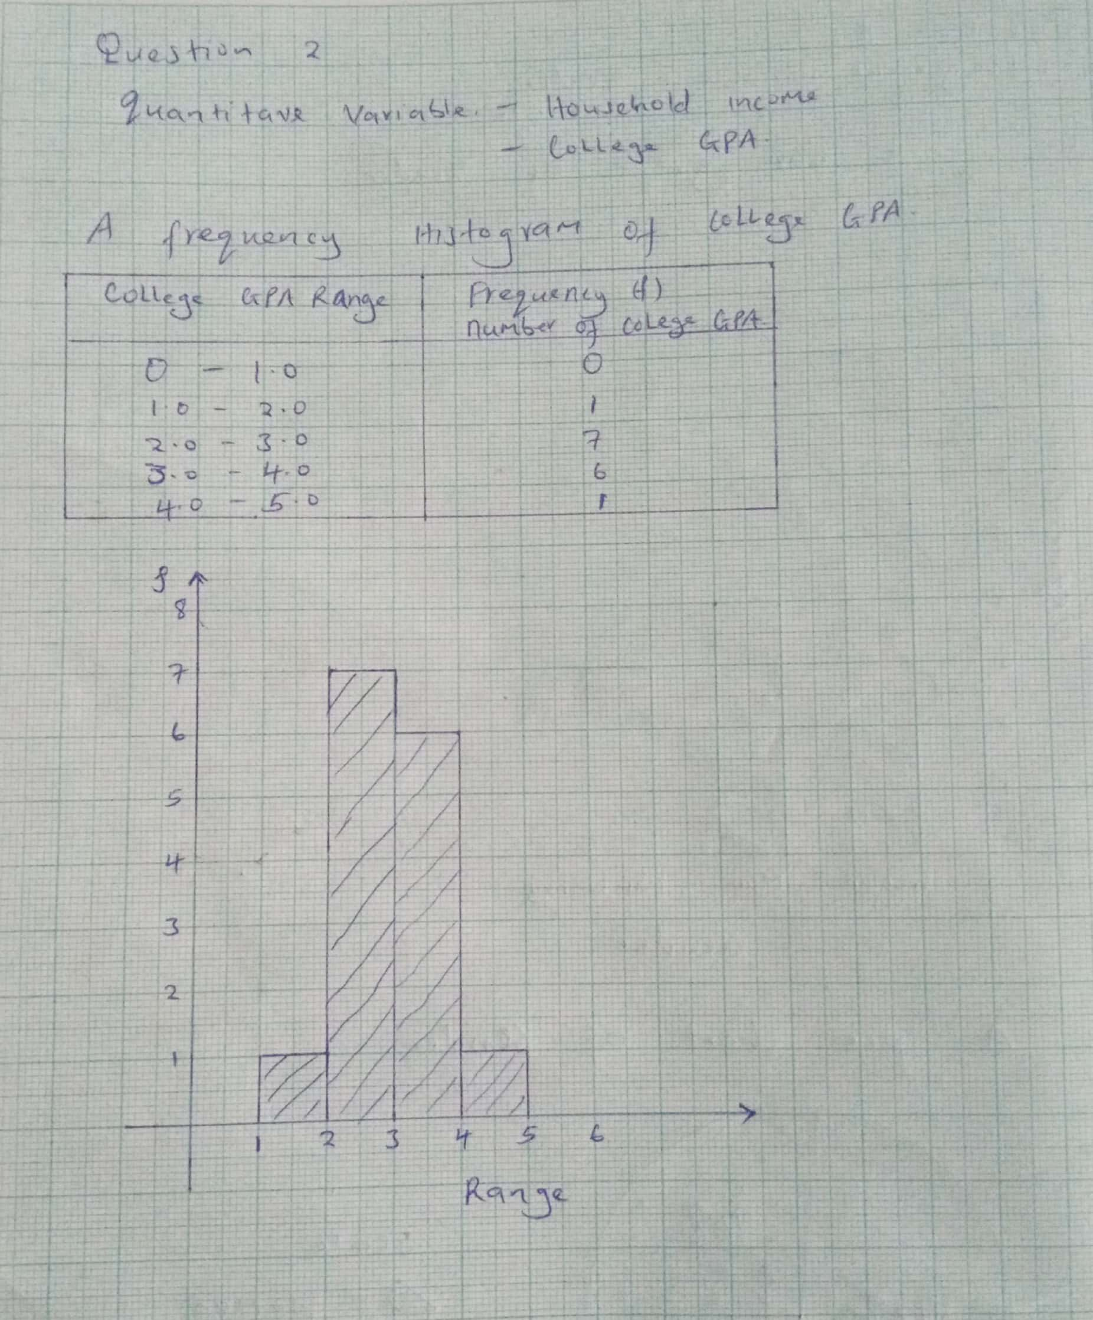

3. Visualize the relationship between household income and GPA making a scatterplot.

Label each student according to the first letter of their name.

Use a ruler to draw your best approximation of the regression line.

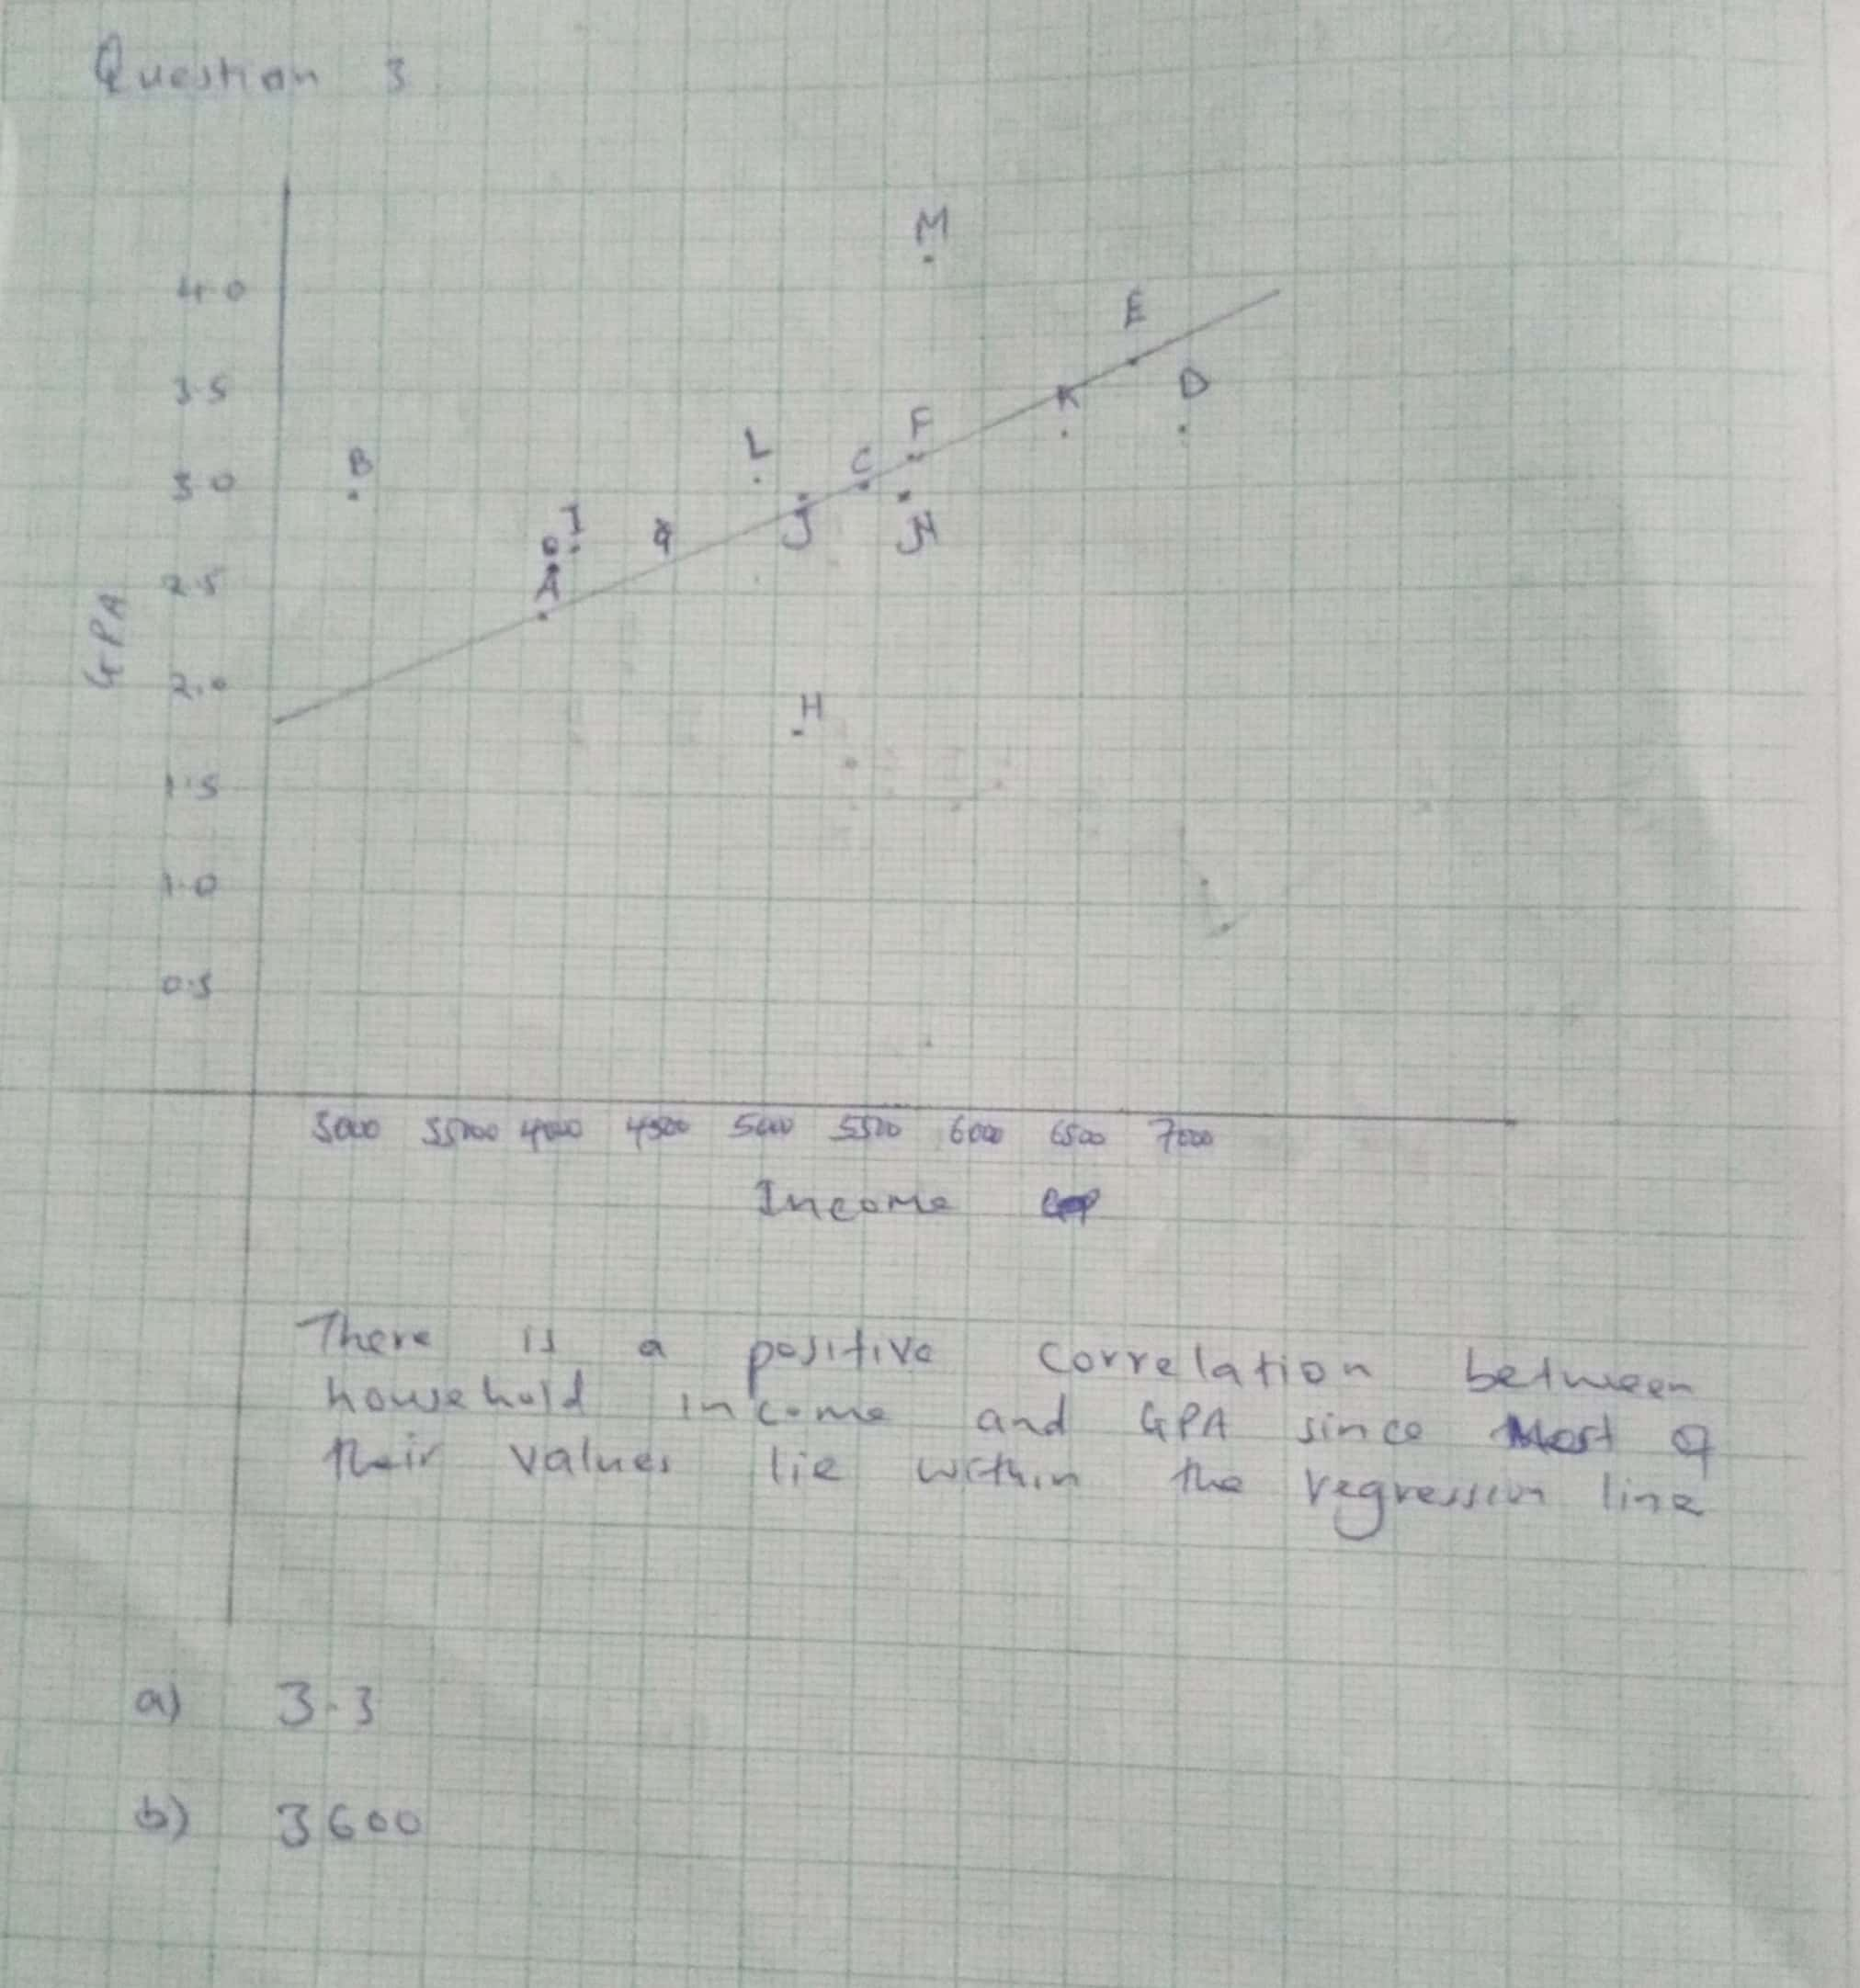

Is there a positive or negative correlation between household income and GPA? **yes**

Use your regression line to answer the following two questions:

(a) What would you expect the GPA of a student whose household income is 60000

to be using the regression line? **3.3**

(b) If a student has a GPA of 2.3 what would you expect their household income to

be using the regression line? **3600**