1)Reinforcement Learning
Reinforcement Learning is a method in which an agent learns what action to take by interacting with the environment.
The agent is not directly told which action is correct. It learns by trying different actions and observing the rewards. This is called trial-and-error search.
Sometimes an action does not give its final reward immediately. The reward may come after some time. This is called delayed reward.
Therefore, the two important features of Reinforcement Learning are:
- Trial-and-error search
- Delayed reward

2)Four Main Elements of Reinforcement Learning
The four main elements of a Reinforcement Learning system are:
- Policy – It tells the agent which action to take.
- Reward Signal – It gives a reward to the agent after an action.
- Value Function – It tells how good a state is based on future rewards.
- Model of Environment – It helps to predict the next state and reward.

3)n-Armed Bandit Problem
The n-armed bandit problem consists of n slot machines or arms.
Each arm gives rewards according to its own reward pattern, but the reward pattern is not known to the agent.
At each step, the agent selects one arm and receives a reward.
The main goal is to maximize the total reward.

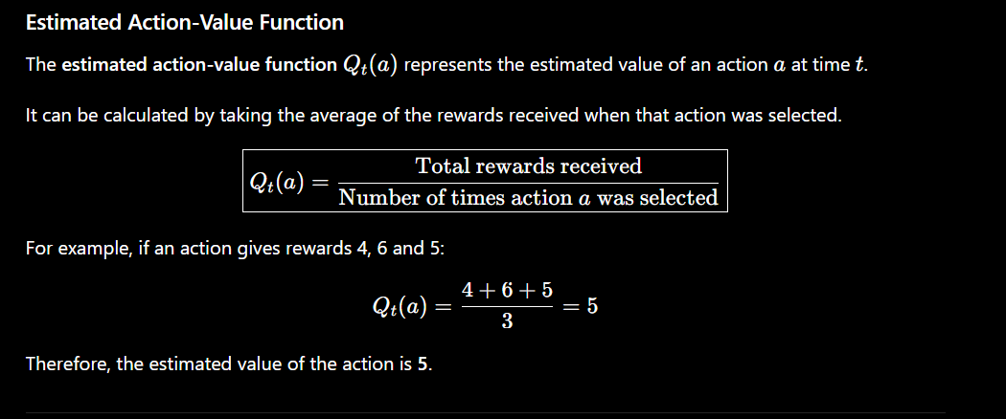
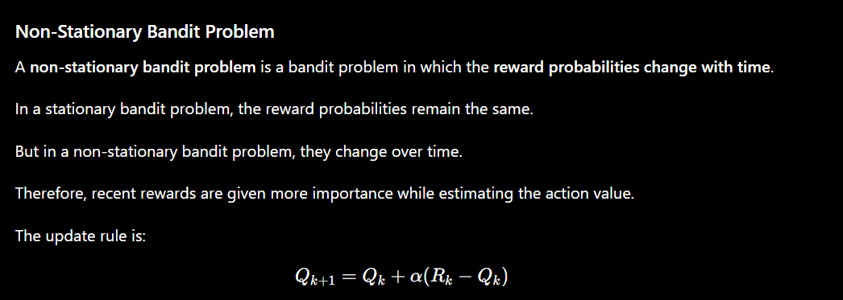

=====================================set 2====================

1)Difference between Reinforcement Learning and Supervised Learning
Reinforcement Learning | Supervised Learning
Learns by interacting with the environment. | Learns from labelled examples.
Correct action is not directly given. | Correct answer is given in the training data.
Learns using rewards and punishments. | Learns by comparing its answer with the given answer.
Trial and error is important. | Trial and error is not the main idea.

2)Value Function
A value function tells us how good a state is by considering the future rewards that can be obtained from that state.
It represents the total reward that an agent can expect to receive in the future, starting from that state.

Difference between Reward and Value
- Reward tells us about the immediate result of an action.
- Value tells us how good a state is considering future rewards.
Therefore:
Reward = immediate
Value = future

3) Greedy Approach
The greedy approach selects the action having the highest estimated reward.
Initially, the available machines are tried to estimate their average rewards.
Then the machine with the highest estimated average reward is selected for the remaining trials.
Thus, the greedy approach mainly uses exploitation after the initial exploration.

🧠 Remember
Greedy = Choose the current best
4)
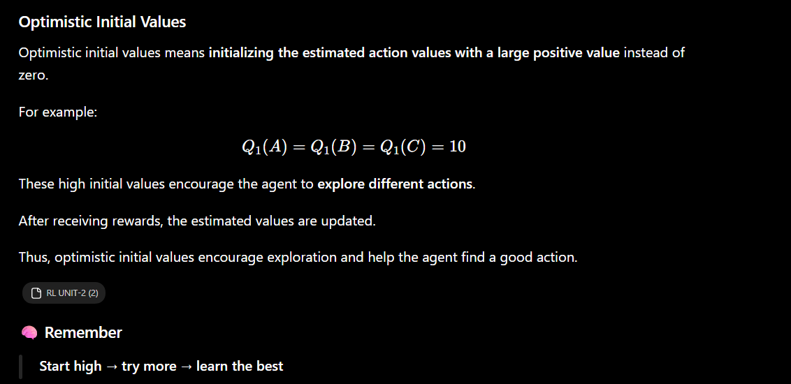

5)Contextual or Associative Bandits
Contextual bandits are bandit problems in which the context or situation is also considered while selecting an action.
Different actions can be selected for different situations.
For example, in online advertisements:
- Shoe-interested users → shoe advertisement
- Medicine-interested users → medicine advertisement
- Diaper-interested users → diaper advertisement
Thus, contextual bandits select an appropriate action based on the given context.

🧠 Remember
Context = Situation
Contextual Bandit = Situation chusi action choose cheyyadam

