The Chinese University of Hong Kong

Department of Computer Science and Engineering

CENG2030 Fundamentals of Embedded System Design

Lab 3: Instrumentation and Measurement

Answer Sheet

Student Name: Lee Kong Yau SID: 1155149600

1. **Installation of TINA**
2. **Multimeter [30%]**
   1. Draw the circuit with voltmeter and ammeter as .TSC file, and upload it as part of your submission. [10%]
   2. Voltage Measurement

VM1: ______3V_____ [10%]

* 1. Current Measurement

AM1: _____3mA_____ [10%]

1. **Build a Timer Circuit [25%]**
   1. Draw the 555 astable timer circuit as .TSC file, and upload it as part of your submission.
2. **Oscilloscope [25%]**
   1. Capture your Oscilloscope window below:

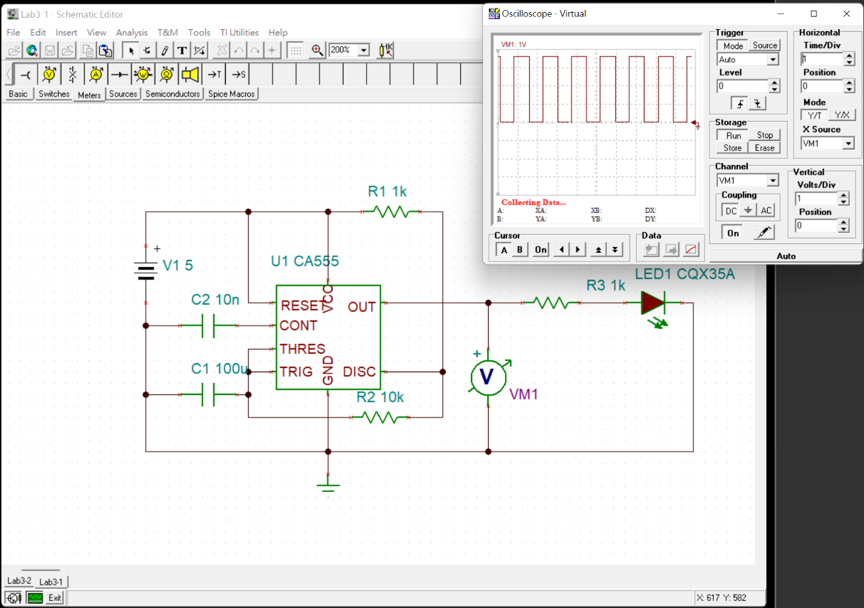

1. **Signal Generator [20%]**
   1. Capture your TINA window below:

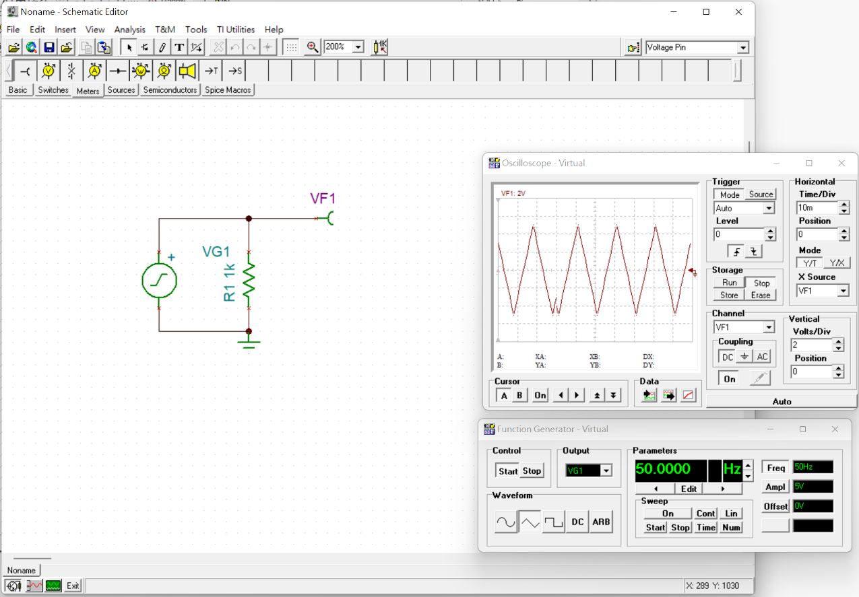

THE END