Lab 1: Introducing Ajax to your web application

**Estimated time to complete this lab: 20 minutes**

**Objectives**

After completing this lab, you will be able to

* Create an asp.net ajax enabled web application
* Understand and use the various default asp.net ajax controls

**Scenario**

There is currently a screen in the main lobby of Contoso showcasing the list of existing customers for Contoso. The problem is the receptionist needs to constantly click a button on her screen to refresh the list and show another list of customers.

After hearing about ASP.NET Ajax, your boss wants you to use ajax to remove the need for the receptionist to constantly click a button on her screen to refresh the showcase.

**Lab Steps**

1. **Start up Visual Studio**

Click on Start -> All Programs -> Microsoft Visual Studio 2008 -> Microsoft Visual Studio 2008

1. **Create a new Web Application Project**

|  |  |
| --- | --- |
|  | * Click on File -> Open -> Web Site * Click on File System * Browse to **D:\Advanced ASP.NET\Website** * Click **Open** |

1. **Create a new webpage for this lab**

|  |  |
| --- | --- |
|  | * Right click on **Chapter1\Lab** * Click on **Add New Item..** * Select **Web Form** * Enter **default.aspx** inside the name field * Click **Add** |

1. **Adding Controls to your page**
   * Click on **Design** to view the page in design view  
     
   * Drag a **ScriptManager** from the ToolBox (located inside Ajax Extensions) to your page
   * Drag an **UpdatePanel** from the ToolBox (located inside Ajax Extensions) to your page, making sure it is placed after the ScriptManager
   * Drag a **Timer** from the ToolBox (located inside Ajax Extensions) to the UpdatePanel
   * Set the **Interval** properties of the Timer control to 5000
   * Drag a **GridView** from the ToolBox (located inside Data) to the UpdatePanel
   * Drag a **Label** from the ToolBox (located inside Standard) to the UpdatePanel

Your page should now look like this

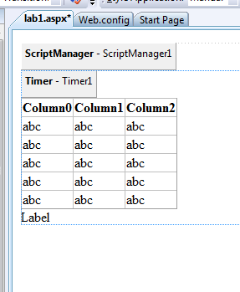

1. **Adding DataSource to your GridView**
   * Click on the GridView, you will notice a small arrow appear
   * Click on the **small arrow**
   * Under Choose DataSource, select **New DataSource**
   * Select **Database**
   * Click **Ok**
   * Click on **New Connection..**
   * Select **Microsoft SQL Server Database File**
   * Click **Continue**
   * Browse to **App_Data\AdventureWorks.mdf**
   * Click **OK**
   * Click **Next**
   * Click **Next**
   * Select **Specify a custom SQL Statement or stored proceure**
   * Click **Next**
   * Enter the following SQL Statement inside the Select SQL Statement box

**SELECT top 20 [Title], [FirstName], [MiddleName], [LastName], [CompanyName] FROM [Customer] ORDER BY newid()**

* + Click **Next**
  + Click **Finish**

1. **Adding code to trigger the auto update**
   * **Double click** the Timer Control
   * Enter the following in the code behind function for Timer1_Tick

**GridView1.DataBind();**

**Label1.Text = "Last Update @ " + DateTime.Now.ToString("dd MMM yyyy hh:mm:ss tt");**

1. **Save all files**
2. **Verification**
   * Start Internet Explorer
   * Goto http://localhost/chapter1/lab/default.aspx
   * Notice how the data refreshes itself every 5 seconds