Lab 3: Introducing Generics and Custom Controls

**Estimated time to complete this lab: 2 hour**

**Objectives**

After completing this lab, you will be able to

* Understand how to use generics
* Understand and use custom controls and web controls

**Scenario**

The product listing page which you have done in the previous task was great. Users love it. But one common complaint is that the listing page only list 10 items at a time and the paging is hard to navigate. They indicated that it will be great if there is a way to quickly jump to a specific page in the grid. Also your boss indicated that he will like the new grid to be used in other portions of the site, so he needs it as a **custom control**.

**Lab Setup**

1. Search and understand the following terms
   1. Page.RegisterRequiresControlState
   2. SaveControlState and LoadControlState
2. Browse the following custom control files covered in the demo
   1. App_Code/Solution/Chapter3/SimpleControl.cs
   2. App_Code/ Solution/Chapter3/AdvancedControl.cs
   3. App_Code/ Solution/Pair.cs
3. Modify Chapter3/Lab/default.aspx and App_Code/Chapter3/Gridview.cs to meet stated requirements
   1. Note that AjaxControlToolkit have been mapped to the tag prefix AjaxCTK inside web.config

**Lab Completion Scenario**

The gridview should meet the following requirements

1. Have a drop down on the top right hand corner allowing users to immediately jump to a specific page
2. The drop down should reflect the current gridview page

Your product listing tab should now look like

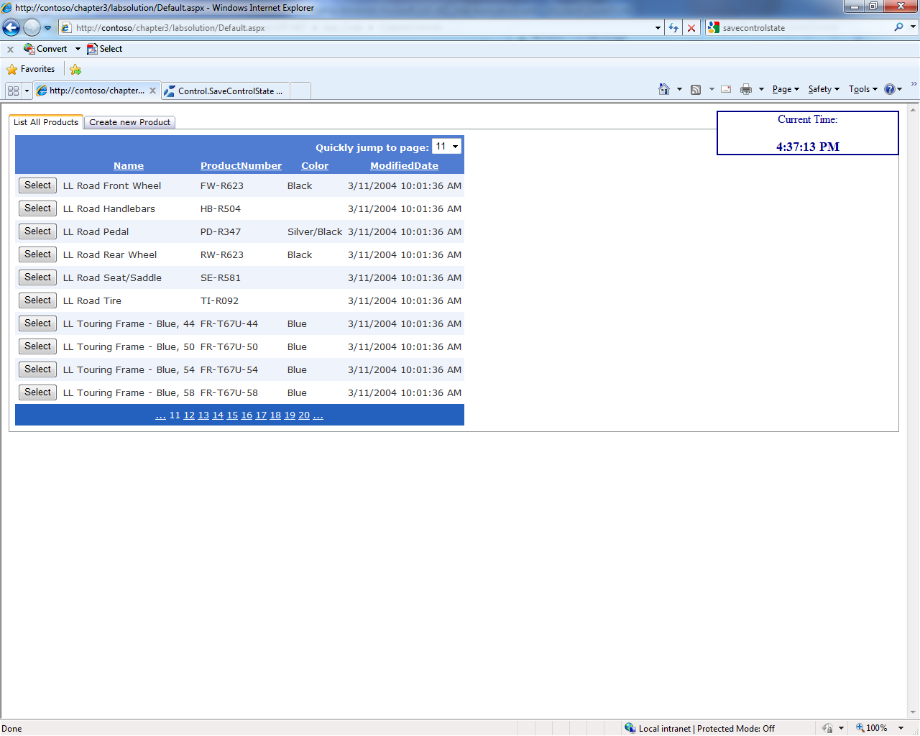

**Advanced Completion Scenario**

Completed the minimal requirements, how about tackling the following advanced requirements

1. Add in a filter which automatically filters all inputs based on entered text
2. Add in an ascending and descending icon to show the current sorted column sorting type
3. Change the select command to an Ajax Control Toolkit Hover menu